**MAE 6220 Project 3 Due: XX/XX**

In this project, we are investigating the capabilities and deficiencies of different turbulence models by numerically simulating flow over a Backward-facing Step (BFS). Figure 1 shows a schematic drawing of the BFS. In this flow setup, boundary layer along a flat plate encounters a drop and abruptly detaches. This results in a recirculation region next to the face of the step with two counter-rotating vortices. The smaller vortex occupies the very corner of the step. The larger one is situated just outside of the inner vortex. Flow reattaches to the lower wall some distance from the step. Flow characteristics (e.g. location of reattachment, pressure distribution along the walls, etc.) depend on the Reynolds number of the incoming flow and the ratio of the boundary layer thickness to step height. This problem has been investigated experimentally by Kim et al. [1] and in this project, we seek to replicate their results numerically.

FLOW

Separation point

Reattachment

Figure 1. Schematic of Backward-facing Step.

Figure 2 presents the computational domain, dimensions and the appropriate coordinate system for this problem. Please note that the drawing is not to scale. The Reynolds number based on freestream velocity and step height is $Re_{h}=\frac{Uh}{ν}=43270$. In the experiments, flow reaches the separation point at $Re_{δ}=\frac{Uδ}{ν}≈13000$ where $δ$ is the boundary layer thickness. At this Reynolds number flow regime is fully turbulent. We need to replicate this in the simulation. This poses a problem: In order to ensure that flow over the upper flat plate has reached $Re=13000$ at separation, the upper plate has to be long enough to accommodate transition from laminar to turbulence (occurs around $Re=9000$) and develop further to the desired Reynolds number. This in turn means a very large domain and much higher number of grid points and computational cost. To circumvent excessive costs, we can consider a much shorter upper flat plate but prescribe a boundary layer velocity profile at the inlet (instead of a uniform velocity profile). These profiles can be obtained from published experiments or numerical studies. Figure 3 shows turbulent boundary layer velocity profile at $Re_{δ}≈13000$. We will prescribe this velocity profile at the inlet using a user-defined function.

Inlet

X

Y

O

X=20 m

X=-10 m

1 m

3 m

Pressure outlet

Figure 2. Computational domain.

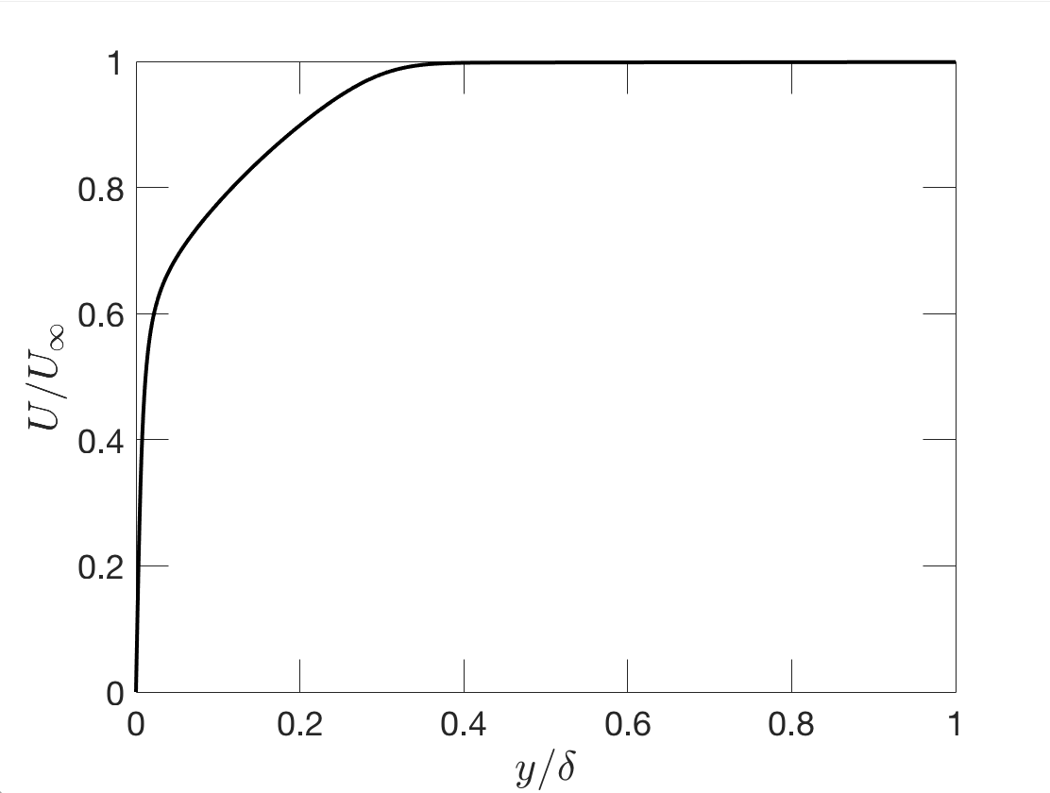

Figure 3. Turbulent boundary layer velocity profile at $Re_{δ}≈13000$.

The profile is defined in a file written in C (vel_profile.c) and has been uploaded to Blackboard. To import the file in FLUENT, from the top menus in UGI go to:

Define > User-Defined > Functions > Interpreted…

In the “Interpreted UFDs” window, load the file and click Interpret (figure 4). This will compile the file and the profile is now ready to use. When prescribing inlet boundary conditions, choose velocity-inlet. Within the Velocity Inlet window, choose “Components” for “Velocity Specification Method”. From the drop-down menu next to X-Velocity, choose “udf inlet_x_velocity”. You can set Y-velocity to zero (not strictly correct however v-velocity is very small in a turbulent boundary layer compared to x-velocity).

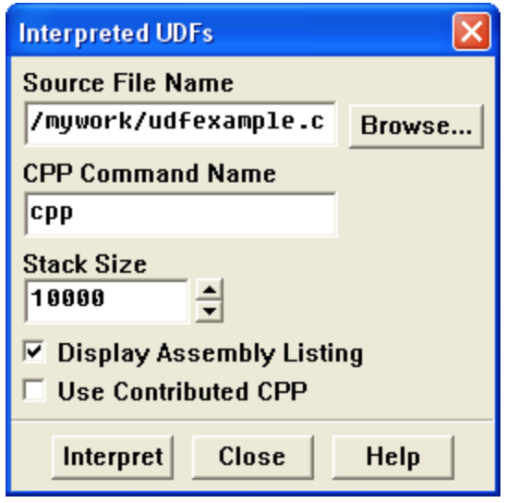

Figure 4. Interpreted UDF window.

Simulate steady turbulent flow over a backward-facing step using three turbulent models: 1) Spalart-Allmaras (one eq. model) 2) $K-ω$ SST 3) Realizable $K-ϵ$.

Prepare a report that includes the following:

1. Give an overall expression of the flow based on contours of streamwise velocity and streamlines.
2. Identify the reattachment region and compare to reference results [1].
3. Plot the pressure coefficient along the walls and compare to reference results (figure 2 in [1]).
4. Compare the turbulence models and their predictive capabilities with regards to this flow regime.
5. Present mesh statistics and features. Explain why you chose that particular grid and why you think it is suitable for this problem.

Notes:

1. Construct the domain geometry exactly as is presented in figure 2. The UDFs are tailored to that particular coordinate system; therefore, any change will yield incorrect results.
2. Turn on Enhanced Wall functions for all turbulence models.
3. Make sure that the closest grid point to the walls is **no more than 0.0018m** away in the wall-normal direction.

References:

[1] Kim, J & J. Kline, S & P. Johnston, J. (1979). Investigation of a Reattaching Turbulent Shear Layer: Flow Over a Backward-Facing Step. *Journal of Fluids Engineering*.