1. Open The Visual Studio
2. Then Open the project file
3. In The Solution Explorer Double Click on this icon

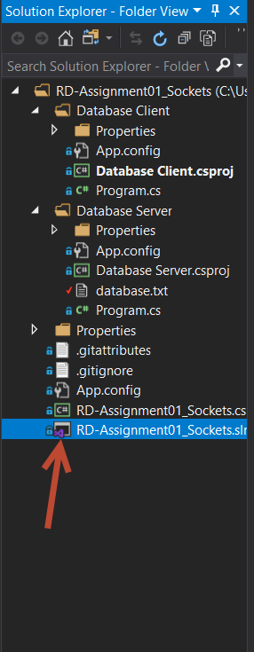

1. Then Right click on following “Solution RD-Assignment01_Sockets”, and go to properties.

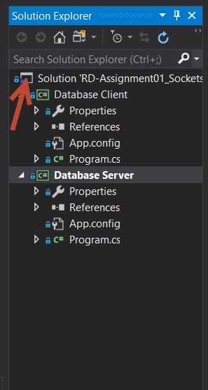

1. In Properties window, under the, Common Properties-> Startup Project. CHECK on Multiple startup projects, like given in the image.

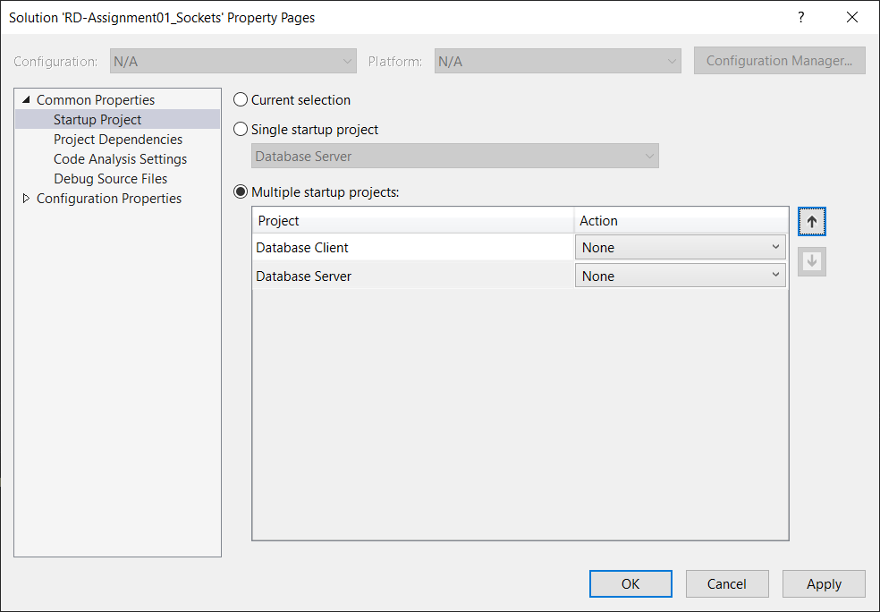

1. Click in Database server and click on the small arrow shown in image below to bring the database server up.

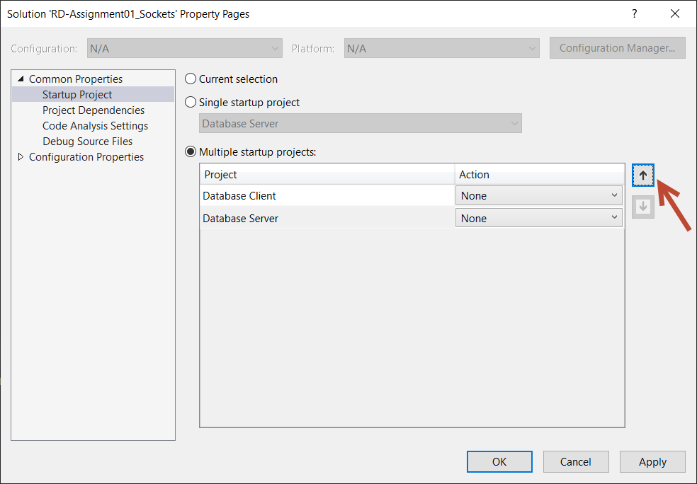

1. Click on “None” to change it to “Start” as shown in the picture below.

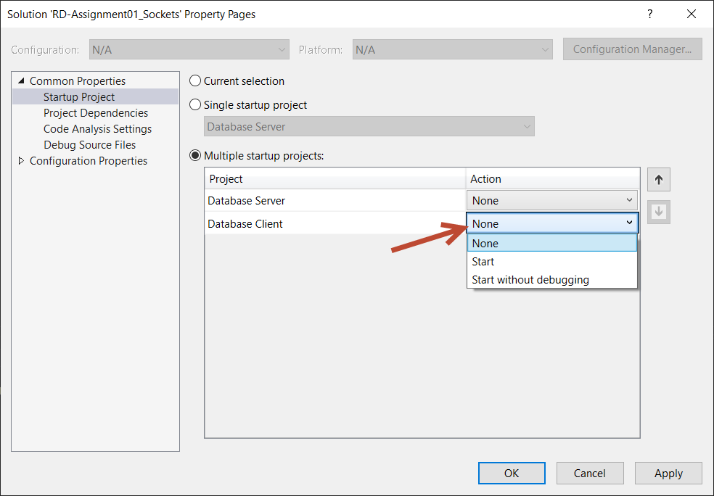

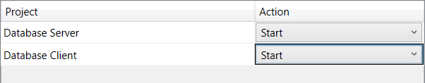

1. Finally Click on Apply and OK, DEBUG the program to work on Server and Client Side.

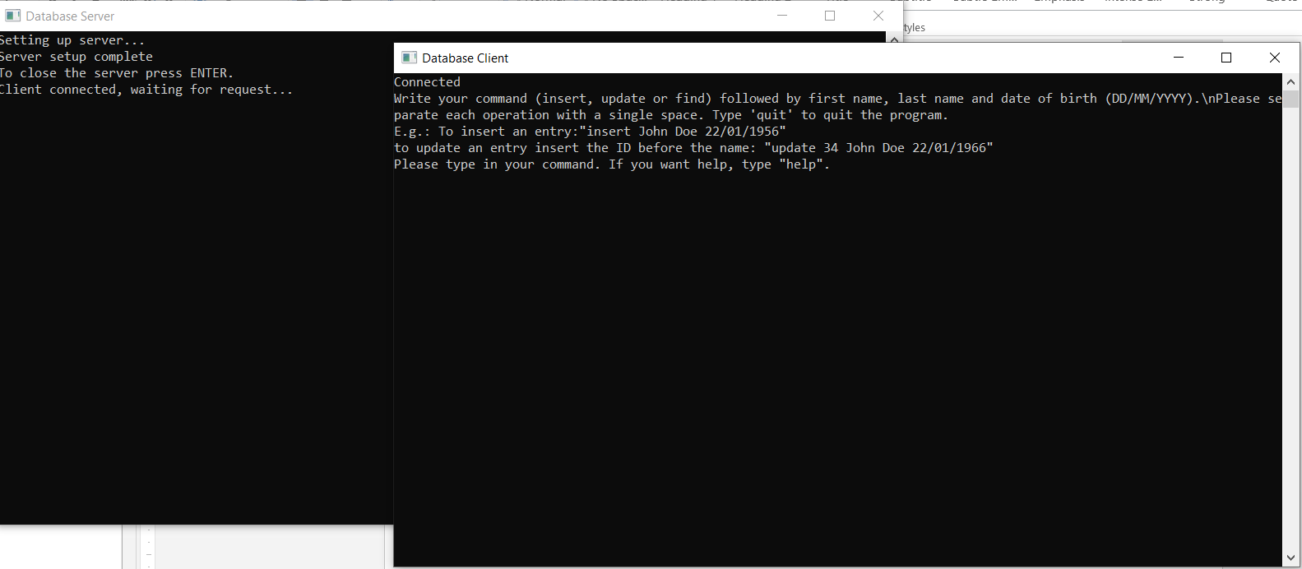

1. Type ‘help’ to understand how the program works.