Windows Environment

For those of you attempting to run the Validation Tool in a Windows environment, here are the steps for setting the CLASSPATH environment variable and executing the software:

Right-click on My Computer on your desktop and select the Properties menu-item.

Navigate to the Advanced tab and select the Environment Variables button.

At this point, you should now see a window like the one below:

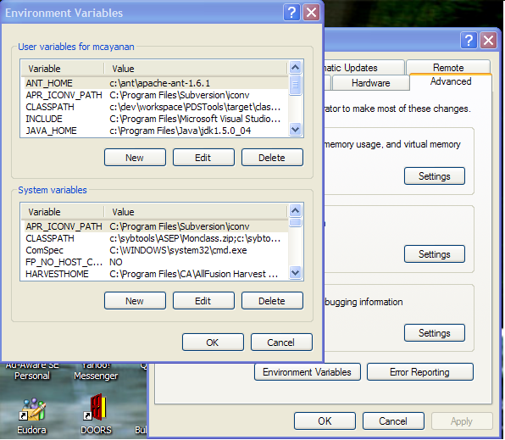

Highlight the CLASSPATH variable in the User Variables list and select the Edit button.

Append to the current contents of the variable, the paths to the jar files that came with the PDS Tools Package. Separate each path with a semicolon as follows:

c:\pds-tools-0.2.0\antlr-2.7.6.jar;c:\pds-tools-0.2.0\commons-cli-1.0.jar;c:\pds-tools-0.2.0\commons-io-1.2.jar;c:\pds-tools-0.2.0\log4j-1.2.13.jar;c:\pds-tools-0.2.0\pds-tools-0.2.0.jar

Do the same for the jar file that came with the PDS Tests Package:

c:\pds-tests-0.1.0\pds-tests-0.1.0.jar

Select the OK button when you are finished editing the CLASSPATH variable, then select the OK button at the Environment Variables window to apply the changes.

Open a DOS window and follow the steps detailed in sections 6.1 and 6.2 for executing the Validation Tool and the regression test suite.

Note: If you already have a DOS window open, you will need to close and re-open the window for the CLASSPATH changes to take in effect.

