Republic of the Philippines

Department of Education

REGION VII – CENTRAL VISAYAS

CITY OF NAGA, CEBU

BALIRONG ELEMENTARY SCHOOL

**SECOND PERIODICAL TEST**

**MATH 2 SCORE:**

**S. Y. 2025-2026**



**Directions: Read the sentences and circle the letter of the correct answer.**

1. Which coin has the smallest value?  
A. 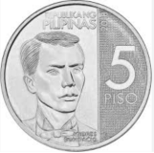 B. 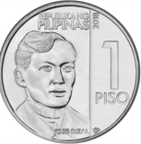 C. 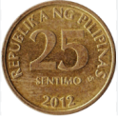 D. 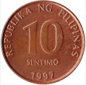

2. What coin is colored gold and has the number 10 on it?  
A. ₱1 B. ₱5 C. ₱10 D. ₱20

3. What money bill has the greatest value?  
A. 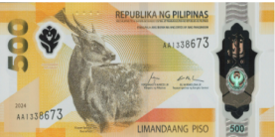 B. 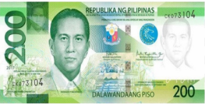 C. 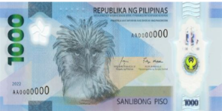 D. 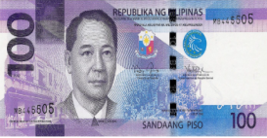

4. Which group has a bigger value?  
 Group 1: 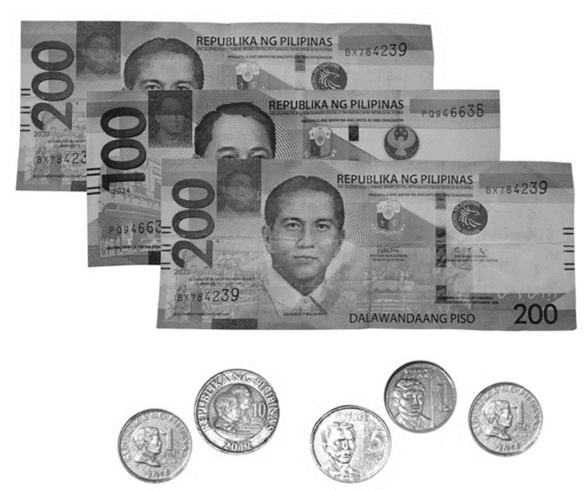 Group 2: 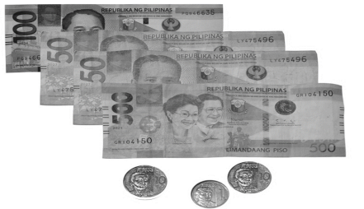  
A. Group 1 B. Group 3 C. Group 2 D. They are the same

5. Ana has ₱1, 200. She got ₱100 from her mom. How much does she have now?  
A. ₱1, 100 B. ₱1, 300 C. ₱1, 200 D. ₱1, 400

6. Mother gave ₱2 000. You bought groceries worth ₱850. How much change will you get?  
A. ₱1, 150 B. ₱2, 100 C. ₱1, 200 D. ₱1, 180

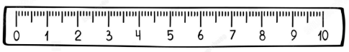

1. 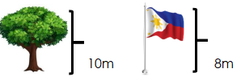What is the length of the pencil below?   
   A. 3 cm B. 5 cm C. 6 cm D. 7 cm
2. Which is longer?   
   A. tree B. the same C. flagpole D. none
3. Which unit will you use to measure the distance from your classroom to the gate?   
   A. cm B. m C. L D. kg
4. Ana’s ribbon is 25 cm long. Bea’s ribbon is 40 cm long. Who has the longer ribbon?  
   A. Ana B. Bea C. Both are the same D. Cannot be measured



1. What is the estimated length of a notebook?
2. 2cm B. 15cm C. 10m D. 2m

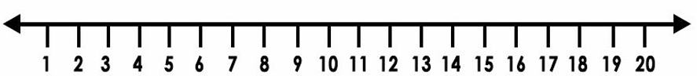

1. Use the number line to find the difference. **15 – 3 =**_______  
   A. 11 B. 12 C. 13 D. 14
2. What is **254 – 97 =**  
   A. 148 B. 147 C. 249 D. 250

14. What is **263 – 78 =**  
A. 156 B. 155 C. 185 D. 257

15. Anna had 156 candies. She gave 23 to her friends. How many candies are left?  
A. 127 B. 133 C. 144 D. 123



1. A basket has 148 apples. If 115 apples were eaten, how many apples remain?  
   A. 134 B. 133 C. 132 D. 135
2. Maria has ₱1900. She bought a toy for ₱1555. How much money does she have left?  
   A. ₱346 B. ₱345 C. ₱344 D. ₱374
3. What is **508 – 243 =**A. 265 B. 264 C. 266 D. 263
4. Mang Jose bought mangoes for ₱850. He paid ₱1000. How much was his change?  
   A. ₱140 B. ₱150 C. ₱160 D. ₱170
5. Which number comes next in the pattern? **15, 20, 25, ___**  
   A. 35 B. 40 C. 30 D. 45
6. Find the missing number: **90, 80, 70, ___, 50**A. 60 B. 40 C. 30 D. 20

22. Which number will complete the pattern? **3, 6, 12, 24, ___**A. 36 B. 48 C. 50 D. 60

23. What is the next two terms in the pattern? **5, 10, 20, 40, ___, ___**  
A. 60, 80 B. 70, 140 C. 80, 160 D. 100, 200

24. Create a decreasing pattern starting with 120 and subtracting 15 each time. What are the first 4 terms?  
A. 120, 115, 110, 105 B. 120, 105, 90, 75  
C. 120, 110, 100, 90 D. 120, 105, 95, 80