

**CYBRON DIPLOMA**

**START AND DEVELOP YOUR CAREER FROM HERE IN CYBER SECURITY**

**GRADE 10TH PASSED CANDIDATE ARE ELIGIBLE FOR THIS COURSE**

CYBER SECURITY RAPID OFFENSIVE NATIVE FORUM

**Published by:**

Cyber Security Rapid Offensive Native Forum

Cybron

404 Old Bedford Road, Luton, England LU2 7BP SIC codes – 62012 United Kingdom

contactus@cybroninternational.com

(+44) 7783 530138

,

All rights reserved. "cybron", the cybron logo, "CYBRON", the Cybron Scout, Cybron Scout logo, "CYBRON-FRAMEWORK", "Cybron”, “and the Cybron International are registered marks of Cybron, Inc.   
The Cybron is a trademark of the Cybron, Inc.

**CONTENTS**

INTRODUCTION 4

CYBRON FRAMEWORK 5

CYBRON FRAMEWORK DESCRIPTION 6

PROGRAM BENEFITS TO & PRE-REQUISITE 7

**REQUIRED QUALIFICATIONS** 7

**CREDENTIALS** 7

**BENEFITS** 7

FURTHER BENEFITS OF THE PROGRAM 8

PROGRAM STRUCTURE 9

OTHER LEARNING ACTIVITIES 10

PROGRESSION OF THE PROGRAM 11

**Awarding of Cybron Diploma** 11

DOMAINS AND TASKS 12

KNOWLEDGE AREAS 13

ASSESSMENT OF PROGRAM (ONLINE) 18

CYBRON DIPLOMA REGISTRATION AND PAYMENT 19

**CYBRON Diploma Eligibility Requirements** 19

**REGISTRATION PROCESS** 19

**PROGRAM BIFURCATION** 19

SEMESTER BIFURCATION 20

CYBRON COURSES 22

CYBRON DIPLOMA FEE STRUCTURE 23

CYBRON DIPLOMA EXAMINATION SYSTEM 24

Partner Institute Internal Examination System 24

Cybron UK Online Exam System 24

CONTINUING EDUCATIONAL REQUIREMENTS (CER) PROGRAM 25

CONTACT DETAILS 26

# INTRODUCTION

We help you to establish your career in Cyber Security

There are number of students who want to establish their career in the field of Cyber Security, but due to unavailability of appropriate guidelines and directions they would not establish their careers according to the requirements. As per research, there are number of courses and curriculums have been running in the schools, colleges and universities, but almost all are obsolete and out of market. Thus! Industry is not accepting them after completing their qualification due to obsolete qualification.

However, emerging technologies are also impacting and new methodologies and systems related to IR 4.0 and 5.0 playing a vital role to establishing society 5.0. Therefore, to survive in the local or international market students and professionals need to understand the newest technologies at all level and learn that how to work on it.

With reference to the above discussion, it has been found a huge gaps between the industry & Academia, and on daily basis, this gap has been broadening, because technology is upgrading very fast and academic people cannot be able to deliver these technologies in time.

In all above context, it is very clear that all of our daily lives either it is pertain to home or office or businesses. All are connecting through digital technologies via Internet and we are delivering all services and products through Information Technology. But, if we are getting the advantage of this electronic medium, we have another challenge of cyber security. Therefore, we establish a new framework, which talks about the Cyber Security from Secondary School Level and gear up to Professional Level.

# CYBRON FRAMEWORK

One of the Leading Learning Framework of Cyber Security

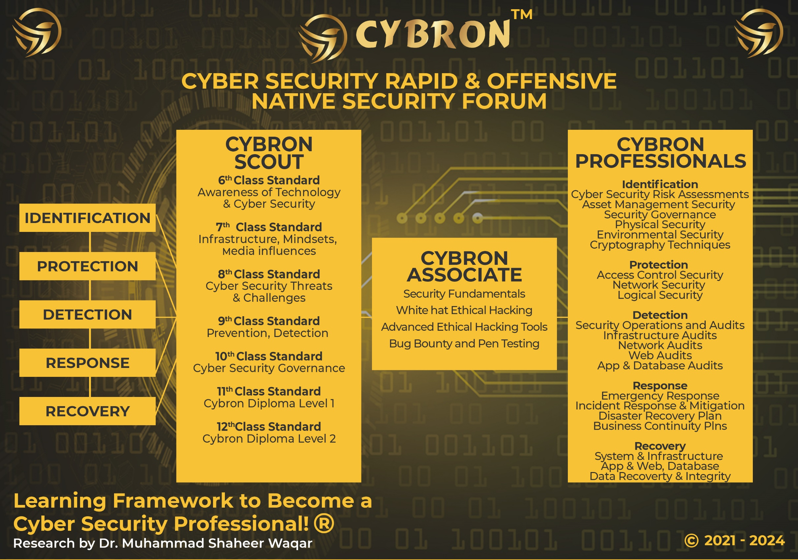

# CYBRON FRAMEWORK DESCRIPTION

The CYBRON framework has been influenced by the International standard NIST USA and it has been further elaborated as per the research. The philosophy behind regarding this framework that organization and industries are implementing lots of security tools and monitoring systems to secure their mechanism, data, system and technology from the unwanted people. But after spending the huge investments, nobody is 100% sure that they are secure and protected from different threats, attacks and risks.

In this context, our research team under the supervision of Dr. M. Shaheer Waqar has found that it is the pure game of the mind-set, because if the people can understand, how these technologies are helpful and beneficial for their lives, so they cannot sabotage or harm it. But we cannot stop the negative mind-set people who never do positive work for the mankind.

Therefore, this framework has been established according to the aforementioned scenarios, and the knowledge set is established from the class 6 grade standard and providing them the required information according to their level about the cyber security. Hence! When from class 6 grades students understand about the pros and cons of the cyber security threats and its challenges and progressively they learn up to date content with positive mindset and understand latest technologies and their impacts. So they are not going to harm or destroy it. Therefore, after using this training methodology, we are hopeful that CYBRON can change the mindsets as well as secure our societies industries and countries.

# PROGRAM BENEFITS TO & PRE-REQUISITE

## 

## **REQUIRED QUALIFICATIONS**

* 10th grade and Equivalent Qualifications
* Basic Knowledge of Computers

## **CREDENTIALS**

* Get the appropriate Cybron Diploma from Cybron - UK
* International Recognized Diploma

## **BENEFITS**

* New comers can opt this diploma
* Program or courses in the diploma is developing the high skills of the candidate
* Each course will provide the better job option in the market
* Getting the advanced IT and Cyber Security Skills in One & half year

# FURTHER BENEFITS OF THE PROGRAM

* Organization’s management required strategic IT & Cyber Security Skills at all levels, this Program encourage the IT People for betterment of the organization.
* The student will equip in the particular area of IT and also opt the knowledge of Cyber Security for their better career.
* Individuals like to increase their profile for good future, this program will also give the clear and right direction to select the right pathways.
* The program also allows to all organization to make the culture of training & development and increase the productivity of the organization.
* The program helps to motivate teams and build their capabilities according to the requirement.
* It will boost the economy in the society and helps to transfer skills from people to people.
* The programs also enable the student efficiency level through different technology tools and methodologies.
* This program will also help the organization in respect of skilled human resources.

# PROGRAM STRUCTURE

|  |  |
| --- | --- |
| Total Courses | 10 |
| One Credit Hour | 10 Learning Hours |
| Total Credits Required | 33 Credit Hours |
| Per Course Certification | Possible |
| Total Hours | 330 Hours |
| Total Duration | One & Half Year |
| Required Courses to Get Diploma | 10 |

# OTHER LEARNING ACTIVITIES

**Practical Assignments of each Course** 1

**Learning Activities in each course**  1

**For Applying Diploma**

Final Presentations Shall be given by each

Trainee of at Least One hour 1

**For Applying CYBRON DIPLOMA**

Question Answer Session one hour arrange by Cybron 1

**One Final Project Submitted By Each After One & half year 1**

Trainee of In Hard and soft Form

(Two Copies)

# PROGRESSION OF THE PROGRAM

Total Credentials = 330 Credit Hours

One Credit Hours = 10 Learning hours

Completion of 10 Courses = Cybron Diploma

Final Assessment The criteria is to develop the provided assignments on the basis of courses.

## **Awarding of Cybron Diploma**

Once the participants shall achieve 10 Courses / 33 Credits-hours marks certificate, then S/he will be able to apply to receive the CYBRON DIPLOMA from CYBRON UK

# DOMAINS AND TASKS

In this document you will find an updated structure for the CYBON Diploma Examination Content Outline. Based on Experience Consultants and stakeholders, we have devised and simplifying the format so that the CYBRON Diploma is easier to understand and interpret.

**The domain and task are well defined on the following pages:**

**Domain:** Defined as the high-level knowledge area that is essential to the practice of Cyber Security.

**Tasks:** The underlying responsibilities of the cyber security team member within each domain area.

Each CYBRON Diploma Course examination will include all tasks for a domain, and CYBRON will adhere to the percentage of coverage at the domain level as outlined in the further pages.

# KNOWLEDGE AREAS

|  |  |
| --- | --- |
| Domain 1: Fundamentals of IT, Networking, System Administration with Cyber Security Concerns | |
| **Task 1** | Demonstration the fundamental of information Technology  Get the knowledge of fundamentals of Computer Systems  Understanding of Computer Hardware and its component  Understanding of computer software, generation and SDLC  Understanding of common threats on computer operating system  Security Measures and best practices of usage of internet and surfing  Understanding of Data Protection and Privacy Matters  Knowledge about the emerging technologies and threats |
| **Task 2** | Understanding of Computer network & its related equipment and usage  How the computer networks are working  Understanding of IP Address classical and CIDR Scheming  Differentiate between IPv4 and IPv6  Understanding of Routing, Mapping, Natting and Super netting  Understanding of Protocols and its usage  Configuration of Protocols  Understanding of Packets and its tracing |

|  |  |
| --- | --- |
| **Task 3** | Practical Understanding of System Administration & System Level Security by using any operating system with concerned families  Understanding of Serves and its usage with configuration of RAID Controller, BIOS, Operating System and its installation  Understating of Network Operating System and its threading techniques  Understanding of Active Directory with its installation of configuration  Understanding of file servers with its installation and configuration  Understanding of DNS, DHCP, and Remote Services  Understanding of Web Server with its installation and configuration |
| **Task 4** | Understanding of Network Administration & its related Cyber Security issues and challenges  Understanding & configuration of IP Address classical and CIDR Scheming  Differentiate between IPv4 and IPv6  Understanding & configuration of Routing, mapping, Natting and Super netting  Understanding & configuration of Protocols and its usage  Understanding & configuration of other Protocols  Understanding & configuration of Packets and its tracing |
| **Task 5** | Understanding of IT Infrastructure  Understanding of Date Centre development and its standards  Understanding the power management system of Data Centre standards  Understanding of Environmental Control system of Data Centre  Monitoring and Maintenance of Data Centre and its related item  Health and Safety Measures requires in the data centre |

|  |  |
| --- | --- |
| **Domain 2: Cyber Security Fundamentals with Application Development & Cyber Security Measures** | |
| **Task 1** | Understanding of Cyber Security Principles & its usage  Knowing about the differences between Cyber & Information Security  Understanding of Cyber Security Governance Structure  Understanding of Cyber Security Policies and Procedures  Understanding of Cyber Security Architecture  Understanding of Encryption Techniques  Understanding of firewalls and its types  Understanding of Risk Assessment techniques  Understanding of Pentest  Understanding of Vulnerability Assessment  Understanding of System, data and Application Security |
| **Task 2** | Understanding of web 2.0 and its development techniques  Understanding of frontend development techniques  Knowing of HTML, CSS, JavaScript and associated languages  Understanding of web security and its requirements  Identification of bugs in the frontend application development  Develop one Project related to front web application |
| **Task 3** | Understanding of web 2.0 and its backend development techniques  Knowing of backend Scripting languages like ASP.NET, PHP  Knowing and development of backend scripting  Understanding and configuring of web servers  Understanding of latest framework and its development techniques  Understanding of web security and its requirements  Identification of bugs in the backend application development  Understanding of Database and its configuration with web applications  Develop one Project related to backend web application |

|  |  |
| --- | --- |
| **Domain 3: Advanced Cyber Security Techniques with True Blue Hacking** | |
|  |  |
| **Task 1** | Understanding of Advance Cyber Security Techniques  Understanding of Advanced Persistent Threats  Understanding and knowing of Risk Assessment with BIA  Understanding of Process Control by using any cyber security framework  Understanding of Network Security and its threats  Understanding of Application Security and its threats  Understanding of incident and devise any incident management plan  Understanding of disaster and devise any disaster recovery plan  Fundamentals of Forensic  Understanding of cell phone technology, its vulnerabilities and threats  Understanding of Cloud and Digital Collaboration |
|  |  |
| **Task 2** | Fundamentals of True Blue Hacking  Understanding of Reconnaissance Technology  Understanding of Scanning Network through some Lab  Understanding of Services Enumeration Usage  Understanding of Vulnerability Analysis Technology  Understanding of System Hacking Technology  Understanding of Malware Threats Technology  Understanding of Sniffing  Understanding of Social Engineering  Understanding of denial of Services  Understanding of Session Hijacking |
|  |  |

|  |  |
| --- | --- |
| **Domain 3: Advanced Cyber Security Techniques with True Blue Hacking** | |
|  |  |
|  | Understanding of Evading IDS, Firewall and Honeypots  Understanding of Hacking Web Servers Technology  Understanding of SQL Injection Technology  Understanding of Hacking Wireless Networks Technology  Understanding of Hacking Mobile Platforms Technology  Understanding of IoT Hacking  Understanding of Cloud Computing |
| **Task 3** | Understanding of Advanced Penetration Testing Techniques  Understanding of Web Application Security with OWASP  Understanding of Advanced malware analysis & Techniques  Understanding of Advanced Network Security Techniques  Understanding of Advanced Cloud Security Techniques  How Social Engineering works and exploit innocent people  Understanding of advanced wireless Security and techniques |
|  |  |

# ASSESSMENT OF PROGRAM (ONLINE/PHYSICAL)

* The paper will be an open book and students can give the answers according to scenarios
* The paper will be online including practical and theory.
* The weightage of examination will be 70% practical, and 30% theoretical.
* Practical assessment will be taken in labs assess by internal examiners, where theory paper will be taken through online or paper based (if online facility not available)
* Those candidate who cannot be able to give the online test and they do not have a facility, Therefore, their papers will be taken a paper based examination. Otherwise, center must have the facility to provide online test mechanism to students and facilitate for the final assessment.
* Assessment will be done according to domain and tasks defined above through our online methodology

EVALUATION AND GRADING

* The performance of students is evaluated through continuous observation of a student’s performance in the class participation, submission of assignments, quizzes and exercises.
* The student will be examined through exams conducted by CYBRON INTERNATIONAL. Total marks for passing the CERTIFICATION/DIPLOMA will be 70 out of a total of 100.

# CYBRON DIPLOMA REGISTRATION AND PAYMENT

## **CYBRON DIPLOMA ELIGIBILITY REQUIREMENTS**

To be eligible for the Cybron Diploma, you need a Secondary School Certificate, or grade 10th global equivalent Certificate from anywhere in the world

|  |  |
| --- | --- |
| **Educational Background** | **Cybron Diploma** |
| Secondary School Certificate, or grade 10th global equivalent Certificate | Must be earned from our any partner institute about 33 Credit hours |

## **REGISTRATION PROCESS**

Registration of the program is to be completed through our registered partners

## **PROGRAM BIFURCATION**

The program is divided into 3 semester where each semester contain courses and you have to complete in 18 months from any recognized institute in all over the world. The description and division of the program and courses are given in below pages.

# SEMESTER BIFURCATION

|  |  |  |  |  |
| --- | --- | --- | --- | --- |
| **Subject**  **SEMESTER – I**  **Duration 6 Months** | **Total Teaching Hours** | **Theory Hours** | **Practical Hours** | **Grade A+, A, B, C, D, E** |
| Cybron - Introduction to Computer Fundamentals | 33 Hours | 12 Hours | 21 Hours | Assessment Based on Performance |
| Cybron - Introduction to Computer Networks | 33 Hours | 16 Hours | 17 Hours | Assessment Based on Performance |
| Cybron - System Administration & Security | 33 Hours | 12 Hours | 21 Hours | Assessment Based on Performance |
| Cybron – Network Administration & Security | 33 Hours | 12 Hours | 21 Hours | Assessment Based on Performance |
|  |  |  |  |  |

|  |  |  |  |  |
| --- | --- | --- | --- | --- |
| **Subject**  **SEMESTER – 2**  **Duration 6 Months** | **Total Teaching Hours** | **Theory Hours** | **Practical Hours** | **Grade A+, A, B, C, D, E** |
|  |  |  |  |  |
| Cybron – Cyber Security Fundamentals | 33 Hours | 25 Hours | 07 Hours | Assessment Based on Performance |
| Cybron – Web Front End Development | 33 Hours | 05 Hours | 28 Hours | Assessment Based on Performance |
| Cybron – Web Back End Development | 33 Hours | 05 Hours | 28 Hours | Assessment Based on Performance |
|  |  |  |  |  |

|  |  |  |  |  |
| --- | --- | --- | --- | --- |
| **Subject**  **SEMESTER – 3**  **Duration 6 Months** | **Total Teaching Hours** | **Theory Hours** | **Practical Hours** | **Grade A+, A, B, C, D, E** |
|  |  |  |  |  |
| Cybron – Cyber Security + | 33 Hours | 25 Hours | 07 Hours | Assessment Based on Performance |
| Cybron – True Blue Hacking | 33 Hours | 05 Hours | 28 Hours | Assessment Based on Performance |
| Cybron – True Blue Hacking + | 33 Hours | 05 Hours | 28 Hours | Assessment Based on Performance |
|  |  |  |  |  |
|  |  |  |  |  |

# CYBRON COURSES

|  |  |  |  |
| --- | --- | --- | --- |
| **S.No** | **Course ID** | **Course Name** | **Course Hours** |
| 1 | CyD7501 | Cybron - Introduction to IT Fundamentals | 33 Hours |
| 2 | CyD7502 | Cybron - Introduction to Computer Networks | 33 Hours |
| 3 | CyD7503 | Cybron - System Administration & Security | 33 Hours |
| 4 | CyD7504 | Cybron – Network Administration & Security | 33 Hours |
| 5 | CyD7505 | Cybron – Cyber Security Fundamentals | 33 Hours |
| 6 | CyD7506 | Cybron – Web Front End Development & Security | 33 Hours |
| 7 | CyD7507 | Cybron – Web Back End Development & Security | 33 Hours |
| 8 | CyD7508 | Cybron – Cyber Security + | 33 Hours |
| 9 | CyD7509 | Cybron – True Blue Hacking | 33 Hours |
| 10 | CyD7510 | Cybron – True Blue Hacking + | 33 Hours |
|  |  |  |  |
| **Total Hours** | | | **330 Hours** |

# CYBRON DIPLOMA FEE STRUCTURE

|  |  |  |
| --- | --- | --- |
| **S. No** | **Description** | **Fees** |
| 1 | Enrollment Fee | 30 British Sterling Pound |
| 2 | Semester One Examination Fee | 30 British Sterling Pound of Each Paper |
| 3 | Semester Two Examination Fee | 30 British Sterling Pound of Each Paper |
| 4 | Semester Three Examination Fee | 30 British Sterling Pound of Each Paper |
| 5 | Diploma Awarding Fee | 10 British Sterling Pound |

# CYBRON DIPLOMA EXAMINATION SYSTEM

## Partner Institute Internal Examination System

* The concerned partner will take examinations and submit to the Cybron International Examination Department

## Cybron UK Online Exam System

Cybron UK will provide access to all partners to schedule the exams of the particular courses of individual candidates. So according to the availability, the partner institutes will schedule the exam of individual candidates’ subject or course/certification.

# CONTINUING EDUCATIONAL REQUIREMENTS (CER) PROGRAM

CER—Continuing Educational Requirements Program is important and supports the ongoing educational and professional development of any candidate. Therefore, Cybron International insists on keeping up with its current market requirements. You have to prepare to meet the demands of the market today due to the most complex and competitive environment of businesses.

The main purpose of CER is:

* Continuously develop yourself and enhance your learning capability
* Keep yourself updated about the latest trends in technologies and their vulnerabilities
* We encourage and recognize individualized learning opportunities
* 40 hours of learning CER is mandatory to make your diploma/certification active
* Global Recognition to sustain the valuable diploma of Cybron International (CI)

# CONTACT DETAILS

[CONTACTUS@CYBRONINTERNATIONAL.COM](mailto:contactus@cybroninternational.com)

ADDRESS 404 Old Bedford Road, Luton, England LU2 7BP SIC codes – 62012 United Kingdom

TELEPHONE [**(+44) 7783 530138**](tel:(+44)%207783%20530138)

Web https://www.cybroninternational.com

EMAIL [info@cybroninternational.com](mailto:info@cybroninternational.com)

**SOCIAL MEDIA ACCOUNT**

Facebook https://www.facebook.com/cybroninternational

Twitter <https://www.twitter.com>/

LinkedIn https://www.linkedin.com/company/cybron-international

YouTube https//www.youtube.com/

CYBRON INTERNATIONAL LIMITED COMPANY REGISTRATION NUMBER 14686268