­­­

**CYBRON SCOUT**

**START AND DEVELOP YOUR CAREER FROM HERE IN CYBER SECURITY**

**6th GRADE STANDARD**

**GRADE 6th CLASS STANDARD ARE ELIGIBLE FOR THIS COURSE**

CYBER SECURITY RAPID OFFENSIVE NATIVE FORUM

**Published by:**

Cyber Security Rapid Offensive Native Forum

C ybron

404 Old Bedford Road, Luton, England LU2 7BP SIC codes – 62012 United Kingdom

contactus@cybroninternational.com

(+44) 7783 530138

,

All rights reserved. "cybron", the cybron logo, "CYBRON", the Cybron Scout, Cybron Scout logo, "CYBRON-FRAMEWORK", "Cybron”, “and the Cybron International are registered marks of Cybron, Inc.   
The Cybron is a trademark of the Cybron, Inc.

Table of Contents

INTRODUCTION 4

CYBRON FRAMEWORK 5

CYBRON FRAMEWORK DESCRIPTION 6

PROGRAM BENEFITS TO & PRE-REQUISITE 7

**REQUIRED QUALIFICATIONS** 7

**CREDENTIALS** 7

**BENEFITS** 7

FURTHER BENEFITS OF THE PROGRAM 8

PROGRAM STRUCTURE 9

OTHER LEARNING ACTIVITIES 10

PROGRESSION OF THE PROGRAM 11

**Awarding of Cybron Scout Certification** 11

DOMAINS AND TASKS 12

KNOWLEDGE AREAS 13

ASSESSMENT OF PROGRAM (ONLINE) 17

CYBRON SCOUT REGISTRATION AND PAYMENT 18

**CYBRON SCOUT ELIGIBILITY REQUIREMENTS** 18

**REGISTRATION PROCESS** 18

**PROGRAM BIFURCATION** 18

CYBRON SCOUT FEE STRUCTURE 19

CYBRON SCOUT EXAMINATION SYSTEM 20

Partner Institute Internal Examination System 20

Cybron UK Online Exam System 20

CONTINUING EDUCATIONAL REQUIREMENTS (CER) PROGRAM 21

CONTACT DETAILS 22

# INTRODUCTION

We help you to establish your career in Cyber Security

There are several students who want to establish their careers in the field of Cyber Security. Still, due to the unavailability of appropriate guidelines and directions, they would not flourish in their careers according to the market requirements. As per research, there are very few curriculums that have been running in the schools regarding cyber security, but it is not intact and up to date and fulfills the requirements of candidates as well as society.

However, emerging technologies are also impacting and new methodologies and systems related to IR 4.0 and 5.0 play a vital role in establishing society 5.0. Therefore, to survive in the local or international market students and professionals need to understand the newest technologies at all levels and learn how to work on them.

With reference to the above discussion, it has been found a huge gap between the industry & Academia, and on a daily basis, this gap has been broadening, because technology is upgrading very fast and academic people cannot be able to deliver these technologies in time.

In all the above context, it is very clear that all of our daily lives whether it is about home office or business. All are connecting through digital technologies via the Internet and we are delivering all services and products through Information Technology. But, if we are getting the advantage of this electronic medium, we have another challenge of cyber security. Therefore, we establish a new framework, which talks about the Cyber Security from Secondary School Level and gears up to the Professional Level.

This Cybron Scout for Grade 6th classes is devised after detailed research and found what should be learned by the candidate at this grade to understand cyber security and its threats and how to protect him or herself. On the other part, we would be developing his/her mindsets positively regarding the use of digital technologies and its benefits. Therefore, during lectures & counseling sessions, we can change the individuals and society mindsets, which will reduce the number of attacks and cybercrimes and create a greater impact on society.

# CYBRON FRAMEWORK

One of the Leading Learning Framework of Cyber Security

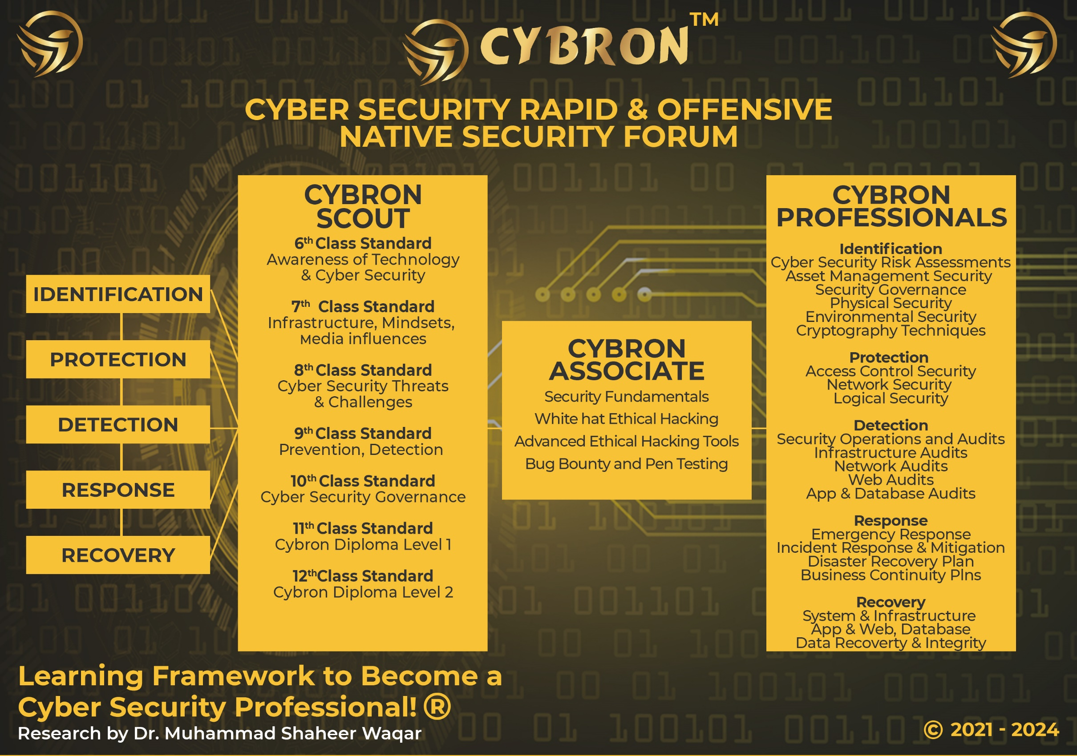

# CYBRON FRAMEWORK DESCRIPTION

The CYBRON framework has been influenced by the International standard NIST USA and it has been further elaborated as per the research. The philosophy behind regarding this framework that organization and industries are implementing lots of security tools and monitoring systems to secure their mechanism, data, system and technology from the unwanted people. But after spending the huge investments, nobody is 100% sure that they are secure and protected from different threats, attacks and risks.

In this context, our research team under the supervision of Dr. M. Shaheer Waqar has found that it is the pure game of the mind-set, because if the people can understand, how these technologies are helpful and beneficial for their lives, so they cannot sabotage or harm it. But we cannot stop the negative mind-set people who never do positive work for the mankind.

Therefore, this framework has been established according to the aforementioned scenarios, and the knowledge set is established from the class 6 grade standard and providing them the required information according to their level about the cyber security. Hence! When from class 6 grades students understand about the pros and cons of the cyber security threats and its challenges and progressively they learn up to date content with positive mindset and understand latest technologies and their impacts. So they are not going to harm or destroy it. Therefore, after using this training methodology, we are hopeful that CYBRON can change the mindsets as well as secure our societies industries and countries.

# PROGRAM BENEFITS TO & PRE-REQUISITE

## 

## **REQUIRED QUALIFICATIONS**

* 6th grade and Equivalent Qualifications
* Basic Knowledge of Computers

## **CREDENTIALS**

* Get the appropriate Cybron Scout Certification from Cybron - UK
* International Recognized Cybron Scout Certificate

## **BENEFITS**

* School candidate from class 6th grade can opt this certification
* The content of the program will develop the skillset of candidate during their studies
* Everyone know about latest scams and threats regarding cybercrimes, this course will help a lot
* Get the Cybron Scout 6th Grade Certification in One year

# FURTHER BENEFITS OF THE PROGRAM

* The program equip the candidates from grass root level
* The candidate will learn the basics of IT and its related security of data and information
* The candidate will learn cyber security basics and how its impacting in our lives
* The candidate will learn about digital age and its benefits
* The candidate will learn transformation of data from manual to electronic and its benefits
* The candidate will learn the use of social media and it impacts
* The candidate will learn the concepts of digital ID and its usage and its importance
* The candidate will learn the digital machines working and its handshaking process with other devices technically and its internal security level
* The candidate will learn networks, and its accessories
* The candidate will learn the numbers system and its importance
* The candidate will learn the applied mathematics and its application in the cyber security
* The candidate will learn the importance of data and its safety
* The candidate will learn the introduction to computer programming
* The candidate will learn the basics of python
* The candidate will learn the basic tools of cyber security and its command

# PROGRAM STRUCTURE

|  |  |
| --- | --- |
| Total Lectures | 10 |
| Online Lectures | Available on LMS |
| Accredited Trainers | Can Deliver the lectures |
| Each Lecture Duration | 2 hours |
| Required Lectures to Complete to class 6th Standard | 10 |
| One Credit Hour | 10 Learning Hours |
| Total Credits Required | 2 Credit Hours |
| Total Time to complete to class 6th Standard | One Year |
| Assessment | Online / Paper based |
| Passing Criteria | 70 percent |

# OTHER LEARNING ACTIVITIES

**Practical Assignments of each Lecture** 1

**Learning Activities in each Lecture**  1

**Presentation**

Recorded 15 Minutes Presentations shall be submitted

By Trainee

**CYBRON SCOUT CERTIFICATION**

Question Answer Session one hour arrange by Cybron 1

# PROGRESSION OF THE PROGRAM

Total Credentials = 2 Credit Hours

One Credit Hours = 10 Learning hours

Completion of 10 Courses = Cybron Scout for Class 6th Standard

Final Assessment = Online or physical assessment can be taken

## **Awarding of Cybron Scout Certification**

Once the candidate has completed the lectures and given the all internal examination, then school or individual can directly apply to Cybron UK for assessment.

# DOMAINS AND TASKS

In this document you will find an updated structure for the CYBRON SCOUT Class 6th Standard Examination Content. Based on Experience Consultants and stakeholders, we have devised and simplifying the format so that the CYBRON SCOUT is easier to understand and interpret.

**The domain and task are well defined on the following pages:**

**Domain:** Defined as the high-level knowledge area that is essential to the practice of Cyber Security.

**Tasks:** The underlying responsibilities of the cyber security team member within each domain area.

Each CYBRON SCOUT Course examination will include all tasks for a domain, and CYBRON SCOUT will adhere to the percentage of coverage at the domain level as outlined in the further pages.

# KNOWLEDGE AREAS

|  |  |
| --- | --- |
| Domain 1: Digital Age And Its Impacts | |
| **Task 1** | Understanding of Digital Age and its impacts in our daily lives  Understanding the usage of digital devices in daily routines  Understanding of digital technology and its paradigm shift  Understanding of fundamentals of security  Why you need to understand cyber security  What are the precautionary measures you needed for cyber security |
| **Task 2** | What is Social Media & what are the impacts in your life  What types of Social Media are available  Understand Social Media Security tabs and settings  What to do and what not to do on social media  Secure your social media accounts  One windows sign ups |

|  |  |
| --- | --- |
| Domain 2 Digital ID and Computer era | |
| **Task 1** | What is digital ID  What is the significance of Digital ID and its importance  How to secure your digital ID  What is Personal Information and how to maintain privacy  What is the future of Digital ID and how it will work  Connection with your digital ID in your phone, internet, banks, social media, education, nationality and etc  How the Gmail and Apple ID important today, and how to secure it |
| **Task 2** | Understanding of Computer Machine  Basic Components of Computer Machine  Understanding the Inside working of Computer Machine  Understanding Data and address handling in the inside of the Computer Machine  Understanding of Information Security in the Internal Parts of Computer Machine  Understanding of Internal and External devices and its handshaking process  Trust of devices from others |

|  |  |
| --- | --- |
| Domain 3: Fundamentals of Computers Network & its Security | |
| **Task 1** | What is Network in the world of Computers  How many types of Networks  Network Domains  Topologies of Networks  What is MAC Address and how its works  What is IP address and how it works  Types of Hubs, Switches and Routers  Basics of Network Security  Permission and Grant on Network and then its checks |
| **Task 2** | Number System  Decimal Number System  Binary Number System  Addition of Binary System  Subtraction of Binary System  ASCII Codes  Unicode – 16, 32, 64  Keyboard working  Operating System Working with Unicode's |
| **Task 3** | Introduction & Importance of Mathematics and Applied Mathematics  Application of mathematics in computers world  introduction to Logic Gates  Details of Logic Gates Operation  Usage of Logic Gates Operation in Computer System  How these gates is use in the computer security  Developing Cipher through Logic Gates  Encoding & Decoding Process Through Logic Gates |

|  |  |
| --- | --- |
| Domain 4: Data and its Value in Electronic System | |
|  |  |
| **Task 1** | What is Data, Definition  Type of Data  Shapes of the data  Importance of the data  Transformation of data into different forms  Data Privacy  Data Security |
|  |  |
| **Task 2** | Introduction to Computer programming  Why need Computer Programming  Generation of Computer Programming  Algorithms, Flow Charts  Python Programming Language  Programming Concept  Concept of Object Oriented Programming  Learn Python with exercises |
|  |  |

# ASSESSMENT OF PROGRAM (ONLINE/PHYSICAL)

* The paper will be an open book and students can give the answers according to scenarios
* The paper will be online including practical and theory.
* The weightage of examination will be 70% practical, and 30% theoretical.
* Practical assessment will be taken in labs assess by internal examiners, where theory paper will be taken through online or paper based (if online facility not available)
* Those candidate who cannot be able to give the online test and they do not have a facility, Therefore, their papers will be taken a paper based examination. Otherwise, center must have the facility to provide online test mechanism to students and facilitate for the final assessment.
* Assessment will be done according to domain and tasks defined above through our online methodology

EVALUATION AND GRADING

* The performance of students is evaluated through continuous observation of a student’s performance in the class participation, submission of assignments, quizzes and exercises.
* The student will be examined through exams conducted by CYBRON INTERNATIONAL. Total marks for passing the CERTIFICATION/DIPLOMA will be 70 out of a total of 100.

# CYBRON SCOUT REGISTRATION AND PAYMENT

## **CYBRON SCOUT ELIGIBILITY REQUIREMENTS**

To be eligible for the Cybron Scout for any level, there is no as such requirements. If you are in secondary school then you have submit your credentials

|  |  |
| --- | --- |
| **Educational Background** | **Cybron Diploma** |
| No Educational Background Required | Must be earned from our any partner institute about 2 Credit hours |

## **REGISTRATION PROCESS**

Registration of the program is to be completed through our registered partners

## **PROGRAM BIFURCATION**

The program is bifurcated into 12 months where each month, you have to complete the contents and submit your assignments in time to your concern school or any accredited trainer.

# CYBRON SCOUT FEE STRUCTURE

|  |  |  |
| --- | --- | --- |
| **S. No** | **Description** | **Fees** |
| 1 | Program Fee (For One Year Subscription) | 10 British Sterling Pound |

# CYBRON SCOUT EXAMINATION SYSTEM

## Partner Institute Internal Examination System

* The concerned partner / institute / trainer will take examinations and submit to the Cybron International Examination Department

## Cybron UK Online Exam System

Cybron UK will provide access to all partners to schedule the exams of the particular courses of individual candidates. So according to the availability, the partner institutes will schedule the exam of individual candidates’ subject or course/certification.

# CONTINUING EDUCATIONAL REQUIREMENTS (CER) PROGRAM

CER—Continuing Educational Requirements Program is important and supports the ongoing educational and professional development of any candidate. Therefore, Cybron International insists on keeping up with its current market requirements. You have to prepare to meet the demands of the market today due to the most complex and competitive environment of businesses.

The main purpose of CER is:

* Continuously develop yourself and enhance your learning capability
* Keep yourself updated about the latest trends in technologies and their vulnerabilities
* We encourage and recognize individualized learning opportunities
* 10 hours of learning CER is mandatory to make your cybron scout certification active
* Global Recognition to sustain the valuable cybron scout certification of Cybron International (CI)

# CONTACT DETAILS

[CONTACTUS@CYBRONINTERNATIONAL.COM](mailto:contactus@cybroninternational.com)

ADDRESS 404 Old Bedford Road, Luton, England LU2 7BP SIC codes – 62012 United Kingdom

TELEPHONE [**(+44) 7783 530138**](tel:(+44)%207783%20530138)

Web https://www.cybroninternational.com

EMAIL [info@cybroninternational.com](mailto:info@cybroninternational.com)

**SOCIAL MEDIA ACCOUNT**

Facebook https://www.facebook.com/cybroninternational

Twitter <https://www.twitter.com>/

LinkedIn https://www.linkedin.com/company/cybron-international

YouTube https//www.youtube.com/

CYBRON INTERNATIONAL LIMITED COMPANY REGISTRATION NUMBER 14686268