

**CYBRON SCOUT**

**START AND DEVELOP YOUR CAREER FROM HERE IN CYBER SECURITY**

**8th GRADE STANDARD**

**GRADE 8th CLASS STANDARD ARE ELIGIBLE FOR THIS COURSE**

CYBER SECURITY RAPID OFFENSIVE NATIVE FORUM

**Published by:**

Cyber Security Rapid Offensive Native Forum

Cybron

404 Old Bedford Road, Luton, England LU2 8BP SIC codes – 62012 United Kingdom

contactus@cybroninternational.com

(+44) 8883 530138

All rights reserved. "cybron", the cybron logo, "CYBRON", the Cybron Scout, Cybron Scout logo, "CYBRON-FRAMEWORK", "Cybron”, “and the Cybron International are registered marks of Cybron, Inc.   
The Cybron is a trademark of the Cybron, Inc.

Contents

INTRODUCTION 4

CYBRON FRAMEWORK 5

CYBRON FRAMEWORK DESCRIPTION 6

PROGRAM BENEFITS TO & PRE-REQUISITE 7

**REQUIRED QUALIFICATIONS** 7

**CREDENTIALS** 7

**BENEFITS** 7

FURTHER BENEFITS OF THE PROGRAM 8

PROGRAM STRUCTURE 9

OTHER LEARNING ACTIVITIES 10

PROGRESSION OF THE PROGRAM 11

**Awarding of Cybron Scout Certification** 11

DOMAINS AND TASKS 12

KNOWLEDGE AREAS 13

ASSESSMENT OF PROGRAM (ONLINE) 17

CYBRON SCOUT REGISTRATION AND PAYMENT 18

**CYBRON SCOUT ELIGIBILITY REQUIREMENTS** 18

**REGISTRATION PROCESS** 18

**PROGRAM BIFURCATION** 18

CYBRON SCOUT FEE STRUCTURE 19

CYBRON SCOUT EXAMINATION SYSTEM 20

Partner Institute Internal Examination System 20

Cybron UK Online Exam System 20

CONTINUING EDUCATIONAL REQUIREMENTS (CER) PROGRAM 21

CONTACT DETAILS 22

# INTRODUCTION

We help you to establish your career in Cyber Security

There are several students who want to establish their careers in the field of Cyber Security. Still, due to the unavailability of appropriate guidelines and directions, they would not flourish in their careers according to the market requirements. As per research, there are very few curriculums that have been running in the schools regarding cyber security, but it is not intact and up to date and fulfills the requirements of candidates as well as society.

However, emerging technologies are also impacting and new methodologies and systems related to IR 4.0 and 5.0 play a vital role in establishing society 5.0. Therefore, to survive in the local or international market students and professionals need to understand the newest technologies at all levels and learn how to work on them.

With reference to the above discussion, it has been found a huge gap between the industry & Academia, and on a daily basis, this gap has been broadening, because technology is upgrading very fast and academic people cannot be able to deliver these technologies in time.

In all the above context, it is very clear that all of our daily lives whether it is about home office or business. All are connecting through digital technologies via the Internet and we are delivering all services and products through Information Technology. But, if we are getting the advantage of this electronic medium, we have another challenge of cyber security. Therefore, we establish a new framework, which talks about the Cyber Security from Secondary School Level and gears up to the Professional Level.

This Cybron Scout for Grade 8th classes is devised after detailed research and found what should be learned by the candidate at this grade to understand cyber security and its threats and how to protect him or herself. On the other part, we would be developing his/her mindsets positively regarding the use of digital technologies and its benefits. Therefore, during lectures & counseling sessions, we can change the individuals and society mindsets, which will reduce the number of attacks and cybercrimes and create a greater impact on society.

# CYBRON FRAMEWORK

One of the Leading Learning Framework of Cyber Security

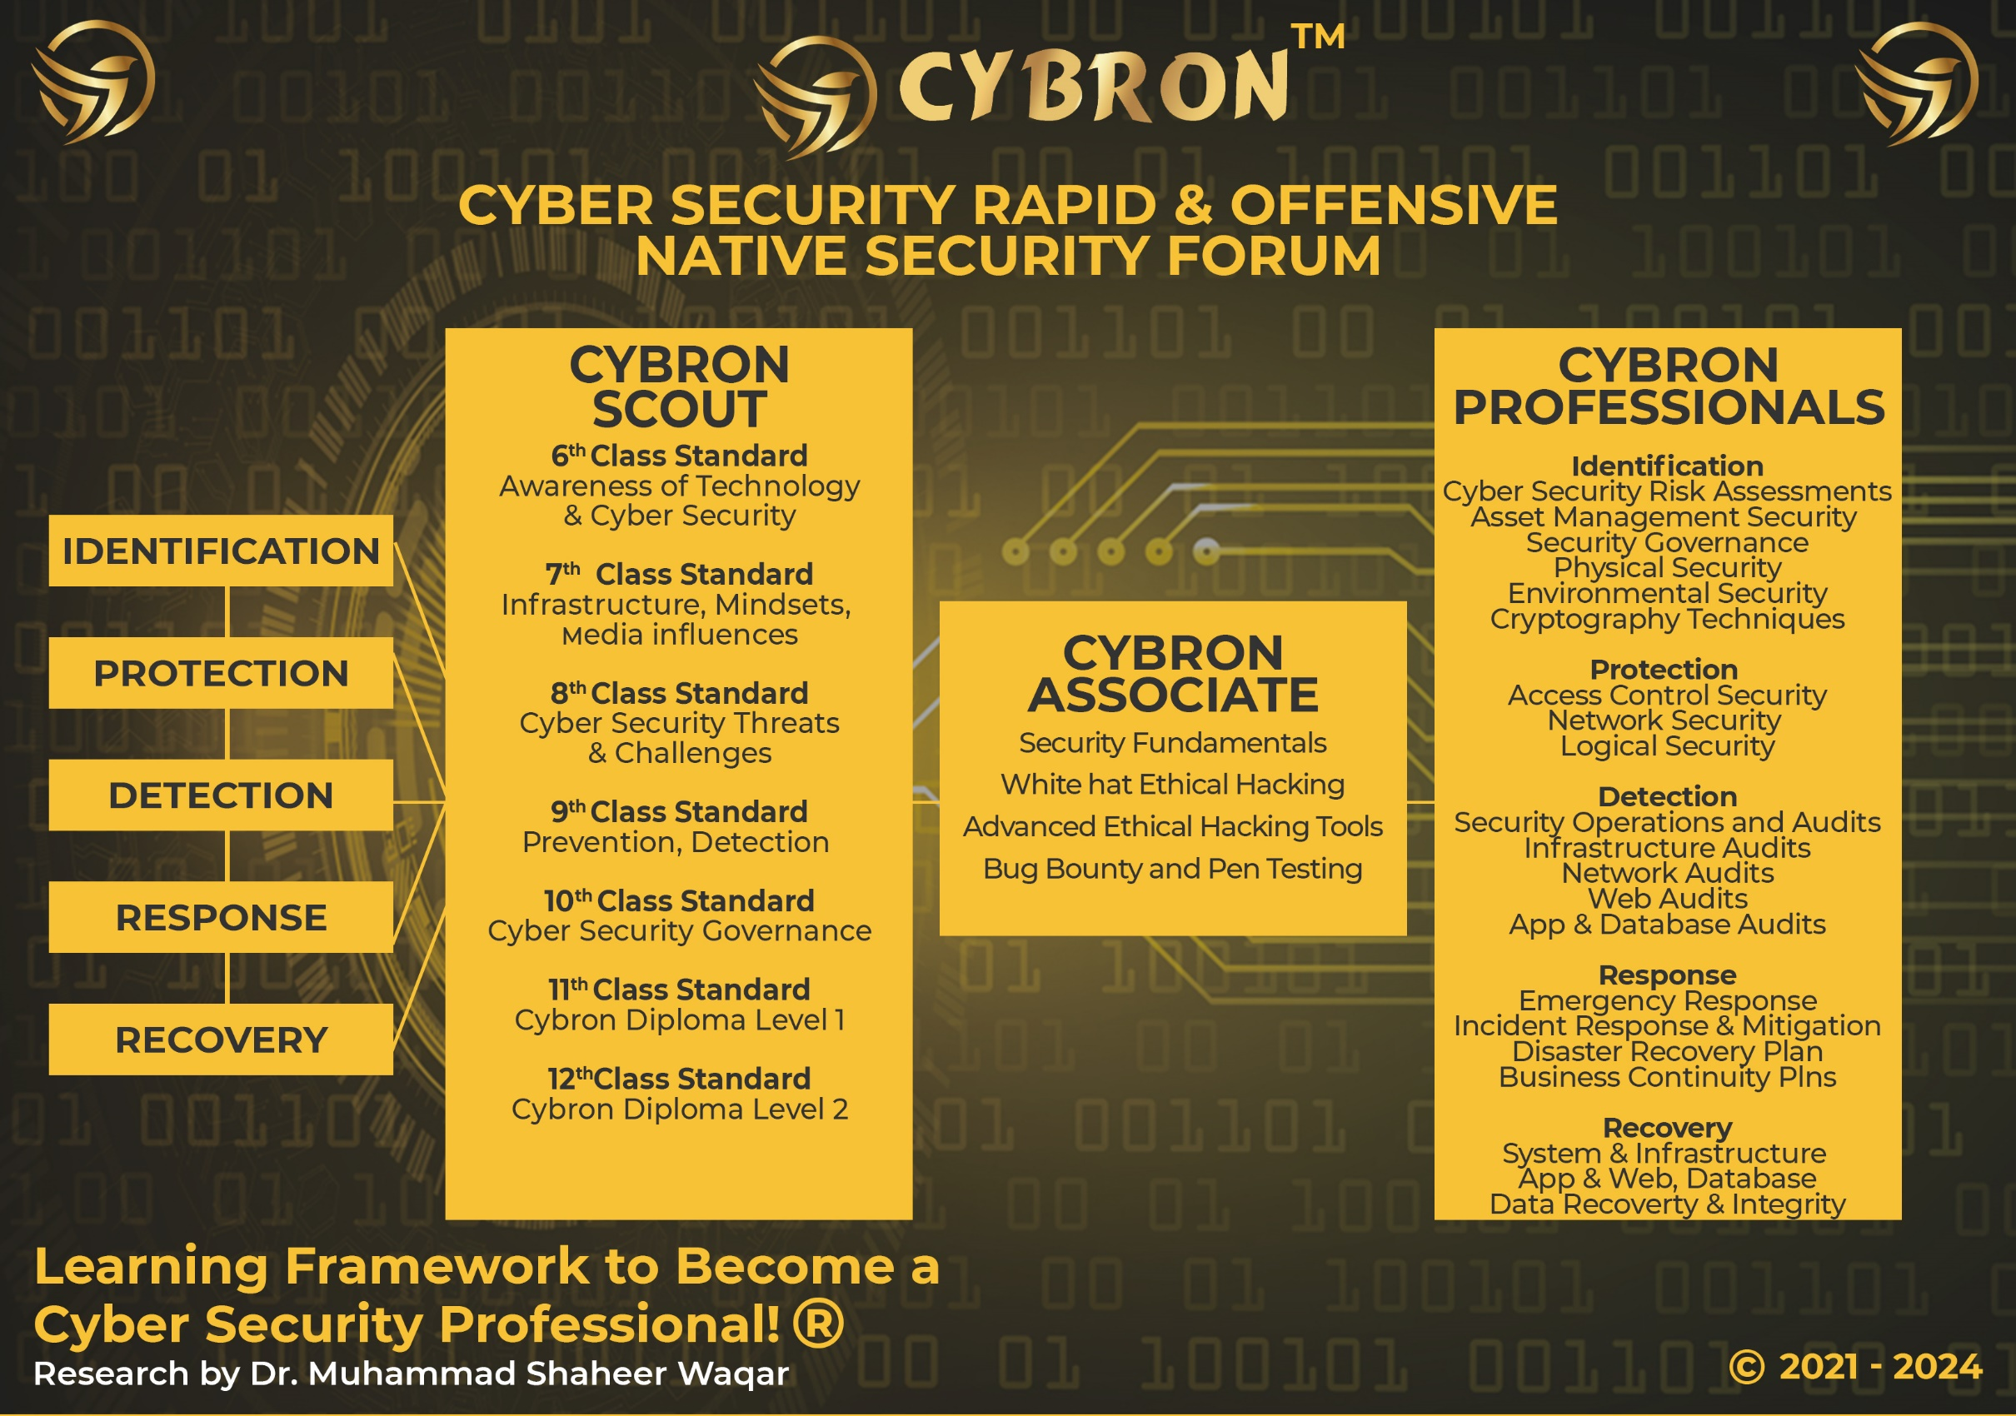

# CYBRON FRAMEWORK DESCRIPTION

The CYBRON framework has been influenced by the International standard NIST USA and it has been further elaborated as per the research. The philosophy behind regarding this framework that organization and industries are implementing lots of security tools and monitoring systems to secure their mechanism, data, system and technology from the unwanted people. But after spending the huge investments, nobody is 100% sure that they are secure and protected from different threats, attacks and risks.

In this context, our research team under the supervision of Dr. M. Shaheer Waqar has found that it is the pure game of the mind-set, because if the people can understand, how these technologies are helpful and beneficial for their lives, so they cannot sabotage or harm it. But we cannot stop the negative mind-set people who never do positive work for the mankind.

Therefore, this framework has been established according to the aforementioned scenarios, and the knowledge set is established from the class 6 grade standard and providing them the required information according to their level about the cyber security. Hence! When from class 6 grades students understand about the pros and cons of the cyber security threats and its challenges and progressively they learn up to date content with positive mindset and understand latest technologies and their impacts. So they are not going to harm or destroy it. Therefore, after using this training methodology, we are hopeful that CYBRON can change the mindsets as well as secure our societies industries and countries.

# PROGRAM BENEFITS TO & PRE-REQUISITE

## 

## **REQUIRED QUALIFICATIONS**

* 8th grade and Equivalent Qualifications
* Basic Knowledge of Computers

## **CREDENTIALS**

* Get the appropriate Cybron Scout Certification from Cybron - UK
* International Recognized Cybron Scout Certificate

## **BENEFITS**

* School candidate from class 8th grade can opt this certification
* The content of the program will develop the skillset of candidate during their studies
* Everyone know about latest scams and threats regarding cybercrimes, this course will help a lot
* Get the Cybron Scout 8th Grade Certification in One year

# FURTHER BENEFITS OF THE PROGRAM

* The program equip the candidates from grass root level
* The candidate will learn the basics of IT and its related security of data and information
* The candidate will learn cyber security basics and how its impacting in our lives
* The candidate will learn about digital age and its benefits
* The candidate will learn transformation of signal into data and data into signals
* The candidate will learn IT Infrastructure
* The candidate will learn the internal components of computer and its working
* The candidate will learn the digital machines working and its handshaking process with other devices technically and its internal security level
* The candidate will learn networks, and its accessories & its security
* The candidate will learn the numbers system and its importance
* The candidate will learn the applied mathematics and its application in the cyber security
* The candidate will learn the importance of data and its safety
* The candidate will learn the introduction to computer programming
* The candidate will learn the basics of python
* The candidate will learn the basic tools of cyber security and its command

# PROGRAM STRUCTURE

|  |  |
| --- | --- |
| Total Lectures | 10 |
| Online Lectures | Available on LMS |
| Accredited Trainers | Can Deliver the lectures |
| Each Lecture Duration | 2 hours |
| Required Lectures to Complete to class 8th Standard | 10 |
| One Credit Hour | 10 Learning Hours |
| Total Credits Required | 2 Credit Hours |
| Total Time to complete to class 8th Standard | One Year |
| Assessment | Online / Paper based |
| Passing Criteria | 70 percent |

# OTHER LEARNING ACTIVITIES

**Practical Assignments of each Lecture** 1

**Learning Activities in each Lecture**  1

**Presentation**

Recorded 15 Minutes Presentations shall be submitted

By Trainee

**CYBRON SCOUT CERTIFICATION**

Question Answer Session one hour arrange by Cybron 1

# PROGRESSION OF THE PROGRAM

Total Credentials = 2 Credit Hours

One Credit Hours = 10 Learning hours

Completion of 10 Courses = Cybron Scout for Class 7th Standard

Final Assessment = Online or physical assessment can be taken

## **Awarding of Cybron Scout Certification**

Once the candidate has completed the lectures and given the all internal examination, then school or individual can directly apply to Cybron UK for assessment.

# DOMAINS AND TASKS

In this document you will find an updated structure for the CYBRON SCOUT Class 8th Standard Examination Content. Based on Experience Consultants and stakeholders, we have devised and simplifying the format so that the CYBRON SCOUT is easier to understand and interpret.

**The domain and task are well defined on the following pages:**

**Domain:** Defined as the high-level knowledge area that is essential to the practice of Cyber Security.

**Tasks:** The underlying responsibilities of the cyber security team member within each domain area.

Each CYBRON SCOUT Course examination will include all tasks for a domain, and CYBRON SCOUT will adhere to the percentage of coverage at the domain level as outlined in the further pages.

# KNOWLEDGE AREAS

|  |  |
| --- | --- |
| **Domain 1: Principle of Cyber Security** | |
| **Task 1** | Principles of Cyber Security  CIA (Confidentiality, Integrity and Availability)  Key Concepts of Cyber Security |
| **Task 2** | What is Personal Digital IDs  What is the importance of Personal Digital ID  How the Personal ID adjunct with your life  Why & How the Hackers need to hack your personal IDs  Methods of reconnaissance or foot-printing  How to Protect your digital devices  Knowing about different platforms and its settings  Personalize your settings |

|  |  |
| --- | --- |
| **Domain 2 Asset and its importance in controlling** | |
| **Task 1** | What is the Asset?  What is the importance of assets in Information and Cyber Security?  What is Asset ID?  Asset Labelling  Identification of Asset and its Labelling  Exercises |
| **Task 2** | Major Parts of the Computers  Internal architecture of the Computer and its Security  Concepts, working of Mother Board and its Security  Concepts, working and types of ROM and its Security  Concepts, working and Types of RAM and its Security  Concept & working of Busses in the computer system and its Security  Concept & working of Main processor and its Security  Concept & working of Hard-disk Drive and its Security  Concept & working of LAN Card and its Security  Concept & working of Modem and its Security |

|  |  |
| --- | --- |
| **Domain 3: Cryptography Hashing and Other related Functions** | |
| **Task 1** | Security Inside the computer System  How the internal message is transferred and secured  How the external message is transferred and secured  What is Hash in the security  One Way Function  What is CRC (Cyclic Redundancy Check) and Parity Bit  What is the Function of Hash to secure the transactions  Examples of message transformation with Hash  Can the Hash decoded |
| **Task 2** | Introduction to Encoding and Decoding  Types of Encoding  Character Encoding  Data Encoding  Compression Encoding  Cryptographic Encoding  Types of Decoding  Character Decoding  Data Decoding  Decompression  Cryptographic Decoding (Decryption)  Encoding and Decoding Algorithms  Encoding Algorithms  Decoding Algorithms  Applications of Encoding and Decoding  Data Transmission  Data Storage  Cryptography  Error Detection and Correction  Challenges in Encoding and Decoding  Data Integrity  Security |

|  |  |
| --- | --- |
| **Domain 4: Cryptography Hashing and PKIs & Data Protection** | |
|  |  |
| **Task 1** | Introduction to cryptography  Basic Concepts in Cryptography  History of cryptography  Types of Cryptography  Cryptographic Hash Functions  Public Key Infrastructure (PKI)  Digital Signatures  Key Management  Applications of Cryptography |
| **Task 2** | Importance of Data  How the data states will be changed in the system  Protection of Data  What is a database and how it works  Use of Data in Industries  Data Backups |
| **Task 3** | Introduction to Web 2.0  Web Technologies  Browsers Security  Purpose of SSL and TLS  How the Web browser works when SSL Enabled |
|  |  |

# ASSESSMENT OF PROGRAM (ONLINE/PHYSICAL)

* The paper will be an open book and students can give the answers according to scenarios
* The paper will be online including practical and theory.
* The weightage of examination will be 70% practical, and 30% theoretical.
* Practical assessment will be taken in labs assess by internal examiners, where theory paper will be taken through online or paper based (if online facility not available)
* Those candidate who cannot be able to give the online test and they do not have a facility, Therefore, their papers will be taken a paper based examination. Otherwise, center must have the facility to provide online test mechanism to students and facilitate for the final assessment.
* Assessment will be done according to domain and tasks defined above through our online methodology

EVALUATION AND GRADING

* The performance of students is evaluated through continuous observation of a student’s performance in the class participation, submission of assignments, quizzes and exercises.
* The student will be examined through exams conducted by CYBRON INTERNATIONAL. Total marks for passing the CERTIFICATION/DIPLOMA will be 70 out of a total of 100.

# CYBRON SCOUT REGISTRATION AND PAYMENT

## **CYBRON SCOUT ELIGIBILITY REQUIREMENTS**

To be eligible for the Cybron Scout for any level, there is no as such requirements. If you are in secondary school then you have to submit your credentials and apply for program

|  |  |
| --- | --- |
| **Educational Background** | **Cybron Diploma** |
| No Educational Background Required | Must be earned from our any partner institute about 2 Credit hours |

## **REGISTRATION PROCESS**

Registration of the program is to be completed through our registered partners

## **PROGRAM BIFURCATION**

The program is bifurcated into 12 months where each month, you have to complete the contents and submit your assignments in time to your concern school or any accredited trainer.

# CYBRON SCOUT FEE STRUCTURE

|  |  |  |
| --- | --- | --- |
| **S. No** | **Description** | **Fees** |
| 1 | Program Fee (For One year Subscription) | 05 British Sterling Pound |

# CYBRON SCOUT EXAMINATION SYSTEM

## Partner Institute Internal Examination System

* The concerned partner / institute / trainer will take examinations and submit to the Cybron International Examination Department

## Cybron UK Online Exam System

Cybron UK will provide access to all partners to schedule the exams of the particular courses of individual candidates. So according to the availability, the partner institutes will schedule the exam of individual candidates’ subject or course/certification.

# CONTINUING EDUCATIONAL REQUIREMENTS (CER) PROGRAM

CER—Continuing Educational Requirements Program is important and supports the ongoing educational and professional development of any candidate. Therefore, Cybron International insists on keeping up with its current market requirements. You have to prepare to meet the demands of the market today due to the most complex and competitive environment of businesses.

The main purpose of CER is:

* Continuously develop yourself and enhance your learning capability
* Keep yourself updated about the latest trends in technologies and their vulnerabilities
* We encourage and recognize individualized learning opportunities
* 10 hours of learning CER is mandatory to make your cybron scout certification active
* Global Recognition to sustain the valuable cybron scout certification of Cybron International (CI)

# CONTACT DETAILS

[CONTACTUS@CYBRONINTERNATIONAL.COM](mailto:contactus@cybroninternational.com)

ADDRESS 404 Old Bedford Road, Luton, England LU2 7BP SIC codes – 62012 United Kingdom

TELEPHONE [**(+44) 7783 530138**](tel:(+44)%207783%20530138)

Web https://www.cybroninternational.com

EMAIL [info@cybroninternational.com](mailto:info@cybroninternational.com)

**SOCIAL MEDIA ACCOUNT**

Facebook https://www.facebook.com/cybroninternational

Twitter <https://www.twitter.com>/

LinkedIn https://www.linkedin.com/company/cybron-international

YouTube https//www.youtube.com/

CYBRON INTERNATIONAL LIMITED COMPANY REGISTRATION NUMBER 14686268