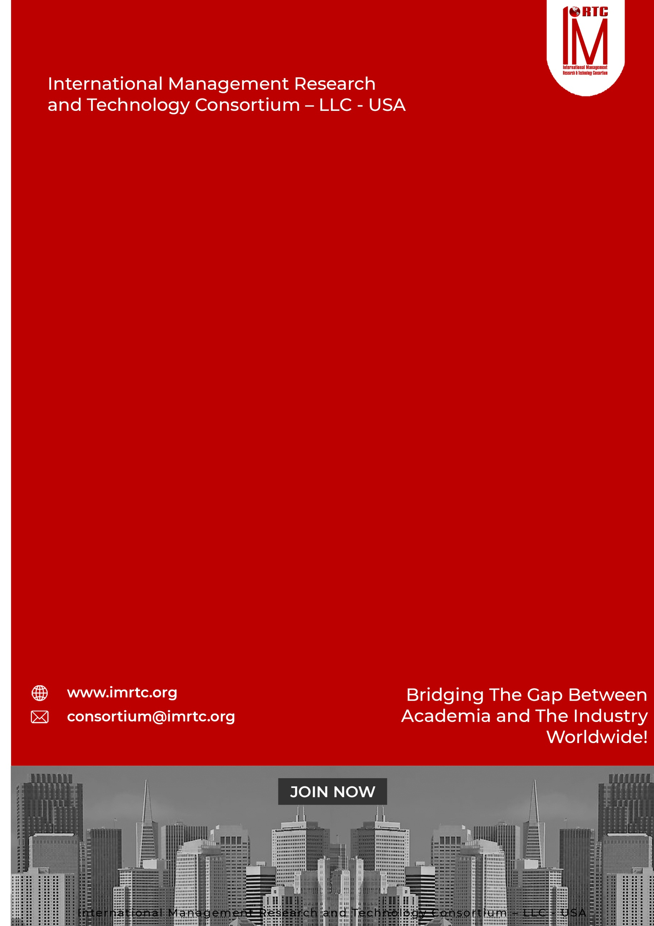

**PROFESSIONAL**

**PDIA**

**AUDIT**

**DIPLOMA IN**

**INTERNAL**



**CONTENTS**

INTRODUCTION 4

ABOUT PDIA 4

PROFESSIONAL DIPLOMA IN INTERNAL AUDIT 4

AUDIENCE 5

THE CREDENTIALS 5

PRE-REQUISITE: 5

PROFESSIONAL DIPLOMA IN INTERNAL AUDIT 5

PROFESSIONAL BENEFITS OF PROGRAM 6

PROFESSIONAL DIPLOMA IN INTERNAL AUDIT 6

PROGRAM STRUCTURE 7

PROGRESSION OF THE PROGRAM 8

AWARDING OF PROFESSIONAL DIPLOMA IN INTERNAL AUDIT 8

COURSE CONTENTS 9

DOMAINS AND TASKS 10

KNOWLEDGE AREAS 11

ASSESSMENT OF PROGRAM (ONLINE/PHYSICAL) 14

EVALUATION AND GRADING 14

PDIA ELIGIBILITY REQUIREMENTS 15

REGISTRATION AND PAYMENT PROCESS 15

REGISTRATION PROCESS 15

IMRTC EXAMINATION SYSTEM 16

PARTNER INSTITUTE INTERNAL EXAMINATION SYSTEM 16

IMRTC ONLINE EXAM SYSTEM 16

FEES STRUCTURE 17

TERMS & CONDITIONS RELATED TO EXAMINATION AND CERTIFICATION 18

PROCESS OF CERTIFICATION 18

EXAM CONTENT PERCENTAGE 19

CONTACT DETAILS 20



**Published by**

International Management Research and Technology Consortium

**IMRTC**

Principal Office: P. O. Box 409, 9300 Conroy Windermere, Windermere, FL-34786, USA,

All rights reserved. "imrtc", the imrtc logo, "IMRTC", the PDIA logo, PDIA , PDIA logo "IMRTC”, “and the IMRTC USA are registered marks of IMRTC, LLC.   
The IMRTC is a trademark of the IMRTC, LLC.



# INTRODUCTION

There is a global demand of industry with highly competent Internal Audit Professionals, Managers and Chief Audit Executive. As the perspective of audit is approaching the organizations very differently, where audit actually continuous improve the organization. IMRTC recognizing the need and in consultation with senior executives and professionals & approved trainers have come up with a comprehensive certification/ diploma program

In this respect, IMRTC domain Experts designed a comprehensive training diploma, which can provide facilitation to the professionals and also provide the structure to maintain and manage the Internal Audit System in the organization. Therefore, with the consultation of senior executives and professional, and trainers have come up with a comprehensive diploma program. **PROFESSIONAL DIPLOMA IN INTERNAL AUDIT (PDIA)**

# ABOUT PDIA

PDIA prepares an internal audit generalist who will be able to help the organizations to maintain the efficiency level as well as to improve the organization by given the inputs to strategic level. The framework and process will help to grow the organizations.

The Professional diploma in Internal Audit is covering all the aspect of Internal Audit by using the IPPF - International professional practices framework and prepare the candidate for real time audit engagements as well as practices and purposes. The diploma assist and prepare you for best auditing standards.

The diploma ensure that the individuals are fully aware of and follow the Professional Code of Conducts, and will be equipped with the Internal Auditing knowledge and understanding of global auditing standards. Understand business process development & re-engineering requirements, Business & Artificial Intelligence with Data Analysis, Information security systems and electronic equipment integration with information systems, change management system, portfolio and project management, financial budgeting for Internal Auditing, global Internal Audit and service management through technology and more content is available for learning and development. The program follows a systematic learning formats with standards and guidelines, audio-visual aids, case studies with real time applications.

# PROFESSIONAL DIPLOMA IN INTERNAL AUDIT

**CERTIFIED ASSOCIATE IN HUMAN**

**RESOURCE MANAGEMENT**

**CERTIFIED ASSOCIATE IN HUMAN**

**RESOURCE MANAGEMENT**

**CERTIFIED ASSOCIATE IN HUMAN**

**RESOURCE MANAGEMENT**



# AUDIENCE

People who are involved in auditing or like to develop their career in the field of internal auditing may join this program. The program is available for whom, who have completed 12th grades accredited study program from any discipline from any BOARD or university.

# THE CREDENTIALS

The candidates who are looking to have appropriate knowledge and understanding of internal audit with the requirements of global industry will earn the Internal Auditing Professional Diploma from IMRTC. The program also a self-develop project base on any case study which can be provided by accredited any partner training institute or trainer.

Three semesters program and will be assessed by IMRTC through our online assessment portal system. The partners can book the exam of any candidate who are ready to give the examination of any semester any time.

Passing criteria is 75% marks to be obtained in each semester and after passing the examination, the candidates can get the credentials from IMRTC.

# ****PRE-REQUISITE****:

* 12 Years Education or equivalent or Baccalaureate, Associate’s degree, or the global equivalent diploma is required to join this session.
* Auditing Experience will be an additional points to get enrolled in this program
* As Such, No Professional Experience is required to opt this diploma program

# PROFESSIONAL DIPLOMA IN INTERNAL AUDIT

**CERTIFIED ASSOCIATE IN HUMAN**

**RESOURCE MANAGEMENT**

**CERTIFIED ASSOCIATE IN HUMAN**

**RESOURCE MANAGEMENT**

**CERTIFIED ASSOCIATE IN HUMAN**

**RESOURCE MANAGEMENT**



# PROFESSIONAL BENEFITS OF PROGRAM

**For Individuals**

* Career advancement into auditing roles.
* Improved understanding of how to align audit principles according to International standards with business goals.
* Recognition as a certified expert in Internal Auditing.
* Using of technologies in Audit with the business methodologies
* Developing skills of internal Audit, Audit Engagement Planning, Audit daily Plan, Audit Conduction Plans, Risk and Gap Analysis, & International Audit Principles and Guidelines,

**For Organizations**

* Assurance of certified professionals with industry-recognized skills.
* Strengthened your strategy with Internal Audit capabilities.
* Enhanced ability to adopt and integrate with latest methodologies of emerging technologies effectively.

# PROFESSIONAL DIPLOMA IN INTERNAL AUDIT

**CERTIFIED ASSOCIATE IN HUMAN**

**RESOURCE MANAGEMENT**

**CERTIFIED ASSOCIATE IN HUMAN**

**RESOURCE MANAGEMENT**

**CERTIFIED ASSOCIATE IN HUMAN**

**RESOURCE MANAGEMENT**



# PROGRAM STRUCTURE

|  |  |
| --- | --- |
| Total Domains | 3 |
| Lectures | Lectures can be delivered through partners and trainers |
| Accredited Trainers | Can Deliver the lectures |
| One Credit Hour | 10 Learning Hours |
| Total Credits Required | 10 Credit Hours |
| Registration Process | Register through our partners / Trainer |
| Assessment | Online / Paper based |
| Passing Criteria | 70 percent |



# PROGRESSION OF THE PROGRAM

Total Credentials = 10 Credit Hours

One Credit Hour = 10 Learning hours

Final Assessment = Online or physical assessment shall be taken by IMRTC Examination Department

# AWARDING OF PROFESSIONAL DIPLOMA IN INTERNAL AUDIT

After getting 70 percent marks from the examination, the candidate will be awarded the Diploma in Internal Audit from IMRTC USA.



# COURSE CONTENTS

Professional Diploma in Internal Audit cover theory, process, and professional practices for internal Audit.

**SEMESTER ONE:**

Duration 4 Months

Foundation of Internal Audit, Standard System, Charter and Approaches

**EXAMS: 3 Hours**

**100 Questions**

**-------------------------------------------------------------------------------------**

**SEMESTER TWO:**

Duration 4 Months

Practical Exposure of Internal Audit

**EXAMS: 3 Hours**

**100 Questions**

**-------------------------------------------------------------------------------------**

**SEMESTER THREE:**

Duration 4 Months

Organization Strategic Planning & Management

Information System Audit Practices

**EXAMS: 3 Hours**

**100 Questions**

**-------------------------------------------------------------------------------------**

**FINAL PROJECT**

Develop one project of Internal Audit which covers all the standards of IPPF and any other from Charter to reporting and submit to IMRTC for review.

The above assignment is the one of the pre-requisites of the program, without submission of the project, the diploma shall not be awarded.

**ONE YEAR COMPLETE DIPLOMA IN INTERNAL AUDIT**

0

# DOMAINS AND TASKS

In this document, you will find an updated structure for the IMRTC Standard Examination Content. Based on Experience Consultants and stakeholders, we have devised and simplified the format so that the IMRTC Examination System can be easier to understand and interpret.

**The domain and task are well-defined on the following pages:**

**Domain:** Defined as the high-level knowledge area that is essential to the practice of PDIA – Professional Diploma in Internal Audit.

**Tasks:** The underlying responsibilities of the Internal Audit within each domain area.

PDIA examination will include all tasks for a domain and will adhere to the percentage of coverage at the domain level as outlined in the further pages.



# KNOWLEDGE AREAS

|  |  |
| --- | --- |
| DOMAIN 1: FOUNDATION OF INTERNAL AUDIT, STANDARD SYSTEM, CHARTER AND APPROACHES | |
| **Task 1** | Foundation of Internal Audit  How Internal Audit System has worked in the organization  Why Internal Audit?  Develop the Charter of Internal Audit |
| **Task 2** | Audit Standards and Guidelines  Approaches of Internal Audit  Importance of Committees  Ethics and Professionalism  Governance Risk Management and Control |
| **Task 3** | Fraud and Risks  Developing Culture in the organization to prevent frauds |



**KNOWLEDGE AREAS**

|  |  |
| --- | --- |
| Domain 2: : Practical Exposure of Internal Audit | |
| **Task 1** | Practical Exposure of Internal Audit |
| **Task 2** | Internal Audit Management Functions  Internal Audit Operations |
| **Task 3** | Developing internal Audit Plan  Quality of Internal Audit Functions |
| **Task 4** | Planning and Performing the Internal Audit Function  Engagement Planning  Information Gathering and Analysis of Evaluation |
| **Task 5** | Engagement, Supervision and Communication  Engagement Results and Monitoring  Develop One Internal Audit System from Planning to Engagement |



**KNOWLEDGE AREAS**

|  |  |
| --- | --- |
| DOMAIN 3: ORGANIZATION STRATEGIC PLANNING & MANAGEMENT | |
| **Task 1** | Organization Strategic Planning & Management |
| **Task 2** | Common Business Processes  Information Technology & Usage  IT Control Frameworks and Information Security |
| **Task 3** | IT Infrastructure & Operations & Audit |
| **Task 4** | Application Systems and Security & Audit  Operating Systems and Security & Audit |
| **Task 5** | Database and Security & Audit  Develop One Internal Audit System from IT Perspective |



# ASSESSMENT OF PROGRAM (ONLINE/PHYSICAL)

* The exam paper will be online/physical as per the choice of the candidate, but it is preferable to give the exam online.
* The exam paper will cover the above topics domain-wise.
* The Passing marks will be 70%.
* Internal Marks can be adjusted in the final marks through accredited trainers by obtaining prior permission from our Examination Department of IMRTC.
* Those candidates who cannot be able to give online tests due to online facility. So they are allowed paper-based examinations. Otherwise, the partner must arrange the center for the online exam as per the guidelines of the Examination Department
* Assessment will be done according to the domains and tasks mentioned above through our online methodology

# EVALUATION AND GRADING

* The student will be examined through exams conducted by IMRTC LLC USA. Total marks for passing the CERTIFICATION/DIPLOMA will be 70 out of 100.



# PDIA ELIGIBILITY REQUIREMENTS

To be eligible for the Professional Diploma in Internal Audit at any level, the candidates must have a 12-years Education or equivalent with no experience. The candidate should have to submit the credentials

|  |  |
| --- | --- |
| **Educational Background** | **Accredited Training** |
| 12 years Education or Equivalent (Baccalaureate, Associate Degree or Global Equivalent) | 10 PTH Training must be earned from any accredited trainer or any partner institute |
| **Professional Experience** | **Certification/Diploma** |
| No Professional Experience Required | After completing all the formalities and passing the test, will get the certification or diploma |

# REGISTRATION AND PAYMENT PROCESS

## REGISTRATION PROCESS

Registration of the program is to be completed through our registered partners and if the partners are not available in your city or country then you can download this registration form and submit the fee in our bank account directly and wait for the email or contact from our Registration or Examination Department. For further information to our examination department contact at [registration@imrtc.org](mailto:registration@imrtc.org).



# IMRTC EXAMINATION SYSTEM

**PROFESSIONAL DIPLOMA IN INTERNAL AUDIT**

## PARTNER INSTITUTE INTERNAL EXAMINATION SYSTEM

The concerned partner/institute/trainer will take examinations online and submit to the International Management Research and Technology Consortium Examination Department.

## IMRTC ONLINE EXAM SYSTEM

IMRTC will provide access to all partners to schedule the exams of the particular courses of any individual candidates. Therefore, according to the availability, the partner institutes will schedule the exam of individual candidates’ subjects or courses/certifications.



|  |  |  |
| --- | --- | --- |
| S. No | Description | Fees |
| 1. | Membership Fee | USD 50 |
| 2. | Examination Fee  For Members | Semester One: USD 95 Semester Two: USD 95 Semester Three: USD 95 |
| 3. | Examination Fee  For Non Members | Semester One: USD 195 Semester Two: USD 195 Semester Three: USD 195 |

# FEES STRUCTURE

**PROFESSIONAL DIPLOMA IN INTERNAL AUDIT**



To get the certification, 100-Professional training hours as PTH is mandatory from any concerned professional trainer or Partner, and participants should submit their training PTH with the Examination Application Form with the attachments of required qualifications and other experience certificates/letters. The Paper is based on 100 Questions with MCQs of each semester and 70% passing marks are required to pass the exam. Further, if the Project is also included in your exam, marks will be distributed according to course & certification.

## TERMS & CONDITIONS RELATED TO EXAMINATION AND CERTIFICATION

* The 100-Training-hours as PTH are valid up to one year.
* If the candidate is failed in the examination then S/he has one more chance to attempt the paper within a year, and if the candidate cannot pass, then they have to pay the examination fee and re-appear in the examination.
* If the candidate cannot pass the examination within one year and after some time S/he would like to appear in the examination then the candidate must resubmit 100 Professional Training hours as PTH again required to appear in the examination.
* The examination system is online and candidate can book the exam anytime according to his or her availability.
* Those countries, that do not have the facility of online examination facility then they can give the paper-based examination, which can be sent to authorized partner/trainers/examiners. The assessment time will be a month and we will send the results to the concerned partner.
* The candidate will get the certificate within one month and the administration will send to the concerned partners.
* To maintain the worth and eligibility in the market, the candidate must have to renew their membership on a yearly basis.

# PROCESS OF CERTIFICATION



|  |  |
| --- | --- |
| **CONTENT** | **DOMAIN WISE PERCENTAGE** |
| Semester I | 25% |
| Semester I | 25% |
| Semester I | 25% |
| Project | 25% |
| Total Percentage | 100% |
|  |  |

# EXAM CONTENT PERCENTAGE

The table below prescribes the proportions of examination questions from each section or Knowledge Areas defined above. The exam will be based on multiple choice questions, fill in the blanks and letter writing.



# CONTACT DETAILS

ADDRESS Principal Office: P. O. Box 409, 9300 Conroy Windermere, Windermere,

FL-34786, USA,

TELEPHONE (+1) (689) 276-4636

Web https://www.imrtc.org

EMAIL [consortium@imrtc.org](mailto:consortium@imrtc.org)

**SOCIAL MEDIA ACCOUNT**

Facebook https://www.facebook.com/imrtc

Twitter <https://www.twitter.com>/

LinkedIn https://www.linkedin.com/company/imrtc

YouTube https//www.youtube.com/

INTERNATIONAL MANAGEMENT RESEARCH AND TECHNOLOGY CONSORTIUM LLC   
REGISTRATION NUMBER L24000411080