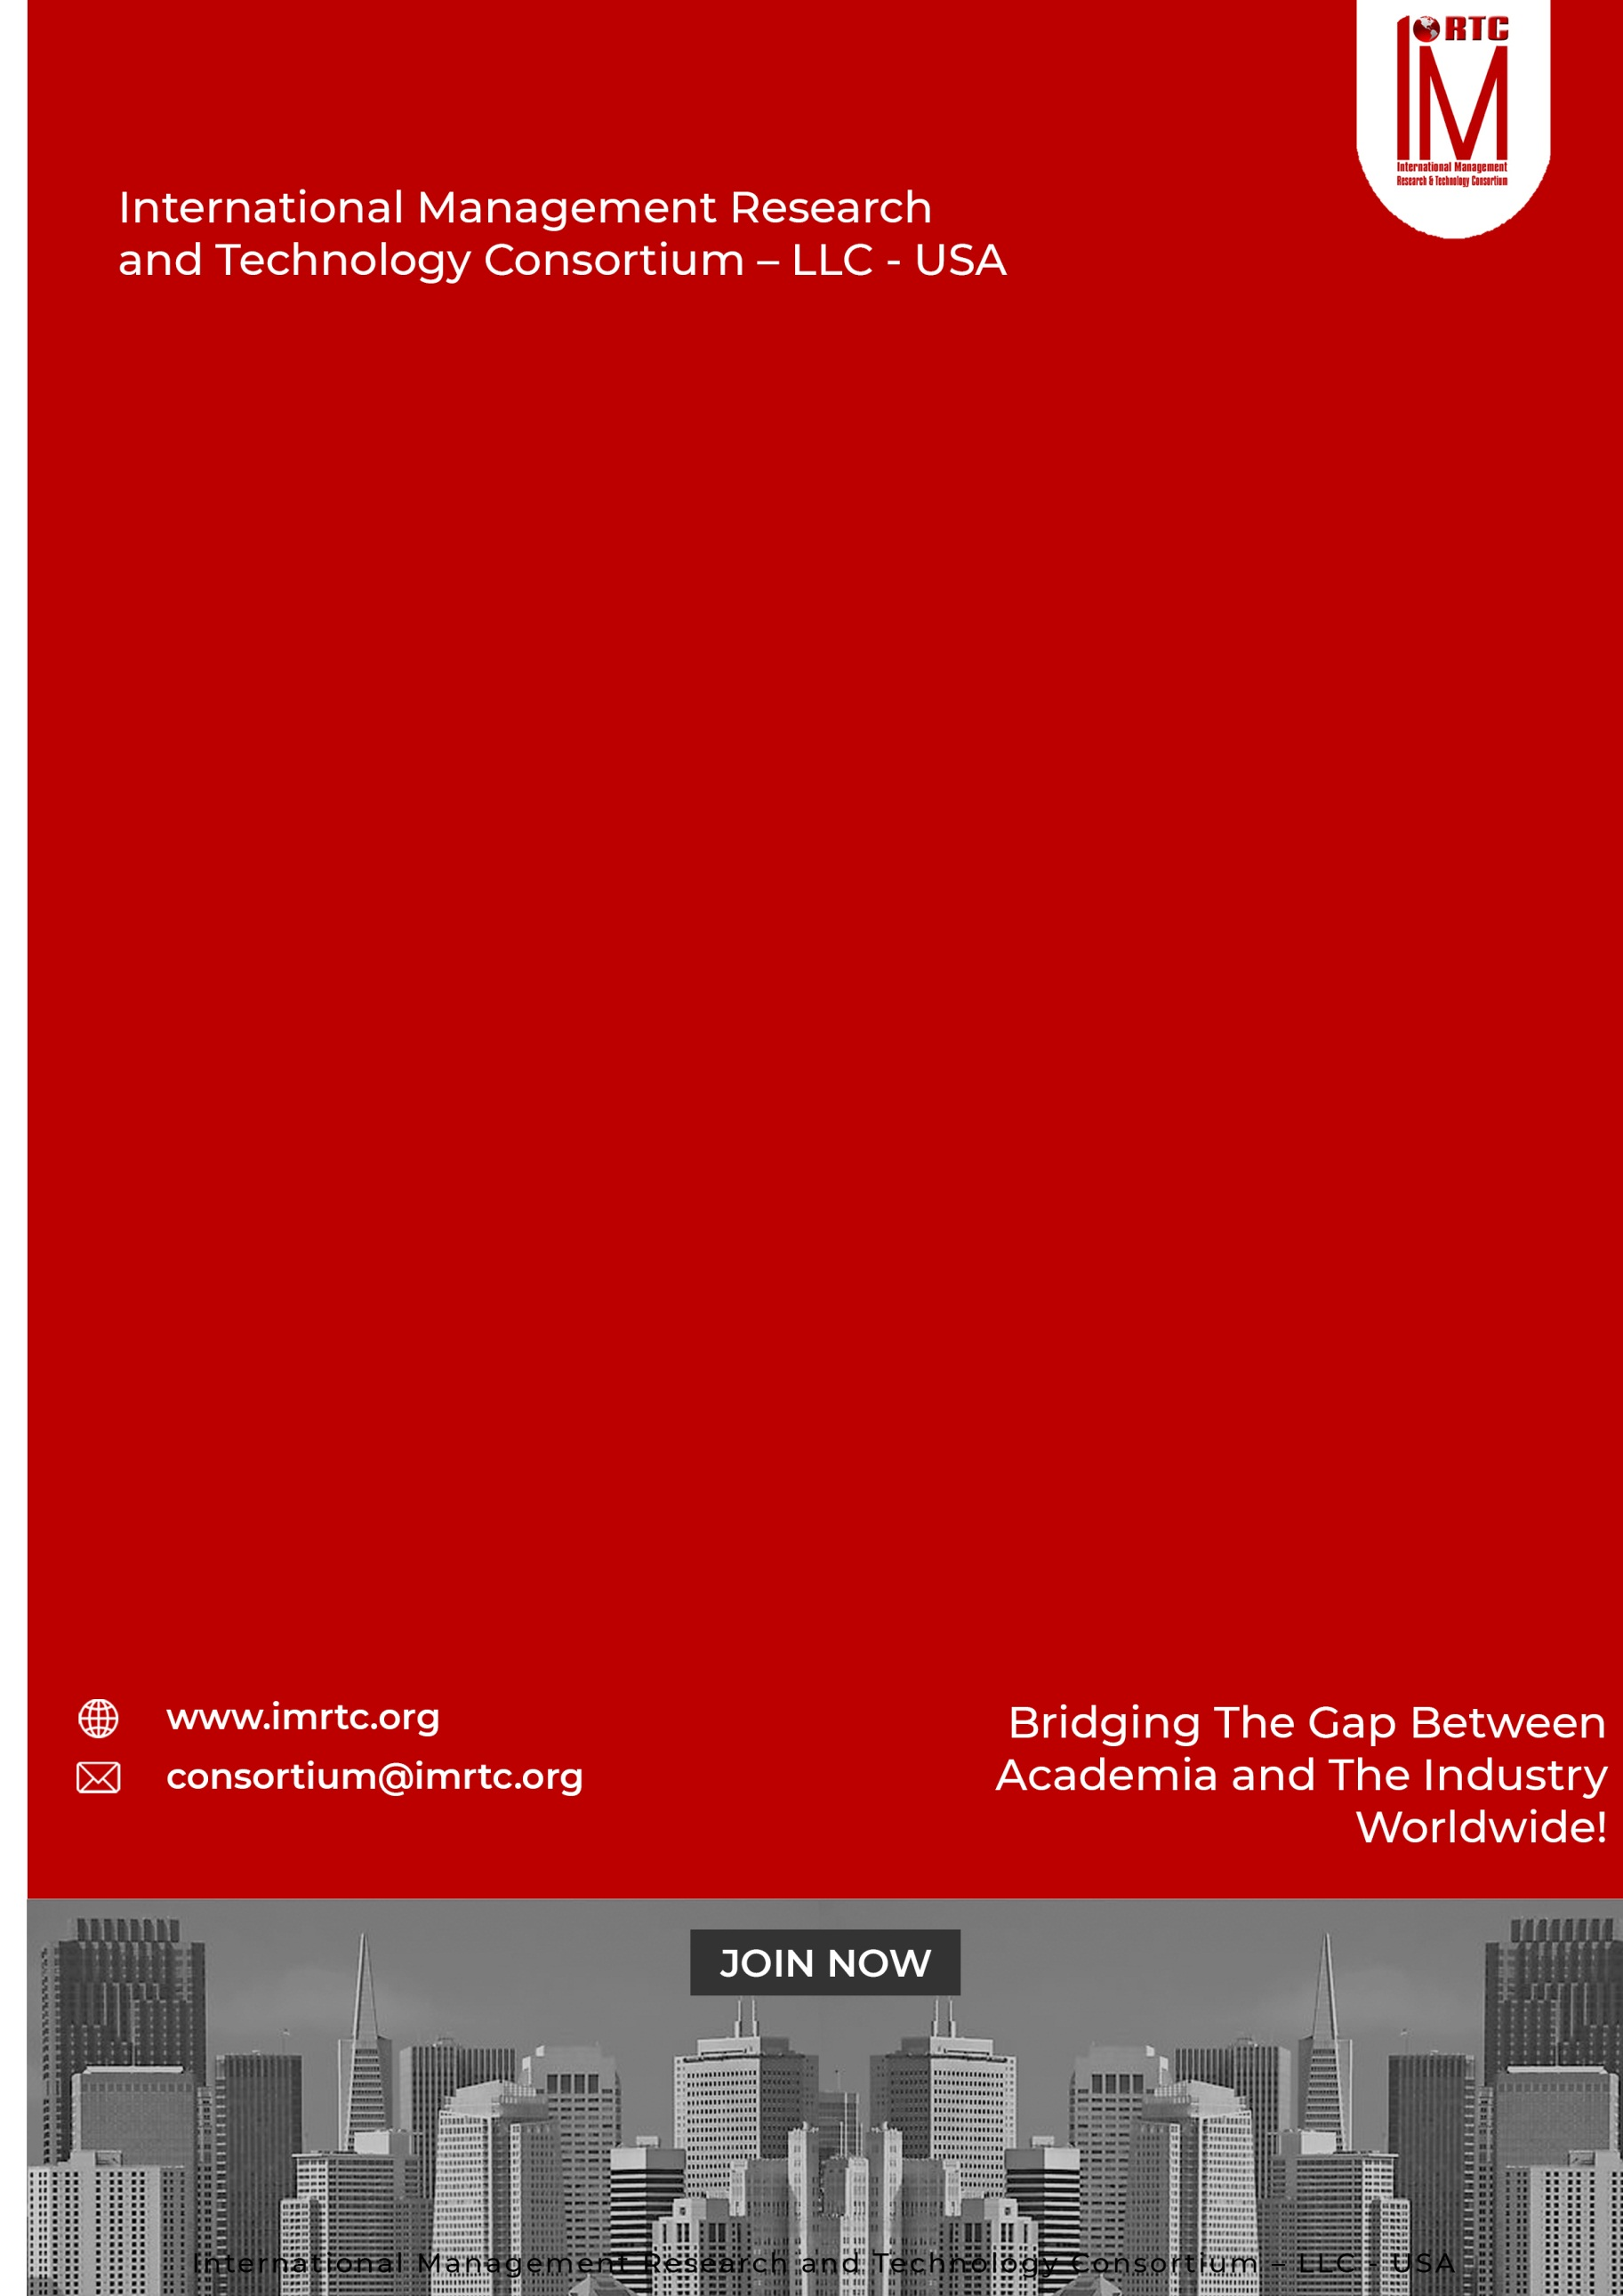
CERTIFIED
MANAGEMENT
HUMAN RESOURCE
ASSOCIATE IN

CAHRM

CONTENTS
THE AUDIENCE 2
THE CREDENTIALS 2
PRE-REQUISITE: 2
BENEFITS OF PROGRAM 2
PROGRAM STRUCTURE 2
PROGRESSION OF THE PROGRAM 2
AWARDING OF CAHRM CERTIFICATION 2
COURSE CONTENTS 2
DOMAINS AND TASKS 2
KNOWLEDGE AREAS 2
ASSESSMENT OF PROGRAM (ONLINE/PHYSICAL) 2
CAHRM ELIGIBILITY REQUIREMENTS 2
REGISTRATION AND PAYMENT PROCESS 2
REGISTRATION PROCESS 2
IMRTC EXAMINATION SYSTEM 2
Partner Institute Internal Examination System 2
IMRTC Online Exam System 2
FEES STRUCTURE 2
PROCESS OF CERTIFICATION 2
TERMS & CONDITIONS RELATED TO EXAMINATION AND CERTIFICATION 2
EXAM CONTENT PERCENTAGE 2
CONTINUING EDUCATIONAL PROGRAM (CEP) PROGRAM 2
CONTACT DETAILS 2

Published by
International Management Research and Technology Consortium

IMRTC
Principal Office: P. O. Box 409, 9300 Conroy Windermere, Windermere, FL-34786, USA,

All rights reserved. "imrtc", the imrtc logo, "IMRTC", the CAHRM, CAHRM logo, CAHRM, CAHRM logo "IMRTC”, “and the IMRTC USA are registered marks of IMRTC, LLC.
The IMRTC is a trademark of the IMRTC, LLC.

THE AUDIENCE
Anyone, who would like to be involved in HR and wants to prove their skills in the market. Assistant Managers, executive secretaries, & Administrators in any sector that belongs to the professional market can join this program and develop their careers in the highly required professional field of HR.

THE CREDENTIALS
There is a global demand for highly professional competent Human Resource officers, managers, or senior managers. IMRTC offers recognized certification for individual executives and professionals who can initiate their careers in human resources to devise a concrete and comprehensive curriculum that accredits the candidate globally.
IMRTC—International Management Research & Technology Consortium offers a globally recognized certification that helps students in their careers, increases their competency, knowledge, and skills, and recognizes the need for global requirements.

PRE-REQUISITE:

Two year Bachelor’s degree (high school diploma, associate’s degree or the global equivalent).

No Professional experience required to earn this certification.

Grade 12 or Intermediate from any recognized board or university can join this program by having 2 years of market experience.

32 PTH – Professional Training Hours certificate is required to give the exams from any IMRTC Accredited Trainer or Partner.

CERTIFIED ASSOCIATE IN HUMAN
RESOURCE MANAGEMENT

CERTIFIED ASSOCIATE IN HUMAN
RESOURCE MANAGEMENT

CERTIFIED ASSOCIATE IN HUMAN
RESOURCE MANAGEMENT

CERTIFIED ASSOCIATE IN HUMAN
RESOURCE MANAGEMENT

BENEFITS OF PROGRAM

The content of the program is equipped about advanced HR system and its latest techniques.
- HR Fundamentals and Strategic HR is the major driver of the program.
- This certification will help you in your career.
- The job market welcomes the international certified candidates.
- The program insist you to keep learning about latest and newest methodologies

PROGRAM STRUCTURE

Total Domains | 08
Lectures | Lectures can be delivered through partners and trainers
Accredited Trainers | Can Deliver the lectures
One Credit Hour | 10 Learning Hours
Total Credits Required | 3 Credit Hours
Registration Process | Register through our partners / Trainer
Assessment | Online / Paper based
Passing Criteria | 70 percent

PROGRESSION OF THE PROGRAM

Total Credentials = 3 Credit Hours

One Credit Hour = 10 Learning hours

Final Assessment = Online or physical assessment shall be taken by IMRTC Examination Department

AWARDING OF CAHRM CERTIFICATION

After getting 70 percent marks from the examination, the candidate will be awarded the CAHRM Certification from IMRTC USA.

COURSE CONTENTS

Certified Associate in Human Resource Management program covers theory, process and practices of HR management skills: Basics, Strategies, Policies, Analysis, Recruitment & Selection, and Performance Management & Appraisals.

DOMAIN 1: FUNDAMENTALS OF HRM

DOMAIN 2: STRATEGIES OF HUMAN RESOURCE MANAGEMENT

DOMAIN 3: HRM POLICIES & PROCEDURES

DOMAIN 4: JOB ANALYSIS & PORTFOLIOS

DOMAIN 5: RECRUITMENT & SELECTION PROCESS STRATEGY

DOMAIN 6: PERFORMANCE MANAGEMENT & APPRAISALS SYSTEM

DOMAIN 7: TRAINING AND CAREER DEVELOPMENT

DOMAIN 8: MOTIVATION & REWARDS
0

DOMAINS AND TASKS

In this document, you will find an updated structure for the IMRTC Standard Examination Content. Based on Experience Consultants and stakeholders, we have devised and simplified the format so that the IMRTC Examination System can be easier to understand and interpret.
The domain and task are well-defined on the following pages:
Domain: Defined as the high-level knowledge area that is essential to the practice of CAHRM.
Tasks: The underlying responsibilities of the Human Resource member within each domain area.

CAHRM Course examination will include all tasks for a domain, and will adhere to the percentage of coverage at the domain level as outlined in the further pages.

KNOWLEDGE AREAS
Domain 1: FUNDAMENTALS OF HUMAN RESOURCE MANAGEMENT
Task 1 | Understanding of Management  Understanding of Management Essentials  Knowing about the Role of HRM in the Organization
Task 2 | Globalization  Understanding Cultural Environments  Impacts of Technology on HRM on the Organization  Impacts of Technology change on the organization  Workforce Diversity
Task 3 | Labor Supply  Employees Involvement  Continuous Improvement Programs  Translating HRM Functions into Practice  Does HRM really matter  HRM in an Entrepreneurial Enterprise  HRM in a Global Village  HR and Corporate Ethics

KNOWLEDGE AREAS
Domain 2: HUMAN RESOURCE MANAGEMENT AND JOB ANALYSIS
Task 1 | Introduction  Organizational framework  Linking Organizational Strategy with HR Management
Task 2 | Job Analysis  Development of Job Description  Advantages of Job Description  Job Evaluation  Job Performance

KNOWLEDGE AREAS
Domain 3: RECRUITMENT AND SELECTION
Task 1 | Introduction  Recruitment Goals  Recruiting: A Global Perspective  Recruiting Sources
Task 2 | Selection  Benefits of Proper Selection  The Selection Process  Types of Interview

KNOWLEDGE AREAS
Domain 4: SOCIAL ORIENTATION AND DEVELOPMENT
Task 1 | Introduction to socialization  The Insider-Outsider Passage  The Socialization Process  The Purpose of New-Employee Orientation
Task 2 | Employee Training  Employee Development  Organizational Development  Evaluating Training and Development Effectiveness  International Training and Development Issues

KNOWLEDGE AREAS
Domain 5: PERFORMANCE MANAGEMENT SYSTEM
Task 1 | Introduction to PMS  Performance Management System  The Appraisal Process  The Appraisal Method  Factors that can Distort Appraisals  Creating More Effective Performance Management Systems  International Performance Appraisal

KNOWLEDGE AREAS
Domain 6: MOTIVATION
Task 1 | Introduction to Motivation  Two types of Rewards  Model of Motivation  Foundations of Motivation  Motivation of Content theories
Task 2 | Hierarchy of Needs Theory  Maslow’s Hierarchy of Needs  ERG Theory  Two Factor Motivation Theory  Acquired Needs Theory  Reinforcement Perspective on Motivation
Task 3 | Job Design for Motivation  Motivational Ideas for Turbulent Times  Empowering People to Meet Higher Needs  Continuum of Empowerment  Giving Meaning to Work

KNOWLEDGE AREAS
Domain 7: CAREER DEVELOPMENT
Task 1 | The Concept of Career  What is Career  Job Progressions  Alternative Career Moves
Task 2 | Promotion  Transfer  Relocation Service  Outplacement Service
Task 3 | HR Role in Career Development  Mentoring Functions  Dual Career Partnerships  Traditional Career Stages  Career Choices and Preferences  CISS Orientation and Basic Scales  Combinations of Career Interests and Skills

KNOWLEDGE AREAS
Domain 8: MANAGING COMPENSATION
Task 1 | Total Compensation  The Reward Management Process  9 Elements of a Compensation Plan  Pay Systems and the Legal Environment

ASSESSMENT OF PROGRAM (ONLINE/PHYSICAL)

- The exam paper will be online/physical as per the choice of the candidate, but it is preferable to give the exam online.
- The exam paper will cover the above topics domain-wise.
- The Passing marks will be 70%.
- Internal Marks can be adjusted in the final marks through accredited trainers by obtaining prior permission from our Examination Department of IMRTC.
- Those candidates who cannot give online tests due to online facility. So they are allowed paper-based examinations. Otherwise, the partner must arrange the center for the online exam as per the guidelines of the Examination Department
- Assessment will be done according to the domains and tasks mentioned above through our online methodology
EVALUATION AND GRADING
- The student will be examined through exams conducted by IMRTC LLC USA. Total marks for passing the CERTIFICATION/DIPLOMA will be 70 out of 100.

CAHRM ELIGIBILITY REQUIREMENTS
To be eligible for the Certified Associate in Human Resource Management for any level, the candidates must have a 12th-grade pass or equivalent by having one-year market experience. The candidate should have to submit the credentials

Educational Background | Certification / Diploma
12 Grade Passed or Equivalent | Must be earned from any partner institute about 3 Credit hours course training

REGISTRATION AND PAYMENT PROCESS

REGISTRATION PROCESS
Registration of the program is to be completed through our registered partners and if the partners are not available in your city or country then you can download this registration form and submit the fee in our bank account directly and wait for the email or contact from our Examination Department. For further information to our examination department contact at registration@imrtc.org.

IMRTC EXAMINATION SYSTEM
CERTIFIED ASSOCIATE IN HUMAN RESOURCE MANAGEMENT

Partner Institute Internal Examination System

The concerned partner/institute/trainer will take examinations online and submit to the International Management Research and Technology Consortium Examination Department

IMRTC Online Exam System

IMRTC will provide access to all partners to schedule the exams of the particular courses of any individual candidates. Therefore, according to the availability, the partner institutes will schedule the exam of individual candidates’ subjects or courses/certifications.
S. No | Description | Fees
1. | Membership Fee | USD 50
2. | Examination Fee  For Members | USD 175
3. | Examination Fee  For Non Members | USD 275

FEES STRUCTURE
CERTIFIED ASSOCIATE IN HUMAN RESOURCE MANAGEMENT

PROCESS OF CERTIFICATION
To get the certification, 32-Professional training hours as PTH is mandatory from any concerned professional trainer or Partner, and participants should have to submit their training PTH with the Examination Application Form with the attachments of required qualifications and other experience certificates/letters. The Paper is based on 100 Questions with MCQs and 70% passing marks is required to pass the exam. Further, if the Project is also included in your exam, marks will be distributed according to course & certification.

TERMS & CONDITIONS RELATED TO EXAMINATION AND CERTIFICATION
- The 32 training hours as PTH are valid for up to one year.
- If the candidate fails the examination then S/he has one more chance to attempt the paper within a year for the same examination fees. If the candidate cannot pass in 2nd attempt, then S/he has to pay the examination fee and re-appear in the examination through concerned partners.
- If the candidate has not passed the examination within one year and after sometime S/he would like to appear in the examination then the candidate must resubmit 32 training hours as PTH is again required to appear in the examination.
- The examination system is online and the candidate can book the exam anytime according to his or her availability through the concerned partner.
- Those countries, that do not have the facility of online examination facility then they can take the paper-based examination, which can be sent to authorized partners/ trainers/examiners.
- The assessment time will be a month and the results will be sent to concerned partners.
- The candidate will get the certificate within one month and the administration will send it to the concerned partners.
- To maintain the worth and eligibility in the market the candidate must renew their membership on a yearly basis and submit their 60 PTH as continue professional education

EXAM CONTENT PERCENTAGE
The table below prescribes the proportions of examination questions from each section or Knowledge Areas defined above. The exam will be based on multiple choice questions, fill in the blanks and letter writing.

CONTENT | DOMAIN WISE PERCENTAGE
DOMAIN I | 10%
DOMAIN II | 15%
DOMAIN III | 15%
DOMAIN IV | 15%
DOMAIN V | 15%
DOMAIN VI | 10%
DOMAIN VII | 10%
DOMAIN VIII | 10%

CONTINUING EDUCATIONAL PROGRAM (CEP) PROGRAM

CEP—Continuing Educational Program is most important and supportive of the ongoing educational and professional development of any candidate. So, IMRTC insists on upgrading your knowledge and skills with the current market requirements. You have to prepare to meet the demands of the market today due to the most complex and competitive environment of businesses.

The main purpose of CEP is:
- Continuously develop yourself and enhance your learning capability
- Keep yourself updated about the latest trends in methodologies and Systems
- We encourage and recognize individualized learning opportunities
- 60 hours of learning CEP is mandatory to make your IMRTC certification active
- Global Recognition to sustain the valuable CAHRM certification of International Management Research and Technology Consortium (IMRTC USA)

CONTACT DETAILS

ADDRESS Principal Office: P. O. Box 409, 9300 Conroy Windermere, Windermere,
FL-34786, USA,

TELEPHONE (+1) (689) 276-4636
Web https://www.imrtc.org
EMAIL consortium@imrtc.org

SOCIAL MEDIA ACCOUNT
Facebook https://www.facebook.com/IMRTConsortium/
LinkedIn https://www.linkedin.com/company/imrtc
YouTube https://www.youtube.com/channel/UCE_GYVI4WJMKIUXQhouA4LA

INTERNATIONAL MANAGEMENT RESEARCH AND TECHNOLOGY CONSORTIUM
USA LLC L24000411080

