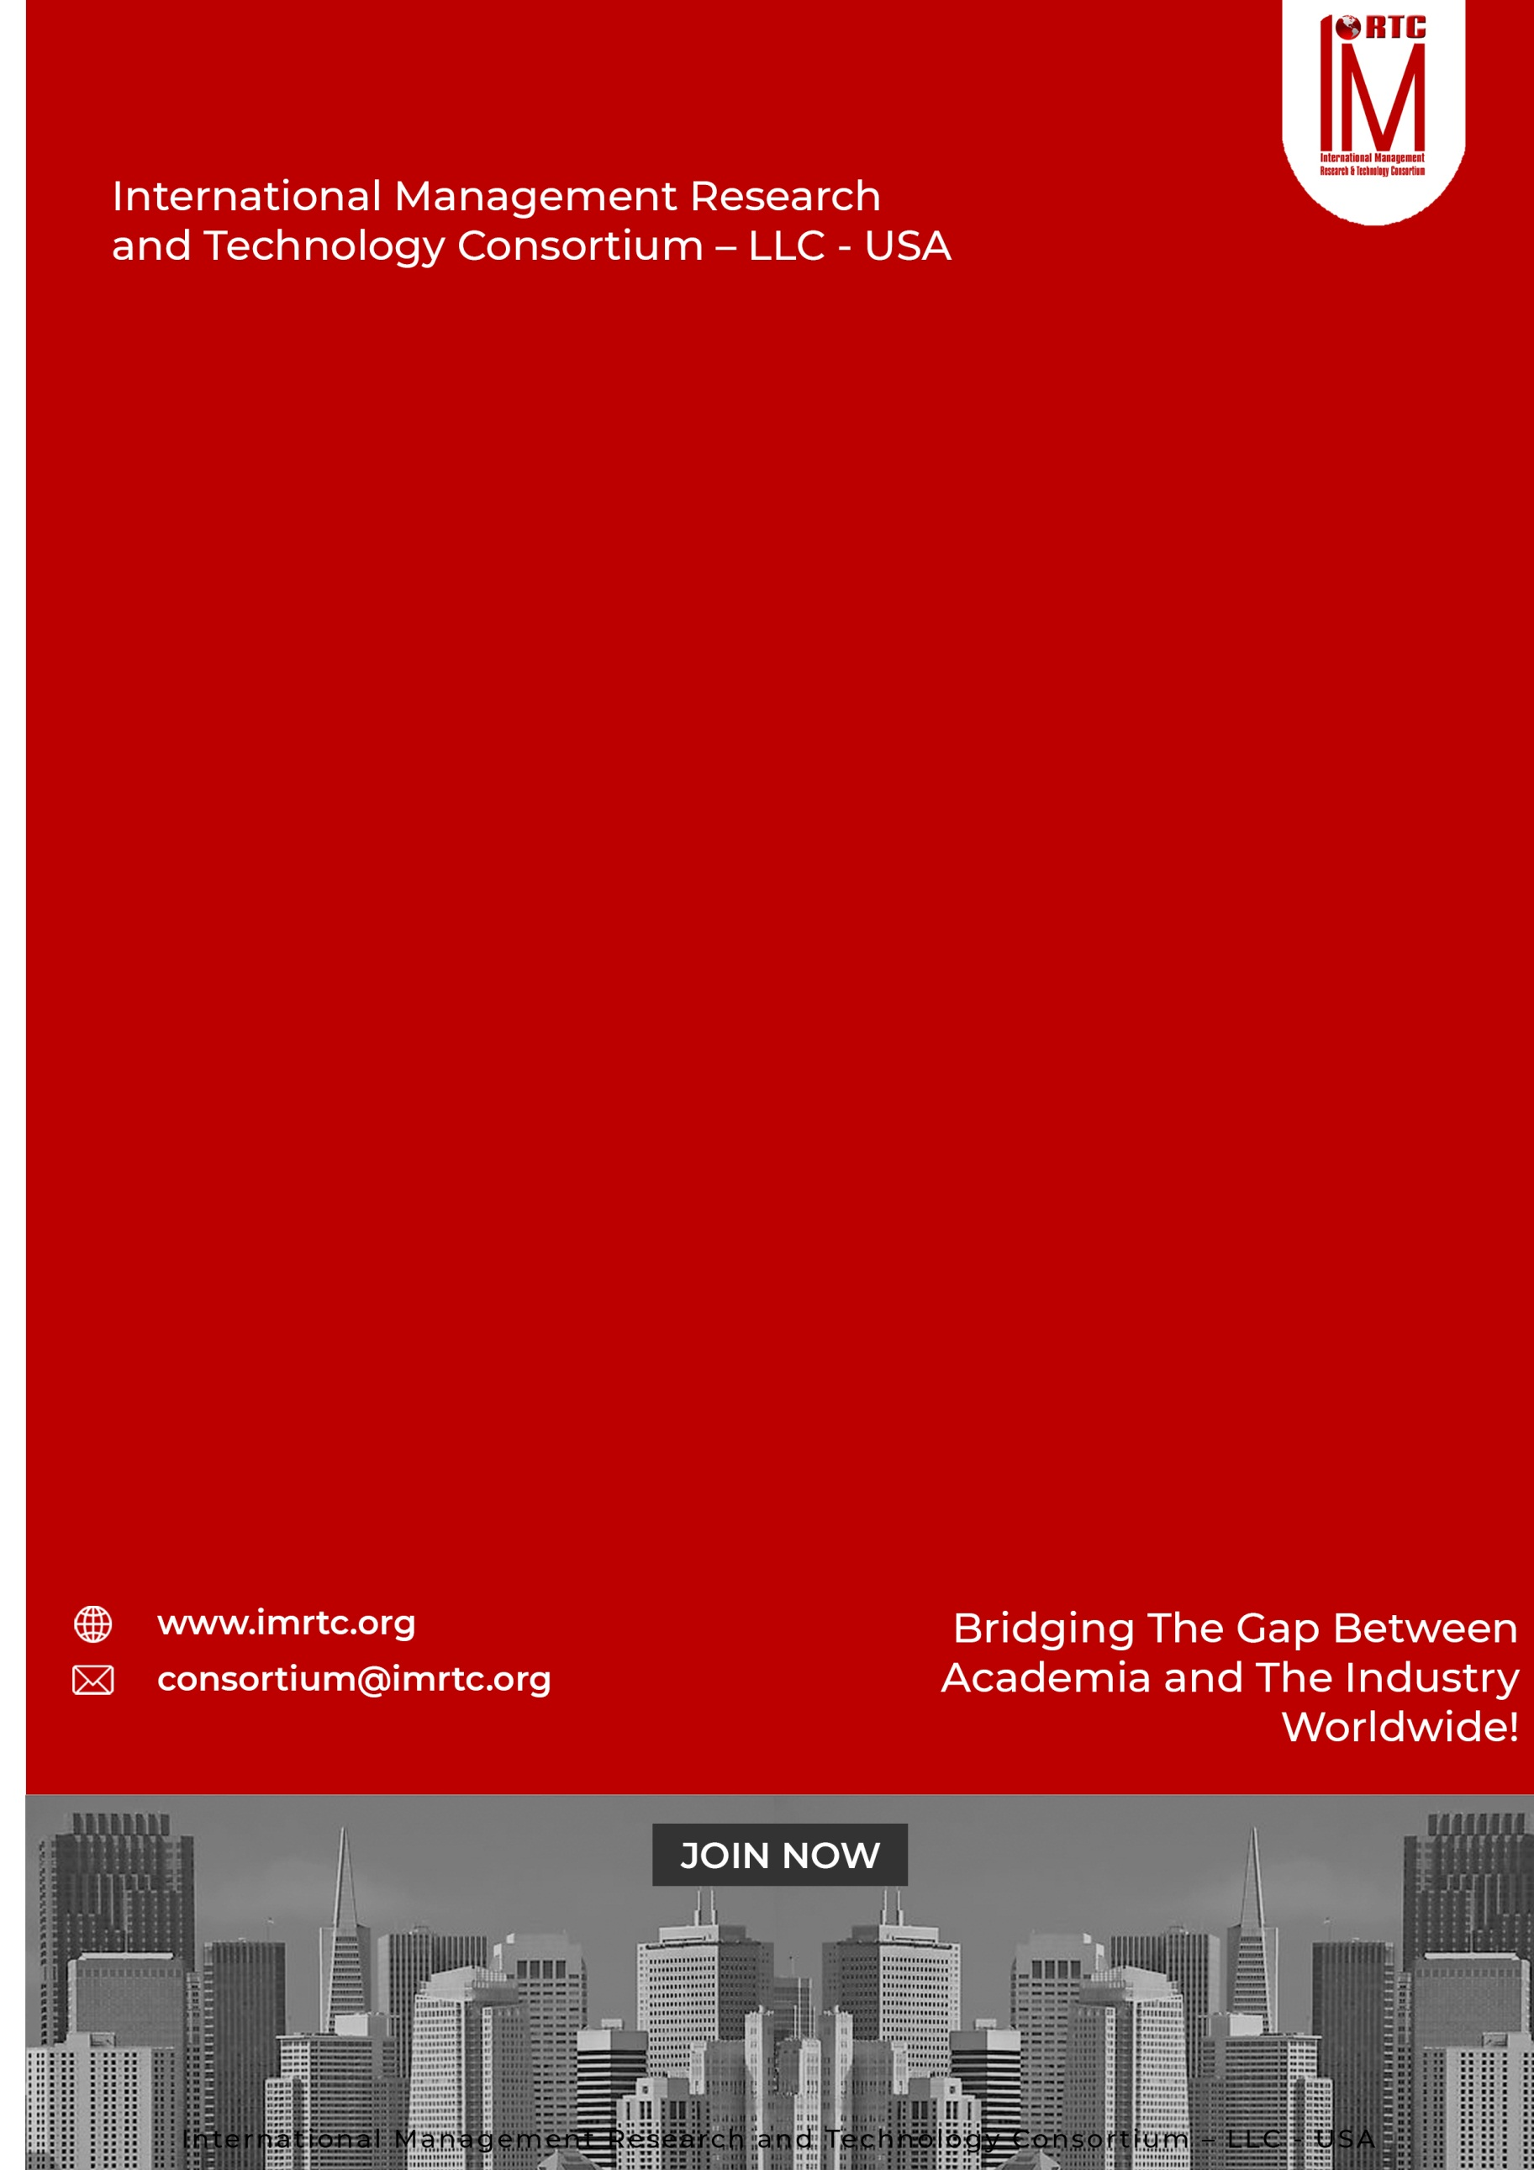
CAMP
CERTIFIED
ADMINISTRATIVE
MANAGEMENT
PROFESSIONAL

CONTENTS
CERTIFIED ADMINISTRATIVE MANAGEMENT PROFESSIONAL 2
INTRODUCTION 2
ABOUT CAMP 2
AUDIENCE 2
THE CREDENTIALS 2
PRE-REQUISITE: 2
CERTIFIED ADMINISTRATIVE MANAGEMENT PROFESSIONAL 2
PROFESSIONAL BENEFITS OF PROGRAM 2
CERTIFIED ADMINISTRATIVE MANAGEMENT PROFESSIONAL 2
PROGRAM STRUCTURE 2
PROGRESSION OF THE PROGRAM 2
AWARDING OF CAMP CERTIFICATION 2
COURSE CONTENTS 2
DOMAINS AND TASKS 2
KNOWLEDGE AREAS 2
ASSESSMENT OF PROGRAM (ONLINE/PHYSICAL) 2
EVALUATION AND GRADING 2
CAMP ELIGIBILITY REQUIREMENTS 2
REGISTRATION AND PAYMENT PROCESS 2
REGISTRATION PROCESS 2
IMRTC EXAMINATION SYSTEM 2
PARTNER INSTITUTE INTERNAL EXAMINATION SYSTEM 2
IMRTC ONLINE EXAM SYSTEM 2
FEES STRUCTURE 2
TERMS & CONDITIONS RELATED TO EXAMINATION AND CERTIFICATION 2
PROCESS OF CERTIFICATION 2
EXAM CONTENT PERCENTAGE 2
CONTACT DETAILS Error! Bookmark not defined.

Published by
International Management Research and Technology Consortium

IMRTC
Principal Office: P. O. Box 409, 9300 Conroy Windermere, Windermere, FL-34786, USA,

All rights reserved. "imrtc", the imrtc logo, "IMRTC", the CAMP logo, CAMP, CAMP logo "IMRTC”, “and the IMRTC USA are registered marks of IMRTC, LLC.
The IMRTC is a trademark of the IMRTC, LLC.

CERTIFIED ADMINISTRATIVE MANAGEMENT PROFESSIONAL

CERTIFIED ASSOCIATE IN HUMAN
RESOURCE MANAGEMENT

CERTIFIED ASSOCIATE IN HUMAN
RESOURCE MANAGEMENT

CERTIFIED ASSOCIATE IN HUMAN
RESOURCE MANAGEMENT

INTRODUCTION

There is a global demand for highly professional competent administrative officers, assistants and secretaries. Unfortunately, there is no recognized institute that offers a comprehensive training in this area. IMRTC after recognizing the need and in consultation with senior executives and trainers have come up with a comprehensive certification program; THE CERTIFIED ADMINISTRATIVE MANAGEMENT PROFESSIONAL (CAMP)

In this respect, IMRTC domain Experts designed a comprehensive training certification, which can provide facilitation to the professionals and also provide the structure to maintain and manage the technology in the organization. Therefore, with the consultation of senior executives and professional, and trainers have come up with a comprehensive certification program. THE CERTIFIED ADMINISTRATIVE MANAGEMENT PROFESSIONAL (CAMP)

ABOUT CAMP
CAMP – Certified Administrative Management Professional is designed to develop necessary expertise and skills required for office administration and management with the goal of increasing cost effective productivity, that is efficiency and effectiveness.
CAMP covers the areas from office management to administration, from business communication to information technology, from organizing work schedules to interpersonal skills, form personal development to grooming subordinates. The program follows a systematic learning format with hands on approach including lot of exercises, quizzes, audio-visual aids, case studies, practice sessions and letter writing etc.

AUDIENCE

Anyone involved in administration and/or office management, an excellent professional qualification for administrators, executive secretaries, administrators in education sector, supervisors, officers, office assistants and assistant managers, etc.

THE CREDENTIALS
Candidates looking to have this certification need a proper training of 32 Professional Training Hours (PTH) from any recognized institute and approved professional trainers of IMRTC.
The program also requires a self-developed project on any case study provided by an accredited training institute or trainer. The project must be in soft form and submitted to our concerned training partners or chapters for assessment. After approval, the candidate can sit in the final examination of IMRTC.
After passing the certification examination the candidates can use this credential CAMP – Certified Administrative Management Professional after their name.
.

PRE-REQUISITE:

- 12 Years Education or equivalent or Baccalaureate, Associate’s degree, or the global equivalent diploma is required to join this session.
- No Professional Experience is required to opt this course and certifications.

CERTIFIED ADMINISTRATIVE MANAGEMENT PROFESSIONAL

CERTIFIED ASSOCIATE IN HUMAN
RESOURCE MANAGEMENT

CERTIFIED ASSOCIATE IN HUMAN
RESOURCE MANAGEMENT

CERTIFIED ASSOCIATE IN HUMAN
RESOURCE MANAGEMENT

PROFESSIONAL BENEFITS OF PROGRAM

For Individuals
- Career advancement into administrative roles.
- Improved understanding of how to align administration work with business goals.
- Recognition as a certified expert in administrative management.
- Using of technologies with the business methodologies
- Developing skills of problem solving, communication skills, time management and interpersonal skills

For Organizations
- Assurance of certified professionals with industry-recognized skills.
- Strengthened your strategy with management capabilities.
- Enhanced ability to adopt and integrate with latest methodologies of emerging technologies effectively.

CERTIFIED ADMINISTRATIVE MANAGEMENT PROFESSIONAL

CERTIFIED ASSOCIATE IN HUMAN
RESOURCE MANAGEMENT

CERTIFIED ASSOCIATE IN HUMAN
RESOURCE MANAGEMENT

CERTIFIED ASSOCIATE IN HUMAN
RESOURCE MANAGEMENT

PROGRAM STRUCTURE

Total Domains | 7
Lectures | Lectures can be delivered through partners and trainers
Accredited Trainers | Can Deliver the lectures
One Credit Hour | 30 Learning Hours
Total Credits Required | 3 Credit Hours
Registration Process | Register through our partners / Trainer
Assessment | Online / Paper based
Passing Criteria | 70 percent

PROGRESSION OF THE PROGRAM

Total Credentials = 3 Credit Hours

One Credit Hour = 10 Learning hours

Final Assessment = Online or physical assessment shall be taken by IMRTC Examination Department

AWARDING OF CAMP CERTIFICATION

After getting 70 percent marks from the examination, the candidate will be awarded the CAMP Certification from IMRTC USA.

COURSE CONTENTS

Certified Administrative Management Professionals cover theory, process, and professional practices for technology management

DOMAIN 1: OFFICE PROCEDURES
DOMAIN 2: OFFICE EQUIPMENTS AND COMPUTERS OPERATIONS
DOMAIN 3: WORD EDITOR, SPREAD SHEETS & E-PRESENTATION
DOMAIN 4: UNDERSTANDING OF ENGLISH/FRENCH LANGUAGE
DOMAIN 5: COMMUNICATION SKILLS
DOMAIN 6: BASICS OF FINANCE
DOMAIN 7: CAREER GROWTH
0

DOMAINS AND TASKS

In this document, you will find an updated structure for the IMRTC Standard Examination Content. Based on Experience Consultants and stakeholders, we have devised and simplified the format so that the IMRTC Examination System can be easier to understand and interpret.
The domain and task are well-defined on the following pages:
Domain: Defined as the high-level knowledge area that is essential to the practice of CAMP.
Tasks: The underlying responsibilities of the Management Consultants within each domain area.

CAMP Course examination will include all tasks for a domain and will adhere to the percentage of coverage at the domain level as outlined in the further pages.

KNOWLEDGE AREAS

Domain 1: OFFICE PROCEDURES
Task 1 | Overview of Office Administration/Secretarial Duties  Daily Routine of an Administrative Assistant/Secretary  Effective Use of Telephone, Handling of Latest Features of Telephonic System
Task 2 | Mail Service and Shipping  Travel Arrangement  Meeting Arrangements
Task 3 | Time Management  Filing and Record Keeping / E-Filing

KNOWLEDGE AREAS
Domain 2: : OFFICE EQUIPMENTS AND COMPUTERS OPERATIONS
Task 1 | Office Equipment’s Handling and its Proper Usage  Effective use of Mobile Apps, widgets
Task 2 | Computer Operating System  OPEN Applications/Software on the Internet and its usage
Task 3 | Emails and Drafting  Use of the Internet in Office Administration
Task 4 | Online Conferencing through Electronic System  Physical and Electronic Security Awareness
Task 5 | Basic Computer Troubleshooting  Office Ergonomics

KNOWLEDGE AREAS
Domain 3: WORD EDITOR, SPREAD SHEETS & E-PRESENTATION
Task 1 | Word Processor  Spread Sheets
Task 2 | Presentation Development Software  Open Office Features and its usage
Task 3 | Publishing Management Software  Text Editor
Task 4 | Email POP Software Usage  Web Applications  Search Techniques and Usage

KNOWLEDGE AREAS
Domain 4: UNDERSTANDING OF ENGLISH/FRENCH LANGUAGE
Task 1 | English/French Grammar
Task 2 | Language Usage and Style
Task 3 | Common Problems in English/ French Language  Punctuation and Spelling
Task 4 | Numerals

KNOWLEDGE AREAS
Domain 5: COMMUNICATION SKILLS
Task 1 | Effective Business Letters  Memos, Drafts, and Replies of Letters
Task 2 | Other Written communication skills  Understanding of Legal Documents
Task 3 | Understanding of Contracts/Agreements/MOUS, Etc.  Developing Contracts/Agreements/MOUS, Etc.
Task 4 | Interpersonal Skills
Task 5 | Effective Presentation Skills

KNOWLEDGE AREAS
Domain 6: : BASICS OF FINANCE
Task 1 | Basic Accounting and Book Keeping
Task 2 | Measuring and Monitoring Expenses  Handling of Petty Cash
Task 3 | Handing of Daily Expenses  Developing Daily Expenditures Sheets

KNOWLEDGE AREAS
DOMAIN 7 CAREER GROWTH
Task 1 | Plan your career
Task 2 | How the organization has to be developed career of employees
Task 3 | Training Requirement with International Certifications of the market
Task 4 | How to upgrade your skills and knowledge
Task 5 | How to organization can become a learned organization

ASSESSMENT OF PROGRAM (ONLINE/PHYSICAL)

- The exam paper will be online/physical as per the choice of the candidate, but it is preferable to give the exam online.
- The exam paper will cover the above topics domain-wise.
- The Passing marks will be 70%.
- Internal Marks can be adjusted in the final marks through accredited trainers by obtaining prior permission from our Examination Department of IMRTC.
- Those candidates who cannot be able to give online tests due to online facility. So they are allowed paper-based examinations. Otherwise, the partner must arrange the center for the online exam as per the guidelines of the Examination Department
- Assessment will be done according to the domains and tasks mentioned above through our online methodology

EVALUATION AND GRADING
- The student will be examined through exams conducted by IMRTC LLC USA. Total marks for passing the CERTIFICATION/DIPLOMA will be 70 out of 100.

CAMP ELIGIBILITY REQUIREMENTS
To be eligible for the Certified Administrative Management Professional for any level, the candidates must have a 12-years Education or equivalent with no experience. The candidate should have to submit the credentials
Educational Background | Accredited Training
12 years Education or Equivalent (Baccalaureate, Associate Degree or Global Equivalent) | 3 PTH Training must be earned from any accredited trainer or any partner institute
Professional Experience | Certification/Diploma
No Professional Experience Required | After completing all the formalities and passing the test, will get the certification or diploma

REGISTRATION AND PAYMENT PROCESS

REGISTRATION PROCESS
Registration of the program is to be completed through our registered partners and if the partners are not available in your city or country then you can download this registration form and submit the fee in our bank account directly and wait for the email or contact from our Registration or Examination Department. For further information to our examination department contact at registration@imrtc.org.

IMRTC EXAMINATION SYSTEM
CERTIFIED ADMINISTRATIVE MANAGEMENT PROFESSIONAL

PARTNER INSTITUTE INTERNAL EXAMINATION SYSTEM

The concerned partner/institute/trainer will take examinations online and submit to the International Management Research and Technology Consortium Examination Department.

IMRTC ONLINE EXAM SYSTEM

IMRTC will provide access to all partners to schedule the exams of the particular courses of any individual candidates. Therefore, according to the availability, the partner institutes will schedule the exam of individual candidates’ subjects or courses/certifications.
S. No | Description | Fees
1. | Membership Fee | USD 50
2. | Examination Fee  For Members | USD 360
3. | Examination Fee  For Non Members | USD 560

FEES STRUCTURE
CERTIFIED ADMINISTRATIVE MANAGEMENT PROFESSIONAL
To get the certification, 30-Professional training hours as PTH is mandatory from any concerned professional trainer or Partner, and participants should submit their training PTH with the Examination Application Form with the attachments of required qualifications and other experience certificates/letters. The Paper is based on 100 Questions with MCQs and 70% passing marks are required to pass the exam. Further, if the Project is also included in your exam, marks will be distributed according to course & certification.

TERMS & CONDITIONS RELATED TO EXAMINATION AND CERTIFICATION
- The 30-Training-hours as PTH are valid up to one year.
- If the candidate is failed in the examination then S/he has one more chance to attempt the paper within a year, and if the candidate cannot pass, then they have to pay the examination fee and re-appear in the examination.
- If the candidate cannot pass the examination within one year and after some time S/he would like to appear in the examination then the candidate must resubmit 30 Professional Training hours as PTH again required to appear in the examination.
- The examination system is online and candidate can book the exam anytime according to his or her availability.
- Those countries, that do not have the facility of online examination facility then they can give the paper-based examination, which can be sent to authorized partner/trainers/examiners. The assessment time will be a month and we will send the results to the concerned partner.
- The candidate will get the certificate within one month and the administration will send to the concerned partners.
- To maintain the worth and eligibility in the market, the candidate must have to renew their membership on a yearly basis.

PROCESS OF CERTIFICATION
CONTENT | DOMAIN WISE PERCENTAGE
DOMAIN I | 10%
DOMAIN II | 15%
DOMAIN III | 15%
DOMAIN IV | 20%
DOMAIN V | 20%
DOMAIN VI | 10%
DOMAIN VII | 10%

EXAM CONTENT PERCENTAGE
The table below prescribes the proportions of examination questions from each section or Knowledge Areas defined above. The exam will be based on multiple choice questions, fill in the blanks and letter writing.

CONTACT DETAILS

ADDRESS Principal Office: P. O. Box 409, 9300 Conroy Windermere, Windermere,
FL-34786, USA,

TELEPHONE (+1) (689) 276-4636
Web https://www.imrtc.org
EMAIL consortium@imrtc.org

SOCIAL MEDIA ACCOUNT
Facebook https://www.facebook.com/IMRTConsortium/
LinkedIn https://www.linkedin.com/company/imrtc
YouTube https://www.youtube.com/channel/UCE_GYVI4WJMKIUXQhouA4LA

INTERNATIONAL MANAGEMENT RESEARCH AND TECHNOLOGY CONSORTIUM
USA LLC L24000411080

