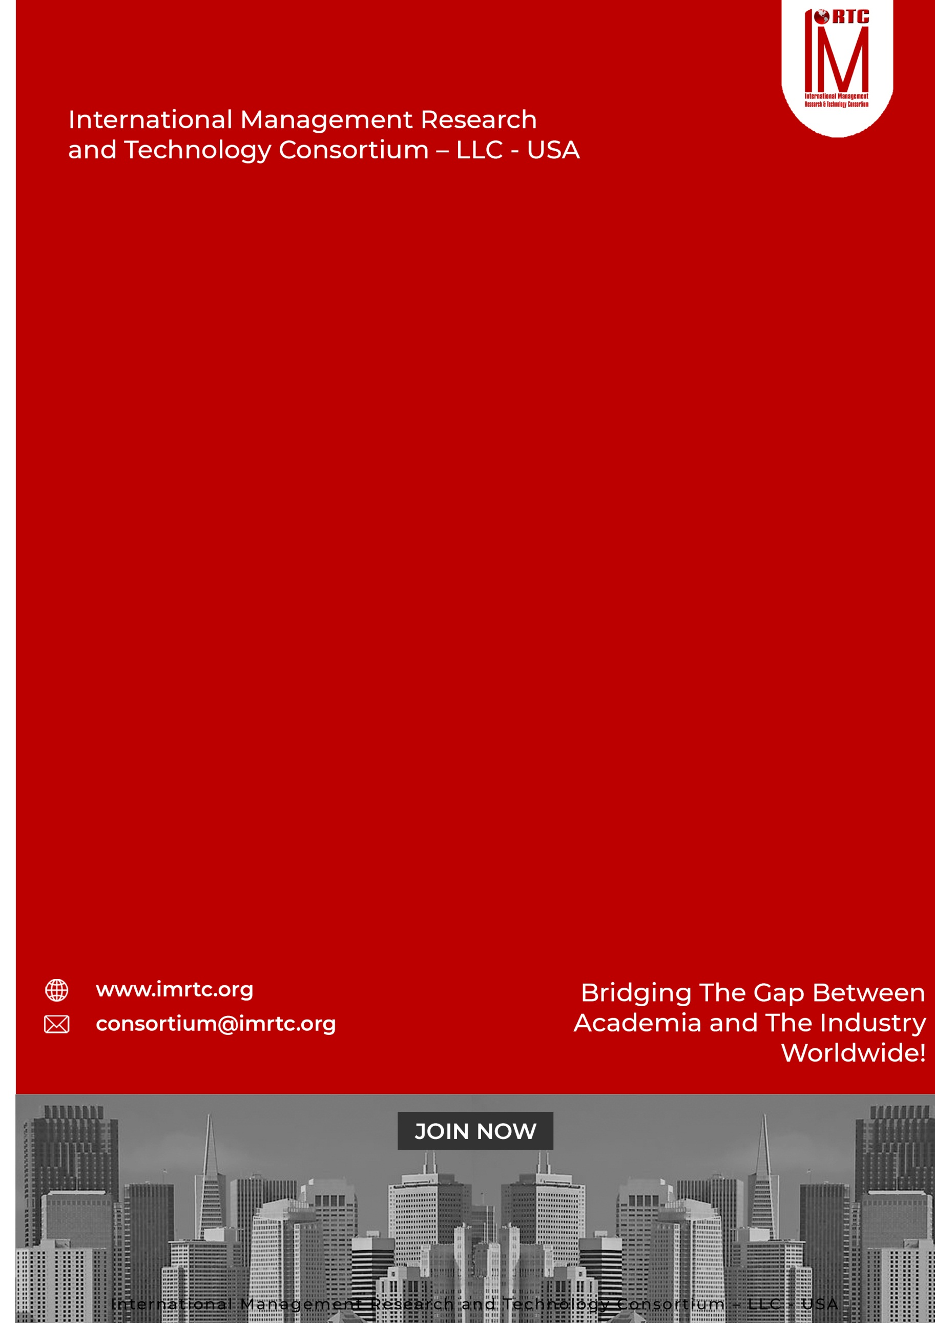
GREEN BELT
SIX SIGMA
CERTIFIED LEAN
CLSSGB

CONTENTS
CERTIFIED LEAN SIX SIGMA GREEN BELT (CLSSGB) 2
INTRODUCTION 2
ABOUT CLSSGB 2
AUDIENCE 2
THE CREDENTIALS 2
PRE-REQUISITE: 2
PROFESSIONAL BENEFITS OF PROGRAM 2
PROGRAM STRUCTURE 2
PROGRESSION OF THE PROGRAM 2
AWARDING OF CLSSGB CERTIFICATION 2
COURSE CONTENTS 2
DOMAINS AND TASKS 2
KNOWLEDGE AREAS 2
Domain 1: DEFINE PHASE 2
Domain 2: MEASURE PHASE 2
Domain 3: ANALYZE PHASE 2
Domain 4: IMPROVE PHASE 2
Domain 5: CONTROL PHASE 2
Domain 6: LEAN TOOLS 2
Domain 7: STATISTICAL TOOLS AND TECHNIQUES 2
Domain 8: PROJECT MANAGEMENT AND TEAMWORK 2
ASSESSMENT OF PROGRAM (ONLINE/PHYSICAL) 2
CLSSBB ELIGIBILITY REQUIREMENTS 2
REGISTRATION AND PAYMENT PROCESS 2
REGISTRATION PROCESS 2
IMRTC EXAMINATION SYSTEM 2
PARTNER INSTITUTE INTERNAL EXAMINATION SYSTEM 2
IMRTC ONLINE EXAM SYSTEM 2
FEES STRUCTURE 2
TERMS & CONDITIONS RELATED TO EXAMINATION AND CERTIFICATION 2
PROCESS OF CERTIFICATION 2
EXAM CONTENT PERCENTAGE 2
CONTACT DETAILS Error! Bookmark not defined.

Published by
International Management Research and Technology Consortium

IMRTC
Principal Office: P. O. Box 409, 9300 Conroy Windermere, Windermere, FL-34786, USA,

All rights reserved. "imrtc", the imrtc logo, "IMRTC", the CLSSGB logo, CLSSGB, CLSSGB logo "IMRTC”, “and the IMRTC USA are registered marks of IMRTC, LLC.
The IMRTC is a trademark of the IMRTC, LLC.

CERTIFIED LEAN SIX SIGMA GREEN BELT (CLSSGB)

CERTIFIED ASSOCIATE IN HUMAN
RESOURCE MANAGEMENT

CERTIFIED ASSOCIATE IN HUMAN
RESOURCE MANAGEMENT

CERTIFIED ASSOCIATE IN HUMAN
RESOURCE MANAGEMENT

INTRODUCTION
There is a global need for market and requires competent Six Sigma Certified Green Belt Managers, who can understand Lean Process and Optimization of Business process and Business Process Re-Engineering. As a recognized institute, we offer a comprehensive training curriculum in this belt. IMRTC after recognizing the need and in consultation with senior members, executives, and trainers has come up with a comprehensive certification program - THE CERTIFIED LEAN SIX SIGMA GREEN BELT (CLSSGB)

ABOUT CLSSGB
LEAN SIX SIGMA GREEN BELT - CLSSGB is required to develop the necessary expertise and skills for Quality Management Systems, Production, Operations, and Services People. The ultimate goal of this certification is that management can increase their productivity by reducing cost effective through lean processes with efficiency and effectiveness. LEAN SIX SIGMA GREEN BELT - CLSSGB covers the areas of Quality Cycle, Lean Management, Qualitative and Quantitative Assessment of Processes, and strategic approaches to operational Management of businesses through information technology ERP, and CRM systems. The program follows a systematic learning format with a hands-on approach including a lot of exercises, quizzes, audio-visual aids, case studies, practice sessions, and case studies for the development of the project.

AUDIENCE

Anyone belongs from Quality, Production, Manufacturing and/or Service Industry, can avail this excellent professional qualifications. It is most suitable for Managers, executive assistants and supervisor in any sector, who are involved directly or indirectly with it.
CERTIFIED LEAN SIX SIGMA GREEN BELT (CLSSGB)

CERTIFIED ASSOCIATE IN HUMAN
RESOURCE MANAGEMENT

CERTIFIED ASSOCIATE IN HUMAN
RESOURCE MANAGEMENT

CERTIFIED ASSOCIATE IN HUMAN
RESOURCE MANAGEMENT

THE CREDENTIALS
The Candidates who are looking to have this certification need a proper training of 36 Professional Training Hours (PTH) from any recognized institute and approved professional trainers of IMRTC. The program also required a self-develop project that depends on real cases and complete problems and issues shall be encountered in this project. The project is required in soft form and submitted to our concerned training partners or chapters for assessment and after approval, then candidate can sit in the final examination of IMRTC. After passing the certification examination, the candidates can use the credentials CERTIFIED LEAN SIX SIGMA GREEN - CLSSGB with their names.

PRE-REQUISITE:

Bachelor’s degree (high school professional diploma, associate’s degree
or the global equivalent)

One years of professional experience in Quality, Manufacturing or Any Service Industry

PROFESSIONAL BENEFITS OF PROGRAM
A Certified Lean Six Sigma Green Belt (CLSSGB) is a valuable credential that demonstrates expertise in improving problem solving and analytical skills, ability to lead process improvement project, increases cross industry applicability, reducing waste, and driving quality improvements and improved organizational impacts. Here are the key benefits of earning this certification:
- Career Advancement
  - A CLSSGB certification enhances your resume and makes you a strong candidate for leadership and managerial roles in various industries.
  - Employers value professionals who can drive process improvements and manage cross-functional teams effectively.
- Increased Earning Potential
  - Certified professionals often earn higher salaries due to their specialized skills and ability to deliver measurable business results.
  - A Six Sigma Green Belt certification is often associated with premium roles in organizations.
- Expanded Career Opportunities
  - Industries such as manufacturing, healthcare, IT, finance, logistics, and consulting frequently seek Lean Six Sigma Green Belts.
  - The certification demonstrates versatility and relevance across sectors.
- Leadership Skills
  - Green Belts are trained to lead and mentor teams, fostering leadership qualities essential for project and change management.
- Improved problem solving and analytical skills
  - Green Belt professionals learn to apply statistical tools and problem-solving methodologies to identify inefficiencies, improve processes, and reduce variability. This training helps develop strong analytical skills that can be applied to various business scenarios.

CERTIFIED LEAN SIX SIGMA GREEN BELT (CLSSGB)

CERTIFIED ASSOCIATE IN HUMAN
RESOURCE MANAGEMENT

CERTIFIED ASSOCIATE IN HUMAN
RESOURCE MANAGEMENT

CERTIFIED ASSOCIATE IN HUMAN
RESOURCE MANAGEMENT

PROGRAM STRUCTURE

Total Domains | 8
Lectures | Lectures can be delivered through partners and trainers
Accredited Trainers | Can Deliver the lectures
One Credit Hour | 10 Learning Hours
Total Credits Required | 3.6 Credit Hours
Registration Process | Register through our partners / Trainer
Assessment | Online / Paper based
Passing Criteria | 70 percent

PROGRESSION OF THE PROGRAM

Total Credentials = 3.6 Credit Hours

One Credit Hour = 10 Learning hours

Final Assessment = Online or physical assessment shall be taken by IMRTC Examination Department

AWARDING OF CLSSGB CERTIFICATION

After getting 70 percent marks from the examination, the candidate will be awarded the CLSSGB Certification from IMRTC USA.

COURSE CONTENTS

Certified Lean Six Sigma Green Belt Covers theory, process and practices of Lean and Six sigma skills
DOMAIN 1: Define Phase
DOMAIN 2: Measure Phase
DOMAIN 3: Analyze Phase
DOMAIN 4: Improve Phase
DOMAIN 5: Control Phase
DOMAIN 6: Lean Tools
DOMAIN 7: Statistical Tools and Techniques
DOMAIN 8: Project Management and Teamwork

0

DOMAINS AND TASKS

In this document, you will find an updated structure for the IMRTC Standard Examination Content. Based on Experience Consultants and stakeholders, we have devised and simplified the format so that the IMRTC Examination System can be easier to understand and interpret.
The domain and task are well-defined on the following pages:
Domain: Defined as the high-level knowledge area that is essential to the practice of CLSSBGB.
Tasks: The underlying responsibilities of the Quality Consultants within each domain area.

CLSSBB Course examination will include all tasks for a domain and will adhere to the percentage of coverage at the domain level as outlined in the further pages.

KNOWLEDGE AREAS

Domain 1: DEFINE PHASE
Task 1 | Project Identification and Selection  Identifying improvement opportunities aligned with business objectives.  Defining the scope and goals of the project.
Task 2 | Voice of the Customer (VoC)  Gathering and translating customer requirements into measurable objectives.
Task 3 | Project Charter Development  Documenting project objectives, scope, team members, and milestones.  Stakeholder Analysis  Identifying and managing stakeholders to ensure project success.

KNOWLEDGE AREAS

Domain 2: MEASURE PHASE
Task 1 | Process Mapping and Documentation  Creating detailed process maps (e.g., SIPOC, value stream mapping).
Task 2 | Data Collection and Sampling  Designing data collection plans.  Sampling techniques to ensure data reliability
Task 3 | Measurement System Analysis (MSA)  Evaluating the accuracy and precision of measurement systems.
Task 4 | Descriptive Statistics  Understanding central tendency, dispersion, and data distribution.
Task 4 | Baseline Performance Metrics  Calculating process capability indices (Cp, Cpk, Pp, Ppk).

KNOWLEDGE AREAS

Domain 3: ANALYZE PHASE
Task 1 | Data Analysis Tools  Hypothesis testing (e.g., t-tests, ANOVA, Chi-square tests).  Correlation and regression analysis.
Task 2 | Root Cause Analysis (RCA)  Using tools like Fishbone diagrams, Pareto charts, and 5 Whys
Task 3 | Failure Mode and Effects Analysis (FMEA)  Identifying potential risks and their impact on the process.
Task 4 | Process Variability Analysis  Analyzing sources of variation in the process.

KNOWLEDGE AREAS

Domain 4: IMPROVE PHASE
Task 1 | Brainstorming and Solution Development  Generating and prioritizing potential solutions.
Task 2 | Lean Tools and Techniques  Implementing tools like 5S, Kaizen, and Kanban.
Task 3 | Design of Experiments (DOE)  Conducting experiments to optimize process parameters.
Task 4 | Cost-Benefit Analysis  Evaluating the feasibility and impact of proposed solutions.

KNOWLEDGE AREAS

Domain 5: CONTROL PHASE
Task 1 | Control Plan Development  Documenting steps to sustain improvements.
Task 2 | Statistical Process Control (SPC)  Using control charts to monitor process performance.
Task 3 | Mistake Proofing (Poka-Yoke)  Implementing error-proofing techniques.
Task 4 | Sustainability Measures  Ensuring long-term adoption of improvements.
Task 5 | Project Closure and Handover  Transitioning ownership to process owners and documenting lessons learned

KNOWLEDGE AREAS

Domain 6: LEAN TOOLS
Task 1 | Waste identification and elimination (e.g., TIMWOOD: Transportation, Inventory, Motion, Waiting, Overproduction, Over processing, Defects).
Task 2 | Value Stream Mapping (VSM) for process flow analysis
Task 3 | Continuous Flow and Pull Systems

KNOWLEDGE AREAS

Domain 7: STATISTICAL TOOLS AND TECHNIQUES
Task 1 | Data Analysis and Statistical Methods  - Basic understanding of statistics (mean, median, mode, standard deviation)  - Applying statistical tools for analyzing data and making informed decisions  - Use of software tools like Minitab or Excel for analysis
Task 2 | Tools & Techniques:  - Descriptive Statistics  - Hypothesis Testing  - Confidence Intervals  - Analysis of Variance (ANOVA)  - Regression Analysis  - Control Charts

KNOWLEDGE AREAS

Domain 8: PROJECT MANAGEMENT AND TEAMWORK
Task 1 | Managing Projects and Leading Teams  - Understanding project management principles and frameworks (e.g., DMAIC)  - Leading project teams and effectively communicating project progress  - Time management, task allocation, and resource management  - Managing change and engaging stakeholders
Task 2 | Tools & Techniques:  - Gantt Charts  - Work Breakdown Structure (WBS)  - Team Roles and Dynamics  - Communication Plans

ASSESSMENT OF PROGRAM (ONLINE/PHYSICAL)

- The exam paper will be online/physical as per the choice of the candidate, but it is preferable to give the exam online.
- The exam paper will cover the above topics domain-wise.
- The Passing marks will be 70%.
- Internal Marks can be adjusted in the final marks through accredited trainers by obtaining prior permission from our Examination Department of IMRTC.
- Those candidates who cannot be able to give online tests due to online facility. So they are allowed paper-based examinations. Otherwise, the partner must arrange the center for the online exam as per the guidelines of the Examination Department
- Assessment will be done according to the domains and tasks mentioned above through our online methodology
EVALUATION AND GRADING
- The student will be examined through exams conducted by IMRTC LLC USA. Total marks for passing the CERTIFICATION/DIPLOMA will be 70 out of 100.

CLSSBB ELIGIBILITY REQUIREMENTS
To be eligible for the Certified Lean Six Sigma Green Belt for any level, the candidates must have a 2 years Bachelor degree pass or equivalent by having One-Year market experience. The candidate should have to submit the credentials

Educational Background | Certification / Diploma
Bachelor degree Passed or Equivalent | Must be earned from any partner institute about 4 Credit hours course training
Professional Experience | Certification / Diploma
One year Minimum Professional Experience Required | From any professional organization or company

REGISTRATION AND PAYMENT PROCESS

REGISTRATION PROCESS
Registration of the program is to be completed through our registered partners and if the partners are not available in your city or country then you can download this registration form and submit the fee in our bank account directly and wait for the email or contact from our Registration or Examination Department. For further information to our examination department contact at registration@imrtc.org.

IMRTC EXAMINATION SYSTEM
CERTIFIED LEAN SIX SIGMA GREEN BELT CERTIFICATION

PARTNER INSTITUTE INTERNAL EXAMINATION SYSTEM

The concerned partner/institute/trainer will take examinations online and submit to the International Management Research and Technology Consortium Examination Department.

IMRTC ONLINE EXAM SYSTEM

IMRTC will provide access to all partners to schedule the exams of the particular courses of any individual candidates. Therefore, according to the availability, the partner institutes will schedule the exam of individual candidates’ subjects or courses/certifications.
S. No | Description | Fees
1. | Membership Fee | USD 50
2. | Examination Fee  For Non Members | USD 299
3. | Examination Fee  For Non Members | USD 199

FEES STRUCTURE
CERTIFIED LEAN SIX SIGMA GREEN BELT
To get the certification, 36-Professional training hours as PTH is mandatory from any concerned professional trainer or Partner, and participants should have to submit their training PTH with the Examination Application Form with the attachments of required qualifications and other experience certificates/letters. The Paper is based on 100 Questions with MCQs and 70% passing marks is required to pass the exam. Further, if the Project is also included in your exam, marks will be distributed according to course & certification.

TERMS & CONDITIONS RELATED TO EXAMINATION AND CERTIFICATION
- The 36-Training-hours as PTH are valid up to one year.
- If the candidate is failed in the examination then S/he has one more chance to attempt the paper within a year, and if the candidate cannot not passed, then they have to pay the examination fee and re-appear in the examination.
- If the candidate has not passed the examination within one year and after sometime S/he would like to appear in the examination then candidate must to resubmit 36-Professional-Training-hours as PTH again required to appear in the examination.
- The examination system is online and candidate can book the exam anytime according to his or her availability.
- Those countries, who do not have the facility of online examination facility then they can give the paper based examination, which can be sent to authorized partner / trainers / examiner. The assessment time will be a month and we will be sent the results to concerned partner.
- The candidate will get the certificate within one month and administration will sent to the concerned partners.
- To maintain the worth and eligibility in the market, the candidate must have to renew their membership on yearly basis.

PROCESS OF CERTIFICATION
CONTENT | DOMAIN WISE PERCENTAGE
DOMAIN I | 11%
DOMAIN II | 11%
DOMAIN III | 11%
DOMAIN IV | 11%
DOMAIN V | 11%
DOMAIN VI | 15%
DOMAIN VII | 15%
DOMAIN VIII | 15%

EXAM CONTENT PERCENTAGE
The table below prescribes the proportions of examination questions from each section or Knowledge Areas defined above. The exam will be based on multiple choice questions, fill in the blanks and letter writing.

CONTACT DETAILS

ADDRESS Principal Office: P. O. Box 409, 9300 Conroy Windermere, Windermere,
FL-34786, USA,

TELEPHONE (+1) (689) 276-4636
Web https://www.imrtc.org
EMAIL consortium@imrtc.org

SOCIAL MEDIA ACCOUNT
Facebook https://www.facebook.com/IMRTConsortium/
LinkedIn https://www.linkedin.com/company/imrtc
YouTube https://www.youtube.com/channel/UCE_GYVI4WJMKIUXQhouA4LA

INTERNATIONAL MANAGEMENT RESEARCH AND TECHNOLOGY CONSORTIUM
USA LLC L24000411080

