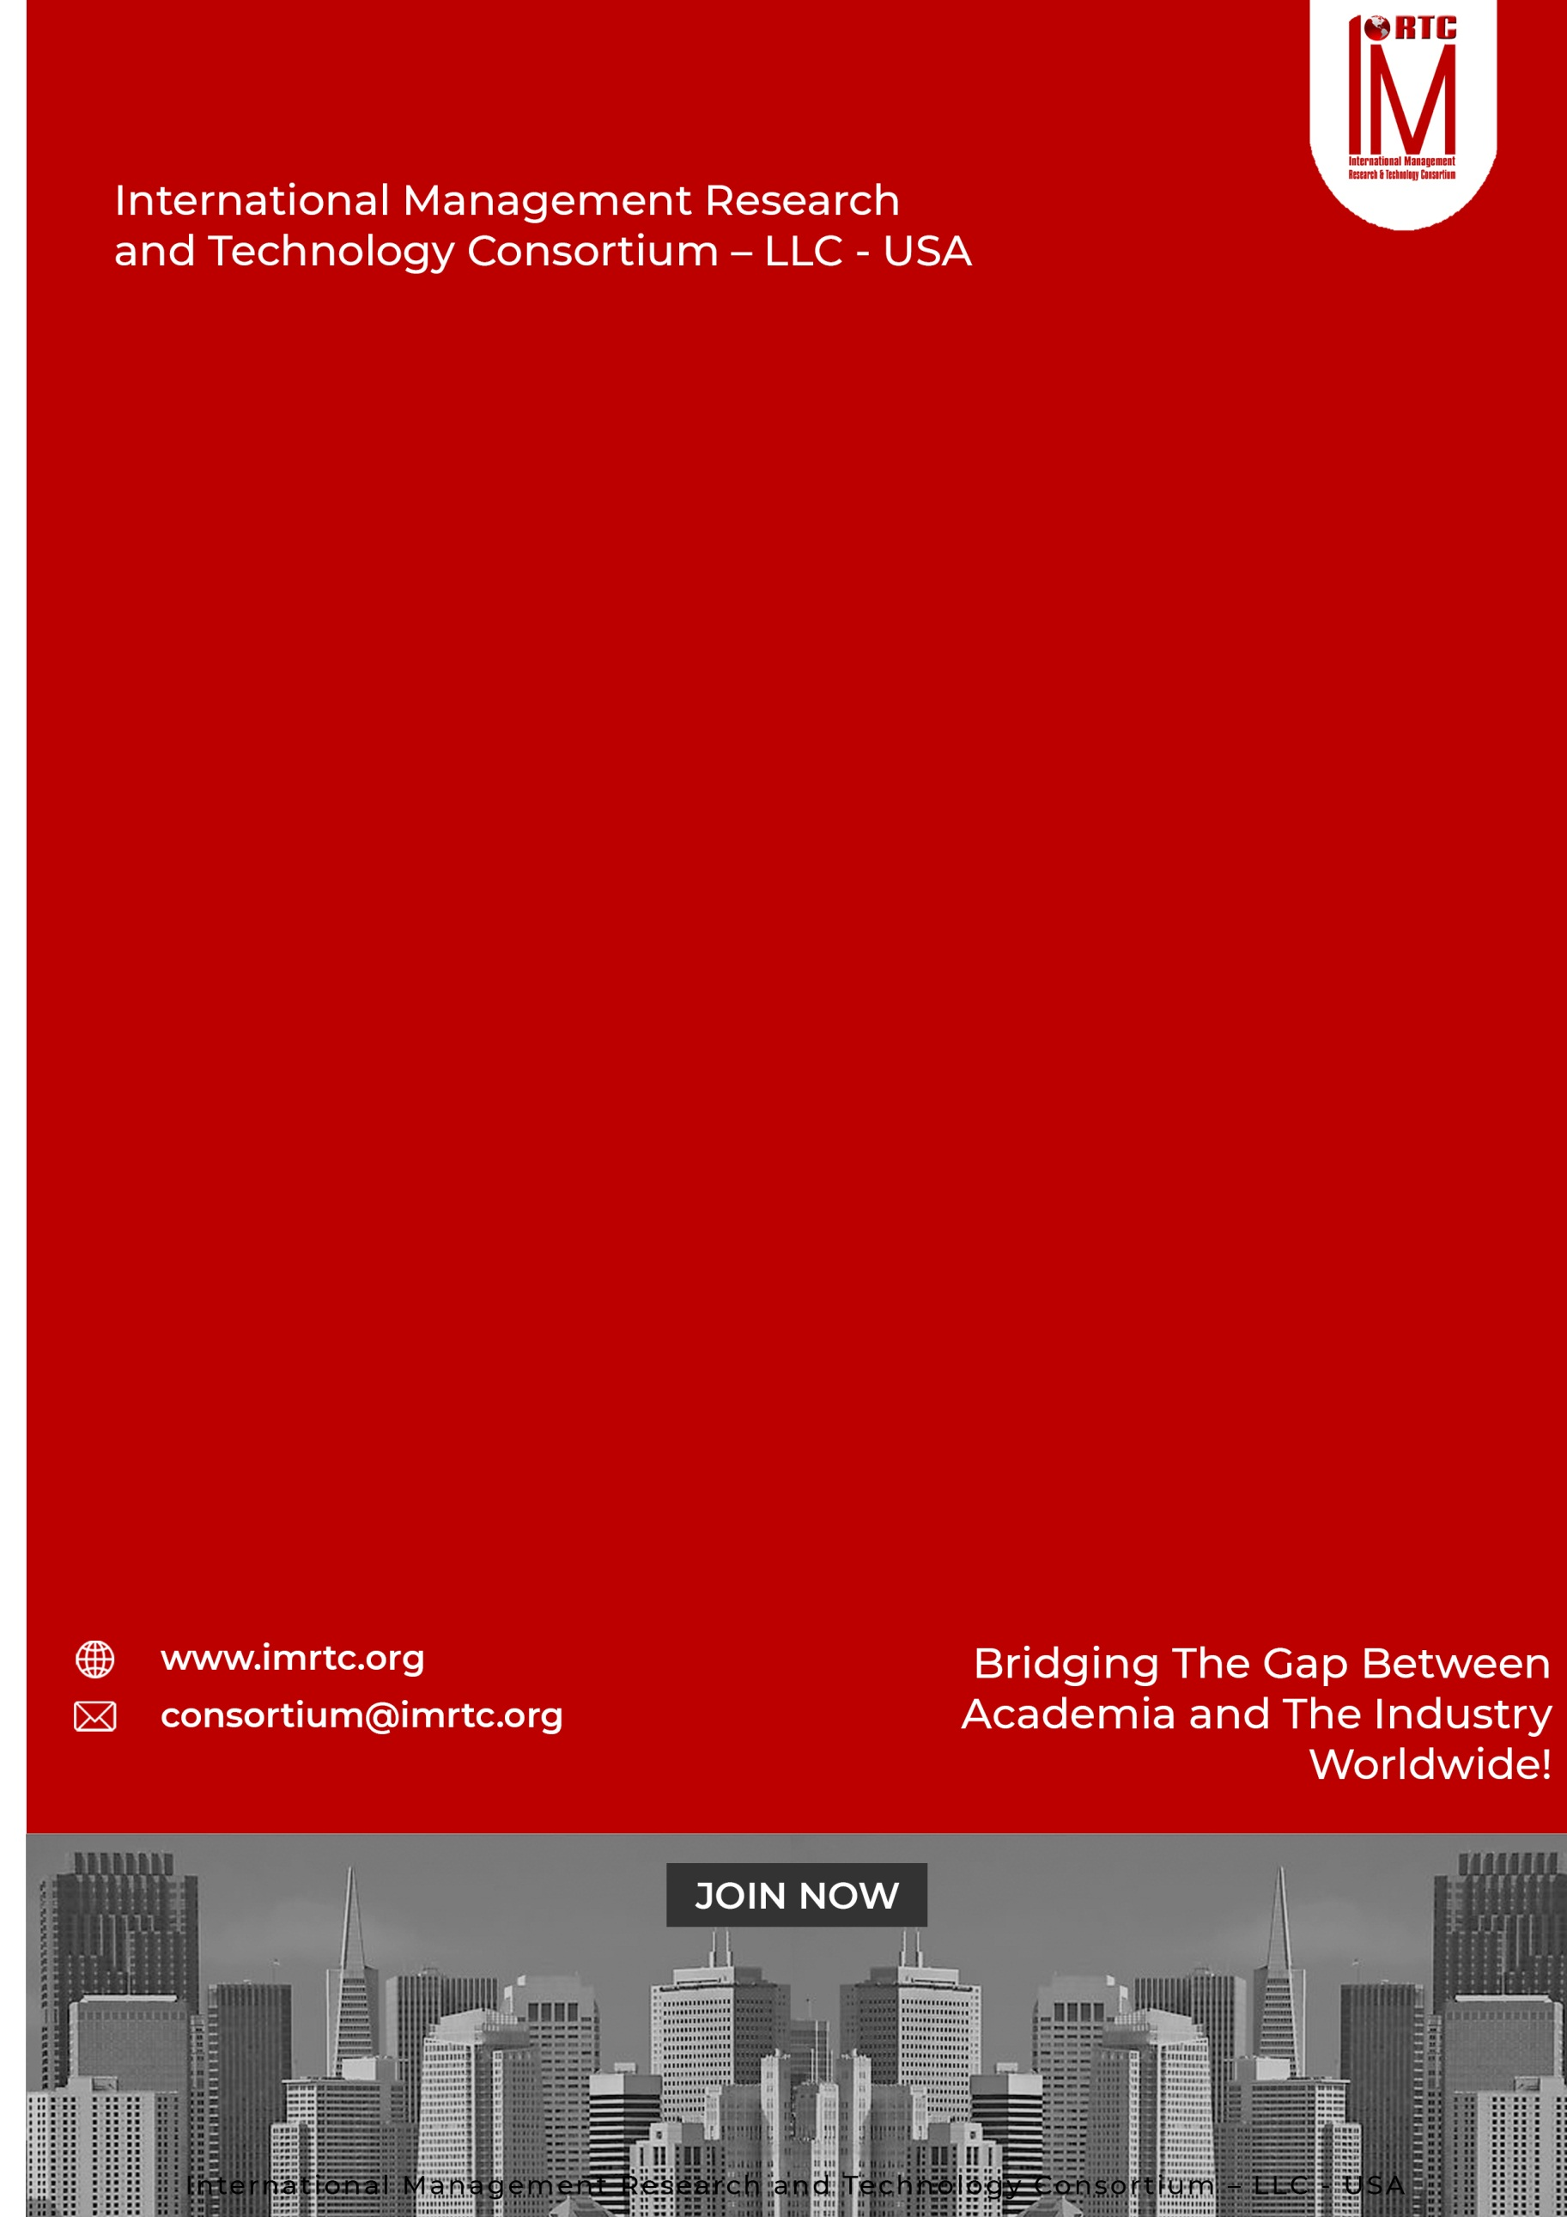
SIX SIGMA
YELLOW BELT
CERTIFIED LEAN
CLSSYB

CONTENTS
CERTIFIED LEAN SIX SIGMA YELLOW BELT (CLSSYB) 2
INTRODUCTION 2
ABOUT CLSSYB 2
AUDIENCE 2
THE CREDENTIALS 2
PRE-REQUISITE: 2
PROFESSIONAL BENEFITS OF PROGRAM 2
PROGRAM STRUCTURE 2
PROGRESSION OF THE PROGRAM 2
AWARDING OF CLSSGB CERTIFICATION 2
COURSE CONTENTS 2
DOMAINS AND TASKS 2
KNOWLEDGE AREAS 2
Domain 1: INTRODUCTION TO LEAN SIX SIGMA METHODOLOGY 2
Domain 2: THE DMAIC FRAMEWORK 2
Domain 3: PROCESS MAPPING 2
Domain 4: BASIC DATA ANALYSIS 2
Domain 5: ROOT CAUSE ANALYSIS 2
Domain 6: BASIC STATISTICAL TOOLS 2
Domain 7: LEAN TOOLS FOR WASTE REDUCTION 2
Domain 8: BASIC PROBLEM-SOLVING TECHNIQUES 2
Domain 9: TEAMWORK AND COMMUNICATION 2
Domain 10: UNDERSTANDING CUSTOMER NEEDS 2
ASSESSMENT OF PROGRAM (ONLINE/PHYSICAL) 2
CLSSYB ELIGIBILITY REQUIREMENTS 2
REGISTRATION AND PAYMENT PROCESS 2
REGISTRATION PROCESS 2
IMRTC EXAMINATION SYSTEM 2
PARTNER INSTITUTE INTERNAL EXAMINATION SYSTEM 2
IMRTC ONLINE EXAM SYSTEM 2
FEES STRUCTURE 2
TERMS & CONDITIONS RELATED TO EXAMINATION AND CERTIFICATION 2
PROCESS OF CERTIFICATION 2
EXAM CONTENT PERCENTAGE 2
CONTACT DETAILS Error! Bookmark not defined.

Published by
International Management Research and Technology Consortium

IMRTC
Principal Office: P. O. Box 409, 9300 Conroy Windermere, Windermere, FL-34786, USA,

All rights reserved. "imrtc", the imrtc logo, "IMRTC", the CLSSYB logo, CLSSYB, CLSSYB logo "IMRTC”, “and the IMRTC USA are registered marks of IMRTC, LLC.
The IMRTC is a trademark of the IMRTC, LLC.

CERTIFIED LEAN SIX SIGMA YELLOW BELT (CLSSYB)

CERTIFIED ASSOCIATE IN HUMAN
RESOURCE MANAGEMENT

CERTIFIED ASSOCIATE IN HUMAN
RESOURCE MANAGEMENT

CERTIFIED ASSOCIATE IN HUMAN
RESOURCE MANAGEMENT

INTRODUCTION
There is a global need for market and requires competent Six Sigma Certified Yellow Belt Assistants, who can understand Lean Process and Optimization of Business process and Business Process Re-Engineering at entry level. As a recognized institute, we offer a comprehensive training curriculum in this belt. IMRTC after recognizing the need and in consultation with senior members, executives, and trainers has come up with a comprehensive certification program - THE CERTIFIED LEAN SIX SIGMA YELLOW BELT (CLSSYB)

ABOUT CLSSYB
LEAN SIX SIGMA YELLOW BELT - CLSSGB is required to develop the necessary expertise and skills for Quality Management Systems, Production, Operations, and Services People. The ultimate goal of this certification is that management can increase their productivity by reducing cost effective through lean processes with efficiency and effectiveness. LEAN SIX SIGMA YELLOW BELT - CLSSYB covers the areas of Quality Cycle, Lean Management, Qualitative and Quantitative Assessment of Processes, and strategic approaches to operational Management of businesses through information technology ERP, and CRM systems. The program follows a systematic learning format with a hands-on approach including a lot of exercises, quizzes, audio-visual aids, case studies, practice sessions, and case studies for the development of the project.

AUDIENCE

Anyone belongs from Quality, Production, Manufacturing and/or Service Industry, can avail this excellent professional qualifications at entry level. It is most suitable for Students, Fresh Engineers, Fresh Graduates, Assistant Managers, executive assistants and supervisor in any sector, who are involved directly or indirectly with it.

THE CREDENTIALS
The Candidates who are looking to have this certification need a proper training of 20 Professional Training Hours (PTH) from any recognized institute and approved professional trainers of IMRTC. The program also required a self-develop project that depends on real cases and complete problems and issues shall be encountered in this project. The project is required in soft form and submitted to our concerned training partners or chapters for assessment and after approval, then candidate can sit in the final examination of IMRTC. After passing the certification examination, the candidates can use the credentials CERTIFIED LEAN SIX SIGMA YELLOW - CLSSYB with their names.

PRE-REQUISITE:

Fresh Bachelor’s degree Holders (high school professional diploma, associate’s degree
or the global equivalent)

No Professional Experience Required to opt this Certification.

CERTIFIED LEAN SIX SIGMA YELLOW BELT (CLSSYB)

CERTIFIED ASSOCIATE IN HUMAN
RESOURCE MANAGEMENT

CERTIFIED ASSOCIATE IN HUMAN
RESOURCE MANAGEMENT

CERTIFIED ASSOCIATE IN HUMAN
RESOURCE MANAGEMENT

PROFESSIONAL BENEFITS OF PROGRAM
A Certified Lean Six Sigma Yellow Belt (CLSSYB) is a valuable credential that understand to improve problem solving and analytical skills, increase the ability to lead process improvement project, increases cross industry applicability, Understanding of reducing waste, and driving quality improvements and improved organizational impacts. Here are the key benefits of earning this certification:
- Foundation in Lean Six Sigma: Provides basic understanding of process improvement concepts.
- Increased Efficiency Awareness: Helps you recognize and reduce inefficiencies in processes.
- Enhanced Marketability: Increases your attractiveness to employers and enhances your resume.
- Career Advancement: Lays the groundwork for future roles and certifications.
- Effective Team Collaboration: Enables you to contribute meaningfully to improvement teams.
- Cost-Effectiveness for Employers: Helps organizations save costs by identifying areas for improvement.
- Improved Communication Skills: Strengthens your ability to communicate process changes clearly.
- Data-Driven Decision Making: Introduces you to the importance of data in making improvements.
- Organizational Understanding: Helps you grasp how your role impacts organizational success.
- Pathway to Advanced Certifications: Serves as a stepping stone to more advanced Lean Six Sigma certifications.
- Increased Job Satisfaction: Allows you to actively contribute to projects that drive positive change.
The Lean Six Sigma Yellow Belt certification is an excellent starting point for anyone looking to understand and apply process improvement techniques. Whether you're new to the field or working in a role that supports process improvement initiatives, this certification can greatly enhance your skills, job performance, and career potential.

CERTIFIED LEAN SIX SIGMA YELLOW BELT (CLSSYB)

CERTIFIED ASSOCIATE IN HUMAN
RESOURCE MANAGEMENT

CERTIFIED ASSOCIATE IN HUMAN
RESOURCE MANAGEMENT

CERTIFIED ASSOCIATE IN HUMAN
RESOURCE MANAGEMENT

PROGRAM STRUCTURE

Total Domains | 10
Lectures | Lectures can be delivered through partners and trainers
Accredited Trainers | Can Deliver the lectures
One Credit Hour | 10 Learning Hours
Total Credits Required | 2 Credit Hours
Registration Process | Register through our partners / Trainer
Assessment | Online / Paper based
Passing Criteria | 70 percent

PROGRESSION OF THE PROGRAM

Total Credentials = 2 Credit Hours

One Credit Hour = 10 Learning hours

Final Assessment = Online or physical assessment shall be taken by IMRTC Examination Department

AWARDING OF CLSSGB CERTIFICATION

After getting 70 percent marks from the examination, the candidate will be awarded the CLSSGB Certification from IMRTC USA.

COURSE CONTENTS

Certified Lean Six Sigma Yellow Belt Covers theory, process and practices of Lean and Six sigma skills
DOMAIN 1: Introduction to Lean Six Sigma Methodology
DOMAIN 2: DMAIC Framework
DOMAIN 3: Process Mapping
DOMAIN 4: Data Collection and Analysis
DOMAIN 5: Root Cause Analysis
DOMAIN 6: Basic Statistical Tools
DOMAIN 7: Lean Tools for Waste Reduction
DOMAIN 8: Problem-Solving Techniques
DOMAIN 9: Teamwork and Communication
DOMAIN 10: Customer Focus

0

DOMAINS AND TASKS

In this document, you will find an updated structure for the IMRTC Standard Examination Content. Based on Experience Consultants and stakeholders, we have devised and simplified the format so that the IMRTC Examination System can be easier to understand and interpret.
The domain and task are well-defined on the following pages:
Domain: Defined as the high-level knowledge area that is essential to the practice of CLSSYB.
Tasks: The underlying responsibilities of the Quality Consultants within each domain area.

CLSSBB Course examination will include all tasks for a domain and will adhere to the percentage of coverage at the domain level as outlined in the further pages.

KNOWLEDGE AREAS

Domain 1: INTRODUCTION TO LEAN SIX SIGMA METHODOLOGY
Task 1 | Overview of Lean and Six Sigma: Understand the combined philosophy of Lean (focused on waste reduction) and Six Sigma (focused on reducing process variation and improving quality)
Task 2 | Key Concepts: Learn the basic principles of Lean and Six Sigma, such as:  - Continuous improvement (Kaizen)  - Reducing defects  - Enhancing efficiency
Task 3 | Key Benefit: Establishes a solid foundation in the Lean Six Sigma methodology, allowing individuals to contribute to projects.

KNOWLEDGE AREAS

Domain 2: THE DMAIC FRAMEWORK
Task 1 | Define: Understand how to define the problem, set project goals, and identify stakeholders.
Task 2 | Measure: Learn how to measure current performance, understand the importance of data collection, and identify key process metrics.
Task 3 | Analyze: Gain basic skills in analyzing data to identify trends, causes of problems, and areas for improvement.
Task 4 | Improve: Learn how to generate ideas for process improvements and how to apply Lean tools for waste reduction and efficiency.
Task 4 | Control: Understand how to sustain improvements over time by establishing control mechanisms and monitoring performance.
Task 5 | Key Benefit: Familiarizes you with the DMAIC (Define, Measure, Analyze, Improve, Control) process, which is a structured approach for solving problems and improving processes.

KNOWLEDGE AREAS

Domain 3: PROCESS MAPPING
Task 1 | Flowcharts: Learn how to create simple flowcharts to visualize process steps and understand the process flow.
Task 2 | SIPOC Diagrams: Understand how to create a SIPOC (Suppliers, Inputs, Process, Outputs, and Customers) diagram to identify and visualize key components of a process.
Task 3 | Key Benefit: Helps in mapping out processes, which is essential for identifying inefficiencies and improvement opportunities.

KNOWLEDGE AREAS

Domain 4: BASIC DATA ANALYSIS
Task 1 | Data Types: Understand the differences between qualitative and quantitative data.
Task 2 | Data Collection Methods: Learn basic data collection techniques, including surveys, interviews, and observation.
Task 3 | Key Performance Indicators (KPIs): Understand the role of KPIs in measuring process performance and identifying areas for improvement.
Task 4 | Key Benefit: Enables you to collect and analyze data effectively to support process improvement efforts

KNOWLEDGE AREAS

Domain 5: ROOT CAUSE ANALYSIS
Task 1 | 5 Whys Technique: Learn how to ask "Why?" five times to dig deeper into the root cause of problems.
Task 2 | Cause-and-Effect Diagram (Fishbone/Ishikawa Diagram): Understand how to use this tool to identify and categorize potential causes of problems.
Task 3 | Key Benefit: Provides basic tools for identifying the root causes of problems, rather than just addressing symptoms

KNOWLEDGE AREAS

Domain 6: BASIC STATISTICAL TOOLS
Task 1 | Pareto Chart: Learn to use this chart to identify the most significant factors in a process, often known as the "80/20 rule."
Task 2 | Histograms: Understand how to use histograms to display frequency distributions of data.
Task 3 | Control Charts: Gain basic knowledge of how control charts are used to monitor process performance over time and detect variations.
Task 4 | Key Benefit: Develops an understanding of how to use simple statistical tools to identify patterns and trends in data

KNOWLEDGE AREAS

Domain 7: LEAN TOOLS FOR WASTE REDUCTION
Task 1 | 8 Types of Waste (TIMWOOD): Learn to identify the eight types of waste in processes:  - Transport  - Inventory  - Motion  - Waiting  - Overproduction  - Over-processing  - Defects  - Skills
Task 2 | Value Stream Mapping (VSM): Understand the concept of mapping the flow of materials and information to identify non-value-added activities and opportunities for improvement.
Task 3 | 5S (Sort, Set in Order, Shine, Standardize, Sustain): Learn how to apply the 5S methodology to improve workplace organization and efficiency.
Task 4 | Key Benefit: Helps you recognize and eliminate waste in processes, leading to more efficient operations.

KNOWLEDGE AREAS

Domain 8: BASIC PROBLEM-SOLVING TECHNIQUES
Task 1 | Brainstorming: Learn how to facilitate or participate in brainstorming sessions to generate potential solutions to problems.
Task 2 | Prioritization Matrices: Understand how to use prioritization tools to select the most important issues or solutions based on criteria such as impact and feasibility.
Task 3 | Key Benefit: Provides foundational problem-solving techniques that are essential for driving improvements in any organization.

KNOWLEDGE AREAS

Domain 9: TEAMWORK AND COMMUNICATION
Task 1 | Roles in Process Improvement Teams: Learn about the different roles that Yellow Belts, Green Belts, and Black Belts play in improvement projects.
Task 2 | Effective Communication: Understand the importance of clear communication in teamwork, reporting progress, and discussing findings with stakeholders.
Task 3 | Key Benefit: Strengthens your ability to work in teams and contribute to process improvement initiatives effectively.

KNOWLEDGE AREAS

Domain 10: UNDERSTANDING CUSTOMER NEEDS
Task 1 | VOC (Voice of the Customer): Learn how to gather and analyze customer feedback to understand their requirements and expectations.
Task 2 | Critical to Quality (CTQ): Understand how to translate customer needs into measurable and actionable process goals.
Task 3 | Key Benefit: Focuses on delivering quality that meets or exceeds customer expectations, a key aspect of Lean Six Sigma.

ASSESSMENT OF PROGRAM (ONLINE/PHYSICAL)

- The exam paper will be online/physical as per the choice of the candidate, but it is preferable to give the exam online.
- The exam paper will cover the above topics domain-wise.
- The Passing marks will be 70%.
- Internal Marks can be adjusted in the final marks through accredited trainers by obtaining prior permission from our Examination Department of IMRTC.
- Those candidates who cannot be able to give online tests due to online facility. So they are allowed paper-based examinations. Otherwise, the partner must arrange the center for the online exam as per the guidelines of the Examination Department
- Assessment will be done according to the domains and tasks mentioned above through our online methodology
EVALUATION AND GRADING
- The student will be examined through exams conducted by IMRTC LLC USA. Total marks for passing the CERTIFICATION/DIPLOMA will be 70 out of 100.

CLSSYB ELIGIBILITY REQUIREMENTS
To be eligible for the Certified Lean Six Sigma Green Belt for any level, the candidates must have a 2 years Bachelor degree pass or equivalent with no experience. The candidate should have to submit the credentials

Educational Background | Certification / Diploma
Bachelor degree Passed or Equivalent | Must be earned from any partner institute or trainer about 2 Credit hours course training
Professional Experience
No Professional Experience Required

REGISTRATION AND PAYMENT PROCESS

REGISTRATION PROCESS
Registration of the program is to be completed through our registered partners and if the partners are not available in your city or country then you can download this registration form and submit the fee in our bank account directly and wait for the email or contact from our Registration or Examination Department. For further information to our examination department contact at registration@imrtc.org.

IMRTC EXAMINATION SYSTEM
CERTIFIED LEAN SIX SIGMA YELLOW BELT CERTIFICATION

PARTNER INSTITUTE INTERNAL EXAMINATION SYSTEM

The concerned partner/institute/trainer will take examinations online and submit to the International Management Research and Technology Consortium Examination Department.

IMRTC ONLINE EXAM SYSTEM

IMRTC will provide access to all partners to schedule the exams of the particular courses of any individual candidates. Therefore, according to the availability, the partner institutes will schedule the exam of individual candidates’ subjects or courses/certifications.
S. No | Description | Fees
1. | Membership Fee | USD 50
2. | Examination Fee  For Non Members | USD 150
3. | Examination Fee  For Non Members | USD 99

FEES STRUCTURE
CERTIFIED LEAN SIX SIGMA BLACL BELT
To get the certification, 20-Professional training hours as PTH is mandatory from any concerned professional trainer or Partner, and participants should have to submit their training PTH with the Examination Application Form with the attachments of required qualifications and other experience certificates/letters. The Paper is based on 100 Questions with MCQs and 70% passing marks is required to pass the exam. Further, if the Project is also included in your exam, marks will be distributed according to course & certification.

TERMS & CONDITIONS RELATED TO EXAMINATION AND CERTIFICATION
- The 20-Training-hours as PTH are valid up to one year.
- If the candidate is failed in the examination then S/he has one more chance to attempt the paper within a year, and if the candidate cannot not passed, then they have to pay the examination fee and re-appear in the examination.
- If the candidate has not passed the examination within one year and after sometime S/he would like to appear in the examination then candidate must to resubmit 20-Professional-Training-hours as PTH again required to appear in the examination.
- The examination system is online and candidate can book the exam anytime according to his or her availability.
- Those countries, who do not have the facility of online examination facility then they can give the paper based examination, which can be sent to authorized partner / trainers / examiner. The assessment time will be a month and we will be sent the results to concerned partner.
- The candidate will get the certificate within one month and administration will sent to the concerned partners.
- To maintain the worth and eligibility in the market, the candidate must have to renew their membership on yearly basis.

PROCESS OF CERTIFICATION
CONTENT | DOMAIN WISE PERCENTAGE
DOMAIN I | 10%
DOMAIN II | 10%
DOMAIN III | 10%
DOMAIN IV | 10%
DOMAIN V | 10%
DOMAIN VI | 10%
DOMAIN VII | 10%
DOMAIN VIII | 10%
DOMAIN IX | 10%
DOMAIN X | 10%

EXAM CONTENT PERCENTAGE
The table below prescribes the proportions of examination questions from each section or Knowledge Areas defined above. The exam will be based on multiple choice questions, fill in the blanks and letter writing.

CONTACT DETAILS

ADDRESS Principal Office: P. O. Box 409, 9300 Conroy Windermere, Windermere,
FL-34786, USA,

TELEPHONE (+1) (689) 276-4636
Web https://www.imrtc.org
EMAIL consortium@imrtc.org

SOCIAL MEDIA ACCOUNT
Facebook https://www.facebook.com/IMRTConsortium/
LinkedIn https://www.linkedin.com/company/imrtc
YouTube https://www.youtube.com/channel/UCE_GYVI4WJMKIUXQhouA4LA

INTERNATIONAL MANAGEMENT RESEARCH AND TECHNOLOGY CONSORTIUM
USA LLC L24000411080

