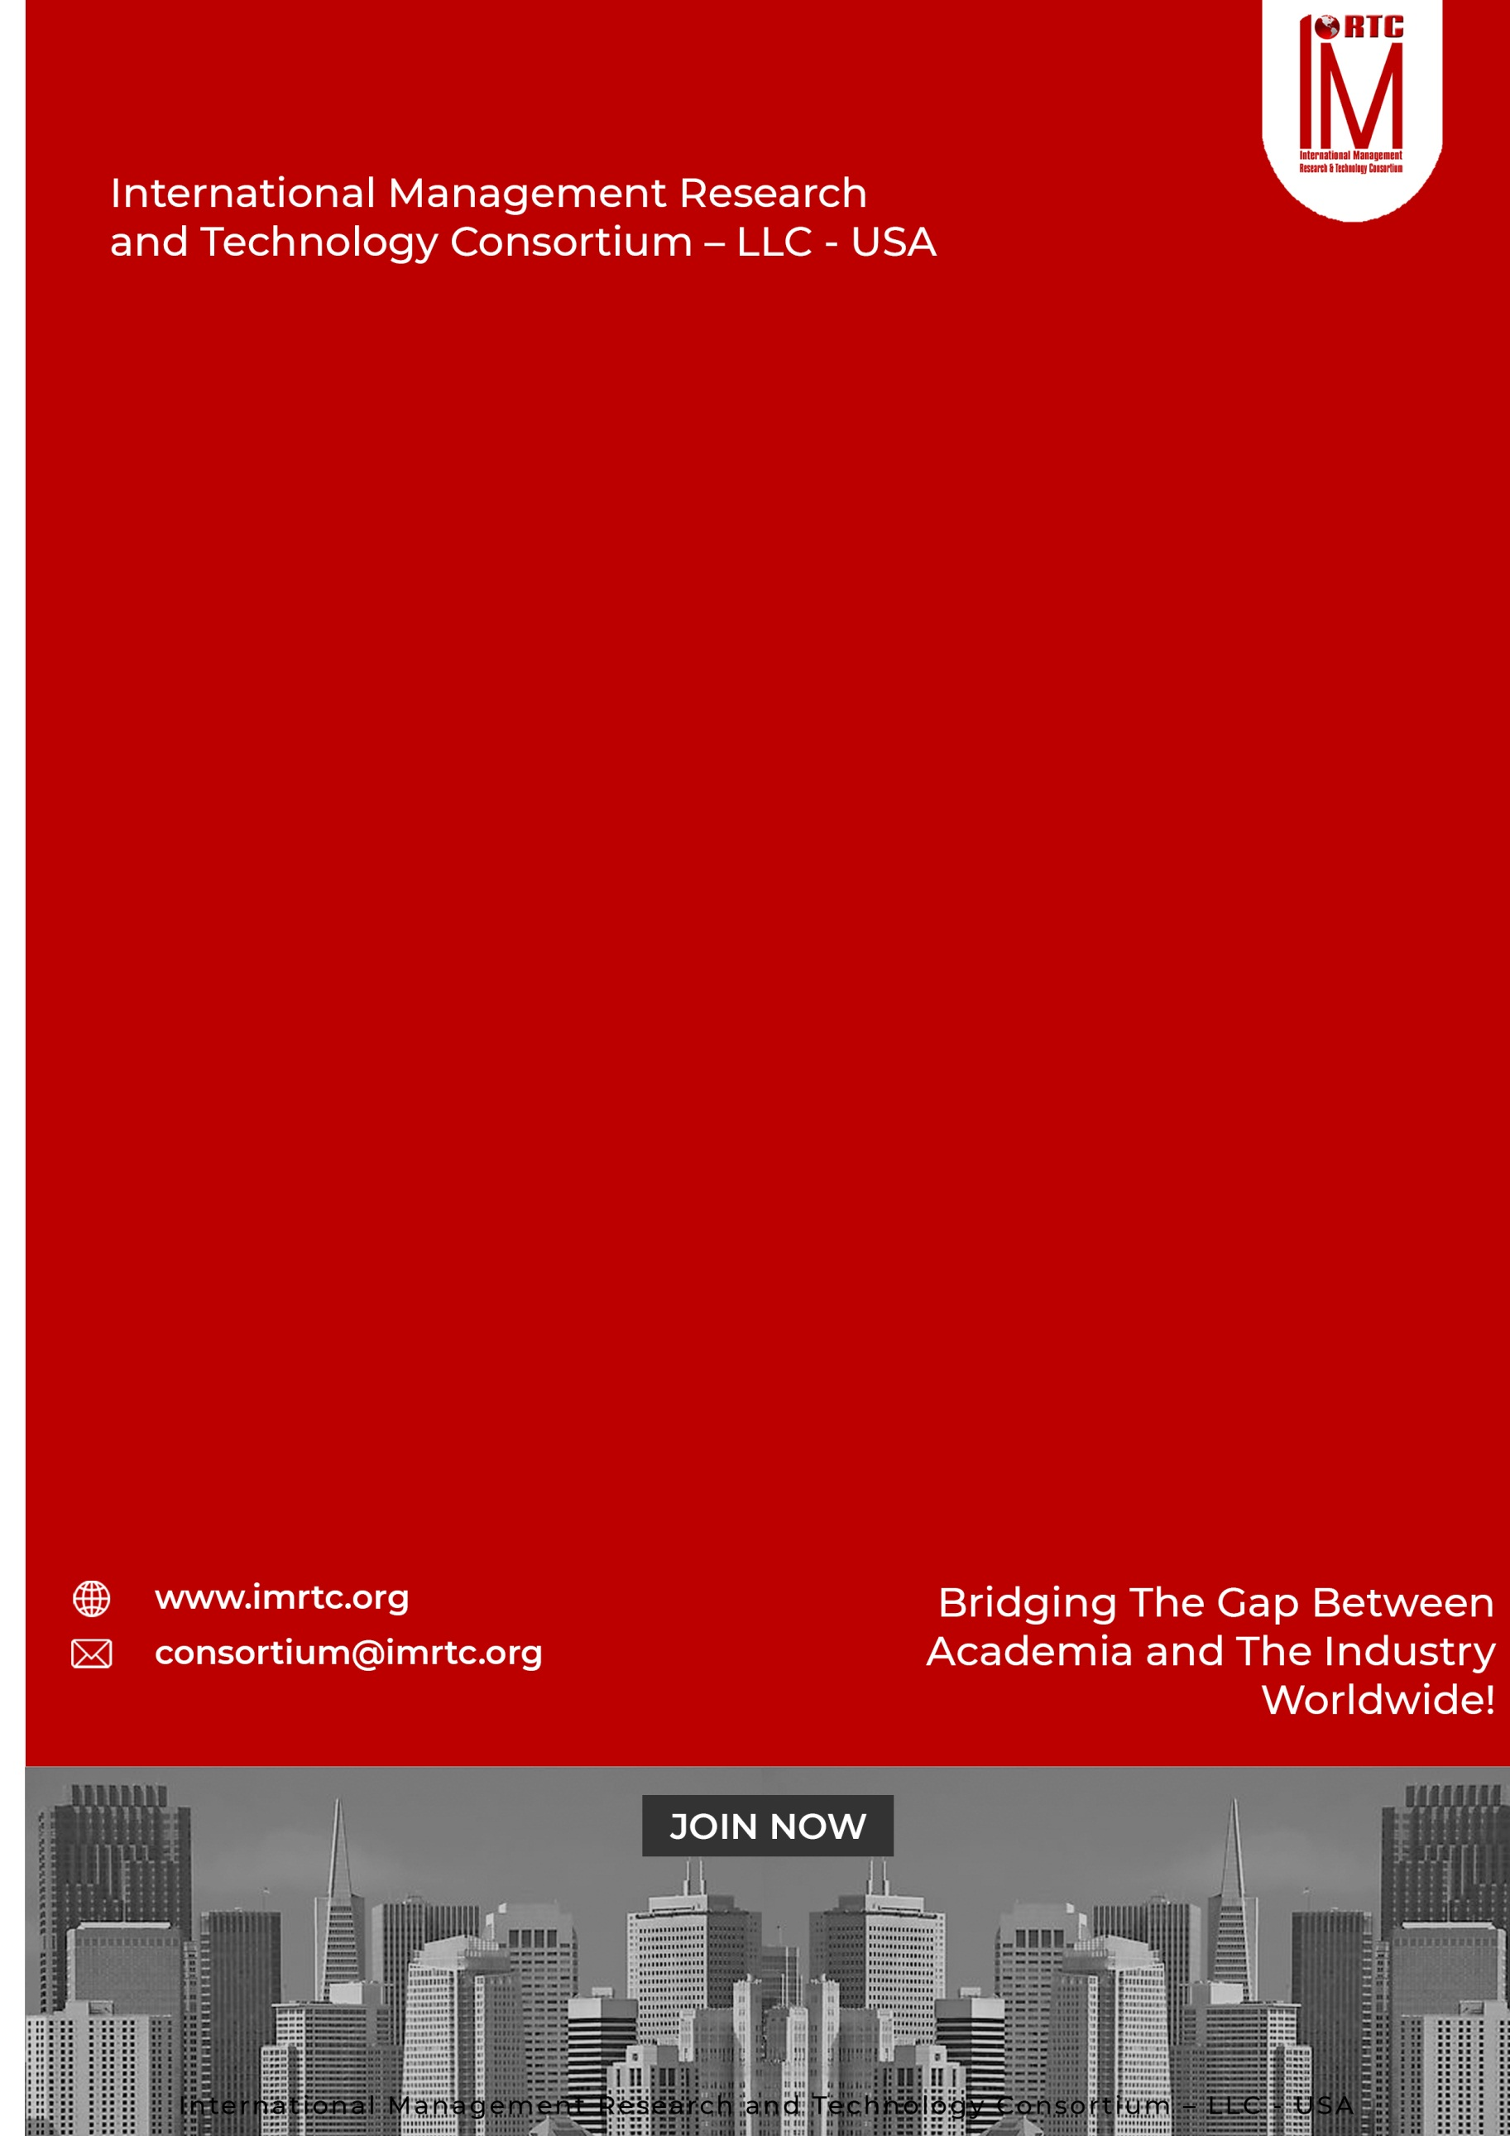
CTMP
CERTIFIED
TECHNOLOGY
MANAGEMENT
PROFESSIONAL

CONTENTS
CERTIFIED TECHNOLOGY MANAGEMENT PROFESSIONAL 2
INTRODUCTION 2
ABOUT CTMP 2
AUDIENCE 2
THE CREDENTIALS 2
PRE-REQUISITE: 2
CERTIFIED TECHNOLOGY MANAGEMENT PROFESSIONAL 2
PROFESSIONAL BENEFITS OF PROGRAM 2
CERTIFIED TECHNOLOGY MANAGEMENT PROFESSIONAL 2
PROGRAM STRUCTURE 2
PROGRESSION OF THE PROGRAM 2
AWARDING OF CTMP CERTIFICATION 2
COURSE CONTENTS 2
DOMAINS AND TASKS 2
KNOWLEDGE AREAS 2
ASSESSMENT OF PROGRAM (ONLINE/PHYSICAL) 2
EVALUATION AND GRADING 2
CTMP ELIGIBILITY REQUIREMENTS 2
REGISTRATION AND PAYMENT PROCESS 2
REGISTRATION PROCESS 2
IMRTC EXAMINATION SYSTEM 2
PARTNER INSTITUTE INTERNAL EXAMINATION SYSTEM 2
IMRTC ONLINE EXAM SYSTEM 2
FEES STRUCTURE 2
TERMS & CONDITIONS RELATED TO EXAMINATION AND CERTIFICATION 2
PROCESS OF CERTIFICATION 2
EXAM CONTENT PERCENTAGE 2
CONTACT DETAILS Error! Bookmark not defined.

Published by
International Management Research and Technology Consortium

IMRTC
Principal Office: P. O. Box 409, 9300 Conroy Windermere, Windermere, FL-34786, USA,

All rights reserved. "imrtc", the imrtc logo, "IMRTC", the CTMP logo, CTMP, CTMP logo "IMRTC”, “and the IMRTC USA are registered marks of IMRTC, LLC.
The IMRTC is a trademark of the IMRTC, LLC.

CERTIFIED TECHNOLOGY MANAGEMENT PROFESSIONAL

CERTIFIED ASSOCIATE IN HUMAN
RESOURCE MANAGEMENT

CERTIFIED ASSOCIATE IN HUMAN
RESOURCE MANAGEMENT

CERTIFIED ASSOCIATE IN HUMAN
RESOURCE MANAGEMENT

INTRODUCTION
There is a global demand of highly competent Technology Professionals, Managers and Head of Departments. Today, organizations are using different sort of technologies and communicating on different scenarios. Where, technology is providing superb facilitations, so it has also required far-reaching management.

In this respect, IMRTC domain Experts designed a comprehensive training certification, which can provide facilitation to the professionals and also provide the structure to maintain and manage the technology in the organization. Therefore, with the consultation of senior executives and professional, and trainers have come up with a comprehensive certification program. THE CERTIFIED TECHNOLOGY MANAGEMENT PROFESSIONAL (CTMP)

ABOUT CTMP
CTMP prepares an information technology generalist who will be able to help the organizations to not only formulate strategic information technology plans but also guide its implementation to operational level.

The Certified Technology Management Professional will serve as the key person to formulate the IT mission and vision, goals and objectives, strategies and actions in line with the corporate mission and vision and will be able to steer the organization smoothly through the transformation and transition processes due to dynamically changing technological environments cost effectively.

The certification will ensure that the individuals are fully aware of and follow the Professional Code of Conduct, are well equipped with the knowledge and understanding of global IT industry and its directions, understand business process development & re-engineering, business intelligence and data analysis, Information security systems and electronic equipment integration with information systems, , change management, IT portfolio and project management, financial budgeting for technology management, global IT management and service management through technology and more. The program follows a systematic learning format with standards and guidelines, audio-visual aids, case studies with real time applications.

AUDIENCE

The certification is most suitable for technology or information technology managers, executives, professionals, consultants, etc. they are eligible to join this program.

THE CREDENTIALS
The Candidates who are looking to have this certification need a proper training of 40 Professional Training Hours (PTH) from any recognized institute and approved professional trainers of IMRTC. The program also required a self-develop project that depends on real cases and complete problems and issues shall be encountered in this project. The project is required in soft form and submitted to our concerned training partners or chapters for assessment and after approval, the candidate can sit in the final examination of IMRTC. After passing the certification examination, the candidates can use the credentials CERTIFIED TECHNOLOGY MANAGEMENT PROFESSIONAL- CTMP with their names.

PRE-REQUISITE:

- 2 Years Bachelor's degree (Baccalaureate, Associate’s degree, or the global equivalent)
- 2 years of professional experience in information technology-related fields for example business intelligence, business analysis, software requirement engineering, software quality assurance, systems engineering, IT risk and security, IT audit, IT sourcing, IT information architecture, etc.
- Basic knowledge of technology infrastructure and management principles.

CERTIFIED TECHNOLOGY MANAGEMENT PROFESSIONAL

CERTIFIED ASSOCIATE IN HUMAN
RESOURCE MANAGEMENT

CERTIFIED ASSOCIATE IN HUMAN
RESOURCE MANAGEMENT

CERTIFIED ASSOCIATE IN HUMAN
RESOURCE MANAGEMENT

PROFESSIONAL BENEFITS OF PROGRAM

For Individuals
- Career advancement into technology leadership roles.
- Improved understanding of how to align technology with business goals.
- Recognition as a certified expert in technology management.

For Organizations
- Assurance of certified professionals with industry-recognized skills.
- Strengthened technology strategy and management capabilities.
- Enhanced ability to adopt and integrate emerging technologies effectively.

CERTIFIED TECHNOLOGY MANAGEMENT PROFESSIONAL

CERTIFIED ASSOCIATE IN HUMAN
RESOURCE MANAGEMENT

CERTIFIED ASSOCIATE IN HUMAN
RESOURCE MANAGEMENT

CERTIFIED ASSOCIATE IN HUMAN
RESOURCE MANAGEMENT

PROGRAM STRUCTURE

Total Domains | 10
Lectures | Lectures can be delivered through partners and trainers
Accredited Trainers | Can Deliver the lectures
One Credit Hour | 10 Learning Hours
Total Credits Required | 4 Credit Hours
Registration Process | Register through our partners / Trainer
Assessment | Online / Paper based
Passing Criteria | 70 percent

PROGRESSION OF THE PROGRAM

Total Credentials = 4 Credit Hours

One Credit Hour = 10 Learning hours

Final Assessment = Online or physical assessment shall be taken by IMRTC Examination Department

AWARDING OF CTMP CERTIFICATION

After getting 70 percent marks from the examination, the candidate will be awarded the CTMP Certification from IMRTC USA.

COURSE CONTENTS

Certified Technology Management Professionals cover theory, process, and professional practices for technology management

DOMAIN 1: PROFESSIONAL CODE OF CONDUCT IN TECHNOLOGY MANAGEMENT
DOMAIN 2: RECRUITMENT, SELECTION & RETENTION OF PROFESSIONALS
DOMAIN 3: INFORMATION TECHNOLOGY MANAGEMENT & STRATEGY
DOMAIN 4: MODERNIZATION OF ORGANIZATION & PLANNING
DOMAIN 5: PORTFOLIO & PROJECT MANAGEMENT
DOMAIN 6: FINANCIAL BUDGETING FOR TECHNOLOGY MANAGEMENT
DOMAIN 7: INFORMATION SECURITY SYSTEMS IN TECHNOLOGY MANAGEMENT
DOMAIN 8: ARTIFICIAL INTELLIGENCE & DATA SCIENCE
DOMAIN 9: GLOBAL INFORMATION SECURITY MANAGEMENT
DOMAIN 10: SERVICE MANAGEMENT THROUGH TECHNOLOGY

0

DOMAINS AND TASKS

In this document, you will find an updated structure for the IMRTC Standard Examination Content. Based on Experience Consultants and stakeholders, we have devised and simplified the format so that the IMRTC Examination System can be easier to understand and interpret.
The domain and task are well-defined on the following pages:
Domain: Defined as the high-level knowledge area that is essential to the practice of CTMP.
Tasks: The underlying responsibilities of the Technology Consultants within each domain area.

CTMP Course examination will include all tasks for a domain and will adhere to the percentage of coverage at the domain level as outlined in the further pages.

KNOWLEDGE AREAS

Domain 1: PROFESSIONAL CODE OF CONDUCT IN TECHNOLOGY MANAGEMENT
Task 1 | Applied Professional Code of Conduct  Ethical Responsibilities  Core Endemic values in professional world
Task 2 | Ethics in Technology, Businesses Management & Law  Failures for selection of wrong frameworks in organization
Task 3 | Intellectual property rights, government regulations, privacy, information  security and cybercrime

KNOWLEDGE AREAS
Domain 2: RECRUITMENT, SELECTION & RETENTIONS OF PROFESSIONALS
Task 1 | Policies with relates to hiring of Technology Professionals
Task 2 | Strategic Organogram for Technical Skilled Professionals
Task 3 | Retention of Technology Professional  Promotional Policies
Task 4 | Career Plans for technical Staff  Job Description according to strategy
Task 4 | Separate Appraisal Systems for technologists
Task 5 | Setting of Key Performance Indicators  Physical and Electronic Security Awareness

KNOWLEDGE AREAS
Domain 3: INFORMATION TECHNOLOGY MANAGEMENT & STRATEGY
Task 1 | Introduction to Managing Technology  Selection of Appropriate Hardware & software
Task 2 | Managing Datacenters  Managing Power Systems  Selection of Software, ERPs and CRMs
Task 3 | Managing Operating System & Policies  SDLC with respect to Methodology, Technology and its Management  Managing Applications, Requirements and its Policies
Task 4 | Managing Change in uncovered requirements in Applications or infrastructure  Managing & Defining business rules  Managing Documentations & Tools
Task 5 | Translating business rules and requirements into technical requirements
Task 6 | Managing Storage  Managing Web Applications  Managing Cloud Applications
Task 7 | Managing Networks and Policies  Managing Remote Users and Servers  Managing Intranet, Extranets  Managing Disasters in Technology & Impact on Businesses

KNOWLEDGE AREAS
Domain 4: MODERNIZATION OF ORGANIZATION & PLANNING
Task 1 | Developing Future Strategies regarding Technology  Technology Enhancement with respect to Business Plans
Task 2 | Data Management & Custodians  Other Electronic Systems Integration & Monitoring
Task 3 | Access Control Systems  Integration of Business Modules & Policy Making
Task 4 | New Goals of Organization & Resource Management of Technology  Short & Long terms Plans with respect to Technology  Business Process Re-engineering techniques & its Management

KNOWLEDGE AREAS
Domain 5: PORTFOLIO & PROJECT MANAGEMENT
Task 1 | Introduction to Portfolio, Program & Project Management
Task 2 | Life Cycle Management in Technology  Organization’s Goals and its Project Planning
Task 3 | Project Execution, Monitoring & Implementation with respect to Technology  Project Procurements and Justifications

Domain 6: FINANCIAL BUDGETING FOR TECHNOLOGY MANAGEMENT
Task 1 | Developing Budgets according to Projects & Business Goals  Usage of Project Costing Methods
Task 2 | Financial Management of Projects  Financial Requirements according to Projects  Developing Processes for the usage of Budgets
Task 3 | Financial Audits with respect to Projects  Systematic Closing Structures of Project and Its financial implications

KNOWLEDGE AREAS
Domain 7: : INFORMATION SECURITY SYSTEMS IN TECHNOLOGY MANAGEMENT
Task 1 | Developing Information Security Policies for Technical Infrastructure  Defining Roles and Duties concerning Infrastructure
Task 2 | Implementing Information Security Systems according to recent guidelines and standards
Task 3 | Information Security Systems in Physical Access  Information Security Systems in Logical Access  Information Security Systems in Environmental  Information Security Systems in Networks  Knowing of Threats, vulnerabilities, and Cyber Crimes through technology  Knowing of Forensics of Technologies using in Organizations

KNOWLEDGE AREAS
Domain 8: ARTIFICIAL INTELLIGENCE & DATA SCIENCE
Task 1 | Introduction to Artificial Intelligence  Introduction to Data Science
Task 2 | Usage of AI & Data Science in organizations  Using of Business Intelligence in Competitive Intelligence in Organizations
Task 3 | Customer Relationship Management  Data warehousing  Data-Marts
Task 4 | Modeling Techniques  Usage of AI Tools in the organization  Prompt Engineering with AI and BI

KNOWLEDGE AREAS
Domain 9: : GLOBAL INFORMATION SECURITY MANAGEMENT
Task 1 | Global Organizational issues of Information Security
Task 2 | Impact of Globalization & Internationalization
Task 3 | Organizational Cultures & Issues
Task 4 | Cyber Crime Laws & Issues
Task 5 | Technological Architecture, Strategy, Frameworks, Standards, and Controls  Managing International Legal Issues

KNOWLEDGE AREAS
Domain 10: BASIC SERVICE MANAGEMENT THROUGH TECHNOLOGY
Task 1 | Concept of Service Management in the organization  Managing Mission, Vision & Goals of the organization through Service Management
Task 2 | Managing Services, Portfolios and Catalogs  How Technology as Service  Integration of technology and services
Task 3 | Handling Issues, problems and SOPs with regard to Services through technology  Using Standard & Guidelines through Service Management Techniques

ASSESSMENT OF PROGRAM (ONLINE/PHYSICAL)

- The exam paper will be online/physical as per the choice of the candidate, but it is preferable to give the exam online.
- The exam paper will cover the above topics domain-wise.
- The Passing marks will be 70%.
- Internal Marks can be adjusted in the final marks through accredited trainers by obtaining prior permission from our Examination Department of IMRTC.
- Those candidates who cannot be able to give online tests due to online facility. So they are allowed paper-based examinations. Otherwise, the partner must arrange the center for the online exam as per the guidelines of the Examination Department
- Assessment will be done according to the domains and tasks mentioned above through our online methodology

EVALUATION AND GRADING
- The student will be examined through exams conducted by IMRTC LLC USA. Total marks for passing the CERTIFICATION/DIPLOMA will be 70 out of 100.

CTMP ELIGIBILITY REQUIREMENTS
To be eligible for the Certified Technology Management Professional for any level, the candidates must have a 2-year Bachelor's degree pass or equivalent with no experience. The candidate should have to submit the credentials
Educational Background | Accredited Training
2 Bachelor degree Passed or Equivalent (Baccalaureate, Associate Degree or Global Equivalent) | 4 PTH Training must be earned from any accredited trainer or any partner institute
Professional Experience | Certification/Diploma
2 years of Professional Experience Required | After completing all the formalities and passing the test, will get the certification or diploma

REGISTRATION AND PAYMENT PROCESS

REGISTRATION PROCESS
Registration of the program is to be completed through our registered partners and if the partners are not available in your city or country then you can download this registration form and submit the fee in our bank account directly and wait for the email or contact from our Registration or Examination Department. For further information to our examination department contact at registration@imrtc.org.

IMRTC EXAMINATION SYSTEM
CERTIFIED TECHNOLOGY MANAGEMENT PROFESSIONAL

PARTNER INSTITUTE INTERNAL EXAMINATION SYSTEM

The concerned partner/institute/trainer will take examinations online and submit to the International Management Research and Technology Consortium Examination Department.

IMRTC ONLINE EXAM SYSTEM

IMRTC will provide access to all partners to schedule the exams of the particular courses of any individual candidates. Therefore, according to the availability, the partner institutes will schedule the exam of individual candidates’ subjects or courses/certifications.
S. No | Description | Fees
1. | Membership Fee | USD 50
2. | Examination Fee  For Members | USD 460
3. | Examination Fee  For Non Members | USD 660

FEES STRUCTURE
CERTIFIED TECHNOLOGY MANAGEMENT PROFESSIONAL
To get the certification, 40-Professional training hours as PTH is mandatory from any concerned professional trainer or Partner, and participants should have to submit their training PTH with the Examination Application Form with the attachments of required qualifications and other experience certificates/letters. The Paper is based on 100 Questions with MCQs and 70% passing marks is required to pass the exam. Further, if the Project is also included in your exam, marks will be distributed according to course & certification.

TERMS & CONDITIONS RELATED TO EXAMINATION AND CERTIFICATION
- The 40-Training-hours as PTH are valid up to one year.
- If the candidate is failed in the examination then S/he has one more chance to attempt the paper within a year, and if the candidate cannot pass, then they have to pay the examination fee and re-appear in the examination.
- If the candidate has not passed the examination within one year and after sometime S/he would like to appear in the examination then candidate must to resubmit 40-Professional-Training-hours as PTH again required to appear in the examination.
- The examination system is online and candidate can book the exam anytime according to his or her availability.
- Those countries, who do not have the facility of online examination facility then they can give the paper based examination, which can be sent to authorized partner / trainers / examiner. The assessment time will be a month and we will be sent the results to concerned partner.
- The candidate will get the certificate within one month and administration will sent to the concerned partners.
- To maintain the worth and eligibility in the market, the candidate must have to renew their membership on yearly basis.

PROCESS OF CERTIFICATION
CONTENT | DOMAIN WISE PERCENTAGE
DOMAIN I | 5%
DOMAIN II | 10%
DOMAIN III | 15%
DOMAIN IV | 15%
DOMAIN V | 10%
DOMAIN VI | 7%
DOMAIN VII | 12%
DOMAIN VIII | 13%
DOMAIN IX | 5%
DOMAIN X | 8%

EXAM CONTENT PERCENTAGE
The table below prescribes the proportions of examination questions from each section or Knowledge Areas defined above. The exam will be based on multiple choice questions, fill in the blanks and letter writing.

CONTACT DETAILS

ADDRESS Principal Office: P. O. Box 409, 9300 Conroy Windermere, Windermere,
FL-34786, USA,

TELEPHONE (+1) (689) 276-4636
Web https://www.imrtc.org
EMAIL consortium@imrtc.org

SOCIAL MEDIA ACCOUNT
Facebook https://www.facebook.com/IMRTConsortium/
LinkedIn https://www.linkedin.com/company/imrtc
YouTube https://www.youtube.com/channel/UCE_GYVI4WJMKIUXQhouA4LA

INTERNATIONAL MANAGEMENT RESEARCH AND TECHNOLOGY CONSORTIUM
USA LLC L24000411080

