1. Login (All User)

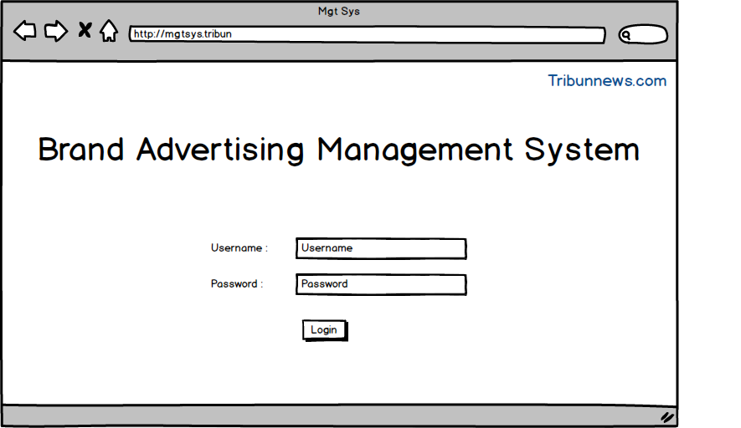

User :

* Admin
* Sales
* Marketing
* Design
* Head of Advertising

1. Admin

* Login
* Homepage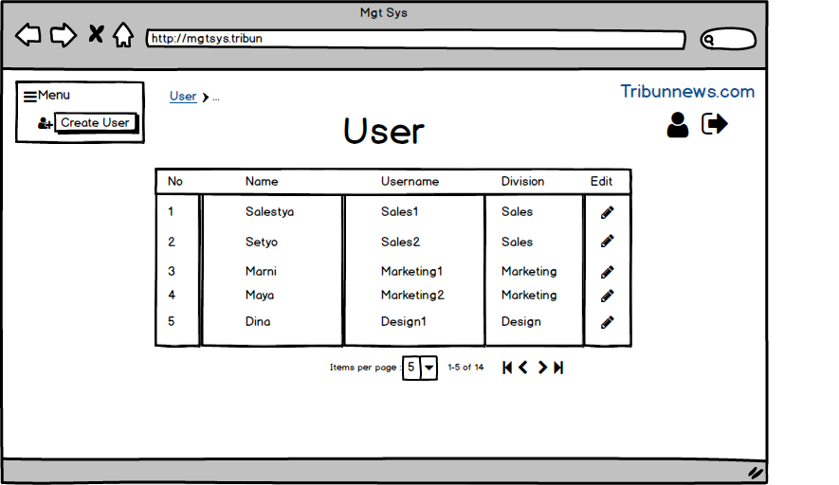
* Create UserEdit/Delete User

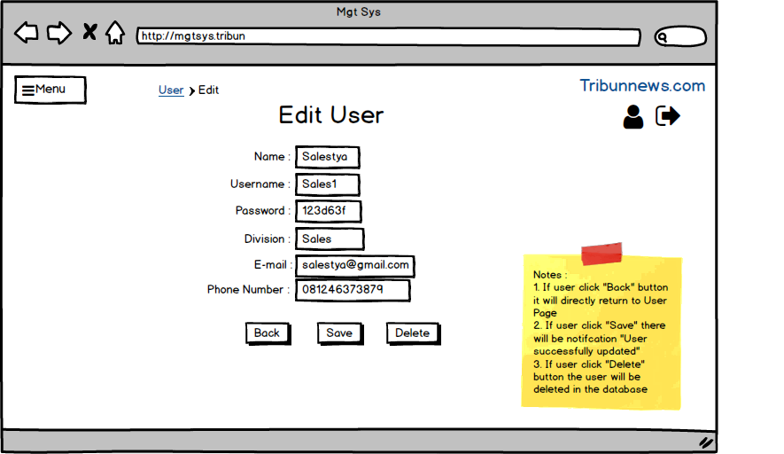

* Detail User

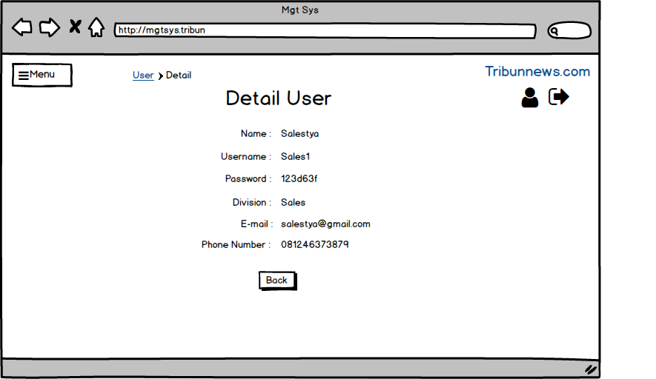

1. Sales

* Login
* Homepage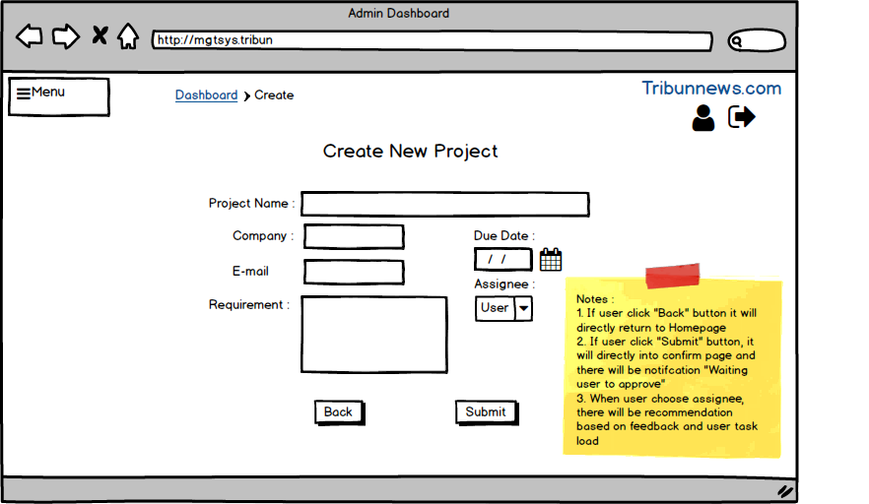
* Create Project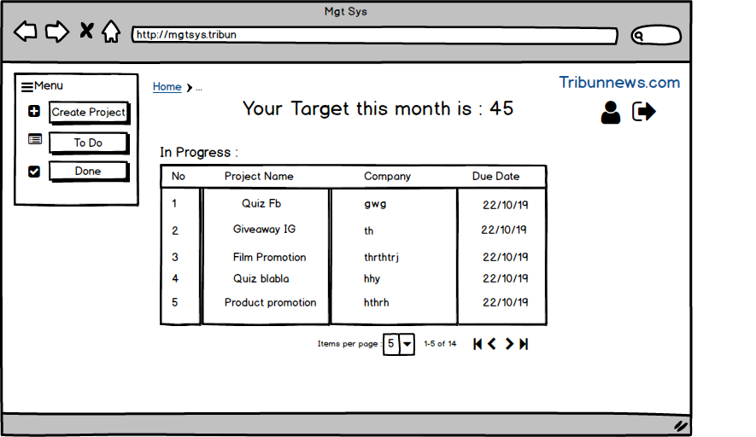

1. Marketing

* Login
* Homepage
* Add Content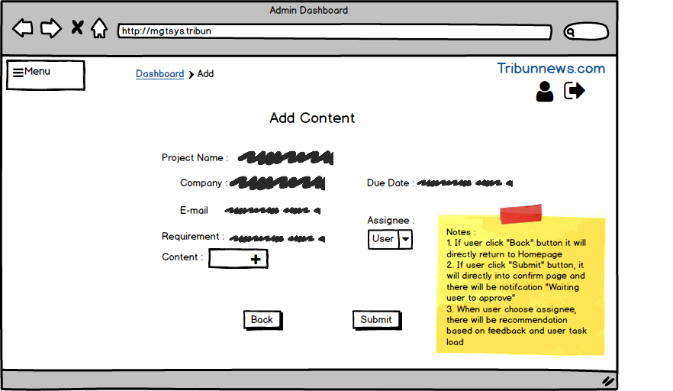

1. Design

* Login
* Homepage
* Add Media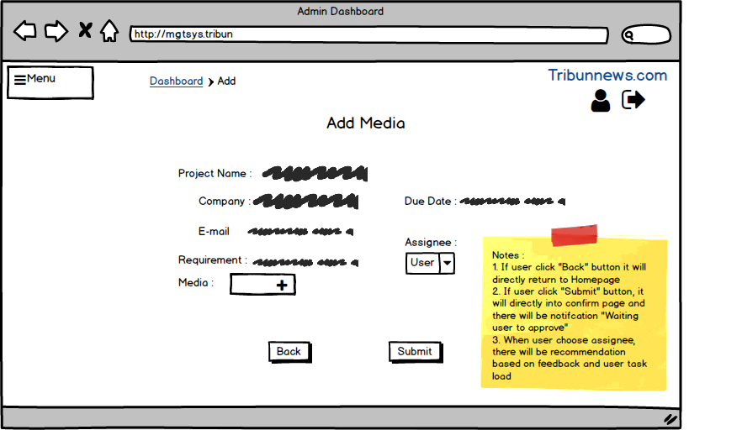

1. HoA

* Login
* Homepage (Approve/reject user)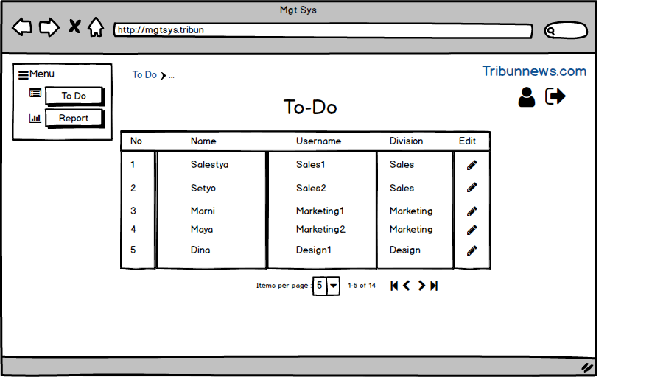
* Report