No | Nama Cake | Ukuran | Harga | Gambar
 | Almond Tree | Alamat: Jalan Margonda Raya No. 27, Pondok Cina, Beji, Pd. Cina, Beji, Kota Depok, Jawa Barat 16424  Telepon: (021) 29436561  Jam buka:  Hari ini buka · 07.00–23.00
 | Salted Caramel Cheesecake | D 20cm  20x30cm | 280.000  420.000 | 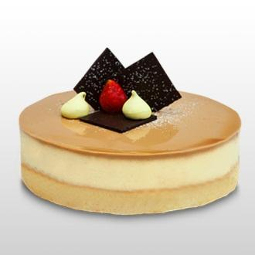
 | Opera | 20x20cm  20 x 30 cm | 290.000  420.000 | 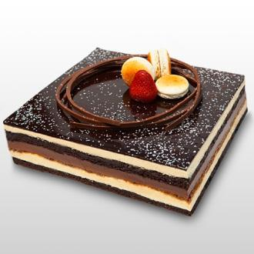
 | Chocolate Royaltine | D 20cm  20 x 30 cm | 300.000  450.000 | 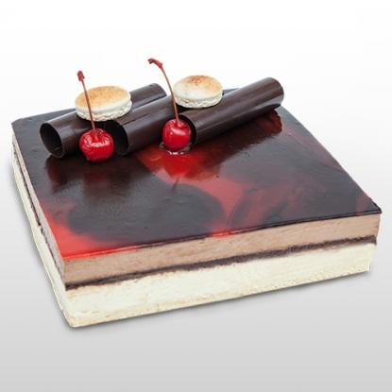
 | Harvest | Alamat: Jl. Margonda Raya No.295, Depok, Beji, Kota Depok, Jawa Barat 16431  Telepon: (021) 77216200  Jam buka:  Hari ini buka · 08.00–22.00
 | Opera | 20 x 20 cm  20 x 30 cm | 290000  420000 | 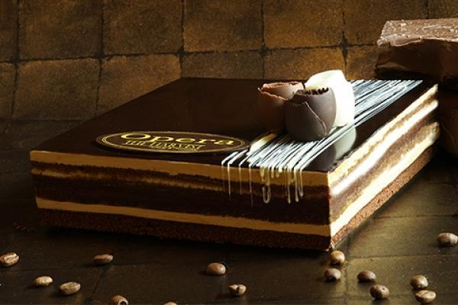
 | Blueberry Cheesecake | 20 x 20 cm  20 x 30 cm | 310000  450000 | 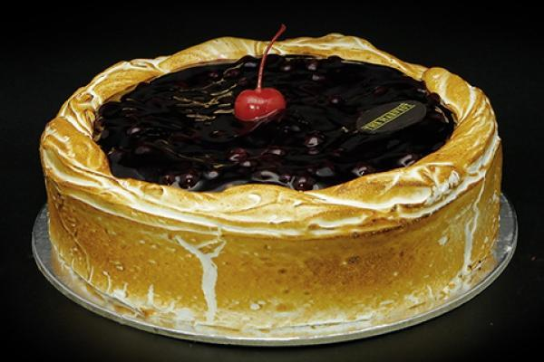
 | Mix Fruit Cheese | 20 x 20 cm  20 x 30 cm | 310000  450000 | 