**Citation:**Vanausdall RA, Dinsmore SJ (2020) Detection and density of breeding marsh birds in Iowa wetlands. PLoS ONE 15(1): e0227825. <https://doi.org/10.1371/journal.pone.0227825>

**Original Figure:**

**Fig 2. Densities (birds/ha) of breeding marsh birds across shallow lakes surveyed in the Prairie Pothole Region of Iowa, summer 2016 and 2017.**

Sites are divided into non-restored, younger (1–5 years since restoration), and older (6–11 years since restoration) shallow lakes. Vertical error bars represent 95% confidence intervals.

**Commentary:**

This figure depicts variation in the densities of 7 focal breeding marsh bird species among sites of varying restoration age (not restored, recent restoration, and older restoration). These densities are obtained from estimates of marsh bird abundances at 31 sites calculated using an abundance modeling framework (i.e. accounting for imperfect detection). I think that figure makes good use of space and the minimalist design is visually appealing. However, I think that the y-axis scale could be modified to allow for easier visual comparison among densities of rarer species. I also think that, while comparing within a species is biologically relevant, it would also be relevant to additionally assess the relative abundances of species within the communities at each site. Though clearly a self-imposed restriction due to figure charges, I also think a color figure would be more visually appealing.

**Updated Figures:**

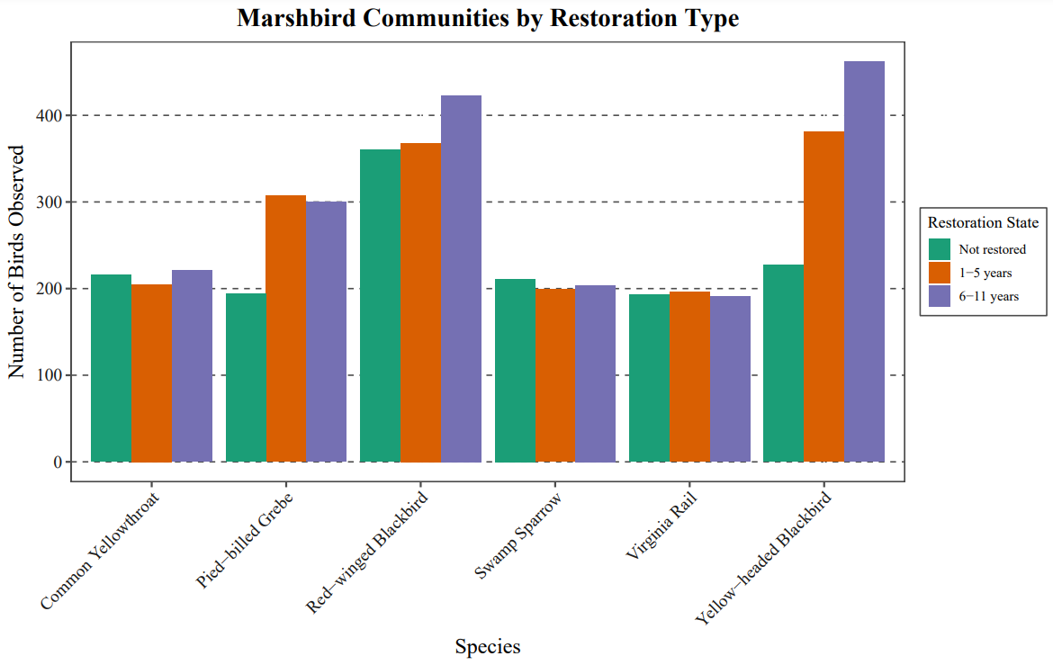

For my first attempt at altering the figure, I tried depicting the raw data with side-by-side bar graphs. I added color of the restoration state variable and reordered the species names on the x-axis to alphabetical order. I added a title and placed the legend outside of the figure, and also added gridlines to the y axis to facilitate comparisons between species counts. I also changed the levels of the restoration state variable to make them more specific (I didn’t think younger and older were descriptive enough).

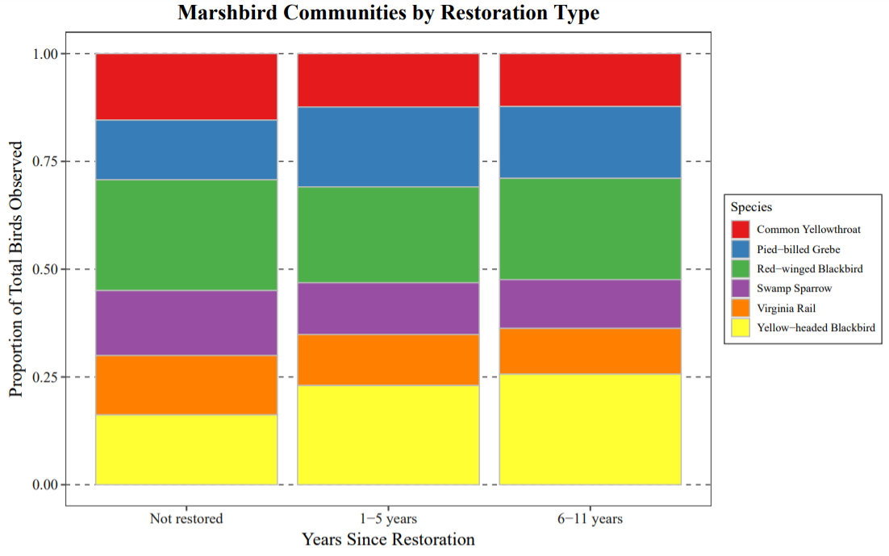

For my second attempt at altering the figure, I tried depicting the proportions of counts of each species with stacked bar graphs. I placed the restoration state variable on the x axis to reduce the number of levels and colored each species using the “Dark2” colorbrewer pallete. Finally, I added a title and placed the legend outside of the figure.