**Citation:**Correll, M. D., W. Hantson, T. P. Hodgman, B. B. Cline, C. S. Elphick, W. Gregory Shriver, E. L. Tymkiw, and B. J. Olsen (2019). Fine-Scale Mapping of Coastal Plant Communities in the Northeastern USA. Wetlands 39:17–28.

**Original Map:**

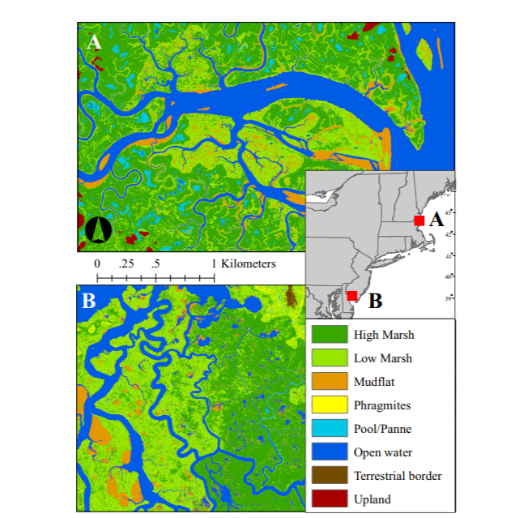

**Commentary:**

This two-panel figure maps marsh landcover types of two tidal marshes in the northeastern US. I like the depiction of the two marshes as well as the inset figure showing where the marshes are located. However, I think that the organization of the inset figure and the legend (as well as the scale bar) gives the map a bit of a clunky feel visually overall. In general, I think the colors selected for the map make sense, but I was a bit concerned over the use of green in the map from a figure accessibility viewpoint (particularly because the two greens are the most prevalent cover types in the figure). One other concern that I had with the figure was that the latitude and longitude of each marsh depicted is not readily apparent. Overall, I think this is a very compelling figure.

**Updated Map:**

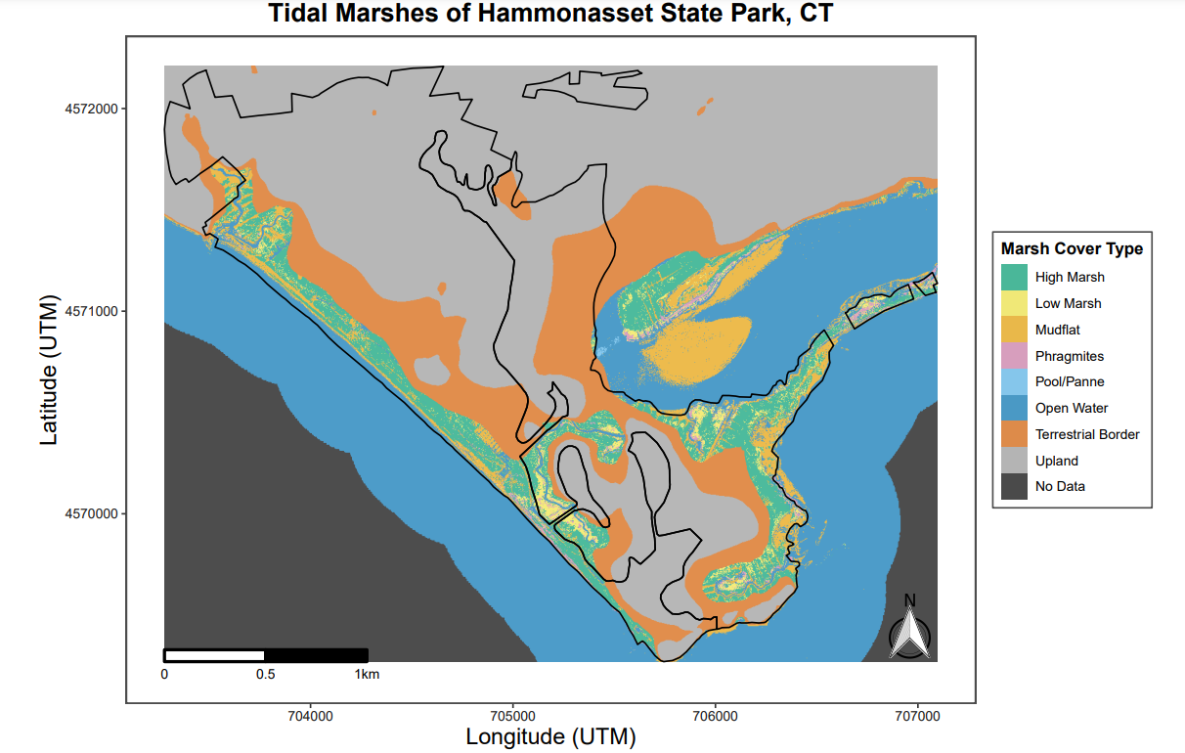

Because I was pleased with the published figure, I attempted to make a similar figure for another northeastern tidal marsh property, Hammonasset State Park, with some slight modifications. I chose to add the latitude and longitude of the location on the map and overlaid a shapefile depicting the boundaries of two properties that jointly make up the tidal marsh parcel (accessed from a publicly available databased curated by DEEP). I modified the color scheme for the cover type fill and used a color-blind friendly palette and used different styles of scale bar and north arrow because I thought they looked more aesthetically pleasing. I also decided against including an inset of the property location on a larger map to make the figure a little less cluttered and moved the figure legend to the side of the figure rather than on top of the figure.

**Updated Map Variant 2:**

I attempted to create an additional representation of the marsh cover of Hammonasset State Park using Google Map imagery as a base map with the marsh landcover types of Hammonasset overlaid. However, I ran into projection issues. Upon further research (http://rstudio-pubs-static.s3.amazonaws.com/16660_7d1ab1b355344578bbacb0747fd485c8.html), I found that the map projection used in Google Map tiles is a “PseudoMercator” projection that is not widely used. I attempted to reproject the raster imagery that depicts marsh landcover types but had trouble reprojecting it to the same projection used in my desired base map. After multiple attempts I was unable to produce this second map variant with any success.