**Citation:**Darras, K., B. Furnas, I. Fitriawan, Y. Mulyani, and T. Tscharntke (2018). Estimating bird detection distances in sound recordings for standardizing detection ranges and distance sampling. Methods in Ecology and Evolution 9:1928–1938.

**Original Figure:**

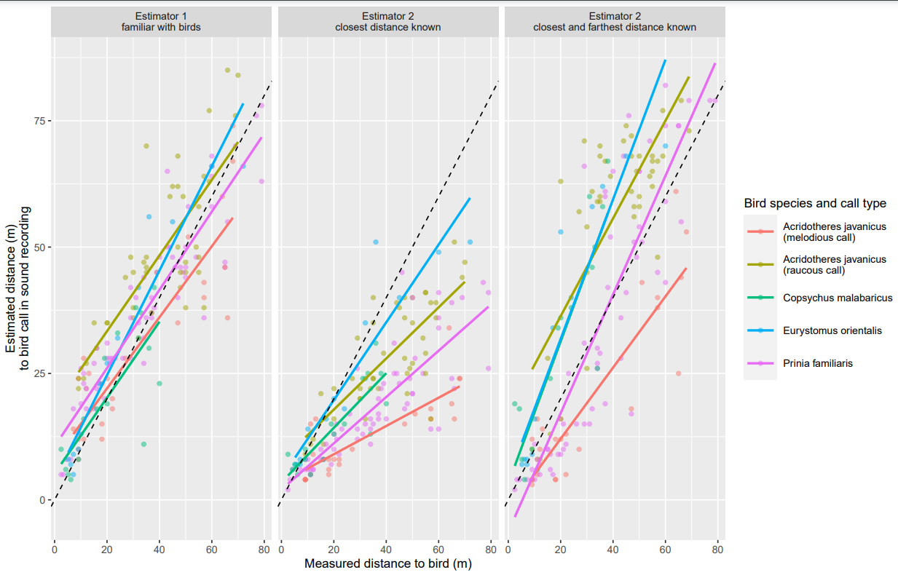

**Figure Commentary:**

This figure from Darras et al. 2020 depicts the relationships between true (known) bird distances and bird distances estimated by listeners reviewing sound recordings collected by autonomous recording units (ARUs). The figure does a good job presenting the data as is, but some slight modifications can be made to improve the overall style of the figure. Of note, the color palette the authors used does not appear to be color-blind friendly, the style of the figure could be updated by modifying the legend and grid lines, and there could be an increase in graphical redundancy to aid the reader in their understanding of the figure.

**Updated Figure and Commentary:**

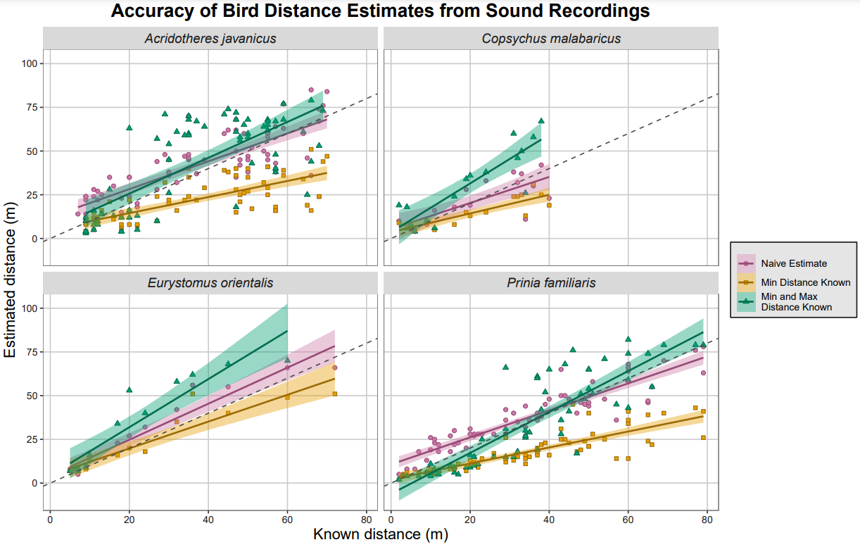

**I first modified this figure by changing the grouping variable: instead of displaying all species on a single plot and generating a separate plot for each estimate type, I displayed all estimate types for a single species on a single plot and then generated a separate plot for each species. This approach seems to enforce the message that the authors are trying to convey: knowledge of the minimum or maximum distance at which a bird can be observed influences the distance estimate made by the observer. I changed the color palette to something more color-blind friendly, increased the graphical redundancy by using both shapes and colors to represent the data, added confidence intervals to trendlines to represent uncertainty, and changed the fonts on the figure to improve legibility.**