COLLEGE OF COMPUTING AND INFORMATION SCIENCES
School of Computing and Informatics Technology

Field Attachment Report 2012/2013

OMNITECH LIMITED

Ninsiima Flavia Delmira
10/U/1382
210000613

A Field Attachment Report Submitted to the School of Computing and Informatics Technology in Partial Fulfillment of the Requirements for the Award of the Degree of Bachelor of
Science in Computer Science Of Makerere University.

August, 2013

DECLARATION
I Ninsiima Flavia Delmira hereby declare that this Field Attachment Report is original and has not been published and/or submitted for any other degree to any other University before.

Signature: _________________________ Date: ___________________
Student:
Ninsiima Flavia Delmira
BSc. CS III

Signature: _________________________ Date: ___________________
Field Supervisor:
Mr. Victor Kakama

Signature: _________________________ Date: ___________________
Academic Supervisor:
Mrs. Doreen Tuheirwe Mukasa

Acknowledgement

I acknowledge the efforts of all those who have enabled the successful accomplishment of this field study. To my employer and fellow employees at Omnitech Limited, for your hospitality and guidance, I am grateful. To my fellow colleagues, with whom internship experiences were exchanged, thank you for the great collaboration. Lastly, to my supervisor Mrs. Doreen Tuheirwe Mukasa, I am truly grateful for your direction and guidance.

List of Appendices
APPENDIX A 11
APPENDIX B 13
APPENDIX C 16
APPENDIX D 23
APPENDIX E 27

List of Abbreviations

CASE | Computer Aided Software Engineering
Ltd | Limited
ICT | Information and Communications Technology
NGO | Non-Governmental Organization
CEO | Chief Executive Officer
IT | Information Technology
SMS | Short Message Service
PHP | Hypertext Preprocessor/Personal Homepage
HTML | Hypertext Markup Language
CSS | Cascading Style Sheets
SQL | Structured Query Language
SVG | Scalable Vector Graphics
SEO | Search Engine Optimization
SERP | Search Engine Results Page

Executive Summary
The aim of Industrial training is to expose university students to the world of the IT industry. Within this period of time, students are expected to note down the activities undertaken at an organization in weekly journal and write a Field attachment report at the end of the period. This report is an account of my experience that occurred between June 3rd and August 9th at Omnitech Limited, a software development company in Kampala, Uganda. I was assigned tasks in line with the operations of the organization such as web training, java programming and system administration.
Amidst various challenges, I was able to learn and experience a great deal from the company such the use of CASE tools, extended knowledge of available programming languages. All of these was both challenging and rewarding and gave me a positive and healthy outlook towards the software development field.

Table of Contents
Field Attachment Report 2012/2013 i
DECLARATION ii
Acknowledgement iii
List of Appendices iv
List of Abbreviations v
Executive Summary vi
Table of Contents vii
Section 1: Introduction 1
1.1 Introduction 1
1.2 Profile of Omnitech Limited 2
1.2.1 About Omnitech Limited 2
1.2.2 Mission 2
1.2.3 Vision 2
1.2.4 Aims and Objectives 2
1.2.5 Organizational Structure of Omnitech Limited 2
1.3 Functions of Omnitech Limited 2
1.4 Ongoing IT projects 3
Section 2: Field Attachment Activities 4
2.1 Orientation 4
2.2 Web Training 4
2.2.1 PHP Revision 4
2.2.2 Development of an Omnitech website 5
2.3 Java Programming 5
2.3.1 Linked Lists in Java 5
2.3.2 Fractals in Java 6
2.4 Google Ads, Facebook Ads and Search Engine Optimization 6
2.5 System Administration 6
Section 3: Challenges and Emerging issues/Discussion of Experiences 8
3.1 Achievements 8
3.2 Challenges 8
Section 4: Conclusion and Recommendations 10
4.1 Recommendations 10
4.2 Conclusion 10
APPENDIX D 23
APPENDIX E 27
GOOGLE ADVERTISEMENTS (GOOGLE ADS) 27
Steps on how to get an advertisement running on Google 27
Facebook Advertisements 28
Steps on how to get and advertisement running on facebook 28
Search Engine Optimization (SEO) 29
Planning for SEO 29

Section 1: Introduction

1.1 Introduction
This report accounts for the industrial training that occurred at Omnitech Limited from 3rd June to 9th August. Internship is integrated into the Makerere University curriculum to expose students to the outside world of the field they are interested in becoming professionals in. Students are encouraged to apply to organizations of their interest. A member of staff at the organization is to become the students’ field supervisor and a member of staff at the university visits the student at the organization to get an account of both of their views about each other.
When I was granted an internship placement at Omnitech, I met the CEO for orientation. Though I was to be the only intern present at the company, I was to be offered a lot of assistance by the employees in my duties in case I happened to get stuck.
Within two months, I was to learn a series of things related to IT e.g. web development, software development, system administration. I was given assignments related to these which were later reviewed for assessment.

1.2 Profile of Omnitech Limited

1.2.1 About Omnitech Limited
Omnitech Ltd is an ICT services and consultancy firm with staff having over 8 years’ experience in bringing Information and Communication Technology (ICT) solutions to all those who need them. The company works with communities, NGOs and Government agencies to deliver innovative, affordable and sustainable ICT solutions that transform business processes. It has established a reputation for exceptional work at all stages of its services and product development, delivering results that address crucial customer needs.

1.2.2 Mission
To be a market leader in providing new ICT solutions in the region

1.2.3 Vision
To simplify business through innovations

1.2.4 Aims and Objectives
To apply and to uphold the core values of:
- Professionalism and excellence in service delivery
- Honesty, integrity and transparency in dealings with everyone
- Trust and respect with stake holders, customers, suppliers, staff, shareholders and the community.
- Commitment to timely, quality and explicit work to ensure customer satisfaction

1.2.5 Organizational Structure of Omnitech Limited
- Chief Executive Officer (Mr. Peter Wakholi Khisa)
- Technical Director in charge of Services (Mr. Victor Kakama)
- Technical Director in charge of Products development (Mr. Ronald Kayondo)
- Web and Software Development (Mr. Albert Apollo Kalibbala)
- Administration (Ms. Milly Nabulya)

1.3 Functions of Omnitech Limited
Omnitech Limited provides the following services to its clients:
- Web Development
- Software Development
- ICT Consultancy Services
- Web Hosting
- Mobile Applications
- Business Support

1.4 Ongoing IT projects
Ongoing IT projects at Omnitech Ltd include:
- Mobile for water
- Nyonza SMS
- Kenga System

Section 2: Field Attachment Activities

2.1 Orientation
The orientation was scheduled for 5th of June. I met the CEO Mr. Peter Khisa Wakholi at their former offices located in plot 25, Kira road Kamwokya. I was informed by Mr. Khisa that their computers were stolen over the Martyrs Day weekend and that as a result, I would probably start the internship the following week on Monday 10th of June. I was requested to return then.
Upon my return on June 10th, I met with the company employees. Mr. Victor Kakama was to be my Field Supervisor. We discussed possible IT areas that would be of interest to me. I mentioned that I would have liked to learn as much as possible during my internship there.
I was given the outline for my internship as follows:
- Web Training
- Java Programming
- System Administration
With the outline given, I proceeded with the task of Web Training under the supervision and guidance of Kalibbala Apollo Albert, the web and software developer at Omnitech Ltd.

2.2 Web Training
My first task was to install a Content Management System namely Drupal 7.0 as this is the software that Omnitech Ltd uses to design all of its websites. With this done, I was advised to first acquaint myself with Hypertext Preprocessor i.e. PHP, since Drupal is written in PHP.

2.2.1 PHP Revision
I expanded my knowledge of PHP through online tutorials and exercises from websites such as
- www.homeandlearn.co.uk
- www.codecademy.com
- http://w3schools.com
to mention but a few. PHP being a widely used web scripting language that is conjunctively used with Hypertext Markup Language (HTML), Cascading Style Scripts (CSS) and My Sequel (MySQL), I was further tasked to revise these three. This was done through tutorials and exercises in the aforementioned websites.
Not only did I delve into PHP, I delved further into an advanced form of the language known as Object Oriented PHP (OO PHP). It was necessary to move away from just basic PHP and learn some advanced PHP because Drupal is written in advanced PHP.
With the revision being done, I was given my first assignment. It was to write a PHP script (see Appendix B) that involves manipulation of a file on a server called bearerbox_server.log and use inbuilt PHP functions regarding regular expressions. This script is useful in that a Telecommunications company can acquire the sender, receiver, and date, time and command status of a communication that transpired. The server used was WampServer Version 2.2. Macromedia Dreamweaver and Notepad ++ were interchangeably used to write PHP scripts.

2.2.2 Development of an Omnitech website
My second assignment involved using Drupal modules to develop a prototype of a website for Omnitech (screenshots can be viewed in Appendix A). Modules can be thought of as components of functionality that can be added to the core modules embedded in Drupal so as to increase functionality. Core modules are necessary for Drupal to work and are hence included in the software. In order to maintain flexibility in terms of size of the software, none-core modules are only added when the developer wishes to do so. (See Drupal documentation at https://drupal.org/documentation)
In order to familiarize myself with Drupal, I experimented with multiple modules such as
- Views (for creation customized lists and queries from database)
- Panels (To work with manipulation of panels and blocks)
- Webform (for creation of forms and questionnaires)
among others. In addition, I searched for and viewed various tutorials to acquaint myself with the software e.g. Master Drupal in 7 hours by Tuthanh Le.
Currently, Omnitech has a website with the Uniform Resource Locator (URL) http://www.omnitech.co.ug/

2.3 Java Programming
At the onset of Java Training, I was advised to acquaint myself with an Integrated Development Environment such as NetBeans IDE 7.1.2 which would be used as the programming environment.

2.3.1 Linked Lists in Java
My 3rd assignment was to revise linked lists and implement this data structure in Java (see Appendix C). Thereafter, I was to convert it into a library. My Field Supervisor explained to me how to program from 1st principles i.e. from understanding the research made. I was shown how to analyze a program using flow charts, a technique that can be useful in case the complexity of an algorithm need be analyzed. Also learnt was the ability to create my own Java Class Library. This was done with the help of NetBeans. This library can be added and used by other programmers who wish to access it.

2.3.2 Fractals in Java
My 4th assignment involved using the knowledge I had acquired in my 3rd assignment to implement an algorithm for Fractals. I was to create a fractal bush (see snapshot and code in Appendix D) using SVG (scalable vector graphics). Upon research, I learnt SVG to be a format that is commended to be light in terms of bandwidth and not likely to lose resolution when scaled unlike bitmap images hence would be suitable for web applications.
Most algorithms and/or pseudo codes (see pseudo code in Appendix D) involved fractal trees and not bushes. The concept being the same, all that was necessary was to alter the algorithm (See initial algorithm at http://rosettacode.org/wiki/Fractal_Tree) so that the trunk of the tree isn’t drawn. Noticeable is the fact that for SVG to be implemented in Java, an SVG library is needed. Two libraries were available, Batik and Salamander. I chose to download and add the former to my NetBeans project and took it upon myself to read the documentation. (See Batik documentation at http://xmlgraphics.apache.org/batik/using/)

2.4 Google Ads, Facebook Ads and Search Engine Optimization
Though not part of the internship outline, the CEO requested that I carry out research on how to advertise on Google and facebook (Appendix E). All these are possible methods that can be undertaken in order to attract more customers to the business.
More importantly, I was to draft a plan for SEO-Search Engine Optimization (Appendix E) i.e. techniques a company can use to get high SERP-search engine results page for their websites upon the search of certain keywords entered in a search engine.
Later on I was asked to explain the research I had made during one of the company’s meetings and what I had done to practically implement the plans. As was noted in Appendix E, Google and Facebook Ads would have necessitated that I have funds in dollars to advertise so this wasn’t feasible as yet. For the SEO plans to be achieved, I discussed them with Kalibbala Apollo Albert in order to realize what had been done and what could be further done to give the website a high SERP.

2.5 System Administration
The final part of my internship revolved around the ability to perform system administration tasks mostly in Linux Systems. For this reason, I installed OpenSuse as a Virtual Machine using VMware Workstation. I also was given a starting point i.e. P. Sheer, LINUX: Rute User’s Tutorial and Exposition. Prentice Hall, 2001
As this was only starting point, this goes to show that the process of learning System Administration is a continuous one and cannot be achieved overnight. So as a beginner I concentrated on the first 6 chapters of the book namely
- Introduction
- Computing sub-basics
- PC hardware
- Basic commands
- Regular expressions
- Editing text files
- Shell Scripting

Section 3: Challenges and Emerging issues/Discussion of Experiences

3.1 Achievements
Over the course of the internship, I achieved the following:
- Ability to maintain a stable work environment while working and communicating with the employees and the employer at Omnitech Ltd.
- Enhanced ability to carry out extensive research that was necessary in order to complete all of my assignments
- Ability to learn and use all kinds of new or existing software e.g. IDEs like NetBeans IDE 7.1.2, external libraries like Batik, debugging tools like Firebug Lite 1.4.0, Content Management Systems like Drupal 7.0
- Enhanced programming skills e.g. incorporating graphics, designing and implementing algorithms, broadening my knowledge of scripting languages such as HTML and PHP
- Appreciation for software development as an exciting field that I might be capable of working in

3.2 Challenges
I encountered quite a number of challenges during my internship at Omnitech namely
- As I am a finalist, there was pressure to complete my Final year project. As a result I would miss some days of work since I would be meeting my group mates and Final year project supervisor in order to finish up the project on time.
- The lack of fellow colleagues doing internship during the recess with which I could exchange internship experiences. Since the majority of the class did their internship last year, I was only able to collaborate with a 3rd year Software Engineering student doing his internship at Orange telecommunications.
- The need to produce deliverables via set deadlines (usually one week). Most assignments required extensive research that would take long periods of time. As a result, most assignments would be handed in 2 days later than the specified time.
- The difficulty in transportation. This arose from the fact that there were no taxis heading in the direction of the office building. As a result, I would have to spend a minimum of 30 minutes walking to and from work.

Section 4: Conclusion and Recommendations

4.1 Recommendations
I would recommend that Omnitech Limited implement some of the possible techniques listed in Appendix E to realize Search Engine Optimization.
I would also recommend that collaboration between interns be encouraged because this helps students realize the diversity of the ICT field when they exchange experiences.
More so, I would recommend students embrace the spirit of research in comparison to being spoon fed as this embeds whatever one has researched on into memory.
Lastly, I would encourage Software Developers to embrace the use of the various CASE tools available as this shortens the Software Development Life Cycle.

4.2 Conclusion
To conclude with, I was happy that I had the opportunity to apply and practice the knowledge and skills I had acquired from the university in the Software Development field. It was a great experience working in a Software Development company and facing and overcoming various life challenges. I am grateful to Omnitech Limited for giving me the chance to intern there.

APPENDIX A



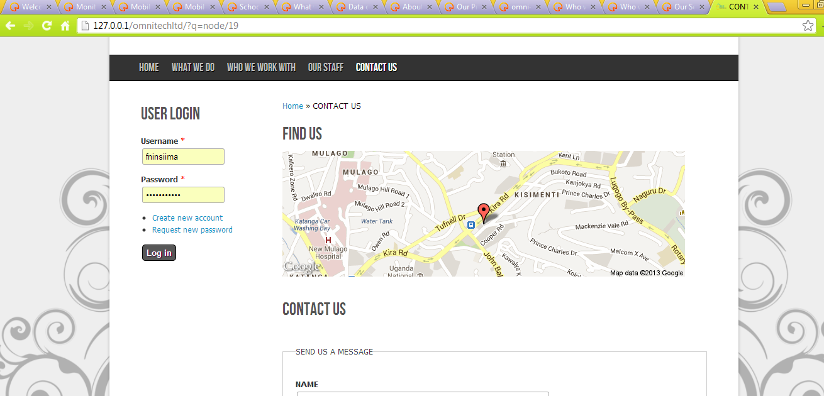

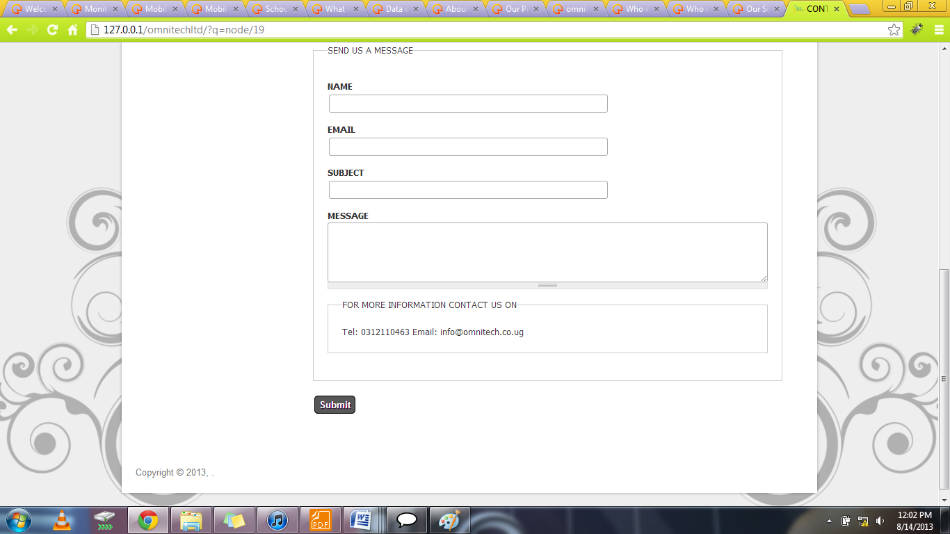
APPENDIX B
<table border="1">
<tr>
<th>DATE</th>
<th>TIME</th>
<th>COMMAND STATUS</th>
<th>SENDER</th>
<th>RECEIVER</th>
</tr>
<?php
ini_set('max_execution_time', 300); //300 seconds = 5 minutes
$fp=new SplFileObject('bearerbox_server.log');
$partA=0;
$partB=0;
$partC=0;
while(!$fp->eof()){

if(!preg_match("/submit_sm_resp/",$fp->current()) && !preg_match("/deliver_sm_resp/",$fp->current()) && (preg_match("/submit_sm/",$fp->current()) || preg_match("/deliver_sm/",$fp->current()))){
$fp->next();
$commandIDStr=explode(' ', $fp->current());
$size=count($commandIDStr);
if($partA==$commandIDStr[$size-3] && $partB==$commandIDStr[$size-2] && $partC==$commandIDStr[$size-1]){
// do nothing
}else{
$partA=$commandIDStr[$size-3];
$partB=$commandIDStr[$size-2];
$partC=$commandIDStr[$size-1];
$fp->next();
$commandStatusStr=explode(' ',$fp->current());
$date=$commandStatusStr[0];
$time=$commandStatusStr[1];
$length=count($commandStatusStr);
$part1=$commandStatusStr[$length - 3];
$part2=$commandStatusStr[$length - 2];
$part3=$commandStatusStr[$length - 1];
$linenum=$fp->key();
$fp->seek($linenum + 5);
$sourceAddrStr=explode(' ',$fp->current());
$length=count($sourceAddrStr);
$sceAddr=$sourceAddrStr[$length - 1];
$linenum=$fp->key();
$fp->seek($linenum + 3);
$destinationAddrStr=explode(' ',$fp->current());
$length=count($destinationAddrStr);
$destAddr=$destinationAddrStr[$length - 1];
?>
<tr>
<td><?php echo $date;?></td>
<td><?php echo $time;?></td>
<td><?php echo $part1." ".$part2." ".$part3;?></td>
<td><?php echo $sceAddr;?></td>
<td><?php echo $destAddr;?></td>
</tr>

<?php
}
}
$fp->next();
}
?>
</table>
APPENDIX C
/**
*
* @author Delmira
* @since 09-07-2013 This class creates a node of a linked list the node has
* data and a link to its neighbor
*/
package org.me.mylib;

public class Node {

private Object data;
private Node nextNode;

//Constructor
public Node(Object data) {
this(data, null);
}

//Another constructor
public Node(Object data, Node nextNode) {
this.data = data;
this.nextNode = nextNode;
}

/**
* Getters
*/
public Object getObj() {
return this.data;
}

public Node getNextNode() {
return this.nextNode;
}

/**
* Setters
*/
public void setObj(Object i) {
this.data = i;
}

public void setNextNode(Node n) {
this.nextNode = n;
}

//Displays a node
public void displayNode() {
System.out.println("{" + this.data + "}");
}
}

/**
*
* @author Delmira
* @since 09-07-2013 This class represents linked list objects its operations
* include insertion and deletion its a singly linked list
*/
package org.me.mylib;

public class LinkedList {

private Node head;
private Node tail;

//Constructor
public LinkedList() {
head = null;
tail = null;
}

//Returns true for empty list
public boolean isEmpty() {
return head == null;
}

//Insert at beginning
public void insert(Object data) {
Node n = new Node(data);
n.setNextNode(head);
head = n;
}

//Remove first Node
public Node delete() {
Node temp = head;
head = head.getNextNode();
return temp;
}

//Function inserts node at end
public void addNode(Object obj) {
Node node = new Node(obj);
if (this.isEmpty()) {
this.head = node;
}
if (this.tail != null) {
this.tail.setNextNode(node);
}
this.tail = node;
}

//Function removes node
public void removeAt(int index) {
Node temp = null;
Node node = this.head;
int i = 0;
while (node != null && i++ < index) {

temp = node;
node = node.getNextNode();

}
if (temp == null) {
this.head = node.getNextNode();
} else {
temp.setNextNode(node.getNextNode());
}
}

public boolean deleteNode(int index) {
if (isEmpty()) {
return false;
}
Node prevNode = this.head;
for (int i = 1; i <= index; ++i) {
Node currentNode = prevNode.getNextNode();
Node nextNode = currentNode.getNextNode();
if (i == index) {
prevNode.setNextNode(nextNode);
} else {
prevNode = currentNode;
}
}
return true;
}

//Displays the list
public void displayList() {
Node currentNode = head;
System.out.println("The list: ");
while (currentNode != null) {
currentNode.displayNode();
currentNode = currentNode.getNextNode();
}
System.out.println("");
}
/**
* public void insertNode(Object newObj, Node n){ Node temp=new
* Node(newObj,n.getNextNode()); temp.setNextNode(n); }
*/
/**
* public void deleteNode(Node n){ if(this.head==n){ head=n.getNextNode();
* }else{ Node temp=head; while(temp.getNextNode()!=n){
* temp=temp.getNextNode(); } temp.setNextNode(n.getNextNode()); } }
*/
}
APPENDIX D
THE PSUEDOCODE
DrawTree(n, direction, length)

if n > 0 do

DrawTrunk(direction, length)

DrawTree(n-1, 3DRandomAngle(direction), length*Factor(n))

DrawTree(n-1, direction + random % 10, length*Factor(n))

DrawTree(n-1, 3DRandomAngle(direction), length*Factor(n))

else

DrawLeaf()

end if

end DrawTree

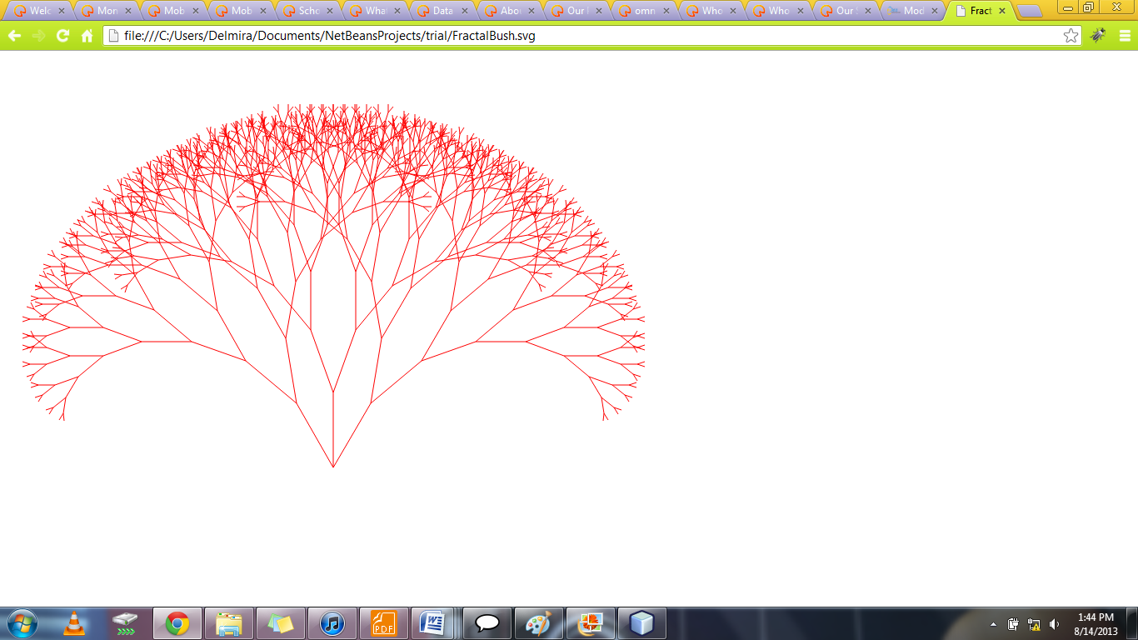
import java.awt.Color;
import java.awt.Graphics2D;
import java.io.*;
import org.apache.batik.dom.GenericDOMImplementation;
import org.apache.batik.svggen.SVGGraphics2D;
import org.w3c.dom.DOMImplementation;
import org.w3c.dom.Document;

public class hello {

public void paint(Graphics2D g2d) {
g2d.setPaint(Color.red);
drawTree(g2d, 400, 500, -60, 9);
drawTree(g2d, 400, 500, -90, 9);
drawTree(g2d, 400, 500, -120, 9);
}

private void drawTree(Graphics2D g, int x1, int y1, double angle, int depth) {
if (depth == 0) {
return;
}
int x2 = x1 + (int) (Math.cos(Math.toRadians(angle)) * depth * 10.0);
int y2 = y1 + (int) (Math.sin(Math.toRadians(angle)) * depth * 10.0);
g.drawLine(x1, y1, x2, y2);
drawTree(g, x2, y2, angle - 20, depth - 1);
drawTree(g, x2, y2, angle + 20, depth - 1);
}

public static void main(String[] args) throws IOException {

// Get a DOMImplementation.
DOMImplementation domImpl =
GenericDOMImplementation.getDOMImplementation();

// Create an instance of org.w3c.dom.Document.
String svgNS = "http://www.w3.org/2000/svg";
Document document = domImpl.createDocument(svgNS, "svg", null);

// Create an instance of the SVG Generator.
SVGGraphics2D svgGenerator = new SVGGraphics2D(document);

// Ask the test to render into the SVG Graphics2D implementation.
hello test = new hello();
test.paint(svgGenerator);

// Finally, stream out SVG to the standard output using
// UTF-8 encoding.
boolean useCSS = true; // we want to use CSS style attributes
File file = new File("FractalBush.svg");
FileOutputStream fos = new FileOutputStream(file);
Writer out = new OutputStreamWriter(fos, "UTF-8");
svgGenerator.stream(out, useCSS);
}
}

APPENDIX E

GOOGLE ADVERTISEMENTS (GOOGLE ADS)

Steps on how to get an advertisement running on Google
- Set up a Google AdWords account.
- Either: Create a Google account
- Or: Use an existing Google account
- Set the time zone and currency (Can’t be altered after account creation)
- Verify the account
- Sign in to AdWords using the URL https://adwords.google.com

- Optional: Target a geographic region
- Is it an ad for a local business in a specific city, postal code, country?
- Is it an ad for global or nationwide attention?
- The ad will appear in the location chosen.

- Creating your 1st Campaign
- Set daily budget(manual bidding)
- You only pay when your ad is clicked on
- Decide how much you should pay per day
- Set the budget under the Bidding and Budget section of the campaign settings

- Control the Cost per Click i.e. the CPC (automatic bidding)
- This is how much you spend per click on your ad
- Select the Automatic Bidding option budget under the Bidding and Budget section

- Create the advertisement
- Specify Ad Title
- Specify the text to be seen in the ad
- Specify the URL to your business’ website

- Select keywords
- The ad will appear when these words are searched for
- You can add, edit and delete the list of keywords
- Consider relevance, quality and quantity when selecting keywords

- Enter billing information
- The final step before activating the account
- Options are a Credit card, Direct debit, and Bank transfer
- Postpay(automatic payments) and prepay(manual payments) options are available
- The payment options available depend on currency chosen and location of billing address

Facebook Advertisements

Steps on how to get and advertisement running on facebook

- Build a Facebook Page
- Create a Page
- This Page provides a way to communicate with customers
- Build your brand by setting a business category, Page name, logo, web address, cover photo etc
- Create posts such as updates, photos, videos for people who like your Page to see
- Invite people you know to like your Page
- This Page can be edited/updated whenever

- Connect with people
- Reach current and potential customers by creating facebook ads
- Ads are not paid for by click per ad. They are paid messages coming from businesses
- Ads are delivered to potential customers based on their likes, location, gender etc
- Set up the ad by choosing what you want to promote e.g. place, app, event, Page etc
- Choose the basic demographic of the intended audience using Location, Age and Gender
- Name your campaign, select your budget and set the schedule for your campaign. You’ll never pay more than your budget, nor more than the actual cost to reach your intended audience

- Engage your Audience
- Post quality content regularly. This keeps people interested. Make them relevant, succinct, friendly, conversational and timely
- Promote your posts to reach more people in news feed.
- Check Page insights to see what’s working e.g. who likes your page, demographic information of viewers etc

Search Engine Optimization (SEO)

Planning for SEO

- Using keywords
- Words that a user might search for to find a piece of our content
- In title of page
- In headers
- Including them throughout the page especially at the top
- Creating “description” meta tag listing keywords to the site
- Summaries defined for each page
- Must be unique & accurate
- Improving the structure of the URLS
- Creating simple-to-understand for users & search engines and conveying content information easily
- Using one version of a URL to reach a document and setting up a 301 redirect from non-preferred URLs to the document
- Creating site maps / Site maps
- List of pages of the website.
- Ensures all pages can be easily found. Search engines learn about the structure of our site and this can increase our coverage of our WebPages
- E.g. XML Sitemap, HTML sitemap, Image Sitemap
- We can have a custom 404 page to guide our users back to a working page on the site
- Getting sites to link to the web page
- How many other Web Pages link to the page in question
- We can offer link exchanges with other sites that cover related material/content (Partnering)
- We can use blog posts, social media services, email, forums, or other means to direct people to our website
- Balancing the content of the website between users and search engines
- Easy-to-read text
- Organized around the topic
- Fresh & unique
- Should be easily accessible to search engines
- Avoiding the use of Black HAT SEO Techniques
- Illegal ways of tricking search engines list your Web Pages high in Search Engine Results Pages (SERP)
- E.g. keyword stuffing, page stuffing, use of invisible text, selling & farming links etc
- In the long run the website can be penalized e.g. rankings can be reduced, can be eliminated from the search engines databases
- Use webmaster tools provided by search engines
- Google-Webmaster Tools
- Yahoo!-Yahoo! Site Explorer
- Microsoft-Bing Webmaster Tools
- Submit your content to search engine e.g. Google
- http://www.google.com/submityourcontent/

