**MAKEREREUNIVERSITY**

COLLEGE OF COMPUTING AND INFORMATION SCIENCES

SCHOOL OF COMPUTING AND INFORMATICS TECHNOLOGY

DEPARTMENT OF COMPUTER SCIENCE

CSC 2212 INDIVIDUAL PROJECT II

LECTURER: NAKIYINGI DIANA

ASSIGNMENT 3

' project: Online Video Rental

' Systems Analyst: Ninsiima Flavia Delmira

' last modified: 23 April 2013

' description: Business Name: Blockbuster Online

' studentNumber: 210000613

' regNumber: 10/U/1382

**Phase 1:**

*Source*: <http://www.blockbuster.co.uk>

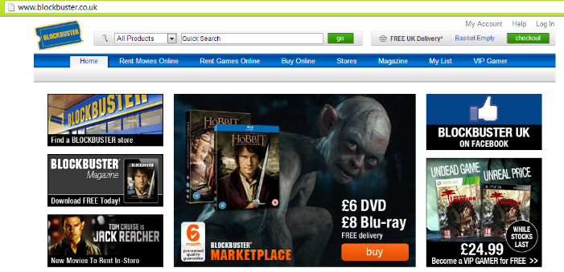

*Brief Functionality:*

Blockbuster online rents movies to members. There is a 14-day trial period for rental services.



Movie information provided includes Title, brief description, summary, cast members, directors, genre and rating. In addition the site allows the viewing of the movie trailer. A movie can be rented as DVD format or Blu-ray format.

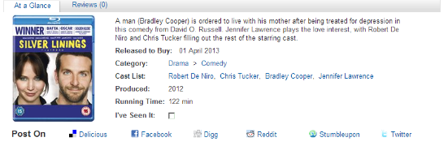

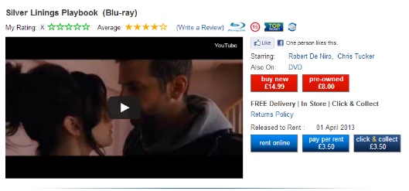

A visitor becomes a member by providing necessary information such as email address, password etc in order to create their account.

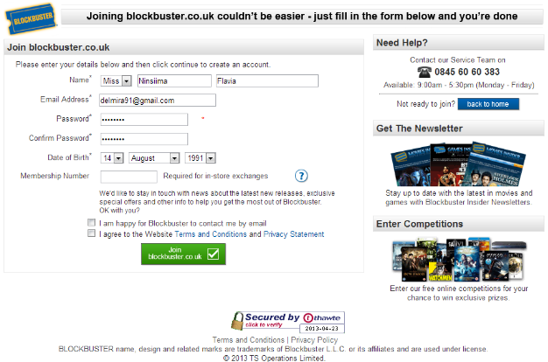

Members have access to help/support via frequently asked questions, Email Support, Telephone support. In addition, they can manage their account details e.g. managing their personal details or adjusting their payment settings.

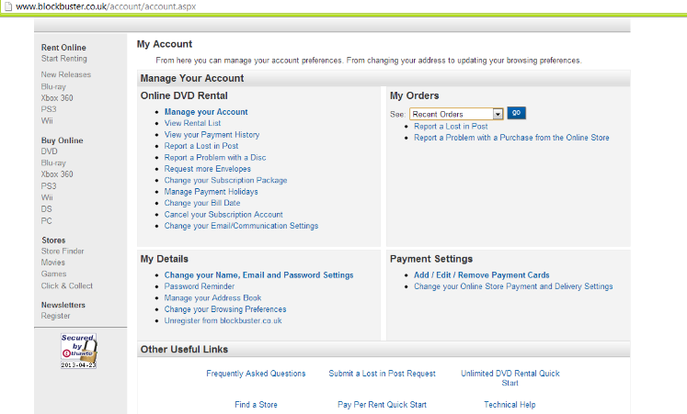

A member rents online by providing their details, choosing a rental plan, inputting their deliver address, card details, and confirming the transaction. Chosen movies are added to a queue & sent via mail.

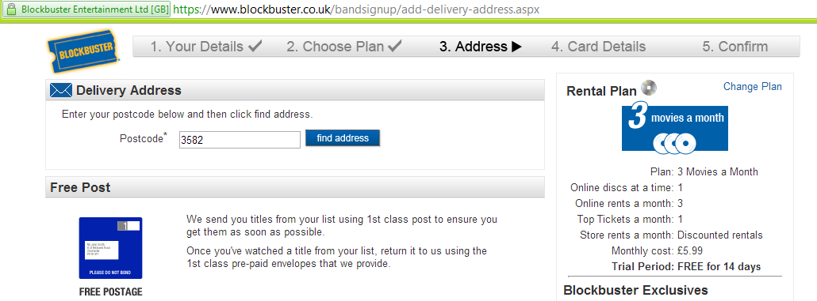

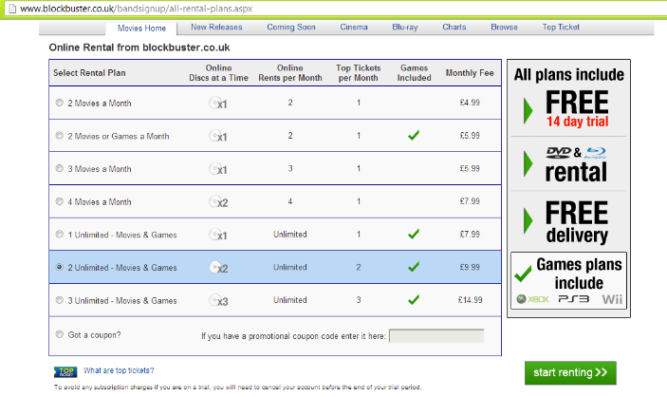

*Problem Statement:*

1. The movie information was lacking a PG rating.
2. The system caters for user reviews and lacks critics reviews

**Phase 2:**

1. State Transition Diagrams

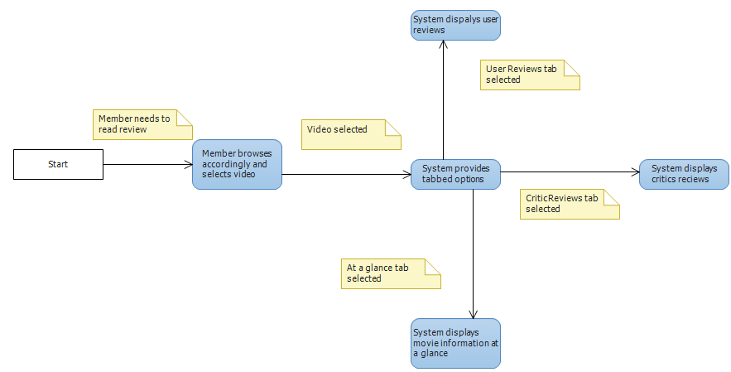

1. Activity Diagrams

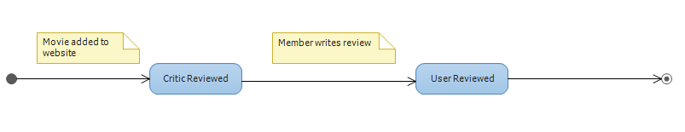

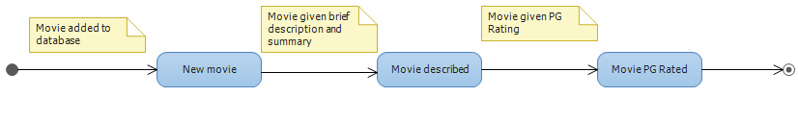

1. Documentation

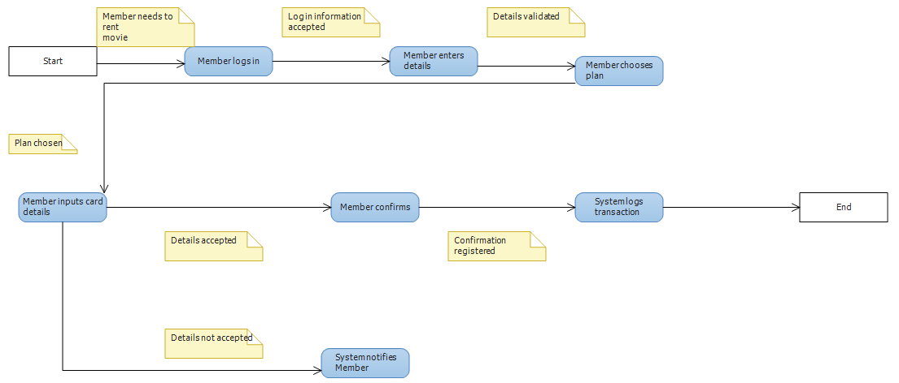

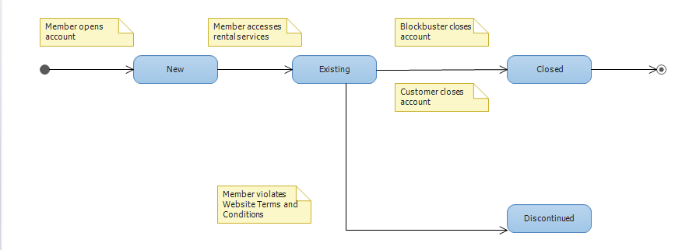

**Phase 3:**

1. Entity Relationship Diagram

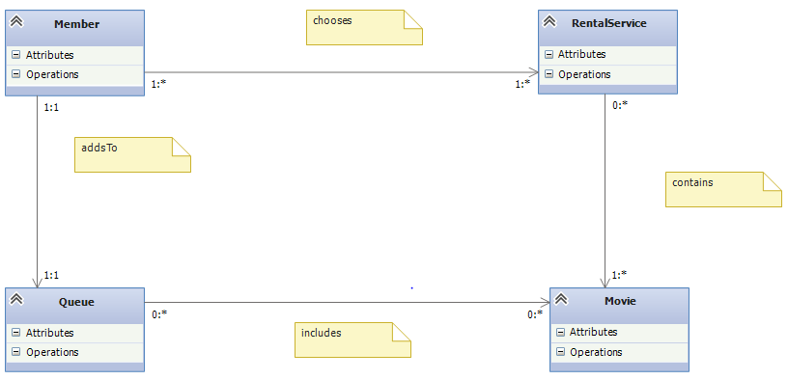

1. Interface and Screen designs

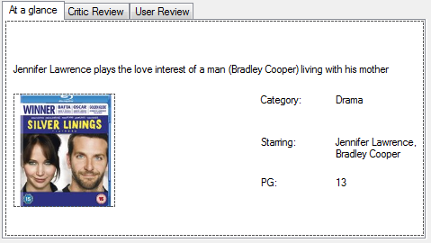

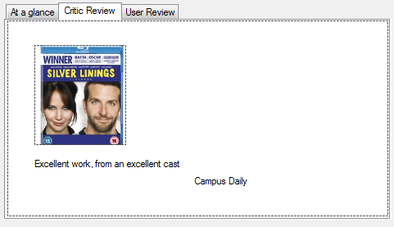

1. Input, Output & Report designs

