
Title
Julia Bend^{*1,2}, Alexander Kvist³
¹ Åbo Akademi University, Turku, Finland
² Linneaus University. Växjö, Swedenы
³ Karolinska University, Stockholm, Sweden
Abstract

© 2026 Elsevier Science. All rights reserved

- Introduction
1.1

- Methods
2.1 Participants
Sixteen healty adults (7 females, 9 males, mean age = 38,7 years) were recruited through advertisements. All participants received verbal and written information and gave written consent prior to study participation. All personal data was anonymised and no personal data was stored.
2.2 Procedure
Prior to the experimental session, participants were asked about health status and to provide their head size (circumference) for the fNIRS measurement. During the experimental session, in addition to the fNIRS measurement, reaction time, accuracy and oral feedback were collected. Demographic data consisted of sex and age.
2.3 Perceptual and working memory load manipulations.
The experiment employed a 2 × 2 factorial design manipulating perceptual load (PL) and working memory load (WML), resulting in four conditions: (1) low PL–low WML, (2) low PL–high WML, (3) high PL–low WML, and (4) high PL–high WML. Each condition consisted of 10 trials. The task was a computer-based letter search paradigm in which participants were required to detect target letters within visually presented letter arrays. Target letters were always presented in uppercase.
Perceptual load (PL) was manipulated by varying the visual complexity of the letter arrays. In low PL conditions, stimuli consisted of simple, homogeneous strings of lowercase letters, with an uppercase target letter that was visually distinct and easily detectable among the distractors. In high PL conditions, stimuli consisted of arrays of uppercase letters, increasing visual similarity between targets and distractors and thereby increasing perceptual competition. This manipulation increased the amount of visual information to be processed, placing greater demands on perceptual processing. Working memory load (WML) was manipulated by varying the number of target letters participants were required to maintain. In low WML conditions, participants searched for a single target letter presented prior to each trial, and this target remained constant across trials within the condition. In high WML conditions, participants were required to remember two target letters on each trial and respond if at least one appeared in the array. Importantly, even in the low WML condition, a baseline level of working memory load was present due to the requirement to retain the target letter across a short delay. The high WML condition further increased cognitive demands by requiring the maintenance and comparison of multiple target representations.
The experimental conditions were organized in a block design. Two conditions (low PL–low WML and high PL–low WML) were presented in the first part of the experiment, followed by a two-minute break, after which the remaining two conditions (low PL–high WML and high PL–high WML) were completed. The total duration of the experiment was approximately 40 minutes, including practice trials and instructions.Participants were instructed to respond by pressing a left arrow (if the target was not present) and a right arrow (if the target was present), as fast and correctly as possible. The responses were recorded to analyze task accuracy as well as reaction time.
Stimuli were presented for 5 s, followed by the participant’s response and a 10-s rest period to allow for baseline measurement (Amaro & Barker, 2006) and to provide feedback on response accuracy. During the rest period, the stimulus display remained unchanged while feedback was presented. Each experimental condition consisted of 10 trials, preceded by three practice trials. Trial order within each condition was randomized to minimize learning effects due to repetition. Participants were given a two-minute break between the second and third experimental blocks.

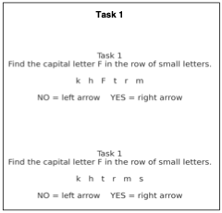
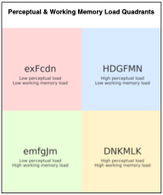
Figure 1. (a) Illustration of the experimental task. Participants searched for a capital target letter (F) within a sequence of lowercase letters and indicated its presence or absence using arrow key responses (left = no, right = yes).
(b) Schematic representation of the four experimental conditions in a 2 × 2 design, defined by the manipulation of perceptual load (low vs. high) and working memory load (low vs. high).

2.4 fNIRS settings and AOIs
The measurement of changes in concentration of oxygenated (HbO) and deoxygenated (HHb) hemoglobin in the PFC was assessed using a NIRSPORT 2 (NIRx Medizintechnik, Berlin, Germany) continuous wave fNIRS device.
The fNIRS headcap consisted of 16 sources and 23 detectors, forming 54 channels with a source–detector separation of approximately 3 cm. Additionally, 8 short-separation detectors were used to account for superficial hemodynamic signals (Figure 2). The source optodes transmitted light at 760 and 850 nm, and data was sampled at 10 Hz. To allow for removal of peripheral interference (stemming from blood flow changes in extracerebral layers of the head), short-separation reference channels (Gagnon et al., 2012) (8 mm separation) were used.
Regions of interest (ROIs) were defined based on the optode layout, focusing on fronto-central areas implicated in executive and attentional processing. Specifically, channels corresponding to AF3/AF4 (prefrontal cortex), FC1/FC2 (fronto-central cortex), FC5/FC6 (lateral frontal regions), and CP1/CP2 (centro-parietal cortex) were selected. These regions are associated with working memory, cognitive control, response selection, and attentional processes.
The collected fNIRS data was streamed to a local computer using Aurora (version 2025.2) software. Event triggers delineating block conditions were sent via a lab streaming layer to Aurora. The accuracy and reaction time were recorded using PsychoPy (version 2025.1.1). The experiment was programmed in PsychoPy (version 2025.1.1) and event triggers were sent via a lab streaming layer from presentaiton PC to a host PC.

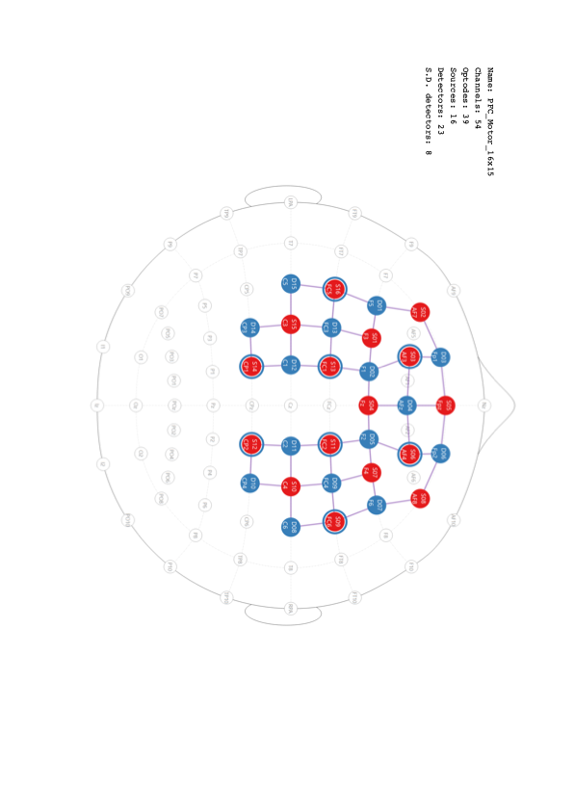
Figure 2. Optode placement based on the international 10–20 system (generated using NirSite 2.0, NIRx Medical Technologies). Detectors are shown in blue and sources in red. Blue rings surrounding selected sources indicate short-separation detectors. LPA and RPA denote the left and right preauricular landmarks; Iz indicates the inion and Nz the nasion.
- Data analysis
- Results
- Discussion

- Bibliography
Acknowledgments
Acknowledgments should be inserted at the end of the paper, before the references, not as a footnote to the title. Use an unnumbered section heading for the Acknowledgments, similar to the References heading.
References
- P. Audebert, P. Hapiot, J. Electroanal. Chem. 361 (1993) 177.
- J. Newman, Electrochemical Systems, 2nd ed., Prentice-Hall, Englewood Cliffs, NJ, 1991.
- A.R. Hillman, in: R.G. Linford (Ed.), Electrochemical Science and Technology of Polymers, vol. 1, Elsevier, Amsterdam, 1987, Ch. 5.
- B. Miller, Proc. 6th Australian Electrochem. Conf., Geelong, Vic., 19-24 Feb., 1984; J. Electroanal. Chem., 168 (1984) 91.
- Jones, personal communication, 1992.

