
Neural Responses to Combined Perceptual and Working Memory Load Measured with Functional Near-Infrared Spectroscopy
Julia Bend^{*1,2}, Alexander Kvist³
¹ Åbo Akademi University, Turku, Finland
² Linneaus University. Växjö, Swedenы
³ Karolinska University, Stockholm, Sweden
Abstract
Perceptual load and working-memory load both influence attention and cognitive performance, but their combined neural effects remain poorly understood. Most neuroscientific studies have examined these effects in terms of distractor processing rather than their direct influence on cortical activation. This study investigated cortical hemodynamic responses to independently manipulated perceptual and working-memory load using functional near-infrared spectroscopy (fNIRS) and an adapted Sternberg paradigm. Perceptual load was manipulated by increasing target–distractor similarity, whereas working-memory load was manipulated by varying the number of target letters maintained during a concurrent visual-search task. Significant hemodynamic responses were primarily associated with high working-memory conditions. Increased oxygenated hemoglobin (HbO) was observed in the orbitofrontal cortex (BA 11) during both high working-memory conditions. Under the combined high perceptual load–high working-memory load condition, decreased HbO was observed in the supplementary motor area (BA 6). No significant contrasts or interaction effects survived false discovery rate correction. These findings suggest that cortical responses in the present paradigm were driven primarily by working-memory demands, whereas perceptual-load-specific effects were limited. The results demonstrate the utility of fNIRS for investigating neural responses during complex cognitive tasks.

© 2026 Elsevier Science. All rights reserved
Keywords: functional near-infrared spectroscopy (fNIRS); perceptual load; working memory load; neural responses; cortical activation.

- Introduction
1.1. Load Theory
Load Theory proposes that the locus of selective attention depends on the perceptual demands of the ongoing task (Lavie, 1995). According to the theory, perceptual processing proceeds automatically until the available processing capacity is exhausted. Under high perceptual load, the processing of task-relevant stimuli consumes the available perceptual capacity, leaving insufficient resources to process task-irrelevant distractors. Consequently, distractor processing is reduced, reflecting an early locus of attentional selection. In contrast, under low perceptual load, processing capacity is not fully occupied by the primary task, allowing the remaining resources to spill over to irrelevant stimuli and resulting in a later locus of selection.
The original formulation of Load Theory focused exclusively on perceptual load (Lavie, 1995). It was later extended to include cognitive load, particularly working-memory load (Lavie et al., 2004). According to this extension, increasing working-memory load reduces the availability of cognitive control resources required to distinguish relevant from irrelevant information, thereby increasing distractor interference. Conversely, under low working-memory load, cognitive control mechanisms remain available to suppress irrelevant stimuli effectively. Thus, unlike perceptual load, the original working-memory account predicted increased distractor processing under conditions of high load. Subsequent revisions of the theory clarified that these effects primarily apply to dual-task paradigms in which working-memory demands compete with attentional control processes (Brockhoff et al., 2022).
Further developments have also highlighted that working memory is not a unitary construct. Early cognitive-load studies mainly taxed the central executive through tasks requiring the maintenance of random digits or letters or through n-back paradigms engaging updating processes. However, according to Baddeley (1996), working memory comprises multiple interacting components, including short-term storage systems and the central executive. Consistent with this framework, Konstantinou and Lavie (2013) demonstrated that different working-memory components influence attention differently. Specifically, loading cognitive-control processes increased distractor processing, whereas loading short-term memory maintenance reduced distractor perception. Consequently, Load Theory was revised to propose that distractor interference depends on the specific working-memory processes engaged rather than on working-memory load alone (Konstantinou & Lavie, 2013). As noted by Brockhoff et al. (2022), this refinement improves theoretical specificity but also complicates the distinction between perceptual load and other forms of cognitive demand. It further raises the possibility that different types of load operate at different stages of the information-processing hierarchy.
Despite its considerable influence, Load Theory has also received substantial criticism. In particular, Murphy et al. (2016) argued that perceptual load still lacks a formal, quantitative definition, making comparisons across studies difficult and contributing to inconsistencies in the literature.
The classical perceptual-load paradigm (Lavie, 1995) requires participants to perform a central letter-search task while ignoring peripheral distractor letters. Perceptual load is manipulated by varying the number of non-target letters surrounding the target. Under low load, only the target letter is presented, whereas under high load the target appears among five non-target letters. The peripheral distractor varies in compatibility with the target, and the load effect is typically quantified as the reduction in distractor interference on reaction time under high relative to low perceptual load. Other studies have instead assessed the reportability of task-irrelevant distractors (e.g., Cartwright-Finch & Lavie, 2007). More broadly, perceptual load has been operationalized in three principal ways: by increasing the amount of perceptual input, by increasing the similarity between target and non-target stimuli, or by varying task instructions while keeping the visual stimuli identical (Brockhoff et al., 2022).
Most neuroscientific studies have investigated perceptual load and working-memory load separately, typically in relation to their effects on task-irrelevant distractor processing (Brockhoff et al., 2022). However, in naturalistic behavior these demands often occur simultaneously, and their combined influence on cortical activity remains poorly understood.
The present study adopts a broader perspective by examining both perceptual load and working-memory load within the same experimental framework (Liu et al., 2022). These two forms of cognitive demand engage different processing mechanisms and therefore may produce distinct patterns of cortical activation (Lavie, 2014). While perceptual load primarily taxes perceptual processing resources, working-memory load places demands on higher-order cognitive control mechanisms. To investigate these processes simultaneously, we employed a fully crossed 2 × 2 factorial design manipulating both perceptual load and working-memory load. This design allowed us to determine whether functional near-infrared spectroscopy (fNIRS) can distinguish between the cortical responses associated with the four resulting combinations of cognitive demand and to evaluate its potential as an objective measure of both general workload and specific types of mental load.
1.2. Perceptual load
Attention facilitates goal-directed behavior by prioritizing task-relevant information and suppressing interference from distractors. Within Load Theory, the neural mechanisms underlying distractor processing are proposed to depend on the perceptual load of the primary task (Lavie, 2005). Specifically, under high perceptual load, task-relevant processing consumes available perceptual resources, leaving insufficient capacity for processing irrelevant stimuli, resulting in reduced distractor processing. In contrast, under low perceptual load, spare processing capacity “spills over” to irrelevant stimuli, leading to increased distractor processing and a later locus of selection.
This framework predicts that perceptual load modulates distractor processing at multiple stages of the processing hierarchy. At low load, distractors are processed more extensively due to available capacity, whereas at high load, they are passively excluded because resources are exhausted (Lavie, 2005; Xu et al., 2011). Consistent with this account, fMRI studies have shown increased distractor-related activity in visual and auditory cortical areas under low compared with high perceptual load, even when distractors are not consciously visible or are presented in different sensory modalities (Schwartz et al., 2005; Yücel et al., 2005).
However, findings across studies are not fully consistent. For example, Yücel et al. (2005) reported reduced distractor-evoked activation in the inferior frontal gyrus (IFG) under high perceptual load, whereas Schwartz et al. (2005) did not observe significant load-dependent differences in frontostriatal circuits. These mixed findings suggest that the neural effects of perceptual load may depend on task design and the specific brain networks involved.
More comprehensive evidence is provided by Xu et al. (2011), who manipulated perceptual load during a visual target-identification task. Under low load, targets were defined by a single feature (e.g., elongated nose), whereas under high load, target identification required conjunction search across multiple facial features. Their results showed increased activation under high perceptual load in a distributed attentional network, including the lateral prefrontal cortex (LPFC), parietal cortex, occipital cortex (including fusiform gyrus), thalamus, basal ganglia, and midbrain. In contrast, decreased activity was observed in default-mode network regions, including the medial prefrontal cortex (MPFC), posterior cingulate cortex (PCC)/precuneus, temporoparietal junction (TPJ), and medial temporal lobe structures such as the hippocampus, parahippocampus, and amygdala.
Similarly, Chong et al. (2008) reported region-specific modulation of perceptual load. The left inferior frontal gyrus (pars triangularis; BA 45) showed reduced activation under high compared with low load, consistent with decreased processing of task-irrelevant information under high attentional demand. In contrast, the right inferior parietal lobule (IPL) exhibited increased activation under high load across multiple stimulus categories, suggesting a role in general attentional and task-demand processing rather than stimulus-specific effects.
Together, these findings indicate that perceptual load influences both sensory and higher-order cortical regions, but in a non-uniform manner across networks. Load-related modulation appears to depend on whether regions are primarily involved in sensory processing, attentional selection, or higher-order control functions.
Finally, similar load-dependent effects have been observed in other systems sensitive to attention. For instance, activity in action observation regions was not uniformly modulated by attentional load, suggesting that some specialized perceptual systems (e.g., biological motion processing) may remain relatively stable under increased task demands (Vuilleumier et al., 2001; Whalen et al., 1998; Williams et al., 2004). This raises the broader question of whether perceptual load effects generalize across different functional systems or are constrained by domain-specific processing architectures.
1.3. Working Memory Load
Cognitive Load Theory (CLT) proposes that working memory capacity is limited and varies across individuals (Paas et al., 2003; Cowan, 2010). According to Sweller and Chandler (1991), successful cognitive performance depends on the interaction between sensory input, working memory, and long-term memory. While long-term memory can store vast amounts of information, working memory serves as a capacity-limited system for temporarily maintaining and integrating information (Paas et al., 2003; Oberauer et al., 2007; Ahmadi et al., 2024).
Working memory is commonly described as a multi-component system responsible for the temporary storage and manipulation of information necessary for complex cognitive activities such as reasoning, comprehension, and learning (Baddeley, 1996; Ma et al., 2017). It consists of the phonological loop and visuospatial sketchpad (storage systems), and the central executive (control system). The central executive further supports three core functions: shifting between tasks or mental sets, inhibitory control of prepotent responses, and updating of working memory representations (Baddeley, 1996).
Working memory relies on a distributed network including the prefrontal cortex, temporal cortex, posterior parietal regions, and inferotemporal areas (Baddeley, 2003; Gómez et al., 2018; Moya et al., 2025). Converging evidence links working-memory performance to activation in prefrontal cortex (Braver et al., 1997; Cohen et al., 1997; Ogawa et al., 2014), and suggests that executive attention plays a key role in resisting distraction (Engle, 2002). This supports a central role of prefrontal systems in working-memory maintenance and control. Beyond cognitive operations, working memory capacity also interacts with other domains such as emotional processing. For instance, increasing working memory load can reduce emotional intensity, suggesting that cognitive resources can be used to regulate affective experience (Van Dillen & Koole, 2007; Kron et al., 2010).
In experimental paradigms, working-memory load is typically manipulated by increasing the number or complexity of items that must be maintained or manipulated. In Xu et al. (2011), for example, participants maintained more feature conjunctions under high load compared with low load conditions. Based on Load Theory (Lavie, 2005), it has been proposed that increasing working-memory load should reduce cognitive control resources and thereby increase distractor interference. Consistent with this, de Fockert et al. (2001) reported increased distractor interference under high working-memory load.
However, this effect is not consistent across studies. Other fMRI findings suggest that increasing working-memory load in the primary task can instead enhance distractor suppression in sensory cortex (Klemen et al., 2010). This discrepancy indicates that the effect of working-memory load on distractor processing depends on task structure, particularly whether working memory demands are integrated into the primary task or imposed as a secondary load. In their study, working-memory load was embedded within the main task, which likely increased distractor inhibition. Accordingly, reduced distractor processing in visual cortex and frontostriatal circuits under high load may reflect the combined influence of perceptual and working-memory demands.
Empirical evidence further highlights domain-specific dissociations between perceptual and working-memory load. Yi et al. (2004), using fMRI, demonstrated that increasing perceptual load attenuated processing of task-irrelevant background scenes in the parahippocampal place area (PPA), whereas increasing working-memory load had no such effect. This suggests that perceptual load primarily modulates perceptual processing resources, whereas working-memory load primarily engages central executive mechanisms without necessarily reducing perceptual processing of irrelevant stimuli. Importantly, concurrent maintenance of visual objects in working memory does not necessarily impair visual search performance (Woodman et al., 2001), supporting a functional distinction between perceptual attention and central executive control.
Neurophysiological evidence from Ahmadi et al. (2024) further demonstrates load-dependent modulation of brain activity during a Sternberg task. They observed a linear relationship between cognitive load and EEG power (upper alpha, lower alpha, theta, and beta bands) across frontal, centrotemporal, and occipitoparietal regions during the maintenance phase. However, this relationship weakened during the probe phase, suggesting that working-memory capacity limits may have been exceeded at higher load levels.
Complementary evidence from fNIRS further suggests that working-memory and perceptual demands differentially affect cortical activation depending on task phase. Baker et al. (2018) manipulated visuospatial working memory load (3 vs. 5 dots) while also varying spatial task difficulty across trials. Although framed as a working-memory manipulation, their paradigm also included a perceptual component related to spatial discriminability. Their results showed that the dot-number manipulation selectively affected cortical activation during encoding and maintenance, but not during retrieval, indicating that working-memory load effects were strongest during active encoding of items. In contrast, retrieval-related activity was more sensitive to spatial task characteristics, suggesting a greater perceptual contribution at this stage. Significant activation was observed in bilateral dorsolateral and superior parietal cortices, with generally stronger prefrontal involvement.
In line with load-dependent prefrontal effects, Tsujimoto et al. (2004) reported load-dependent increases in oxyhemoglobin concentration in dorsolateral prefrontal cortex (BA 9/46) during a spatial working-memory task. High-load conditions elicited stronger and more sustained activation in LPFC compared to low-load conditions, with activity beginning approximately 5 seconds after stimulus onset and persisting through the response period. These findings are consistent with a robust role of LPFC in maintaining spatial information under increased working-memory demands.
Additional evidence indicates that hemispheric contributions may vary depending on age and task strategy, with adults showing relatively greater left LPFC involvement and children showing right-lateralized activation patterns, although these differences were not statistically strong (Tsujimoto et al., 2004).
Together, these findings indicate that working-memory load reliably engages prefrontal executive systems, but its effects on perceptual processing and distractor inhibition depend strongly on task structure, load type, and the integration of cognitive demands within the primary task.
1.4. Functional near-infrared spectroscopy (fNIRS)
Functional near-infrared spectroscopy (fNIRS) is a non-invasive, portable, and relatively easy-to-use neuroimaging technique that has been widely applied across diverse populations and research domains (Yücel et al., 2021). The method measures brain activity by transmitting near-infrared light through cortical tissue and exploiting the distinct optical absorption properties of oxygenated hemoglobin (HbO₂) and deoxygenated hemoglobin (HbR), thereby enabling the assessment of task-related hemodynamic responses (Scholkmann et al., 2014). fNIRS provides measurements of cortical hemodynamic activity and can be used in experimental paradigms involving natural head movements, thereby facilitating data collection in relatively unconstrained behavioral settings (Herold et al., 2017).
Previous studies have successfully used fNIRS to assess working-memory processes. For example, increased prefrontal activation has been observed with increasing task difficulty in n-back paradigms, indicating a relationship between working-memory load and cortical oxygenation (Molteni et al., 2008). Similarly, lateral prefrontal cortex activation has been linked to working-memory performance (Tanida et al., 2012), and fNIRS has been applied to evaluate different approaches for analyzing working-memory tasks (Keshmiri et al., 2018). Previous studies observed an increase in fNIRS activity in prefrontal cortex in response to emotional stimuli (Moya et al., 2025; Hu et al., 2019).
Most previous fNIRS studies have investigated working-memory load using relatively simple paradigms, such as n-back or delayed-recognition tasks (Tsujimoto et al., 2004; Baker et al., 2018), in which working-memory demands were manipulated in isolation. However, real-world cognition rarely relies on a single cognitive process. Everyday activities typically require the simultaneous allocation of perceptual attention and working-memory resources, making combined paradigms more representative of natural cognitive behavior.
Despite growing interest in cognitive workload assessment using fNIRS, it remains unclear whether the technique can distinguish cortical responses associated with perceptual load from those associated with working-memory load when both demands are manipulated simultaneously. To our knowledge, no previous fNIRS study has independently manipulated perceptual load and working-memory load within a fully crossed 2 × 2 factorial design, enabling the main effects of each load type and their interaction to be examined within the same experimental paradigm.
1.5. Aims of the present study
The present study investigated whether fNIRS can differentiate cortical hemodynamic responses associated with perceptual load and working-memory load using an adapted Sternberg paradigm (Sternberg, 1965). Perceptual load and working-memory load were manipulated independently in a 2 × 2 factorial design, yielding four experimental conditions representing all combinations of low and high perceptual load and low and high working-memory load.
Perceptual load was manipulated by increasing the similarity between target and non-target letters, corresponding to one of the established operationalizations of perceptual load (Brockhoff et al., 2022). Working-memory load was manipulated by varying the number of target letters that participants were required to maintain during a concurrent visual-search task. This design enabled the investigation of both the independent and combined effects of perceptual and working-memory load while providing a task that more closely resembles the simultaneous cognitive demands encountered in everyday behavior.
Specifically, the study aimed to determine whether distinct patterns of prefrontal cortical activation could be identified for perceptual load and working-memory load, to identify the cortical regions most responsive to each type of load, and to examine whether concurrent increases in perceptual and working-memory demands produce additive or interactive effects on task-related hemodynamic responses measured with fNIRS.
- Methods
2.1 Participants
Sixteen healty adults (7 females, 9 males, mean age = 38,7 years) were recruited through advertisements. All participants received verbal and written information and gave written consent prior to study participation. All personal data was anonymised and no personal data was stored.
2.2 Procedure
Prior to the experimental session, participants were asked about health status and to provide their head size (circumference) for the fNIRS measurement. During the experimental session, in addition to the fNIRS measurement, reaction time, accuracy and oral feedback were collected. Demographic data consisted of sex and age.
The experiment employed a 2 × 2 factorial design manipulating perceptual load (PL) and working memory load (WML), resulting in four conditions: (1) low PL–low WML, (2) low PL–high WML, (3) high PL–low WML, and (4) high PL–high WML (Figure 1). Each condition consisted of 10 trials. The task was a computer-based letter search paradigm in which participants were required to detect target letters within visually presented letter arrays. Target letters were always presented in uppercase.
Perceptual load (PL) was manipulated by varying the visual complexity of the letter arrays. In low PL conditions, stimuli consisted of simple, homogeneous strings of lowercase letters, with an uppercase target letter that was visually distinct and easily detectable among the distractors. In high PL conditions, stimuli consisted of arrays of uppercase letters, increasing visual similarity between targets and distractors and thereby increasing perceptual competition. This manipulation increased the amount of visual information to be processed, placing greater demands on perceptual processing. Working memory load (WML) was manipulated by varying the number of target letters participants were required to maintain. In low WML conditions, participants searched for a single target letter presented prior to each trial, and this target remained constant across trials within the condition. In high WML conditions, participants were required to remember two target letters on each trial and respond if at least one appeared in the array. Importantly, even in the low WML condition, a baseline level of working memory load was present due to the requirement to retain the target letter across a short delay. The high WML condition further increased cognitive demands by requiring the maintenance and comparison of multiple target representations.
The experimental conditions were organized in a block design. Two conditions (low PL–low WML and high PL–low WML) were presented in the first part of the experiment, followed by a two-minute break, after which the remaining two conditions (low PL–high WML and high PL–high WML) were completed. The total duration of the experiment was approximately 40 minutes, including practice trials and instructions. Participants were instructed to respond by pressing a left arrow (if the target was not present) and a right arrow (if the target was present), as fast and correctly as possible. The responses were recorded to analyze task accuracy as well as reaction time.
Stimuli were presented for 5s, followed by the participant’s response and a 10s rest period to allow for baseline measurement (Amaro & Barker, 2006) and to provide feedback on response accuracy. During the rest period, the stimulus display remained unchanged while feedback was presented. Each experimental condition consisted of 10 trials, preceded by three practice trials. Trial order within each condition was randomized to minimize learning effects due to repetition. Participants were given a two-minute break between the second and third experimental blocks.
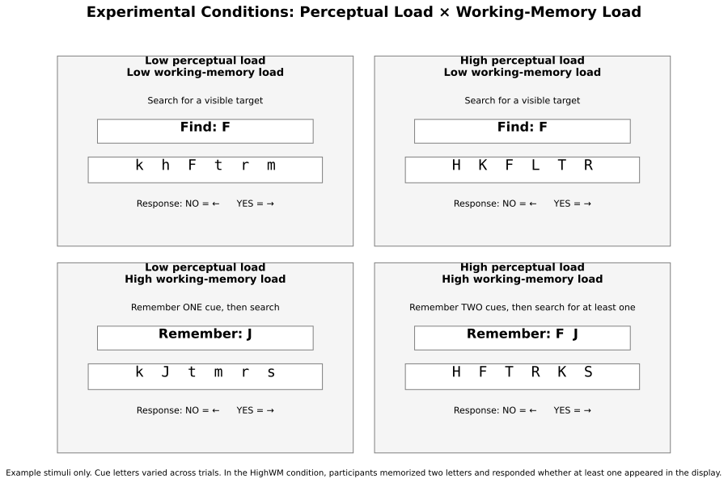
Figure 1. Schematic representation of the four experimental conditions in a 2 × 2 design, defined by the manipulation of perceptual load (low vs. high) and working memory load (low vs. high). Participants searched for a capital target letter/s within a sequence of letters and indicated its presence or absence using arrow key responses (left = no, right = yes).
2.3 fNIRS settings and AOIs
The measurement of changes in concentration of oxygenated (HbO) and deoxygenated (HbR) hemoglobin in the PFC was assessed using a NIRSPORT 2 (NIRx Medizintechnik, Berlin, Germany) continuous wave fNIRS device. Current best-practice guidelines recommend reporting both oxygenated and deoxygenated hemoglobin signals, as the complementary information provided by HbO and HbR contributes to a more comprehensive interpretation of cortical activation patterns (Yücel et al., 2021).
The fNIRS headcap consisted of 16 sources and 23 detectors, forming 54 channels with a source–detector separation of approximately 3 cm. Additionally, 8 short-separation detectors were used to account for superficial hemodynamic signals (Figure 2). According to Yücel et al. (2021), the combined use of short- and long-separation channels improves sensitivity to cortical activity while reducing sensitivity to extracerebral layers. To further account for superficial physiological signals, short-separation regression (Saager & Berger, 2005) was applied, whereby signals measured by short-separation channels were regressed out from the long-separation channel measurements. This procedure improves the specificity of the estimated cortical hemodynamic responses.

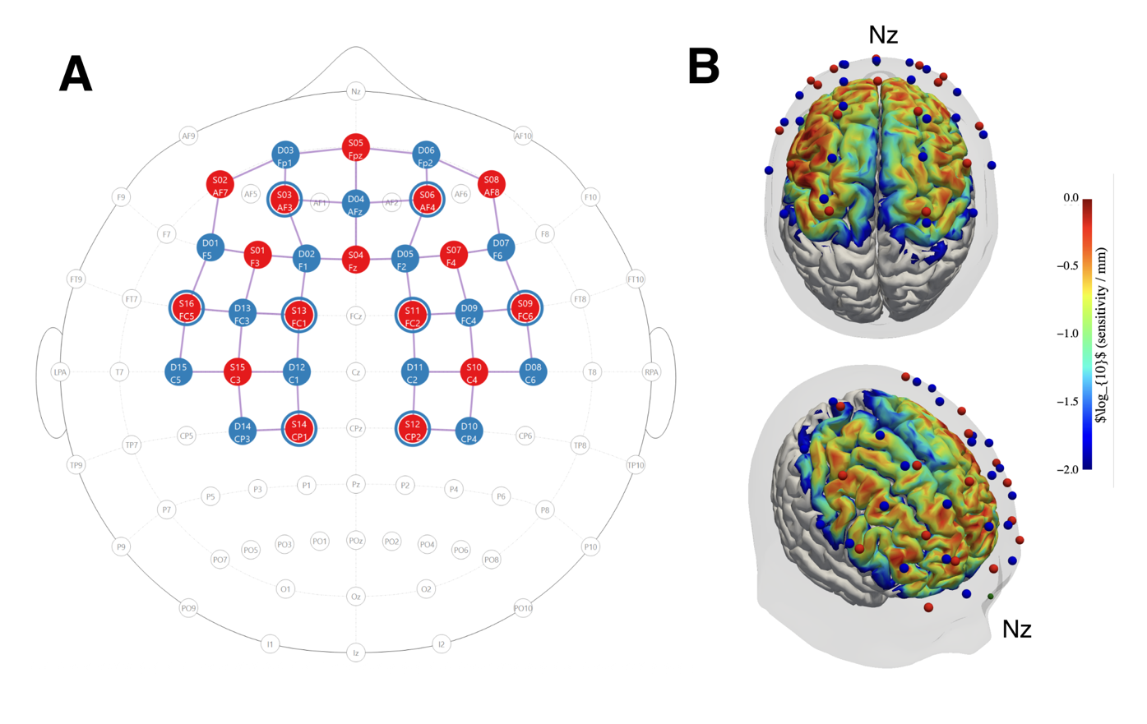
Figure 2. A: Optode placement based on the international 10–20 system (generated using NirSite 2.0, NIRx Medical Technologies). Detectors are shown in blue and sources in red. Blue rings surrounding selected sources indicate short-separation detectors. LPA and RPA denote the left and right preauricular landmarks; Iz indicates the inion and Nz the nasion. B: Sensitivity profile of montage visualized on the colin27 atlas, via Cedalion and NIRFASTer.
Reference points (e.g. nasion/inion) were controlled when fitting the cap, the optodes were fitted to a cap according to the international 10-20 system. The source optodes transmitted light at 760 and 850 nm, and data was sampled at 10 Hz. The montage covered prefrontal, fronto-central, and central cortical regions, including areas associated with executive control, attention, working memory, response selection, and motor planning.
The collected fNIRS data was streamed to a local computer using Aurora (version 2025.2) software. Event triggers delineating block conditions were sent via a lab streaming layer to Aurora. The accuracy and reaction time were recorded using PsychoPy (version 2025.1.1). The experiment was programmed in PsychoPy and event triggers were sent via a lab streaming layer from presentaiton PC to a host PC.
- Data analysis
3.1 Data, software and analysis notebooks

All data and code used to produce the results in this article are available at the project’s Github repository (https://github.com/JuliaAA-lab/Perceptual-fnirs) in a series of Jupyter notebooks that can be run interactively. All data preparation and analysis was performed in Python (v3.14.5) using MNE (v1.12.1) (Gramfort et al., 2013), MNE-BIDS (v0.18.0) and MNE-NIRS (Luke et al., 2021) (forked version from v0.15.2; see Github repository for details).

The dataset is available at OpenNeuro (Markiewicz et al., 2021) (link) in BIDS (Luke et al., 2025) format. The BIDS dataset was prepared using MNE-NIRS write_raw_bids.

3.2 Trigger alignment

Due to technical issues with lab streaming layer event triggers, triggers had to be reinserted from PsychoPy timestamps and aligned to fNIRS data. Because of a time offset between presentation and host PC, triggers were aligned based on fNIRS cap accelerometer data, where visible behavioral changes during pauses in the experimental protocol were used to create an initial alignment. Then, the alignment was refined based on acceleration magnitude and derivative (jerk) in order to minimize alignment offsets.

The alignment was evaluated by assessing whether individual and group block averages across all prefrontal optodes corresponded to an expected hemodynamic response function (HRF) shape; full details can be found in the alignment notebooks. Visual inspection revealed variability in the timing of individual HRFs, with peaks occurring slightly earlier or later than expected stimulus HRF. However, the group-level block average exhibited a canonical HRF profile, with grand mean ± standard error of the mean (SEM) showing non-overlapping intervals for HbO and HbR and consistent timing to expected HRF.

3.2 fNIRS analysis

Analysis of fNIRS data followed a general linear model (GLM) approach, utilizing short channel regressors, autoregressive noise model, cosine drift regressors and a nuisance regressor for the two-minute break in the experimental protocol.

First, raw data was converted into optical density and then into changes of HbO and HbR using the modified Beer-Lambert law (Delpy et al., 1988) with the partial path-length factor (PPF) set to a default value of 0.1.

Subject-level design matrices for GLM analysis included experimental condition HRF regressors (Glover) and a boxcar regressor for the protocol pause. Cosine drift regressors were added, with cutoff frequency 0.0295 Hz based on the longest inter-stimulus interval period. Short separation regressors were added as the mean of all short separation channels. Finally, accelerometer and gyroscope regressors were added via TCCA (von Lühmann et al., 2020). Variance inflation factors (VIFs) (Mumford et al., 2015) were calculated to characterize collinearity of regressors. Subject-level GLM estimates were saved for further statistical analysis.

Channel quality was evaluated for each participant via scalp coupling index (SCI) (Pollonini et al., 2016) over the entire length of the signal. Channels with SCI < 0.8 were marked as bad and excluded from statistical analysis. Channel quality was also summarized across participants with median and interquartile range (IQR).

3.3 Statistical analysis

Group level analysis estimated condition affects against baseline, as well as condition contrasts and interaction effects. Subject level GLM condition estimates (theta) were entered into a linear mixed-effects model using the statsmodels (v0.14.6) (Seabold and Perktold, 2010) package.

For estimating condition effects against baseline, the used model was specified as follows in Wilkinson notation, with subject as a random intercept to account for between-subject variability:

theta ~ -1 + ch_name:Chroma:Condition + (1 | Subject)

For condition contrasts and interactions, the model was specified as follows, where “Load” included both high perceptual load conditions, and “Memory” both high memory conditions:

theta ~ Load * Memory + (1 | Subject)

Channel-level results were separated into HbO and HbR and corrected for multiple comparisons using Benjamini-Hochberg false discover rate (FDR) correction.

For visualization, channel-level results were visualized on a template brain (fsaverage), with FreeSurfer (Fischl, 2012) anatomical regions from the PALS-B12 atlas (Van Essen, 2005) highlighted.
- Results
The signal quality in terms of SCI was generally high (median SCI=0.989, IQR=0.026) during the experiment, reflecting a good optode coupling to the scalp. There were few channels below quality criteria per participant (median number of channels n=1, IQR=2.5).

Design matrix VIFs for the condition regressors ranged from 1.28 to 1.33 (mean VIF ≈ 1.3), indicating low multicollinearity and good separation between the four experimental conditions. Therefore, the observed variability across analyses is unlikely to be attributable to collinearity between regressors and is more likely related to temporal alignment and inter-individual variability in HRF estimation.
Channel-level analysis identified four FDR-corrected significant effects (Table 1; Figure 3). Increased HbO was observed in channel S2_D3 during both the HighPL–HighWM and LowPL–HighWM conditions, indicating that conditions involving higher working-memory demands elicited robust task-related activation. Based on FreeSurfer labels, this channel approximately corresponded to the orbitofrontal cortex (Brodmann Area 11). The strongest effect was observed during the combined HighPL–HighWM condition (β = 4.15, pFDR = 0.0037), while a similar but slightly weaker response was observed during the LowPL–HighWM condition (β = 3.68, pFDR = 0.0141).
In contrast, channel S11_D11, approximately corresponding to the supplementary motor area (Brodmann Area 6), showed a significant decrease in HbO during the HighPL–HighWM condition (β = −3.35, pFDR = 0.0496). Additionally, channel S14_D12 exhibited a significant increase in HbR during the HighPL–HighWM condition (β = 1.69, pFDR = 0.0489). Both effects were limited to the combined high perceptual load and high working-memory load condition. No channel-level contrast or interaction effect (Figure 4) were significant after FDR correction.
Channel | Condition | Chroma | Coef. | 95% CI (Lower) | 95% CI (Upper) | Significant | P_FDR
S2_D3 | HighPL-HighWM | hbo | 4.1539 | 2.2410 | 6.0669 | True | 0.0037
S2_D3 | LowPL-HighWM | hbo | 3.6842 | 1.7713 | 5.5972 | True | 0.0141
S11_D11 | HighPL-HighWM | hbo | -3.3545 | -5.3247 | -1.3844 | True | 0.0496
S14_D12 | HighPL-HighWM | hbr | 1.6899 | 0.7787 | 2.6011 | True | 0.0489
Table 1. Condition effects.

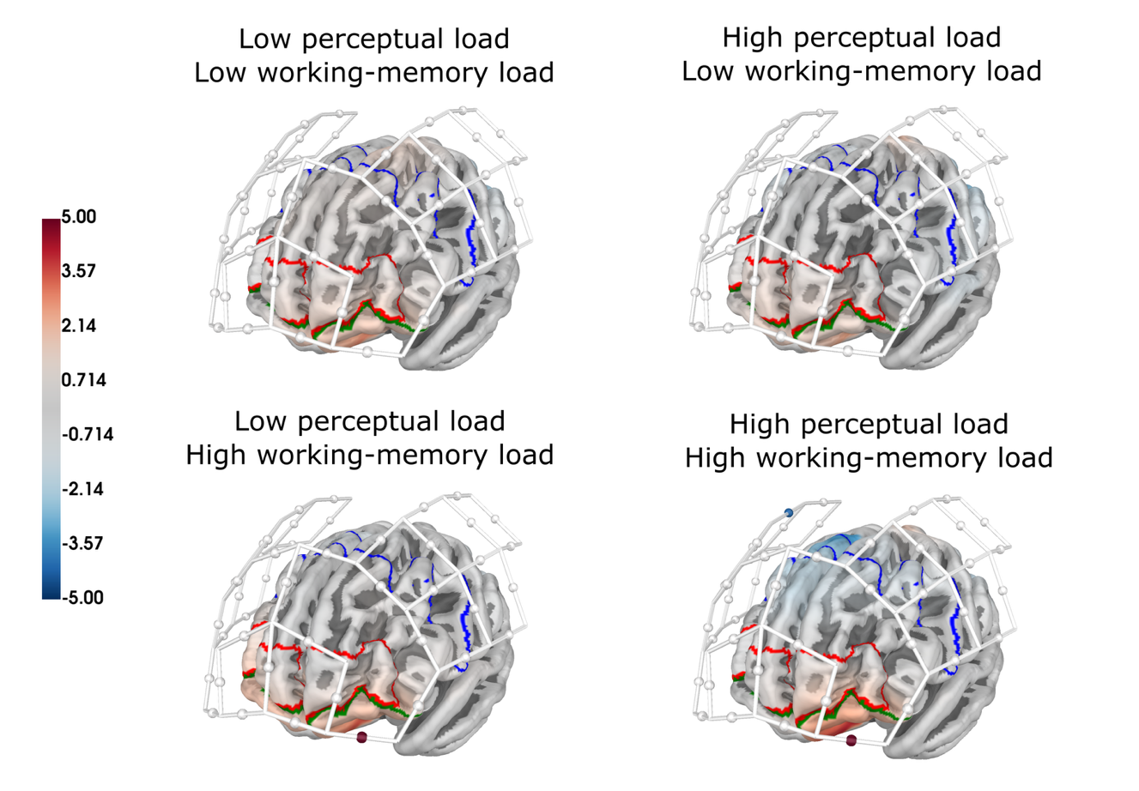
Figure 3. Condition channel-level effects, illustrating an increase in HbO for the high memory low perceptual load condition in BA11 and increase in BA11 but decrease in BA6 for high memory high perceptual load. Blue outline: BA6, red outline: BA10, green outline: BA11. Significant channels are indicated with a colored sphere at the midpoint of the channel.

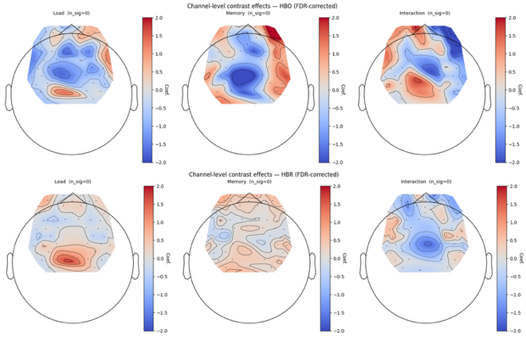
Figure 4. Contrast channel-level effects. Top: HbO. Bottom: HbR.
- Discussion
The present study examined whether fNIRS could distinguish cortical hemodynamic responses associated with perceptual load and working-memory load using an adapted Sternberg paradigm. By independently manipulating both factors, we investigated their separate and combined effects on cortical activation. Overall, the results indicate that fNIRS detected robust neural responses primarily related to working-memory load, whereas evidence for independent perceptual-load effects and load interactions was limited.

In the present study, a 2x2 factorial design was employed, manipulating perceptual load (high/ low) and working-memory load (high/ low), resulting in four experimental conditions, similar to Liu et al. (2022). Perceptual load was increased by enhancing stimulus similarity, consistent with Brockhoff et al. (2022), thereby increasing competition within visual cortex (Torralbo & Beck, 2008). The working-memory manipulation was embedded within a concurrent visual search task, creating substantial combined cognitive demands.

Under these conditions, significant prefrontal activation was observed during working-memory maintenance, indicating successful engagement of cognitive control and memory-related processes. However, the direct contrast between working-memory load levels did not survive FDR correction, suggesting that the manipulation (one vs. two target letters) induced only a modest increase in memory demand relative to the overall task complexity. For comparison, Baker et al. (2018) employed larger working-memory load differences (e.g., 3 vs. 5 dots), which may have produced stronger separation between conditions. This interpretation is consistent with Yi et al. (2004), who reported that working-memory load (one-back vs. two-back) did not significantly modulate processing of task-irrelevant visual information in ventral cortex, whereas perceptual load did. Importantly, Yi et al. (2004) did not include a combined high perceptual–high working-memory condition, highlighting important differences in task structure relative to the present study.

Taken together, the present findings suggest that neural activity primarily reflects general working-memory-related engagement rather than a strong differentiation between load levels. This is supported by the most robust effect observed in channel S2_D3, corresponding approximately to orbitofrontal cortex (BA11), where increased HbO was present in both High PL - High WM and Low PL - High WM conditions. This pattern suggests consistent recruitment of prefrontal regions involved in task monitoring, attentional allocation, and evaluation of cognitive demands. The strongest activation observed under combined high perceptual and high working-memory load further indicates that overlapping demands place additional pressure on cognitive control systems.

In contrast to findings from Xu et al. (2011), who reported increased LPFC and decreased MPFC activation under high perceptual load using fMRI, the present study did not reveal significant perceptual load specific effects after FDR correction. Although the fNIRS montage covered comparable lateral and medial prefrontal regions, perceptual load was embedded within a concurrent working-memory task, which may have reduced the sensitivity of the manipulation and limited the detectability of perceptual-load-specific effects. It is therefore likely that neural responses in the present paradigm reflect the combined influence of task demands rather than isolated perceptual load effects, rather than indicating a dominant contribution of either load type.
Regarding working memory, activation in the present study was observed primarily in the orbitofrontal cortex (BA11) rather than in the dorsolateral prefrontal cortex (BA9/46), which is more commonly associated with working-memory maintenance (Tsujimoto et al., 2004). This may reflect the specific demands of the combined visual-search and working-memory paradigm, in which evaluative and task-monitoring processes may have been more strongly engaged than classical executive maintenance functions. It may also reflect the limited spatial coverage of the fNIRS montage. In contrast, Steve Majerus et al. (2012) reported that increasing short-term memory load (6 vs. 2 items) increased activation in the dorsal attention and executive-control network while producing greater deactivation in the ventral attention/default-mode network, including the orbitofrontal cortex (OFC). Furthermore, their phase-specific analyses demonstrated that the dorsal attention network (primarily SFG and IPS) showed load-dependent increases in activation during encoding and early maintenance, followed by reduced activation during retrieval, whereas ventral attention regions (TPJ and ventral frontal cortex) exhibited the opposite pattern, with greater deactivation during encoding/maintenance and reduced deactivation during retrieval. In the present study, by contrast, increased HbO was observed in the OFC (BA11), while reduced HbO was detected in a fronto-central region corresponding approximately to the premotor/SMA cortex (BA6) under the combined HighPL–HighWM condition. Because our analyses compared each condition with baseline rather than directly contrasting load levels or task phases, the present results cannot be directly compared with the load-dependent and phase-specific network dynamics reported by Majerus et al. (2012). The divergent findings likely reflect differences in task structure, the strength of the working-memory manipulation, and the limited cortical coverage of fNIRS relative to whole-brain fMRI. Methodologically, the present findings should be interpreted in the context of the combined demands imposed by the dual-task design. The simultaneous visual search and working-memory requirements likely induced substantial shared cognitive resource competition, which may have reduced the separability of perceptual and working-memory load manipulations and masked dissociable load-specific effects. From a resource allocation perspective, overlapping task demands can lead to a ceiling-like engagement of domain-general control systems, thereby limiting the sensitivity to detect condition-specific modulations in prefrontal hemodynamics. In addition, inter-individual variability in cognitive capacity and neurovascular coupling may have further reduced statistical sensitivity at the channel level.
More broadly, inconsistencies across studies likely reflect differences in how cognitive load is operationalized. Some paradigms manipulate attentional rather than perceptual load (Cartwright-Finch & Lavie, 2007), and working-memory load effects on distractor processing vary depending on whether memory is associated with primary or secondary task demands (Xu et al., 2011). Thus, the functional impact of working-memory load appears to depend strongly on task structure and cognitive context.

According to a recent review of Load Theory from a neuroscientific perspective (Brockhoff et al., 2022), fMRI studies consistently show reduced processing of visual distractors under high perceptual load. These effects emerge in both early sensory and higher-order cortical regions, depending on task demands and distractor type. Similarly, working-memory load has been associated with reduced distractor processing across unimodal and crossmodal paradigms at multiple processing stages. Overall, both perceptual and working-memory load appear to modulate neural processing in distributed cortical networks, although findings vary across methodologies and experimental designs. Importantly, direct comparisons between perceptual and working-memory load remain challenging due to differences in study designs and the smaller number of working-memory investigations. Nevertheless, both forms of load are generally associated with reduced processing under high-demand conditions.

Interestingly, Gao et al. (2025) demonstrated that 8-week adaptive working-memory training enhances functional connectivity between premotor cortex (BA6) and bilateral dorsolateral prefrontal cortex, while reducing DLPFC activation during task performance, suggesting increased neural efficiency. These findings are consistent with the present observation of BA6 involvement under high cognitive demand, indicating that premotor regions may contribute to broader executive control networks under increased workload.

Finally, future studies should consider increasing working-memory load magnitude (e.g., one vs. four or more items) to improve sensitivity to load-dependent effects and to better dissociate perceptual and working-memory contributions to cortical activation.
- Limitations
This study has several limitations. First, working-memory load may have been influenced by factors such as fatigue (despite block randomization), individual differences in cognitive capacity, and task-specific demands. In particular, baseline variability in working-memory capacity may have affected participants’ performance under high cognitive load conditions (Baddeley, 2003).

A further limitation concerns the use of fNIRS as a relatively emerging neuroimaging technique. Although increasingly applied in cognitive neuroscience, the number of studies examining combined perceptual and working-memory load remains limited, which reduces the availability of a well-established comparative framework. In addition, while optode placement was guided by standard cap fitting procedures and anatomical landmarks (e.g., nasion and inion), more precise spatial registration would likely have improved localization accuracy of the underlying cortical regions (Wyser et al., 2022).

It is important to note that certain aspects of the experimental manipulation may have been overlooked due to the relatively slow hemodynamic response measured by fNIRS compared with neuronal activity (Cui et al., 2010). Although the analyses explicitly modelled the delayed hemodynamic response, the inherent temporal characteristics of the signal limit the detection of rapid event-related neural dynamics. Multimodal approaches combining fNIRS with electroencephalography (EEG) may therefore provide a more comprehensive characterization of both the temporal and spatial aspects of cognitive processing.

Despite these limitations, the findings have several practical implications. Future research should aim to increase sample size and include more diverse populations in terms of age, education, and cultural background to improve generalizability. In addition, given evidence that fronto-parietal activation differs between encoding and retrieval phases (Baker et al., 2018), future studies should further disentangle phase-specific effects of perceptual and working-memory load.

Finally, the present montage primarily targeted prefrontal regions and did not provide full cortical coverage. Future work would benefit from denser optode configurations and broader coverage, particularly including occipital areas, to better capture perceptual load–related activity in visual cortex.
- Conclusion
This study investigated the effects of combined perceptual and working-memory load on prefrontal hemodynamics using fNIRS. The results indicate that neural responses were primarily driven by working-memory demands, with the strongest effects observed under high working-memory conditions, particularly when combined with high perceptual load. Significant activation was found in orbitofrontal regions (BA11), while perceptual-load–specific effects did not survive FDR correction. In addition, reduced activation in a fronto-central region (BA6) and modulation of HbR suggest involvement of both prefrontal control and premotor-related systems under increased cognitive demand. Overall, the findings support an integrated view of cognitive load effects on prefrontal function and highlight the importance of working-memory demands in shaping task-related brain activity.

CRediT authorship contribution statement
Conceptualization, J.B.; Methodology, J.B., A.K.; Data collection: J.B. Data Analysis, A.K; Supervision: J.B.; Writing - original draft, J.B., A.K.; Writing - review and editing, J.B., A.K. All authors have read and agreed to the published manuscript.
Data availability
This study is registered on:
where additionally all scripts used for data analysis can be found.
The original raw data can be found online:
Declaration of Competing Interest
The authors declare that they have no known compelling financial interests or personal relationships that could have appeared to influence the work reported in this paper.
Acknowledgments
We want to thank NIRx Medizintechnik GmbH for providing fNIRS equipment; and Åbo Akademi foundation and Karolinska Institutet for supporting this study.
Appendix A. Supplementary data.
Supplementary data to this article can be found online at:

References

- Ahmadi, M.; Michalka, S.W.; Najafabadi, M.A.; Wünsche, B.C.; Billinghurst, M. (2024). EEG, Pupil Dilations, and Other Physiological Measures of Working Memory Load in the Sternberg Task. Multimodal Technol. Interact., 8, 34. https://doi.org/10.3390/mti8040034
- Amaro, E., & Barker, G. J. (2006). Study design in fMRI: Basic principles. Brain and Cognition, 60(3), 220–232. https://doi.org/10.1016/j.bandc.2005.11.009
- Baddeley, A. (2003). Working memory: Looking back and looking forward. Nature Reviews Neuroscience, 4(10), 829–839. https://doi.org/10.1038/nrn1201
- Baddeley, A. (1996). The fractionation of working memory. Proc Natl Acad Sci USA; 93(24):13468-72. https://doi.org/10.1073/pnas.93.24.13468
- Baker, J.M., Bruno, J.L., Gundran, A., Hosseini, S.M.H., Reiss, A.L. (2018). fNIRS measurement of cortical activation and functional connectivity during a visuospatial working memory task. PLoS ONE 13(8): e0201486. https://doi.org/10.1371/journal.pone.0201486
- Braver, T.S., Cohen, J.D., Nystrom, L.E., Jonides, J., Smith, E.E., Noll, D.C. (1997). A parametric study of prefrontal cortex involvement in human working memory, Neuroimage, 5 (1), 49–62. https://doi.org/10.1006/nimg.1996.0247
- Brockhoff, L., Schindler, S., Bruchmann, M., Straube, T. (2022). Effects of perceptual and working memory load on brain responses to task-irrelevant stimuli: Review and implications for future research, Neuroscience & Biobehavioral Reviews, Volume 135, 104580. https://doi.org/10.1016/j.neubiorev.2022.104580
- Cartwright-Finch, U. & Lavie, N. (2007). The role of perceptual load in inattentional blindness. Cognition, 102, 3, 321-340, https://doi.org/10.1016/j.cognition.2006.01.002
- Chong, T.T.-J., Williams, M.A., Cunnington, R., Mattingley, J.B. (2008). Selective attention modulates inferior frontal gyrus activity during action observation. NeuroImage 40, 298–307. https://doi.org/10.1016/j.neuroimage.2007.11.030
- Cohen, J.D., Perlstein, W.M., Braver, T.S., Nystrom, L.E., Noll, D.C., Jonides, J. et al. (1997). Temporal dynamics of brain activation during a working memory task, Nature. 386 (6625) 604. https://doi.org/10.1038/386604a0
- Cowan, N. (2010). The magical mystery four: How is working memory capacity limited, and why? Curr. Dir. Psychol. Sci., 19, 51–57. https://doi.org/10.1177/0963721409359277
- Cui, X., Bray, S., Reiss, A.L. (2010). Speeded near infrared spectroscopy (NIRS) response detection. PLoS One, 5 (11), e15474. https://doi.org/10.1371/journal.pone.0015474
- de Fockert, J.W., Rees, G., Frith, C.D., Lavie, N. (2001). The role of working memory in visual selective attention. Science 291: 1803–1806. https://doi.org/10.1126/science.1056496
- Delpy, D.T., Cope, M., van der Zee, P., Arridge, S., Wray, S., Wyatt, J., 1988. Estimation of optical pathlength through tissue from direct time of flight measurement. Physics in Medicine and Biology 33, 1433–1442. https://doi.org/10.1088/0031-9155/33/12/008
- Engle, R.W. (2002). Working memory capacity as executive attention, Curr. Dir. Psychol. Sci. 11 (1), 19–23. https://doi.org/10.1111/1467-8721.00160
- Fischl, B., 2012. FreeSurfer. NeuroImage, 20 YEARS OF fMRI 62, 774–781. https://doi.org/10.1016/j.neuroimage.2012.01.021
- Gao, Y., Fang, P., Xing, W., Zeng, L., Wang, H., Zhu, X., Wang, X. (2025). Enhancing brain plasticity: Functional near-infrared spectroscopy evidence for computerized working memory training in healthy adults. Brain Research Bulletin, Volume 233, 111646, https://doi.org/10.1016/j.brainresbull.2025.111646
- Gómez, C. M., Barriga-Paulino, C. I., Rodríguez-Martínez, E. I., Rojas- Benjumea, M. A., Arjona, A., & Gómez-González, J. (2018). The neurophysiology of working memory development: From childhood to adolescence and young adulthood. Reviews in the Neurosciences, 29(3), 261–282. https://doi.org/10.1515/revneuro-2017-0073
- Gramfort, A., Luessi, M., Larson, E., Engemann, D., Strohmeier, D., Brodbeck, C., Goj, R., Jas, M., Brooks, T., Parkkonen, L., Hämäläinen, M., 2013. MEG and EEG data analysis with MNE-Python. Frontiers in Neuroscience 7.
- Herold, F., Wiegel, P., Scholkmann, F., Thiers, A., Hamacher, D., Schega, L. (2017). Functional near-infrared spectroscopy in movement science: a systematic review on cortical activity in postural and walking tasks. Neurophotonics 4, 041403. https://doi.org/10.1117/1.NPh.4.4.041403
- Hu, X., Zhuang, C., Wang, F., Liu, Y. J., Im, C. H., & Zhang, D. (2019). fNIRS evidence for recognizably different positive emotions. Frontiers in Human Neuroscience, 13, 120. https://doi.org/10.3389/fnhum.2019.00120
- Keshmiri, S., Sumioka, H., Yamazaki, R., Ishiguro, H. (2018). Differential entropy preserves variational information of near-infrared spectroscopy time series associated with working memory, Front. Neuroinform. 12, 33. https://doi.org/10.3389/fninf.2018.00033
- Klemen, J., Buchel, C., Buhler, M., Menz, M.M., Rose, M. (2010). Auditory working memory load impairs visual ventral stream processing: toward a unified model of attentional load. J Cogn Neurosci, 22: 437–446. https://doi.org/10.1162/jocn.2009.21204
- Konstantinou, N., & Lavie, N. (2013). Dissociable roles of different types of working memory load in visual detection.Journal of Experimental Psychology: Human Perception and Performance, 39(4), 919–924. https://doi.org/10.1037/a0033037
- Kron, A., Schul, Y., Cohen, A., & Hassin, R. R. (2010). Feelings don’t come easy: Studies on the effortful nature of feelings. Journal of Experimental Psychology: General, 139(3), 520– 534. https://doi.org/10.1037/a0020008
- Kvist, A., Bezuidenhout, L., Johansson, H., Albrecht, F., Conradsson, D.M., Franzén, E. (2024). Validation of fNIRS measurement of executive demand during walking with and without dual-task in younger and older adults and people with Parkinson’s disease. NeuroImage: Clinical, 43, 103637, https://doi.org/10.1016/j.nicl.2024.103637
- Lavie, N. (2005) Distracted and confused?: selective attention under load. Trends Cogn Sci., 9: 75–82. https://doi.org/10.1016/j.tics.2004.12.004
- Lavie, N. (1995). Perceptual load as a necessary condition for selective attention. J. Exp. Psychol. Hum. Percept. Perform. 21, 451–468. https://doi.org/10.1037//0096-1523.21.3.451
- Lavie, N., Hirst, A., de Fockert, J. W., Viding, E. (2004). Load Theory of Selective Attention and Cognitive Control. Journal of Experimental Psychology: General, 133(3), 339–354. https://psycnet.apa.org/doi/10.1037/0096-3445.133.3.339
- Lavie, N. (1995). Perceptual load as a necessary condition for selective attention. Journal of Experimental Psychology: Human Perception and Performance, 21(3), 451 468. https://psycnet.apa.org/doi/10.1037/0096-1523.21.3.451
- Lavie, N., Beck, D.M., Konstantinou, N.(2014). Blinded by the load: attention, awareness and the role of perceptual load. Philos Trans R Soc Lond B Biol Sci 5, 369 (1641): 20130205. https://doi.org/10.1098/rstb.2013.0205
- Liu, J.-C., Li, K.-A., Yeh, S.-L., Chien, S.-Y. (2022). Assessing Perceptual Load and Cognitive Load by Fixation-Related Information of Eye Movements. Sensors, 22(3), 1187. https://doi.org/10.3390/s22031187
- Liu, X., Liu, S., Guo, D., Sheng, Y., Ke, Y., An, X., Xu, M., He, F., Cheng, X, & Ming, D. (2018). Effect of emotion states on the updating function of working memory. In: 40th Annual international conference of the IEEE engineering in medicine and biology society (pp. 1907–1910). https://doi.org/10.1109/EMBC.2018.8512660
- Lucas, I., Urieta, P., Balada, F., Blanco, E., Aluja, A. (2020). Differnces in prefrontal cortex activity based on difficulty in a working memory task using near-infrared spectroscopy. Behavioural Brain Research, 392, https://doi.org/10.1016/j.bbr.2020.112722
- Luke, R., Larson, E.D., Shader, M.J., Innes-Brown, H., Yper, L.V., Lee, A.K.C., Sowman, P.F., McAlpine, D., 2021. Analysis methods for measuring passive auditory fNIRS responses generated by a block-design paradigm. Neurophotonics 8, 025008. https://doi.org/10.1117/1.NPh.8.2.025008
- Luke, R., Oostenveld, R., Cockx, H., Niso, G., Shader, M.J., Orihuela-Espina, F., Innes-Brown, H., Tucker, S., Boas, D., Yücel, M.A., others, 2025. NIRS-BIDS: Brain imaging data structure extended to near-infrared spectroscopy. Scientific Data 12, 159.
- Ma, L., Chang, L., Chen, X., Zhou, R. (2017). Working memory test battery for young adults: Computerized working memory assessment. PLOS ONE 12(3):e0175047. https://doi.org/10.1371/journal.pone.0175047
- Majerus, S., Attout, L., D’Argembeau, A., Degueldre, C., Fias, W., Maquet, P., Martinez Perez, T., Stawarczyk, D., Salmon, E., Van der Linden, M., Phillips, C., Balteau, E. (2012). Attention supports verbal short-term memory via competition between dorsal and ventral attention networks. Cereb. Cortex, 22, 1086–1097. https://doi.org/10.1093/cercor/bhr174
- Markiewicz, C.J., Gorgolewski, K.J., Feingold, F., Blair, R., Halchenko, Y.O., Miller, E., Hardcastle, N., Wexler, J., Esteban, O., Goncavles, M., Jwa, A., Poldrack, R., 2021. The OpenNeuro resource for sharing of neuroscience data. eLife 10, e71774. https://doi.org/10.7554/eLife.71774
- Molteni, E., Butti, M., Bianchi, A.M., Reni, G. (2008). Activation of the prefrontal cortex during a visual n-back working memory task with varying memory load: a near infrared spectroscopy study. In 2008 30th Annual International Conference of the IEEE Engineering in Medicine and Biology Society, 4024–4027. https://doi.org/10.1109/iembs.2008.4650092
- Moya, C., Fuentes-Sánchez, N., Martínez-Sáez, M.C. et al. (2025). Influence of working memory overload on emotional processing and recognition memory: An fNIRS study. Mem Cogn 54, 216–232. https://doi.org/10.3758/s13421-025-01746-5
- Mumford, J.A., Poline, J.-B., Poldrack, R.A., 2015. Orthogonalization of Regressors in fMRI Models. PLoS ONE 10, e0126255. https://doi.org/10.1371/journal.pone.0126255
- Murphy, G., Groeger, J.A. & Greene, C.M. (2016). Twenty years of load theory—Where are we now, and where should we go next?. Psychon Bull Rev 23, 1316–1340. https://doi.org/10.3758/s13423-015-0982-5
- Neubauer, A.C., Fink, A. (2009). Intelligence and neural efficiency. Neurosci. Biobehav. Rev. 33, 1004–1023. https://doi.org/10.1016/j.neubiorev.2009.04.001
- Oberauer, K., Süß, H.M., Wilhelm, O., Sander, N. (2007). Individual differences in working memory capacity and reasoning ability. In Variation in Working Memory; Oxford University Press: Oxford, UK.
- Ogawa, Y., Kotani, K., Jimbo, Y. (2014). Relationship between working memory performance and neural activation measured using near-infrared spectroscopy, Brain Behav., 4 (4), 544–551. https://doi.org/10.1002/brb3.238
- Paas, F., Tuovinen, J.E., Tabbers, H., Van Gerven, P.W. (2003). Cognitive load measurement as a means to advance cognitive load theory. Educ. Psychol., 38, 63–71. https://doi.org/10.1207/S15326985EP3801_8
- Pollonini, L., Bortfeld, H., Oghalai, J.S., 2016. PHOEBE: A method for real time mapping of optodes-scalp coupling in functional near-infrared spectroscopy. Biomedical Optics Express 7, 5104–5119. https://doi.org/10.1364/BOE.7.005104
- Rees, G., Frith, C.D., Lavie, N. (1997). Modulating irrelevant motion perception by varying attentional load in an unrelated task. Science 278, 1616–1619. https://doi.org/10.1126/science.278.5343.1616
- Saager R. B. & Berger A. J. (2005). Direct characterization and removal of interfering absorption trends in two-layer turbid media. J. Opt. Soc. Am. A. 22(9), 1874. https://doi.org/10.1364/josaa.22.001874
- Scholkmann, F., Kleiser, S., Metz, A.J., Zimmermann, R., Mata Pavia, J., Wolf, U., Wolf, M. (2014). A review on continuous wave functional near-infrared spectroscopy and imaging instrumentation and methodology. Neuroimage 85 (1), 6–27. https://doi.org/10.1016/j.neuroimage.2013.05.004
- Schwartz, S., Vuilleumier, P., Hutton, C., Maravita, A., Dolan, R.J., et al. (2005). Attentional load and sensory competition in human vision: modulation of fMRI responses by load at fixation during task-irrelevant stimulation in the peripheral visual field. Cereb Cortex, 15: 770–786. https://doi.org/10.1093/cercor/bhh178
- Seabold, S., Perktold, J., 2010. Statsmodels: Econometric and Statistical Modeling with Python. SciPy 2010. https://doi.org/10.25080/Majora-92bf1922-011
- Sternberg, S. (1965). High-speed scanning in human memory. Science, 153 (3736), 652-654.
- Sweller, J. and Chandler, P. (1991). Evidence for cognitive load theory. Cogn. Instr., 8, 351–362. https://doi.org/10.1207/s1532690xci0804_5
- Tanida, M., Sakatani, K., Tsujii, T. (2012). Relation between working memory performance and evoked cerebral blood oxygenation changes in the prefrontal cortex evaluated by quantitative time-resolved near-infrared spectroscopy, Neurol. Res. 34 (2), 114–119. https://doi.org/10.1038/s41598-026-36717-6
- Torralbo, A., Beck, D.M., 2008. Perceptual-load-induced selection as a result of local competitive interactions in visual cortex. Psychol. Sci. 19, 1045–1050. https://doi.org/10.1111/j.1467-9280.2008.02197.x
- Tsujimoto, S., Yamamoto, T., Kawaguchi, H., Koizumi, H., Sawaguchi, T. (2004). Prefrontal Cortical Activation Associated with Working Memory in Adults and Preschool Children: An Event-related Optical Topography Study, Cerebral Cortex, Volume 14, 7, 703–712, https://doi.org/10.1093/cercor/bhh030
- Van Dillen, L. F., & Koole, S. L. (2007). Clearing the mind: A working memory model of distraction from negative mood. Emotion, 7(4), 715–723. https://doi.org/10.1037/1528-3542.7.4.715
- Van Essen, D.C., 2005. A Population-Average, Landmark- and Surface-based (PALS) atlas of human cerebral cortex. NeuroImage 28, 635–662. https://doi.org/10.1016/j.neuroimage.2005.06.058
- Vogel, E.K. & Machizawa, M.G. (2004). Neural activity predicts individual differences in visual working memory capacity. Nature 428, 748–751. https://doi.org/10.1038/nature02447
- von Lühmann, A., Li, X., Müller, K.-R., Boas, D.A., Yücel, M.A., 2020. Improved physiological noise regression in fNIRS: A multimodal extension of the General Linear Model using temporally embedded Canonical Correlation Analysis. NeuroImage 208, 116472. https://doi.org/10.1016/j.neuroimage.2019.116472
- Wang, R., Liu, M., Cheng, X., Wu, Y., Hildebrandt, A., Zhou, C., (2021). Segregation, integration and balance of large-scale resting brain networks configure different cognitive abilities. Proc. Natl. Acad. Sci. (23), e2022288118. https://doi.org/10.1073/pnas.2022288118
- Woodman, G.F., Vogel, E.K., Luck, S.J. (2001). Visual search remains efficient when visual working memory is full. Psychol. Sci. 12, 219–224. https://doi.org/10.1111/1467-9280.00339
- Wyser, D.G., Kanzler, C.M., Salzmann, L., Lambercy, O., Wolf, M., Scholkmann, F., Gassert, R. (2022). Characterizing reproducibility of cerebral hemodynamic responses when applying short-channel regression in functional near-infrared spectroscopy. Neurophotonics 9, 015004. https://doi.org/10.1117/1.NPh.9.1.015004
- Xu, J., Monterosso, J., Kober, H., Balodis, I.M., Potenza, M.N. (2011) Perceptual Load-Dependent Neural Correlates of Distractor Interference Inhibition. PLoS ONE 6(1): e14552. https://doi.org/10.1371/journal.pone.0014552
- Yi, DJ., Woodman, G., Widders, D. et al. (2004). Neural fate of ignored stimuli: dissociable effects of perceptual and working memory load. Nat Neurosci, 7, 992–996. https://doi.org/10.1038/nn1294
- Yücel, M.A., Lühmann, A. v., Scholkmann, F., Gervain, J., Dan, I., Ayaz, H., Boas, D., Cooper, R.J., Culver, J., Elwell, C.E., Eggebrecht, A., Franceschini, M.A., Grova, C., Homae, F., Lesage, F., Obrig, H., Tachtsidis, I., Tak, S., Tong, Y., Torricelli, A.,Wabnitz, H., Wolf, M. (2021). Best practices for fNIRS publications. Neurophotonics 8, 012101. https:/org.doi/10.1117/1.NPh.8.1.012101
- Yücel, G., Petty, C., McCarthy, G., Belger, A. (2005). Graded visual attention modulates brain responses evoked by task-irrelevant auditory pitch changes. J Cogn Neurosci, 17: 1819–1828. https://doi.org/10.1162/089892905775008698

