
Title
Julia Bend^{*1,2}, Alexander Kvist³
¹ Åbo Akademi University, Turku, Finland
² Linneaus University. Växjö, Swedenы
³ Karolinska University, Stockholm, Sweden
Abstract

© 2026 Elsevier Science. All rights reserved

- Introduction
Text about PL and WML – in progress
Previous studies have reported an association between working-memory performance and increased prefrontal cortex (PFC) activation (Braver et al., 1997; Cohen et al., 1997; Ogawa et al., 2014). Increased working-memory load has also been linked to executive attention and the ability to resist distraction (Engle, 2002), suggesting that the PFC plays a central role in supporting working-memory processes.

fNIRS part – done
Functional near-infrared spectroscopy (fNIRS) is a non-invasive, portable, and relatively easy-to-use neuroimaging technique that has been widely applied across diverse populations and research domains (Yücel et al., 2021). The method measures brain activity by transmitting near-infrared light through cortical tissue and exploiting the distinct optical absorption properties of oxygenated hemoglobin (HbO₂) and deoxygenated hemoglobin (HbR), thereby enabling the assessment of task-related hemodynamic responses (Scholkmann et al., 2014). fNIRS provides measurements of cortical hemodynamic activity and can be used in experimental paradigms involving natural head movements, thereby facilitating data collection in relatively unconstrained behavioral settings (Herold et al., 2017).
Previous studies have successfully used fNIRS to assess working-memory processes. For example, increased prefrontal activation has been observed with increasing task difficulty in N-back paradigms, indicating a relationship between working-memory load and cortical oxygenation (Molteni et al., 2008). Similarly, lateral prefrontal cortex activation has been linked to working-memory performance (Tanida et al., 2012), and fNIRS has been applied to evaluate different approaches for analyzing working-memory tasks (Keshmiri et al., 2018). However, to our knowledge, no previous fNIRS study has simultaneously manipulated perceptual load and working-memory load within a 2 × 2 factorial design.
Curent study. Objectives, aims – done
The present study investigated the validity of fNIRS as an indicator of perceptual and working-memory load. To achieve this, we employed an adapted Sternberg paradigm (Sternberg, 1965) to independently manipulate perceptual load and working-memory load. Participants were required to identify target letters within visually presented letter arrays while retaining either one or two target letters in memory. The experimental design enabled the examination of distinct patterns of brain activation associated with variations in perceptual and working-memory demands at both the individual and group levels. Furthermore, the study sought to identify cortical regions most strongly associated with these two forms of cognitive load as measured by fNIRS.
Based on previous literature, we hypothesized that perceptual load would primarily modulate activation in visual cortical regions, whereas increasing working-memory load would elicit greater activation in prefrontal regions associated with executive control and attentional processes. More specifically, increased working-memory demands were expected to engage regions implicated in the maintenance and manipulation of information in working memory, including the dorsolateral prefrontal cortex.
- Methods
2.1 Participants
Sixteen healty adults (7 females, 9 males, mean age = 38,7 years) were recruited through advertisements. All participants received verbal and written information and gave written consent prior to study participation. All personal data was anonymised and no personal data was stored.
2.2 Procedure
Prior to the experimental session, participants were asked about health status and to provide their head size (circumference) for the fNIRS measurement. During the experimental session, in addition to the fNIRS measurement, reaction time, accuracy and oral feedback were collected. Demographic data consisted of sex and age.
The experiment employed a 2 × 2 factorial design manipulating perceptual load (PL) and working memory load (WML), resulting in four conditions: (1) low PL–low WML, (2) low PL–high WML, (3) high PL–low WML, and (4) high PL–high WML (Figure 1). Each condition consisted of 10 trials. The task was a computer-based letter search paradigm in which participants were required to detect target letters within visually presented letter arrays. Target letters were always presented in uppercase.
Perceptual load (PL) was manipulated by varying the visual complexity of the letter arrays. In low PL conditions, stimuli consisted of simple, homogeneous strings of lowercase letters, with an uppercase target letter that was visually distinct and easily detectable among the distractors. In high PL conditions, stimuli consisted of arrays of uppercase letters, increasing visual similarity between targets and distractors and thereby increasing perceptual competition. This manipulation increased the amount of visual information to be processed, placing greater demands on perceptual processing. Working memory load (WML) was manipulated by varying the number of target letters participants were required to maintain. In low WML conditions, participants searched for a single target letter presented prior to each trial, and this target remained constant across trials within the condition. In high WML conditions, participants were required to remember two target letters on each trial and respond if at least one appeared in the array. Importantly, even in the low WML condition, a baseline level of working memory load was present due to the requirement to retain the target letter across a short delay. The high WML condition further increased cognitive demands by requiring the maintenance and comparison of multiple target representations.
The experimental conditions were organized in a block design. Two conditions (low PL–low WML and high PL–low WML) were presented in the first part of the experiment, followed by a two-minute break, after which the remaining two conditions (low PL–high WML and high PL–high WML) were completed. The total duration of the experiment was approximately 40 minutes, including practice trials and instructions.Participants were instructed to respond by pressing a left arrow (if the target was not present) and a right arrow (if the target was present), as fast and correctly as possible. The responses were recorded to analyze task accuracy as well as reaction time.
Stimuli were presented for 5s, followed by the participant’s response and a 10s rest period to allow for baseline measurement (Amaro & Barker, 2006) and to provide feedback on response accuracy. During the rest period, the stimulus display remained unchanged while feedback was presented. Each experimental condition consisted of 10 trials, preceded by three practice trials. Trial order within each condition was randomized to minimize learning effects due to repetition. Participants were given a two-minute break between the second and third experimental blocks.
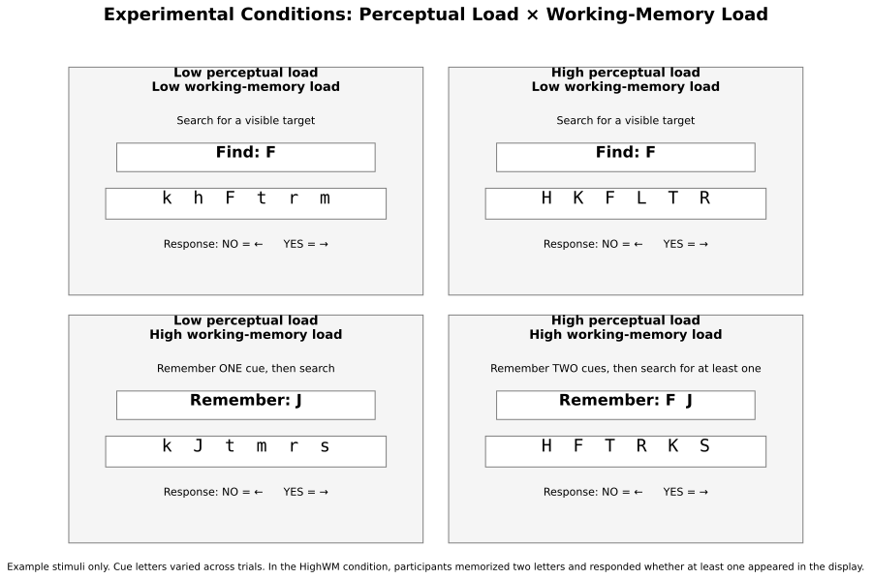
Figure 1. Schematic representation of the four experimental conditions in a 2 × 2 design, defined by the manipulation of perceptual load (low vs. high) and working memory load (low vs. high). Participants searched for a capital target letter/s within a sequence of letters and indicated its presence or absence using arrow key responses (left = no, right = yes).
2.3 fNIRS settings and AOIs
The measurement of changes in concentration of oxygenated (HbO) and deoxygenated (HHb) hemoglobin in the PFC was assessed using a NIRSPORT 2 (NIRx Medizintechnik, Berlin, Germany) continuous wave fNIRS device. Current best-practice guidelines recommend reporting both oxygenated and deoxygenated hemoglobin signals, as the complementary information provided by HbO₂ and HbR contributes to a more comprehensive interpretation of cortical activation patterns (Yücel et al., 2021).
The fNIRS headcap consisted of 16 sources and 23 detectors, forming 54 channels with a source–detector separation of approximately 3 cm. Additionally, 8 short-separation detectors were used to account for superficial hemodynamic signals (Figure 2). According to Yücel et al. (2021), the combined use of short- and long-separation channels improves sensitivity to cortical activity while reducing sensitivity to extracerebral layers. To further account for superficial physiological signals, short-separation regression (Saager & Berger, 2005) was applied, whereby signals measured by short-separation channels were regressed out from the long-separation channel measurements. This procedure improves the specificity of the estimated cortical hemodynamic responses.

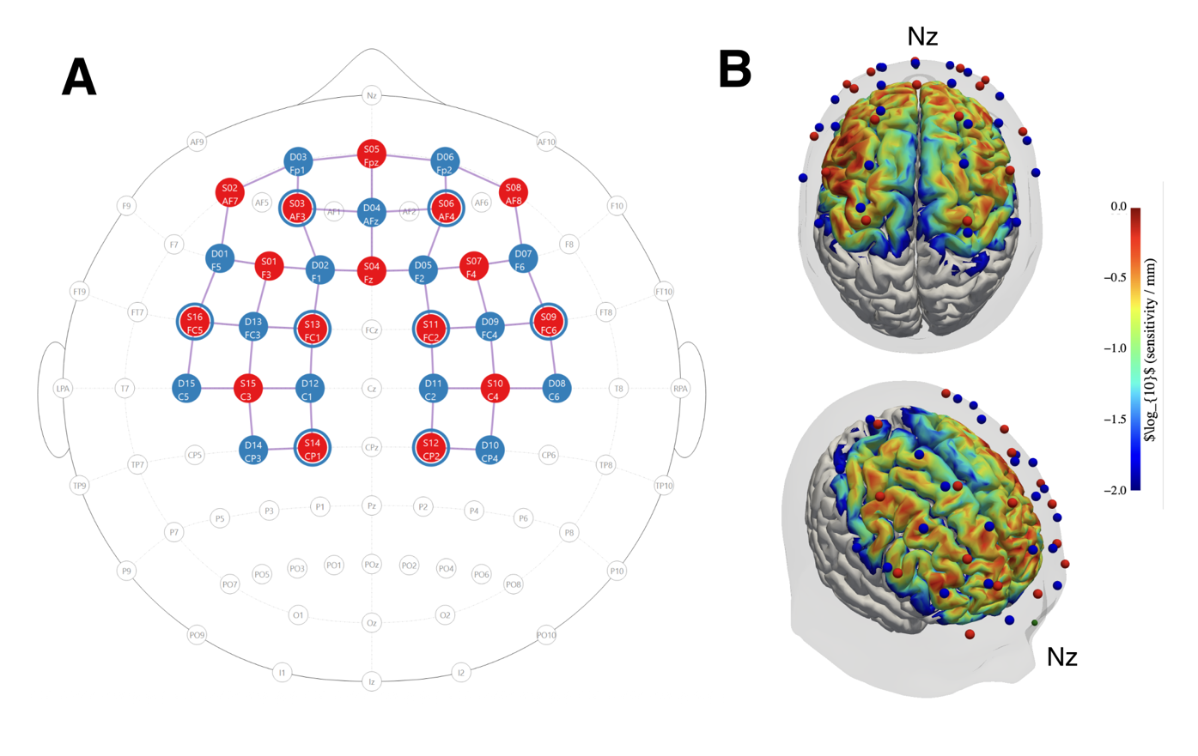
Figure 2. A: Optode placement based on the international 10–20 system (generated using NirSite 2.0, NIRx Medical Technologies). Detectors are shown in blue and sources in red. Blue rings surrounding selected sources indicate short-separation detectors. LPA and RPA denote the left and right preauricular landmarks; Iz indicates the inion and Nz the nasion. B: Sensitivity profile of montage visualized on the colin27 atlas, via Cedalion and NIRFASTer.
Reference points (e.g. nasion/inion) were controlled when fitting the cap, the optodes were fitted to a cap according to the international 10-20 system. The source optodes transmitted light at 760 and 850 nm, and data was sampled at 10 Hz. To allow for removal of peripheral interference (stemming from blood flow changes in extracerebral layers of the head), short-separation reference channels (Saager and Berger, 2005) (8 mm separation) were used.
Regions of interest (ROIs) were defined based on the optode layout. The montage covered prefrontal, fronto-central, and central cortical regions, including areas associated with executive control, attention, working memory, response selection, and motor planning.
The collected fNIRS data was streamed to a local computer using Aurora (version 2025.2) software. Event triggers delineating block conditions were sent via a lab streaming layer to Aurora. The accuracy and reaction time were recorded using PsychoPy (version 2025.1.1). The experiment was programmed in PsychoPy (version 2025.1.1) and event triggers were sent via a lab streaming layer from presentaiton PC to a host PC.s
The signal quality in terms of SCI was generally high ( ) during the experiment, reflecting a good optode coupling to the scalp. The average peak spectral power was above the customary threshold for a good signal 0.1. (Pollonini et al., 2016). Channel quality was evaluated for each participant via scalp coupling index (SCI) (ref). Channels with SCI < 0.8 were marked as bad and excluded from statistical analysis.

- Data analysis
3.1 Data, software and analysis notebooks

All data and code used to produce the results in this article are available at the project’s Github repository (https://github.com/JuliaAA-lab/Perceptual-fnirs) in a series of Jupyter notebooks that can be run interactively. All data preparation and analysis was performed in Python (v3.14.5) using MNE (v1.12.1) (ref), MNE-BIDS (v0.18.0) and MNE-NIRS (forked version from v0.15.2; see Github repository for details).

The dataset is available at OpenNeuro (ref) (link) in BIDS (ref) format. The BIDS dataset was prepared using MNE-NIRS write_raw_bids.

3.2 Trigger alignment

Due to technical issues with lab streaming layer event triggers, triggers had to be reinserted from PsychoPy timestamps and aligned to fNIRS data. Because of a time offset between presentation and host PC, triggers were aligned based on fNIRS cap accelerometer data, where visible behavioral changes during pauses in the experimental protocol were used to create an initial alignment. Then, the alignment was refined based on acceleration magnitude and derivative (jerk) in order to minimize alignment offsets.

The alignment was evaluated by assessing whether individual and group block averages across all prefrontal optodes corresponded to an expected hemodynamic response function (HRF) shape; full details can be found in the alignment notebooks. The final alignment was determined to have some uncertainty between participants, but on group level corresponding to an expected HRF.

3.2 fNIRS analysis

Analysis of fNIRS data followed a general linear model (GLM) approach, utilizing short channel regressors, autoregressive noise model, cosine drift regressors and a nuisance regressor for the two-minute break in the experimental protocol.

First, raw data was converted into optical density and then into changes of oxygenated (HbO) and deoxygenated hemoglobin (HbR) using the modified Beer-Lambert law (ref) with the partial path-length factor (PPF) set to a default value of 0.1.

Subject-level design matrices for GLM analysis included experimental condition HRF regressors (Glover) and a boxcar regressor for the protocol pause. Cosine drift regressors were added, with cutoff frequency 0.0295 Hz based on the longest inter-stimulus interval period. Short separation regressors were added as the mean of all short separation channels. Finally, accelerometer and gyroscope regressors were added via TCCA (ref). Variance inflation factors (VIFs) (ref) were calculated to characterize collinearity of regressors. Subject-level GLM estimates were saved for further statistical analysis.

3.3 Statistical analysis

Group level analysis estimated condition affects against baseline, as well as condition contrasts and interaction effects. Subject level GLM condition estimates (theta) were entered into a linear mixed-effects model using the statsmodels (v0.14.6) (ref) package.

For estimating condition effects against baseline, the used model was specified as follows in Wilkinson notation, with subject as a random intercept to account for between-subject variability:

theta ~ -1 + ch_name:Chroma:Condition + (1 | Subject)

For condition contrasts and interactions, the model was specified as follows, where “Load” included both high perceptual load conditions, and “Memory” both high memory conditions:

theta ~ Load * Memory + (1 | Subject)

Channel-level results were separated into HbO and HbR and corrected for multiple comparisons using Benjamini-Hochberg false discover rate (FDR) correction.

For visualization, channel-level results were visualized on a template brain (fsaverage), with FreeSurfer (ref) anatomical regions from the PALS-B12 atlas (ref) highlighted.

- Results
Design matrix VIFs for the condition regressors ranged from 1.28 to 1.33 (mean VIF ≈ 1.3), indicating low multicollinearity and good separation between the four experimental conditions. Therefore, the observed variability across analyses is unlikely to be attributable to collinearity between regressors and is more likely related to temporal alignment and inter-individual variability in HRF estimation.
Channel-level analysis identified four FDR-corrected significant effects (Table 1; Figure 3). Increased HbO was observed in channel S2_D3 during both the HighPL–HighWM and LowPL–HighWM conditions, indicating that conditions involving higher working-memory demands elicited robust task-related activation. Based on standard montage registration and photon sensitivity simulations, this channel approximately corresponded to the orbitofrontal cortex (Brodmann Area 11). The strongest effect was observed during the combined HighPL–HighWM condition (β = 4.15, pFDR = 0.0037), while a similar but slightly weaker response was observed during the LowPL–HighWM condition (β = 3.68, pFDR = 0.0141).
In contrast, channel S11_D11, approximately corresponding to the supplementary motor area (Brodmann Area 6), showed a significant decrease in HbO during the HighPL–HighWM condition (β = −3.35, pFDR = 0.0496). Additionally, channel S14_D12 exhibited a significant increase in HbR during the HighPL–HighWM condition (β = 1.69, pFDR = 0.0489). Both effects were limited to the combined high perceptual load and high working-memory load condition.

Channel | Condition | Chroma | Coef. | 95% CI (Lower) | 95% CI (Upper) | Significant | P_FDR
S2_D3 | HighPL-HighWM | hbo | 4.1539 | 2.2410 | 6.0669 | True | 0.0037
S2_D3 | LowPL-HighWM | hbo | 3.6842 | 1.7713 | 5.5972 | True | 0.0141
S11_D11 | HighPL-HighWM | hbo | -3.3545 | -5.3247 | -1.3844 | True | 0.0496
S14_D12 | HighPL-HighWM | hbr | 1.6899 | 0.7787 | 2.6011 | True | 0.0489
Table 1. Condition effects.
Taken together, the results suggest that the strongest and most reliable hemodynamic responses occurred under combined perceptual and working-memory demands. Significant HbO activation was observed exclusively in conditions involving high working-memory load, whereas HbR effects emerged only during the HighPL–HighWM condition. However, direct contrasts between perceptual-load and working-memory-load levels did not survive FDR correction, indicating that although workload-related activation was present, the effects were insufficiently large to produce robust contrast-level differences after correction for multiple comparisons. Figure, condition effects 2x2 (SVG is in the img folder, we should edit this so it has labels for which is which condition, now it is in the same order as figure 1). No channel-level contrast or interaction effect (Figure 4) survived FDR correction.

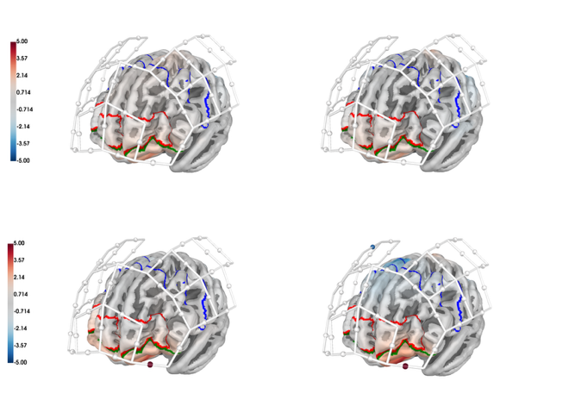
Figure 3. Condition channel-level effects, illustrating an increase in HbO for the high memory low perceptual load condition in BA11 and increase in BA11 but decrease in BA6 for high memory high perceptual load. Blue outline: BA6, green outline: BA11. Significant channels are indicated with a colored sphere at the midpoint of the channel.

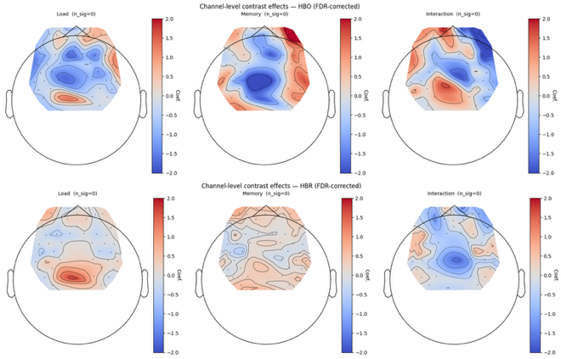
Figure 4. Contrast channel-level effects. Top: HbO. Bottom: HbR.
- Discussion
The working-memory manipulation was performed simultaneously with a visual-search task involving varying levels of perceptual load. Under these dual-task conditions, significant activation was observed in prefrontal channels during conditions requiring working-memory maintenance, suggesting that the paradigm successfully engaged cognitive-control and memory-related processes. However, the direct contrast between the two working-memory levels did not survive FDR correction. One possible explanation is that the difference between maintaining one versus two target letters produced only a modest increase in memory demands relative to the overall cognitive requirements of the visual-search task. Consequently, the observed activation may primarily reflect the recruitment of working-memory processes in general rather than a strong differentiation between the two memory-load levels. Future studies could employ a broader range of memory loads (e.g., one versus four or more items) to further characterize the relationship between working-memory demand and cortical activation and to increase sensitivity for detecting load-dependent effects.

- Limitations
The working-memory manipulation was performed simultaneously with a visual search task involving varying levels of perceptual load. As perceptual load itself requires attentional and cognitive resources, the additional demand of maintaining two rather than one target letter may have been relatively modest compared with the overall task demands. Consequently, potential working-memory effects may have been obscured by the broader cognitive demands of the task and by inter-individual variability in hemodynamic responses.
Future studies could strengthen the working-memory manipulation by increasing memory load (e.g., from one versus two letters to one versus four or more letters), which may produce a larger separation between conditions and increase sensitivity to detect working-memory-related differences in cortical activation.
Optodes were fitted om caps and reference points (e.g. nasion/inion) were controlled when fitting the cap. However, more precise spatial registration could likely have improved the precision with thich underlying regions were measured (Wyser et al., 2022; Kvist et al., 2024).
It is important to highlight that, like every hemodynamic variable, the responses recorded with fNIRS have a temporal delay with regard to cortical activation itself (Cui et al., 2010).

- Conclusion

CRediT authorship contribution statement

Data availability
This study is registered on:
where additionally all scripts used for data analysis can be found.
The original raw data can be found online:
Declaration of Competing Interest
The authors declare that they have no known compelling financial interests or personal relationships that could have appeared to influence the work reported in this paper.

Acknowledgments
We want to thank NIRx Medizintechnik GmbH for providing fNIRS equipment; and Åbo Akademi foundation and Karolinska Institutet for supporting this study.
Appendix A. Supplementary data.
Supplementary data to this article can be found online at:

References
- Saager R. B. & Berger A. J. (2005). Direct characterization and removal of interfering absorption trends in two-layer turbid media. J. Opt. Soc. Am. A. 22(9), 1874. https://doi.org/10.1364/josaa.22.001874
- Yücel, M.A., Lühmann, A. v., Scholkmann, F., Gervain, J., Dan, I., Ayaz, H., Boas, D., Cooper, R.J., Culver, J., Elwell, C.E., Eggebrecht, A., Franceschini, M.A., Grova, C., Homae, F., Lesage, F., Obrig, H., Tachtsidis, I., Tak, S., Tong, Y., Torricelli, A.,Wabnitz, H., Wolf, M. (2021). Best practices for fNIRS publications. Neurophotonics 8, 012101. https:/org.doi/10.1117/1.NPh.8.1.012101
- Wyser, D.G., Kanzler, C.M., Salzmann, L., Lambercy, O., Wolf, M., Scholkmann, F., Gassert, R. (2022). Characterizing reproducibility of cerebral hemodynamic responses when applying short-channel regression in functional near-infrared spectroscopy. Neurophotonics 9, 015004. https://doi.org/10.1117/1.NPh.9.1.015004
- Herold, F., Wiegel, P., Scholkmann, F., Thiers, A., Hamacher, D., Schega, L. (2017). Functional near-infrared spectroscopy in movement science: a systematic review on cortical activity in postural and walking tasks. Neurophotonics 4, 041403. https://doi.org/10.1117/1.NPh.4.4.041403
- Amaro, E., & Barker, G. J. (2006). Study design in fMRI: Basic principles. Brain and Cognition, 60(3), 220–232. https://doi.org/10.1016/j.bandc.2005.11.009
- Scholkmann, F., Kleiser, S., Metz, A.J., Zimmermann, R., Mata Pavia, J., Wolf, U., Wolf, M. (2014). A review on continuous wave functional near-infrared spectroscopy and imaging instrumentation and methodology. Neuroimage 85 (1), 6–27. https://doi.org/10.1016/j.neuroimage.2013.05.004
- Sternberg, S. (1965). High-speed scanning in human memory. Science, 153 (3736), 652-654.
- Cui, X., Bray, S., Reiss, A.L. (2010). Speeded near infrared spectroscopy (NIRS) response detection. PLoS One, 5 (11), e15474. https://doi.org/10.1371/journal.pone.0015474
- Molteni, E., Butti, M., Bianchi, A.M., Reni, G. (2008). Activation of the prefrontal cortex during a visual n-back working memory task with varying memory load: a near infrared spectroscopy study. In 2008 30th Annual International Conference of the IEEE Engineering in Medicine and Biology Society, 4024–4027. https://doi.org/10.1109/iembs.2008.4650092
- Tanida, M., Sakatani, K., Tsujii, T. (2012). Relation between working memory performance and evoked cerebral blood oxygenation changes in the prefrontal cortex evaluated by quantitative time-resolved near-infrared spectroscopy, Neurol. Res. 34 (2), 114–119. https://doi.org/10.1038/s41598-026-36717-6
- Keshmiri, S., Sumioka, H., Yamazaki, R., Ishiguro, H. (2018). Differential entropy preserves variational information of near-infrared spectroscopy time series associated with working memory, Front. Neuroinform. 12, 33. https://doi.org/10.3389/fninf.2018.00033
- Kvist, A., Bezuidenhout, L., Johansson, H., Albrecht, F., Conradsson, D.M., Franzén, E. (2024). Validation of fNIRS measurement of executive demand during walking with and without dual-task in younger and older adults and people with Parkinson’s disease. NeuroImage: Clinical, 43, 103637, https://doi.org/10.1016/j.nicl.2024.103637
- Lucas, I., Urieta, P., Balada, F., Blanco, E., Aluja, A. (2020). Differnces in prefrontal cortex activity based on difficulty in a working memory task using near-infrared spectroscopy. Behavioural Brain Research, 392, https://doi.org/10.1016/j.bbr.2020.112722
- Ogawa, Y., Kotani, K., Jimbo, Y. (2014). Relationship between working memory performance and neural activation measured using near-infrared spectroscopy, Brain Behav., 4 (4), 544–551. https://doi.org/10.1002/brb3.238
- Engle, R.W. (2002). Working memory capacity as executive attention, Curr. Dir. Psychol. Sci. 11 (1), 19–23. https://doi.org/10.1111/1467-8721.00160
- Braver, T.S., Cohen, J.D., Nystrom, L.E., Jonides, J., Smith, E.E., Noll, D.C. (1997). A parametric study of prefrontal cortex involvement in human working memory, Neuroimage, 5 (1), 49–62. https://doi.org/10.1006/nimg.1996.0247
- Cohen, J.D., Perlstein, W.M., Braver, T.S., Nystrom, L.E., Noll, D.C., Jonides, J. et al. (1997). Temporal dynamics of brain activation during a working memory task, Nature. 386 (6625) 604. https://doi.org/10.1038/386604a0

