 | Second Kenya Urban Support Program (KUSP2)  “Making Kenyan Towns Work!” | 

MINISTRY OF LANDS, PUBLIC WORKS, HOUSING AND URBAN DEVELOPMENT
State Department for Housing and Urban Development

CONSULTANCY SERVICES FOR DESIGN, PREPARATION OF TECHNICAL SPECIFICATIONS AND BIDDING DOCUMENT FOR AN ELECTRONIC GRIEVANCE MANAGEMENT SYSTEM (e-GRM)
Contract No. KE - MOTI – 434503 - CS - INDV

KUSP2 E-GRM TERMS OF REFERENCE

Submitted by
Yapo Jesus Ekie (Individual Consultant)

February, 2026

Table of Contents
1. BACKGROUND & CONTEXT 8
1.1 Program Overview and Strategic Alignment 8
1.2 Lessons from KUSP1 and Rationale for the e-GRM 9
1.3 Legal, Policy and Institutional Framework 11
1.4 Alignment with KUSP2 Results Areas and Disbursement Architecture 12
1.5 Definitions, Abbreviations and Acronyms 13
2. OBJECTIVES OF THE ASSIGNMENT 17
2.1 Overall Objective 17
2.2 Specific Objectives 18
2.3 Expected Outcomes and Benefits 22
2.4 Phase Structure and Intended Results 22
3. SCOPE OF WORK 23
3.1 Phase 1: Design and Procurement Preparation (Completed – Provided as Inputs) 23
3.2 Phase 2 (3 Months): Implementation and Commissioning 24
3.2.1 Mobilization, Inception and Requirements Confirmation 25
3.2.2 Solution Build/Configuration and Data Model Implementation 26
3.2.3 Multi-Channel Intake and Communications 28
3.2.4 Security, Privacy, Accessibility and Compliance Implementation 30
3.2.5 Testing, Go-Live, Hypercare and Handover 32
4. FUNCTIONAL SCOPE OF THE E-GRM 34
4.1 Case Intake and Registration 34
4.2 Case Processing, Assignment and Escalation 37
4.3 Communications and Notifications 39
4.4 Appeals and Closure 40
4.5 Reporting, Dashboards and Analytics 42
4.6 Administration and Configuration 43
5. NON-FUNCTIONAL REQUIREMENTS 45
5.1 Performance and Capacity 45
5.2 Availability and Resilience 47
5.3 Security and Privacy 48
5.4 Accessibility and Usability 50
5.5 Interoperability and Extensibility 51
5.6 Maintainability and Supportability 52
6. STANDARDS & COMPLIANCE REQUIREMENTS 53
6.1 World Bank Procurement Regulations and Integrity 54
6.2 Government of Kenya ICT and Data Protection Requirements 55
6.3 Information Security Standards and Guidelines 56
6.4 Accessibility Standards 57
6.5 Open Standards and Technology Neutrality 58
6.6 Intellectual Property and Licensing 58
6.7 Environmental and Social Safeguards Alignment 59
7. GOVERNANCE, REPORTING & COORDINATION 60
7.1 Client Oversight and Decision-Making Structure 60
7.2 Roles and Responsibilities (RACI) 61
7.3 Meetings, Reviews and Approvals 63
7.4 Progress Reporting and Issue Management 64
7.5 Change Control and Configuration Management 65
8. DELIVERABLES & SUBMISSION REQUIREMENTS 68
8.1 Phase 2 Deliverables (Required) 68
8.2 Deliverables Schedule and Acceptance Criteria 69
8.3 Deliverable Formats, Language and Document Control 72
9. IMPLEMENTATION TIMELINE & MILESTONES 73
9.1 Phase 1 Timeline and Milestone Plan (Reference) 73
9.2 Phase 2 Timeline and Milestones (3 months) 74
9.3 Key Dependencies and Assumptions 76
10. TEAM COMPOSITION & QUALIFICATIONS 77
10.1 Minimum Key Positions (Indicative) 77
10.2 Experience and Qualification Requirements 80
10.3 Knowledge Transfer and Local Capacity 82
11. TESTING, ACCEPTANCE & QUALITY 84
11.1 Quality Assurance Plan 84
11.2 Test Strategy and Coverage 86
11.3 Security and Performance Testing 88
11.4 User Acceptance Testing and Sign-off 89
11.5 Acceptance Criteria and Defect Resolution 89
11.6 Independent Verification (if applicable) 91
12. TRAINING & CHANGE MANAGEMENT 91
12.1 Training Strategy and Curriculum 91
12.1.1 Training objectives (minimum) 91
12.1.2 Training approach and learning principles 92
12.1.3 Training needs confirmation and participant profiling 93
12.1.4 Role-based training tracks (minimum set) 93
12.1.5 Curriculum content (minimum modules) 94
12.1.6 Training assessment and verification (minimum) 95
12.2 Training Materials and Delivery 95
12.2.1 Required training materials (minimum set) 96
12.2.2 Format, language and accessibility of materials 96
12.2.3 Training delivery modalities and logistics 96
12.2.4 Training records and completion evidence 97
12.3 Adoption, Communications and Support Aids 97
12.3.1 Adoption approach (minimum) 97
12.3.2 Public guidance content (minimum) 97
12.3.3 Staff-facing support aids (minimum) 98
12.3.4 Support model during adoption 98
12.4 Capacity Building for Client Teams 98
12.4.1 Super-user model and sustainability 99
12.4.2 Hands-on administrator coaching 99
12.4.3 Transition-to-ownership and handover alignment 99
13. OPERATIONS, SUPPORT & MAINTENANCE 100
13.1 Service Levels and KPIs 100
13.2 Support Tiers and Escalations 101
13.3 Incident, Problem and Change Management 102
13.4 Monitoring, Patching and Vulnerability Management 104
13.5 Backup, Restore and DR Testing 105
13.6 Service Reporting and Reviews 106
14. RISK MANAGEMENT 106
14.1 Risk Categories and Register 107
14.1.1 Baseline inputs and alignment 107
14.1.2 Minimum structure of the risk register 107
14.1.3 Risk rating approach and review discipline 108
14.1.4 Relationship to issue management and change control 108
14.2 Mitigation Measures and Owners 108
14.2.1. Role clarity and process ownership across national/county/municipal levels 108
14.2.2. Dependence on telecom services for toll-free hotline and SMS/USSD channels (approvals and lead times) 109
14.2.3. Data protection and privacy compliance risks, including sensitive grievances and breach risk 110
14.2.4. Stakeholder adoption and inclusion risks (low uptake, exclusion of vulnerable groups, capacity gaps at local level) 110
14.2.5. Integration and reliability risks (channel integrations, performance under load) 111
14.2.6. Political or governance changes affecting continuity and resourcing 112
14.3 Contingency and Escalation Protocols 112
14.3.1 Escalation thresholds 112
14.3.2 Fallback procedures for channel unavailability 113
14.3.3 Manual continuity procedures for system downtime 113
14.3.4 Contingency actions for critical risks 113
14.3.5 Escalation pathways and decision rights 113
15. SECURITY, PRIVACY & DATA MANAGEMENT 114
15.1 Identity and Access Management 114
15.2 Encryption and Key Management 116
15.3 Audit Trails, Logs and Forensics 117
15.4 Data Classification, Retention and Disposal 118
15.5 Incident Response and Breach Notification 120
15.6 Data Residency and Cross-Border Transfers 121
16. INTEROPERABILITY & INTEGRATION 122
16.1 Integration with KUSP2 Website and Channels 122
16.2 Telephony/USSD/IVR/SMS/Email Gateways 123
16.3 API Management and Webhooks 125
16.4 Data Import/Export and ETL 126
16.5 Single Sign-On and Directory Services 127
17. INFRASTRUCTURE & HOSTING 128
17.1 Hosting Model and Environments 128
17.2 Capacity, Performance and Scalability 130
17.3 High Availability and Resilience 131
17.4 Observability and Monitoring 132
17.5 Compliance and Auditability 132
18. ETHICS, INCLUSION & SEA/SH 133
18.1 Code of Conduct and Ethics 133
18.2 SEA/SH Sensitive Intake and Handling Protocols 135
18.3 Accessibility and Inclusive Design 137
18.4 Vulnerable and Marginalized Groups Considerations 138
19. BUDGET & PAYMENT TERMS 139
19.1 Contract Type and Phasing 139
19.2 Payment Milestones and Conditions 140
19.3 Invoicing, Taxes and Reimbursables 141
19.4 Retentions, Adjustments and Deductions 142
20. PROPOSAL REQUIREMENTS 143
20.1 Technical Proposal Structure 143
20.2 Financial Proposal Structure 147
20.3 Mandatory Forms and Declarations 148
20.4 Proposal Validity, Language and Copies 149
20.5 Pre-Bid Conference and Clarifications 149
21. EVALUATION & AWARD CRITERIA 150
21.1 Evaluation Methodology 150
21.2 Technical Evaluation Sub-Criteria (Indicative) 151
21.3 Financial Evaluation 153
21.4 Combined Scoring and Ranking 153
21.5 Negotiations and Due Diligence 154
21.6 Award Notification and Contract Finalization 154
22. CONTRACTUAL & LEGAL PROVISIONS 155
22.1 Fraud and Corruption Provisions 156
22.2 Conflict of Interest and Eligibility 156
22.3 Confidentiality and Non-Disclosure 157
22.4 Intellectual Property and Ownership 158
22.5 Liability, Indemnity and Warranties 158
22.6 Insurance Requirements 159
22.7 Force Majeure and Termination 159
22.8 Dispute Resolution and Governing Law 160
22.9 Notices and Communications 160
23. BID SUBMISSION INSTRUCTIONS 160
24. ANNEXES & SCHEDULES 163
24.1 Reference and Supporting Annexes (to be issued with the RFQ/RFP) 163
24.2 Appendix A – Standard Grievance Intake Dataset (Implementation Baseline) 165
24.3 Appendix B – Illustrative Workflow Scenarios (Acceptance Scenarios) 168
24.4 Appendix C – System Requirements Specification (Software + Hardware) 169
24.4.1 Purpose and scope of this System Requirements Specification 169
24.4.2 Deployment model statement (acceptable models and bidder obligations) 170
24.4.3 Responsibility split / RACI baseline (Client vs Supplier vs third party) 170
24.4.4 Minimum environments and environment separation rules 173
24.4.5 Minimum infrastructure / hosting requirements (hardware baseline) 174
24.4.6 Client endpoint requirements (devices, browsers, and connectivity) 177
24.4.7 Software dependencies and platform prerequisites (technology-neutral) 177
24.4.8 Acceptance evidence checklist (minimum compliance and handover evidence) 178

1. BACKGROUND & CONTEXT
This chapter sets out the operational and strategic context for the KUSP2 electronic Grievance Redress Mechanism (e-GRM). It clarifies (i) how the e-GRM fits within KUSP2’s accountability architecture; (ii) why KUSP1 experience necessitated a standardized, auditable digital approach; (iii) the core legal, policy and institutional parameters that must shape the solution; and (iv) how e-GRM performance information supports program monitoring and decision-making across national, county and municipal levels.
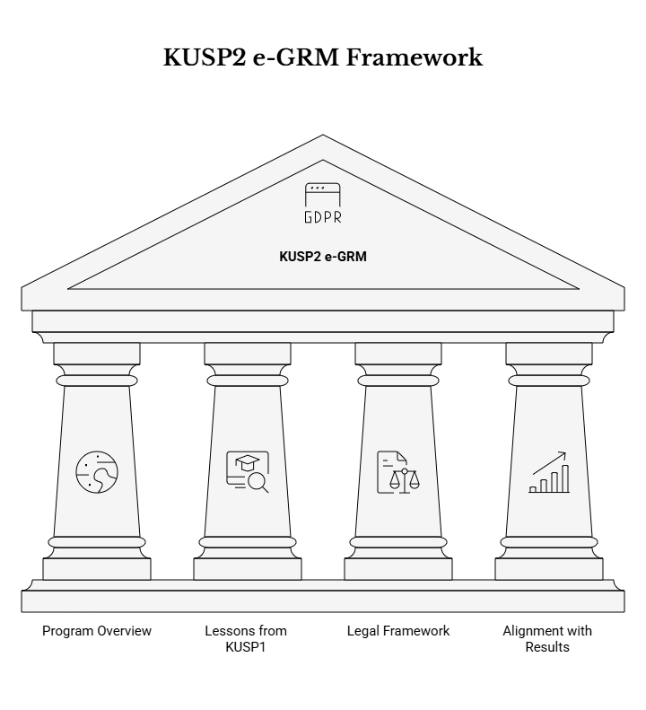

1.1 Program Overview and Strategic Alignment
KUSP2 is a Government of Kenya program supported by development partners to strengthen urban institutions and improve delivery of urban infrastructure and services. The program requires an electronic grievance redress mechanism (e-GRM) to provide a structured, inclusive and transparent way to receive, process, resolve and monitor grievances linked to KUSP2 activities across participating counties and municipalities.
KUSP2 is a five-year Government program (2024–2028) implemented through the State Department for Housing and Urban Development (SDHUD) and its National Program Coordination Team (NPCT), with implementation responsibilities distributed across 45 counties and 79 municipalities. It builds on KUSP1 (2017–2023) and continues to support urban planning, infrastructure, climate resilience, governance and inclusive service delivery—areas where citizen feedback and grievance handling are essential to maintaining trust and ensuring responsive public service delivery.
Within this program context, the e-GRM is positioned as a core accountability and service-improvement instrument. It is expected to:
- Complement existing county and municipal GRM structures (rather than replace them) by providing a program-wide “system of record” for grievances and actions taken;
- Strengthen transparency and responsiveness through trackable cases, auditable processing, and timely feedback to complainants; and
- Enable program-wide insight through standardized analytics and reporting (e.g., volumes, categories, resolution timelines, escalations), supporting management decisions and corrective actions.
Strategically, the e-GRM aligns with Kenya’s governance and participation expectations—counties are required to facilitate public participation and establish ICT-based participation platforms—making a digital GRM an appropriate and scalable channel for petitioning, feedback and grievance redress across dispersed municipalities.
The e-GRM is also explicitly aligned to development partner standards, including the World Bank’s requirements on stakeholder engagement and accessible grievance mechanisms, which emphasize responsiveness, inclusivity, transparency, confidentiality and protection from retaliation. These principles shape both the public-facing user experience (how people submit and track grievances) and the internal case management controls (how data is accessed, shared and acted on).
Finally, this procurement sits within a two-phase approach to the e-GRM initiative, where Phase 1 deliverables (requirements, workflows, data standards, compliance mapping and procurement documentation) are provided as implementation inputs for Phase 2. Phase 2 focuses on implementing and commissioning a working solution within a three-month implementation period, without redefining the agreed functional intent.

1.2 Lessons from KUSP1 and Rationale for the e-GRM
Experience from prior implementation highlighted inconsistent and weakly documented handling of grievances across counties and municipalities. The e-GRM is intended to standardize grievance handling, improve responsiveness and accountability, and generate reliable management information for monitoring performance and informing corrective actions.
KUSP1 experience (as reflected in stakeholder consultations and documentation reviews) highlighted recurring, practical weaknesses that the e-GRM is intended to address, including:
- Non-standard practices and uneven capacity: grievance handling approaches varied widely by county/municipality, with differences in intake channels, escalation practices, and documentation discipline;
- Paper-based or poorly structured recordkeeping: inconsistent and poorly documented grievance records reduced traceability, made follow-up difficult, and limited learning; and
- Limited management visibility: fragmented data meant the program could not reliably aggregate trends or monitor timeliness and outcomes across the portfolio.
These issues are not merely administrative—they directly affect trust, reputational risk and program performance. KUSP2’s risk context and financing arrangements place strong emphasis on having a functional complaints handling system early in implementation, reinforcing the need for a mechanism that can demonstrate both existence (a working GRM) and performance (timely and fair handling with evidence).
The e-GRM rationale is therefore to establish a unified, program-wide capability that:
- Standardizes grievance lifecycle management from intake through closure using configurable workflows (including assignment, investigation notes, responses, escalation and closure);
- Enforces consistent data capture aligned to a standardized intake/data collection form (so that all counties and municipalities collect comparable information);
- Improves responsiveness by supporting clear service standards and automated prompts (acknowledgements, reminders, escalation triggers); and
- Provides actionable, reliable reporting to support governance, supervision and continuous improvement.

From a service-standard perspective, KUSP2 requires both timely engagement and timely outcomes. Program commitments include providing a response to grievances within defined timelines (including a requirement to respond within 14 days), while GRM guidance to complainants emphasizes an aim to resolve grievances within 30 days where feasible. The e-GRM is expected to make these expectations operational by enabling date stamping, due-date tracking, escalation and performance reporting.
The rationale also includes strengthening safe and appropriate handling of different grievance types—including environmental, social, integrity-related issues and other sensitive matters—through controlled workflows, referral pathways and restricted access where required. For example, sensitive cases (including SEA/SH-related complaints) require a confidential pathway with restricted access and minimal sensitive data capture, reinforcing the need for a digital solution that can enforce differentiated controls by category.

1.3 Legal, Policy and Institutional Framework
The e-GRM must operate within the Government of Kenya legal and policy framework, including data protection and access to information obligations, county governance and public participation requirements, and relevant ICT and accessibility standards. The solution must also support KUSP2’s commitments on stakeholder engagement, confidentiality, inclusion, and non-retaliation.
a) Core legal and policy drivers
The e-GRM operates in a governance environment where public participation, access to information and citizen petitioning are legal expectations. Relevant Kenyan requirements include, among others:
- County Governments Act (2012): establishes principles of public participation, the right to petition county government, and county duties to respond expeditiously; it also reinforces the establishment of ICT-based platforms for citizen participation;
- Access to Information Act (2016): supports citizens’ rights to access information held by public entities and reinforces openness principles; and
- Related governance frameworks referenced in KUSP2 stakeholder engagement planning, including constitutional principles on transparency and accountability and urban governance requirements.
The e-GRM also collects and processes personal data, making Kenya’s Data Protection Act (2019) central to system design and operations. This requires a privacy-by-design approach, including data minimization, purpose limitation and storage limitation, and influences hosting decisions, retention configurations, and user access controls. Hosting is expected to prioritize government-approved infrastructure and compliant data localization approaches.
In addition, the legal and compliance context for e-GRM includes:
- Telecommunications compliance under Kenya Information and Communications Act (KICA) and Communications Authority regulations, which is particularly relevant for any SMS/USSD short codes and toll-free channels;
- Accessibility obligations, including Persons with Disabilities Act and national accessibility standards for public digital systems; and
- Relevant labor, OSH, and environmental requirements that shape the need to receive and route specific categories (e.g., worker issues, environmental issues) to the appropriate responsible units and authorities.
b) Implications for e-GRM design and operation
These legal and policy drivers translate into concrete system and operational requirements, including:
- Privacy and confidentiality controls: role-based access controls, audit logging, and controlled sharing of case information—particularly for sensitive categories—so that only authorized users can view or act on certain grievances;
- Data governance and lifecycle management: configurable retention and storage limitation aligned to program needs; secure hosting consistent with government and data protection expectations; and user-facing privacy notices/consent processes as applicable;
- Accessibility and inclusion by design: ensuring the e-GRM is usable by persons with disabilities and those with limited digital access, through accessible web design (aligned to national accessibility standards that mirror WCAG) and provision of alternative channels (e.g., toll-free phone line, assisted intake at offices); and
- Regulatory readiness for channels: recognizing that telecom channels require licensing/approvals and consumer protection compliance, and may involve client-led commercial arrangements with vendor technical integration support.
KUSP2’s commitments also include operational safeguards that must be embedded as guiding principles of the mechanism—namely that the GRM be accessible, free to use, transparent, confidential, and protective against retaliation—which should be reinforced both in system design (e.g., user journey, information disclosure) and in procedures/training for users handling grievances.
c) Institutional arrangements and accountability
Institutionally, the e-GRM must support a distributed operating model:
- SDHUD/NPCT provides national oversight, system stewardship, consolidation of reporting and coordination with development partners and oversight bodies;
- County and municipal structures (including designated GRM officers/focal points and relevant committees) are responsible for day-to-day grievance intake (including assisted intake), investigation/response, documentation of actions and closure at the appropriate level; and
- Referral and escalation pathways are required for grievances that must be handled by specialized institutions (e.g., integrity/corruption allegations, certain environmental matters, sensitive safeguarding matters), with controlled information sharing and traceable handoff.
Given this model, the Implementing Firm should treat the e-GRM not only as a software build, but as an enabling platform for governance and compliance: the system must embed workflow discipline, produce evidence, and support supervision, while remaining usable under real-world conditions (varying connectivity, variable capacity, multiple languages, and diverse user profiles).

1.4 Alignment with KUSP2 Results Areas and Disbursement Architecture
The e-GRM supports KUSP2 by enabling consistent tracking and reporting of grievance handling performance (e.g., volumes, categories, resolution timeliness, escalations). These outputs contribute to strengthened accountability and service delivery at municipal and county levels.
KUSP2’s financing and performance environment places strong emphasis on measurable governance and accountability. Under the World Bank Program-for-Results instrument, KUSP2’s overall risk profile was assessed as substantial, and a functional complaints handling system is required early in implementation—making GRM performance data a practical input into program oversight and risk management.
In this context, the e-GRM supports results areas and disbursement architecture by producing reliable, standardized management information that can be used at multiple levels:
- Operational level (municipality/county): backlog management, workload balancing, timeliness tracking, escalation support, and documentation of actions/outcomes;
- Program coordination level (NPCT/SDHUD): consolidated dashboards and trend analysis to identify systemic issues, guide technical support, and prioritize corrective actions; and
- Compliance/reporting level (development partners and oversight bodies): generation of standardized reporting outputs required for entities such as CAJ (Ombudsman), NEMA, the World Bank and others as applicable.
To support these uses, the e-GRM should enable monitoring of a practical performance “minimum set” of indicators, such as:
- Intake volumes by time period, county, municipality, and channel (web, email, phone-assisted, etc.);
- Categorization trends (e.g., environmental, social, integrity/fraud, service delivery, project implementation);
- Timeliness metrics (e.g., acknowledgement, first response, resolution/closure), including compliance reporting against required service standards (e.g., response within 14 days) and “target” resolution timelines (e.g., aim for resolution within 30 days where feasible);
- Escalations/referrals (counts and destinations), including the ability to track “hand-offs” while maintaining confidentiality; and
- Outcome/satisfaction signals where captured (e.g., complainant satisfied/not satisfied, reopened cases), to support continuous improvement.

The e-GRM therefore enables KUSP2 to move from ad hoc grievance recording toward a consistent performance management approach, where grievance handling becomes a measurable part of strengthening municipal and county accountability and improving service delivery across the program footprint.

1.5 Definitions, Abbreviations and Acronyms
Key terms used in this ToR include e-GRM: electronic grievance redress mechanism; Grievance: any concern, suggestion, request for information, allegation or feedback related to KUSP2 activities, including environmental, social, integrity, service delivery and other issues, submitted through any approved channel; Complainant: the person or group submitting a grievance (may be anonymous) or their authorized representative; Client: State Department for Housing and Urban Development (SDHUD), acting through the National Program Coordination Team (NPCT) and relevant county/municipal structures; and Implementing Firm (Supplier): the contracted firm responsible for building/configuring, deploying, and commissioning the e-GRM in Phase 2.
For additional clarity in interpretation and implementation, the following terms and acronyms are also used in KUSP2 e-GRM documentation and are relevant to this ToR:
- GRM: Grievance Redress Mechanism (the overall mechanism, including both digital and non-digital channels and procedures).
- NPCT: National Program Coordination Team (SDHUD’s program coordination structure).
- CPCT: County Program Coordination Team (county coordination structure supporting program implementation).
- GRC: Grievance Redress Committee (committee structure supporting review and resolution/escalation where applicable).
- ESS10 / ESF / ESCP: World Bank Environmental and Social Standard 10; Environmental and Social Framework; Environmental and Social Commitment Plan—frameworks that set stakeholder engagement and GRM expectations.
- CAJ / EACC / NEMA: Commission on Administrative Justice (Ombudsman) / Ethics and Anti-Corruption Commission / National Environment Management Authority—oversight/referral institutions relevant to certain grievance categories.
- SEA/SH and GBV/SEAH: Sensitive safeguarding-related complaint categories that require confidential handling pathways with restricted access and minimal sensitive data capture.
- PII: Personally Identifiable Information—any data that can identify a complainant or other individual, subject to Data Protection Act requirements.
- KICA / CA Regulations: Kenya Information and Communications Act and Communications Authority regulations, relevant to SMS/USSD/toll-free channels.
- KS 2952 / WCAG: Kenya Standard on ICT accessibility and related web accessibility guidelines, relevant to disability-inclusive design and testing.
- UAT: User Acceptance Testing—formal validation by users prior to go-live/commissioning.

ACRONYM | DESCRIPTION
API | Application Programming Interface: Technical interfaces enabling integration between the e-GRM system and external systems such as SMS gateways, email services, and the KUSP2 website for seamless data exchange and functionality.
BRD | Business Requirements Document: A document defining business requirements for the e-GRM system, referenced alongside the Terms of Reference for requirements mapping and validation.
CPCT | County Program Coordination Team: County-level teams responsible for coordinating KUSP2 activities and grievance handling at the county level, working under the oversight of the NPCT.
CR | Change Request: A formal request to modify agreed requirements or scope of the e-GRM implementation, subject to impact assessment and approval through the documented change control process.
CSV | Comma-Separated Values: A file format used for data exports from the e-GRM system, enabling analysis in spreadsheet applications and integration with external monitoring and evaluation tools.
DOCX | Microsoft Word Document Format: An editable document format used for training materials, user manuals, and documentation deliverables in the e-GRM implementation project.
DR | Disaster Recovery: Procedures and capabilities for recovering the e-GRM system and data in case of system failures or disasters, ensuring continuity of grievance handling services.
e-GRM | Electronic Grievance Redress Mechanism: The digital system being procured to receive, process, resolve, and monitor grievances linked to KUSP2 activities, providing a structured, inclusive, and transparent accountability mechanism across participating counties and municipalities.
FAQ | Frequently Asked Questions: Public content on the e-GRM system providing guidance to citizens on how to submit grievances, what to expect from the process, and how confidentiality is maintained.
GBV | Gender-Based Violence: A category of sensitive grievances that may be reported through the e-GRM system, requiring confidential handling, restricted access, and survivor-centered approaches similar to SEA/SH cases.
GRM | Grievance Redress Mechanism: The broader framework for handling complaints and grievances from citizens and stakeholders affected by KUSP2 activities, which the e-GRM digitalizes and standardizes.
ICT | Information and Communications Technology: Technologies used for digital platforms, including the e-GRM system and related citizen participation platforms required under Kenyan county governance frameworks.
ID | Identifier: Unique reference numbers or codes used to track grievances, issues, users, and other entities in the e-GRM system, ensuring traceability and accountability throughout the grievance lifecycle.
IP | Intellectual Property: Rights related to software, configurations, and documentation that must be properly licensed and transferred to the Client to ensure sustainable operation of the e-GRM after handover.
KICA | Kenya Information and Communications Act: The primary legislation governing telecommunications in Kenya, relevant for obtaining regulatory approvals for SMS/USSD short codes and toll-free channels used by the e-GRM.
KPI | Key Performance Indicator: Metrics used to measure e-GRM performance, such as grievance resolution rates, response times, escalation patterns, and complainant satisfaction levels.
KUSP1 | First Kenya Urban Support Program: The predecessor program (2017-2023) upon which KUSP2 builds, whose experiences with inconsistent grievance handling informed the need for a standardized digital GRM.
KUSP2 | Second Kenya Urban Support Program: A five-year Government of Kenya program (2024-2028) supported by development partners to strengthen urban institutions and improve delivery of urban infrastructure and services across 45 counties and 79 municipalities.
L1/L2/L3 | Level 1/Level 2/Level 3 Support: Tiered technical support structure for the e-GRM where L1 handles basic user issues, L2 handles more complex technical problems, and L3 handles the most specialized or development-related issues.
M&E | Monitoring and Evaluation: The systematic process of tracking KUSP2 program performance and assessing outcomes, supported by e-GRM reporting, analytics, and data exports.
MFA | Multi-Factor Authentication: A security control requiring multiple verification methods for user authentication, particularly for privileged administrative access to the e-GRM system.
NPCT | National Program Coordination Team: The national-level team within SDHUD responsible for coordinating KUSP2 implementation, providing oversight of the e-GRM system, and serving as the primary client interface for the implementation.
OSH | Occupational Safety and Health: Requirements related to worker safety that may be the subject of grievances within the e-GRM system, requiring appropriate routing to responsible authorities.
PDF | Portable Document Format: A file format used for reports, exports, and controlled distribution of documentation in the e-GRM system, ensuring consistent presentation across platforms.
PPTX | Microsoft PowerPoint Format: A presentation format used for training materials and stakeholder briefings during the e-GRM implementation and rollout.
QA | Quality Assurance: The systematic process of ensuring the e-GRM system meets quality standards through testing, reviews, verification activities, and defect management throughout the implementation.
QRG | Quick Reference Guide: Concise one-to-two page guides for common e-GRM tasks such as creating cases, assigning grievances, escalating issues, closing cases, and running reports.
RACI | Responsible, Accountable, Consulted, Informed: A matrix used to define roles and responsibilities for e-GRM implementation activities, clarifying who performs work, who approves, who provides input, and who needs to be kept informed.
RAG | Red/Amber/Green: A status indicator system used in progress reporting to show delivery confidence for timeline, scope, and quality of the e-GRM implementation project.
RBAC | Role-Based Access Control: A security approach where e-GRM system access permissions are assigned based on user roles (administrator, supervisor, handler, etc.), ensuring users can only access data and functions appropriate to their responsibilities.
RFP | Request for Proposal: A procurement document soliciting detailed technical and financial proposals from potential suppliers for the e-GRM implementation.
RFQ | Request for Quotation: A procurement document soliciting price quotes from potential suppliers for the e-GRM implementation.
SDHUD | State Department for Housing and Urban Development: The government department under the Ministry of Lands, Public Works, Housing and Urban Development responsible for implementing KUSP2 and overseeing the e-GRM deployment.
SEA/SH | Sexual Exploitation and Abuse/Sexual Harassment: Sensitive categories of grievances requiring confidential handling, restricted access, survivor-centered approaches, and specialized referral pathways within the e-GRM system.
SEAH | Sexual Exploitation, Abuse, and Harassment: An alternative formulation of SEA/SH used in the document to describe sensitive grievance categories requiring confidential handling.
SLA | Service Level Agreement: Defined performance standards and timelines for grievance handling in the e-GRM, including acknowledgement (immediate), response (within 14 days), and resolution (within 30 days where feasible).
SMS | Short Message Service: A text messaging service used as one of the intake channels for grievance submission in the e-GRM system, enabling access for users with basic mobile phones.
SOP | Standard Operating Procedure: Documented procedures for consistent grievance handling across all channels (web, phone, in-person, SMS/USSD) and jurisdictions (national, county, municipal).
TOR | Terms of Reference: The formal document outlining the scope, objectives, requirements, deliverables, and specifications for the procurement of the KUSP2 e-GRM Digital System implementing firm.
ToR | Terms of Reference: Alternative capitalization of TOR used in the document, referring to the same formal procurement document.
UAT | User Acceptance Testing: The testing phase where end users (NPCT, county, and municipal staff) verify that the e-GRM system meets requirements and is ready for production deployment.
USSD | Unstructured Supplementary Service Data: A protocol used by mobile phones to communicate with service provider computers, enabling an alternative low-bandwidth channel for grievance submission accessible to users without smartphones.
VAT | Value Added Tax: Tax applicable to the e-GRM implementation contract that must be clearly stated in financial proposals per Kenyan tax requirements.
VPN | Virtual Private Network: A secure network connection method used for remote administrative access to the e-GRM system, particularly for cross-border support scenarios.
WCAG | Web Content Accessibility Guidelines: International standards for web accessibility (specifically WCAG 2.1 AA or equivalent) that the e-GRM must align with to ensure usability by persons with disabilities.

2. OBJECTIVES OF THE ASSIGNMENT

2.1 Overall Objective
To implement, configure, deploy and commission a technology-neutral e-GRM solution within a three-month implementation period, in accordance with the agreed requirements, workflows, data collection standards, and compliance obligations.
In this ToR, “implement and commission” means the Supplier shall deliver a working, secure and operational e-GRM that is ready for sustained use by national, county and municipal stakeholders. At minimum, commissioning shall entail: (i) a functioning public-facing grievance submission and status-tracking experience and an internal staff console for processing cases; (ii) configured workflows, routing, escalation and service-level monitoring aligned to the agreed GRM process; (iii) enabled intake channels as agreed for Phase 2 (with web and assisted intake as the baseline and other channels enabled where applicable/available); (iv) implemented data model and standardized intake dataset with appropriate validation; (v) configured privacy, security and accessibility controls; (vi) completed testing (including UAT readiness), production deployment, and post go-live stabilization; and (vii) delivery of documentation, training and handover artifacts so that the Client can operate the system sustainably beyond the implementation window.
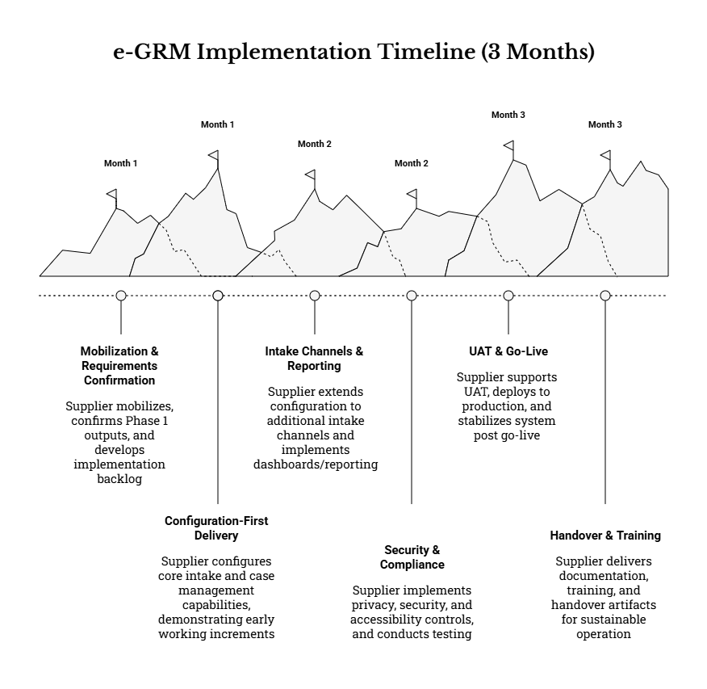

2.2 Specific Objectives
The Supplier shall deliver the following specific objectives, each of which is required to achieve the overall objective within the three-month period:
a) Configure and operationalize end-to-end grievance lifecycle management across multiple intake channels.
The Supplier shall configure the e-GRM to support the full grievance lifecycle from intake to closure, including (as applicable to the agreed workflows):
- Registration and acknowledgement: creation of a single grievance record per submission, allocation of a unique reference number, and acknowledgement through the originating or agreed channel.
- Triage and classification: initial screening, categorization, prioritization, and determination of confidentiality/sensitivity requirements (including special handling pathways where applicable).
- Assignment and workload management: routing to responsible national/county/municipal units and assignees based on configured rules (e.g., geography, category/help topic, responsible department), supported by queues, filters, and search.
- Investigation and action tracking: structured capture of actions taken, internal notes, attachments/evidence, and linked tasks/reminders to support timely handling and traceability.
- Escalation and referral: escalation to higher levels (municipal → county → national or other agreed escalation levels) based on elapsed time, severity, unresolved status, or other configured rules; and referral handling where matters must be redirected to an appropriate authority consistent with the GRM procedures.
- Resolution, closure, and re-opening/appeal: capture of resolution summaries and closure conditions, recording complainant satisfaction where applicable, and enabling controlled re-opening or appeal workflows where complainants are dissatisfied or where further review is warranted.
These capabilities shall be implemented so that all enabled channels feed a unified case register with consistent numbering, status tracking, and auditability across the system.
b) Implement standardized grievance intake data fields and data quality controls as defined in the agreed intake/data collection form.
The Supplier shall implement the standardized intake dataset and associated processing fields as the authoritative data standard for the e-GRM, ensuring that data captured through all supported channels is consistent and fit-for-purpose for monitoring, reporting and audits. This shall include, at minimum:
- Field implementation and validation: correct configuration of mandatory/optional/conditional fields; input validation (e.g., formats, completeness checks); and configurable lists/reference data (e.g., counties/municipalities, categories/help topics, status codes).
- Controlled vocabularies and disaggregation: implementation of category/type taxonomies and geography fields so grievances can be consistently filtered, routed and reported at national and sub-national levels.
- Consent and anonymity handling: ability to capture consent for personal data processing where personal data is provided, and ability to lodge grievances anonymously without preventing processing (subject to agreed procedures for follow-up limitations).
- Attachment handling: capture and secure storage of supporting evidence/attachments with configurable file type and size limits, and access controls aligned to grievance sensitivity and user permissions.
- Data quality monitoring: configuration of data completeness checks and operational prompts to reduce incomplete records, and enable reliable exports for analysis and statutory/program reporting.
Implementation shall align to the agreed standardized form and data dictionary provided as Phase 1 inputs, and shall be reflected consistently in both public-facing and assisted intake workflows.
c) Enable role-based access, auditability, and secure handling of personal and sensitive grievance data in line with applicable legal and policy requirements.
The Supplier shall implement privacy-by-design and security-by-design controls proportionate to the sensitivity of grievance information. This shall include:
- Role-based access control (RBAC) and least privilege: role and permission structures for national, county and municipal users, limiting visibility and actions to what is required for each role.
- Sensitive grievance controls: restricted visibility, controlled routing and appropriate notification suppression/redaction for sensitive grievance types, with enhanced logging of access attempts and actions on such cases.
- Audit trails and traceability: immutable or tamper-evident logs of key actions (e.g., create/view/update, assignment, status changes, communications, configuration changes) with timestamps and user identifiers to support oversight and investigations.
- Secure transmission and storage: secure configurations for data in transit and at rest, and protection of attachments/evidence consistent with access controls.
- Retention and archiving controls: configuration options to support retention, archiving, and controlled disposal/anonymization where required by the agreed policy and lawful requirements.
- Operational security readiness: security and compliance documentation and testing evidence to demonstrate that required controls are implemented and functioning as configured.
These controls shall support the e-GRM’s compliance posture and protect complainants, staff, and the integrity of the GRM process.
d) Deliver dashboards, reports, and exports required for operational monitoring and programme reporting.
The Supplier shall configure dashboards and reporting outputs that enable both day-to-day operational management and consolidated programme reporting across counties and municipalities. This shall include:
- Operational dashboards for volumes, status distribution, overdue/at-risk cases, workload by unit/assignee, and pipeline views (received → in progress → resolved/closed).
- Performance/timeliness reporting (including configurable service level monitoring and escalation triggers) to support management follow-up and performance reviews.
- Disaggregation and filtering by time period, county, municipality, intake channel, category/help topic, priority, and other agreed attributes.
- Exports in common formats (e.g., CSV/Excel) to support analysis, audits, and integration into programme reporting workflows, including production of aggregate/anonymized outputs suitable for disclosure where required.
- Audit-ready outputs, including the ability to export a complete grievance case file (subject to permissions) and export activity logs for compliance verification.
e) Deliver training, user support materials, and handover artifacts to enable sustainable operation by national, county and municipal users.
The Supplier shall implement a structured training and knowledge transfer package to ensure that the Client can operate, administer and extend the e-GRM after commissioning. This shall include:
- Role-based training for (i) system administrators; (ii) supervisors/managers; (iii) grievance handlers; and (iv) reporting users, including practical workflows and confidentiality expectations.
- Training materials and job aids (user guides, administrator guides, quick reference guides, SOPs/scripts for assisted intake) in formats suitable for reuse in ongoing onboarding.
- Configuration and “as-built” documentation describing key configurations (forms, routing rules, roles, templates, SLAs, integrations), including version control and a practical operating model for routine administration.
- Handover artifacts sufficient to support continuity (including configuration snapshots and documented procedures for data export/backup, user management, and routine operational monitoring).
Training and materials shall be suitable for use across dispersed locations and shall support sustainable operation by both NPCT and sub-national teams.
f) Achieve go-live readiness, complete user acceptance testing, and provide post go-live stabilization (hypercare) within the three-month window.
The Supplier shall drive implementation to verified operational readiness, including:
- Testing readiness and evidence: functional, integration, regression, performance, security, and accessibility testing proportionate to the implementation scope, with documented test artifacts and defect remediation tracking.
- UAT support: preparation of UAT scripts mapped to agreed workflow scenarios; support to Client-led UAT execution; and delivery of a UAT results/sign-off pack (or agreed conditional sign-off plan where residual risks are documented and accepted).
- Go-live and cutover: production deployment, cutover planning, and operational readiness checks (user access, monitoring, backup/restore readiness, configuration freeze/versioning as applicable).
- Hypercare stabilization: post go-live support focused on rapid issue resolution, monitoring of early operational performance, and completion of final handover deliverables within the implementation period.

2.3 Expected Outcomes and Benefits
Expected outcomes and benefits include:
- A single, standardized system of record for KUSP2 grievances across participating counties and municipalities, consolidating multi-channel intake into one register and reducing fragmentation, duplication, and inconsistent documentation.
- Improved accessibility through multiple channels and disability-inclusive design, including a baseline of web and assisted intake and the ability to enable additional channels (e.g., email, SMS/USSD, hotline) where applicable/available, complemented by accessible user interfaces and inclusive user guidance.
- Improved timeliness and consistency of grievance processing through configurable workflows, service-level monitoring, escalation triggers, reminders, and task/action tracking—reducing reliance on ad-hoc follow-up and improving predictability for complainants and managers.
- Improved transparency and accountability through structured acknowledgements, status tracking, communications history, and auditable action logs that clearly show who did what, when, and why, while safeguarding confidentiality where required.
- Improved management information for decision-making, compliance monitoring, and continuous improvement, including dashboards and disaggregated reports to identify grievance trends, bottlenecks, recurring issues, and systemic corrective actions required at municipal, county, or national level.

Collectively, these outcomes strengthen stakeholder trust, support programme accountability, and improve feedback loops between service providers and communities participating in or affected by KUSP2 activities.

2.4 Phase Structure and Intended Results
This procurement relates to Phase 2 (Implementation, 3 months). Phase 1 outputs (requirements, workflows, forms, reporting needs, risk and compliance matrices, and procurement documentation) will be made available to the Implementing Firm as implementation inputs. The Implementing Firm shall validate these inputs during mobilization and implement the solution accordingly, without redefining the agreed functional intent.
To operationalize this requirement in Phase 2, the Supplier is expected to:
- Conduct a structured requirements confirmation and gap analysis during mobilization, translating Phase 1 outputs into an implementation/configuration backlog, an agreed delivery plan, and an evidence-based testing and training approach.
- Prioritize configuration-first delivery (consistent with technology neutrality), demonstrating early working increments of the core intake and case management capabilities, then extending to additional channels, reporting, and compliance controls as agreed.
- Apply disciplined change control so that any proposed changes to agreed requirements are documented, assessed for schedule/compliance impact, and approved through the Client’s governance arrangements before implementation.
- Deliver commissioning outcomes within the three-month window, including go-live readiness, UAT completion, hypercare stabilization, and a complete handover package for sustained operations by NPCT and sub-national users.

3. SCOPE OF WORK
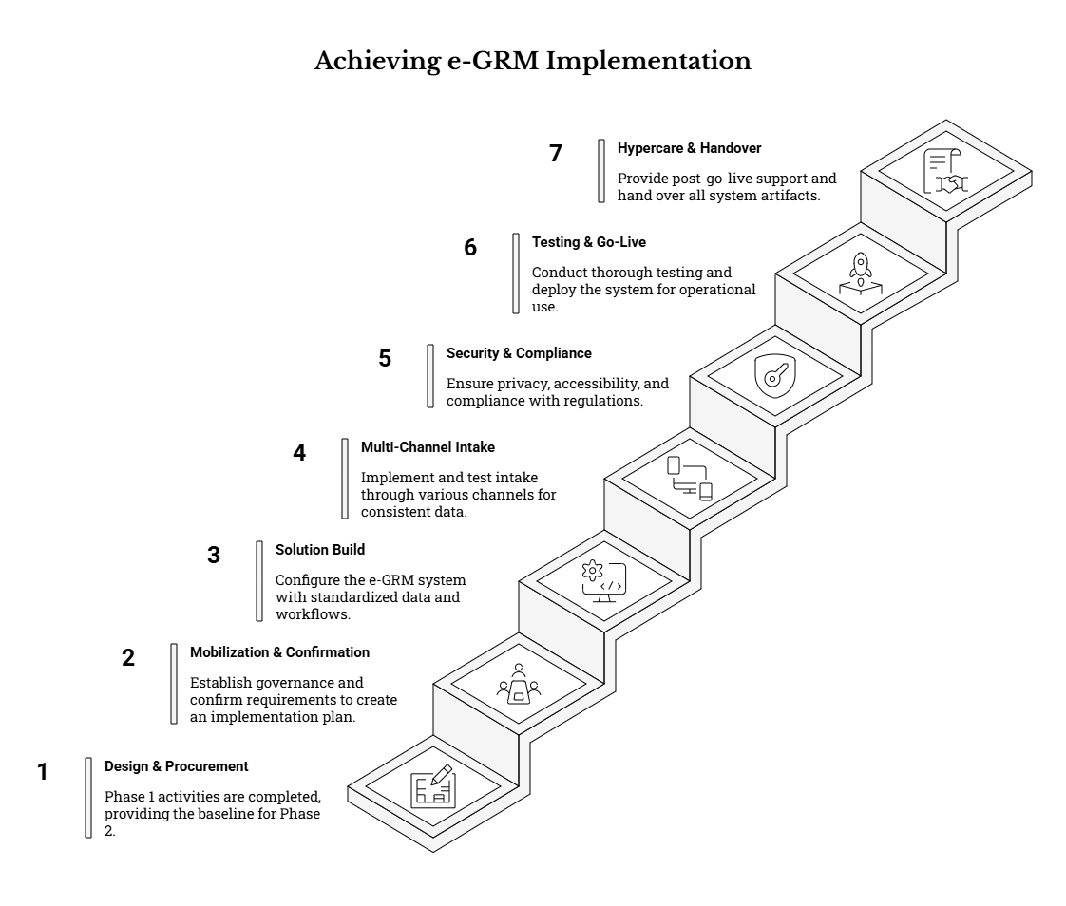

3.1 Phase 1: Design and Procurement Preparation (Completed – Provided as Inputs)
Phase 1 activities are not part of this Supplier’s scope. However, Phase 1 outputs constitute the baseline implementation package for Phase 2 and shall be treated as the authoritative reference for functional intent, standardized datasets, reporting requirements, and compliance expectations. The Supplier shall use these outputs as implementation inputs and demonstrate, through the Phase 2 mobilization and requirements confirmation activities, how each input is translated into configuration, integrations, testing, training, and commissioning.
At a minimum, the Supplier shall:
- Acknowledge and ingest Phase 1 deliverables as “controlled inputs.” The Supplier shall establish a document register that lists Phase 1 outputs received (requirements/workflows, data standards, reporting needs, risk and compliance matrices, stakeholder engagement guidance, and work plan expectations) and assign internal owners responsible for implementing each input area.
- Maintain traceability from inputs to configuration and acceptance. The Supplier shall map Phase 1 requirements and workflows into an implementation backlog and demonstrate alignment through (i) configuration workbooks/design packs, (ii) test scripts and evidence, and (iii) go-live readiness checks. Any configuration choices that affect the user experience, workflow states, data capture, or reporting outputs shall be justified against the Phase 1 intent.
- Respect “no redefinition” of agreed functional intent. The Supplier shall not re-open or re-scope the agreed requirements in a way that changes the core functional objectives, workflows, or compliance obligations. Where minor clarifications or practical adjustments are needed for implementation feasibility, the Supplier shall document these as controlled changes (including rationale, impacts, and approval).
- Use Phase 1 risk and compliance instruments as implementation guardrails. The Supplier shall align delivery planning, sequencing, and mitigations to the agreed risk matrix and compliance mapping matrix, ensuring known risks (e.g., adoption, data protection, telecom dependencies, local capacity) are actively managed within Phase 2 delivery.

3.2 Phase 2 (3 Months): Implementation and Commissioning
The Supplier is responsible for delivering a production-ready e-GRM solution and associated documentation, training, and handover within a three-month implementation period. The Supplier shall propose an implementation approach and schedule that meets or improves the required milestones in Section 9, while ensuring compliance and quality.
In delivering Phase 2, the Supplier shall ensure that the e-GRM is not only technically deployed, but also operationally usable by national, county, and municipal stakeholders. This requires simultaneous attention to: (i) configured end-to-end workflows; (ii) standardized data capture and data quality controls; (iii) multi-channel intake and communications; (iv) security, privacy, accessibility, and SEA/SH-sensitive handling; (v) reporting and monitoring outputs; and (vi) training, adoption support, and handover for sustainability.
The Supplier’s Phase 2 scope includes, at minimum:
- Configuration and/or development activities required to implement the agreed workflows, datasets, roles, and reporting outputs in a technology-neutral manner;
- Environment setup and deployment (development/test/staging/production as applicable and approved) and release management across the three-month delivery window;
- Integration enablement for agreed channels (web, email, SMS/USSD, hotline/phone assisted intake), noting dependencies on Client-led regulatory/commercial arrangements for telecom services;
- Quality assurance and testing (functional, integration, regression, performance, security, and accessibility), including evidence packs sufficient for acceptance decisions;
- Pilot rollout support in Client-selected municipalities representing diverse contexts, incorporation of prioritized feedback, and readiness assurance for broader go-live; and
- Training, hypercare, and handover, including documentation, administrative procedures, and operational artifacts required for sustained use by Client teams after commissioning.

3.2.1 Mobilization, Inception and Requirements Confirmation
The Supplier shall conduct a mobilization kickoff with the Client and agree governance arrangements, working groups, and communication protocols. The Supplier shall review Phase 1 outputs and conduct a structured requirements confirmation and gap analysis to translate them into an Implementation Plan and configuration backlog. The Supplier shall produce a detailed Implementation Plan (including sprint plan, environments, responsibilities, testing approach, training plan, and go-live plan) for Client approval. The Supplier shall establish a risk and issue log and propose mitigation actions aligned to the agreed risk matrix.
To strengthen delivery certainty within the fixed three-month window, the Supplier shall expand mobilization and requirements confirmation to include the following practical elements:
a) Implementation governance and delivery management
- Establish an implementation governance model with clear decision-making pathways, including a core working group (NPCT + Supplier) and structured touchpoints with selected county/municipal representatives (as agreed).
- Confirm meeting cadence and minimum artifacts, including: weekly working meetings, regular demos/reviews, action logs, a decisions register, and escalation thresholds for schedule, compliance, or quality risks.
- Agree a RACI refined from the ToR baseline, including named focal persons for: (i) GRM process validation, (ii) ICT/hosting approvals, (iii) data protection and privacy matters, (iv) accessibility validation, and (v) pilot/UAT coordination.
b) Structured confirmation of Phase 1 inputs (no redefinition, but implementable clarification)
- Conduct a structured walk-through of Phase 1 workflows and requirements to confirm: grievance lifecycle states, escalation levels, SLA expectations, roles and responsibilities across levels (municipal/county/national), required reporting outputs, and sensitive grievance handling protocols.
- Identify “implementation clarifications” (e.g., field mappings, routing rule logic, notification channel preferences) and document them in a requirements confirmation memo or backlog item list for approval—without altering the agreed functional intent.
- Produce a consolidated “configuration backlog” that is prioritized for delivery sequencing across the three-month period, distinguishing Must-deliver elements for go-live from items that may be staged (where dependency-driven, e.g., telecom readiness).
c) Implementation Plan and delivery approach
The detailed Implementation Plan shall be sufficiently operational to guide delivery and acceptance. It shall include, at minimum:
- A week-by-week plan aligned to the required milestones, with internal sprint/release cadence and demo points;
- Environment setup plan (including access, approvals, and deployment responsibilities);
- Configuration and build approach (configuration-first, development where necessary), including how forms, workflow states, routing rules, and reporting are implemented;
- Testing strategy and evidence plan (how tests will be designed, executed, recorded, and presented for acceptance);
- Training and adoption plan (target audiences, training formats, schedule, required materials, and “super user” approach);
- Go-live and cutover plan (readiness criteria, backout/rollback considerations, and continuity procedures);
- Hypercare plan (scope, contact points, issue severity definitions, response targets, and daily/weekly reporting during stabilization); and
- A clear dependencies plan (e.g., hosting readiness, telecom channel parameters, stakeholder availability for UAT and training) with mitigation/fallback actions.
d) Risk, issues, dependencies, and change control
- Establish and maintain: (i) a risk register (aligned to the agreed risk matrix), (ii) an issues log, (iii) a dependency tracker, and (iv) a change control process for any adjustments to requirements or configuration.
- Define triggers and escalation thresholds (e.g., critical path slippage, unresolved severity-1 defects, security or privacy incidents, telecom integration delays) and agree how decisions will be escalated to the Client for timely resolution.

3.2.2 Solution Build/Configuration and Data Model Implementation
The Supplier shall set up required environments (development/test/staging/production as applicable) and configure the solution to implement the agreed workflows and data structures. The Supplier shall implement the standardized grievance intake data fields, including mandatory/optional fields, validation rules, and attachment handling. The Supplier shall configure user roles, departments/units, routing rules, escalation paths, and service level targets consistent with the agreed GRM process. The Supplier shall configure multi-language support (at minimum English and Kiswahili) for user-facing components and template messages, with extensibility for additional local languages where required.
The Supplier shall configure or build reporting dashboards and exports to meet the agreed operational and program reporting needs.

To ensure a coherent, scalable, and auditable implementation, the Supplier shall address solution build/configuration through the following minimum activities:
a) Environment setup and release management
- Establish approved environments with clear segregation and controls (e.g., development → test → staging → production), including access controls, auditability, and deployment permissions.
- Implement a controlled release process, including versioning of configuration artifacts (forms, workflow rules, templates) and documentation of changes between releases/sprints.
- Configure backup routines for each relevant environment (at minimum for staging/production) and ensure restoration procedures are documented for operational readiness.
b) Data model and standardized intake dataset implementation
- Implement the standardized intake/data collection dataset as the baseline for all channels, ensuring field meaning and data rules are preserved even if the platform’s native field names differ.
- Configure mandatory/optional/conditional fields, validation rules (e.g., required location fields such as county and municipality; category selection; consent capture; closure-required fields), and controlled vocabularies (drop-down lists) to support consistent classification and reporting.
- Configure attachment handling, including: allowable file types, maximum size, number of attachments per submission/action (where supported), and secure attachment access consistent with role-based controls.
- Implement internal processing fields required for operational control, including status, priority, assignment, escalation level, SLA plan/due dates, action notes, and closure outcomes, ensuring these are separated appropriately from public-facing fields where necessary.
c) Workflow configuration and SLA/escation logic
- Configure grievance lifecycle states aligned to agreed GRM practice, including clear rules for when a case transitions to resolved/closed and what data is required at each stage (e.g., resolution summary and date on closure).
- Implement SLA targets and due date calculations consistent with agreed service standards and working schedules (including business hours and holiday calendars where relevant).
- Configure escalation paths and triggers based on overdue status, grievance type/priority, or governance level (municipality → county → national), ensuring escalations are logged and auditable.
- Enable tasking/reminder capabilities (where supported) to operationalize investigation steps and follow-ups, with responsibility tracking and due dates aligned to SLA logic.

d) User roles, organizational structures, and routing
- Configure role-based access control using a least-privilege approach across national, county, and municipal levels, including separation between standard case handlers and system administrators.
- Configure organizational structures required for routing and workload management (departments/units, teams, assignees), ensuring routing rules can reflect geography (county/municipality) and grievance category/help topic.
- Configure routing logic to support consistent triage and assignment, with clear handling for exceptions (manual reassignment by authorized supervisors, referral workflows, escalation overrides).
e) Multi-language and content configuration
- Implement multilingual support for user-facing components at minimum in English and Kiswahili, including portal content, labels, and notification templates.
- Ensure that message templates and public guidance content are editable by authorized administrators (where feasible), reducing long-term dependence on the Supplier for routine content changes.
f) Reporting dashboards and export configuration
- Configure operational dashboards for volume, status, categories, timeliness (SLA compliance), overdue cases, escalations, and workload distribution by unit/assignee, with filtering by time period and geography.
- Configure report exports in common formats (e.g., CSV/Excel/PDF where applicable), ensuring reporting outputs can support programme reporting and audits without exposing personal data inappropriately.
- Implement audit-ready exports and the ability to produce a grievance case file (metadata + actions + communications) for internal review and lawful requests, subject to access permissions.

3.2.3 Multi-Channel Intake and Communications
The Supplier shall implement and test intake through multiple channels as agreed, including web, email, phone (toll-free hotline) and SMS/USSD (subject to Client’s regulatory and commercial arrangements with telecom providers). The Supplier shall ensure all channels feed into one unified grievance register and apply consistent reference numbering and status tracking. The Supplier shall implement acknowledgement and notification mechanisms that respect user consent and privacy preferences (e.g., SMS/email/phone/post/in-person), and include templates and message logs.
To make multi-channel intake operationally reliable and consistent across counties and municipalities, the Supplier shall ensure:
a) Unified register and consistent identity across channels
- All channels shall create or update records in a single system of record, using a consistent grievance reference numbering approach that is unique, traceable, and usable across channels.
- Where channel characteristics increase duplicate risk (e.g., the same grievance submitted via web and hotline), the Supplier shall configure practical operational controls (e.g., search and linkage of related records, optional merge controls where supported, or staff guidance and SOPs for duplicate handling).
b) Web and assisted intake as baseline channels
- Implement a public-facing web submission interface and a staff console for assisted intake (phone/in-person/letter) that uses the same standardized dataset and validation rules, ensuring consistent data quality regardless of channel.
- Ensure assisted intake workflows enable staff to capture: submission channel, consent where personal data is recorded, preferred contact method, location fields, grievance category/type, and supporting evidence (attachments or logged evidence references), as applicable.
c) Email channel enablement
- Implement outbound email notifications and correspondence with managed sender identities and template controls.
- Where inbound email processing is enabled/approved, configure safe handling rules for creating new grievances or appending to existing grievances, including routing logic and protection against unintended disclosure (e.g., careful handling of email threads and attachments).
d) SMS/USSD and hotline channel integrations (dependency-aware)
- Implement and test SMS/USSD and hotline integrations subject to Client-led regulatory and commercial arrangements and timely provision of integration parameters by telecom providers.
- Where telecom dependencies delay full activation, configure operational fallbacks that preserve unified recording (e.g., assisted intake with later channel activation; alternative acknowledgements using approved channels) without compromising the single system of record.
e) Acknowledgements, notifications, and communications governance
- Configure acknowledgements (automated where feasible) to provide reference numbers and set expectations on process steps and timelines, while avoiding disclosure of sensitive information through insecure channels.
- Configure notification templates and rules for key events (registration, assignment, request for more information, resolution, closure, escalation/appeal), ensuring that:
  - Notifications align to the complainant’s preferred contact method and recorded consent;
  - Message content is privacy-aware (no unnecessary personal or sensitive details in SMS/USSD); and
  - Message logs and delivery status (where supported) are retained as part of the audit trail.
f) Communications records and evidence
- Ensure each grievance record maintains a chronological communication history (external messages, responses, call notes, letters, and internal notes), with timestamps and sender/recipient metadata, and clear separation between internal-only notes and complainant-visible communications.

3.2.4 Security, Privacy, Accessibility and Compliance Implementation
The Supplier shall implement privacy-by-design controls, including consent capture, data minimization, role-based access, audit trails, secure transmission and storage, and retention/archiving controls. The Supplier shall implement accessibility and inclusive design requirements for user-facing components, including compatibility with assistive technologies and support for low-bandwidth use cases. The Supplier shall implement SEA/SH-sensitive handling protocols (including confidential intake options, restricted access, and referral workflows) consistent with agreed procedures. The Supplier shall support compliance readiness by providing configuration evidence, security documentation, and test results for Client review.
The Supplier shall treat this subsection as a “must-pass” workstream for acceptance, ensuring controls are not only configured but evidenced through documentation and testing.
a) Privacy-by-design and data protection controls
- Implement consent capture aligned to the privacy notice for any grievance submission that includes personal data, including date/time and (where applicable) versioning of the consent notice.
- Apply data minimization principles in form design and channel flows, including the ability to submit grievances anonymously without preventing processing.
- Configure access controls and segmentation so that users see only the data required for their role, geography, department, and assignment responsibilities (least privilege).
- Ensure audit logs are enabled for key actions (create, view, update, assign/transfer, escalate, respond, close, export), including who did what and when, and ensure logs are accessible only to authorized roles.
b) Security controls and secure configuration
- Enforce secure transmission (e.g., HTTPS/TLS) and implement secure authentication and session management suitable for a system handling personal and potentially sensitive information.
- Implement enhanced controls for privileged users (e.g., strong password policy and optional multi-factor authentication where supported), and administrative separation to reduce misconfiguration risk.
- Implement secure attachment handling (access inherited from grievance permissions; authentication required for access where configured) and apply malware/virus scanning where feasible within the hosting environment.
- Provide incident readiness artifacts appropriate to Phase 2 scope (e.g., incident handling contacts and steps; procedures for containment and recovery; backup/restore procedures and test evidence where required).
c) Retention, archiving, and controlled disposal
- Configure retention and archiving controls consistent with agreed policy and legal obligations, ensuring closed cases remain retrievable for authorized users while supporting controlled archiving and (where applicable) lawful deletion/anonymization.
- Ensure retention controls do not compromise auditability (audit trails and key decision records must remain available for the required period).
d) Accessibility and inclusive design implementation
- Implement accessibility requirements for public-facing and key staff workflows, including compatibility with assistive technologies, keyboard navigation, readable UI structure, and clear validation/error messaging.
- Ensure usability under low-bandwidth conditions through lightweight interface design, optimized content loading, and practical fallbacks for users with limited connectivity.
- Ensure language support at minimum in English and Kiswahili for user-facing interfaces and templates, with design extensibility for additional languages if required.
e) SEA/SH-sensitive handling and confidentiality protocols
- Implement a dedicated sensitive case handling mechanism that supports: confidential intake options, restricted visibility (need-to-know), safe routing to designated focal persons, and suppression/redaction of notifications that could expose sensitive information.
- Ensure the system supports survivor-centred handling by minimizing unnecessary capture of sensitive details in free-text fields, and enabling structured recording of actions/referrals consistent with agreed procedures.
- Ensure reporting for sensitive cases is aggregate by default and that exports containing personal/sensitive details are restricted, controlled, and auditable.
- Provide targeted training and SOPs for users assigned to sensitive case handling so system controls are matched by correct operational practice.
f) Compliance readiness evidence
The Supplier shall provide an evidence package suitable for Client review that may include: configuration screenshots/exports, role-permission matrices, audit log exports (sample), security configuration summaries, accessibility test summaries, and test results demonstrating compliance controls operate as intended.

3.2.5 Testing, Go-Live, Hypercare and Handover
The Supplier shall prepare and execute testing (functional, integration, regression, performance, security and accessibility tests) and support Client-led user acceptance testing. The Supplier shall support pilot rollout in a Client-selected set of municipalities representing different contexts (e.g., large city, smaller municipality, and a refugee-hosting town), collect feedback and implement agreed fixes. The Supplier shall deploy to production, support cutover activities, and provide hypercare stabilization support after go-live. The Supplier shall deliver training and capacity building for national, county and municipal users, and hand over all system artifacts, documentation, credentials and warranties/support arrangements.
To make acceptance and sustainability practical within a three-month window, the Supplier shall implement this subsection as an integrated readiness pathway:
a) Testing strategy and coverage (evidence-driven)
- Develop and maintain test plans and test scripts aligned to agreed workflow scenarios and requirements, including end-to-end flows from intake → assignment → action logging → resolution → closure, plus escalation and appeal scenarios where applicable.
- Execute and evidence, at minimum:
  - Functional testing of core workflows and form validations;
  - Integration testing for each enabled channel and interface;
  - Regression testing across releases/sprints to ensure changes do not break prior functionality;
  - Performance testing proportionate to expected usage (especially for search and reporting);
  - Security testing appropriate to risk, including authentication/authorization checks and verification of audit logging and encryption controls; and
  - Accessibility testing for public-facing and key staff journeys, with remediation tracking.
- Maintain a defect register with severity classification, owners, target resolution dates, and retest evidence, ensuring critical defects are resolved prior to go-live.
b) Client-led User Acceptance Testing (UAT) enablement
- Provide UAT scripts, test data guidance, and structured support for execution, including daily triage sessions during UAT windows and rapid remediation cycles for agreed defects.
- Ensure UAT participants include NPCT and selected county/municipal users, and include accessibility validation where feasible.
- Produce a UAT sign-off pack summarizing: completed scenarios, open defects and residual risks (if any), and a recommendation on go-live readiness.
c) Pilot rollout and incorporation of feedback
- Support pilot rollout in Client-selected municipalities representing diverse contexts (large city, smaller municipality, refugee-hosting town) to validate real-world usability, routing, local capacity considerations, and channel reliability.
- Capture pilot feedback in a structured manner (issues, enhancements, training gaps, data quality observations), prioritize fixes required for go-live, and implement approved changes within the timeline.
d) Go-live readiness, cutover and continuity
- Prepare a go-live checklist covering: environment readiness, user provisioning, roles/permissions verification, template readiness (English/Kiswahili), reporting outputs validation, backup configuration and restore readiness, and incident/hypercare readiness.
- Support cutover activities including production deployment, configuration migration (where applicable), and validation of critical operations (intake, acknowledgements, assignment, reporting).
- Define and document continuity procedures for downtime scenarios (temporary manual intake and later entry) so grievances can still be received and recorded during disruptions.
e) Hypercare stabilization and operational transition
- Provide post go-live hypercare support for stabilization, including defined channels for issue reporting, severity-based response, and a documented daily/weekly hypercare report summarizing issues encountered and resolutions.
- Ensure knowledge transfer includes not only “how to use the system,” but also how to manage operational routines (user onboarding, configuration changes, report generation, audit log access, and basic troubleshooting).
f) Training, materials, and handover dossier
- Deliver role-based training for national, county, and municipal users, including administrators, supervisors, grievance handlers, and reporting users.
- Provide user support materials and SOPs tailored to operational needs, including:
  - User guides and quick reference guides (English and Kiswahili);
  - Administrator guide (configuration management, user/role management, backup/restore procedures, audit log access);
  - Assisted intake scripts and job aids for hotline/in-person intake; and
  - Data quality and classification guidance (how to use standardized categories and required fields).
- Handover shall include all system artifacts and access materials required for sustainability, such as: as-built configuration documentation, integration specifications, credentials handover procedures, warranty/support terms, and any agreed source code/customization deliverables.

4. FUNCTIONAL SCOPE OF THE E-GRM
This section defines the minimum functional capabilities that the e-GRM shall provide as a programme-wide system of record for grievances linked to KUSP2. The intent is to ensure consistent end-to-end grievance handling across participating counties and municipalities while enabling decentralized operations (municipal/county handling with national oversight), multi-channel access, and robust auditability. The functional framework below shall be implemented in a technology-neutral manner, prioritizing configuration over customization where feasible, while still meeting all required outcomes and controls.
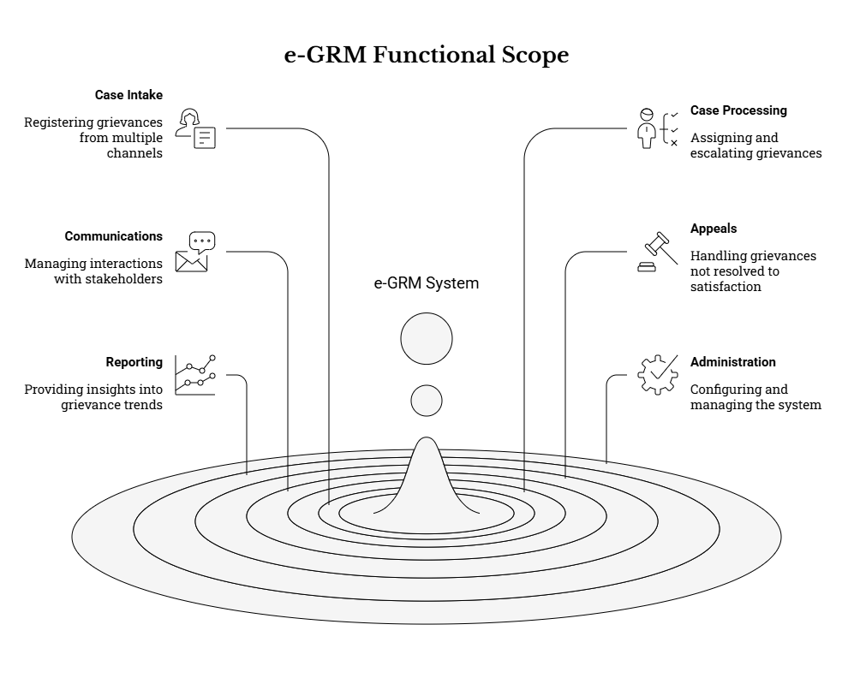

4.1 Case Intake and Registration
The solution shall support the registration of grievances from multiple channels and create a single system record per grievance. Each registered grievance shall receive a unique reference number used for tracking across all channels.
In addition to the requirements listed below, intake and registration functions shall be designed to: (i) minimize barriers to access (including for low-literacy and low-connectivity users), (ii) standardize data capture to enable consistent reporting and escalation, and (iii) prevent loss of grievances submitted outside the web channel by ensuring staff-assisted workflows are equally robust and auditable.
a) Intake channels: at minimum, web form and staff-assisted entry; and where enabled by Client arrangements, email, toll-free phone intake, and SMS/USSD intake.
- The solution shall ensure that all enabled channels feed into one unified grievance register (single system of record), with consistent numbering, categorization, timestamps, and status tracking.
- Staff-assisted entry shall support grievances received through in-person walk-ins, community meetings, letters, or other offline channels by enabling authorized users to register these grievances in the system using the same standardized intake fields and validation rules.
- For SMS/USSD and phone-based intake (where enabled), the solution shall support “minimum viable intake” (short, structured capture) and a follow-on workflow to complete additional details through staff follow-up, while still generating a reference number immediately and recording the intake channel.
- The solution shall avoid use of automated chatbots for grievance intake; user support may be provided via guided forms, tooltips, and FAQs/knowledge resources that help users submit complete grievances without replacing human-assisted channels where needed.
b) Ability to submit grievances anonymously, without preventing processing; where contact details are provided, they shall be captured with consent and according to the complainant’s preferred method of contact.
- The solution shall allow a complainant to lodge a grievance without providing personally identifying details, while still capturing sufficient information to enable triage, assignment and action.
- For anonymous grievances, the system shall still provide the unique reference number and enable status tracking through agreed mechanisms (e.g., reference number plus a secure verifier such as an email/phone where provided, or other agreed approach that does not expose personal data).
- The system shall clearly distinguish anonymous grievances in staff views and apply appropriate rules (e.g., complainant notifications not possible unless a contact method exists).
- Where contact details are provided, the solution shall support capture of preferred contact method (e.g., SMS, email, phone, post, in-person), and enable channel-specific acknowledgement and follow-up consistent with the complainant’s preference and consent.
c) Ability for a representative to submit on behalf of another person or group, including capture of representative details and confirmation of authorization.
- The solution shall support recording whether the grievance is submitted by: (i) the affected person, (ii) a representative, or (iii) a group/organization.
- Where a representative submits, the system shall capture representative identity and contact details, relationship/role (e.g., family member, community leader, CSO), and a confirmation/attestation of authorization (as per the standardized intake form).
- The solution shall support recording whether the complainant is an individual or group, and—where applicable—capture basic group identifiers (e.g., group name) without over-collecting personal data.
d) Ability to capture and store supporting evidence/attachments, with configurable limits and accepted file types.
- The solution shall support attaching one or more files at intake and during processing (e.g., photos, letters, PDFs), while enforcing configurable controls (file size limits, permitted file types, maximum number of files).
- Attachment handling shall inherit access controls from the grievance record (i.e., restricted grievances must also restrict their attachments).
- The solution shall support capturing basic attachment metadata (upload time, uploader role, filename/type) to support auditability and chain-of-custody for sensitive evidence.
- Where feasible in the hosting environment, the solution should support malware scanning and safe handling of uploaded files to reduce security risk.
e) Data validation and completeness checks consistent with the standardized grievance intake form (see Appendix A).
- The solution shall enforce mandatory fields and conditional requirements (e.g., representative fields required if “submitted by representative” is selected).
- Validation shall include format checks (e.g., email/phone formats), controlled lists (e.g., counties/municipalities), and minimum content rules for narrative fields to reduce unusable submissions.
- The system shall support “save-as-draft” or staged completion for staff-assisted intakes where information is collected over multiple touchpoints, while maintaining audit trails of changes.
- The solution shall support basic duplicate detection and handling (e.g., flag potential duplicates based on contact details, location, date, and similar subject text) and allow authorized users to link related grievances rather than losing visibility through manual deletion.
f) Automatic capture of date/time, channel, location fields (county, city/municipality, site), and categorization fields.
- The solution shall automatically record intake timestamp, intake channel/source, and the user/agent (for staff-created records).
- Location fields shall be standardized using reference lists (counties/municipalities) that can be updated administratively over time.
- The solution shall support capturing additional location detail (e.g., ward, neighbourhood, project site name/identifier) where required by the agreed data standards, while keeping optionality where not available.
- Categorization shall align to agreed help topics/categories and support multi-select where applicable (e.g., a grievance that has both service delivery and environmental concerns), subject to agreed classification rules.
g) Explicit statement and capture of consent to personal data use at the point of intake, aligned to the privacy notice.
- Where personal data is collected, the solution shall present a privacy notice and capture explicit consent (including timestamp and channel).
- The solution shall support differentiated consent handling where feasible (e.g., consent to be contacted via SMS/email, consent to store personal data for follow-up), aligned to applicable requirements and Client policy.
- Where consent is not provided, the system shall support lawful alternatives consistent with the programme approach (e.g., allowing anonymous submission or limiting data capture to non-identifying content).
h) Ability to record additional contacts/collaborators for a grievance (e.g., copied stakeholders), with controlled visibility and consent considerations.
- The solution shall support adding additional participants/collaborators (internal or external) where needed for coordination, while allowing administrators to control whether collaborators can view the full grievance record or only receive notifications.
- Any external collaborator contact details shall be captured and used in line with consent and data minimization principles.
- The system shall provide clear separation between “complainant contacts” and “internal stakeholders copied for action,” to avoid accidental disclosure of complainant identity.

4.2 Case Processing, Assignment and Escalation
The solution shall support an end-to-end workflow from receipt to closure, including assignment to responsible units and escalation where timelines are breached or where a higher level of decision-making is required.
This workflow shall be designed to support decentralized handling (municipal/county resolution) with clear escalation pathways and auditable decision-making at each stage, including referrals to specialized entities where appropriate.
a) Configurable workflow statuses aligned to agreed GRM practice (e.g., Open/Pending, Resolved, Referred, Escalated, Closed) and the ability to add sub-statuses where required.
- The solution shall allow the Client to configure: status names, allowable transitions (e.g., Open → Resolved → Closed; Open → Referred; Open → Escalated), and sub-statuses that improve operational clarity (e.g., “Awaiting Complainant Information,” “Under Investigation,” “Action in Progress”).
- The system shall support reopening (or equivalent) where a grievance is closed prematurely or an appeal is raised, with full audit trail and reason capture.
- Status change actions shall require appropriate permissions and shall be recorded in the case history with user, date/time, and rationale (where configured as mandatory).
b) Assignment rules based on county/municipality, grievance category/help topic, and responsible department/unit; ability for authorized users to reassign.
- The solution shall support automated routing to the appropriate queue/department/unit using configurable rules based on geography, category, and other intake attributes.
- Authorized users shall be able to reassign grievances (e.g., if misrouted), with mandatory reason capture where configured, and notification to the receiving unit as appropriate.
- The system shall support assignment to individuals and/or teams, enabling workload balancing and continuity during leave/turnover.
- The solution shall support escalation/transfer between municipal, county and national levels using clearly defined routing logic and visibility controls.
c) Priority levels (e.g., Low/Normal/High/Emergency) and due dates/target timelines; visual indicators for overdue grievances and escalation triggers.
- The solution shall support configurable priority/severity levels and associated handling rules (e.g., shorter target timelines for urgent cases).
- The system shall calculate and display due dates based on configured service standards (acknowledgement, response, resolution) and working calendars (business hours, weekends/holidays where applicable).
- The solution shall provide dashboards/queues for “due soon,” “overdue,” and “escalation triggered,” and shall support automated reminders and escalations when thresholds are reached.
- Escalation rules shall support both time-based triggers (e.g., overdue) and category-based triggers (e.g., sensitive cases routed to specialized focal persons).
e) Internal action log and notes for investigation and follow-up steps; ability to capture referrals and escalation decisions with dates and reasons.
- The system shall maintain a chronological case history capturing all key actions (assignment, status changes, communications, referrals, attachments, approvals).
- Internal notes shall be distinguishable from external communications and visible only to authorized users.
- The solution shall support structured capture of investigation activities and outcomes (e.g., actions taken, site visit conducted, evidence reviewed), including attachments and links to referenced documents.
- For referrals/escalations, the system shall capture: referral target (unit/level/agency), referral reason, date, and any reference numbers used by external bodies, to ensure traceability.
f) Support for confidential handling of sensitive grievances (including SEA/SH) through restricted visibility and controlled routing.
- The solution shall support classification/flagging of sensitive cases and automatically apply enhanced confidentiality controls (restricted queues, limited roles able to view, masked fields where appropriate).
- The system shall support survivor-centred handling principles by minimizing capture of sensitive narrative in free-text fields and enabling structured referral tracking where required by agreed protocols.
- Notifications for sensitive cases shall be configurable to avoid disclosure through insecure channels (e.g., SMS messages should not include sensitive content).
- The solution shall ensure all access to sensitive records is logged and reviewable for compliance and accountability.
g) Ability to flag, tag, or mark grievances for follow-up and to schedule reminders/tasks linked to grievance handling timelines.
- The solution shall enable staff to apply tags/flags (e.g., “requires site visit,” “legal review,” “pending contractor response”) to support prioritization and management oversight.
- The system shall support task/reminder functionality linked to grievances (e.g., follow-up call date, inspection date), with due dates and assignment to responsible staff, and visibility aligned to permissions.
- The solution shall support linking related grievances (and where supported, merging duplicates) to improve trend analysis and reduce fragmented handling.

4.3 Communications and Notifications
The solution shall support structured communications with complainants and internal stakeholders, while protecting confidentiality and adhering to consent and contact preferences.
Communications functions shall support predictable, documented interaction with complainants, reduce ad hoc follow-ups, and create a complete case record of what was communicated, when, and by whom.
a) Acknowledgement of receipt with reference number and date, generated automatically where possible and otherwise recordable as a manual action.
- The solution shall support automatic acknowledgements for digital channels (e.g., web form, email) and a “record acknowledgement” action for staff-assisted channels (e.g., in-person, phone) to ensure consistent documentation.
- Acknowledgements shall include the grievance reference number, basic next steps, and where appropriate a link or instructions for status tracking—without exposing sensitive personal data.
- The system shall support acknowledgement templates per channel and per language (at minimum English and Kiswahili for user-facing content).
b) Two-way communication log per grievance (messages, responses, call notes, letters), with distinction between internal notes and external communications.
- The solution shall maintain a structured thread that captures complainant messages and staff responses, and separately captures internal notes and deliberations.
- Call notes (hotline follow-ups), meeting notes, and outgoing letters shall be recordable with timestamps and responsible staff identifiers.
- Where communications include attachments, these shall be stored securely with the grievance record and protected by the same access controls.
c) Notification rules and templates for key events (registration, assignment, request for additional information, resolution, closure, appeal), delivered through selected channels (SMS, email, phone scripts, printable letters) subject to consent and channel availability.
- The system shall support configurable event-based notifications to: (i) complainants, (ii) assigned staff/teams, and (iii) supervisors/managers for escalations and overdue cases.
- Templates shall support variable substitution (e.g., reference number, status, next steps) while allowing administrators to restrict/disable variables that would expose sensitive information.
- The solution shall support channel fallbacks (e.g., if SMS delivery fails, switch to email where available) and recording of delivery failures to support follow-up.
- Phone scripts and printable letter templates shall be available for offline communications, ensuring standard messaging and documentation.

d) Message history retained in the grievance record with timestamps and sender/recipient metadata.
- The system shall record the date/time, sender identity (user/role), recipient (complainant/contact method), channel used, and message status (sent/failed/manual) where applicable.
- The solution shall support audit-ready extraction of communication history as part of a grievance case file for internal review and lawful requests.
e) Ability to withhold complainant identity from downstream actors where confidentiality is requested, while still enabling investigation and resolution.
- The solution shall support configurable data masking and role-based field visibility so that units handling actions can access necessary issue details without automatically receiving identifying complainant data.
- The system shall support controlled sharing of identity only where required for resolution, and only to roles authorized under agreed procedures, with all access logged.

4.4 Appeals and Closure
The solution shall support recording complainant satisfaction and managing appeals/escalations for grievances where the complainant is not satisfied with the resolution.
Closure and appeal handling shall ensure decisions are well documented, consistently communicated, and traceable, while supporting escalation pathways and continuous improvement.
a) Capture of resolution summary, resolution date, and evidence of communication of the outcome to the complainant.
- The system shall support structured capture of resolution details, including: summary outcome, key actions taken, responsible unit/approver (where applicable), and resolution date.
- Evidence of communication shall include a record of the channel used, message content (or reference to template), and date/time; where physical letters are used, the system shall allow uploading/scanning proof of dispatch if available.
- The solution shall support categorization of closure reason/outcome codes (e.g., resolved, referred to another authority, insufficient information, duplicate/merged) to improve reporting and learning.
b) Capture of complainant response (Satisfied / Not satisfied / Not applicable for anonymous).
- The solution shall record complainant satisfaction status and (where feasible) optional feedback comments.
- For anonymous grievances, the system shall allow closure without satisfaction capture while maintaining clear reporting separation for “not applicable due to anonymity/unreachable.”
- The system shall support linking satisfaction capture to the closure workflow (e.g., prompt to record satisfaction before final closure, where appropriate).
c) Ability to trigger an appeal/escalation workflow where the complainant is not satisfied, including re-assignment to the next level.
- The solution shall support appeal initiation through both complainant channels (where enabled) and staff-initiated escalation.
- Appeal handling shall capture: appeal reason, date, receiving level/unit, and the outcome of the appeal decision, with corresponding communications logged.
- The system shall support escalation between levels (municipality → county → national) consistent with agreed governance and decision-making structures.
d) Closure controls requiring mandatory completion of key fields and documentation before final closure.
- The solution shall support a closure checklist approach, enforcing completion of mandatory fields (e.g., status, resolution summary, dates, responsible unit, communication record) before allowing closure.
- The system shall support supervisory review/approval for closure of specific categories (e.g., high priority, escalated, sensitive) where required by agreed procedures.
- The solution shall support preventing closure when critical linked tasks remain open, where task management is enabled.
e) Archiving and retention controls for closed grievances consistent with the agreed retention policy.
- The system shall support archiving of closed grievances, preserving full audit trails and attachments while limiting access according to role and need.
- Retention controls shall support retention periods by grievance category where applicable (e.g., different handling for sensitive cases), and shall allow controlled anonymization/deletion in line with policy and applicable requirements.
- The solution shall support “legal hold” or equivalent preservation controls for cases under investigation or audit, preventing deletion or alteration while the hold is active.

4.5 Reporting, Dashboards and Analytics
The solution shall provide operational dashboards and reporting outputs to support day-to-day management and programme reporting, without exposing personal data inappropriately.
Reporting shall serve both operational management (workload, overdue cases, escalation) and programme-level accountability (trend analysis, compliance monitoring, performance reporting), while enabling safe aggregation and disclosure where required.
a) Dashboards for volumes, categories, status distribution, resolution timelines, overdue grievances, and workload by unit/assignee.
- Dashboards shall support national, county and municipal views consistent with permissions and data segmentation.
- Core metrics should include: total received, open/backlog, resolved/closed, overdue, escalated, referred, and average/median handling times (acknowledgement, response, resolution as configured).
- Workload views shall support queue-level and assignee-level monitoring to identify bottlenecks and support resource planning.
b) Filtering by time period, county, city/municipality, channel, category/help topic, priority, and other agreed attributes.
- The solution shall support interactive filtering and drill-down from national to county/municipal levels where permitted.
- Users shall be able to save commonly used filters/views (e.g., “My open grievances,” “Overdue in my municipality,” “SEA/SH aggregate view”) subject to role permissions.
- The system shall support search and filtering across key fields, including reference number and structured taxonomy fields.
c) Standard reports and exports (e.g., CSV/Excel/PDF) for periodic reporting and audits, including aggregate/anonymized outputs suitable for public disclosure where required.
- The solution shall support export of operational lists and summary tables in open, commonly used formats, with configurable selection of fields (and default exclusion of personal data where not needed).
- The system shall support generating printable reports for management meetings and audit reviews, and exporting data for external analysis (e.g., M&E).
- Where public disclosure is required, the system shall support anonymized/aggregated reporting outputs that remove identifying details and suppress small-number disclosure where appropriate.
e) Ability to generate reports aligned to KUSP2 reporting requirements (e.g., resolution within target timelines such as 30 days where feasible) and to support analysis of trends over time.
- The solution shall support SLA/timeliness reporting aligned to configured service standards (including acknowledgement/response/resolution targets as agreed), and allow these standards to be updated over time without redevelopment.
- Trend analytics shall support identifying recurrent issues by category, location, and implementing unit, enabling corrective action planning and learning loops.
- Reports shall support tracking of escalations and referrals to inform governance performance and system improvements.
f) Audit-ready logs of actions and status changes, and the ability to export a complete grievance case file for internal reviews or lawful external requests.
- The solution shall maintain auditable case histories showing “who did what, when, and why” for all key case actions (assignment, status change, communications, edits, access where applicable).
- The system shall support exporting a complete case file (including metadata, communications log, action history, and attachments where authorized) in a structured format suitable for audits, investigations, and lawful information requests.
- Access to audit logs and full case file exports shall be permission-controlled and recorded in administrative logs.

4.6 Administration and Configuration
User and role management (national, county, municipal levels), including role-based access control and least-privilege permissions. Configuration of categories/help topics, departments/units, SLAs/target timelines, escalation rules, templates, and channel settings. Configuration of forms and data fields, including the standardized grievance intake form and additional internal fields for processing.
To enable sustainability and minimize reliance on the Supplier post-go-live, administration and configuration capabilities shall be sufficiently robust for authorized Client administrators to manage day-to-day operational changes and periodic updates without software redevelopment.
Administrative dashboards for system health (where applicable), audit log access, and configuration change tracking. Ability to configure and manage integrations (e.g., SMS gateway, USSD gateway, email, telephony) using open interfaces. Configurable grievance list views with filters (status, category/help topic, priority, assignee, location, date ranges) and saved filters for common operational views. Search capabilities including reference number search and full-text search across key grievance fields, subject to access permissions. Ability to print or export an individual grievance case file (including action history and communications) for internal review and lawful information requests.
Template management for common responses and acknowledgements to ensure consistent communications. Configuration of working schedules and service level targets to drive overdue identification and escalation. Directory management for users/agents and organizational structures (departments/units) that support decentralized operations. Form and list management tools to maintain dropdown options (e.g., counties/municipalities, project contexts, categories) and support updates over time without re-development.
Administrative audit log view and export for configuration changes and privileged actions.
In expanding the above, the solution’s administration function shall additionally support, at minimum:
- Role catalogue and segregation of duties: ability to define roles (e.g., administrator, supervisor, grievance handler, reporter/view-only) and apply least-privilege permissions, including special roles for sensitive grievance handling.
- User lifecycle management: creation, modification, deactivation, and periodic review of accounts (including handling of staff transfers and turnover), with audit logs for all privileged actions.
- Configuration governance: versioning or change tracking for key configuration elements (forms, lists, routing rules, SLAs, templates), with the ability to roll back changes where feasible and record who approved/implemented changes.
- Reference data administration: maintain controlled vocabularies (counties/municipalities, categories/help topics, escalation levels, outcomes) and ensure changes are reflected consistently across forms, routing rules, and reports.
- Channel integration management: configure and test integration settings (email addresses, SMS/USSD gateway parameters, telephony metadata where applicable), monitor integration health (e.g., failed message delivery), and support safe credential management (API keys/secrets controlled and auditable).
- SLA schedule administration: configure working calendars (business hours, weekends/holidays) to ensure accurate due date calculation and escalation triggers across decentralized operations.
- Data export and continuity controls: enable periodic exports for backup/analysis, support controlled handover/export of all grievance data and configuration to prevent vendor lock-in, and maintain clear administrative procedures for data extraction when required.

5. NON-FUNCTIONAL REQUIREMENTS

5.1 Performance and Capacity
The solution shall meet performance requirements appropriate for national and decentralized use across multiple counties/municipalities, including efficient search and reporting. The Supplier shall specify expected capacity assumptions (concurrent users, monthly grievance volume, attachment storage) and demonstrate that the proposed solution can support them.
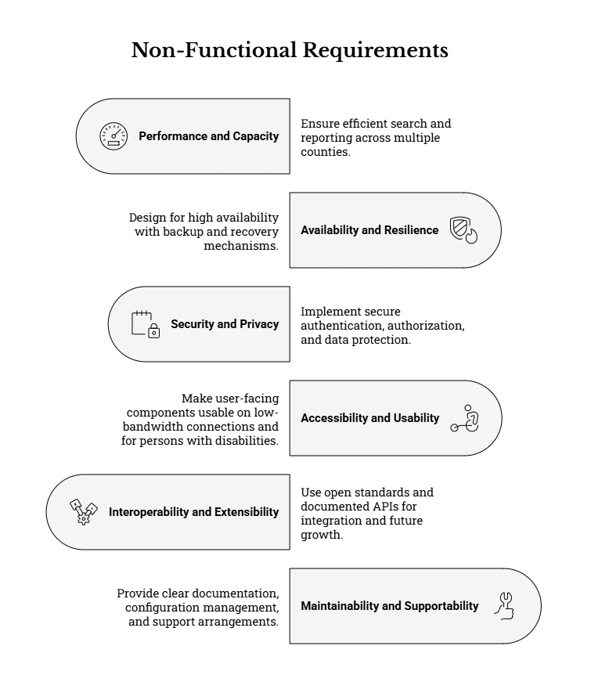
To strengthen predictability and acceptance during Phase 2, the Supplier shall, at minimum:
- Define explicit sizing and load assumptions (baseline + growth)
  - Provide an initial capacity and sizing statement as part of the Implementation Plan, including:
    - Estimated number of staff users (national, county, municipal), and expected concurrent users at peak periods (e.g., during public sensitization campaigns, audits, or high-profile incidents).
    - Estimated public submissions per month by channel (web, assisted entry, email, SMS/USSD, hotline) and expected seasonality or surge factors.
    - Expected attachment volumes (number per case, average size, maximum size), and overall storage projections for the Phase 2 go-live plus a forward projection.
    - Assumptions about data retention/archiving volumes that may affect database and storage growth.
  - Include a scalability approach showing how the solution can be scaled without re-architecture (e.g., vertical/horizontal scaling options, storage expansion, and database tuning options), while remaining technology-neutral.
- Adopt measurable performance targets and user experience benchmarks
  - Propose and agree (with the Client) measurable performance targets for common operations (at minimum):
    - Public portal: submit grievance, check status, load guidance pages.
    - Staff console: open case record, list/queue filtering, advanced search, add action note, attach evidence, update status, assign/reassign, generate case print/export.
    - Reporting: render dashboards, generate standard operational reports, export filtered datasets.
  - As an indicative baseline for acceptance testing, the Supplier should design for targets such as:
    - 95% of key pages/actions responding within a few seconds under expected peak load, and
    - Search and list filtering completing within a few seconds for typical query scopes,
    - With any exceptions clearly justified (e.g., large exports, large attachments).
- Ensure reporting performance is “operationally usable”
  - Reporting and dashboards shall be designed so they do not degrade operational use (e.g., avoid reports that lock tables or excessively slow case handling).
  - Where appropriate, the Supplier shall implement optimized reporting strategies (e.g., indexed fields used for filters, time-bounded queries, caching for aggregate dashboards, or scheduled report generation), provided this remains technology-neutral and does not reduce auditability.
- Demonstrate performance through evidence-based testing
  - The Supplier shall provide a performance and capacity test plan proportionate to expected national usage, including:
    - Test scenarios for peak periods (e.g., multiple counties logging cases concurrently, hotline-assisted intake peaks, and simultaneous reporting).
    - Test data volumes that reflect expected operational reality (including attachments).
  - The Supplier shall submit test evidence (results, environment notes, and any tuning performed) as part of the testing artifacts, and document any limitations and mitigation actions.

5.2 Availability and Resilience
The solution shall be designed for high availability and include backup and recovery mechanisms appropriate to the criticality of grievance records. The Supplier shall propose service availability targets and provide a disaster recovery approach proportionate to risk and constraints.
To ensure continuity of service and protection of grievance records, the Supplier shall, at minimum:
- Define and commit to availability targets (service uptime)
  - Propose an availability target appropriate for a public grievance channel, clearly stating:
    - How uptime is measured,
    - Exclusions (e.g., planned maintenance windows), and
    - How outages are logged, reported, and reviewed.
  - Provide a maintenance approach (planned downtime windows, notifications, and a public-facing maintenance/offline notice page where applicable).

- Implement backup, restore, and data integrity safeguards
  - Provide a backup schedule for application data and attachments appropriate to operational criticality, including:
    - Backup frequency (e.g., daily full, periodic incremental—final schedule to be agreed),
    - Backup retention periods,
    - Secure backup storage controls (including access control and encryption where applicable),
    - Backup monitoring (success/failure alerts).
  - Demonstrate restore procedures through at least one documented restore test prior to go-live (or during hypercare, if agreed), including evidence of:
    - Restore success,
    - Time to restore,
    - Data integrity checks.
- Define Disaster Recovery (DR) parameters proportionate to risk
  - Propose a DR approach that includes, as applicable:
    - Recovery Time Objective (RTO) and Recovery Point Objective (RPO) targets aligned to programme risk tolerance and hosting constraints,
    - Roles and responsibilities (who declares an incident, who executes DR steps, who communicates),
    - A DR runbook (step-by-step procedures),
    - A plan for periodic DR validation (at minimum, a tabletop exercise during implementation or hypercare).

- Provide operational continuity fallback procedures
  - Because channel disruptions can occur (connectivity outages, gateway outages, hosting interruptions), the Supplier shall document continuity procedures, including:
    - How grievances received during downtime are temporarily captured (e.g., manual logs/assisted capture),
    - How they are entered into the e-GRM once service is restored,
    - How reference numbering and traceability are preserved to avoid duplicate or lost cases.

5.3 Security and Privacy
Secure authentication, role-based authorization, audit logging, and protection of data in transit and at rest. Privacy-by-design controls aligned to the Data Protection Act, including consent, minimization, retention and controlled access.
Given that grievance records can contain personal data and highly sensitive content, the Supplier shall implement security and privacy controls proportionate to risk, including at minimum:
- Identity and access management
  - Role-based access control (RBAC) aligned to national/county/municipal operating structures, enforcing least privilege and separation of duties (e.g., admin vs case handler vs reporting-only roles).
  - Record-level access controls where required (e.g., restricting access by geography, department/unit, assignment, and sensitive-case designation).
  - Strong authentication controls for staff users, including:
    - Password policy enforcement,
    - Account lifecycle management (create/disable, leavers, role changes),
    - Support for multi-factor authentication for privileged users (and for broader staff users where feasible and agreed).
  - Controlled access to attachments (including options such as “authentication required to view attachments” and logging of attachment access).
- Secure handling of sensitive grievances (including SEA/SH)
  - Implement “need-to-know” access controls, restricted routing, and controlled notifications for sensitive cases.
  - Minimize storage of unnecessary sensitive narrative in free-text fields where agreed procedures require survivor-centred handling (i.e., capture only what is needed to route/referral and manage the case safely).
- Encryption and secure configuration
  - Protect data in transit using secure transport (e.g., HTTPS/TLS) and enforce secure transport where applicable.
  - Protect data at rest (database and attachments) through encryption and secure storage controls appropriate to the hosting environment and risk profile.
  - Apply secure configuration practices across environments (development/test/staging/production), ensuring production secrets/keys are not reused across non-production environments.
- Auditability, logging, and non-repudiation
  - Maintain an audit trail sufficient for accountability and investigations, capturing at minimum:
    - Who did what, when, and to which record (create/view/edit/status change/assignment/closure),
    - Administrative configuration changes,
    - Authentication events (login failures, privilege changes),
    - Export activity where applicable.
  - Support log retention and access controls for audit logs, with filtering/export capabilities for lawful internal reviews and compliance audits.
- Vulnerability management and security assurance
  - Provide a proportionate security testing approach, which may include:
    - Vulnerability scanning,
    - Secure configuration review,
    - Access control verification,
    - Remediation of critical findings prior to go-live.
  - Document patching and vulnerability response procedures during hypercare and warranty periods.
- Privacy-by-design and legal alignment
  - Implement privacy controls aligned to Kenya’s data protection obligations, including:
    - Consent capture where personal data is collected (and retention of consent evidence),
    - Data minimization (collect only what is required to process the grievance),
    - Purpose limitation (use data only for GRM functions and authorized reporting),
    - Retention and archiving controls (including policy-driven retention periods and secure disposal/anonymization where applicable),
    - Controlled access to personally identifiable information (PII), particularly in reports/exports.
  - Provide a practical approach to support data subject rights workflows (e.g., access/correction) consistent with Client procedures and legal obligations, without compromising the integrity of grievance records and audit logs.

- Incident response readiness
  - Provide incident response procedures appropriate to the system’s risk profile, including:
    - Detection and escalation steps,
    - Containment and recovery actions,
    - Evidence preservation and audit log protection,
    - Support to Client breach assessment/notification obligations where applicable.

5.4 Accessibility and Usability
User-facing components shall be usable on low-bandwidth connections and common devices, and shall support accessibility requirements for persons with disabilities. Interfaces shall support at minimum English and Kiswahili.
To ensure equitable access and practical usability across all KUSP2 contexts, the Supplier shall, at minimum:
- Low-bandwidth and device compatibility
  - Design for reliable use on:
    - Low-bandwidth connections,
    - Common smartphones and basic desktops/laptops in county/municipal offices,
    - Modern mainstream browsers (final list to be confirmed during mobilization).
  - Implement performance-conscious user interfaces (e.g., lightweight pages, efficient assets, clear loading states).
- Accessibility requirements (persons with disabilities)
  - Ensure user-facing components (public portal and staff console) align with recognized accessibility expectations (e.g., WCAG 2.1 AA or equivalent applicable standards), including:
    - Keyboard-only navigation for core journeys,
    - Screen-reader compatible labels, headings, and error messages,
    - Accessible form validation feedback,
    - Readable contrast and non-color-only meaning cues,
    - Accessible document/print outputs where applicable.
  - Include accessibility testing within test execution and UAT support, and document results and remediation actions.
- Language and comprehension
  - Provide at minimum English and Kiswahili user interfaces for public-facing components and key system messages/templates.
  - Ensure plain-language public guidance is available (process overview, confidentiality and non-retaliation assurances, how to track a case using the reference number, and no-fee statements).
- Usability for both public users and staff users
  - Public-facing journey should be simple and guided (clear categories/help topics, contextual guidance, and predictable confirmation).
  - Staff-facing journey should support efficiency (queues, saved filters, bulk actions where authorized, and clear SLA/overdue indicators).
  - Error messages and validation shall be clear, actionable, and non-technical for public users.

5.5 Interoperability and Extensibility
Use of open standards and documented APIs to integrate with the KUSP2 website and communication channels. Ability to extend categories, forms and reports without major rework.
To preserve technology neutrality and reduce lifecycle risk, the Supplier shall, at minimum:
- Use open, documented interfaces
  - Provide integrations through open, documented interfaces (e.g., standard web APIs) for:
    - KUSP2 website embedding/linking of submission and status tracking,
    - Email notification and (where enabled) inbound processing,
    - SMS/USSD gateways and telephony integration points (subject to Client arrangements).
  - Provide interface documentation sufficient for future maintenance and troubleshooting (including authentication methods, endpoints, payload formats, and error handling).
- Support data portability and downstream reporting
  - Ensure data can be exported in common, non-proprietary formats (e.g., CSV/Excel-compatible formats, and printable PDF outputs where required).
  - Support full extraction of grievance data and configuration necessary for continuity (to mitigate vendor lock-in risk and support audits, migration, or program transitions).
- Enable configuration-driven evolution
  - Ensure the Client can update, without software redevelopment:
    - Categories/help topics and routing rules,
    - Form fields and validation rules (within the agreed standardized intake framework),
    - Notification templates (English/Kiswahili),
    - SLA/target timelines and escalation triggers,
    - Standard report filters and views.
  - Where extensions/plugins are proposed, they should be optional, well-documented, and not create dependency risks that undermine sustainable operation.

5.6 Maintainability and Supportability
Clear documentation, configuration management, and administrative tools to support routine operation by Client teams. Supplier to provide support arrangements (warranty, defect resolution, and optional longer-term support) as part of the proposal.
To ensure the e-GRM remains operational and manageable after Phase 2 handover, the Supplier shall, at minimum:
- Provide a complete documentation and handover package
  - Deliver a structured “as-built” dossier including:
    - System configuration workbook (forms, fields, workflows, roles, routing rules, SLAs, templates),
    - Administrator guide (user/role management, configuration changes, backups/restores, audit log access),
    - User guides and quick reference job aids (national/county/municipal roles),
    - Integration documentation (email/SMS/USSD/hotline/website) and troubleshooting guidance,
    - Testing evidence pack and defect closure summary,
    - A clear inventory of licenses/third-party components (if any), including terms and renewal responsibilities.
- Implement configuration management and controlled change practices
  - Ensure configuration changes are controlled and traceable through:
    - Versioning of configuration where feasible,
    - An auditable configuration change log,
    - Rollback procedures for high-risk changes (e.g., workflow edits, template edits affecting confidentiality, changes to routing/escalation rules).
- Provide practical support arrangements
  - Include, in the proposal, a clear support model covering:
    - Hypercare/stabilization after go-live (on-site/remote mix, as agreed),
    - Warranty and defect resolution commitments (including severity classification and response/target resolution times),
    - Optional longer-term support arrangements (if requested by the Client) that remain non-lock-in and allow transition to Client-managed support if desired.
- Support sustainable capacity through training and knowledge transfer
  - Provide role-based training for NPCT, county, and municipal users, including:
    - System administration and configuration,
    - Data quality and standardized intake compliance,
    - Confidentiality/non-retaliation practices, including sensitive grievance protocols,
    - Reporting and dashboard use for operational management.
  - Identify and strengthen a small cohort of Client “super users” to support ongoing onboarding and first-line support.

6. STANDARDS & COMPLIANCE REQUIREMENTS
This assignment is being implemented within a regulated public-sector environment and under development partner requirements. Compliance is therefore a core delivery requirement, not an optional enhancement.
Across Phase 2, the Supplier shall:
- Implement the e-GRM in a manner that is legally compliant, auditable, and defensible (including evidence packs for acceptance).
- Maintain a Compliance Register (or equivalent) mapping each requirement in this section to: (i) implemented control/configuration, (ii) test case(s) and results, and (iii) documentation or artifacts submitted for Client review.
- Ensure all subcontractors, cloud/service providers, and third-party tooling used in delivery are bound to equivalent obligations, and that the weakest link in the delivery chain does not undermine compliance (e.g., insecure SMS/email handling, poor access controls, unmanaged logs, or undocumented data transfers).

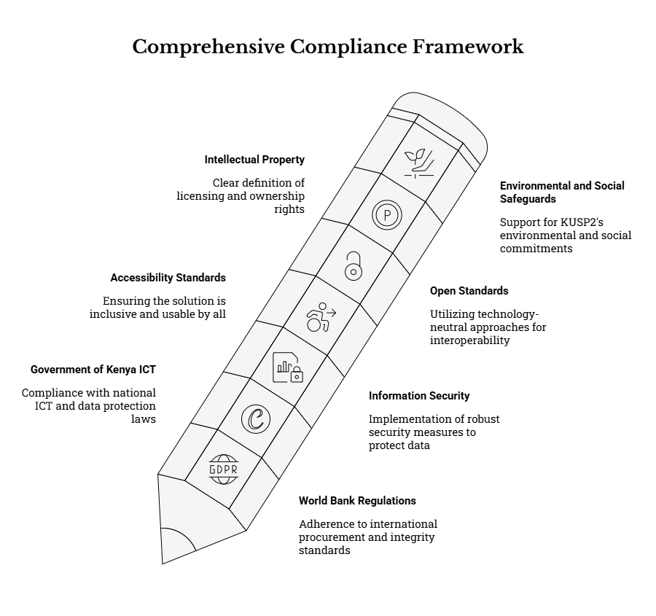

6.1 World Bank Procurement Regulations and Integrity
The Supplier shall comply with applicable World Bank procurement regulations and integrity provisions, including requirements on fraud and corruption, conflict of interest, and eligibility. The Supplier shall ensure that its delivery approach, pricing and solution design support transparency and fair competition.
In practical terms, the Supplier shall:
- Demonstrate eligibility and integrity compliance as required in the solicitation documents, including truthful disclosures and avoidance of misrepresentation.
- Maintain and enforce a code of conduct for all personnel assigned to the assignment, including confidentiality obligations, ethical case handling expectations, and prohibition of retaliation or misuse of grievance data.
- Implement internal controls to prevent and detect: conflicts of interest, collusion, kickbacks, facilitation payments, and inappropriate influence on procurement or implementation decisions.
- Maintain a clear separation between Client decision-making and Supplier commercial interests, and avoid proposing “bundled” commercial terms that restrict the Client’s ability to compete future enhancements or support.
To avoid unjustified vendor lock-in and preserve fair competition, the Supplier shall:
- Propose a solution architecture that enables data portability and continuity (e.g., full export of grievance records, attachments metadata, configuration, and audit logs using common formats).
- Disclose any proprietary dependencies (including licensing, specialized hosting, closed APIs, or proprietary reporting tools) and justify them where unavoidable.
- Avoid solution conditions that create artificial switching costs (e.g., inability to export all records, proprietary formats only, undocumented interfaces, or restricted administrator capabilities).

6.2 Government of Kenya ICT and Data Protection Requirements
The Supplier shall comply with the Kenya Data Protection Act (2019) and related regulations, guidance and directives, including lawful processing, consent and transparency obligations, data subject rights, security safeguards, and storage limitation.
The Supplier shall comply with Government of Kenya ICT standards and guidance relevant to hosting, security, electronic records management, interoperability and accessibility, as applicable. The Supplier shall support data residency requirements and any Client directions regarding hosting location and approvals.
Accordingly, the Supplier shall:
- Implement lawful processing and support the Client’s governance obligations by ensuring the e-GRM has:
  - Clear and configurable privacy notice content for all public-facing intake channels.
  - Explicit consent capture where required, including timestamping, versioning of the notice presented, and the channel used.
  - Purpose limitation and data minimization controls, including restricting free-text where it increases risk (especially for sensitive cases) and ensuring only necessary data is captured to process and resolve a grievance.
- Support operational handling of data subject rights (as applicable), by ensuring the system can reliably retrieve and export an individual’s records when lawfully requested, and can support correction, restriction, and lawful deletion/anonymization workflows where required by policy and approvals.
- Implement and document storage limitation / retention controls, including:
  - Configurable retention periods by grievance type where required (e.g., sensitive cases vs. general service issues).
  - Archiving controls that preserve auditability while restricting routine access to closed cases.
  - Controlled deletion/anonymization procedures requiring appropriate authorization and audit logging.
For Government of Kenya ICT alignment, the Supplier shall:
- Implement hosting and operations consistent with Client-approved infrastructure, including any required government approvals for hosting environments and production access.
- Ensure records and evidence are maintained in a manner consistent with public-sector records management expectations, including traceable case histories, immutable audit trails, and defensible reporting outputs.
- Ensure interoperability requirements are met using open standards (see Section 6.5), including where the e-GRM must connect to government web presences or approved communication gateways.
Where telecom-related channels are enabled (SMS/USSD/hotline), the Supplier shall:
- Ensure technical integrations are implemented in a manner consistent with the Client’s regulatory/commercial arrangements and any applicable national requirements, including secure handling of phone numbers and message content as personal data.
- Implement safeguards to prevent sensitive grievance content from being exposed via inherently insecure channels (e.g., avoid transmitting sensitive narrative via SMS; use minimal messages referencing a case number and next steps).

6.3 Information Security Standards and Guidelines
Security controls shall be proportionate to risk, reflecting that the e-GRM may handle personal data, allegations of misconduct, and sensitive grievances. The Supplier shall implement security-by-design and provide a security architecture description and evidence of security testing in Phase 2.
At a minimum, the Supplier shall implement:
- Identity and access management
  - Strong authentication for staff users, with enhanced controls for privileged roles (e.g., administrators and sensitive-case handlers).
  - Role-based access control (RBAC) and least privilege (national/county/municipal roles; segregation of duties; need-to-know access for sensitive grievances).
  - Controlled account lifecycle processes (creation, suspension, role change, and timely deactivation).
- Protection of data in transit and at rest
  - Secure transport (e.g., TLS) for all web interfaces and APIs.
  - Encryption at rest for databases and storage where feasible/required, including protection of attachments and backups.
  - Documented key management approach aligned to the hosting environment.
- Auditability and monitoring
  - Immutable audit logs for key actions (create/view/edit; assignment and escalation; status changes; communications; export actions; privileged configuration changes).
  - Configurable log retention, with restricted access to logs and controlled export.
  - Basic observability for system health and integration failures (e.g., SMS delivery failure logging, email bounce handling, webhook/API errors).
- Secure configuration and hardening
  - Secure defaults (no default admin passwords; strong password policy; session hardening; protection against common web risks).
  - Secure handling of attachments (file type/size controls; malware scanning where feasible; authenticated access to protected files).
- Vulnerability management and incident readiness
  - Periodic vulnerability scanning (as appropriate to the environment) and documented remediation actions.
  - An incident response approach covering detection, containment, recovery, and post-incident review, aligned to Client governance and legal obligations (including personal data breach handling).
Evidence requirements: the Supplier shall provide, at minimum:
- A concise security architecture and data flow description (including trust boundaries and main integrations).
- A control implementation summary mapped to risks (including SEA/SH confidentiality controls).
- Security testing outputs (e.g., vulnerability scan summary, remediation log, and re-test results) suitable for Client review and acceptance.

6.4 Accessibility Standards
The solution shall comply with applicable accessibility requirements for ICT services, including alignment to WCAG 2.1 AA or equivalent and Kenya’s relevant ICT accessibility standards. Accessibility testing shall form part of user acceptance testing, including involvement of users with disabilities where feasible.
The Supplier shall ensure that:
- Public-facing interfaces and staff consoles support inclusive access, including:
  - Keyboard-only navigation, screen-reader compatibility, meaningful labels and error messages, and accessible form validation.
  - Mobile-friendly and low-bandwidth designs suitable for varied connectivity environments.
  - Clear language and predictable workflows that reduce cognitive burden.
- Multi-language requirements (at minimum English and Kiswahili) are implemented in a way that supports accessibility (e.g., consistent labels, accessible content structure, and translatable templates).
Accessibility assurance shall include:
- Accessibility test cases embedded into UAT scripts for priority journeys (submit grievance, check status, staff triage, update status, close case).
- Documented evidence of issues found and remediations applied (or a Client-agreed mitigation plan for non-blocking issues).
- Where feasible, inclusion of users with disabilities or accessibility specialists in validation of key workflows.

6.5 Open Standards and Technology Neutrality
The solution shall be technology-neutral and allow the Supplier to propose appropriate platforms, while ensuring the Client can operate and maintain the system without proprietary lock-in. All integrations shall use open, documented interfaces (e.g., standard web APIs) and data exports in common formats.
Accordingly, the Supplier shall:
- Implement integrations using documented interfaces (e.g., RESTful APIs, webhooks, standard mail protocols) and avoid hard-coded dependencies on proprietary connectors that cannot be maintained by the Client or future suppliers.
- Provide export capability sufficient for operational continuity and compliance, including:
  - Routine reports and extracts (CSV/Excel/PDF or equivalent common formats).
  - Full data export capability for transition (including metadata, audit logs, reference data, and configuration settings as applicable).
- Ensure the system remains configurable rather than code-dependent for routine program changes, including categories/help topics, organizational units, SLAs, templates, routing rules, and reporting views—so that the Client can update the system without repeated vendor re-development.
- Document interfaces and configurations sufficiently to support maintainability and future competition for support/enhancements.

6.6 Intellectual Property and Licensing
The Supplier shall clearly describe licensing terms for any third-party components and ensure the Client has the rights needed to operate the system sustainably. Ownership and handover of system artifacts (configuration, documentation, and where applicable source code) shall be defined contractually.
At minimum, the Supplier shall:
- Provide a license inventory identifying all third-party software/components used (including open-source and proprietary), the applicable license terms, renewal requirements (if any), and any usage limits.
- Ensure the Client has legally sufficient rights to:
  - Use the system for the duration required (including beyond the Supplier’s engagement).
  - Access and use documentation and configuration artifacts.
  - Obtain necessary administrator-level access to operate the system (including user management, configuration updates, and report generation).
- Where custom development is undertaken, define and deliver:
  - Ownership/rights and handover arrangements for source code and build artifacts (where applicable under the contract).
  - As-built configuration documentation and environment-specific deployment notes.
- Avoid licensing constructs that undermine sustainability, such as:
  - Mandatory ongoing subscription to access core records,
  - Restrictions that prevent exporting data/configuration,
  - “Black box” components without documentation or supportability.

6.7 Environmental and Social Safeguards Alignment
The solution shall support KUSP2’s environmental and social commitments, including inclusive access, confidentiality, non-retaliation, and survivor-centred approaches for SEA/SH-related grievances.
Accordingly, the Supplier shall ensure the e-GRM:
- Enables safe and inclusive access through multiple channels, including assisted intake pathways and designs suitable for low-connectivity settings.
- Supports confidential and sensitive-case handling, including:
  - Configurable sensitive flag/classification,
  - Restricted visibility and routing to designated focal persons,
  - Suppression/redaction controls for notifications and exports,
  - Structured referral tracking that minimizes storage of highly sensitive narrative.
- Embeds non-retaliation and confidentiality messaging in public-facing guidance and staff training materials, aligned to Client-approved content.
- Supports monitoring and reporting that enables safeguards oversight while preventing inappropriate disclosure of personal data (e.g., aggregate reporting for sensitive cases by default; export restrictions and audit logs for PII access).
The Supplier shall integrate these safeguards requirements into:
- System configuration (roles, workflows, templates, routing rules),
- Training and SOPs (including staff handling protocols),
- Testing and acceptance evidence (including validation of restricted access and safe-notification behavior).

7. GOVERNANCE, REPORTING & COORDINATION

7.1 Client Oversight and Decision-Making Structure
The Client (SDHUD/NPCT) is the system owner and will provide strategic oversight, approve key deliverables, and lead acceptance decisions throughout Phase 2. Governance for Phase 2 shall be structured to enable (i) timely decision-making, (ii) strong quality assurance and compliance oversight, and (iii) practical coordination with counties and municipalities to support adoption.
a) Core oversight principles
- Single ownership and accountability: SDHUD/NPCT retains ownership of the e-GRM, including ownership of grievance data, program-facing performance reporting, and decisions on go-live readiness and acceptance.
- Decentralized participation with centralized standards: County Program Coordination Teams (CPCTs) and municipal GRM focal points participate in validation, testing, and training, while NPCT ensures consistent national standards (workflows, data fields, reporting outputs, confidentiality controls).
- Evidence-based approvals: Approvals shall be based on documented evidence (demonstrations, test results, training completion records, security/accessibility checks, and deliverable acceptance criteria).
- Technology-neutral oversight: Governance focuses on outcomes, controls, and deliverables rather than mandating a specific vendor platform or architecture.
b) Governance layers and working arrangements (minimum)
To support implementation within three months, the following practical governance arrangements shall be applied (and refined during mobilization):
- Steering / Management Oversight (NPCT-led): Provides direction, resolves escalations, and approves key stage gates (Implementation Plan, UAT sign-off, go-live, handover).
- Implementation Working Group (NPCT + Supplier core team): Manages day-to-day execution, delivery planning, backlog prioritization, dependency tracking, and resolution of implementation blockers.
- County/Municipal User Group (representative CPCTs and municipal focal points): Provides user validation input, participates in sprint reviews/demos, supports UAT execution, and validates field usability and operational practicality (including low-bandwidth and assisted intake realities).
- Compliance and Safeguards Oversight (NPCT + designated focal persons): Confirms privacy-by-design, confidentiality arrangements (including sensitive cases), accessibility requirements, and adherence to relevant legal/policy obligations.
c) Decision rights and approval authority
- NPCT as acceptance authority: NPCT is the final authority for formal acceptance of deliverables and go-live readiness. Counties/municipalities provide operational validation and user acceptance participation, but NPCT issues final sign-off.
- Supplier execution responsibility: The Supplier is responsible for executing agreed activities, producing deliverables and evidence packs, and proposing mitigation actions where risks or dependencies threaten delivery.
- Structured escalation pathway: Issues that cannot be resolved at working level within agreed timelines shall be escalated to NPCT leadership per the escalation mechanism defined in the Implementation Plan.
d) Documentation discipline and record of decisions
To ensure traceability and auditability, the Supplier shall maintain and share with the Client, at minimum:
- A Decision Log (unique ID, decision description, options considered, decision owner, decision date, implications).
- An Action Tracker (assigned actions, owners, due dates, status).
- A Deliverables Register (deliverable IDs, versions, submission dates, review comments, acceptance status).
- A Central Repository (secure, access-controlled) for project artifacts, configuration workbooks, test evidence, training materials, and handover items.

7.2 Roles and Responsibilities (RACI)
The table below illustrates a high-level RACI for Phase 2 implementation activities. The Supplier shall propose and agree a refined RACI during mobilization. In refining the RACI, the Supplier shall ensure that responsibilities are assigned to named roles (not only institutions) to avoid gaps and delays.
Key expectations for the refined RACI (mobilization output):
- Identify single points of contact for NPCT, each participating pilot municipality, and the Supplier team (Delivery Lead, Technical Lead, QA Lead, Training Lead).
- Define approval owners for deliverables and clarify what constitutes “approval” (e-signature, email confirmation, meeting minutes sign-off).
- Specify who is authorized to (i) approve configuration changes, (ii) approve workflow/SLA changes, (iii) approve user role templates, and (iv) authorize production access.
- Include third-party dependency roles where applicable (e.g., telecom providers), while keeping accountability with Client/Supplier as appropriate.

Activity / Output | Client (NPCT) | Counties/Municipalities | Supplier
Mobilization kickoff; confirm governance | A/R | C | R
Implementation Plan (incl. schedule, risks, testing, training) | A | C | R
Solution setup and environments | C | I | R
Configuration of workflows, roles, categories, forms | A | C | R
Channel integrations (web, email, SMS/USSD, hotline) | A (for regulatory/commercial approvals) | C | R (technical build/config)
Data protection and security controls implementation | A | I | R
Accessibility and usability implementation | A | C | R
Testing (supplier QA) | C | C | R
User Acceptance Testing (UAT) and sign-off | A | R (user participation) | R (support)
Training delivery and completion | A | R (attendance) | R
Go-live decision | A | C | C/R (readiness evidence, execution)
Hypercare and stabilization | C | C | R
Handover dossier and documentation | A | I | R

Legend: R = Responsible, A = Accountable, C = Consulted, I = Informed.

Operational clarifications (to reduce implementation friction):
- Counties/Municipalities as “R” for participation-based activities: For UAT and training, county/municipal stakeholders are “R” for participation because outcomes depend on attendance, execution of test scripts, and provision of feedback within the agreed windows.
- NPCT accountability for external enablement: Where channels depend on regulatory/commercial arrangements (e.g., toll-free hotline, USSD short codes), NPCT remains accountable for enablement decisions and approvals, while the Supplier remains responsible for technical integration once parameters are provided.
- Supplier accountability within its delivery scope: While NPCT remains system owner, the Supplier is responsible for delivery planning, implementation execution, and providing readiness evidence aligned to acceptance criteria.

7.3 Meetings, Reviews and Approvals
To maintain delivery momentum within the three-month implementation window, structured meetings, reviews, and approvals shall be implemented with clear agendas, outputs, and decision/approval records.
a) Weekly implementation working meetings (Supplier + NPCT core team)
- Purpose: Progress review, dependency management, risk/issue resolution, and confirmation of the next-week workplan.
- Minimum agenda:
  - Progress against plan and milestone status (deliverables and releases)
  - Review of open risks/issues and blockers (including owners and due dates)
  - Dependency check (Client inputs, access approvals, telecom/hosting prerequisites)
  - Review of change requests (new/changed requirements, configuration changes)
  - Confirm decisions needed and assign actions
- Outputs: Minutes, updated action tracker, updated risk/issue log, and any decision log entries.
b) Fortnightly sprint demos / reviews (Supplier + NPCT + selected county/municipal representatives)
- Purpose: Validate working increments against agreed workflows and user scenarios; confirm readiness to progress to the next build stage.
- Minimum demo focus: End-to-end case flows (intake → triage → assignment → action logging → resolution → closure), communications templates, reporting views, and any channel integrations enabled for testing.
- Acceptance support: Demos shall be mapped to agreed scenarios and evidence captured (screenshots, demo scripts, defect log references) to support later UAT sign-off.
c) Monthly steering / management reviews (Supplier + NPCT + selected county/municipal representatives)
- Purpose: Executive oversight of timeline confidence, adoption readiness, compliance posture, and high-impact risks.
- Minimum agenda: Milestone readiness, unresolved escalations, UAT readiness, training readiness, go-live gating criteria, and support model readiness (hypercare and warranty).
- Outputs: Steering decisions recorded in minutes and decision log; any scope/time trade-offs formally captured through change control.
d) Formal approval points (stage gates)
Formal approvals shall be issued at the following minimum points, with clear acceptance evidence:
- Implementation Plan approval: Confirms governance, schedule, responsibilities, risks, testing approach, training plan, and go-live plan.
- UAT sign-off: Confirms successful completion of UAT, resolution of critical defects, and acceptance of residual risk plan (if any).
- Go-live readiness approval: Confirms production deployment readiness (security/access controls, backups, monitoring, support procedures).
- Final handover acceptance: Confirms receipt and adequacy of handover dossier, documentation, credentials handover procedures, and any agreed warranty/support arrangements.

7.4 Progress Reporting and Issue Management
The Supplier shall implement disciplined progress reporting and issue management practices that support transparency, early warning of delays, and rapid escalation of critical risks. Reporting shall be aligned to the three-month milestone structure and shall be suitable for circulation to both technical and management stakeholders.
a) Weekly status updates (minimum content)
Weekly status updates shall be concise (ideally 1–2 pages) and include:
- Progress summary: What was completed (by deliverable, release, or backlog items).
- Planned next period activities: What will be delivered next week and which stakeholders are required (e.g., review sessions, UAT participation).
- Delivery confidence: RAG (Red/Amber/Green) status for timeline, scope, and quality.
- Top risks/issues: The top 5–10 items with current status, owners, and mitigation actions.
- Dependencies and decisions required: Items requiring Client inputs or approvals (e.g., environment approvals, content approvals, channel parameters).
- Testing/training snapshot: Progress against test execution and training preparation/delivery (as applicable to the stage).
b) Monthly progress reports (minimum content)
Monthly reports shall provide greater depth, including:
- Deliverables completed and acceptance status
- Updated workplan and milestone forecast
- Summary of testing conducted and key results (functional, integration, security, accessibility, performance as applicable)
- Training delivered (numbers trained by user group), training evaluation outcomes, and adoption risks
- Channel readiness status (web, email, hotline, SMS/USSD—where enabled) including failure rates and mitigation
- Updated risk register aligned to the agreed risk matrix, including trend analysis (new risks, closed risks, risks escalated)
- Summary of change requests raised/approved/rejected and their impact
c) Central issue log and defect management
The Supplier shall maintain a central issue log that covers both project issues (dependencies, access, scheduling blockers) and product issues (defects, configuration gaps). Each issue shall include, at minimum:
- Unique ID, title, description, category (technical / compliance / stakeholder / dependency / operational)
- Severity/priority, owner, target resolution date, current status
- Impact statement (schedule impact, compliance impact, service continuity impact)
- Resolution notes and evidence of closure (e.g., retest evidence)
d) Escalation mechanism (critical issues)
A clear escalation mechanism shall apply to issues affecting timeline, compliance, or service continuity. Minimum escalation rules shall include:
- Immediate escalation for security/privacy concerns, unauthorized access risks, confirmed data exposure, or inability to meet minimum confidentiality controls.
- Time-bound escalation for blockers unresolved within an agreed window (e.g., 48–72 hours for critical path items).
- Escalation pathway from Working Group → NPCT accountable lead → Steering/Management review, with decisions recorded in the decision log.
e) Risk and dependency management alignment
- The Supplier shall maintain a risk register and update it at least weekly, ensuring alignment to the agreed risk matrix and mitigation expectations.
- Dependencies (telecom enablement, hosting approvals, stakeholder availability for UAT/training, required content approvals) shall be explicitly tracked in a dependency log with owners and target dates, to prevent hidden schedule risks.

7.5 Change Control and Configuration Management
Any changes to agreed requirements or scope shall follow a documented change control process. The Supplier shall maintain configuration management for forms, workflows, templates and integrations, including versioning and rollback procedures where applicable. The approach shall ensure that rapid implementation does not undermine auditability, data quality, or compliance controls.
a) Change control process (minimum steps)
- Change Request (CR) submission: Any stakeholder may propose a change, but it shall be logged formally with rationale.
- Impact assessment: The Supplier assesses impact on timeline, cost (if applicable), quality, compliance, training, and supportability.
- Classification: CRs categorized (e.g., defect fix vs enhancement vs compliance requirement vs operational preference).
- Approval / rejection: NPCT approves/rejects CRs based on program priorities and phase constraints; approvals recorded in the decision log.
- Implementation and testing: Approved CRs implemented through controlled configuration/development, with regression testing evidence.
- Documentation update: Update configuration workbook, release notes, training materials, and any affected SOPs.
- Deployment and communication: Changes deployed via agreed release procedures and communicated to relevant users/stakeholders.
b) Configuration management (forms, workflows, templates, routing rules)
The Supplier shall:
- Maintain a configuration baseline (what is configured, where, when, and why), including forms/data fields, workflow statuses, routing rules, SLA settings, notification templates, and role definitions.
- Apply version control to configuration artifacts and documentation (version numbers, dates, authors, change summaries).
- Ensure traceability from agreed requirements to configured solution components and test cases (e.g., a requirements traceability mapping embedded in the configuration workbook or test pack).
- Implement role-based control over who can modify configuration in each environment, with configuration changes logged and auditable.
c) Environment and release controls
- The Supplier shall define rules for promotion between environments (e.g., dev → test → staging → production) and ensure that production changes are controlled and approved.
- Releases shall include release notes identifying changes, resolved issues, known limitations, and any user-impacting updates (including updated templates or workflow steps).
- Where feasible, configuration changes shall support rollback (restore prior configuration snapshot) to reduce downtime and mitigate implementation risk.

d) Data and reporting integrity under change
Any changes affecting data fields, taxonomies, or reporting outputs shall be assessed for downstream impacts, including:
- Continuity of KPI definitions and report comparability over time
- Data quality validation rules and mandatory field compliance
- Access controls and confidentiality impacts (especially for sensitive grievance handling)
- Export formats and program reporting needs at national and sub-national levels

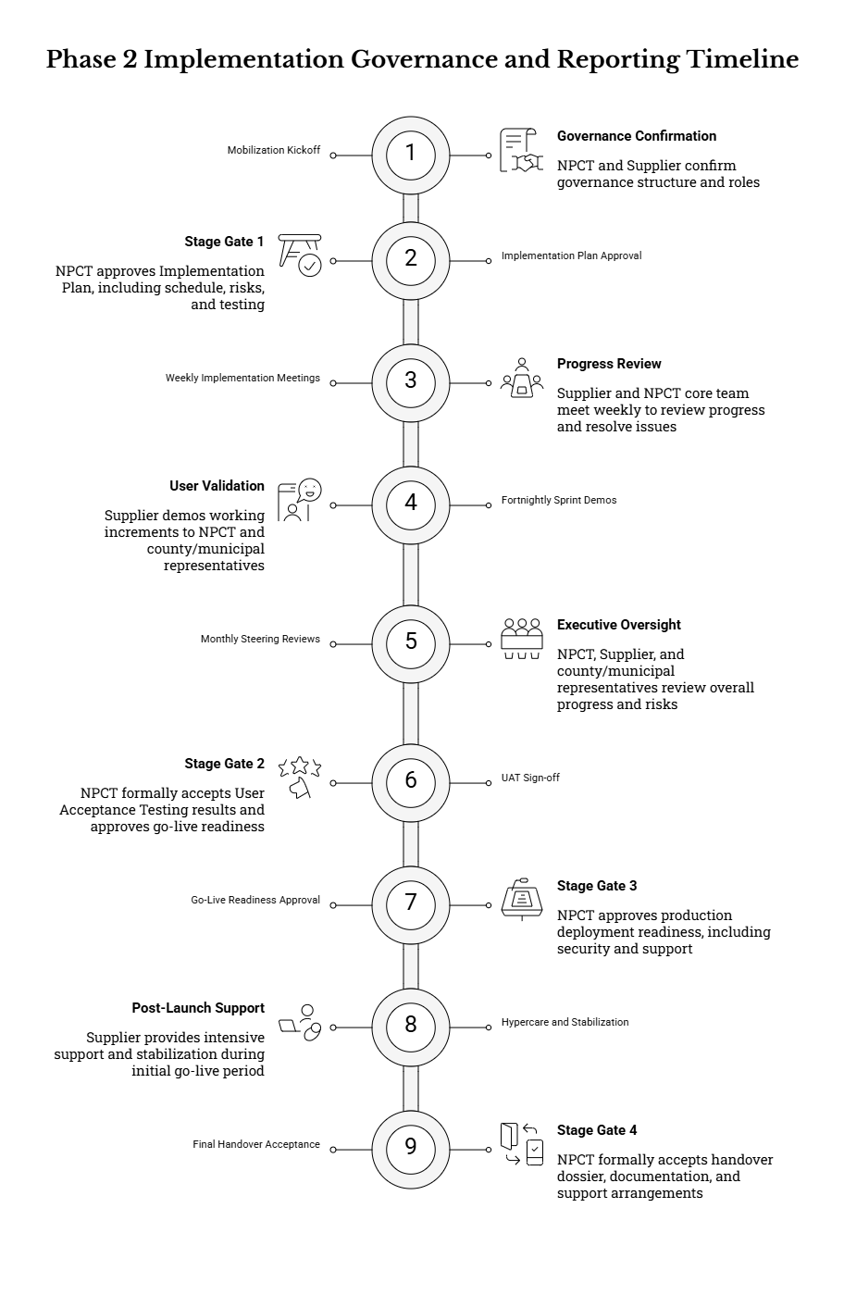

8. DELIVERABLES & SUBMISSION REQUIREMENTS

8.1 Phase 2 Deliverables (Required)
Deliverables under Phase 2 are designed to evidence (i) a working, production-ready e-GRM solution; (ii) compliance with the agreed functional/non-functional requirements; and (iii) readiness for sustainable operation by NPCT and decentralized county/municipal users within the three-month implementation window. Deliverables shall be treated as formal contractual outputs and will form the basis for review, acceptance, and (where applicable) milestone payments.
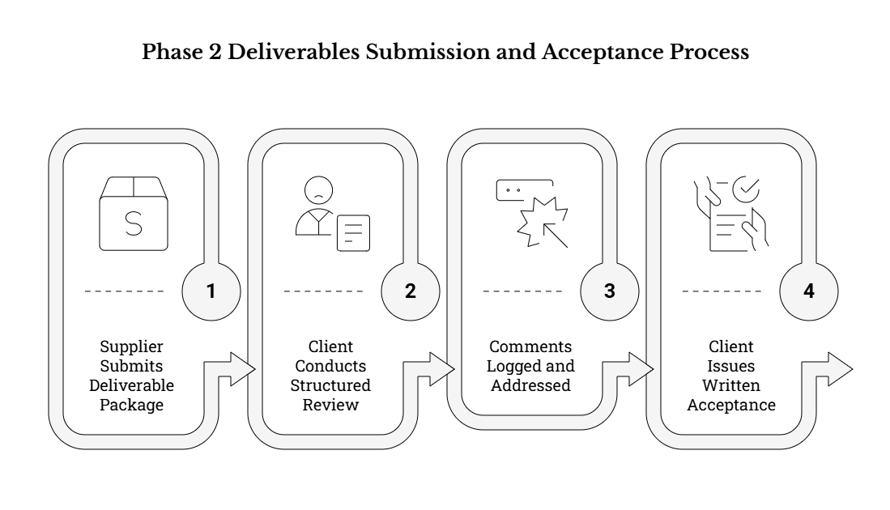
In addition to the minimum deliverables listed in Section 8.2, the Supplier may propose interim outputs (e.g., sprint backlog extracts, configuration snapshots, demo notes, pilot feedback summaries) where these improve transparency, reduce delivery risk, and accelerate approvals—provided they do not replace or dilute the required deliverables and do not introduce vendor lock-in.
Across all Phase 2 deliverables, the following cross-cutting requirements apply:
- Traceability to agreed inputs: Each deliverable shall clearly reference the Phase 1 inputs (workflows, standardized intake form/data dictionary, reporting/KPIs, and compliance/risk guidance) and show how they are implemented/configured in Phase 2 (e.g., configuration workbook mappings, test case coverage, report prototypes).
- Evidence-based acceptance: Where a deliverable claims functionality, security, accessibility, or performance, the Supplier shall provide verifiable evidence (screenshots, configuration exports, test results, logs, or demonstration scripts) sufficient for NPCT review and auditability.
- Protection of data during delivery: Any artifacts shared for review (e.g., test evidence, exported case files) shall avoid exposure of real personal data unless explicitly authorized by the Client. Where demonstration or UAT requires realistic scenarios, the Supplier shall use synthetic/anonymized data and follow confidentiality controls.
- Operational focus: Deliverables must be usable by NPCT and sub-national teams, meaning they must go beyond “technical completion” to demonstrate workability (e.g., trained users can complete end-to-end workflows; reports can be generated by designated roles; admins can manage categories/templates/forms without developer intervention).
- Alignment to risk and dependency management: Deliverables shall reflect active management of known risks and dependencies (e.g., telecom lead times, adoption capacity, data protection) through an up-to-date risk/issue/dependency log and documented mitigations.

8.2 Deliverables Schedule and Acceptance Criteria
The Deliverables Schedule below is tailored to the three-month Phase 2 implementation window. Due dates are calendar references based on the agreed mobilization start date and shall be confirmed in the Implementation Plan (D1).
General acceptance approach (applies to all deliverables):
(i) the Supplier submits the deliverable package in the required formats; (ii) the Client conducts a structured review (including demonstrations where relevant); (iii) comments are logged and addressed; and (iv) the Client issues written acceptance (or conditional acceptance with agreed actions, owners, and deadlines). Acceptance of an interim deliverable does not waive the Supplier’s obligation to resolve defects discovered later, particularly defects impacting security, privacy, accessibility, or core workflow integrity.
ID | Deliverable | Due | Contents (Minimum) | Acceptance / Success Criteria
D1 | Mobilization & Implementation Plan | End of Week 2 | Implementation Plan including: (a) detailed schedule aligned to the 3-month window and Section 9 milestones; (b) agreed governance and working arrangements (meetings, stakeholders, escalation path); (c) refined RACI and named focal persons; (d) consolidated implementation backlog mapped to Phase 1 inputs/BRD requirements; (e) environment approach and access needs; (f) testing strategy (including accessibility and security testing approach); (g) training plan and adoption support approach; (h) go-live and cutover plan (incl. hypercare scope); (i) risk/issue/dependency log and decision log (initial baseline). | Approved by Client. Plan demonstrates feasibility within 3 months, clearly identifies dependencies (e.g., hosting approvals, telecom arrangements, user availability), includes realistic sequencing, and defines measurable readiness gates for Sprint releases, UAT, and go-live. Risks and mitigation actions are explicit and owned.
D2 | Configured Environments & Solution Design Package | End of Week 3 | Evidence of environment setup (dev/test/staging/production as applicable) and controlled access; a solution configuration/design package including: (a) configuration workbook and mapping to standardized intake form and data rules; (b) workflow/status model and routing/assignment rules; (c) integration approach for enabled channels (web, email, SMS/USSD, hotline); (d) role model and access control matrix; (e) initial reporting/dashboard catalog; (f) security and privacy controls to be enabled (consent capture, audit logging, retention approach); (g) accessibility approach and low-bandwidth considerations. | Client review of documentation and access. Environments are reachable and usable by authorized Client reviewers; configuration workbook is complete enough to guide build; design decisions are consistent with agreed functional intent; and key controls (RBAC, logging, consent points) are defined in implementable terms.
D3 | Sprint 1 Release (Core Intake & Case Management) | End of Month 1 (Week 4) | Working increment in a test environment implementing core use cases: grievance registration (web + staff-assisted intake), reference numbering, core data fields and validation rules, basic assignment/routing, basic notification/acknowledgement, internal action logging/notes, and baseline operational reporting. Includes a short demo script and initial defect/issue log. | Demonstrated against agreed scenarios. Core standardized data fields implemented with validation; reference numbering and status tracking work end-to-end; issues are logged and triaged; and the increment is stable enough to proceed to Sprint 2 enhancements.
D4 | Sprint 2 Release (Channels, Reporting, Compliance Controls) | End of Month 2 (Week 8) | Working increment in staging environment implementing: configured channels available within Client arrangements (email/SMS/USSD/hotline integration as applicable), escalation rules and reminders, audit logging and privacy controls (consent, access restrictions, retention/archiving settings), accessibility enhancements and evidence of checks, enhanced dashboards/exports aligned to operational and programme reporting. | Demonstration completed; test evidence provided (functional + integration + accessibility at minimum); compliance controls demonstrably enabled (e.g., RBAC, audit logs, consent capture, secure handling of attachments); staging release is sufficiently complete and stable for pilot/UAT.
D5 | Testing Artifacts and Results | Weeks 6–10 (iterative) | Test plan and approach; documented test cases/scripts mapped to key workflows and requirements; defect log with severity, ownership, and closure status; evidence of functional/regression tests, integration tests for enabled channels, performance checks (proportionate to expected usage), security testing (e.g., vulnerability scan results and fixes), and accessibility testing evidence (including issues and remediation). | Defects are triaged and tracked; all critical defects are resolved prior to UAT/go-live; evidence is sufficient for Client verification; testing demonstrates that changes do not break prior releases; and key compliance assertions (logging, RBAC, consent, retention behaviors) are verifiable.
D6 | Training Delivery and Materials | Weeks 8–11 | Training curriculum and role-based learning tracks (NPCT admins, supervisors, handlers, reporting users); user guides, admin guide, quick reference/job aids; delivery of training sessions (virtual and/or in-person as agreed) for NPCT and selected county/municipal participants; practical exercises for intake, triage, escalation, closure, and reporting; and administrator coaching for configuration and troubleshooting. | Attendance captured; post-training evaluations and/or competency checks completed; materials accepted by Client; trainees can perform agreed core tasks in the system; and a small set of “super users”/admins are demonstrably prepared for first-line support after go-live.
D7 | User Acceptance Testing (UAT) Support and Sign-off Pack | End of Week 11 | UAT plan and scripts mapped to end-to-end scenarios; support for execution (test environment readiness, defect triage, re-test cycles); consolidated UAT results, defect closure evidence, and remediation summary; go-live readiness checklist results; residual risks/issues register with agreed owners and timelines (if any); sign-off pack for go-live decision. | UAT completed with NPCT and selected county/municipal users; critical defects resolved; sign-off provided by Client (or conditional sign-off with clearly documented residual items and controls); readiness evidence supports go-live decision-making.
D8 | Go-Live, Cutover and Hypercare Report | End of Week 12 | Production deployment evidence; cutover checklist completion (including backup and rollback readiness); operational readiness confirmation (monitoring/alerts as applicable, admin access, integration health checks); hypercare support report (issues encountered, severity, resolution actions, and trends); and final configuration snapshot/as-built notes reflecting the production state. | System operational in production; core workflows function end-to-end in the live environment; initial stabilization is completed; any remaining issues are documented with an agreed resolution plan and support pathway; and service continuity procedures are defined for incidents.
D9 | Final Completion and Handover Dossier | End of Week 12 | Complete handover package including: as-built configuration workbook and exports; integration specifications and credentials handover procedure; documentation set (admin guide, user guides, SOPs/job aids); test evidence archive; training materials; warranty/support terms and contacts (including hypercare transition); data export/backup procedures and proof of exportability; and (where applicable and agreed) source code/build artifacts and deployment instructions. | Client confirms receipt and usability of handover package; NPCT can administer core configurations and generate required reports without Supplier intervention; sustainability arrangements are in place (support contacts, access credentials procedure, documentation completeness); and the Client retains access to and ownership of grievance data and necessary configuration artifacts.

8.3 Deliverable Formats, Language and Document Control
Unless otherwise agreed in writing, all deliverables shall be submitted in editable formats (e.g., DOCX, XLSX, PPTX/diagram source formats where used) and in PDF for formal review and approval. Where deliverables include technical artifacts (e.g., configuration exports, scripts, release notes, test evidence, integration payload samples), these shall be provided in commonly used, non-proprietary formats where feasible (e.g., CSV/JSON/TXT), with clear instructions for use.
Minimum requirements for language and accessibility of materials:
- User-facing materials (public portal content, job aids, and end-user guidance) shall be provided at minimum in English and Kiswahili, written in clear, plain language suitable for non-technical users and frontline GRM officers.
- Where the Client requires additional local language support for public guidance, the Supplier shall provide source files in a way that supports efficient translation updates (e.g., template-based content and separated language strings where relevant), without requiring software redevelopment for text changes.
- Training and guidance outputs should be designed for practical use in decentralized settings (printable quick guides, low-bandwidth-friendly PDFs, and step-by-step screenshots), and should reflect the confidentiality and ethical handling expectations for grievances, including sensitive cases.

Document control standards (applies to every deliverable submission):
- Each document shall include version number, date, author/owner, and a change log summarizing substantive changes since the prior version.
- File naming conventions shall be consistent and unambiguous (e.g., KUSP2_eGRM_D6_TrainingMaterials_v1.2_YYYYMMDD).
- Where comments are resolved across iterations, the Supplier shall provide a simple comment resolution matrix (or tracked changes plus a response log), especially for D1, D2, D7, and D9 where governance and sign-off are critical.
- Any deliverables containing sensitive configuration details (e.g., access control matrices, integration credentials procedures, security test results) shall be shared using Client-approved secure channels and clearly marked with appropriate confidentiality labels.

9. IMPLEMENTATION TIMELINE & MILESTONES

9.1 Phase 1 Timeline and Milestone Plan (Reference)
Phase 1 activities (design and procurement preparation) are completed and will be provided as implementation inputs to the Supplier. The Supplier shall treat Phase 1 outputs as the baseline for Phase 2 delivery and shall align Phase 2 implementation to the milestone expectations established in the Phase 1 work plan, including commissioning within the required three-month Phase 2 window.
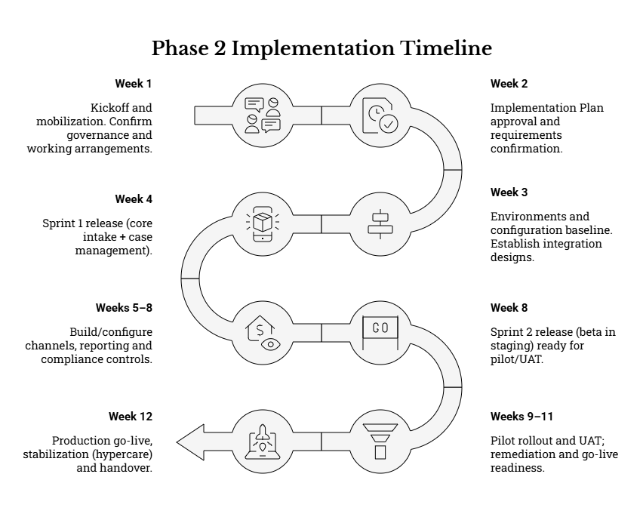
To ensure continuity from Phase 1 to Phase 2, the Supplier shall, during mobilization, complete a structured “implementation readiness” review of the Phase 1 package and confirm that the Phase 2 plan, backlog and configuration approach are demonstrably mapped to the provided inputs (without redefining the agreed functional intent). This includes, as applicable:
- Requirements, workflows and process maps, including escalation and appeal pathways;
- Standardized grievance intake/data collection form and associated data dictionary (field definitions, mandatory/optional fields, validation logic);
- Reporting templates and KPI definitions, including timeliness and overdue monitoring requirements;
- Risk and compliance considerations (including privacy, security, accessibility, SEA/SH-sensitive handling); and
- Stakeholder engagement and rollout guidance (who must be engaged, when, and for which validation decisions).
Where the Supplier identifies gaps, constraints, or implementation risks that could affect delivery within three months, these shall be documented in the Implementation Plan and raised promptly through the agreed governance mechanism. Any proposed deviations from Phase 1 intent shall be managed through the formal change control process described in Section 7.5 of this ToR (change control and configuration management), including clear impact assessment on schedule, cost, compliance and operations.

9.2 Phase 2 Timeline and Milestones (3 months)
The Supplier shall propose a detailed plan, but as a minimum, the milestone structure below is expected. The Supplier’s Implementation Plan shall show how the Supplier will meet the minimum milestones and the linked deliverables in Section 8 (D1–D9), including the activities, responsibilities, dependencies, and acceptance evidence required for each stage gate.
To meet the three-month window, the Supplier is expected to adopt an implementation approach that supports rapid delivery and validation (e.g., agile sprints with frequent demonstrations), while maintaining strong documentation, test evidence, and control of configuration changes. “Build” activities shall not be deferred to the end; quality assurance, security/privacy controls, accessibility checks, and reporting outputs shall be implemented and validated iteratively throughout the period.

Minimum milestone structure (expected focus / outputs):
Period | Expected Focus / Milestones
Week 1 | Kickoff and mobilization. Confirm implementation governance and working arrangements (working group, escalation routes, decision owners), reporting cadence, and ways of working. Secure access to Phase 1 inputs and agree the authoritative source repository. Confirm hosting direction and environment plan (dev/test/staging/production as applicable). Establish delivery tools (issue tracker, decision log, configuration register). Initiate stakeholder onboarding for NPCT core users and selected county/municipal focal points to confirm availability for demos, training, pilot and UAT.
Week 2 | Implementation Plan approval and requirements confirmation. Complete a structured requirements confirmation and “fit-to-standard” gap analysis against Phase 1 outputs, translating them into a prioritized configuration backlog and sprint plan. Establish the risk/issue/dependency log, including owners and target resolution dates. Submit and obtain approval of the Implementation Plan (D1), including testing strategy (functional/integration/regression/performance/security/accessibility), training plan, cutover plan, and go-live readiness criteria.
Week 3 | Environments and configuration baseline. Provision and validate environments (including access, security baseline, logging, and backup approach as applicable). Complete initial data model mapping to the standardized intake form and implement baseline forms, reference lists, roles and routing rules in configuration workbooks/design pack (D2). Establish initial integration designs for enabled channels (web embedding/linkage, email, and—where available—SMS/USSD/hotline integration parameters). Implement baseline language configuration (English/Kiswahili) for user-facing components and templates.
Week 4 | Sprint 1 release (core intake + case management). Demonstrate a working increment that covers (at minimum) core grievance registration (web + staff-assisted), unique reference numbering, core workflow statuses, assignment/reassignment, internal notes/action logging, acknowledgement capability, and basic operational reporting in a test environment (D3). Provide initial QA evidence and defect log, including defect severity classification and remediation plan. Confirm pilot/UAT municipality selection criteria and onboarding needs.
Weeks 5–8 | Build/configure channels, reporting and compliance controls (iterative). Implement and test enabled channel integrations and ensure all channels feed a unified register with consistent reference numbering and status tracking. Expand dashboards, exports and KPI reporting. Implement compliance controls iteratively (role-based access, audit logging, consent capture/privacy notice presentation, retention settings), and incorporate accessibility/usability improvements (including low-bandwidth considerations). Conduct iterative demos/reviews at agreed intervals and maintain test evidence and remediation tracking. Begin drafting training materials and SOPs early (do not wait until Week 8).
Week 8 | Sprint 2 release (beta in staging) ready for pilot/UAT. Provide a staging-ready release including: configured channel integrations (as available), escalation rules and overdue indicators, advanced reporting/dashboards, auditability, privacy and accessibility controls. Submit supporting test evidence suitable for UAT readiness (D4/D5 iterative components) and provide draft training materials for review. Confirm UAT entry criteria and test scripts mapped to agreed workflow scenarios.
Weeks 9–11 | Pilot rollout and UAT; remediation and go-live readiness. Support pilot rollout in Client-selected municipalities representing different contexts and validate real-world workflows, user roles, connectivity constraints and reporting needs. Execute Client-led UAT with Supplier support (triage, fixes, retesting). Complete training delivery for NPCT and selected county/municipal users and confirm competency for key roles (handlers, supervisors, administrators, reporting users). Prepare and submit the UAT sign-off pack and go-live readiness materials (D6/D7). Ensure all critical defects are resolved prior to go-live and residual risks are documented with agreed mitigations and ownership.
Week 12 | Production go-live, stabilization (hypercare) and handover. Execute production deployment and cutover based on an approved checklist and rollback approach. Validate operational readiness (access provisioning, monitoring/logging, backup/restore procedures, integration health checks, support contacts). Provide hypercare support and stabilization reporting, including issues encountered and resolutions (D8). Deliver final completion and handover dossier (D9), including as-built documentation, configuration records, integration specifications, and agreed support/warranty arrangements.

Cross-cutting expectations across the three months (applies throughout Phase 2):
- Governance and reporting: Maintain weekly status reporting, including progress against milestones, key risks/issues, decisions required, and dependencies. Maintain a decision log and ensure approvals are captured for stage gates (Implementation Plan, UAT sign-off, go-live readiness, final handover).
- Quality and test evidence: Embed QA throughout delivery; maintain a living test pack and defect log. Ensure security and accessibility testing are not deferred to the end of the project.
- Documentation and sustainability: Produce implementation documentation progressively (configuration workbook, admin guidance, operational SOPs, integration runbooks), ensuring that final handover is not a “rush activity” at Week 12.
- Change control: Any changes affecting agreed requirements, workflows, compliance posture, delivery timelines, or operational procedures shall follow formal change control with documented impacts and approvals.

9.3 Key Dependencies and Assumptions
Successful delivery within three months depends on timely availability of inputs, approvals, and operational readiness actions by multiple stakeholders. As a minimum, the following dependencies and assumptions apply:
- Timely access to Phase 1 outputs and implementation inputs
  - The Supplier assumes Phase 1 outputs are made available promptly at mobilization (requirements/workflows, standardized intake form/data dictionary, reporting requirements, risk/compliance matrices, stakeholder engagement guidance).
  - The Supplier assumes these inputs represent the agreed baseline intent and are sufficient to configure/build without re-initiating a design phase.
- Stakeholder availability for validations, training, pilot and UAT
  - NPCT and selected county/municipal users must be available for scheduled sprint demos, workflow validations, UAT execution, and training sessions within the compressed timeline.
  - The Supplier shall plan for structured participation (attendance rosters, sign-off responsibilities, and agreed scheduling) and shall flag early if availability risks the critical path.
- Client-led telecom regulatory/commercial arrangements for hotline and SMS/USSD (where applicable)
  - Where SMS/USSD and toll-free hotline channels are required, regulatory and commercial arrangements (short codes, toll-free provisioning, bulk messaging, contracts with aggregators/providers) are Client-led. The Supplier’s responsibility is technical integration and testing once the Client provides the required integration parameters and access.
  - If telecom arrangements are delayed, the Supplier shall propose practical fallback approaches (e.g., proceed with web + assisted intake + email where enabled) while ensuring a unified register and consistent reference numbering is maintained, and integrate telecom channels once available.
- Timely Client reviews, feedback, and approvals at decision points
  - The schedule assumes timely review and approval of key deliverables and stage gates, including: Implementation Plan (Week 2), environment/configuration package (Week 3), UAT sign-off (Week 11), and go-live readiness (Week 12).
  - The Supplier shall provide decision-ready submissions (clear content, evidence, and approval asks) to reduce review cycles, and shall escalate promptly where approval delays threaten critical milestones.
- Hosting/environment readiness and access provisioning
  - The Supplier assumes timely access to approved hosting environments (or timely approvals of the Supplier’s proposed environments, where applicable), including credentials, network access, and any required security approvals.
  - The Supplier shall identify environment and security dependencies early (Week 1–2) and maintain an access tracker to avoid late-stage deployment constraints.
- Availability of minimum ICT infrastructure at municipal level (or agreed mitigations)
  - The schedule assumes municipal GRM users have access to basic devices and connectivity adequate for case management tasks, or that agreed mitigations are in place (e.g., staff-assisted intake workflows, offline capture with later entry, or shared access points).
  - The Supplier shall design rollout and training to reflect real conditions in the pilot municipalities and adjust operational guidance accordingly (e.g., low-bandwidth guidance, assisted intake SOPs).
- Availability of approved content and policy inputs needed for production launch
  - The Supplier assumes the Client will provide/approve essential operational content required for the public-facing interface and notifications, such as privacy notice text, user guidance content, and approved contact information, within timeframes that support configuration, translation (English/Kiswahili), and testing.

Where dependencies threaten delivery, the Supplier shall (i) document the risk in the dependency/risk register, (ii) propose mitigation and contingency actions, (iii) escalate through the agreed governance structure, and (iv) maintain transparency on impact to milestones and go-live readiness.

10. TEAM COMPOSITION & QUALIFICATIONS

10.1 Minimum Key Positions (Indicative)
The Supplier shall propose a suitably qualified, delivery-ready team with sufficient depth and continuity to implement and commission the e-GRM within the three-month Phase 2 window. The proposed team shall collectively cover (i) GRM process and safeguards expertise, (ii) ICT solution configuration/development, (iii) channel integration and interoperability, (iv) security and data protection compliance, (v) accessibility and inclusive design, (vi) testing and quality assurance, and (vii) training, adoption and operational handover.
The Client expects the following minimum key competencies to be covered. The Supplier may combine roles where appropriate, provided that (a) responsibilities remain clearly assigned, (b) independence of quality assurance and security/compliance review is preserved where practical, and (c) the Supplier demonstrates that combined roles do not introduce delivery, quality, or compliance risk within the compressed timeline. The Supplier shall identify named key personnel, reporting lines, and back-up cover for critical functions (e.g., Project Manager, Technical Lead, Security/Data Protection, QA/Test Lead) to reduce schedule and continuity risk.
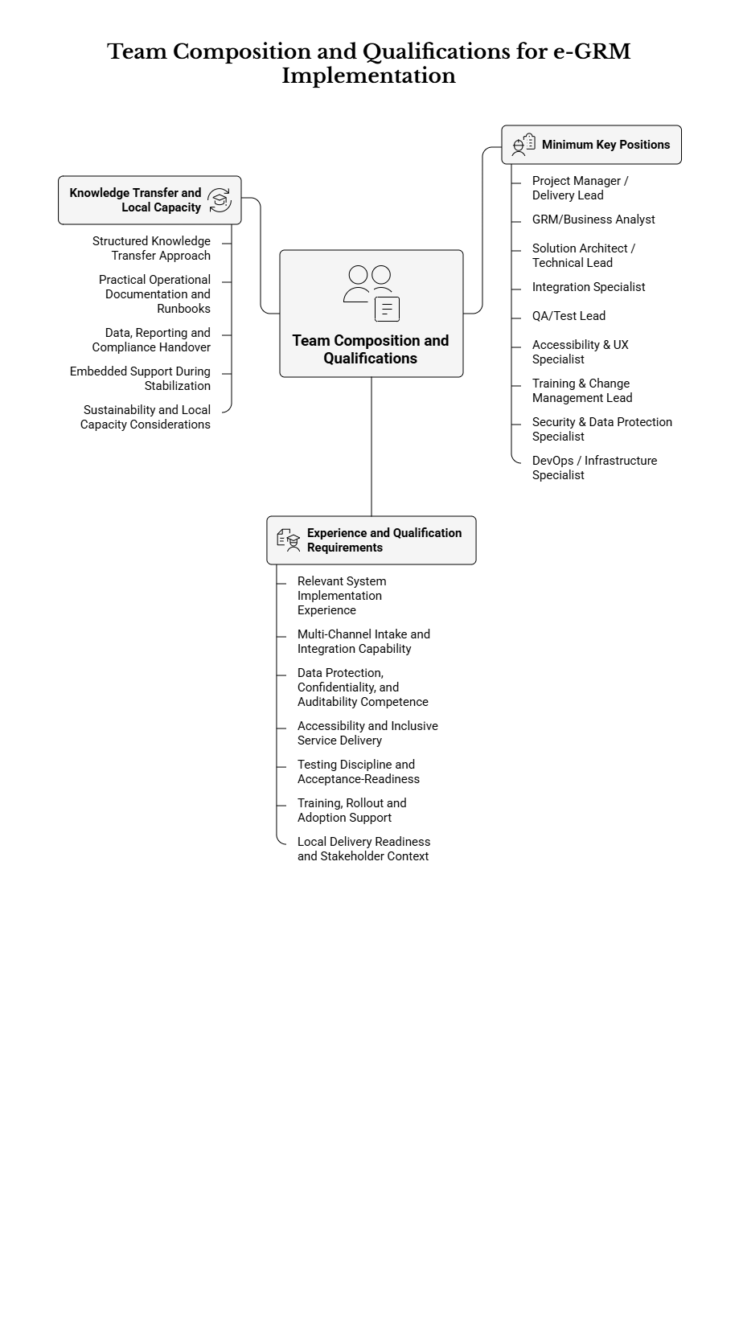

Role | Key Responsibilities
Project Manager / Delivery Lead | Overall delivery management, including detailed planning aligned to the Phase 2 milestone cadence; coordination of day-to-day implementation activities; facilitation of governance and working group meetings; management of dependencies (including Client-led telecom/regulatory arrangements); progress reporting (weekly updates and monthly summaries); maintenance of decision log and action tracker; management of scope, change control, and configuration baseline; ownership of risk/issue log (including prioritization, escalation, and closure); oversight of readiness for UAT, go-live and hypercare; and management of handover packaging and acceptance.
GRM/Business Analyst | Translate GRM workflows, escalation logic, and data standards into implementable configuration and testable scenarios; ensure alignment to the standardized intake/data collection form and agreed data dictionary; define and validate categories/help topics and routing rules with NPCT and county/municipal focal points; develop user stories and end-to-end workflow scenarios for demonstrations and UAT; define SLA/target timelines and escalation triggers with stakeholders; support design of complainant-facing process content (process overview, confidentiality/non-retaliation messages); and validate reporting outputs against operational and programme needs.
Solution Architect / Technical Lead | Own overall technical design and implementation approach (technology-neutral), including environment design, configuration/development standards, integration architecture, and performance considerations; ensure “secure-by-design” and “privacy-by-design” implementation; lead technical backlog and sprint planning; ensure appropriate separation of environments (dev/test/staging/production as applicable); define configuration patterns that support decentralized operations across counties/municipalities; validate technical feasibility of channels and interfaces; oversee technical quality of builds/configuration; and ensure production readiness (deployment approach, rollback plan, monitoring/observability basics, and operational runbooks).
Integration Specialist | Implement, configure and test integrations for the agreed channels and interfaces, including (as applicable) web embedding/linkage, inbound/outbound email, SMS gateway, USSD gateway, and hotline/call-centre workflows; ensure that all channels feed into a unified register with consistent reference numbering and status tracking; design robust error handling and reconciliation for message delivery failures (e.g., undelivered SMS/email); implement monitoring for integration health where feasible; document interfaces, credentials handover procedures, and integration configurations; and support end-to-end integration testing and UAT execution support.
QA/Test Lead | Own testing strategy and evidence pack across the three-month window; develop and maintain test plan, test cases/scripts and traceability to requirements and workflow scenarios; manage defect lifecycle (logging, triage, prioritization, verification, regression checks); coordinate and evidence functional, integration, regression, accessibility, and security/performance testing (proportionate to risk and scope); support Client-led UAT by providing scripts, guidance, triage support and retesting; and contribute to go-live readiness by confirming critical defect closure and documenting residual risks with mitigation plans.
Accessibility & UX Specialist | Ensure an inclusive, accessible and usable experience for both complainants and staff users; validate that the public portal and staff interfaces support low-bandwidth usage and common devices; ensure language readiness (at minimum English and Kiswahili) for user-facing components and templates; review form design for clarity and minimal burden (especially for assisted intake); support accessibility testing and remediation (keyboard navigation, screen reader compatibility, form error handling, and accessible content patterns); and provide usability recommendations for adoption and reduced handling time.
Training & Change Management Lead | Develop a practical training and adoption approach suited to dispersed users and short timelines; define role-based training tracks (NPCT administrators, supervisors, grievance handlers, reporting users, county/municipal focal points); produce training materials (user guides, admin guide, quick reference job aids, phone scripts for assisted intake where applicable) in English and Kiswahili; coordinate and deliver training sessions (virtual and/or in-person as agreed); capture attendance and feedback; support “super user” development within NPCT and selected counties/municipalities; and ensure training aligns with confidentiality, ethical handling, and sensitive-case procedures.
Security & Data Protection Specialist | Lead implementation of security and privacy controls aligned to applicable Kenya legal/policy requirements and the Client’s compliance expectations; ensure consent capture and privacy notice implementation; define data minimization and retention/archiving configurations; validate role-based access design (least privilege), restricted visibility for sensitive grievances (including SEA/SH), and audit logging completeness; support security testing evidence (e.g., vulnerability scanning outcomes and remediation actions as feasible); contribute to incident response readiness (roles, logging, escalation, and breach handling procedures); and document compliance evidence for Client review during acceptance.
DevOps / Infrastructure Specialist (as applicable) | Set up and/or configure environments and deployments in the approved hosting context; implement configuration for backups and restoration procedures; support performance monitoring and basic operational alerting where feasible; manage deployment packaging and release processes; support cutover planning and execution; document environment configurations, accounts/credentials handover procedures, and operational runbooks; and support stabilization during hypercare (triage and remediation coordination for environment/infrastructure-related issues).

Additional resourcing expectations (to support delivery confidence within the three-month window):
- The Supplier shall ensure that key personnel are available for the duration of Phase 2 and during critical periods (Weeks 1–4 for foundation build; Weeks 8–12 for UAT, go-live and hypercare).
- The Supplier shall provide a clear escalation path within the Supplier organization for rapid resolution of critical issues (e.g., security defects, channel integration failures, go-live blockers).
- Where roles are combined, the Supplier shall explicitly describe how responsibilities will be balanced to avoid bottlenecks and ensure adequate QA and compliance assurance.

10.2 Experience and Qualification Requirements
The Supplier shall demonstrate organizational capability and relevant, verifiable experience implementing digital grievance, case management, or comparable public service request/complaints systems in multi-stakeholder environments. The Supplier’s proposal shall include sufficient evidence that the team can deliver within a compressed implementation period while meeting security, privacy, accessibility, and reporting obligations.
At minimum, the Supplier shall demonstrate the following:
a) Relevant system implementation experience
- Demonstrated experience delivering end-to-end deployment of a case management or grievance/complaints system, including intake, assignment, investigation/action logging, escalation, closure, and reporting.
- Demonstrated experience implementing decentralized workflows (national + sub-national users), including routing by geography and organizational unit, and supporting multiple user roles with least-privilege access controls.
- Demonstrated experience delivering implementation in constrained timelines, using structured delivery controls (e.g., iterative releases, frequent demos, and a robust defect and change management process).
b) Multi-channel intake and integration capability
- Demonstrated experience implementing at least two intake channels in addition to web and assisted intake (e.g., email integration and one of SMS/USSD or hotline/call-centre integration), and consolidating these into a single system of record with consistent reference numbering and status tracking.
- Practical capability to implement, test, and document integrations using open and documented interfaces, and to manage operational realities such as delivery failures, retries, and auditability for inbound/outbound communications.
c) Data protection, confidentiality, and auditability competence
- Demonstrated experience implementing solutions handling personal data and sensitive information, including role-based access control, audit logging, and secure handling of attachments.
- Demonstrated understanding of privacy-by-design measures relevant to public grievance systems, including consent capture, data minimization, retention/archiving controls, and support to lawful access and audit processes.
- Demonstrated capability to implement restricted handling for sensitive grievances (including SEA/SH), including controlled visibility, safe communications templates (avoiding sensitive data in insecure channels), and referral-oriented workflows consistent with agreed procedures.
d) Accessibility and inclusive service delivery
- Demonstrated experience delivering accessible digital services and testing against recognized accessibility standards (including practical testing of key user journeys for both public and staff users).
- Demonstrated capability to implement low-bandwidth-friendly user interfaces and assisted-intake workflows suitable for municipalities with varying levels of connectivity and digital maturity.
- Demonstrated capability to deliver bilingual user-facing content (at minimum English and Kiswahili), including templates and public guidance text.
e) Testing discipline and acceptance-readiness
- Demonstrated ability to deliver test artifacts and evidence appropriate to acceptance, including functional, integration, regression, accessibility, and security/performance testing proportionate to risk.
- Demonstrated experience supporting Client-led UAT, including preparation of scripts aligned to end-to-end workflow scenarios and structured remediation.
f) Training, rollout and adoption support
- Demonstrated experience delivering role-based training and practical user support materials for dispersed users, including remote/virtual modalities.
- Ability to support initial rollout and stabilization (hypercare), including rapid incident triage, prioritization, and resolution tracking.
g) Local delivery readiness and stakeholder context
- Ability to provide on-the-ground support in Kenya where required for key milestones (e.g., pilot/UAT support, training delivery, go-live support), while also being capable of remote delivery where agreed.
- Demonstrated experience working with public sector stakeholders and multi-layer governance contexts (national, county, municipal), including structured engagement and coordination practices.
For evaluation and verification, the Supplier should provide (as applicable):
- CVs for proposed key personnel highlighting directly relevant assignments and responsibilities.
- At least three references for comparable assignments (preferably including multi-channel intake and public-sector or multi-stakeholder deployment contexts).
- Short descriptions of similar deployments, including scope, channels implemented, governance model, timeline, and outcomes (with emphasis on privacy, security, auditability, and accessibility).
- A statement of availability for key personnel for the full three-month period and the critical milestones within it.

10.3 Knowledge Transfer and Local Capacity
The Supplier shall prioritize knowledge transfer and practical capacity building to enable sustainable operation of the e-GRM by NPCT and designated county/municipal users after Phase 2 handover. Knowledge transfer shall be treated as a structured workstream throughout implementation (not only at the end), with specific, usable outputs delivered in formats that support day-to-day administration, onboarding, troubleshooting, reporting, and future configuration changes.
At minimum, the Supplier shall provide:
a) Structured knowledge transfer approach
- A knowledge transfer plan integrated into the Implementation Plan, identifying target audiences (NPCT administrators, supervisors, grievance handlers, reporting users, county/municipal focal points), delivery methods (hands-on sessions, job aids, walkthroughs), and timing aligned to releases and go-live readiness.
- A “train-the-trainer” approach to develop a small cadre of Client “super users” at NPCT (and selected sub-national focal points where feasible) who can support ongoing onboarding and first-line support post-handover.
b) Practical operational documentation and runbooks
- An Administrator Guide that enables Client teams to perform routine administration without Supplier dependency, including: user and role management, organizational structure management (departments/units), category/help topic maintenance, SLA/target timeline configuration, escalation rule configuration, template/message management, and audit log access and export.
- Operational runbooks covering: backup and restore procedures (and how to verify backups), basic monitoring/health checks, common incidents and troubleshooting steps (including channel integration issues), and a go-live rollback approach (where applicable).
- Configuration and “as-built” documentation that clearly records what has been configured (forms/fields, validation rules, routing rules, escalation paths, templates, integrations), including versioned configuration baselines to support future change control.
c) Data, reporting and compliance handover
- Clear documentation of the data model mapping to the standardized intake fields, including any channel-specific constraints (e.g., minimum fields captured via USSD versus web or assisted intake).
- Reporting guides for NPCT and sub-national users explaining how to use dashboards and generate required reports/exports, including recommended standard views for operational management (overdue queues, workload by unit, volumes by category/location) and programme reporting.
- Compliance-oriented documentation and evidence packages suitable for internal review (e.g., confirmation of consent capture configuration, audit logging coverage, restricted access configuration for sensitive cases, retention/archiving settings), aligned to the Client’s acceptance process.
d) Embedded support during stabilization (hypercare) and transition
- Hands-on support to NPCT and selected county/municipal users during hypercare, including coaching on real-case handling, correct categorization, escalation practices, and documentation of actions/outcomes.
- A clear transition plan from hypercare to steady-state operations, including recommended support tiers (who does what at NPCT, and what is escalated to the Supplier during warranty/defect liability), response targets during warranty, and clear contact pathways.
e) Sustainability and local capacity considerations
- Emphasis on configuration-driven maintenance (rather than code changes) to support sustainability and reduce total cost of ownership, including guidance on how to safely update reference lists (counties/municipalities, categories), workflows, and templates over time.
- Guidance for county/municipal focal points on minimum operational practices to sustain performance (e.g., routine queue reviews, SLA monitoring, escalation handling, and monthly reporting), aligned to the decentralized nature of KUSP2 operations.

11. TESTING, ACCEPTANCE & QUALITY

11.1 Quality Assurance Plan
The Supplier shall prepare and implement a Quality Assurance (QA) Plan describing the quality management approach, quality controls, review points, and roles/responsibilities for Phase 2.
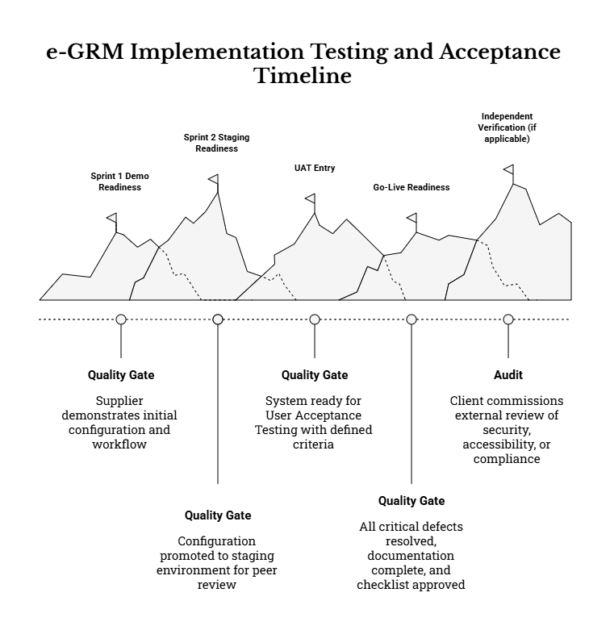
QA shall be embedded throughout configuration/build and delivery activities, not deferred to the end of the implementation period.
The QA Plan shall, at minimum, include:
- Quality objectives and principles
  - Clear quality objectives aligned to the e-GRM’s operational purpose (reliable case handling, confidentiality, auditability, accessibility, and timely processing).
  - “Configuration-first” and “technology-neutral” delivery approach, prioritizing sustainable configuration and documented administration over bespoke customization unless justified.
- Quality governance and roles
  - Definition of QA roles for Supplier team members (e.g., QA/Test Lead, Solution Architect, Security/Data Protection Specialist, Accessibility Specialist) and Client participation points.
  - Quality responsibilities aligned to the agreed RACI and governance meetings (weekly working meetings, sprint reviews, formal approvals).
- Quality controls throughout the delivery lifecycle (minimum controls)
  - Requirements traceability: Maintain a Requirements Traceability Matrix (RTM) mapping requirements (including standardized intake data fields, workflows, reporting, and compliance controls) to configuration items, test cases, and acceptance evidence.
  - Design/configuration reviews: Formal peer review of configuration workbook(s), workflow configuration, roles/permissions model, notification templates, and integration approach before promotion to staging/production.
  - Build quality checks: Validation of naming conventions, versioning, configuration hygiene, and separation of environments (dev/test/staging/production as applicable).
  - Documentation quality: Structured templates and quality review for deliverables (implementation plan, configuration workbook, test plan, training materials, handover dossier), including version control and change logs.
  - Data quality assurance: Field-level validation rules and completeness checks aligned to the agreed standardized grievance intake dataset, including required/optional/conditional fields and controlled vocabulary lists.
- Quality gates and approval points
  - Defined entry/exit criteria and evidence expectations for each stage (e.g., Sprint 1 demo readiness, Sprint 2 staging readiness, UAT entry, go-live readiness).
  - A clear approach for addressing Client feedback, logging defects/issues, and tracking decisions.
- Evidence pack structure
  - Definition of the test evidence pack contents and storage approach (e.g., test cases/scripts, execution logs, screenshots, defect logs, security test outputs, accessibility checks, performance results), ensuring evidence is organized, auditable, and available for acceptance reviews.

11.2 Test Strategy and Coverage
The Supplier shall develop and execute a comprehensive test strategy that ensures the e-GRM is fit for purpose for national and decentralized use, meets functional and non-functional requirements, and supports compliance obligations.
At minimum, the test strategy shall cover the following test levels and types:
- Functional testing
  - Testing against agreed user stories and end-to-end workflow scenarios, including core lifecycle steps: intake → validation → reference generation → triage → assignment → investigation/action logging → communication → resolution → satisfaction capture (where applicable) → closure → archiving/retention controls.
  - Validation of role-based workflows for national, county and municipal users (e.g., municipal handler queues, county oversight views, national escalations).
- Integration testing
  - Integration tests for all enabled channels and interfaces, including (as applicable):
    - Web portal (submission, consent capture, status-check functionality).
    - Staff-assisted intake (including consistent reference numbering and standardized fields).
    - Email integrations (outbound templates; inbound ingestion where enabled).
    - SMS/USSD integrations (where enabled and available), including delivery failure handling and safe message content.
    - Hotline/toll-free workflows (assisted intake and logging), and any call metadata integration if implemented.
    - Any approved web/API integration points (e.g., embedding/linking from the KUSP2 website, exports, APIs).
- Regression testing
  - Regression testing across releases/sprints to ensure changes do not break previously demonstrated functionality, particularly for:
    - Core case workflows and state transitions
    - Access controls and confidentiality rules
    - Reporting filters and exports
    - Notifications and template rendering
    - Attachment upload and access rules
- Data validation testing
  - Verification of standardized intake form fields and rules (mandatory/optional/conditional logic), validation messages, controlled lists (counties/municipalities/categories), and field formats (dates, contact fields, reference number structure).
  - Validation of data consistency across channels (e.g., grievances submitted via USSD/hotline still generate a complete and usable system record and do not bypass key controls).
  - Validation of category, location, and workflow metadata required for reporting and KPI monitoring.
- Accessibility testing
  - Accessibility testing for user-facing components (public portal and relevant staff interfaces), including keyboard navigation, form labels/error handling, screen-reader compatibility, and language support (minimum English and Kiswahili).
  - Practical validation of accessibility for key user journeys (submit grievance, consent, upload evidence, check status, staff triage and response) and remediation of identified barriers.
The test strategy shall also specify:
- Test environments and release management
  - Clear separation of environments and rules for promoting configurations/builds (dev → test → staging → production).
  - Use of controlled and anonymized test data in non-production environments, including realistic case volumes and attachments for performance and usability validation.
- Test case design and scenario coverage
  - A scenario-based test catalogue that includes typical and edge cases, such as:
    - Anonymous submissions and the implications for follow-up and satisfaction fields.
    - Submissions by representatives on behalf of others, including authorization capture.
    - Sensitive grievances (including SEA/SH) that require restricted access, safe routing, and suppression/redaction of notifications where needed.
    - Escalations triggered by breached timelines or by complainant dissatisfaction/appeal pathways.
    - Incorrect or incomplete intake submissions and system validation behaviour.
    - Duplicate or related grievances and the handling approach (linking/merging where supported).
- Defect management approach
  - Defect logging, severity classification, triage cadence, ownership, re-test requirements, and closure criteria.
  - Agreement on how defects and configuration changes are tracked and versioned for auditability.

11.3 Security and Performance Testing
The Supplier shall perform security and performance testing proportionate to risk, with emphasis on the sensitivity of grievance records (including personal and potentially sensitive categories) and the need for dependable service in decentralized operations.
Security testing (minimum expectations):
- Identity and access control validation
  - Verify authentication flows, password policy enforcement (where applicable), optional multi-factor authentication controls, session management, and logout behaviour.
  - Verify role-based access control (RBAC) and least-privilege behaviour at record level (e.g., county/municipal scoping, restricted queues, sensitive case restrictions).
  - Verify access restrictions to attachments, including prevention of unauthorized access via direct links and logging of access attempts.
- Audit logging and traceability validation
  - Confirm that key events are logged (create/view/edit/status change/assignment/communications/exports/configuration changes), with timestamps and actor metadata, and that logs are exportable for audit.
  - Confirm that privileged and administrative actions (role changes, configuration changes, retention settings) are captured and reviewable.
- Secure configuration and vulnerability checks
  - Baseline verification that communications are protected (e.g., encrypted transport), security headers/configuration (as applicable), and that unnecessary services/features are disabled.
  - Vulnerability scanning appropriate to the hosting model, with remediation of critical findings prior to go-live.
  - Validation that notifications and messages do not inadvertently expose sensitive personal data (especially on SMS/USSD), and that templates follow “minimum necessary information” principles.
- Data protection controls validation
  - Validate consent capture mechanisms, secure storage and access controls for personal data, and enforcement of retention/archiving rules aligned to agreed policy.
  - Validate handling of data exports, including restrictions and auditability for exports that might contain personal data.
Performance and capacity testing (minimum expectations):
- Performance and capacity testing proportionate to expected usage, focusing on:
  - Core staff operations (search, list filtering, opening a case, posting updates).
  - Reporting and dashboard generation (which can be heavy operations).
  - Attachment upload/download performance within configured limits.
  - Integration throughput and failure handling (e.g., email/SMS delivery response logging).
- The Supplier shall document test assumptions (expected concurrent users, expected grievance volumes, attachment sizing) and demonstrate that the solution performs acceptably under those assumptions.
- Performance results shall be recorded and submitted as part of the test evidence pack, including identified bottlenecks and remediation actions completed before go-live.

11.4 User Acceptance Testing and Sign-off
User Acceptance Testing (UAT) will be led by the Client, with the Supplier providing UAT scripts, test environments, support during execution, and remediation of agreed defects. UAT shall include users from NPCT and selected counties/municipalities and include accessibility validation where feasible.
The Supplier shall support UAT through:
- UAT planning and readiness
  - A UAT plan with scope, schedule, participant roles, entry criteria, exit criteria, and test data preparation.
  - UAT scripts aligned to agreed workflow scenarios and acceptance criteria, including channel-specific scenarios and sensitive grievance scenarios (with safe testing protocols).
- UAT execution support
  - Facilitation support (helpdesk-style triage during UAT sessions), rapid issue reproduction, and structured defect logging.
  - Controlled deployment of fixes into staging/UAT environments with clear versioning and re-test scheduling.
- UAT results and sign-off pack
  - Consolidated UAT results (pass/fail by scenario), defect summary (open/closed by severity), remediation summary, and a go-live recommendation supported by evidence.
  - Identification of any residual risks and proposed mitigations if conditional go-live is considered.

11.5 Acceptance Criteria and Defect Resolution
The Supplier shall meet the acceptance criteria defined by the Client and provide evidence to support acceptance decisions. Acceptance criteria shall be applied consistently across functional readiness, compliance controls, operational readiness, and documentation/handover completeness.
Minimum acceptance conditions include:
- Defect resolution thresholds
  - All critical (Severity 1) defects resolved prior to go-live.
  - High severity defects resolved prior to go-live, or explicitly mitigated with an agreed workaround and time-bound resolution plan approved by the Client.
  - Clear severity classification criteria applied consistently (e.g., Severity 1: system unusable / major security/privacy failure / inability to process grievances end-to-end; Severity 2: major functional impairment with no acceptable workaround; Severity 3–4: minor defects/usability improvements).
- End-to-end workflow demonstration
  - Core workflow scenarios successfully demonstrated end-to-end (intake → assignment → action logging → resolution → closure), including:
    - At least one case per key channel enabled (web, assisted intake; and email/SMS/USSD/hotline where applicable).
    - Escalation behaviour and overdue indicators where timeline triggers are configured.
    - Appeals/reopening pathway where complainant is not satisfied (as configured/required).
    - Correct handling of anonymous cases and representative-submitted cases.
- Compliance controls evidence
  - Consent capture demonstrated for personal data intake; privacy notice presentation where applicable.
  - Role-based access control demonstrated, including restrictions for sensitive grievances (including SEA/SH) and need-to-know access.
  - Audit logging demonstrated and exportable.
  - Retention/archiving controls demonstrated and documented, including the administrative process and audit trail expectations.
- Reporting verification
  - Dashboards, standard reports, and exports verified against agreed templates and KPIs, including filters by geography, channel, category, status, timeliness, and workload distribution.
  - Confirmation that public or shareable reporting outputs do not expose personal data inappropriately, and that aggregated/anonymized outputs can be produced where required.
- Go-live readiness checklist
  - A documented go-live readiness checklist completed and approved by the Client, covering at minimum:
    - Production deployment readiness and rollback approach
    - User accounts/roles provisioned and validated
    - Backup/restore readiness (and, where applicable, restoration test evidence)
    - Monitoring/alerting configured (where applicable)
    - Integration readiness and failure-handling procedures for enabled channels
    - Hypercare support arrangements and escalation contacts
    - Final “as-configured/as-built” documentation snapshot prepared for handover

11.6 Independent Verification (if applicable)
The Client may commission independent verification or audits (e.g., security review, accessibility review, or compliance validation). The Supplier shall cooperate and provide necessary evidence, access, and technical clarifications, subject to agreed security procedures and confidentiality constraints.
Independent verification cooperation shall include, as applicable:
- Provision of relevant test evidence packs, configuration documentation, and environment access for auditors under controlled accounts and agreed time windows.
- Support for remediation of audit findings within agreed timelines, including clear documentation of fixes and re-test evidence.
- Secure handling of any audit artifacts and reports, ensuring no unnecessary exposure of personal or sensitive grievance data during verification activities.

12. TRAINING & CHANGE MANAGEMENT

12.1 Training Strategy and Curriculum
The Supplier shall develop and deliver a structured training and change management program that enables consistent, safe, and sustainable use of the e-GRM across national (NPCT), county (CPCT) and municipal levels, including for staff who will support assisted intake (in-person/phone) and those who will use the system primarily for supervision and reporting. Training shall be planned and executed as a core implementation workstream (not an end-stage activity), and shall be aligned to the Phase 2 timeline and deliverables, including the required training deliverable and evidence pack.

12.1.1 Training objectives (minimum)
The training program shall, at minimum, enable participants to:
- Apply the standardized GRM process consistently, including correct use of workflow statuses, escalation pathways, closure controls, and appeals handling.
- Capture high-quality grievance data using the standardized intake/data collection fields, including mandatory fields, validation rules, and appropriate use of structured fields versus free text.
- Handle grievances ethically and safely, including confidentiality, inclusion, and non-retaliation commitments, and special handling protocols for sensitive grievances (including SEA/SH) using need-to-know access and referral workflows.
- Operate and administer the system (for administrators), including role/permission management, configuration updates (categories, templates, SLAs, routing rules), audit log access, and basic operational troubleshooting.
- Use dashboards and reports effectively for operational monitoring, programme reporting, and compliance oversight without inappropriate exposure of personal data.
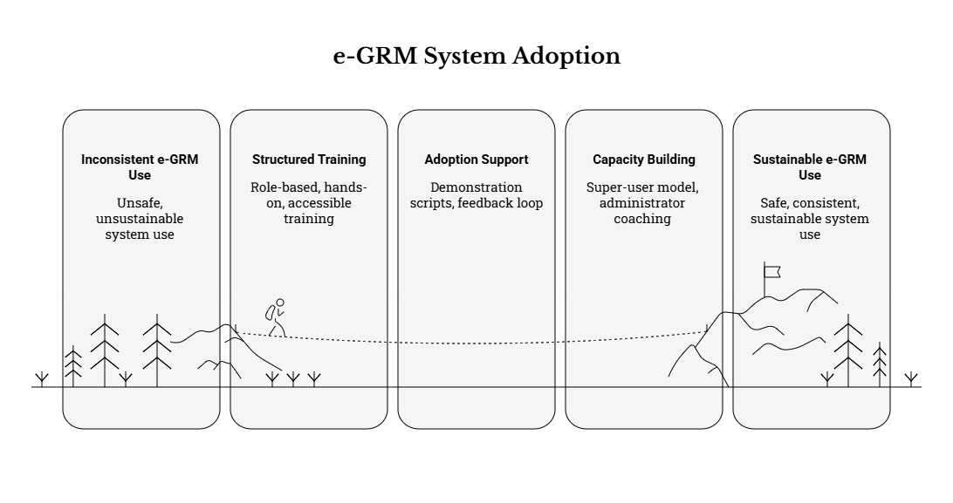

12.1.2 Training approach and learning principles
The Supplier shall implement a blended, role-based approach designed for a decentralized operating model and varying levels of ICT familiarity:
- Role-based tracks with targeted curriculum depth (handlers vs supervisors vs administrators).
- Hands-on, scenario-driven training using realistic end-to-end case simulations (intake → triage → assignment → action logging → resolution → closure/appeal), including common and edge cases (anonymous grievance, representative submission, missing data, attachment upload, escalation trigger, complainant not reachable).
- Progressive delivery aligned to system readiness, so training is delivered against the configured system (or a stable training/staging environment) and reinforced during pilot/UAT and hypercare.
- Accessibility-conscious training delivery, ensuring materials and delivery methods are usable by participants with disabilities (e.g., screen-reader-friendly documents, clear fonts/structure, captioned recordings where produced).
- Bilingual delivery at minimum in English and Kiswahili for user-facing training materials and key job aids, with provision to support further translation where directed by the Client.

12.1.3 Training needs confirmation and participant profiling
During mobilization and prior to delivery, the Supplier shall confirm training needs and logistics through a rapid training readiness check, covering at minimum:
- Target counties/municipalities participating in training (and pilot/UAT) and their nominated participants.
- Participant role profiles (administrator, supervisor, handler, reporting user, call intake agent, safeguards focal person).
- Digital readiness constraints (device availability, connectivity, ability to join virtual sessions).
- Language considerations and any accommodation needs for participants with disabilities.
Outputs of this readiness check shall inform the training schedule, session sizes, and modality mix.

12.1.4 Role-based training tracks (minimum set)
The Supplier shall provide training tracks that, at minimum, cover the following groups (roles may overlap in smaller municipalities, but competencies must still be addressed):
- Track A – System Administrators (NPCT and designated administrators): configuration, security controls, user and role management, audit logs, backup/restore procedures, configuration change control, template management, reference data updates (counties/municipalities/categories), and basic operational monitoring.
- Track B – Supervisors/Managers (NPCT/CPCT/municipal leadership): workload monitoring, SLA/overdue management, escalation oversight, approval/closure checks, reporting and trend analysis, and governance responsibilities.
- Track C – GRM Officers/Handlers (municipal/county/national case handlers): intake review, triage, categorization, assignment, investigation/action logging, communications, referrals, resolution documentation, closure controls, satisfaction capture, and appeals escalation.
- Track D – Assisted Intake Agents (front office, hotline/call-handlers where applicable): assisted intake procedures, consent capture, confidentiality, reference number issuance, minimum data capture for low-bandwidth/phone contexts, scripts and escalation triggers.
- Track E – M&E and Reporting Users: dashboards, standard reports, export procedures, anonymized/aggregated reporting principles, and interpretation of KPIs and trends for management action.
- Track F – Safeguards / Sensitive Case Focal Persons (including SEA/SH focal persons): confidential intake options, restricted access workflows, safe referral recording, “minimum necessary data” discipline, and prevention of inappropriate notifications or disclosures.

12.1.5 Curriculum content (minimum modules)
Across the training tracks above, the Supplier shall cover the following modules at appropriate depth:
- GRM fundamentals and KUSP2 context
- GRM purpose, principles (accessibility, predictability, transparency, fairness), and link to accountability/service delivery.
- Institutional roles across NPCT/CPCT/municipal levels, escalation principles, and non-retaliation commitments.
- System overview and user journeys
- Public-facing journey (where applicable): submitting a grievance, receiving acknowledgement/reference number, status tracking.
- Staff journey: queues, assignment, action logging, communications, closure, reporting.
- Standardized intake and data quality
- Mandatory vs optional fields; representative submissions; anonymous submissions; consent fields and privacy notice.
- Common data quality errors and how to avoid them (misclassification, missing location, inconsistent narratives).
- Attachment handling rules and evidence management (file types/size limits, naming conventions, secure viewing).
- Triage, categorization, assignment and escalation
- Applying categories/help topics consistently; routing logic; reassignment controls.
- Priority levels and how they relate to due dates/target timelines.
- SLA concepts (acknowledgement/response/resolution targets) and escalation triggers (overdue rules, governance escalations).
- Case handling and documentation discipline
- Action logs: what must be recorded, minimum documentation standards, timestamps, and evidence of decisions.
- Distinguishing internal notes vs external communications.
- Closure controls: required fields, resolution summary quality, supporting documentation.
- Communications and confidentiality controls
- Consent-aware communications (preferred channel), template usage, message logging.
- Avoiding disclosure of personal/sensitive data in insecure channels (e.g., minimizing sensitive content in SMS).
- Withholding complainant identity where confidentiality is requested.
- Sensitive grievance handling (SEA/SH and other confidential cases)
- Restricted visibility workflows and “need-to-know” routing.
- Survivor-centred approach: safe handling, referral workflow recording, and minimizing capture of sensitive narrative in free-text fields where procedures require structured referral recording.
- Do’s and don’ts for system users to prevent accidental exposure (attachments, notifications, screenshots, exports).
- Reporting and dashboards
- Operational dashboards: volumes, categories, status distribution, overdue queues, workloads.
- Programme reporting: disaggregation by geography/channel/category, trend analysis, escalation patterns.
- Export procedures (CSV/Excel/PDF), anonymization principles, and audit-ready exports.
- Operational continuity and incident-aware behaviors (user-level)
- What to do during downtime or channel unavailability (temporary manual intake and later entry, consistent reference handling).
- Recognizing and escalating suspected security/privacy incidents (who to contact, immediate steps).

12.1.6 Training assessment and verification (minimum)
To support go-live readiness and sustainability, the Supplier shall implement lightweight training verification measures, such as:
- Short pre/post checks (knowledge quizzes) for key tracks (handlers and administrators).
- Practical competency checks using defined scenarios (e.g., each handler completes a case lifecycle exercise; administrators complete a configuration change exercise and demonstrate rollback/traceability).
- Training feedback collection to identify gaps requiring targeted refresher sessions during hypercare.

12.2 Training Materials and Delivery
The Supplier shall produce a complete, reusable training package and deliver training through agreed modalities (virtual and/or in-person) appropriate to dispersed users and the Phase 2 timeline.

12.2.1 Required training materials (minimum set)
Training materials shall be clear, role-appropriate, and designed for continued use post-handover. At minimum, the Supplier shall provide:
- Training curriculum and session plans: agendas, learning objectives, target roles, durations, prerequisites, and hands-on exercises.
- User manuals (English and Kiswahili): step-by-step guidance for grievance handlers and supervisors, including screenshots and common workflows.
- Quick Reference Guides (QRGs)/Job aids: one–two page guides for common tasks (create case, assign, escalate, close, run report), including data quality reminders.
- Administrator guide: configuration, user/role management, reference data updates, templates, SLA schedules, audit log access, backup/restore procedures (as applicable), and operational monitoring basics.
- Channel SOPs: standardized operating procedures for web-assisted intake, in-person intake, email processing (where enabled), and phone/hotline intake (including call scripts and minimum data set).
- SEA/SH-sensitive handling job aid: role-specific guidance that reinforces confidentiality, restricted access, referral recording discipline, and safe communications.
- Reporting pack: definition of standard dashboards/reports, how to filter/export, and guidance on anonymized reporting for broader circulation.

12.2.2 Format, language and accessibility of materials
- All materials shall be delivered in editable formats (e.g., DOCX, PPTX) and as PDF for controlled distribution/approval, with document version control and change logs.
- User-facing materials and key SOPs shall be available at minimum in English and Kiswahili.
- Materials shall follow accessibility-aware authoring practices (structured headings, readable layout, meaningful link text, and inclusion of text alternatives for key visuals) to support inclusive use.

12.2.3 Training delivery modalities and logistics
The Supplier shall deliver training using a mix of modalities agreed with the Client, including:
- Virtual sessions for NPCT and dispersed county/municipal participants (with recorded demonstrations where appropriate).
- In-person sessions where needed for key pilot municipalities and administrator/super-user deep dives (subject to Client direction and logistics).
- Training environment and accounts: training shall be conducted on a stable training/staging environment with pre-provisioned user accounts by role, and a prepared set of sample grievances representing realistic KUSP2 contexts.
- Session structure: training shall emphasize short demonstrations followed by guided practice and troubleshooting time, rather than lecture-only formats.

12.2.4 Training records and completion evidence
The Supplier shall maintain and submit training evidence as part of the Phase 2 deliverables, including:
- Attendance registers (participant name, organization, role, county/municipality, session attended).
- Session evaluation summaries (what worked, common issues, recommended refinements).
- A training completion note indicating which tracks were delivered, to whom, and any residual capability gaps to be covered during hypercare.

12.3 Adoption, Communications and Support Aids
The Supplier shall support adoption by equipping both public users and staff users with clear guidance on how to use the e-GRM, what to expect from the process, and how confidentiality and non-retaliation commitments are upheld. Adoption support shall be coordinated with the Client’s stakeholder engagement approach and shall be practical for rollout across diverse municipalities.

12.3.1 Adoption approach (minimum)
The Supplier shall incorporate adoption support throughout Phase 2 by:
- Providing demonstration scripts and structured walkthroughs for stakeholder briefings (including pilot municipalities).
- Supporting the Client to implement a “train + use + reinforce” cycle: initial training, supported live usage during pilot/UAT, and refinement of materials based on real user feedback.
- Establishing a feedback loop to capture usability issues and frequently asked questions, and updating guidance materials accordingly during the implementation window.

12.3.2 Public guidance content (minimum)
Where requested by the Client, the Supplier shall provide content templates suitable for web and printable formats that explain:
- Available submission channels (web, assisted intake, and other channels where enabled).
- That use of the GRM is free of charge and what to do if anyone requests payment to lodge a grievance.
- Privacy notice and consent basics (what information is collected and why), confidentiality expectations, and non-retaliation commitments.
- How to track a grievance using the reference number (and what information is required to retrieve status where applicable).
- Expected process steps and indicative timelines (acknowledgement, follow-up, resolution/closure), in simple, user-friendly language.

12.3.3 Staff-facing support aids (minimum)
The Supplier shall provide operational job aids to reduce inconsistency and support data quality, including:
- Triage and categorization guide: definitions of categories/help topics and examples, common misclassification pitfalls, and “when to escalate” prompts.
- Escalation and referral guide: escalation thresholds, routing pathways (municipal → county → national), and documentation requirements for referral/escalation decisions.
- Data quality checklist: mandatory fields for closure, minimum documentation standards for resolution summaries, and “structured-first” guidance to avoid overreliance on free text.
- Confidentiality and privacy quick guide: what information can/cannot be shared via different channels, how to handle attachments, and how to prevent accidental disclosure through exports or screenshots.
- SEA/SH-sensitive handling quick guide: restricted access rules, safe referral recording, and notification suppression/redaction behaviors.

12.3.4 Support model during adoption
The Supplier shall align adoption aids with the hypercare and warranty approach by:
- Defining how users will request help (e.g., designated support contacts, ticket logging approach during hypercare).
- Providing a structured “common issues” troubleshooting guide (login/access, assignment errors, missing reference data, report filters, notification failures).
- Recommending practical adoption monitoring indicators for NPCT (e.g., number of active users by municipality, overdue backlog trends, data completeness rates for mandatory fields), using built-in reporting where available.
Note: automated chatbots shall not be used for grievance intake. The Supplier may provide FAQs/knowledge resources and guided forms to assist users, consistent with this requirement.

12.4 Capacity Building for Client Teams
Capacity building shall prioritize sustainable operation after handover, ensuring the Client can administer, support, and continuously improve the e-GRM without unnecessary dependency on the Supplier.

12.4.1 Super-user model and sustainability
The Supplier shall support the Client to designate a small group of NPCT and sub-national “super users” who can:
- Provide first-line operational support to users in their jurisdictions.
- Support onboarding of new municipal users and refresher sessions.
- Act as champions for consistent data entry, workflow compliance, and confidentiality practices.
Selection of super users should consider role relevance, availability, and demonstrated competence during training/practice sessions.

12.4.2 Hands-on administrator coaching
Beyond classroom-style training, the Supplier shall deliver hands-on administrator sessions that cover real operational tasks, including:
- Creating/disabling user accounts; role assignment; segregation of duties.
- Updating categories/help topics and reference lists (counties/municipalities and other controlled vocabularies).
- Updating templates (English/Kiswahili), notification rules, working schedules and SLA targets.
- Reviewing audit logs and configuration change history; preparing audit exports when required.
- Performing and verifying backup/restore procedures (where applicable to hosting model) and documenting the operational runbook steps.
- Applying change control practices for configuration updates, including versioning and rollback where supported.

12.4.3 Transition-to-ownership and handover alignment
Capacity building shall be tied to handover readiness by ensuring:
- Administrators can demonstrate execution of key admin workflows without Supplier intervention.
- Super users can demonstrate core handler workflows and basic troubleshooting.
- All capacity-building materials and configuration documentation form part of the final handover dossier, ensuring continuity for counties/municipalities beyond Phase 2.

13. OPERATIONS, SUPPORT & MAINTENANCE

13.1 Service Levels and KPIs
The Supplier shall propose service level targets for system availability and support response, and shall configure the solution to monitor key operational KPIs (e.g., grievance resolution timeliness, overdue rates) for management reporting. The proposed service levels shall be practical for a nationally used, decentralized system and shall be defined in a way that is measurable, auditable, and aligned to the e-GRM operating model across NPCT, counties, and municipalities.
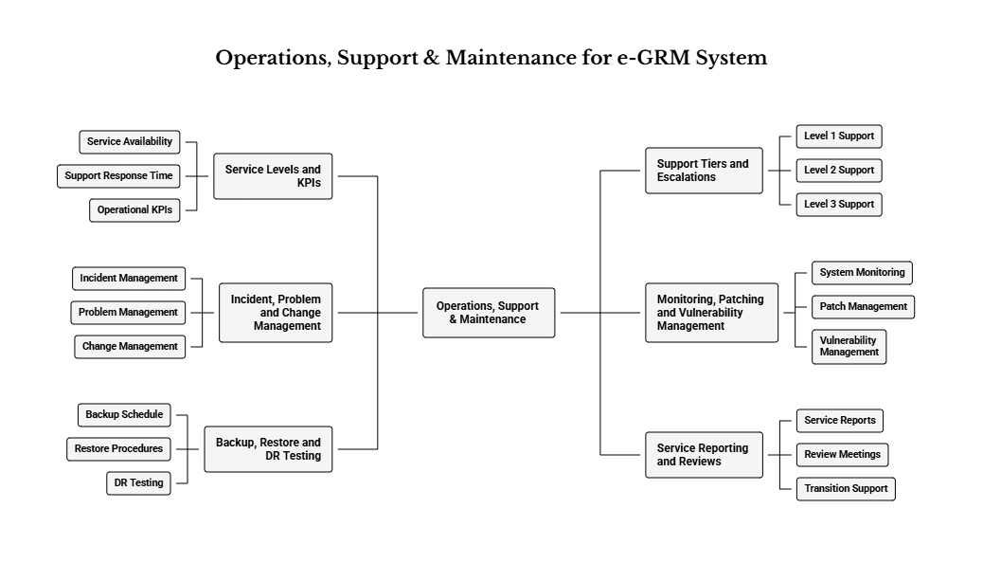
In particular, the Supplier shall:
- Define service availability and performance targets appropriate to a public-service channel, including (as applicable):
  - Uptime/availability target(s) and how they are measured (e.g., monthly service availability excluding planned maintenance windows).
  - Maximum planned maintenance window(s) and notification arrangements.
  - Key performance expectations for common user journeys (e.g., case search, case opening, dashboard loading, exporting reports), including how performance will be monitored.
  - Integration availability expectations (e.g., email/SMS/USSD gateway reachability, message delivery confirmation where supported), including handling of partial outages.
- Define support service levels that clearly distinguish between:
  - Response time (time to acknowledge/log and begin triage),
  - Resolution time (time to implement fix or workaround), and
  - Restore time (time to restore service during an outage).
These targets shall be aligned to incident severity levels (see Section 13.3) and the reality of operating hours, escalation paths, and dependencies on third parties (e.g., telecom providers).
- Configure and report on GRM operational KPIs that support day-to-day management and programme oversight, including at minimum:
  - Case volume and throughput: new cases received, cases closed, backlog trends.
  - Timeliness KPIs: acknowledgement timeliness (where measurable), first response time (where applicable), resolution time, and closure time by category and location.
  - Overdue and escalation KPIs: overdue counts, overdue rate, escalation volumes, and escalation reasons.
  - Workload KPIs: caseload distribution by county/municipality, department/unit, and assignee/team; aging of open cases.
  - Outcome and satisfaction KPIs: resolution outcomes, complainant feedback/satisfaction capture rates (where contactable), and reopened/appealed cases.
  - Data quality KPIs: completeness of mandatory intake fields, frequency of “unknown/other” categories, attachment usage rates (where relevant), and rate of duplicate cases (where identifiable).
- Define privacy-appropriate KPI reporting to ensure operational dashboards do not expose personal data unnecessarily. KPI views intended for broad distribution shall be aggregated and/or anonymized, with sensitive-case reporting presented in line with confidentiality controls.
- Establish KPI governance and cadence by proposing:
  - A minimum reporting cadence (e.g., weekly operational summaries during hypercare; monthly thereafter where applicable).
  - Clear ownership of KPI review (NPCT, CPCT, municipal focal points) and the decision-making actions expected from KPI review (e.g., targeted coaching for low-performing units, configuration tuning for routing/escalation).

13.2 Support Tiers and Escalations
The Supplier shall define support tiers (e.g., Level 1 user support, Level 2 application support, Level 3 technical escalation) and contacts during hypercare and warranty. The Supplier shall provide an escalation process for critical incidents impacting service availability or data integrity. The proposed model shall support both centralized oversight (NPCT) and decentralized operations (county/municipal users), and shall be consistent with the agreed governance arrangements for Phase 2.
At minimum, the Supplier shall:
- Define a tiered support model that clearly specifies scope and responsibilities, such as:
  - Level 1 (L1) – User support / service desk: account access support, password resets (as permitted), navigation/how-to guidance, logging incidents and requests, basic triage, and routing to L2/L3.
  - Level 2 (L2) – Application support / functional administration: configuration changes (forms, lists, templates, routing rules), workflow and permission troubleshooting, report/dashboard troubleshooting, non-code fixes, and coordination with L3 on defects.
  - Level 3 (L3) – Technical escalation: defect fixes requiring code/configuration packages, integration faults (email/SMS/USSD/hotline), infrastructure and performance tuning (as applicable), security patching, database/storage issues, and deployment/release management.
- Provide a clear escalation pathway including:
  - Named roles/contacts (by function) for the Supplier during hypercare and warranty/support periods.
  - Escalation triggers (e.g., Severity 1 outage; suspected data breach; suspected data corruption; failed backups; inability to access sensitive-case controls).
  - Maximum time to escalate from L1→L2→L3 by severity.
  - A “major incident” communication protocol (who is notified, how often updates are issued, and how resolution and closure are communicated).
- Describe support channels and tooling including:
  - How users will log issues (e.g., ticketing system, email address, phone bridge) and minimum information required (reference number, screenshots, time of occurrence, user role, affected municipality, and steps to reproduce).
  - Ticket classification (incident vs service request vs change request) and routing rules.
  - Expectations for remote support versus on-site support (where required and feasible), and how such support will be scheduled and approved.
- Specify third-party dependency escalation for telecoms and other providers (where channels are enabled), including how the Supplier will coordinate with Client-led commercial/regulatory arrangements while ensuring technical issue isolation, evidence collection, and tracking of third-party tickets.

13.3 Incident, Problem and Change Management
Incident logging and tracking process, including severity classification, response and resolution targets. Problem management for recurring issues and root-cause analysis where relevant. Change management process for configuration and updates, including approval steps and rollback plans.
To operationalize this, the Supplier shall:
- Implement and document an incident management workflow that includes, at minimum:
  - Standard incident record fields (incident ID, timestamp, reporter, affected service/module, affected locations, severity, current status, actions taken, and closure notes).
  - A consistent severity classification model, for example:
    - Severity 1 (Critical): system unavailable; widespread inability to log or process grievances; security incident with high risk; suspected data corruption.
    - Severity 2 (High): major function degraded (e.g., routing failing, notifications failing broadly, reporting unusable for many users).
    - Severity 3 (Medium): limited functional issue with workaround; affects a subset of users/locations.
    - Severity 4 (Low): minor defect, cosmetic issue, or advisory request.
  - Clear ownership for triage and resolution across L1/L2/L3, including the requirement to maintain a decision log for major incidents.
- Define problem management practices for recurring or systemic issues, including:
  - Criteria for when an incident becomes a “problem” (e.g., repeated incidents of the same type, performance degradation trend, repeated gateway failures).
  - Root-cause analysis (RCA) expectations for high-severity problems, including timeline for producing an RCA summary, corrective/preventive actions, and validation that actions are effective.
  - Known error records/workarounds and how these are communicated to users and administrators.
- Implement change management appropriate to the e-GRM context, covering both configuration-only changes and technical releases, including:
  - A documented change request process (request, impact assessment, approval, implementation, verification, and closure).
  - A lightweight approval model aligned to governance (e.g., NPCT approval for changes affecting workflows, privacy controls, SLA logic, or public portal content).
  - Rollback planning for any change that could affect availability, data integrity, or security posture.
  - Versioning of configuration (forms, lists, templates, routing rules) and retention of configuration baselines/snapshots to support rollback and auditability.
- Include continuity procedures for periods of service disruption, including how grievances will be received temporarily (e.g., manual intake) and later registered into the e-GRM without breaking audit trails or duplicating cases, subject to Client-agreed operating procedures.

13.4 Monitoring, Patching and Vulnerability Management
Monitoring approach covering uptime, performance, error rates, and integration health. Patch management and vulnerability handling process, including timely remediation of critical vulnerabilities.
The Supplier shall, at minimum:
- Define and implement system monitoring coverage appropriate to the proposed hosting model, including:
  - Service uptime checks (public portal and staff console).
  - Application performance indicators (page load time, API response time where applicable, queue processing time).
  - Error monitoring (application errors, failed jobs, failed notifications).
  - Integration health monitoring (email delivery failures, SMS gateway failures, USSD session failures, telephony interface failures where applicable).
  - Storage and capacity monitoring (database growth, attachment storage thresholds, backup success/failure status).
  - Audit/security event monitoring (e.g., repeated failed logins, suspicious access patterns), consistent with the agreed security controls and log access restrictions.
- Define alerting and response procedures including:
  - Alert thresholds (what triggers an alert vs an informational warning).
  - On-call and escalation rules during hypercare and warranty/support.
  - A clear distinction between alerts that require immediate action (e.g., backup failures, security alarms) and those that can be reviewed on a scheduled basis.
- Provide a patch management approach that addresses:
  - Patching cadence for application components, dependencies, and infrastructure components under Supplier responsibility.
  - How patches are tested (including regression and security checks) and promoted across environments (test → staging → production).
  - Maintenance window planning and communication for production patches.
  - Documentation of changes applied (release notes) and how they are shared with NPCT.
- Provide a vulnerability management process including:
  - Vulnerability identification methods (e.g., periodic scanning, supplier advisories, penetration test findings where applicable).
  - Prioritization based on severity and exposure.
  - Target remediation timelines for critical/high vulnerabilities (and interim mitigations where immediate patching is not possible).
  - Evidence of remediation and re-test outcomes, maintained as part of the operational record and acceptance evidence where required.

13.5 Backup, Restore and DR Testing
Backup schedule and retention for system data and configuration. Demonstrate restoration procedures and, where applicable, disaster recovery testing prior to go-live or during hypercare.
The Supplier shall propose, implement, and document:
- Backup scope and frequency, covering at minimum:
  - Core grievance data (database).
  - Attachments/evidence repositories.
  - Configuration artifacts (forms, templates, routing rules, role/permission sets, reference lists).
  - Integration configurations and secrets/keys handling approach (without exposing sensitive key material in documentation).
- Retention and protection controls including:
  - Backup retention periods and rotation strategy aligned to risk and storage constraints.
  - Secure storage of backups (encryption, access control, separation of duties).
  - Verification mechanisms (e.g., backup job success confirmation, checksum/validation where supported).
- Documented restore procedures (runbooks) that include:
  - Step-by-step restoration process for database and attachments.
  - Restoration prerequisites and access requirements.
  - Expected restoration time (and any assumptions), including coordination steps if third-party hosting providers are involved.
- Disaster recovery (DR) approach proportionate to risk, including:
  - Recovery objectives such as Recovery Time Objective (RTO) and Recovery Point Objective (RPO) proposed by the Supplier for Client agreement.
  - Failover approach (if applicable) and constraints specific to the approved hosting environment.
  - Clear delineation of responsibilities between Supplier, Client, and hosting provider (if any).
- Demonstration and testing including:
  - At least one documented restore test (database and attachments as applicable) performed prior to go-live or during hypercare, with evidence of results.
  - Where DR mechanisms are implemented, a DR test (tabletop or technical failover test, as appropriate) demonstrating readiness and documenting lessons learned and remediation actions.

13.6 Service Reporting and Reviews
During hypercare and any warranty/support period, the Supplier shall provide service reports summarizing incidents, resolutions, system health and recommended improvements.
To strengthen operational transparency and continuous improvement, the Supplier shall:
- Provide structured service reporting for the hypercare period (and warranty/support period where applicable), including at minimum:
  - Incident and request summary: counts by severity, average response/resolution times, open/closed trends, and recurring themes.
  - Availability and performance summary: uptime results, notable slowdowns, peak-load observations, and any capacity risks.
  - Integration health summary: delivery success/failure patterns for enabled channels and recommended stabilizations.
  - Security and vulnerability summary: patching performed, vulnerabilities identified/remediated, notable security events (reported in a privacy-appropriate manner).
  - Backup/restore status: backup success rates, restore tests performed, and any issues found.
  - Recommendations: prioritized improvements (technical, configuration, training, SOP refinements) with suggested owners and timelines.
- Hold periodic service review meetings with NPCT (and where appropriate, selected county/municipal representatives) to review service performance, agree corrective actions, and confirm readiness to transition from hypercare to steady-state support.
- Support transition to Client-led operations by:
  - Ensuring the ticket backlog is triaged and that any residual issues have an agreed resolution plan and ownership.
  - Handing over operational runbooks, monitoring dashboards access, and support contact directories.
  - Confirming that Client “super users” and administrators can perform common operational tasks (user onboarding, configuration updates, report generation, and audit-log access), consistent with the handover requirements.

14. RISK MANAGEMENT
Effective risk management is essential to delivering a production-ready e-GRM within the three-month Phase 2 window, while meeting governance, compliance, inclusion, and operational performance expectations. The e-GRM is being implemented in a context where broader programme risks (including institutional capacity and safeguards-related risks) are inherently elevated; therefore, risks must be managed proactively and transparently throughout implementation and early operations.
The Supplier shall apply active risk management as a core delivery discipline (not an administrative afterthought), integrating risk controls into planning, configuration/build, testing, training, go-live readiness, and hypercare. Risks and dependencies that could prevent delivery of the Phase 2 milestones must be surfaced early, with clear ownership and actionable mitigations agreed with the Client.

14.1 Risk Categories and Register
The Supplier shall maintain a living risk register covering technical, schedule, stakeholder, governance, compliance, and external dependency risks. The register shall be reviewed in weekly status meetings and escalated when required.

14.1.1 Baseline inputs and alignment
- The Supplier shall use the Phase 1 risk matrix/risk register as the baseline, and update it for Phase 2 implementation realities (e.g., confirmed hosting model, integration endpoints, telecom readiness, rollout sequencing, and staffing availability).
- The Supplier shall ensure risk management aligns with the agreed implementation governance and reporting cadence (weekly working meetings; monthly management reviews as applicable).
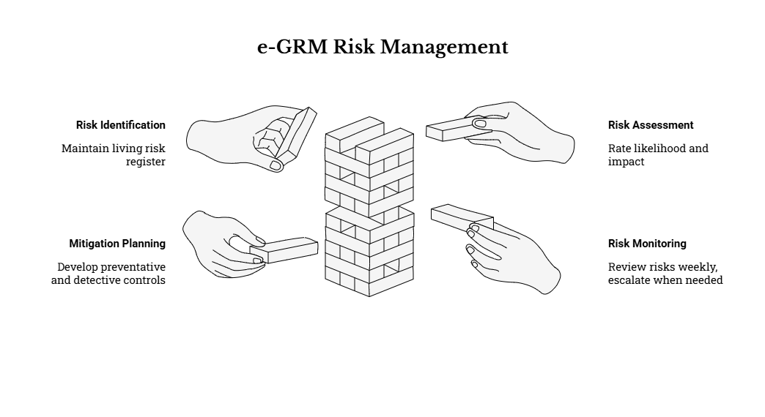

14.1.2 Minimum structure of the risk register
At minimum, the risk register shall be maintained in an Excel-ready format that can be shared and updated collaboratively, and shall include:
- Risk ID and Risk Title
- Risk description (cause → event → consequence), including what “failure” looks like in operational terms
- Category (technical, stakeholder, governance, compliance, schedule, external)
- Likelihood and Impact rating, and an overall Risk Rating
- Mitigation measures (preventative and detective controls), with actions, due dates, and responsible parties
- Contingency measures (what will be done if the risk materializes)
- Risk Owner (NPCT / Supplier / County partners / joint / third party, as applicable)
- Status (e.g., Open / In progress / Mitigated / Closed) and review date/notes

14.1.3 Risk rating approach and review discipline
- The Supplier shall apply a consistent likelihood/impact assessment approach (e.g., Low/Medium/High for each dimension), combining these into an overall rating (e.g., High/Moderate/Low) to support prioritization and escalation decisions.
- High-rated risks shall have explicit contingency plans and measurable early-warning indicators, and shall be reviewed as standing agenda items in weekly meetings until materially reduced.

14.1.4 Relationship to issue management and change control
- The Supplier shall maintain a clear distinction between:
  - Risks (potential future events), and
  - Issues (risks that have already materialized or current blockers),
while ensuring traceability between the risk register, issue log, and decision log.
- Material scope/configuration changes arising from risk responses shall follow the agreed change control and configuration management approach (including versioning and rollback where applicable).

14.2 Mitigation Measures and Owners
Key risks already identified for the e-GRM initiative include (non-exhaustive):

14.2.1. Role clarity and process ownership across national/county/municipal levels
Risk description and impact: Unclear ownership for triage, assignment, investigation, escalation, approvals, and closure can cause workflow stalling, inconsistent handling across counties/municipalities, and failure to meet grievance response timelines and reporting expectations.
Minimum mitigation measures:
- Conduct an early RACI workshop (NPCT + CPCTs + municipal GRM focal points) to confirm who does what at each stage of the grievance lifecycle, including escalations and appeals, and to agree a practical escalation hierarchy that reflects KUSP2 operational realities.
- Translate agreed roles into system configuration: queue/routing logic by geography and category, role-based permissions, approval steps (where required), and escalation triggers that route to the correct level when timelines are breached.
- Produce and validate Standard Operating Procedures (SOPs) and user job aids aligned to the configured workflows, ensuring users understand both the process and the system steps.
Indicative owner(s): Client (process ownership) with Supplier responsible for translating the agreed process into configuration and training outputs.
Early warning indicators / triggers:
- High rates of reassignment, large volumes in “unassigned” queues, repeated status churn, or growing overdue backlog in early pilot/UAT.
- Counties/municipalities reporting uncertainty about who is accountable for closure or escalation decisions.

14.2.2. Dependence on telecom services for toll-free hotline and SMS/USSD channels (approvals and lead times)
Risk description and impact: Delays in securing short codes/toll-free arrangements or unreliable telecom performance can reduce accessibility, cause missed acknowledgements/notifications, and weaken public trust in the system at go-live.
Minimum mitigation measures:
- Treat telecom readiness as a managed dependency in the risk register and implementation plan, with clear assumptions and decision points (e.g., “If USSD is not ready by [milestone], proceed with web + assisted intake and add USSD as a controlled enhancement.”).
- Implement channel integrations with fallback paths, including:
  - assisted intake workflows to ensure grievances can still be captured into the unified register;
  - alternate notification channels where consent allows (e.g., email if SMS fails); and
  - explicit tracking of delivery failures in logs/monitoring to avoid “silent failures.”
- Ensure telecom integrations comply with applicable requirements for secure handling of phone numbers and compliant messaging, recognizing that commercial/regulatory arrangements are Client-led while technical integration is Supplier-led.
Indicative owner(s): Client (commercial/regulatory arrangements) and Supplier (technical integration and monitoring).
Early warning indicators / triggers:
- Short code/toll-free parameters not available by the agreed integration build window.
- High SMS delivery failure rates in staging/pilot testing; network-specific failures during field testing.

14.2.3. Data protection and privacy compliance risks, including sensitive grievances and breach risk
Risk description and impact: Non-compliance or a privacy breach can create legal and reputational consequences and may expose complainants—particularly for sensitive cases—undermining uptake and trust.
Minimum mitigation measures:
- Implement privacy-by-design controls: consent capture, data minimization, role-based access control, secure storage/transmission, audit logging, and retention/archiving controls as configured features (not “policy-only” commitments).
- Ensure sensitive grievance types (including SEA/SH) have restricted workflows, safe communications, and controlled visibility so downstream handling does not inadvertently expose identities or sensitive details.
- Provide compliance evidence artifacts during Phase 2 (e.g., access control matrix, audit log export samples, security configuration summary, and documented data flows).
- Establish incident response readiness for security/privacy events, including contacts, decision rights, and containment steps aligned with Client obligations and agreed procedures.
Indicative owner(s): Supplier (controls and evidence) and Client (governance and oversight).
Early warning indicators / triggers:
- Audit logs show inappropriate access attempts, excessive privileged activity, or repeated permission exceptions.
- Users request access outside their role due to unclear role design or operational pressure (a sign of misconfigured RBAC and/or unclear process).

14.2.4. Stakeholder adoption and inclusion risks (low uptake, exclusion of vulnerable groups, capacity gaps at local level)
Risk description and impact: Low adoption or uneven adoption across counties/municipalities leads to continued parallel/manual registers, poor data quality, weak reporting, and persistent barriers for vulnerable groups (including persons with disabilities or those without smartphones/internet).
Minimum mitigation measures:
- Deliver strong change management within the three-month window: role-based training, practical job aids, and supervised early usage during pilot/hypercare to build confidence and correct errors early.
- Support inclusion through:
  - multi-channel access (including assisted intake);
  - low-bandwidth design; and
  - accessible user interfaces and testing evidence (involving users with disabilities where feasible).
- Monitor operational adoption indicators through dashboards (e.g., logins, queue volumes, backlog/overdue rates, data completeness error rates) and use these as triggers for targeted refresher training and support.
Indicative owner(s): Joint responsibility (Client + Supplier).
Early warning indicators / triggers:
- Low grievance capture volumes despite active outreach, low login rates, or persistent use of informal/manual registers.
- High rates of incomplete intake fields, misclassification, or repeated reopening of cases due to weak documentation.

14.2.5. Integration and reliability risks (channel integrations, performance under load)
Risk description and impact: Integration failures (email/SMS/USSD/hotline, web embedding) and poor performance (especially search and reporting) can block day-to-day operations and undermine trust in the unified system of record.
Minimum mitigation measures:
- Design and test integrations in staging with defined end-to-end scenarios before pilot/UAT; include monitoring for delivery failures and clear operational procedures for retries and exception handling.
- Execute proportionate performance testing focused on reporting and search, and prioritize remediation of bottlenecks before go-live; use phased rollout (pilot) to manage reliability risk in a controlled manner.
- Maintain operational readiness controls (backup/restore, monitoring, and configuration snapshots) as part of go-live readiness and hypercare planning.
Indicative owner(s): Supplier (technical delivery) with NPCT ICT oversight/coordination where applicable.
Early warning indicators / triggers:
- Recurrent integration errors, high failure rates for notifications, or unacceptable report generation times during UAT/pilot.
- Increased downtime or instability during pilot as volume and concurrency increase.

14.2.6. Political or governance changes affecting continuity and resourcing
Risk description and impact: Leadership transitions or shifting priorities at national/county levels may reduce buy-in, delay decisions, or weaken resourcing for GRM operations; interference risk can undermine credibility of the grievance process and discourage use.
Minimum mitigation measures:
- Embed e-GRM oversight in programme governance and maintain a clear line of sight from operational metrics (volumes, timeliness, overdue rates) to accountability, enabling issues to be escalated beyond individual offices when necessary.
- Sustain stakeholder engagement through transparent, aggregate reporting and clear public guidance on channels and non-retaliation/ confidentiality principles (within legal and policy limits).
- Ensure continuity through documentation, structured handover, and super-user capacity building so knowledge survives staff turnover.
Indicative owner(s): Client leadership structures (SDHUD/NPCT) with support from counties and programme governance partners, and Supplier support for adoption/enablement activities where requested.
Early warning indicators / triggers:
- Delayed approvals at key gates (Implementation Plan, UAT sign-off, go-live readiness).
- Loss of designated focal persons or prolonged vacancies in key operational roles.

14.3 Contingency and Escalation Protocols
The Supplier shall define practical, time-bound escalation thresholds and continuity procedures, recognizing the compressed three-month delivery window and the operational criticality of grievance records. At minimum, the following shall be defined and agreed during mobilization and refined through implementation:

14.3.1 Escalation thresholds
Escalation thresholds shall be specific enough to trigger action early, including:
- Schedule / milestone slippage thresholds (e.g., any critical-path activity forecast to slip beyond the tolerance agreed in the Implementation Plan; failure to meet sprint exit criteria; delayed readiness of environments/integration parameters).
- Quality thresholds (e.g., repeated failure of end-to-end workflow scenarios in demos/UAT; unacceptable defect backlog; inability to produce agreed reporting outputs).
- Security/privacy thresholds (e.g., suspected unauthorized access, evidence of misconfigured permissions, or any incident with potential personal data exposure), triggering immediate incident response and Client notification per agreed procedures.

14.3.2 Fallback procedures for channel unavailability
The Supplier shall define channel fallback procedures that preserve a single unified grievance register and avoid “off-system” handling, including:
- If SMS/USSD is delayed or experiences sustained outages, proceed with:
  - web portal intake (where available),
  - staff-assisted intake at municipal/county level, and
  - alternative acknowledgements/notifications (e.g., email or phone) where consent allows,
while ensuring all grievances are registered and tracked consistently in the e-GRM system.
- If the toll-free hotline is delayed, implement interim phone intake scripts and staff-assisted entry processes, ensuring call notes are captured in the grievance record and linked to the reference number.

14.3.3 Manual continuity procedures for system downtime
The Supplier shall define a practical continuity procedure for temporary downtime, including:
- Use of a temporary manual intake template (paper or spreadsheet) capturing the minimum standardized intake fields required for later entry.
- A controlled method for assigning temporary reference numbers (or holding references) during downtime and reconciling them once service is restored.
- A back-entry procedure (including QA checks) to ensure grievances received during downtime are entered into the system promptly and are not lost or duplicated.
- Clear instructions on what can/cannot be recorded offline for sensitive grievances to preserve confidentiality and reduce risk.

14.3.4 Contingency actions for critical risks
For high-rated risks, the Supplier shall document contingency actions that can be executed rapidly, such as:
- Phased rollout (pilot in selected municipalities first, then expand) to manage reliability and adoption risks while maintaining delivery confidence.
- Scope sequencing within Phase 2 that protects Must requirements and compliance controls if external dependencies delay some channels, without losing the “single system of record” objective.

14.3.5 Escalation pathways and decision rights
The Supplier shall document and agree:
- the escalation pathway from working team → NPCT focal points → management/steering level (as applicable);
- decision rights for go/no-go items (e.g., channel enablement decisions, conditional go-live decisions with residual risk plans, and security incident containment measures); and
- communication protocols for urgent incidents and major risks requiring rapid Client input.

15. SECURITY, PRIVACY & DATA MANAGEMENT
This section sets the minimum security, privacy, and data management requirements that the Supplier shall implement during Phase 2. Controls shall be proportionate to risk, consistent with privacy-by-design, and aligned to the approved Phase 1 compliance/risk inputs and the standardized intake/data collection requirements. The Supplier shall implement controls in a way that supports decentralized operations (national, county, and municipal users) while protecting complainants, preventing unauthorized access, and ensuring auditability and lawful processing of personal data.
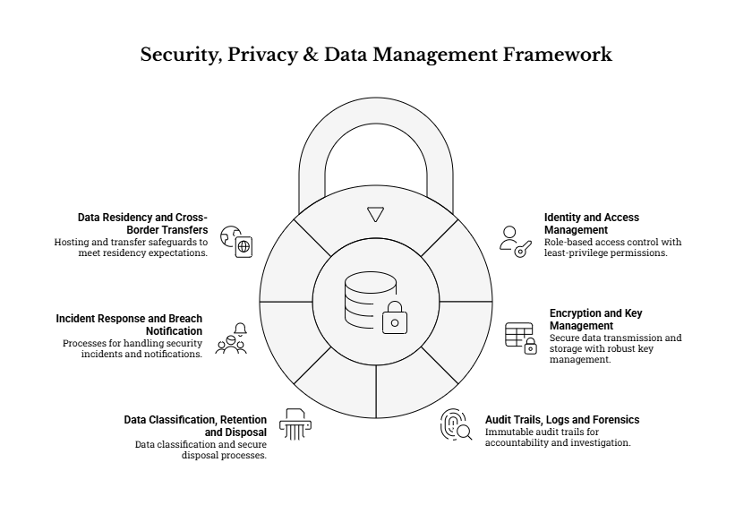

15.1 Identity and Access Management
The Supplier shall implement role-based access control (RBAC) with least-privilege permissions for national, county and municipal users. The Supplier shall support segregation of duties and restricted access for sensitive grievances. The Supplier shall implement strong authentication and session controls and account lifecycle management (create, modify, disable).
To operationalize the above, the Supplier shall, at minimum:
a) RBAC model, scope, and segregation of duties
- Implement a hierarchical but configurable access model that supports national oversight while limiting routine access to only the grievances and functions required by each user role (e.g., municipal handler, county supervisor, NPCT administrator, reporting-only user).
- Separate privileged administration functions from day-to-day grievance handling functions, including (at minimum):
  - User/role administration
  - Configuration management (forms, workflows, templates, escalation rules)
  - Audit log access and export
  - Security settings (MFA enforcement, IP restrictions, retention settings)
- Support segregation of duties for sensitive actions, where feasible, such as:
  - User provisioning vs. approval of privileged roles
  - Configuration change vs. configuration approval (or at minimum, configuration change logging plus Client review)
  - Case resolution vs. final closure approval for selected categories (where the GRM process requires supervisory closure).
b) Role and record-level access controls
- Implement record-level controls that allow the Client to restrict grievance visibility and permissible actions based on parameters such as: location (county/municipality), category/help topic, assigned unit/team, escalation level, and sensitivity flags.
- Provide field-level or section-level restrictions where required (e.g., mask or hide complainant identifiers and contact details from users who only need to see the issue details and resolution tasks).
- Ensure attachments inherit the grievance’s access controls and cannot be accessed via “direct link” without authorization.
c) Sensitive grievance handling (“need-to-know” controls)
- Implement restricted queues/workflows for sensitive grievances (including SEA/SH) with:
  - Limited visibility to explicitly authorized roles (designated focal persons and authorized supervisors)
  - Suppression or redaction of notifications that could inadvertently expose sensitive information
  - Additional access logging (including “view” events) and controlled export permissions
  - Optional “break-glass” access where the Client approves such a feature, with mandatory justification capture and heightened logging.
d) Authentication, session security, and hardening
- Enforce unique user accounts for all staff users; shared accounts shall not be permitted.
- Implement password policy controls (minimum length, complexity, reuse prevention, expiry policy if required by Client standards) and secure password reset processes.
- Support multi-factor authentication (MFA) for administrative and other high-privilege roles, and provide the Client the ability to mandate MFA for all staff roles if desired.
- Implement session controls including idle timeout, absolute session lifetime, secure cookie/token handling, protection against session fixation, and automatic logout on role removal/disablement.
- Support account lockout / throttling for repeated failed login attempts and provide visibility of failed authentication events in system/security logs.
- Where requested by the Client, support additional access restrictions such as IP allowlisting for staff and/or administrative interfaces.
e) Account lifecycle management and access governance
- Provide controlled workflows or administrative procedures for user onboarding, role assignment, changes, and offboarding, including:
  - Defined authorization steps for granting privileged roles
  - Rapid disablement procedures for departing staff or reassigned roles
  - Periodic access review support (e.g., export of current users/roles for quarterly review by NPCT/CPCT)
- Log all access-control and privilege changes (create/modify/disable accounts; role assignments; permission changes).

15.2 Encryption and Key Management
Encrypt data in transit using secure protocols. Encrypt stored data and sensitive attachments as appropriate; define key management approach.
The Supplier shall, at minimum:
a) Data in transit
- Enforce secure transport (e.g., HTTPS/TLS) for all web-based access (public portal, staff console, administrative interfaces, and APIs).
- Ensure secure configurations for integrations (email gateways, SMS/USSD aggregators, hotline/call-center tools where applicable), including authentication, integrity protection, and avoidance of transmitting sensitive details over insecure channels.
- Ensure notifications sent via SMS/USSD or email are privacy-aware by design, and do not include unnecessary personal data or sensitive grievance content (use reference numbers and minimal status messaging).
b) Data at rest
- Encrypt databases and file storage used to store grievance records and attachments, using encryption aligned to the hosting environment capabilities and risk level.
- Apply stronger protection for particularly sensitive attachments where feasible (e.g., encryption plus strict access controls plus restricted export).
- Ensure backups are encrypted and protected to the same (or higher) standard as production data.
c) Key management and secrets handling
- Define and document a key management approach that covers: generation, storage, access controls, rotation, revocation, and recovery.
- Restrict key access to the minimum administrative roles required, with audit logging of key-related administrative actions where supported by the platform.
- Store credentials and secrets (API keys, database credentials, gateway credentials) in secure secret storage mechanisms appropriate to the chosen hosting model, and avoid hard-coding secrets in configuration files or source code.
- Provide procedures for secure handover of credentials and secrets to the Client at go-live/handover, including a controlled method for credential rotation post-handover.

15.3 Audit Trails, Logs and Forensics
Immutable audit trail for key actions (create, view, edit, status change, assignment, communication). Administrative access logging and configuration change logging. Log retention and access procedures to support audits and investigations, consistent with privacy obligations.
The Supplier shall implement logging and auditability that is sufficient for oversight, accountability, and investigation of misuse while respecting data protection principles.
Minimum requirements include:
a) Audit trail scope (what must be captured)
- Record auditable events for the full grievance lifecycle, including (at minimum):
  - Creation of grievances (by any channel)
  - Viewing/accessing a grievance record (especially for sensitive grievances)
  - Edits to core grievance fields (category, location, priority, due date, complainant info)
  - Status transitions (including reopen/appeal/escalation events)
  - Assignment/reassignment and routing rule actions
  - Creation/updates/completion of tasks linked to grievances (where implemented)
  - Outbound and inbound communications logged against the case (with channel metadata)
  - Attachment upload/download/view events (as feasible)
- Record administrative events including: user creation/disablement; role assignment changes; permission changes; configuration changes to workflows/forms/templates; integration configuration changes; changes to retention/archiving settings; and enabling/disabling security controls such as MFA.

b) Audit record attributes and integrity controls
- Each audit record shall include: actor identity, timestamp, action type, object/reference, and source context (e.g., IP address/device/session ID where feasible).
- Implement controls to protect audit integrity (e.g., write-once/append-only configurations where possible; restricted delete permissions; administrative deletion—if permitted—must be itself auditable).
- Ensure consistent time synchronization (system clocks) to support reliable correlation of events during audits and investigations.

c) Log access, retention, and privacy
- Restrict access to audit logs and security logs to explicitly authorized roles and ensure access itself is logged.
- Implement log retention settings aligned to the agreed policy and practical audit needs, with the ability to export logs for authorized internal reviews or lawful external requests.
- Minimize exposure of personal data in logs (e.g., avoid logging full grievance narrative text in system error logs; avoid placing contact details in unprotected logs).
d) Forensic readiness
- Provide procedures for evidence preservation and export for investigation (e.g., how to export a complete case file, audit history, and relevant logs while maintaining confidentiality).
- Support the Client’s escalation and investigation workflows, including secure packaging of case files for authorized reviewers, and maintaining traceability of who exported what and when.

15.4 Data Classification, Retention and Disposal
The Supplier shall classify data according to sensitivity (personal data, sensitive grievance types, system metadata). The Supplier shall implement retention and disposal/anonymization rules for closed grievances in line with agreed policy and legal obligations. The Supplier shall provide administrative tools to support data subject requests (access, correction) and lawful deletion/anonymization where applicable.
Minimum requirements include:
a) Data classification model
- Propose a practical classification scheme for e-GRM data, such as:
  - Public content (e.g., FAQs/process pages)
  - Operational content (case workflow metadata)
  - Personal data (complainant identifiers/contact details)
  - Sensitive grievance content (e.g., SEA/SH, integrity allegations, or other categories designated by the Client)
  - System/security metadata (audit logs, security events)
- Apply classification through system configuration and access controls (e.g., restrict export fields, restrict visibility of contact details, isolate sensitive categories in restricted queues).
b) Retention and archiving
- Implement configurable retention and archiving rules for:
  - Closed grievance records
  - Attachments and supporting evidence
  - Communications logs
  - Audit logs and system/security logs
- Retention settings shall be aligned to the agreed policy and legal requirements, with the ability to implement different retention periods by grievance category/type if required (e.g., longer retention for audit-relevant categories, more restricted handling for sensitive categories).
- Provide an “archive” state that preserves integrity and auditability while reducing routine visibility and operational load.
c) Disposal and anonymization
- Implement controlled disposal processes at the end of retention periods, including:
  - Secure deletion or anonymization of personal data (as legally appropriate)
  - Controlled deletion of attachments, including ensuring that deleted files are not accessible via URLs or cached links
  - Clear administrative permissions and logging for disposal actions
- Ensure disposal procedures address backups appropriately (e.g., define how deleted/anonymized records are handled in backup retention cycles).
d) Data subject rights and lawful requests
- Provide administrative capabilities and documented procedures to support data subject requests and lawful requests, including:
  - Access and correction of personal data (where identity is verifiable)
  - Export of an individual case file for internal review or lawful external requests, subject to permissions and redaction rules
  - Where applicable, lawful deletion/anonymization workflows that preserve audit trails of the action taken (without retaining unnecessary personal data)
- Define how requests will be handled for anonymous grievances (e.g., where identity cannot be verified, the system should still allow management of the grievance without collecting additional personal data).
e) Data quality and minimization
- Reinforce data minimization by ensuring only necessary fields are collected for each channel and grievance type, and by limiting free-text capture for sensitive categories where agreed protocols require minimal data capture.
- Implement validation rules, controlled vocabularies (reference data lists), and completeness checks in line with the standardized intake form to reduce inaccurate or incomplete records and to support consistent reporting.

15.5 Incident Response and Breach Notification
The Supplier shall define and document an incident response process, including containment, eradication, recovery and lessons learned. The Supplier shall support Client obligations for notification and reporting in the event of a reportable personal data breach.
Minimum requirements include:
a) Incident response process and governance
- Define incident categories and severity levels (e.g., availability incident, suspected unauthorized access, confirmed personal data breach, integration compromise, malware/attachment-related incident).
- Establish an escalation path and points of contact during hypercare and any warranty/support period, including a clear process for reporting suspected incidents to the Client without delay.
- Document incident handling steps: detection, triage, containment, eradication, recovery, and post-incident review.
b) Evidence preservation and communications
- Ensure incident procedures include evidence preservation measures (relevant logs, audit records, configuration snapshots) in a manner consistent with privacy obligations and confidentiality requirements.
- Provide incident communication templates and decision-support information (what happened, what data may be affected, actions taken, residual risk, recommended next steps), suitable for Client governance and any regulatory reporting requirements.
c) Breach notification support
- Support the Client in assessing whether an incident is reportable and in preparing the information needed for any required notifications.
- Ensure the solution’s logging and audit capabilities can produce timely evidence for breach assessment (scope, affected records, time window, users/actions involved).
d) Testing and readiness
- During Phase 2 (preferably prior to go-live or during hypercare), conduct at least one incident response readiness exercise (e.g., tabletop simulation) with NPCT technical and GRM leads to validate contacts, escalation, and evidence capture procedures.

15.6 Data Residency and Cross-Border Transfers
The Supplier shall propose a hosting approach that meets data residency expectations and avoids unauthorized cross-border transfers of personal data. Where any cross-border processing is proposed, the Supplier shall describe safeguards and approvals required.
Minimum requirements include:
a) Hosting and residency controls
- Clearly document where production data (including databases, attachments, backups, and logs) will be hosted and processed, and ensure this location is approved by the Client and consistent with applicable Kenya requirements.
- Ensure that monitoring, support tooling, and third-party services (including email/SMS/USSD gateways) do not inadvertently replicate or store personal data in unapproved locations without Client approval.

b) Cross-border access and support safeguards
- Where Supplier support resources are outside Kenya or where remote access is required, implement safeguards such as:
  - Restricted and time-bound privileged access
  - MFA for privileged sessions
  - VPN or secure administrative access methods
  - Full logging of privileged access sessions and actions
  - Explicit Client authorization for any exceptional access to sensitive grievance categories
- Maintain a register of subprocessors and third-party services that may process grievance-related data, with a description of what data is processed, where, and under what protections.
c) Data transfer approvals and contractual safeguards
- If any cross-border transfer/processing is necessary, the Supplier shall identify:
  - The lawful basis and required approvals
  - The technical safeguards (encryption, minimization, access controls)
  - The contractual safeguards with third parties (data processing terms, confidentiality, breach reporting obligations)
  - How the Client retains practical control and auditability over these arrangements.

16. INTEROPERABILITY & INTEGRATION

16.1 Integration with KUSP2 Website and Channels
The Supplier shall embed or link the grievance submission interface within the KUSP2 web presence as directed by the Client. The Supplier shall provide public-facing status tracking functionality based on grievance reference number where required, without exposing personal data.
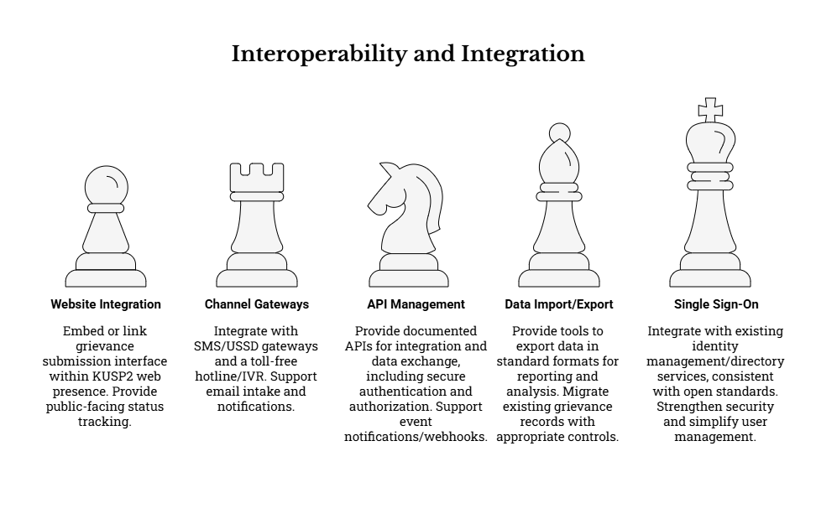
To ensure a coherent user experience and reduce access barriers, the Supplier shall design the web integration so that the e-GRM is reachable through clear, low-friction user journeys from the KUSP2 website and related online channels. The integration approach shall be technology-neutral but must support common implementation patterns such as:
- Embedded experience (e.g., embedded form or secure frame) to allow grievance submission without leaving the KUSP2 web domain, where feasible and approved by the Client.
- Linked experience (e.g., a prominent “Submit a Grievance” button/URL redirect) where embedding is not feasible due to security, hosting, or governance constraints.
- Mobile-first navigation, ensuring the grievance submission and status tracking pages render correctly on smartphones and low-end devices commonly used by the public.
The Supplier shall ensure that the KUSP2 website integration supports, at minimum, the following functional and operational expectations:
- Public-facing pages and content alignment
  - Clear entry points for: (i) submitting a grievance, (ii) tracking a grievance, and (iii) accessing guidance/FAQs on how the GRM works.
  - Consistent branding and trusted identity cues (programme name, official logos, and consistent styling), subject to Client brand guidance.
  - A configurable “service offline/maintenance” notice and alternative channels (e.g., hotline, in-person, email) when the portal is unavailable.
- Public status tracking with privacy protection
  - Status tracking shall be based on the unique grievance reference number and a secondary verifier (e.g., email address, phone number, or another agreed identifier), to prevent unauthorized disclosure.
  - The public tracking view shall display only the minimum necessary information to be useful (e.g., current status, date last updated, next step guidance), and shall not expose staff names, internal notes, sensitive categories, or personal identifiers.
  - Where a grievance is marked confidential or sensitive (e.g., SEA/SH), the public status view shall be appropriately restricted/redacted, and the portal shall provide safe guidance on follow-up without revealing sensitive details.
- Secure web integration controls
  - All web integrations shall enforce secure transport (HTTPS/TLS), prevent unintended cross-site data leakage, and follow safe embedding/linking practices (e.g., protection against clickjacking and unsafe third-party script dependencies).
  - Where the e-GRM is embedded, the Supplier shall align with the Client’s security posture for embedding permissions (e.g., allowed domains) and ensure no insecure mixed-content behavior is introduced.
- Accessibility and language in the integrated web journey
  - Web journeys originating from the KUSP2 website shall maintain accessible navigation, readable content, and clear error messages.
  - User-facing pages shall support, at minimum, English and Kiswahili, with a mechanism to extend to additional languages if directed by the Client.

16.2 Telephony/USSD/IVR/SMS/Email Gateways
The Supplier shall integrate with SMS/USSD gateways and a toll-free hotline/IVR as available, ensuring unified grievance registration and consistent acknowledgements. The Supplier shall support email intake and email notifications with proper logging and confidentiality controls. The Supplier shall ensure integrations are testable across mobile networks and include monitoring for delivery failures.
To operationalize multi-channel access while maintaining one authoritative “system of record,” the Supplier shall implement channel integrations so that all enabled channels (digital or assisted) result in:
- Creation (or update) of a grievance record in a single unified register;
- Assignment of a unique reference number at registration, used consistently across all follow-up communications; and
- A complete channel activity trail (timestamps, message/call metadata where applicable, delivery outcomes, and audit logs), subject to role-based access controls.
Minimum requirements by channel include:
- SMS (notifications and, where enabled, intake/supporting messages)
  - Support outbound acknowledgements and status notifications via SMS where the complainant has provided a phone number and consented to SMS contact.
  - Ensure SMS templates are privacy-aware and do not include sensitive grievance content; messages should generally include only the reference number, high-level status, and next steps.
  - Support delivery reporting (where supported by the gateway) and implement retry/queue mechanisms for transient failures, with clear operational visibility of failed deliveries.
- USSD (where enabled by Client arrangements)
  - Implement USSD flows that are short and structured, recognizing session time limits and user constraints on feature phones.
  - Capture the minimum dataset required for registration (as defined in the standardized intake requirements), while enabling follow-up through assisted channels when deeper details are required.
  - Provide multilingual prompts (English/Kiswahili at minimum) and clear confirmation of successful submission, including the reference number.
- Toll-free hotline and IVR (where enabled by Client arrangements)
  - Support staff-assisted intake through an operator/call handler interface where call agents record grievances directly into the e-GRM (or via an integrated call centre tool where available).
  - Where integration with telephony systems is feasible, capture call metadata (e.g., time, agent identifier, call disposition) linked to the grievance record; avoid storing unnecessary call content beyond what is required for handling.
  - Ensure callers can receive the reference number verbally during the call and optionally via SMS where consent and capability exist.
- Email intake and email notifications
  - Support outbound notifications by email using approved sender identities and controlled templates (including English/Kiswahili variants as required).
  - Where enabled, support inbound email processing to (i) create new grievances from designated inboxes and/or (ii) append messages to existing grievances using reference numbers or routing rules.
  - Implement safeguards for email processing such as spam handling, attachment controls, and prevention of accidental disclosure in email threads (e.g., careful handling of CC/BCC, controlled forwarding rules, and protection of sensitive data).
Across all channel integrations, the Supplier shall:
- Align dependencies and responsibilities: recognize that regulatory/commercial arrangements (e.g., USSD short codes, toll-free provisioning, SMS bundles) are Client-led, while the Supplier provides technical integration and testing support.
- Provide end-to-end testing and monitoring: implement test plans and monitoring checks for channel reliability (message delivery, queue backlogs, gateway timeouts, email bounces), and provide an operational approach for resolving failures.
- Define continuity fallback procedures: where a channel is delayed or unavailable, ensure alternative intake routes remain operational and that grievances can still be registered and tracked in the unified register (including manual-assisted entry where required).

16.3 API Management and Webhooks
The Supplier shall provide documented APIs for integration and data exchange, including secure authentication and authorization. The Supplier shall support event notifications/webhooks as needed for integrations (e.g., dashboards, external reporting).
To enable interoperability with present and future systems (including reporting platforms and approved government digital services), the Supplier shall provide integration interfaces designed around open standards and secure governance controls, including:
- Documented APIs (minimum expectations)
  - Provide clear API documentation describing endpoints, request/response schemas, authentication methods, error codes, and versioning approach.
  - Support common integration use cases such as: creation of a grievance record from an external channel, status updates, retrieval of summarized case data for dashboards, and controlled export of aggregated data for programme reporting.
  - Ensure API responses and exports can be governed to prevent disclosure of personal or sensitive data unless explicitly authorized.
- Security, authorization, and governance controls
  - Use secure authentication mechanisms (e.g., API keys/tokens and/or other standards-based methods) and enforce authorization boundaries consistent with role-based access control and least privilege.
  - Support controls such as IP allowlisting (where applicable), rate limiting, and logging of API access for auditability.
  - Ensure integrations can be enabled/disabled without redevelopment, to support operational risk management and incident response.
- Webhooks / event notifications (where required)
  - Provide a webhook mechanism for defined events such as: grievance created, assigned, escalated, overdue, resolved/closed, and key workflow transitions (as agreed with the Client).
  - Implement webhook delivery reliability features (e.g., retries, failure visibility, and protection against duplicate events through idempotent design).
  - Secure webhook payloads (e.g., signed payloads/secret validation) and ensure webhook outputs are privacy-aware and minimize sensitive data.
- Integration readiness support
  - Provide a “sandbox” or test configuration for integrations, where feasible, to allow Client or third parties to validate connectivity and payloads without affecting production data.
  - Provide integration runbooks that define who monitors what, how failures are detected, and how issues are escalated during hypercare and warranty.

16.4 Data Import/Export and ETL
The Supplier shall provide tools to export data in standard formats for reporting and analysis. Where the Client requires migration of existing grievance records, propose an approach to import historical data with appropriate data quality and privacy controls.
To support programme reporting, audits, and continuity of operations, the Supplier shall implement robust, practical data exchange mechanisms, including:
- Exports for reporting and oversight
  - Provide on-demand and scheduled exports in common, non-proprietary formats (e.g., CSV, spreadsheet-compatible formats, and PDF for printable outputs) consistent with reporting requirements.
  - Support both operational exports (for case management and supervision) and aggregate/anonymized outputs (for wider reporting and disclosure where permitted), with role-based restrictions and audit logging of exports.
  - Support export of a complete case file (where permitted) including key metadata, action history, communication logs, and attachments (or secure references), for internal reviews or lawful external requests.
- Data quality controls for exports
  - Ensure exports use consistent field definitions aligned to the standardized intake dataset and data dictionary.
  - Include consistent timestamps/time zones and stable identifiers to support trend analysis and reconciliation.
- Historical data migration (where required by the Client)
  - Propose a structured migration approach covering: (i) mapping legacy fields to the standardized dataset, (ii) data cleansing rules, (iii) de-duplication logic, (iv) validation checks, and (v) secure handling of sensitive records.
  - Provide import templates and procedures suitable for typical legacy sources (e.g., spreadsheets, registers transcribed into electronic form), including controlled handling of attachments/evidence where available.
  - Ensure that any migrated data is flagged as migrated, retains traceability to its source where appropriate, and is subject to the same access controls and audit requirements as newly created records.
- ETL and downstream analytics enablement (where required)
  - Where the Client requires automated extraction into external reporting tools, define an ETL approach that supports incremental updates and stable reporting datasets while preserving privacy-by-design controls (e.g., separating PII from operational analytics datasets where appropriate).
  - Ensure any automated data transfers are logged, governed, and can be paused if required by the Client (e.g., during incidents or audits).

16.5 Single Sign-On and Directory Services
If the Client requires integration with existing identity management/directory services, the Supplier shall propose an approach consistent with open standards.
To strengthen security, simplify user management, and support sustainable operations, the Supplier shall be prepared to integrate the e-GRM with Client-approved identity services where available. The Supplier’s approach shall remain technology-neutral and standards-based, and shall include:
- Standards-based SSO options
  - Support common open standards (e.g., SAML 2.0 and/or OpenID Connect) where required by the Client’s identity environment.
  - Ensure SSO integration does not compromise the required role-based access controls; authentication (SSO) and authorization (roles/permissions) must remain clearly governed.
- Account lifecycle and access governance
  - Support onboarding, role assignment, and de-provisioning workflows aligned to government operational practices, including timely disabling of accounts for staff transfers or departures.
  - Provide mechanisms for emergency access management (e.g., break-glass admin access) under strict audit controls, if agreed by the Client.
- Role mapping and least-privilege implementation
  - Define how directory groups/attributes (where used) map to e-GRM roles (national/county/municipal) and any additional scoping rules (e.g., a county user sees only their county’s cases).
  - Ensure segregation of duties is supported (e.g., separation of administration, case handling, and reporting roles).
- Fallback authentication (where needed)
  - Where SSO is not available or not approved for all user groups, support a secure fallback approach (e.g., local accounts) with strong authentication controls, session security, and alignment to Client policies (including optional multi-factor authentication for privileged roles).

17. INFRASTRUCTURE & HOSTING
The e-GRM will operate as a national system supporting decentralized use across counties and municipalities. Infrastructure and hosting arrangements must therefore prioritize: (i) reliable public access for grievance submission and status checking, (ii) secure access for authorized staff at national/county/municipal levels, (iii) strong data protection and auditability controls for personal and sensitive grievance data, and (iv) scalability as usage expands. This chapter sets the minimum expectations for the hosting model, environments, resilience, and operational readiness consistent with the ToR’s non-functional requirements and compliance obligations.
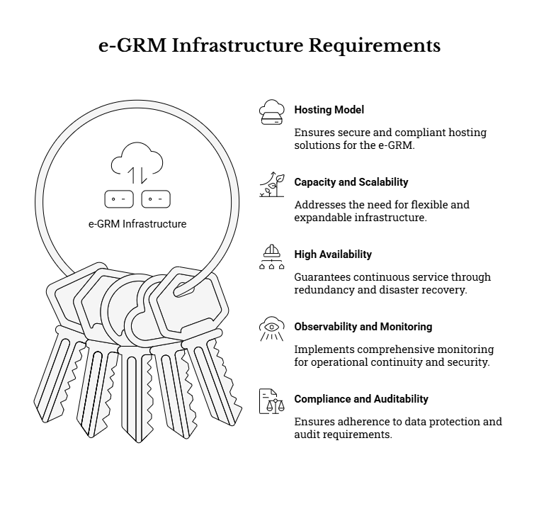

17.1 Hosting Model and Environments
The Supplier shall propose a hosting model that (a) complies with applicable Government of Kenya requirements and Client directions, (b) supports the required environments, and (c) enables secure operations for a public-facing service with sensitive case handling. The hosting model proposal shall clearly state what is provided/managed by the Client versus the Supplier versus any third-party hosting provider.
a) Hosting model options and approval pathway
The Supplier shall present a hosting approach suitable for Government delivery, such as (illustratively) hosting in a government data centre or a government-approved cloud environment, subject to Client approval and data residency expectations. The proposal shall include the decision assumptions, required approvals, and lead times (e.g., for procurement/activation, security reviews, and connectivity).
- The Supplier’s hosting recommendation shall be technology-neutral, but must explicitly address:
  - Data residency and cross-border transfer controls, including how unauthorized cross-border transfers of personal data are prevented or governed.
  - Security-by-design expectations for public sector systems (e.g., strong access control, MFA for privileged users, audit logs).
  - Operational sustainability, including how the Client can administer the environment post-handover and what recurring dependencies exist (licenses, hosting subscriptions, certificates, gateways).
b) Environment structure and separation of duties
The Supplier shall support environments appropriate to a controlled implementation and release process, at minimum including test/staging/production (and development where required). Environments shall be configured to reflect security and stability needs, including:
- Production environment: restricted access, least-privilege administration, strong authentication, hardened configuration, and monitoring enabled by default.
- Staging/pre-production: as close as feasible to production (configuration, integrations, performance characteristics) to support realistic UAT and cutover rehearsals.
- Test: used for functional/regression/integration testing and defect reproduction, with controlled test data.
The Supplier shall define how configuration and releases are promoted between environments, including version control and rollback approach, consistent with change control expectations in the ToR.
c) Data handling rules for non-production environments
To protect complainants, the Supplier shall ensure production personal data is not used in non-production environments unless explicitly authorized by the Client and protected by equivalent controls. Where realistic datasets are needed, the Supplier shall propose anonymized/synthetic test datasets and controlled refresh procedures.
d) Network, domain, and connectivity prerequisites
The Supplier shall identify the practical prerequisites required to operationalize the solution, including (as applicable): DNS and domain naming approach, TLS certificates, inbound/outbound firewall rules, IP allowlists for administrative access, and connectivity requirements to enable channels (email/SMS/USSD/hotline) and integrations. Where government infrastructure readiness is uncertain, the Supplier shall include mitigations and sequencing options to avoid timeline slippage.

17.2 Capacity, Performance and Scalability
The Supplier shall define sizing assumptions and a scalability approach for users, grievance volume, reporting workloads, and attachment storage, and shall demonstrate that performance remains acceptable under expected loads. This includes both (i) day-to-day operational use by staff and (ii) periodic reporting/analytics workloads.
a) Capacity planning assumptions (baseline and growth)
The Supplier shall explicitly document sizing assumptions for the national and decentralized footprint (including growth over time), covering at minimum:
- Number of active staff users (NPCT, county, municipal) and expected concurrent users in peak periods.
- Expected grievance volumes (daily/weekly/monthly), including potential surge scenarios (e.g., during major project works or publicity campaigns).
- Attachment volume and storage growth, including the expected proportion of grievances with attachments and average attachment size.
- Reporting demand, including frequency and complexity of dashboards and exports (especially when filtering across counties/municipalities and long date ranges).
These assumptions should be realistic for a program operating across many jurisdictions (the broader KUSP2 context includes multiple counties and municipalities) and should support scale-up without redesign.
b) Performance expectations (minimum benchmarks)
The Supplier shall ensure responsive performance for core journeys (public intake, staff triage, search, reporting). As a minimum, performance testing and tuning shall be aligned to the BRD’s non-functional expectations, including responsiveness for key pages and timely completion of search/filter operations under expected peak load.
c) Scalability approach (without vendor lock-in)
The Supplier shall describe how the hosting/infrastructure design supports scaling while preserving technology neutrality. This may include, for example:
- Ability to scale application capacity and background processing capacity independently (to handle intake spikes and notification bursts).
- Database/storage scaling approach to maintain search/report performance as data grows.
- Archiving strategy (aligned to the retention policy) to keep operational datasets performant while preserving auditability.
The Supplier shall include how scaling actions are executed (manual vs automated), expected downtime (if any), and the cost implications of scaling events.
d) Low-bandwidth and distributed access considerations
The Supplier shall ensure the solution remains usable and responsive in low-bandwidth contexts, including efficient page payloads, pagination for lists, and optimized reporting queries, consistent with the ToR emphasis on decentralized use and accessibility.

17.3 High Availability and Resilience
The Supplier shall provide redundancy, failover and disaster recovery arrangements appropriate to the criticality of grievance records, and shall define recovery objectives as applicable. High availability must cover not only the core application, but also supporting components (database/storage, integrations, and authentication mechanisms).
a) Availability target and maintenance controls
The Supplier shall propose service availability targets and supporting design. At minimum, availability planning should align with the BRD expectation for high availability for a public service channel, including planned maintenance controls such as an offline/maintenance mode page for the public portal.
b) Redundancy and failover design
The Supplier shall describe how redundancy is achieved at each layer, proportionate to the approved hosting model, including:
- Application/service redundancy (to avoid single points of failure).
- Database resiliency and data integrity protections.
- Attachment storage resiliency.
- Failover approach (automatic vs manual), including any service degradation expectations during failover.
c) Disaster recovery (DR) planning and objectives
The Supplier shall define RTO/RPO targets and the DR approach (e.g., backup-based recovery, secondary site, or equivalent). The DR plan shall include:
- The scope of DR (application + database + attachments + configuration + logs).
- Backup frequency, retention, and protection measures.
- A practical DR test or restore rehearsal approach, proportionate to risk and timeline, to validate that recovery procedures are functional.
The broader design considerations highlight the importance of local hosting or compliant data localization and a DR plan with periodic backups to a secondary location where applicable.
d) Resilience for dependency delays and channel availability
Where channels or hosting prerequisites are subject to external lead times (e.g., in-country hosting readiness, SMS/USSD/hotline arrangements), the Supplier shall propose pragmatic sequencing and fallbacks that preserve a unified system of record (e.g., enabling web and assisted intake first while integration dependencies complete). This aligns with identified implementation risks and mitigations.

17.4 Observability and Monitoring
The Supplier shall implement monitoring across application, database, and integrations, and shall configure alerting for critical failures. Monitoring shall support both operational continuity and compliance needs (e.g., detecting suspicious access patterns, integration delivery failures, or storage saturation).
a) Monitoring scope (minimum)
The monitoring approach shall cover, at minimum:
- Application health: uptime/availability checks, response time/latency, error rates, queue/backlog indicators (where applicable).
- Database health: connectivity, replication status (if used), storage growth, slow queries impacting search/reporting.
- Storage health: attachment storage capacity and access errors.
- Integration health: delivery success/failure rates and latency for enabled channels (email, SMS/USSD, hotline), including monitoring for delivery failures across mobile networks.
b) Logging and operational dashboards
The Supplier shall ensure logs are sufficiently detailed for troubleshooting and incident response while respecting privacy and access controls. Operational dashboards for administrators shall include at least: service status, critical component status, integration status, and alert history. The log approach should support configurable verbosity and retention policies aligned with the BRD.
c) Alerting and escalation
The Supplier shall define alert thresholds and escalation paths consistent with the support model (hypercare/warranty), including:
- Immediate alerts for outages, severe degradation, or data integrity risks.
- Alerts for integration failure spikes (e.g., SMS gateway down, email delivery failures).
- Alerts for security-relevant events (e.g., repeated failed logins, abnormal access attempts), routed to authorized security/admin roles.

17.5 Compliance and Auditability
Hosting and operations shall support auditability and compliance requirements, including access logs, configuration change tracking, and secure backups. The infrastructure design must enable the Client to demonstrate due diligence in protection of personal data and integrity of grievance case handling.
a) Data residency and lawful processing controls
The Supplier shall ensure the hosting approach satisfies Client-approved data residency expectations and supports compliance with Kenya data protection requirements, including controls to prevent unauthorized cross-border transfers and to support local hosting where required. This is a known compliance risk area and must be addressed explicitly in the hosting proposal and as-built documentation.
b) Audit logging and traceability
The Supplier shall ensure auditability at infrastructure and application levels, including:
- Audit logs capturing key actions with actor identity, timestamps, and source information (e.g., IP address) to support investigations and accountability.
- Administrative and privileged action logging (including configuration changes and access to sensitive data areas).
- Time synchronization controls (so audit timestamps are reliable across components).
c) Secure backup handling and evidence of recoverability
The Supplier shall ensure backups are protected (confidentiality, integrity, access control) and auditable. Evidence of backup configuration and at least one successful restore demonstration (as appropriate to the timeline and hosting model) shall be included in implementation evidence packs and the final handover materials.
d) Compliance-ready documentation (“as-built” hosting pack)
The Supplier shall provide documentation sufficient for Client review, operational continuity, and audits. At minimum this should include:
- High-level hosting architecture description (components and responsibilities).
- Environment definitions and access control approach.
- DR/backup plan and restore procedures.
- Monitoring and alerting configuration summary.
- Log retention configuration and audit log export approach.
These artifacts support the broader ToR requirement for compliance readiness evidence and sustainable operation.

18. ETHICS, INCLUSION & SEA/SH

18.1 Code of Conduct and Ethics
Supplier personnel shall adhere to ethical conduct standards, confidentiality obligations, and integrity requirements. Zero tolerance for retaliation or misuse of grievance data; ensure staff handling sensitive grievances are trained on confidentiality.
To operationalize these requirements during Phase 2 implementation and commissioning, the Supplier shall:
- Adopt and enforce a project-specific Code of Conduct (CoC) applicable to all Supplier staff, subcontractors, and any third parties engaged by the Supplier who may access the e-GRM environments, data, or implementation stakeholders. The CoC shall, at minimum, cover:
  - Respectful and non-discriminatory engagement with complainants and stakeholders.
  - Prohibition of retaliation, intimidation, or any action that could deter grievance submission or follow-up.
  - Prohibition of requesting or accepting any fees, gifts, favors, or benefits related to grievance handling or system access.
  - Conflict-of-interest disclosure requirements (including relationships with county/municipal actors, telecom providers, or other connected parties).
  - Confidentiality, privacy and appropriate information sharing (need-to-know only).
  - Mandatory reporting obligations for suspected misuse of grievance data or unethical conduct.
- Ensure CoC onboarding and acknowledgment by:
  - Requiring written acknowledgment/signature of the CoC prior to any system access (including development, staging, or production access).
  - Conducting mandatory induction for all personnel at mobilization and refresher briefings before UAT and go-live when access widens to more users and locations.
  - Maintaining a register of staff who have completed ethics and confidentiality induction, linked to role assignment and access provisioning.
- Embed ethical safeguards into access and delivery practices, including:
  - Separation of duties within the Supplier team (e.g., configuration vs. security review vs. QA sign-off) to reduce the risk of unreviewed changes or inappropriate access.
  - Prohibition of using personal email accounts, personal cloud storage, or unapproved devices for transferring project data, system exports, test datasets, or screenshots.
  - Controlled use of test data: where real grievance data is unavoidable (e.g., for pilot verification), it must be minimized, protected, and handled only in approved environments under Client direction.
- Implement a misconduct reporting and response pathway for Supplier personnel and stakeholders engaged during implementation activities (training, pilots, UAT), including:
  - A clear escalation route to Supplier management and to the Client focal point for any alleged misconduct.
  - Time-bound investigation and corrective action steps proportionate to severity.
  - Documentation of actions taken, while protecting complainant confidentiality and avoiding retaliation.
These measures reinforce the ToR’s requirements for integrity, confidentiality, and responsible handling of grievance information across decentralized operational contexts.
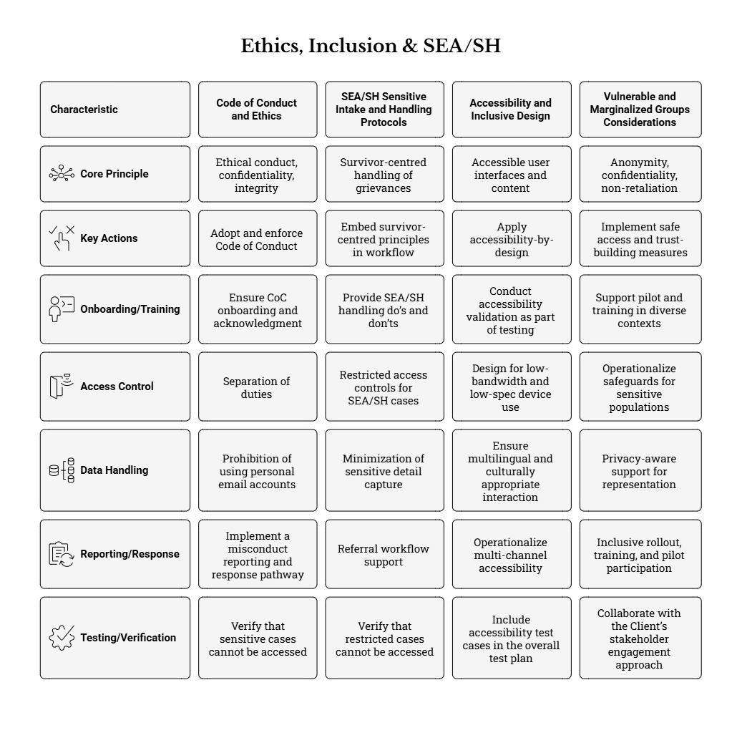

18.2 SEA/SH Sensitive Intake and Handling Protocols
The solution and implementation approach shall support survivor-centred handling of SEA/SH-related grievances. This includes confidential intake options, restricted access, and workflows that enable referral to specialized services while minimizing capture of sensitive details in the system where required by agreed protocols.

To translate this requirement into implementable system controls and operational procedures, the Supplier shall ensure that the e-GRM supports the following minimum SEA/SH-sensitive design and handling features:
- Survivor-centred handling principles embedded in workflow design, including:
  - Safety and confidentiality as primary considerations in intake, processing, and follow-up.
  - Informed consent for any follow-up contact or referral recording (where contact details exist).
  - Non-discrimination and respectful communication standards in all scripts, templates, and staff training.
- Confidential intake options across enabled channels, such that:
  - Public-facing interfaces (web, and any enabled USSD/SMS flows) clearly present a confidential reporting option and explain what information is (and is not) required.
  - Assisted channels (hotline and in-person staff-assisted intake) include a clear intake script to avoid probing questions and to prioritize immediate referral where appropriate.
  - Anonymous submission remains available and does not prevent case logging or referral actions.
- Restricted access controls for SEA/SH and other highly sensitive cases, including:
  - A dedicated “sensitive” classification/flag (e.g., SEA/SH) that automatically applies restricted visibility and routing.
  - A need-to-know access model (e.g., access limited to designated focal persons at municipal/county level and designated NPCT roles), with all access attempts and views recorded in audit logs.
  - Controlled attachments for sensitive cases (e.g., restrict who can upload/view attachments; apply stronger download controls).
- Minimization of sensitive detail capture, ensuring that:
  - The system can record that a SEA/SH-related grievance exists and that a referral or survivor support action has been initiated without requiring detailed narrative in free-text fields.
  - Where structured tracking is needed (e.g., referral date, receiving service provider category, follow-up consent status), these are implemented via controlled fields rather than unstructured notes.
  - Templates and guidance text in the staff console discourage recording unnecessary sensitive details.
- Referral workflow support, including:
  - Ability to route a SEA/SH grievance to a designated focal role/queue for immediate handling.
  - Ability to record referral actions (date/time, referral type, high-level outcome status) without exposing sensitive content broadly.
  - Configuration of closure/referred statuses aligned to agreed procedures (e.g., “Referred to service provider” / “Closed—Referral completed”), while maintaining auditability.
- Notification and communication safeguards, ensuring that:
  - Automated notifications for sensitive cases are either disabled by default or strictly controlled to avoid disclosure through insecure channels.
  - Any outbound messages (SMS/email) contain only the minimum necessary information (e.g., reference number and generic next steps) and avoid sensitive content.
  - Internal notifications are restricted to authorized roles only.
- Testing and readiness evidence for SEA/SH controls, including:
  - Verification during QA and UAT that restricted cases cannot be accessed by non-authorized roles (including through exports, dashboards, search results, or attachments).
  - Evidence that audit trails capture sensitive-case access and handling actions reliably.
  - Confirmation that training includes SEA/SH handling do’s and don’ts for intake staff, supervisors, and administrators.
These measures align with the ToR’s requirement for confidentiality, restricted access, and survivor-centred approaches for SEA/SH-related grievances, and are consistent with the broader safeguards expectations described in KUSP2 implementation materials.

18.3 Accessibility and Inclusive Design
The Supplier shall implement accessible user interfaces and content, compatible with assistive technologies and usable via keyboard navigation. The Supplier shall implement multiple channels to reduce barriers for people without smartphones or internet access. The Supplier shall support English and Kiswahili and provide culturally appropriate user guidance.
To ensure accessibility is implemented as a verifiable and operational requirement (not only a design intention), the Supplier shall:
- Apply accessibility-by-design across both public-facing and staff-facing components, including:
  - Keyboard operability for all essential user journeys (submit grievance, upload attachments, check status, acknowledge/assign/close a case).
  - Compatibility with common assistive technologies (screen readers and magnifiers) through correct labels, headings, focus order, and error messaging.
  - Clear, consistent navigation and form behavior to reduce cognitive load (especially important for first-time users).
- Design for low-bandwidth and low-spec device use, including:
  - Responsive layouts that work on common smartphones and older devices.
  - Efficient page weight and optimized loading for limited connectivity environments.
  - Progressive enhancement where feasible (core functions available even when advanced features load slowly).
- Ensure multilingual and culturally appropriate interaction, including:
  - Provision of English and Kiswahili for all user-facing pages, key instructions, and standard notification templates (acknowledgements, requests for additional information, closure messages).
  - Clear language selection and consistent terminology for grievance types/help topics.
  - Plain-language guidance on what information is needed and why, including a clear privacy notice and non-retaliation assurances.
- Operationalize multi-channel accessibility, ensuring that:
  - Assisted intake processes (municipal offices, hotline) can register grievances on behalf of users who cannot access digital channels.
  - Where SMS/USSD is enabled, user flows minimize complexity and session length and avoid requesting unnecessary personal data.
- Conduct accessibility validation as part of testing and acceptance, including:
  - Accessibility test cases included in the overall test plan and executed before UAT sign-off.
  - Where feasible, inclusion of users with disabilities in UAT or structured walkthrough testing, with documented findings and remediation actions.

These requirements reinforce the ToR and BRD expectations for disability-inclusive design, multilingual support, and practical accessibility for stakeholders with diverse connectivity and capability constraints.

18.4 Vulnerable and Marginalized Groups Considerations
The Supplier shall ensure anonymity options, confidentiality controls, and clear non-retaliation messaging to encourage uptake among vulnerable groups. The Supplier shall support pilot and training in diverse contexts, including where refugees or other vulnerable groups may be present, as directed by the Client.
To strengthen inclusion and trust in the e-GRM across all KUSP2 operational contexts, the Supplier shall ensure the system and implementation activities support the following:
- Safe access and trust-building measures, including:
  - Prominent non-retaliation messaging on public-facing interfaces and in staff scripts, emphasizing that grievances can be submitted without fear of reprisal.
  - Clear options for anonymous submission and confidential handling, without blocking case registration or follow-up actions.
  - Clear “free-of-charge” messaging (especially relevant for hotline and assisted intake) to reduce fear of hidden costs or gatekeeping.
- Privacy-aware support for representation, ensuring that:
  - The system can capture grievances submitted by representatives (e.g., a community leader, guardian, advocate, or authorized organization) while recording authorization/relationship appropriately.
  - Visibility and consent considerations are respected (e.g., avoid exposing complainant identity beyond those who need it to resolve the issue).
- Inclusive rollout, training, and pilot participation, including:
  - Support to Client-selected pilots that represent diverse municipal contexts (e.g., large urban area, smaller municipality, and refugee-hosting setting), ensuring the system is usable in each context.
  - Training materials and examples that address scenarios commonly affecting vulnerable groups (e.g., barriers to access, language, fear of retaliation, concerns about confidentiality).
  - Collaboration with the Client’s stakeholder engagement approach to ensure outreach materials and user guidance are adapted to local realities (literacy levels, preferred channels, and community trusted points of contact).
- Operational safeguards for sensitive populations, including:
  - Configuration that limits who can access personally identifying data and prevents unnecessary disclosure in reports, dashboards, exports, and notifications.
  - Practical guidance for municipal and county users on how to handle grievances involving vulnerable persons (e.g., ensuring privacy during assisted intake, using appropriate contact preferences, and avoiding unnecessary data capture).

These measures support the intended inclusive, confidential, and non-retaliatory design of the KUSP2 e-GRM and strengthen the system’s credibility and usability across all participating counties and municipalities, including settings where vulnerability and protection risks may be elevated.

19. BUDGET & PAYMENT TERMS

19.1 Contract Type and Phasing
The Client intends to engage a Supplier for the Phase 2 implementation period (three months) under a fixed-price and/or milestone-based contract, structured to align payments with objectively verifiable delivery outputs and acceptance decisions. The Supplier’s financial proposal shall therefore:
- Provide a clear total lump-sum price for Phase 2 implementation, inclusive of all labour, tooling, configuration/build effort, testing, training, documentation, deployment support, and handover required to deliver the e-GRM to production readiness within the agreed timeline.
- Break down the price by milestones/deliverables (aligned to Section 8 deliverables and acceptance criteria) to enable transparent evaluation and contract administration.
- Explicitly distinguish included vs. excluded costs, particularly where dependencies are Client-led (e.g., commercial agreements for USSD short codes and toll-free lines). The proposal shall clearly state any third-party charges, assumptions, or prerequisites that affect price and schedule.
- Maintain technology neutrality and avoid vendor lock-in through pricing structure, by ensuring costs are not dependent on proprietary, non-transferable components unless fully disclosed and justified. Any recurring license subscriptions or platform fees proposed by the Supplier must be clearly identified (amount, period, renewal terms, and the entity responsible for payment).
Where the Supplier proposes optional enhancements (e.g., extended post go-live support beyond hypercare/warranty, additional integrations, or expanded analytics packs), these shall be priced as optional line items and must not be bundled in a way that obscures comparability across bids.
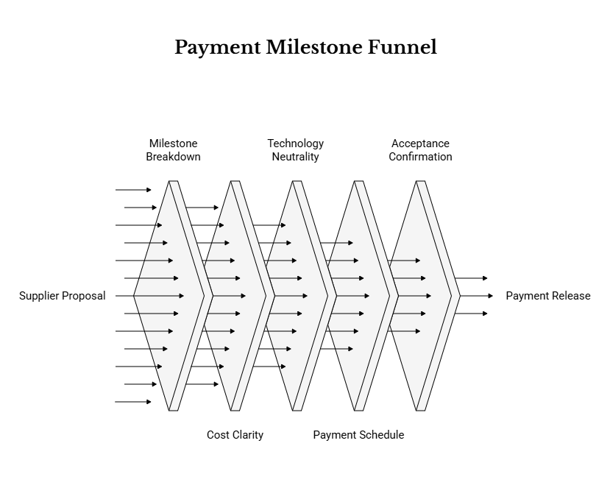

19.2 Payment Milestones and Conditions
Payments will be tied to the successful delivery and formal acceptance of agreed deliverables and milestone outputs. As a minimum, the Supplier shall propose a payment schedule mapped to the Phase 2 deliverables (Section 8), with payments released only upon evidence-based acceptance by the Client.
Minimum conditions for milestone payment eligibility shall include:
- Submission of the deliverable in the required formats and languages (where applicable), including version control and supporting annexes/evidence (e.g., configuration workbook, test results, training attendance).
- Completion of the acceptance review process defined by the Client (including demonstrations where required), and issuance of a written acceptance confirmation (e.g., sign-off email or acceptance certificate).
- Resolution of critical issues that prevent the deliverable from meeting its acceptance criteria, particularly for releases intended to support UAT and go-live readiness.
Indicative milestone linkage (for structuring the Supplier’s proposal)
The Supplier’s payment schedule should, at minimum, align to the delivery checkpoints below (actual percentages/amounts to be proposed by the Supplier and assessed by the Client):
- D1 Mobilization & Implementation Plan (approval by end of Week 2)
- D3/D4 Sprint/Release milestones demonstrating working system increments (Month 1 and Month 2)
- D7 UAT Support and Sign-off Pack (end of Week 11)
- D8 Go-Live, Cutover and Hypercare Report (Week 12)
- D9 Final Completion and Handover Dossier (Week 12)
To strengthen delivery assurance, the Supplier shall also specify in its proposal how payments will be protected against incomplete outcomes, including:
- Clear “definition of done” for each milestone (what constitutes completion, what evidence is provided, and what defects are permissible at that stage).
- Treatment of conditional acceptance, where the Client may accept a deliverable with minor defects subject to an agreed corrective action plan and timeline (without undermining go-live quality gates).
- Dependency-related conditions, where the Client’s approvals or third-party readiness (e.g., telecom integration parameters) may affect completion of certain deliverables—these must be transparently reflected in the payment logic to avoid disputes.

19.3 Invoicing, Taxes and Reimbursables
Invoicing requirements (to be finalized in the RFQ/RFP and contract) shall be supported by a predictable, auditable invoicing package. At a minimum, each invoice should reference:
- Contract title/number and purchase order/reference (as applicable).
- The specific milestone/deliverable ID being invoiced (e.g., D3, D7) and its acceptance date.
- A copy of the Client’s written acceptance confirmation (or an agreed acceptance certificate template).
- A brief milestone completion summary and any agreed defect punch-list (if conditional acceptance is used).
- Any approved reimbursable claims (if permitted), with supporting documentation.
Taxes
The Supplier shall clearly state whether its prices are inclusive or exclusive of applicable taxes, duties, and statutory withholdings, in accordance with the RFQ/RFP instructions and Kenyan tax requirements. Where VAT or other taxes apply, they shall be itemized transparently in the financial proposal. Any withholding tax treatment should be anticipated in the Supplier’s cashflow planning and invoicing format.
Reimbursables and third-party costs (if applicable)
Unless explicitly allowed in the RFQ/RFP, the Client’s default expectation is that Phase 2 is priced as all-inclusive (lump sum), with limited or no reimbursables. Where reimbursables are permitted, they shall be governed by the following minimum controls:
- Reimbursables must be pre-approved in writing by the Client prior to cost incurrence.
- Claims must be supported by receipts and an itemized breakdown consistent with the agreed reimbursement rules.
- Reimbursables must be limited to essential delivery needs that cannot reasonably be priced as part of the fixed fee (e.g., agreed travel for in-person trainings in specific counties, if required by the Client and not feasible virtually).
For avoidance of doubt, the Supplier shall separately identify any third-party pass-through costs that may arise in relation to enabled channels (e.g., SMS gateway costs, USSD aggregator fees, toll-free hotline operating costs), noting that commercial/regulatory arrangements are Client-led while the Supplier provides technical integration/configuration support.

19.4 Retentions, Adjustments and Deductions
Any retention amounts, adjustments, and deductions will be defined in the RFQ/RFP and contract, but the Supplier shall anticipate standard public procurement controls that protect delivery outcomes, system quality, and operational continuity. The Supplier’s proposal shall therefore describe how it will support the following contract administration mechanisms (as applicable):
- Retention / holdback arrangements: the contract may include a retention percentage withheld until completion of final handover and/or expiry of a short warranty/hypercare period, to incentivize timely remediation of defects identified during stabilization.
- Non-performance deductions: the contract may allow deductions or set-offs for failure to meet agreed acceptance criteria, non-delivery of required handover materials, or failure to resolve defects within agreed timelines during warranty/hypercare.
- Delay-related remedies: where delivery delays materially affect go-live readiness or program needs, the contract may include remedies such as liquidated damages or reduced payments for delayed milestones, subject to the final procurement terms.
- Change control and price adjustments: given the short, time-bound nature of Phase 2, the baseline expectation is no price escalation under a fixed-price arrangement. Any adjustments should occur only through a documented change control process tied to changes in scope, compliance obligations, or Client-approved enhancements.
- Defect remediation linkage: where a deliverable is accepted conditionally, the contract may link a portion of the milestone payment (or retention release) to closure of agreed defects within an agreed timeframe, especially for security, privacy, accessibility, and core workflow issues.

These measures are intended to ensure that payments remain aligned to verified outcomes and that the commissioned e-GRM system is operationally stable, compliant, and fully handed over to the Client for sustainable operation.

20. PROPOSAL REQUIREMENTS

20.1 Technical Proposal Structure
The Supplier’s Technical Proposal shall be structured in a clear, auditable manner that enables the Client to verify: (i) full understanding of the assignment; (ii) credible delivery within the three-month Phase 2 window; and (iii) compliance with functional, non-functional, security/privacy, accessibility, and integration requirements. The proposal shall remain technology-neutral (i.e., describe what will be delivered and how it will be achieved, without constraining the Client into unjustified proprietary lock-in).
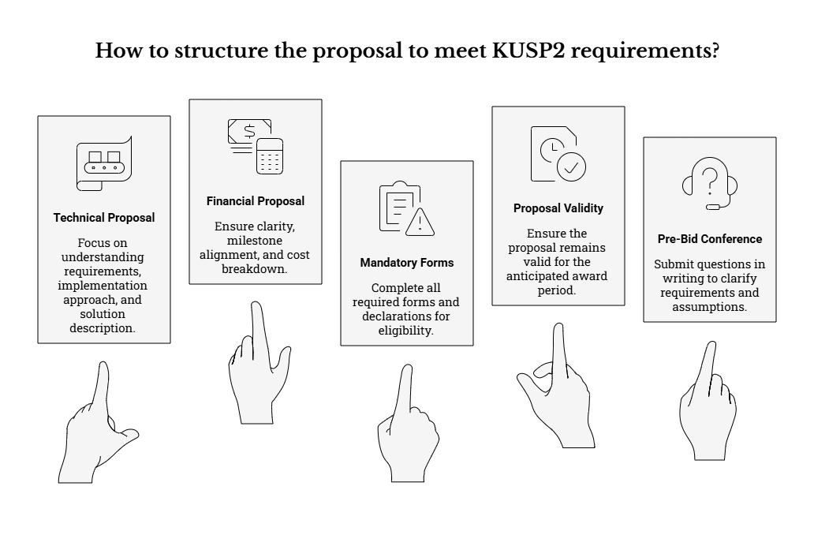
At a minimum, the Technical Proposal shall include the sections below (Suppliers may add further subsections as needed, provided the core structure remains intact and easy to assess):
a) Understanding of requirements and constraints; confirmation of scope and assumptions
The Supplier shall provide a concise but complete statement confirming:
- Understanding of KUSP2 e-GRM purpose and operating model, including decentralized use across counties/municipalities with national oversight and aggregated reporting.
- Confirmation of Phase 2 scope (implementation/configuration/deployment/commissioning in 3 months) and explicit acknowledgement that Phase 1 outputs are inputs to be implemented and not redefined.
- Assumptions and dependencies that affect delivery, clearly separated into:
  - Client-led dependencies (e.g., regulatory/commercial arrangements for SMS/USSD and toll-free hotline; hosting approvals and access; availability of nominated users for training/UAT).
  - Supplier-led dependencies (e.g., proposed environments, configuration backlog, staffing availability, tooling).
- Constraints and exclusions, including confirmation that automated chatbots will not be used for grievance intake.
- A clear statement of what constitutes “done” for go-live and handover (e.g., production deployment completed, UAT sign-off obtained, training delivered, handover dossier submitted and accepted).
b) Proposed implementation approach and work plan aligned to Section 9 (including sprint plan, governance, and risk management)
The Supplier shall provide a delivery approach that is realistic for a three-month implementation and demonstrates strong operational discipline. The approach shall include:
- Implementation methodology and cadence, typically sprint-based and demo-driven (e.g., Sprint 1 core intake and case management; Sprint 2 channels/reporting/compliance controls), with frequent validation checkpoints.
- A week-by-week work plan aligned to the required milestones, showing key activities, decision points, and required Client engagement (requirements confirmation, demos, pilot/UAT, go-live).
- Governance arrangements, including:
  - Proposed working groups (technical, GRM/business, safeguards/SEA/SH, training/change).
  - Meeting schedule (weekly working sessions, sprint reviews/demos, steering reviews) and reporting outputs (weekly status update, monthly progress report).
  - Decision-making and escalation paths for blockers impacting timeline/compliance.
- Risk management approach, including:
  - A living risk register aligned to the program’s risk matrix categories (technical, compliance, adoption, dependencies, schedule).
  - Early identification of telecom and hosting lead-time risks and mitigation/fallback measures (e.g., proceed with web + assisted intake while SMS/USSD is finalized, ensuring a unified register).
  - Issue management and decision logs with owners and target dates.
c) Proposed solution description (technology-neutral) demonstrating how functional and non-functional requirements will be met, including channels and compliance controls
The Supplier shall describe the proposed solution in a way that allows objective evaluation without prescribing specific brands. The description shall include:
- Logical solution overview (modules/components) covering at minimum: intake & registration, case management workflow, communications, appeals/closure, reporting & dashboards, administration & configuration, audit & logs.
- How the solution meets key functional requirements, including:
  - Single system-of-record and unique reference numbering across all enabled channels.
  - Standardized intake dataset implementation with validation rules and completeness checks aligned to the agreed intake/data collection form.
  - Configurable workflow statuses, assignment rules, SLAs/targets, escalation triggers, and action logging.
  - Complainant communications and message logging, respecting consent and contact preferences, and supporting templates (English and Kiswahili at minimum).
  - Confidential handling controls for sensitive cases (including SEA/SH) with restricted access and appropriate referral workflow support.
- How the solution meets non-functional requirements, including:
  - Performance and responsiveness for decentralized use (case search, lists, dashboards).
  - Availability, backup, restore, and DR approach proportionate to risk and hosting constraints.
  - Security and privacy-by-design controls (RBAC, audit trails, encryption in transit/at rest, retention/archiving).
  - Accessibility and usability for low-bandwidth contexts and persons with disabilities.
  - Interoperability via open standards/APIs and export formats (CSV/Excel/PDF), avoiding unjustified lock-in.
d) Requirements response matrix (mandatory) and traceability
To strengthen clarity and reduce evaluation ambiguity, the Supplier shall include:
- A Requirements Response Matrix mapping each major requirement area (functional, non-functional, security/privacy, accessibility, integration, reporting) to:
  - Proposed approach (configure vs. customize vs. integrate),
  - Any prerequisites/assumptions,
  - Evidence/demonstration method (demo scenario, test case, configuration screenshot, documentation artifact), and
  - Delivery timing (which sprint/release).
- A concise statement on configuration-first delivery, explaining which requirements can be met through standard configuration and which require development/customization, with rationale and risk controls.
e) Channel enablement and integration approach (web, email, SMS/USSD, hotline) and KUSP2 website integration
The Supplier shall describe:
- Web intake and assisted intake approach as the minimum baseline for go-live.
- Email intake/notifications design, including logging, routing rules, template governance, and confidentiality controls (e.g., avoiding sensitive details in unsecured channels by default).
- SMS/USSD integration approach (where enabled), including gateway assumptions, message templates, delivery monitoring, and fallback if delivery reports are unavailable.
- Hotline (toll-free) assisted intake approach (where enabled), including operator scripts, call logging expectations, reference number issuance, and escalation of sensitive grievances.
- KUSP2 website embedding/linking approach for public portal intake and reference-number-based status tracking while preventing personal data exposure.

f) Testing and quality approach, including security and accessibility testing
The Supplier shall submit a practical quality approach that is “built-in” throughout delivery. At minimum:
- Test strategy covering functional, integration, regression, performance, security, and accessibility.
- Approach to creating test evidence packs aligned to acceptance criteria and deliverables (including defect logs and remediation tracking).
- Security testing approach proportionate to risk (authentication/authorization checks, vulnerability scanning where feasible, verification of audit logging and encryption).
- Accessibility testing approach and inclusion of users with disabilities where feasible in UAT validation activities.
g) Training and change management approach
The Supplier shall describe:
- Role-based training tracks (administrators, supervisors, grievance handlers, reporting users).
- Training content coverage: workflows, confidentiality and ethics, SEA/SH-sensitive handling procedures, data quality, and reporting.
- Delivery modalities (virtual/in-person mix), proposed schedule aligned to UAT and go-live, and how training effectiveness will be assessed (attendance, evaluations, practical exercises).
- Adoption support aids (job aids, SOPs for assisted intake channels, public guidance templates for “how to submit a grievance” and “how confidentiality/non-retaliation works”).
h) Operations, support and warranty approach (hypercare and post go-live support)
The Supplier shall propose:
- Hypercare scope (staffing levels, hours of coverage, defect triage, release cadence for fixes).
- Warranty/defect liability approach, including response and resolution targets by severity.
- Support model and escalation tiers (L1/L2/L3), including contact points and incident handling procedures.
- Handover approach to enable Client teams to operate and configure the system independently (admin guide, configuration workbook, credentials handover procedure, backup/restore runbooks).
i) Team composition, CVs, roles/responsibilities; confirmation of availability
The proposal shall include:
- Team structure with named personnel (or named key roles where permitted by the RFQ/RFP) and clear responsibilities.
- CVs demonstrating experience relevant to GRM/case management systems, multi-channel intake, security/privacy, accessibility, testing, training, and Kenyan operating context where applicable.
- Time allocation (level of effort) and availability confirmation across the full three-month window, including go-live and hypercare.
- Local support arrangements (on-the-ground support in Kenya where required), including how county/municipal engagements will be supported.
j) Relevant experience and at least three references for comparable assignments
The Supplier shall provide:
- At least three references for comparable implementations (public sector or large multi-stakeholder deployments; case management/GRM/helpdesk systems; multi-channel intake integrations).
- Short case studies for each reference: scope, timeline, channels integrated, user scale, compliance context, and outcomes achieved.
- Contact details for reference checks as requested in the RFQ/RFP.

20.2 Financial Proposal Structure
The Financial Proposal shall be clear, milestone-aligned, and internally consistent with the Technical Proposal and implementation plan. It shall be submitted as a fixed-price or milestone-based breakdown aligned to deliverables in Section 8, and shall separately identify any optional items and third-party costs where applicable.
At minimum, the Financial Proposal shall include:
- Summary price table showing the total proposed contract price and a line-by-line breakdown aligned to deliverables (e.g., D1–D9), including:
  - Professional services (configuration/build, integration, testing, training, deployment, hypercare),
  - Any required licenses/subscriptions (if applicable),
  - Hosting/infrastructure costs (if included in scope), and
  - Documentation and handover activities.
- Milestone payment schedule that matches the deliverable acceptance points (e.g., D1 Implementation Plan, D3 Sprint 1 release, D7 UAT sign-off, D8 go-live/hypercare report, D9 final handover).
- Clear assumptions underpinning the price (e.g., number of training sessions/users, number of pilot sites supported, enabled channels in Phase 2, expected data migration volume if any).
- Optional items priced separately (for example: extended support beyond warranty; additional language localization beyond English/Kiswahili; additional integrations not required for go-live).
- Third-party costs and recurring fees identified separately and flagged as Client-led where applicable (e.g., telecom costs for SMS/USSD and toll-free lines), including the Supplier’s assumptions on what is excluded vs. included.
- Taxes and duties handled per RFQ/RFP instructions, with currency clearly stated and consistent across all tables.

20.3 Mandatory Forms and Declarations
The RFQ/RFP will specify the mandatory forms and declarations that must be submitted, including integrity and eligibility declarations. The Supplier shall ensure that all required documents are completed, signed, and submitted in the required format(s).
In addition, and without limiting the RFQ/RFP requirements, the Supplier should ensure its submission package is administratively complete and includes (where requested):
- Integrity and eligibility declarations, including disclosures of conflict of interest and confirmation of compliance with applicable procurement rules and ethical standards.
- Data protection and confidentiality undertakings relevant to handling personal and sensitive grievance information, including acknowledgement of restricted handling requirements for SEA/SH-related cases.
- Company legal documentation (registration/incorporation, tax compliance certificates, etc.) as required in the solicitation.
- Subcontractor/consortium documentation (if applicable): roles, responsibilities, contractual arrangement, and lead entity accountability.
- Signed confirmation of key commitments, such as technology neutrality, avoidance of unjustified lock-in, provision of handover artifacts, and compliance with accessibility requirements and security testing obligations.

20.4 Proposal Validity, Language and Copies
Proposals shall be valid for the period stated in the RFQ/RFP and submitted in the language(s) and number of copies specified therein.
To support efficient evaluation and reduce administrative clarifications, the Supplier should also ensure:
- Validity: the proposal validity period covers the anticipated award and contracting period; any exceptions are explicitly stated.
- Language: the Technical and Financial Proposals follow the required language rules; where supporting evidence is in another language, a summary translation is provided when needed for evaluation.
- Submission format and structure:
  - Separate Technical and Financial submissions as instructed (including separate files/envelopes where applicable).
  - Editable formats where requested and a PDF version for reference, with consistent version control.
  - Clear file naming, page numbering, and an index/table of contents for navigation.
- Completeness: all annexes referenced in the proposal (CVs, references, work plan, matrices) are included and cross-referenced correctly.

20.5 Pre-Bid Conference and Clarifications
A pre-bid conference and clarification process may be organized by the Client. The Supplier shall submit questions within the specified timelines.
Where a pre-bid process is conducted, the Supplier should assume (unless the RFQ/RFP states otherwise) that:
- Clarification questions must be submitted in writing to the designated contact point and within the stated deadline.
- Questions should be specific and actionable, referencing the relevant ToR/BRD section and clearly stating the interpretation risk or information gap (e.g., hosting approvals, channel readiness, pilot site selection, required reports).
- The Client’s responses (and any formal addenda) become part of the solicitation package and shall be reflected in the final proposal submission.
- The Supplier is responsible for ensuring its solution and pricing remain consistent with any issued clarifications/addenda, including updated assumptions about enabled channels or hosting constraints.

21. EVALUATION & AWARD CRITERIA

21.1 Evaluation Methodology
Evaluation methodology and scoring will be defined in the RFQ/RFP. The Client expects evaluation to consider both technical quality and price, consistent with applicable procurement regulations.
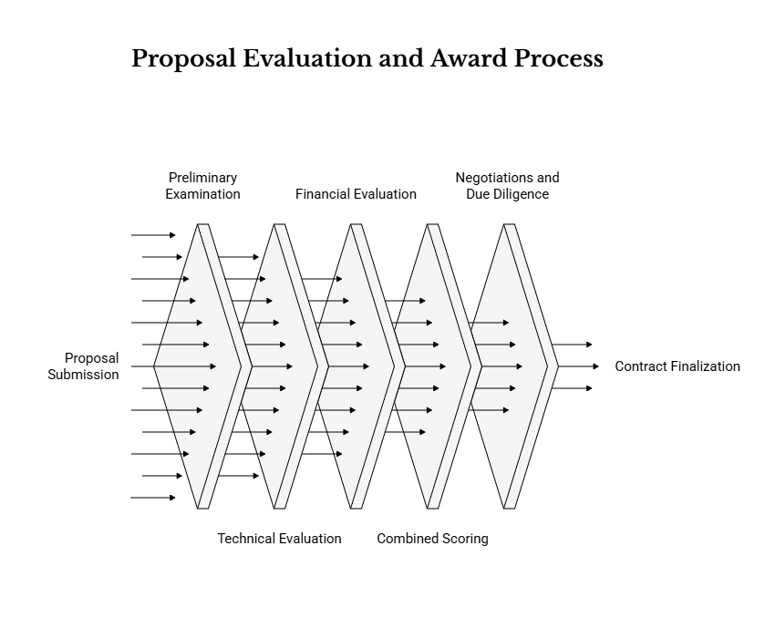
To promote transparency and consistency, the RFQ/RFP is expected to define (at minimum):
- Evaluation stages and sequencing, typically including: (i) preliminary examination / administrative compliance, (ii) technical evaluation, (iii) financial evaluation, and (iv) combined scoring and ranking.
- Eligibility and responsiveness checks, including mandatory forms, signed declarations, and completeness of the submission in the required formats. Non-responsive proposals may be rejected at this stage.
- Minimum technical threshold(s) (where applicable) to ensure the selected Supplier can deliver within the three-month Phase 2 window and meet compliance requirements.
- Evaluation committee roles and governance, including conflict-of-interest declarations, confidentiality provisions, and standardized evaluation templates to support auditability and defensibility of decisions.
- Clarification rules, noting that the Client may request written clarifications to understand proposals, without permitting changes that would distort fair competition or alter the substance of the proposal beyond what is allowed under procurement rules.
- Demonstrations or solution walk-throughs (if included), describing the format (e.g., scripted demo scenarios aligned to the ToR/BRD), how they will be scored (if at all), and how they will be used to validate claims made in the written proposal.
The RFQ/RFP may also specify that evaluation will prioritize solutions that: (i) preserve technology neutrality, (ii) avoid unjustified vendor lock-in, and (iii) enable sustainable operations and handover to NPCT/county/municipal users in line with the Phase 2 deliverables and timeline.

21.2 Technical Evaluation Sub-Criteria (Indicative)
Responsiveness to the ToR and completeness of the proposed approach. Demonstrated ability to deliver within three months, including risk management and dependency planning. Quality of proposed compliance approach (data protection, security, accessibility, SEA/SH handling). Relevant experience and qualifications of key personnel. Quality of testing, training, and handover approach.
To provide clearer guidance to bidders and evaluators, the RFQ/RFP is expected to elaborate these sub-criteria into assessable elements, such as:
a) Responsiveness and completeness of the technical proposal
- Clear confirmation that the Supplier will implement the Phase 1 outputs as implementation inputs, and a practical plan for requirements confirmation that validates (but does not redefine) the agreed functional intent.
- Evidence that the proposal addresses the full scope: multi-channel intake (as enabled), workflow implementation, reporting, security/privacy, accessibility, training, go-live, hypercare, and handover.
- Explicit identification of assumptions, client dependencies, and third-party dependencies (e.g., telecom arrangements), with mitigations and fallback options that preserve a unified grievance register.
b) Delivery approach and feasibility within the three-month window
- A time-bound delivery plan aligned to the milestones in Section 9 and deliverables in Section 8, with clear sequencing (mobilization → configuration/build → testing → training/UAT → go-live/hypercare).
- Adequate resourcing and staffing continuity for the duration of the three-month period, including local presence in Kenya where required.
- Practical sprint or work-package breakdown showing how the Supplier will deliver early working increments (e.g., “core intake + case management” before expanding channels and compliance controls).
c) Risk management and dependency planning
- A risk register aligned to the known risk categories in Section 14, with realistic triggers, owners, and contingency measures.
- Specific attention to “critical path” risks such as: hosting approvals and environment readiness, stakeholder availability for UAT/training, and readiness of any SMS/USSD/hotline integrations.
- A clear approach to change control and configuration management to protect timeline and compliance, especially for changes proposed after mobilization.
d) Compliance approach (data protection, security, accessibility, SEA/SH)
- Demonstrated understanding of Kenya Data Protection obligations and how privacy-by-design will be implemented through consent capture, data minimization, controlled access, retention/archiving, and audit logs.
- A credible security-by-design plan that includes secure configuration baselines, access control model, auditability, vulnerability management, and incident response readiness.
- Accessibility approach aligned to recognized standards (e.g., WCAG 2.1 AA or equivalent), with a practical plan for accessibility testing and remediation within Phase 2.
- SEA/SH-sensitive handling approach that supports confidentiality and restricted access, and enables safe referral workflows while minimizing capture of unnecessary sensitive details.
e) Solution fit and technology neutrality (without prescribing platforms)
- Evidence that the proposed solution can meet functional and non-functional requirements while remaining configurable and maintainable by Client teams post-handover.
- Clear approach to integrations via open interfaces and standard export formats, with attention to confidentiality and monitoring of delivery failures for messaging channels.
- Avoidance of proprietary dependencies that would prevent the Client from operating, administering, and extracting its data independently.
f) Testing, training, adoption, and handover quality
- Test strategy covering functional, integration, regression, performance, security, and accessibility tests, including submission of test evidence as part of acceptance.
- Training approach that is role-based (admin/supervisor/handler/reporting users), includes data quality and ethics/confidentiality modules, and is practical for decentralized users.
- Handover approach that is specific and verifiable (as-built configuration pack, admin guides, credentials handover procedures, and knowledge transfer to designated super users).
g) Relevant experience and personnel qualifications
- Demonstrated experience implementing grievance/case management or similar multi-stakeholder public-service systems, including multi-channel intake and secure handling of personal data.
- CVs showing that the key roles in Section 10 are covered with adequate seniority and availability, including named back-up arrangements for critical positions.
- References for comparable assignments (ideally involving government or donor-funded programs, decentralized deployment, and compliance-heavy environments).

21.3 Financial Evaluation
Financial evaluation approach and weighting will be defined in the RFQ/RFP.
The RFQ/RFP is expected to specify how price proposals will be assessed to ensure comparability, affordability, and value for money, including (as applicable):
- Price schedule structure and completeness, including milestone-based pricing aligned to the deliverables in Section 8 and clarity on what is included/excluded.
- Treatment of taxes and duties, currency, and any allowable adjustments, consistent with the RFQ/RFP instructions.
- Arithmetic checks and consistency checks between totals and line items, and how discrepancies will be resolved under the applicable procurement rules.
- Identification of optional items (e.g., extended support beyond warranty), ensuring optional items do not distort baseline comparability of required Phase 2 scope.
- Transparency on third-party costs that are not within the Supplier’s financial control (e.g., telecom fees for SMS/USSD and toll-free services), where applicable, and how such costs are treated for evaluation purposes (e.g., excluded, pass-through, or separately assessed).
- Assessment of price realism and delivery risk, particularly where unusually low prices may indicate under-scoping of compliance, testing, accessibility, training, or handover activities needed for successful commissioning.

21.4 Combined Scoring and Ranking
Combined scoring and ranking procedures will follow the RFQ/RFP evaluation instructions.
The RFQ/RFP is expected to specify:
- The relative weighting of technical and financial scores, consistent with applicable procurement rules (e.g., a quality-and-cost approach where technical quality remains a key determinant).
- Any minimum technical score required to proceed to financial evaluation (if applicable).
- The scoring formula used to compute the combined score and how ties will be handled.
- The approach for handling conditionalities (e.g., conditional go-live readiness, conditional integrations) and how these affect scoring and/or contract conditions.
In applying combined scoring, the Client will seek a proposal that offers the best overall value, balancing price with the demonstrated ability to deliver a compliant, secure, accessible, production-ready e-GRM and complete sustainable handover within the three-month implementation window.

21.5 Negotiations and Due Diligence
The Client may conduct clarifications, negotiations, and due diligence checks with the highest-ranked bidder, as permitted by procurement rules.
Where applicable, clarifications, negotiations, and due diligence may include:
- Verification of key personnel availability, including confirmation that proposed staff are available for the full three-month delivery period and are not simultaneously committed to conflicting engagements.
- Reference checks with prior clients to validate delivery performance, quality of support, and ability to deliver within constrained timelines.
- Solution validation through structured demonstrations or scenario walk-throughs aligned to the required workflows (intake → assignment → action logging → resolution → closure), including how sensitive cases are protected and how audit logs are produced.
- Security and privacy due diligence, such as review of the Supplier’s security governance (policies, vulnerability management processes, incident response procedures) and evidence of prior delivery of systems handling personal data.
- Hosting and data residency verification, confirming the proposed hosting model complies with Client direction and applicable requirements, and that cross-border transfers (if any) are controlled and approved.
- Licensing and IP review, confirming that licensing terms do not create unjustified vendor lock-in and that the Client will receive the rights needed for sustainable operation (including configuration artifacts and source code where applicable).
- Confirmation of implementation feasibility, including review of the bidder’s Implementation Plan approach (to be finalized after contract award) and readiness to align to the deliverable acceptance criteria in Section 8.
Negotiations (where permitted) are expected to focus on finalizing contract terms and delivery arrangements, such as: implementation governance, acceptance and defect resolution protocols, security and confidentiality obligations, handover contents, warranty/support obligations, and any clarified dependency responsibilities between Client and Supplier.

21.6 Award Notification and Contract Finalization
Award notification and contract finalization will be conducted in accordance with the RFQ/RFP and applicable procurement regulations.
Contract finalization steps are expected to include (as applicable):
- Formal notification to the successful bidder and communication to unsuccessful bidders in line with the RFQ/RFP process (including any debriefing processes allowed/required).
- Final contract documentation, including the finalized scope, deliverables, acceptance criteria, milestone payment schedule, and service/warranty arrangements.
- Confirmation of mobilization readiness, including submission of any required performance securities/guarantees (if applicable), confirmation of the Supplier’s implementation team, and agreement on kickoff date and governance structure.
- Contractual embedding of compliance obligations, including data protection, confidentiality, integrity requirements, accessibility, SEA/SH-sensitive handling, and auditability requirements.
- Transition to implementation, including scheduling of the mobilization kickoff and initial access to Phase 1 outputs and required Client inputs to enable timely delivery of the Week 2 Implementation Plan deliverable.

22. CONTRACTUAL & LEGAL PROVISIONS
This section sets out the minimum contractual and legal provisions expected to be reflected in the RFQ/RFP and the final contract for Phase 2 implementation of the KUSP2 e-GRM.
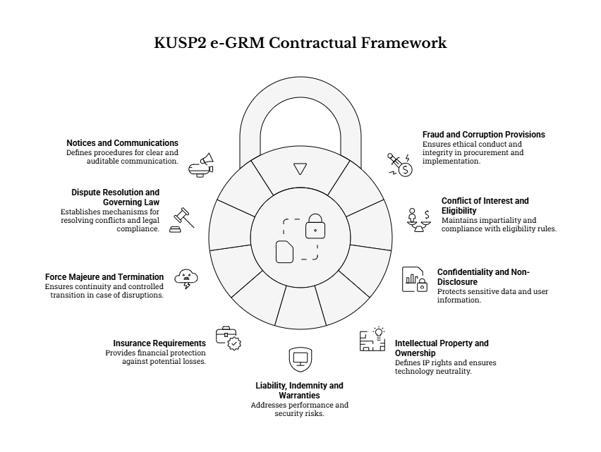
Given the nature of the assignment (a national-facing digital system handling personal and potentially sensitive grievances), the contract shall include clear protections for integrity, confidentiality, data governance, continuity of service, and the Client’s long-term operational control. These provisions are intended to (i) safeguard complainants and programme stakeholders, (ii) protect the Client from operational, legal and reputational risks, and (iii) ensure deliverables can be sustained after handover without undue vendor dependence.

22.1 Fraud and Corruption Provisions
The Supplier shall comply with all fraud and corruption provisions, integrity requirements, and ethical conduct obligations applicable to the procurement and contract. These provisions shall apply to the Supplier, its affiliates, personnel, agents, and any subcontractors or third parties engaged for implementation (e.g., SMS gateway integrator, hosting support provider). At minimum, the RFQ/RFP and contract shall:
- Define prohibited practices and standards of conduct, including (as applicable) corruption, fraud, collusion, coercion, and obstruction, and explicitly prohibit facilitation payments, kickbacks, or improper influence related to (i) procurement, (ii) implementation activities, or (iii) handling of grievance data and outcomes.
- Require the Supplier to maintain adequate records and audit trails supporting invoices, milestone claims, subcontractor payments, and any cost elements where transparency is required, and to retain such records for a contractually defined period.
- Provide audit and inspection rights for the Client (and any authorized oversight bodies as permitted in the RFQ/RFP/contract) to review relevant contract performance records, including testing evidence, configuration/workflow evidence, and deliverable acceptance artifacts.
- Require prompt notification and cooperation in investigations if credible allegations of fraud, corruption, data misuse, or unethical handling of grievances arise (including misuse of privileged access).
- Include remedies and sanctions for breach, which may include rejection of deliverables, suspension of payments, termination, and any other remedies provided under the RFQ/RFP, the contract, and applicable procurement rules.
Where integrity issues relate specifically to grievance handling (e.g., attempted retaliation, tampering with records, or unauthorized disclosure), the Supplier shall support evidence preservation and provide relevant logs consistent with the agreed security and privacy controls.

22.2 Conflict of Interest and Eligibility
Eligibility and conflict of interest requirements shall apply as specified in the RFQ/RFP and contract, and shall be treated as continuing obligations throughout the contract period. In addition to standard procurement eligibility requirements, the RFQ/RFP and contract should require that:
- The Supplier submits full disclosure of any actual, potential, or perceived conflicts of interest, including relationships with public officials, programme stakeholders, telecom providers involved in integrations, or parties that may be subject to grievances within the system.
- The Supplier warrants that it (and any subcontractors) is not subject to restrictions that would make it ineligible under the applicable procurement framework or any other binding eligibility rules stated in the RFQ/RFP.
- The Supplier maintains independence and impartiality in implementing the e-GRM, including neutrality in configuring categories, routing, and reporting, and avoiding any configuration that could unfairly influence grievance outcomes.
- Conflicts that arise during implementation are subject to a defined mitigation and escalation process, including potential replacement of conflicted personnel, additional oversight controls, or other measures determined by the Client under the contract.

22.3 Confidentiality and Non-Disclosure
The Supplier shall treat all project information—including grievance data—as confidential, and shall comply with non-disclosure requirements and data protection obligations as defined in the RFQ/RFP and contract. Confidentiality provisions shall be structured to reflect the sensitivity of grievance information and the multi-level governance model (national/county/municipal). At minimum, the contract should:
- Define confidential information broadly to include: grievance records (content, attachments, identity/contact details), user credentials, system configuration, security architecture, integration credentials (API keys, gateway tokens), and any non-public programme documents or operational data.
- Require need-to-know access controls for Supplier personnel, including role-based access aligned to implementation responsibilities (e.g., segregation between developers, testers, and support personnel where feasible).
- Require Supplier personnel and subcontractors to sign confidentiality undertakings and comply with the Client’s instructions on controlled handling of sensitive grievances (including SEA/SH-related cases and other restricted categories).
- Specify secure handling requirements for all data and artifacts during implementation (e.g., secure file transfer, encrypted storage, controlled sharing of test datasets), including explicit restrictions on copying production data into non-approved environments and restrictions on use of real grievance data for demos or training unless explicitly authorized and anonymized where appropriate.
- Define permitted exceptions to confidentiality (e.g., disclosure required by law) and the process for such disclosures (notice to Client, minimization, lawful basis, controlled disclosure).
- Require return, deletion, or verified destruction of Client data and confidential information upon contract completion or termination, subject to any lawful retention obligations and the Client’s operational continuity needs.

22.4 Intellectual Property and Ownership
The contract shall define intellectual property (IP), licensing, and ownership arrangements in a manner that supports technology neutrality while preserving the Client’s ability to operate, maintain, and evolve the e-GRM after handover. At minimum, the contract should provide that:
- Ownership of grievance data and all programme-generated operational data remains with the Client at all times, including during hosting and while in transit through enabled channels and integrations.
- The Client receives all necessary rights to use, administer, and maintain the solution, including perpetual (or contractually sufficient) licenses for any third-party components required for continued operation, subject to the agreed licensing model.
- All implementation artifacts required for sustainability are handed over, including (as applicable): configuration workbooks, workflow definitions, forms and data dictionaries, templates, integration specifications, deployment scripts, environment configuration parameters, and administrator documentation.
- For any custom development delivered under the contract (if applicable), the contract clearly defines whether source code ownership transfers to the Client or whether the Client receives an irrevocable license with rights to modify and maintain; in either case, the contract shall ensure the Client is not locked out of future maintenance or enhancement.
- All third-party/open-source dependencies are disclosed in a license inventory, with confirmation that licenses permit the intended government use and do not impose restrictions that would hinder ongoing operation or lawful publication of required reports.
- The Supplier provides a practical exit/transition posture, including complete export of data and configuration in open formats sufficient for transition to another provider or platform if required by the Client in future.

22.5 Liability, Indemnity and Warranties
The contract shall include appropriate liability, indemnity and warranty provisions commensurate with the risks of implementing a system that manages personal data, sensitive grievances, and official records. Without limiting the RFQ/RFP and contract terms, provisions should address:
- Performance warranties that deliverables will materially conform to agreed requirements, workflows, and acceptance criteria, and that the system will be fit for purpose for the intended operational context (national and decentralized use).
- Security and quality warranties, including that the Supplier will apply secure development/configuration practices, will not knowingly introduce malicious code, and will remediate verified vulnerabilities and defects within agreed severity timelines (particularly during hypercare and any warranty period).
- IP infringement indemnity (as applicable) protecting the Client against third-party claims that the delivered solution or its components infringe intellectual property rights, with clear obligations for defense, mitigation, and replacement where needed.
- Allocation of liability for data breach and confidentiality failures, including Supplier responsibilities where breach is attributable to Supplier actions, negligence, misconfiguration, or failure to follow agreed security controls.
- Limitation of liability (if included) should be structured so that it does not undermine protections for confidentiality, data protection, or integrity breaches, and remains consistent with applicable procurement and contracting rules.

22.6 Insurance Requirements
Insurance requirements (if any) will be specified in the RFQ/RFP and contract. Given the risk profile, the Client may require the Supplier to maintain, for the contract period (and any additional tail period where applicable), appropriate insurance coverage such as:
- Professional indemnity (errors and omissions) covering failures in implementation/configuration/testing/training that result in loss to the Client.
- Cyber / data liability coverage where available and appropriate, considering the system handles personal and potentially sensitive grievance data.
- Commercial general liability and (where applicable) employer’s liability/work injury coverage for on-the-ground activities in Kenya.

The contract should also specify evidence requirements (certificates), minimum limits (if applicable), and notification obligations if policies are cancelled or materially changed.

22.7 Force Majeure and Termination
Force majeure and termination provisions will be specified in the contract, ensuring continuity of critical grievance-handling operations and controlled transition in case of contract disruption. At minimum, provisions should:
- Define force majeure events, notice requirements, mitigation obligations, and how schedule impacts are assessed and approved.
- Provide the Client with clear rights and procedures for termination for default (e.g., persistent failure to meet milestones, refusal to remedy critical defects, material breaches of confidentiality/integrity obligations) and, where applicable, termination for convenience consistent with procurement rules.
- Include transition and continuity obligations upon termination, including: handover of current configurations and artifacts, secure transfer/return of Client data, delivery of data exports, and support for orderly cutover to an alternate solution or provider (as directed by the Client).
- Define payment and deliverable valuation principles upon termination (e.g., payments linked to accepted deliverables, treatment of partially completed milestones), aligned to the milestone-based structure.

22.8 Dispute Resolution and Governing Law
Dispute resolution and governing law provisions will be specified in the contract. The contract should define an escalation pathway that supports timely resolution of disputes without disrupting implementation timelines, including:
- Good-faith negotiation between designated contract managers as a first step, with defined timelines.
- Escalation to a defined management/steering level (e.g., NPCT leadership and Supplier executive sponsor) where disputes cannot be resolved operationally.
- Where needed, a formal mechanism such as mediation and/or arbitration (or other agreed mechanism), including venue, governing rules, and language of proceedings, consistent with the contract and applicable law.
- Clear statement of the governing law and jurisdiction applicable to the contract, aligned to Government of Kenya contracting requirements and the RFQ/RFP instructions.

22.9 Notices and Communications
Notices and communications procedures will be specified in the RFQ/RFP and contract to ensure clear contract administration and auditable decision-making. At minimum, the contract should:
- Define official contact persons and addresses for the Client and Supplier for contractual notices, including escalation contacts for urgent incidents (e.g., security incidents during hypercare).
- Specify acceptable notice methods (e.g., formal letter, email to designated addresses) and when a notice is considered delivered/received.
- Require that key implementation communications that affect scope, timelines, cost, risk, or compliance (e.g., change requests, acceptance decisions, go-live approvals) are captured through documented, traceable channels and recorded in agreed decision/change logs.
- Require meeting cadence and record-keeping consistent with governance arrangements (e.g., weekly working meetings and formal approval points), including circulation of minutes/action logs and decision tracking.
- Define protocols for security-sensitive communications, including controlled sharing of credentials, API keys, and system access details, and restrictions on transmitting sensitive information through insecure channels.

23. BID SUBMISSION INSTRUCTIONS
Bid submission instructions (method, address/portal, deadlines, and any bid opening procedures) will be specified in the RFQ/RFP document. Bidders shall comply with those instructions.
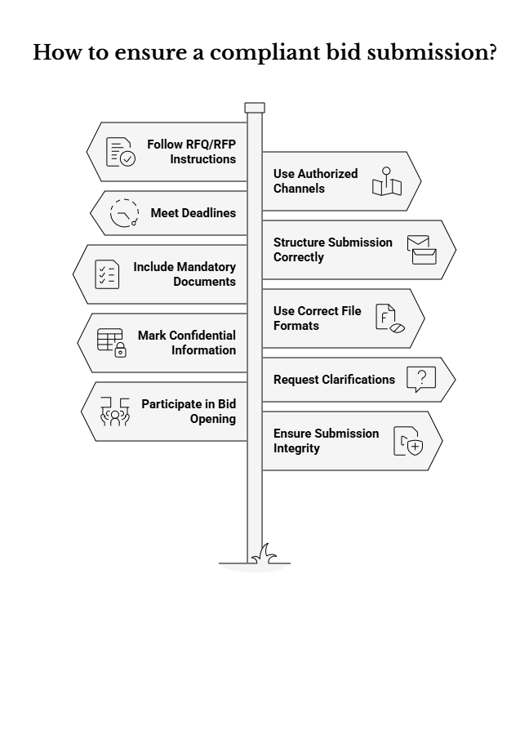
To strengthen procedural clarity and reduce the risk of non-responsive submissions, the following principles shall apply in interpreting and implementing the RFQ/RFP bid submission instructions (without replacing or contradicting them):
- RFQ/RFP as the single source of truth: The RFQ/RFP (including any clarifications, addenda, or amendments formally issued by the Client) shall constitute the authoritative and complete set of submission instructions. Bidders shall ensure they rely only on official communications channels and written addenda issued by the Client, rather than informal guidance.
- Submission method and permitted channels: The RFQ/RFP will specify whether submissions are to be made via an e-procurement portal, email, physical delivery, or a combination (e.g., electronic submission with limited hard-copy originals). Bidders shall:
  - Submit only through the authorized method(s) and to the exact address/portal stated in the RFQ/RFP;
  - Avoid alternative delivery routes or addresses, which may render a submission non-compliant;
  - Ensure that submissions are accessible to evaluators (e.g., readable file formats, non-corrupted files, and compliance with any password/encryption rules defined in the RFQ/RFP).
- Deadline management and “late bid” treatment: The RFQ/RFP will state the bid closing date and time and how timeliness is determined (e.g., portal timestamp, receipt stamp, or email server timestamp). Bidders shall:
  - Treat the stated deadline as strict and plan for contingencies (connectivity issues, portal congestion, courier delays);
  - Note that submissions received after the deadline may be rejected in line with the RFQ/RFP and applicable procurement requirements.
- Required submission package structure: Where the RFQ/RFP requires separate envelopes/files for Technical and Financial proposals, bidders shall follow the specified separation rules. This typically includes:
  - Separate files/envelopes clearly labelled (e.g., “Technical Proposal” and “Financial Proposal”);
  - Avoiding inclusion of pricing or cost information in the technical proposal if prohibited by the RFQ/RFP.
- Mandatory documents and completeness checks: The RFQ/RFP will specify mandatory forms and declarations (e.g., eligibility, integrity, conflict of interest, technical forms). Bidders shall:
  - Submit all required documents in the required format(s), signed where required;
  - Ensure that any supporting evidence (e.g., team CVs, references, methodology write-up) is provided and clearly cross-referenced;
  - Ensure that any required authorizations, powers of attorney, or company registration evidence (if requested) are included.
- File format, naming conventions, and document control: The RFQ/RFP may prescribe acceptable formats (e.g., PDF for signed documents; DOCX/XLSX for editable schedules) and naming conventions. Where prescribed, bidders shall:
  - Use the required file formats and avoid formats that hinder opening/review;
  - Follow naming conventions to support traceability and reduce evaluation delays;
  - Maintain internal version control to avoid submitting draft or superseded files.
- Confidentiality and marking of proprietary information: If the RFQ/RFP allows marking of confidential/proprietary sections, bidders shall clearly label such information as instructed, while recognizing that the Client may be subject to applicable access-to-information obligations and disclosure rules.
- Clarifications process (during bidding): The RFQ/RFP will define how bidders may request clarifications and the deadline for questions. Bidders shall:
  - Submit clarification questions within the allowed timeframe and only through the prescribed channel;
  - Rely on the Client’s written responses/addenda as the formal basis for any interpretation.
- Bid opening (if applicable): If a public or controlled bid opening is specified, the RFQ/RFP will define the procedure (location/virtual link, time, and what information is read out). Bidders shall follow participation instructions (if any), noting that bid opening procedures do not substitute for compliance with submission requirements.
- Responsibility for submission integrity: Bidders are responsible for ensuring that their submissions are complete, virus-free, readable, and consistent (e.g., totals in the financial proposal reconcile with breakdowns). Where electronic submission is used, bidders should retain proof of submission (e.g., portal confirmation receipt) where the RFQ/RFP provides for this.

This expanded guidance is intended to clarify the operational implications of Section 23 and support fair, consistent, and auditable bid receipt—while keeping the RFQ/RFP’s specific instructions as the governing requirements.

24. ANNEXES & SCHEDULES

24.1 Reference and Supporting Annexes (to be issued with the RFQ/RFP)
The annexes listed below form an integral part of the RFQ/RFP package and provide (i) mandatory implementation baselines (data standards and compliance obligations) and (ii) reference materials that guide delivery approach, stakeholder engagement, and schedule alignment. The Supplier shall review all annexes during mobilization and explicitly map how each relevant annex input is implemented through configuration, build activities, testing, training, and handover artifacts.
Annex set (minimum):
- Annex 1 – Detailed Stakeholder Engagement Plan for the e-GRM under KUSP2 (reference): Defines stakeholder groups, engagement expectations, and rollout communication considerations. The Supplier shall align training delivery, pilots/UAT participation, and change management deliverables to this plan, and ensure implementation governance includes the required stakeholder touchpoints.
- Annex 2 – Revised Standard Grievance Intake/Data Collection Form (mandatory data standard): Defines the minimum standardized dataset and field rules that must be implemented. Where the Supplier’s solution uses different internal field names, the Supplier shall preserve the meaning, data types, mandatory/conditional logic, and validation intent of the standard.
- Annex 3 – Risk Matrix for KUSP2 e-GRM (reference): Provides baseline risks and mitigations that the Supplier shall reflect in a Phase 2 risk/issue log and actively manage throughout the three-month implementation period, including dependencies (e.g., telecom arrangements) and adoption risks.
- Annex 4 – Legal and Compliance Mapping Matrix (mandatory compliance reference): Establishes compliance requirements that must be demonstrated through design/configuration evidence, security/privacy controls, testing results, and documented operating procedures.
- Annex 5 – Work Plan with Gantt Chart (reference milestone expectations): Provides Phase 1 milestone expectations that Phase 2 must align to. The Supplier shall propose a Phase 2 schedule that meets or improves the milestone cadence in this ToR and demonstrate feasibility (including realistic testing, training, and cutover windows).
- Annex 6 – Engagements and Data Collection Plan (reference): Provides context on stakeholder engagements and data collection used to define requirements; the Supplier shall use this to inform validation sessions, pilot selection support, and fit-to-context rollout planning.
- Annex 7 – System Requirements Specification (Software + Hardware) (mandatory baseline): Consolidates the minimum system-level requirements for acceptable deployment models, minimum environments, baseline infrastructure/hosting expectations, client endpoint requirements, software dependencies, and the acceptance evidence checklist. For bidder convenience, this annex is included in this ToR as Appendix C (Section 24.4).
- Initial Exploration Documentation of Screens/Workflows (reference): Illustrates baseline user journeys and workflow intent; the Supplier shall use it to accelerate configuration and reduce ambiguity during requirements confirmation, while remaining aligned to the agreed functional intent.

Document precedence and change management (implementation rule):
- In case of minor differences between annexes and the configured solution, the Supplier shall resolve discrepancies through the agreed requirements confirmation and gap analysis process and record outcomes in the Implementation Plan and configuration workbook. Any substantive deviation from mandatory baselines (e.g., the standardized dataset or mandatory compliance controls) shall be treated as a formal change request and requires Client approval through change control.
- The Supplier shall maintain a deliverable traceability approach (e.g., mapping annex requirements → configuration items → test cases → training modules → handover artifacts) so the Client can verify completeness at UAT and handover.

24.2 Appendix A – Standard Grievance Intake Dataset (Implementation Baseline)
The Supplier shall implement the standardized grievance intake and processing fields at minimum as set out below (derived from Annex 2). Field names may vary in the proposed solution, but meaning and data rules shall be preserved.
Minimum standardized dataset
Section | Field | Mandatory | Type | Notes / Rules
A | Complainant Name | Optional | Text | Allow blank for anonymous submission.
A | Contact Phone Number | Optional | Telephone | Recommended for follow-up; store with consent.
A | Email Address | Optional | Email | Store with consent.
A | Postal/Physical Address | Optional | Text | For correspondence where applicable.
A | Preferred Method of Contact | Optional | Select | Phone, Email, SMS, Post, In-person.
A | Representative’s Name | Conditional | Text | If lodging on behalf of another person/group.
A | Relationship/Organization | Conditional | Text | Describe relationship to affected person/group.
A | Representative’s Contact | Conditional | Telephone/Email | If different from complainant contact.
A | Consent of Affected Person | Conditional | Checkbox | Confirm authorization to lodge on behalf.
A | Consent to Personal Data Use | Required | Checkbox | Consent to collect and use personal data per privacy notice.
B | Date of Submission | Optional | Date | Receiving officer may record if blank.
B | Grievance Reference Number | System | ID | System-generated unique reference.
B | Submission Channel | Required | Select | In-person, Phone Call, Email, Online Form, Letter, etc.
B | County | Required | Select | Select county where issue is relevant.
B | City/Municipality | Required | Select | Select city/municipality where issue is relevant.
B | Location/Site of Concern | Optional | Text | Specific location details (neighborhood, project site).
B | Grievance Category | Required | Multi-select | Environmental; Social; Gender-Based (GBV/SEAH); Corruption/Fraud; Project Implementation; Institutional/Policy; Other (specify).
B | Description of Grievance | Required | Long text | Detailed description; allow attachments.
B | Evidence/Supporting Documents | Optional | Attachment(s) | Allow upload/list; guidance on limits.
B | Reported Elsewhere? | Optional | Yes/No + text | If yes, capture details and any reference number.
C | Expected Outcome | Optional | Multi-select + text | Information/Explanation; Corrective Action; Compensation/Remedy; Accountability/Disciplinary Action; Other (specify).
D | Date Received | Required | Date | For official use.
D | Received By (Name & Office) | Required | Text | Officer/office that received/logged.
D | Assigned To (Officer/Unit) | Required | Text/Select | Responsible handler/unit.
D | Actions Taken / Investigation Notes | Optional | Long text | Record key steps and findings.
D | Grievance Status | Required | Select | Open/Pending; Resolved; Referred; Escalated (Municipality/County/National); Closed.
D | Resolution Outcome/Summary | Conditional | Long text | Mandatory on resolution/closure.
D | Date of Resolution | Conditional | Date | If resolved.
D | Complainant Informed of Outcome | Conditional | Yes/No + date | If anonymous/unreachable mark accordingly.
D | Complainant Response | Conditional | Select | Satisfied; Not satisfied; N/A (anonymous).
D | Referral/Escalation Details | Conditional | Long text | If referred/escalated capture details.

Implementation requirements for preserving meaning and rules (minimum guidance)
To ensure the above dataset is implemented as a usable national standard (not merely as a set of fields), the Supplier shall incorporate the following in configuration and documentation:
- Data dictionary and mapping evidence
- Produce and maintain a data dictionary / configuration workbook mapping each standardized field to the solution’s internal field name(s), data type, validation rule(s), visibility (public vs staff-only), and reporting availability. This mapping shall be included in the Solution Design Package and final handover dossier.
- Where the solution uses combined fields (e.g., a unified “Contact Details” object), the Supplier shall still ensure that each standardized element can be captured, validated, permissioned, and reported as required.
- Channel-specific minimum capture rules
- Ensure all channels create a single grievance record with the standardized dataset applied, while allowing practical channel adaptations:
  - Web: enforce all required fields at point of submission (including Consent to Personal Data Use); provide clear error messages and guidance text for accessibility and comprehension.
  - Assisted intake (in-person/phone): enable staff to complete mandatory fields and record when information is unavailable (e.g., anonymous, unreachable). Include a staff prompt/check to confirm details back to the complainant (where feasible) to improve data accuracy.
  - SMS/USSD (if enabled): implement a minimal viable capture flow aligned to mandatory fields and usability constraints (short sessions), while preserving core meaning (especially location, category, and description/summary). Ensure consent and privacy handling aligns to agreed procedures and channel limitations.
- Conditional fields and validation logic
- Configure conditional fields so they are enforced only when applicable:
  - Representative fields and Consent of Affected Person shall be required when “submitted by representative” is indicated.
  - Resolution/closure fields (e.g., Resolution Outcome/Summary, Date of Resolution, Complainant Informed of Outcome, Complainant Response) shall become mandatory at the appropriate workflow stage(s).
- Configure validation rules for formats (email, phone), mandatory selection constraints (county/municipality lists), and controlled vocabularies (category list values).
- Reference data governance
- Configure and maintain controlled dropdown lists (e.g., county, municipality, categories) using administrative tools so they can be updated without redevelopment.
- Maintain auditability for reference data changes (who changed what and when) to protect data consistency for longitudinal reporting.
- Consent, privacy notice linkage, and confidentiality controls
- Implement explicit consent capture (timestamped) and ensure it is linked to the relevant privacy notice/version presented at intake.
- Ensure role-based controls restrict access to personal data, and enforce additional restrictions for sensitive categories (e.g., GBV/SEA/SH), consistent with agreed protocols (restricted visibility, limited free-text, safe reporting outputs).
- Attachments and evidence handling
- Configure accepted file types, size limits, and storage controls proportionate to security and bandwidth constraints.
- Ensure attachments inherit the grievance record’s access restrictions and are included in audit logs (upload/view/download events, where supported).
- Data quality controls for monitoring and reporting
- Ensure required fields are available for reporting and disaggregation (channel, county, municipality, category, status, dates).
- Provide configuration to reduce duplicate data entry (e.g., reference number search, duplicate detection prompts) and to standardize “unknown/not provided” handling for optional fields, to keep datasets analytically usable over time.

24.3 Appendix B – Illustrative Workflow Scenarios (Acceptance Scenarios)
The scenarios below are the minimum illustrative acceptance scenarios for demonstrations, testing, and UAT sign-off. The Supplier shall translate these scenarios into UAT scripts and test cases, and provide evidence (screenshots/logs/test results) showing that each scenario works end-to-end, including auditability and appropriate access controls.
- Web grievance submission with consent, acknowledgement, assignment, resolution and closure
- Expected flow: public submission → consent capture → system generates reference number → acknowledgement recorded/sent → routing/assignment to correct unit → action logging and communications → resolution summary recorded → closure with required fields completed.
- Minimum evidence: reference number format demonstration; consent record; message log (acknowledgement and resolution communication); audit log entries for assignment/status changes; closure field validation.
- Anonymous grievance submission (web or assisted), with reference number and status tracking without disclosure of identity
- Expected flow: submission without identity/contact → reference number generated and provided → workflow proceeds internally → status tracking available via reference number (without exposing personal data) → closure marked with “N/A (anonymous)” where required.
- Minimum evidence: system allows blank complainant name/contact; permissions prevent staff from adding identifying info without authorization; status tracking returns only permitted details; reporting aggregates do not expose identity.
- Phone-assisted grievance intake logged by an officer, including read-back confirmation and acknowledgement
- Expected flow: complainant calls → officer logs grievance using standardized dataset → officer confirms key details (read-back) → reference number provided verbally and/or via configured acknowledgement channel → routing and SLA countdown begins.
- Minimum evidence: assisted intake form supports mandatory fields; submission channel captured as Phone Call; acknowledgement recorded; call notes stored in communications log (staff-only where appropriate).
- Grievance requiring referral (e.g., corruption allegation) with controlled information sharing and status tracking
- Expected flow: grievance captured and categorized appropriately → restricted routing/referral to designated unit → controlled access ensures only authorized roles can view full content → complainant receives safe updates (no sensitive detail disclosed) → referral outcome recorded and tracked to closure.
- Minimum evidence: referral/escalation details captured; restricted visibility enforced; safe notification templates validated; audit log shows access and transfer actions.
- SEA/SH-related grievance intake using a confidential pathway with restricted access and referral, with minimal sensitive data captured
- Expected flow: confidential intake option selected → system applies sensitive classification and restricted access → referral workflow triggers per agreed protocol → minimal data captured in free text; structured fields used for tracking referrals/actions → reporting limited to aggregate outputs.
- Minimum evidence: restricted roles/queues demonstrated; notification suppression/redaction demonstrated; audit logs capture access; exports/reporting show aggregation without personally identifying or highly sensitive narrative.

These scenarios shall be used not only to validate functional completeness, but also to validate privacy-by-design, role-based access, auditability, data quality rules, and multi-channel consistency (single record of truth with consistent reference numbering and status tracking).

24.4 Appendix C – System Requirements Specification (Software + Hardware)
This Appendix provides the consolidated System Requirements Specification (SRS) for the KUSP2 e-GRM. It translates hosting and environment expectations that are currently described across the ToR and BRD into an explicit, procurement-ready baseline so that quotations can be priced consistently and implementation can be accepted against measurable evidence.
The requirements below are technology-neutral and define minimum outcomes and minimum operational baselines. Where bidders propose alternative architectures (e.g., managed services, container platforms, or SaaS), the bidder shall demonstrate equivalence and provide the evidence items listed in Section 24.4.8 of this Appendix.

24.4.1 Purpose and scope of this System Requirements Specification
This Appendix shall be read together with the main ToR (especially Sections 5, 11–19 and 21) and is intended to clarify the system-level requirements that affect hosting, infrastructure, endpoint compatibility, software prerequisites, and acceptance evidence. It does not replace functional requirements; instead, it defines the minimum operating conditions under which the functional requirements must be delivered.
For clarity, this System Requirements Specification covers the following minimum areas:
- Acceptable deployment/hosting models and bidder obligations (Section 24.4.2).
- Responsibility split between the Client, Supplier, and third parties (Section 24.4.3).
- Minimum environments and environment separation rules (Section 24.4.4).
- Minimum infrastructure/hosting requirements (hardware) in a technology-neutral manner (Section 24.4.5).
- Client endpoint requirements for staff and public users (Section 24.4.6).
- Software dependencies and platform prerequisites, including integration prerequisites (Section 24.4.7).
- Acceptance evidence checklist (Section 24.4.8).
Bidders shall use this Appendix as the baseline for their technical proposals and shall clearly state any assumptions, dependencies, or variances. Any variance from a mandatory baseline requirement shall be treated as a deviation and may render a quotation non-responsive, unless the RFQ/RFP explicitly allows and evaluates alternatives.

24.4.2 Deployment model statement (acceptable models and bidder obligations)
The e-GRM is a public-facing national system with sensitive case handling. The solution shall therefore be deployed in a manner that supports secure operations, data protection obligations, availability expectations, and sustainable administration after handover. For procurement clarity, the following deployment models are acceptable, subject to Client approval and compliance with applicable Government of Kenya requirements.
- Model A – Government-Hosted (preferred): Hosting is provided in a Government data centre or Government-approved cloud environment. The Supplier implements, configures, and hands over the solution and all operational artifacts to the Client.
- Model B – Supplier-Hosted SaaS (conditionally acceptable): The Supplier hosts the solution as a managed service, subject to data residency requirements, security/compliance controls, and evidence obligations that allow the Client to verify compliance and retain access to required data and logs.
- Model C – On-premises hardware supplied (only if confirmed in the RFQ/RFP): The Supplier supplies on-premises hardware and deploys the solution on that hardware. This model shall only be proposed if the RFQ/RFP explicitly requests supply of hardware as part of the goods package or allows an on-premises option.
Bidders shall propose at least one deployment model and provide a clear architecture summary (logical and deployment views), including environment separation, how data residency is ensured, and how the Client will administer the solution post-handover. Where a bidder proposes Model B or Model C, the bidder shall clearly state all service dependencies, recurring costs, and any conditions required for compliance and acceptance.

24.4.3 Responsibility split / RACI baseline (Client vs Supplier vs third party)
To avoid ambiguity in pricing and delivery, a baseline responsibility split is defined below. This baseline assumes Model A (Government-Hosted) as the preferred approach. Bidders shall confirm this baseline in their quotation and shall provide an updated responsibility matrix if proposing an alternative deployment model, clearly identifying any third-party dependencies (telecom/aggregators/call centre) and any items that are excluded from the Supplier’s scope.
The matrix below uses practical accountability language to indicate who is expected to provide and/or manage each dependency. Where responsibilities are shared, the matrix indicates the primary party responsible for ensuring the dependency is available and operational for go-live.
Item / dependency | Client (NPCT/Government) | Supplier | Third party (telecom/other) | Minimum expectation / notes
Hosting infrastructure (compute, storage, network) | Client provides/approves (Gov DC/Gov-approved cloud) | Supplier specifies minimum sizing and deploys application components | N/A (unless cloud provider under Client contract) | Supplier to validate sizing during mobilization and provide sizing worksheet.
Database platform (DB service or self-managed DB tier) | Client provides approved platform/services where available | Supplier configures DB schema, security, backups and tuning (or proposes managed alternative) | N/A | DB must support encryption at rest, auditability, backups and restore testing.
Backup configuration and retention | Client provides backup storage/location and retention policy inputs | Supplier configures backups, documents procedures, and performs restore test evidence | N/A | Restore test evidence required before go-live.
Disaster Recovery (DR) site/replication | Client provides DR location where applicable | Supplier defines DR procedure and supports configuration/testing proportionate to risk | N/A | RTO/RPO targets to be agreed within ToR expectations; evidence required.
Monitoring and alerting tools | Client may provide enterprise tools (if available) | Supplier implements monitoring/alerting dashboards and thresholds for app/DB/integrations | N/A | Monitoring must be operational during hypercare and handed over.
Domain/DNS management | Client provides domain and DNS administration approval | Supplier provides DNS records required and validates resolution | Registrar/ISP as applicable | Includes public portal domain and any API endpoints.
SSL/TLS certificates | Client provides/approves trusted certificate source | Supplier installs/configures certificates and renewal procedure | Certificate authority as applicable | TLS must be enforced for all public and admin access.
Email service (SMTP relay) and domain configuration (SPF/DKIM/DMARC) | Client provides SMTP relay and domain settings approvals | Supplier integrates email notifications and validates deliverability | Email provider as applicable | Personal email accounts are not permitted for system operations.
SMS gateway/aggregator account and fees | Client procures account/contract and pays fees unless otherwise stated | Supplier integrates and tests message delivery and logs | Telecom/aggregator | Channel activation depends on regulatory/commercial lead times.
USSD short code provisioning and fees | Client procures short code/aggregator arrangement unless otherwise stated | Supplier integrates and tests USSD flows (if enabled) | Telecom/aggregator | USSD may be staged; system must maintain single record of truth.
Toll-free hotline/IVR provisioning and call centre operations | Client procures number and call centre operations unless otherwise stated | Supplier integrates IVR/call logging where required (or supports assisted intake) | Telecom/call centre provider | If hotline integration is not in scope, assisted intake remains mandatory.
Identity and access management (RBAC, optional SSO/MFA) | Client provides SSO/MFA platform where required/available | Supplier implements RBAC and integrates SSO/MFA as approved | IAM provider as applicable | MFA required for privileged roles; fallback auth must be secure.
Penetration testing / vulnerability scanning | Client may commission independent testing (optional) | Supplier performs vulnerability assessment and remediates findings | Security assessor as applicable | Evidence of remediation required before final acceptance.
Data migration (if any) | Client provides source data, approvals, and data quality decisions | Supplier performs migration and reconciliation where required | N/A | Any migration scope to be confirmed during mobilization.
End-user devices and connectivity | Client provides devices and connectivity for NPCT/county/municipal users | Supplier provides endpoint requirements and supports testing on target devices | ISPs/telecoms | Includes minimum browser versions and bandwidth assumptions.
Hosting approvals and security reviews | Client leads approvals (hosting, security, compliance) | Supplier supports by providing architecture/evidence and addressing findings | Gov authorities as applicable | Lead times must be reflected in the Implementation Plan.
This responsibility split shall be refined during mobilization and confirmed in the Implementation Plan. Any change to responsibilities that has cost or schedule implications (e.g., shifting hosting or telecom arrangements to the Supplier) shall be treated as a formal change request and requires Client approval through change control.

24.4.4 Minimum environments and environment separation rules
The e-GRM shall be implemented and operated using a controlled release process that protects complainant data, supports realistic testing, and enables auditable promotion of changes. At minimum, the following environments shall be established and maintained for the duration of implementation and warranty/hypercare, unless the Client approves an equivalent controlled approach.
- Development (Dev) – required where configuration/customization is needed; may be combined with Test only with Client approval and where controls remain adequate.
- Test (QA) – used for functional, integration and regression testing, defect reproduction, and security/accessibility verification using controlled test data.
- Staging / Pre-production (UAT) – configured as close as feasible to Production (including integrations and performance characteristics) to support UAT and cutover rehearsals.
- Production (Prod) – live environment for public access and official case handling, with restricted access, hardened configuration, monitoring enabled by default, and controlled administrative operations.
Environment separation rules shall be applied consistently. Production personal data shall not be used in non-production environments unless explicitly authorized by the Client and protected by equivalent controls. Where realistic datasets are required, the Supplier shall use anonymized, masked or synthetic datasets and document the refresh procedure.
The Supplier shall define and implement a release promotion process (Dev → Test → Staging → Production) that includes: version control for configuration and any code artifacts, approval gates for promotion to Production, rollback procedures, and an auditable change log that can be reviewed during UAT and handover.

24.4.5 Minimum infrastructure / hosting requirements (hardware baseline)
Even where the procurement is primarily software-focused, a minimum infrastructure baseline is required so that the Client and bidders can plan and price consistently. The requirements below are expressed in a technology-neutral manner ("or equivalent"), and bidders may propose alternative sizing and architectures provided they can demonstrate that performance, availability, security and auditability requirements in the ToR are met.
a) Option A – Government-hosted (Client-provided hosting baseline)
Where the Client provides hosting (Government data centre or Government-approved cloud), the Supplier shall, at minimum, specify and validate the infrastructure sizing required to meet the ToR’s functional and non-functional requirements. The table below provides the minimum starting baseline for initial go-live; the Supplier shall refine sizing during mobilization based on agreed volumes and shall demonstrate adequacy through testing and/or architecture evidence.
Component | Production (minimum starting baseline) | Test/Staging (minimum baseline) | Notes / evidence required
Application / web tier compute | >= 4 vCPU and >= 16 GB RAM (or equivalent scalable service) | >= 2 vCPU and >= 8 GB RAM (or equivalent) | Must support horizontal scaling; include sizing worksheet and scale-out approach.
Background processing / notifications | Included within app tier or separate worker capacity as needed | As per Test/Staging needs | If separate workers/queues are used, include capacity assumptions for notification bursts.
Database tier compute | >= 8 vCPU and >= 32 GB RAM (or equivalent managed DB service) | >= 4 vCPU and >= 16 GB RAM (or equivalent) | DB must support encryption at rest, backups, auditability, and performance tuning.
Database storage | >= 200 GB initial, expandable (includes indexes/audit data) | >= 100 GB initial, expandable | Retention/archiving strategy required to preserve performance over time.
Attachment/evidence storage | >= 1 TB initial, expandable | >= 200 GB initial | Define file type/size limits; storage must inherit access controls and be auditable.
Log/audit storage | Sized to meet retention requirements (minimum 90 days online unless otherwise approved) | Sized as needed | Logs must be protected from tampering and exportable for audit purposes.
Backup storage | Sufficient for full backups and retention (minimum 30 days operational retention plus longer-term retention as approved) | As needed | Provide backup configuration summary and at least one restore test record before go-live.
In addition to compute and storage baselines, the Supplier shall identify and implement the minimum network and security prerequisites required to operationalize the solution in the Client-hosted environment. At minimum, these prerequisites shall include:
- Inbound/outbound connectivity rules required for public access and integrations (e.g., HTTPS access to public portal and staff console; secure outbound connectivity to email/SMS/USSD/hotline gateways as applicable).
- DNS and domain naming approach for the public portal and any APIs, including required DNS records and certificate validation steps.
- TLS enforcement for all user and administrative access, including secure configuration and certificate renewal procedures.
- Administrative access controls, such as IP allowlisting and/or VPN access for privileged administration, consistent with Government security requirements.
- Reverse proxy and/or web application firewall (WAF) expectations (where available/required), including protection against common web threats and rate limiting as appropriate for a public service.
The Supplier shall confirm high availability and disaster recovery arrangements in the approved hosting environment, including backup frequency, retention, and restore testing. Where RTO/RPO targets are agreed, the Supplier shall document how the infrastructure and procedures meet those targets and provide proportionate test evidence (restore test and/or DR rehearsal evidence).
b) Option B – Supplier-hosted SaaS (minimum service requirements)
Where a Supplier-hosted SaaS model is proposed (subject to Client approval), the Supplier shall meet or exceed the following minimum service requirements. These requirements are intended to protect data, ensure continuity for a public service, and enable the Client to verify compliance and retain access to required data and audit evidence.
At minimum, the Supplier-hosted service shall provide:
- Service availability target of at least 99.5% per month (excluding agreed planned maintenance), with monitoring and incident response procedures during hypercare and ongoing support.
- Documented backup policy, including backup frequency, retention, encryption, and at least one successful restore test record prior to go-live.
- Disaster recovery capability with documented RTO/RPO commitments and a proportionate DR rehearsal or recovery test approach.
- Data residency and cross-border transfer controls consistent with applicable Government of Kenya requirements and Client directions, including explicit controls that prevent unauthorized cross-border transfer of personal data.
- Vulnerability and patch management processes, including timely security patching and remediation of identified vulnerabilities.
- Secure administrative access controls (least privilege, MFA for privileged roles, audit logs) and retention of audit logs for compliance review.
- Client access to data exports and audit evidence, including the ability to export grievance data and associated logs in non-proprietary formats as required by the ToR.
Where the Supplier-hosted model introduces recurring dependencies (licenses, hosting subscriptions, gateway fees, certificates), the Supplier shall disclose these costs and renewal conditions clearly in the quotation and shall describe how continuity is ensured if the contract ends (including data export and transition assistance).
c) Option C – On-premises hardware supply (only if requested in the RFQ/RFP)
If the RFQ/RFP explicitly requires supply of on-premises hardware, the Supplier shall provide a hardware Bill of Quantities (BoQ) that covers, at minimum: production and DR (if required) server capacity, storage, backup equipment, and any network/security appliances needed to host the e-GRM securely. Hardware specifications shall be brand-neutral and allow equivalent alternatives, and shall be accompanied by warranty and support details. Where hardware is not requested, proposals shall not assume hardware supply as part of scope and shall instead follow Option A or Option B.

24.4.6 Client endpoint requirements (devices, browsers, and connectivity)
To reduce acceptance disputes and ensure equitable access, the minimum endpoint requirements below apply to both staff-facing and public-facing components of the e-GRM. The Supplier shall design, configure and test the solution against these baseline endpoints, and shall document any additional endpoint requirements introduced by the proposed solution.
At minimum, the solution shall support the following endpoint baseline:
- Web browsers: the latest two major versions of Google Chrome, Microsoft Edge and Mozilla Firefox for staff and public portal access. Where Safari is required for iOS devices, the solution shall also support current supported Safari versions for the public portal.
- Devices: common smartphones and standard desktops/laptops used in county/municipal offices. The public portal shall be responsive for mobile use; the staff console shall be usable on standard desktop/laptop screens and, where offered, on tablets.
- Screen resolution: responsive design down to typical smartphone screen sizes, and full usability on standard office resolutions (minimum 1366x768 for staff console unless an equivalent baseline is agreed).
- Connectivity: usable under low-bandwidth conditions (as required by the ToR), including efficient page payloads, pagination for long lists, and avoidance of unnecessary heavy assets.
- No dependency on proprietary plugins: access shall not require browser plugins that are not commonly available in Government environments.
The Supplier shall confirm any special requirements for assisted intake stations (e.g., scanners for document intake, headsets for call handling where a call centre is used) only where such items are explicitly included in scope. End-user devices and connectivity remain Client-provided unless the RFQ/RFP explicitly includes them as part of the goods package.

24.4.7 Software dependencies and platform prerequisites (technology-neutral)
The e-GRM solution may be implemented using different technology stacks. However, to remain procurement-ready and to enable consistent acceptance, bidders shall meet the minimum software capability requirements below and shall declare any external dependencies introduced by their proposed solution. Where a bidder proposes a managed service alternative, the bidder shall demonstrate equivalence to these requirements.
At minimum, the proposed solution shall satisfy the following software prerequisites and capability requirements:
- Server platform: compatible with commonly used Government hosting environments (Linux and/or Windows Server) or equivalent managed runtime services. Any required runtime components (e.g., application servers, container runtimes) shall be identified and included in the implementation scope.
- Database capability: database layer must support encryption at rest, strong access control, backup/restore, audit logging, and scaling to meet the ToR’s reporting and search requirements. Technology choice may vary, but required capabilities are mandatory.
- Identity and access management: role-based access control (RBAC) is mandatory, with multi-factor authentication (MFA) for privileged roles. If SSO is used, the solution shall support integration to an approved identity provider. Where SSO is not available, secure local authentication with strong controls shall be provided.
- Logging and audit trail: the solution shall provide audit logs for key actions (case access, status changes, assignment, data exports, admin changes) with retention and exportability aligned to the ToR and compliance requirements.
- Integration prerequisites: the solution shall support integration to (i) an SMTP email relay for email notifications, (ii) an SMS gateway/aggregator for SMS notifications and (where enabled) intake, (iii) a USSD aggregator for USSD flows (where enabled), and (iv) hotline/IVR interfaces where hotline integration is included. Where channel integrations are staged, the solution shall still maintain a single system of record and consistent reference numbering across channels.
- Interoperability: the solution shall provide APIs and/or export mechanisms to support integration and reporting, using common secure standards (e.g., RESTful APIs over HTTPS) and non-proprietary export formats (e.g., CSV, XLSX, PDF) as required by the ToR.
Bidders shall explicitly state any licensing constraints, proprietary components, or third-party services that are required for the solution to operate (including costs and renewal conditions). The Client will not accept hidden dependencies that create operational lock-in or prevent the Client from meeting its compliance obligations.

24.4.8 Acceptance evidence checklist (minimum compliance and handover evidence)
To make compliance measurable and acceptance auditable, the Supplier shall submit an evidence pack as part of UAT readiness, go-live approval, and final handover. This checklist consolidates evidence requirements implied across the ToR (hosting, security, accessibility, testing, and handover). The Client may request additional evidence proportionate to risk, but the items below are the minimum.
At minimum, the Supplier shall provide the following acceptance evidence artifacts:
- Architecture diagrams: logical architecture and deployment architecture for the approved hosting model, including environment separation and key components (application, database, storage, integrations).
- Environment inventory: list of environments (Dev/Test/Staging/Prod) with access controls, URLs/endpoints, and administrative account management approach (under controlled accounts).
- Sizing worksheet: documented sizing assumptions and capacity plan (users, grievance volumes, storage growth) and how scaling is performed; include any performance testing results used to validate sizing.
- Backup configuration summary and restore test evidence: backup schedule, retention, encryption, and at least one successful restore test record prior to go-live.
- Disaster recovery procedure and test/rehearsal evidence (proportionate): documented DR approach, RTO/RPO commitments where applicable, and evidence of a DR rehearsal or recovery validation appropriate to the approved model.
- Security configuration summary: hardening controls, RBAC/MFA implementation, audit logging configuration, and secure configuration of integrations (SMTP/SMS/USSD/hotline as applicable).
- Vulnerability assessment results and remediation summary: scan/test results (as applicable), prioritized findings, and evidence that critical/high findings have been remediated or formally accepted by the Client.
- Accessibility test summary: results of accessibility checks for key user journeys (public intake and staff processing), issues found, and remediation actions taken.
- Monitoring/alerting configuration summary: monitoring dashboards, alert thresholds, and escalation procedures used during hypercare and ongoing operations.
The evidence pack shall be delivered in an organized and reviewable format (index and filenames), and shall be referenced in the Handover Dossier. Failure to provide the minimum evidence may delay acceptance and go-live approval until compliance is demonstrated.

