
Ministry of lands, public works, housing and urban development

state department for housing and urban development

Second Kenya Informal Settlements Improvement Project (KISIP2)

Slums and Informal Settlements in Kenya

Status Report, 2026

Volume I – National Outlook

June, 2026

Disclaimer
This report presents findings from the National Slum and Informal Settlement Mapping and Profiling Exercise undertaken under the Second Kenya Informal Settlement Improvement Project (KISIP II). The analysis is based on settlement mapping, infrastructure profiling, household survey data collected through the 2024–2026 surveys, and population estimates derived from the 2019 Kenya Population and Housing Census projected to 2026 using county-level population projections published by the Kenya National Bureau of Statistics (KNBS). The findings therefore reflect conditions observed during the data collection period and should be interpreted as a national baseline and situational assessment, rather than a definitive or static representation of all settlement conditions.
While considerable efforts were made to ensure data quality through standardized tools, field verification, harmonization, and quality assurance processes, variations in response completeness, missing data, household participation, and field conditions may influence the interpretation of selected indicators. In several socio-economic indicators, percentages are calculated using valid (non-missing) responses, meaning denominators may vary between variables and direct comparison across indicators should be undertaken with caution. Additionally, some categories were harmonized during analysis to address variations in coding, terminology, and field reporting practices.
The report is intended to support evidence-based planning, policy formulation, settlement upgrading, investment prioritization, and intergovernmental coordination. Findings should therefore be interpreted alongside county-level realities, complementary datasets, and evolving administrative, legal, environmental, and socio-economic contexts. Settlement conditions are dynamic and may change over time due to urban growth, infrastructure investments, displacement, climate risks, demographic shifts, and policy interventions.
The Government of Kenya, KISIP II, participating institutions, and technical partners shall not be held liable for decisions made solely on the basis of this report without further verification, localized assessment, or sector-specific technical analysis. Users are encouraged to utilize the report in conjunction with the Kenya Slum Management Information System (KeSMIS) and other official planning instruments for updated and context-specific decision-making.

Executive Summary
The National Slum and Informal Settlement Status Report present findings from the National Slum and Informal Settlement Mapping and Rapid Profiling Exercise undertaken under the Second Kenya Informal Settlement Improvement Project (KISIP II). The exercise provides the first comprehensive, nationally coordinated evidence base on the status, characteristics, and conditions of slums and informal settlements across all counties in Kenya, supporting evidence-based planning, investment prioritization, and coordinated urban upgrading efforts. The assessment combined settlement mapping, infrastructure profiling, household surveys, and geospatial analysis to examine settlement characteristics, socio-economic conditions, infrastructure access, environmental risks, and community priorities.
The findings confirm that slums and informal settlements are a permanent and structurally embedded feature of Kenya’s urbanization process, rather than temporary spaces of transition. Many settlements demonstrate characteristics of long-term occupation, dense populations, permanent or semi-permanent structures, and established socio-economic systems. At the same time, these settlements continue to experience varying degrees of exclusion from formal planning, infrastructure investment, land administration, and service delivery systems.
The demographic profile reveals a predominantly young and economically active population, with the majority of residents concentrated within the productive age groups of 26–45 years. Females constitute a slight majority of respondents, while household structures are generally small to medium-sized, averaging between three and four persons per household. Residency patterns further indicate that many households have occupied settlements for prolonged periods, reinforcing the reality that informal settlements increasingly function as established urban neighborhoods rather than temporary settlements. Based on the 2019 Kenya Population and Housing Census projected to 2026 using KNBS county-level population projections, the estimated population living in mapped slums and informal settlements is approximately 3.91 million people nationally. The largest concentrations are observed in major urban and rapidly urbanizing counties, with Nairobi accounting for the highest projected settlement population, followed by Mombasa, Kilifi, Mandera, Nakuru, Wajir, Kiambu, Kisumu, Tana River, and Garissa.
Socio-economic findings highlight persistent income vulnerability and widespread livelihood informality. Household incomes remain concentrated within lower income brackets, with a significant proportion of households earning below KES 20,000 per month, reflecting continued dependence on informal employment, casual labour, petty trade, and self-employment activities. While the youthful population presents opportunities for labour productivity and entrepreneurship, persistent unemployment, underemployment, and limited economic diversification continue to constrain household resilience.
Access to basic infrastructure and services remains uneven, despite improvements in selected sectors. Access to electricity for lighting is relatively widespread, although affordability and connection costs remain barriers for some households. However, clean cooking energy remains limited, with many households continuing to rely on charcoal and firewood, exposing residents to indoor air pollution and environmental degradation.
Water access is largely dependent on shared piped systems, though substantial numbers of households continue to rely on shallow wells, rivers, and water vendors. Sanitation remains dominated by pit latrines, while formal sewer-connected systems remain limited. Hygiene conditions remain mixed, with only a minority of households reporting access to handwashing facilities equipped with both soap and water, exposing communities to continued public health risks.
Health access findings indicate that public hospitals remain the primary source of treatment, serving the majority of residents. Although many households live within reasonable proximity to healthcare facilities, utilization rates remain moderate and perceptions of service quality vary. Factors such as affordability, waiting times, overcrowding, and medicine availability continue to influence access and utilization.
The report also highlights significant social vulnerability and unequal access to social protection mechanisms. A notable proportion of households report the presence of persons living with disabilities, elderly persons, widows, orphans, and child-headed households, yet many remain outside formal social protection systems. Low registration under welfare and disability support programmes increases vulnerability to economic and environmental shocks. Despite broader socio-economic challenges, the findings demonstrate strong foundations for digital and social resilience. Mobile phone ownership and mobile money usage are nearly universal, presenting opportunities for digital service delivery, financial inclusion, information dissemination, and community engagement. Community organizations—including women’s groups, savings associations, youth groups, and welfare organizations—continue to play an important role in strengthening social cohesion, livelihoods, and collective action, although participation remains uneven.
Environmental and climate-related risks remain a major concern across many settlements. Households report exposure to flooding, drought, disease outbreaks, fires, and insecurity, sometimes occurring simultaneously and reinforcing one another. Security concerns are particularly pronounced after dark, with perceptions of safety declining significantly at night. These concerns are strongly reflected in community priorities, where security, health, roads, water, employment opportunities, and lighting at night consistently emerge as the most urgent needs. The findings demonstrate that residents view settlement challenges as interconnected, requiring integrated rather than fragmented interventions.
Overall, the findings underscore that Kenya’s slums and informal settlements are socially resilient but physically underserved, economically active yet vulnerable, and increasingly permanent despite continued exclusion from adequate services and formal systems. Addressing these challenges will require integrated, multi-sectoral, and evidence-based interventions that combine infrastructure upgrading, climate resilience, tenure responsiveness, livelihood support, healthcare improvements, social protection expansion, and strengthened local governance mechanisms. The national evidence generated through this exercise provides a critical foundation for the Kenya Slum Management Information System (KeSMIS) and offers an important basis for targeted planning, policy formulation, investment prioritization, and coordinated implementation of settlement upgrading interventions by national and county governments, development partners, and communities.

Table of Contents
Disclaimer 2
Executive Summary 3
Table of Contents 5
List of Figures 7
1 Background 8
1.1 Scope 9
1.2 Rationale 9
1.3 Definitions: Slum vs. Informal settlement 10
1.4 Structure of the Report 11
2 Methods 12
2.1 Overview 12
2.2 Tools 12
2.3 Approach 13
2.3.1 Settlement Identification 13
2.3.2 Infrastructure Mapping 13
2.3.3 Socio-Economic Profiling 14
2.3.4 Quality Assurance 14
2.3.5 Data Management 14
3 Findings 15
3.1 Settlement characteristics 15
3.1.1 Distribution by County 15
3.1.2 Population within slums and Informal settlements 16
3.1.3 Settlement Typologies 18
3.1.4 Land Tenure and Ownership 21
3.2 Infrastructure and Services 25
3.2.1 Electricity 25
3.2.2 Piped Water 26
3.2.3 Sewer 28
3.2.4 Road Infrastructure 29
3.2.5 Encroachment on Reserves 30
3.2.6 Environmental Hazards 30
3.3 Socio-Economic characteristics 32
3.3.1 Demographic Composition 32
3.3.2 Household Income 34
3.3.3 Water, Sanitation, and Hygiene (WASH) 35
3.3.4 Energy Access 37
3.3.5 Health Access and Services 39
3.3.6 Vulnerability and Social Protection 41
3.3.7 Digital Access and Information 42
3.3.8 Social Capital and Community Engagement 43
3.3.9 Security and Safety Perceptions 44
3.3.10 Disaster Risk and Climate Resilience 45
3.4 Community Priorities 46
3.4.1 Priority Landscape 46
3.4.2 Dominant Priority Combinations and Interlinkages 46
4 Conclusion 48
4.1 Key National Findings and Implications 48
4.2 Strategic Directions for Action 49
5 Annexes 50
5.1 Annex 1: Mapping Tools 50
5.2 Annex 2: Household Questionnaire 50
5.3 Annex 3: Settlement Profile Outline 50
5.4 Annex 4: Adopted national criteria for defining slums and informal settlements 50

List of Figures
Figure 1: Overall mapping workflow 12
Figure 2: Top 10 Counties by Number of Slums and informal Settlements 15
Figure 3: Distribution of settlements across the country. Symbols size represents the estimated populations within a settlement 16
Figure 4: Population within informal settlements and slums (Top 10 counties) 17
Figure 5: Average Household sizes across the counties (Top 10 counties) 18
Figure 6: Settlement Typologies 19
Figure 7:Mapped settlements by type and density typology; circle size is proportional to population. 19
Figure 8: Single-storey housing in an urban informal settlement, City Carton, Nairobi County. Structures are predominantly temporary, with iron-sheet/grass roofing and earth/polythene-carton walling. 20
Figure 9: Settlement structures comprised of largely temporary structures in Hola, Tana River (Left) and settlements comprised of permanent structures in Mombasa (Right) 21
Figure 10: Land Tenure status in the profiled settlements 21
Figure 11: Plot ownership distribution for select counties 22
Figure 12: Land occupancy and tenancy arrangements within slums and informal settlements in select counties 23
Figure 13 : Evidence of Tenure security in select counties 23
Figure 14: Availability of Electricity Infrastructure in the profiled settlements 25
Figure 15: Distribution of settlements with piped water infrastructure within the settlement 27
Figure 16:Climate and Environmental Vulnerability Rating of Profiled Settlements — Distribution of settlements by vulnerability category, showing predominantly medium vulnerability, followed by low vulnerability, with few settlements classified as highly vulnerable 30
Figure 17: Distribution of profiled households per county 31
Figure 18: Age-gender population distribution within the settlements 32
Figure 19: Residency within settlements 33
Figure 20:Reported places of work within the slums and informal settlements 33
Figure 21: Average Monthly Household Income 34
Figure 22:Sanitation Facility Types used within a Settlement 36
Figure 23: Household connection to main electricity grid 37
Figure 24: Source of Lighting in the settlements 38
Figure 25: Vulnerable persons within settlements 41

Background
Kenya is experiencing sustained urbanization, driven by population growth, rural–urban migration, natural increase, and the concentration of economic opportunities in major towns and secondary urban centres. According to KNBS, the country’s urban population increased from 12.02 million in 2009 to 14.84 million in 2019, while the number of urban centres rose from 230 to 372 over the same period. Although the share of the population living in urban areas declined slightly from 31.9 percent to 31.2 percent in that period, the absolute increase of approximately 2.81 million urban residents has continued to place significant pressure on land, housing, infrastructure, service delivery, and urban governance systems. Devolution has further reshaped Kenya’s urbanization landscape by transferring key planning, service delivery, infrastructure, and local development functions to county governments. This has increased the importance of county headquarters, municipalities, and emerging secondary towns as centres of administration, investment, employment, and service provision. As a result, urban growth pressures are increasingly distributed across counties, requiring stronger urban governance, integrated planning, and coordinated national–county responses.
Slums and Informal settlements in Kenya are characterized by a combination of insecure land tenure, substandard housing, inadequate access to basic infrastructure and services such as water, sanitation, drainage, roads, and electricity, and limited integration into formal urban planning frameworks. Residents of these settlements are disproportionately exposed to environmental and climate-related hazards, including flooding, landslides, heat stress, and pollution, as well as socio-economic vulnerabilities linked to poverty, informality of livelihoods, and exclusion from formal service delivery systems. These conditions reinforce cycles of urban inequality and undermine inclusive and sustainable urban development.
Recognizing the scale and multidimensional nature of the challenge, the Government of Kenya has, over time, articulated a series of policy, legal, and programme interventions aimed at upgrading slums, preventing the formation of new informal settlements, and improving tenure security for low-income urban residents. These efforts are anchored within national development frameworks such as Vision 2030, the National Slum Upgrading and Prevention Policy (2016), and the Kenya Slum Upgrading and Prevention Strategy (2024–2034), which collectively emphasize integrated settlement upgrading, improved urban governance, and inclusive spatial planning.
Within this context, the Government, through the Ministry of Lands, Public Works, Housing and Urban Development and with support from the International Development Association (IDA) of the World Bank Group, is implementing the Second Kenya Informal Settlements Improvement Project (KISIP2). KISIP2 builds upon lessons from earlier phases of slum upgrading interventions and seeks to address persistent structural constraints by strengthening institutional capacity, enhancing coordination between national and county governments, and grounding investments in reliable spatial and socio-economic evidence. The Project Development Objective of KISIP2 is to improve access to basic services and tenure security of residents in participating urban informal settlements, while strengthening national and county systems for sustainable slum prevention and upgrading.
KISIP2 is also aligned with Kenya’s international commitments, including Sustainable Development Goal 11, which calls for inclusive, safe, resilient, and sustainable cities, and the New Urban Agenda, which underscores the importance of secure tenure, participatory planning, and data-driven urban policy. Achieving these commitments requires not only targeted investments, but also a comprehensive and up-to-date understanding of the location, scale, characteristics, and conditions of slums and informal settlements across the country.
Against this backdrop, the national mapping and profiling of slums and informal settlements undertaken under KISIP2 represents a critical step toward establishing a consistent, authoritative evidence base for urban policy and investment decision-making in Kenya. This synthesis report draws from that national exercise to situate settlement-level findings within a broader national narrative, supporting strategic planning, policy dialogue, and long-term monitoring of progress toward inclusive urban development goals.

Scope
The mapping of slums and informal settlements undertaken under the Second Kenya Informal Settlements Improvement Project (KISIP2) covered all counties in Kenya, implemented through clustered consultancy assignments in accordance with standardized national Terms of Reference. The scope of the mapping included the identification, delineation, and spatial validation of all slums and informal settlements, using harmonized definitions and mapping standards to ensure consistency across counties. Settlement boundaries were mapped through field verification, and stakeholder validation at county and settlement levels; detailed spatial and attribute data collection to support settlement profiling and upgrading planning. This included mapping of internal infrastructure such as roads, footpaths, drainage, water points, sanitation facilities, electricity infrastructure, and public facilities, as well as assessment of land tenure status, planning and survey status, development characteristics, and environmental risk exposure.
The mapping outputs were subjected to quality assurance and validation processes involving consultants, county governments, and the National Project Coordination Team, and were structured for inclusion into the Kenya Slum Management Information System (KeSMIS) to support long-term data management, updating, and use for planning, investment prioritization, and monitoring.

Rationale
Historically, national data on slums and informal settlements in Kenya has been limited and insufficiently detailed for comprehensive settlement-level planning. The 2019 Kenya Population and Housing Census Analytical Report on Urbanization provides an important national reference point, reporting an urban informal settlement population of 1,016,913 people, equivalent to 6.9 percent of the total urban population. However, the report identified informal settlement populations in only 19 out of Kenya’s 372 urban centres, indicating that the available national evidence was not comprehensive enough to provide a complete settlement-level inventory across all counties. This limitation has constrained the ability of national and county governments to develop a coherent understanding of the scale, distribution, and characteristics of informal settlements, and reinforces the need for harmonized mapping, profiling, and monitoring systems such as KeSMIS.
The national mapping and profiling programme implemented under KISIP2 was designed to address these challenges by establishing a harmonized, spatially explicit baseline of all slums and informal settlements across the country. This synthesis report consolidates the validated outputs of that exercise to provide national-level insights that support strategic planning, cross-county comparison, policy dialogue, and engagement with development partners.

Definitions: Slum vs. Informal settlement
The identification of slums and informal settlements under KISIP2 was guided by an adopted set of criteria derived from the National Slum Upgrading and Prevention Policy (2016, and 2024 (revised) and internationally recognized definitions by UN-Habitat, and operationalized through a harmonized working definition. A settlement was classified as a slum or informal settlement if it met one or more agreed criteria relating to;
- insecure tenure—including lack of full ownership rights or occupation of public, community, or private land without secure tenure
- the absence of approved development plans, unplanned or non-compliant development,
- high population and building density, or location within environmentally sensitive or hazardous areas.
- the predominance of temporary or semi-permanent building materials and row-housing typologies,
- inadequate access to basic infrastructure and services such as roads, water, sanitation, waste management, health, education, and security, as well as conditions of overcrowding, limited living space, and elevated poverty and unemployment levels.
Collectively, these criteria provided a consistent national framework for settlement identification, validation, and classification, ensuring that mapping outputs reflected both national policy intent and on-the-ground settlement realities.
For the purposes of this report, the following definitions apply:
- Slum: A densely built-up settlement characterized by insecure tenure (no rights whatsoever), unplanned and non-compliant development, overcrowding, substandard housing conditions, inadequate access to basic services, and high socio-economic and environmental vulnerability.
- Informal Settlement: A residential area that has developed outside approved planning and regulatory frameworks, typically lacking full secure tenure(partial), approved layouts, and adequate infrastructure and services, and exhibiting the characteristics of a slum.

Structure of the Report
The report is structured into chapters covering methodology, national settlement distribution, tenure and land status, infrastructure and services, socio-economic conditions, environmental risk exposure, policy implications, and strategic recommendations.

Methods

Overview
The mapping adopted a standardized, nationally coordinated methodology to ensure consistency, comparability, and reliability of outputs across all counties. The approach combined geospatial analysis, field-based data collection, and participatory validation processes (Figure 1), implemented through clustered consultancy assignments under the oversight of the KISIP national team and with active participation of county governments. Counties provided critical local knowledge, supported mobilization and field coordination, assisted in the identification and confirmation of informal settlements, and participated in the review and validation of all outputs. All mapping activities were guided by harmonized definitions, data models, and quality standards to support integration of the outputs into county planning processes and national information systems.

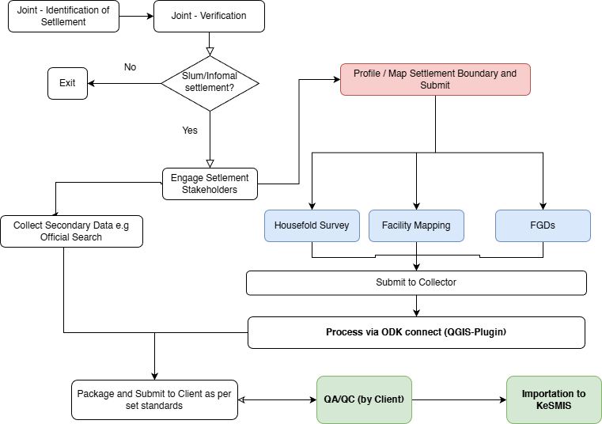
Figure 1: Overall mapping workflow

Tools
The mapping and profiling of slums and informal settlements was supported by a set of standardized tools to ensure consistency and comparability of outputs across all counties. Spatial data collection was guided by a structured Settlement Mapping Tool, which defined mapping standards for settlement boundaries, infrastructure, facilities, land status, development characteristics, and environmental features. Socio-economic data was captured using a Household Socio-Economic Profiling Questionnaire administered to Sampled households within the mapped settlements. In addition, settlement-level reporting followed a standard Settlement Profile Outline to ensure uniform presentation of spatial, socio-economic, and analytical outputs. These tools collectively enabled harmonized data capture, validation, and integration into the Kenya Slum Management Information System (KeSMIS) and are provided in Annex 1 (Mapping Tools), Annex 2 (Household Questionnaire), and Annex 3 (Settlement Profile Outline), respectively.

Approach

Settlement Identification
The identification of slums and informal settlements was undertaken through a structured, collaborative process involving the National Project Coordination Team (NPCT), county governments, and the consulting teams. At the outset, the NPCT provided an initial national list of slums and informal settlements based on existing programme records, previous mapping exercises, and administrative datasets. In parallel, county governments submitted their own settlement lists derived from local knowledge, county records, and prior planning and upgrading initiatives.
The consulting teams reviewed, harmonized, and consolidated these lists through a joint verification process conducted in collaboration with county technical officers. This process involved the application of agreed national criteria for defining slums and informal settlements, including settlement morphology, tenure conditions, planning status, infrastructure access, and development characteristics (Annex 4). Settlements that met the agreed criteria were confirmed for inclusion, while duplications, misclassifications, and boundary ambiguities were resolved through joint technical discussions and field verification where necessary.
Following confirmation, a final validated list of slums and informal settlements was generated for each county. This validated settlement register formed the basis for detailed spatial mapping, infrastructure and facilities mapping, and settlement-level profiling under the KISIP2 mapping programme.

Infrastructure Mapping
Within each mapped settlement, internal infrastructure and key facilities were spatially captured to support future upgrading and service planning. This included mapping of access roads and footpaths, drainage channels, water points, sanitation facilities, electricity infrastructure, and public or community facilities such as schools, health centers, markets, and open spaces. Data capture was undertaken using GPS-enabled mobile tools and structured data collection forms aligned with the national data schema.
Mapped infrastructure features were classified using standardized categories to enable aggregation and comparison across settlements and counties. Attribute completeness and spatial accuracy were verified through field checks, desktop review, and consistency checks prior to integration into the national database.

Socio-Economic Profiling
In parallel with the spatial mapping, household socio-economic profiling was undertaken to characterize the living conditions, service access, tenure arrangements, livelihoods, and vulnerability conditions of households within the mapped settlements. In most settlements, data was collected from sampled households using a structured Household Socio-Economic Profiling Questionnaire (Annex 2) administered through field interviews. However, in selected settlements undergoing tenure regularization under KISIP, complete household census data was available and was incorporated to provide more comprehensive household-level information.
The key household-level attributes captured included household composition, occupancy and tenure status, housing characteristics, access to water, sanitation, drainage, solid waste management, electricity and roads, livelihood and income sources, education and health-related indicators, and exposure to environmental risks such as flooding or proximity to riparian reserves and infrastructure wayleaves. The data was coded using predefined response categories and standardized value lists to ensure consistency, comparability, and integration into the Kenya Slum Management Information System (KeSMIS).

Quality Assurance
A multi-layered quality assurance and validation framework was applied throughout the mapping process. At consultant level, internal checks were conducted to ensure spatial accuracy, attribute completeness, and adherence to mapping standards. County-level validation workshops were then held to review settlement boundaries, attributes, and infrastructure mapping, allowing counties to confirm accuracy and provide corrective input where necessary.
Final validation was undertaken by the National Project Coordination Team through systematic review of spatial and attribute datasets, including topology checks, logical consistency tests, and cross-reference with existing national and county datasets. Only validated datasets were accepted and integrated into the Kenya Slum Management Information System (KeSMIS).

Data Management
All validated spatial and attribute data generated through the mapping exercise were structured, coded, and stored within the Kenya Slum Management Information System (KeSMIS) as the central national geospatial database for slums and informal settlements. The data models, naming conventions, and coding standards used during the mapping were aligned with KeSMIS requirements to ensure consistency, interoperability, routine updating, and integration with relevant government and sectoral datasets.

Findings

Settlement characteristics
The national mapping and profiling exercise documented slums and informal settlements across all 47 counties, providing a consolidated evidence base for analysis and planning. The dataset captures 1,034 settlements with an estimated population of 3,906,666 people and approximately 1,598,632 households. Of these, 747 are classified as informal settlements and 287 as slums, while 957 settlements were fully profiled, 75 not profiled, and 2 partially profiled. The settlements vary by density, tenure and planning status, housing and development typology, service access, and environmental risk exposure. Most are low-density and predominantly single-storey settlements, with a mix of planned and surveyed, unplanned and unsurveyed, partially regularized, and unknown land-status categories. These variations are discussed in the sections below to highlight patterns relevant to upgrading, tenure regularization, service delivery, risk mitigation, and investment prioritization.

Distribution by County
The distribution of slums and informal settlements across Kenya’s 47 counties reveals marked spatial disparities, with concentrations in major urban, coastal, and peri-urban growth areas. Nairobi County accounts for the highest number of mapped settlements, with 211 settlements, representing 20.41% of the national total, followed by Mombasa with 63 settlements (6.09%) and Kilifi with 46 settlements (4.45%). Other counties with notable concentrations include Kirinyaga, Nakuru, Laikipia, Nyeri, Turkana, Mandera, and Tana River. The remaining counties collectively account for 69.05% of all mapped settlements, confirming that while slums and informal settlements are a national phenomenon, their intensity is highest in counties experiencing rapid urban growth, coastal expansion, migration pressures, and peri-urban transformation.
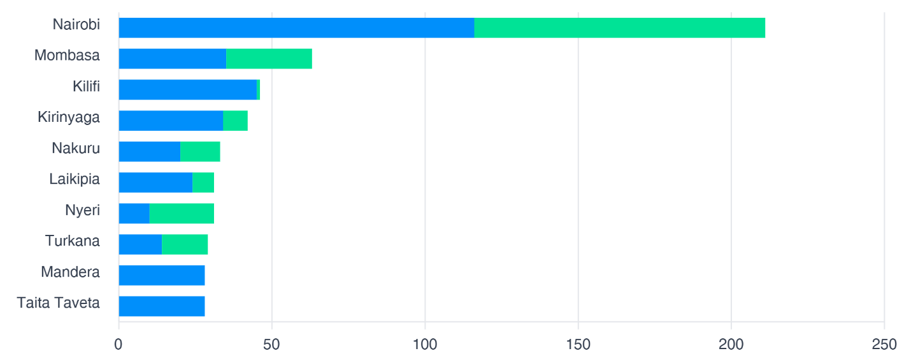
Figure 2: Top 10 Counties by Number of Slums and informal Settlements
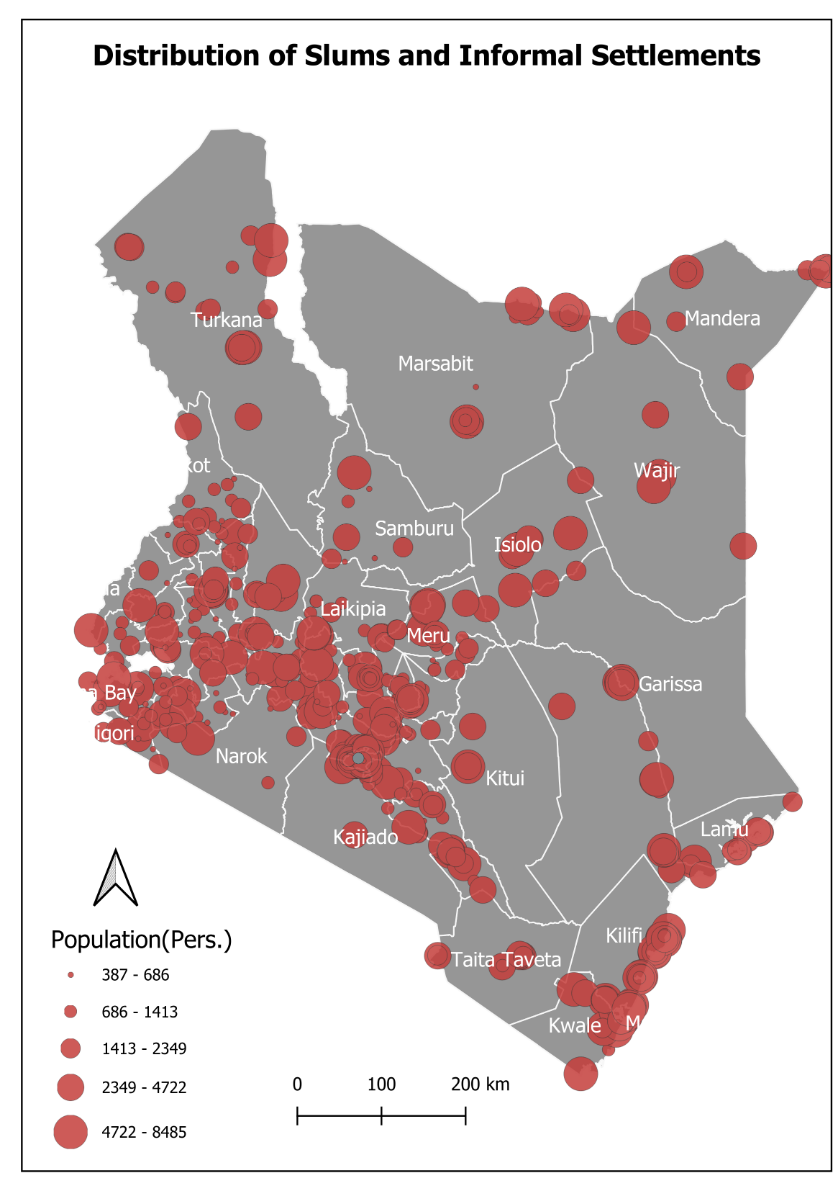
Figure 3: Distribution of settlements across the country. Symbols size represents the estimated populations within a settlement

Population within slums and Informal settlements
Population distribution patterns differ significantly from settlement counts, reflecting major variation in average settlement size across counties. Nairobi has the largest mapped slum and informal-settlement population, with 1,171,275 people, representing about 29.98% of the national total, followed by Mombasa with 420,982 people (10.78%), Kilifi with 223,024 people (5.71%), Mandera with 176,274 people (4.51%), and Nakuru with 155,067 people (3.97%). While Nairobi also has the highest number of mapped settlements, some counties have fewer settlements but relatively large average settlement populations, including Kajiado, Wajir, Mombasa, Kisumu, Mandera, Kiambu, and Kilifi.
By settlement typology, informal settlements accommodate the largest share of the mapped population, with 2,993,293 people, or 76.62% of the total, compared to 913,373 people, or 23.38%, in settlements classified as slums. However, for settlements with complete population and area records, slums record a much higher population density than informal settlements, at approximately 145 persons per hectare compared to about 40 persons per hectare. This suggests that although informal settlements are more numerous and accommodate a larger absolute population, slums generally face more acute overcrowding and spatial pressure, requiring differentiated upgrading, service delivery, tenure regularization, and risk-reduction responses.

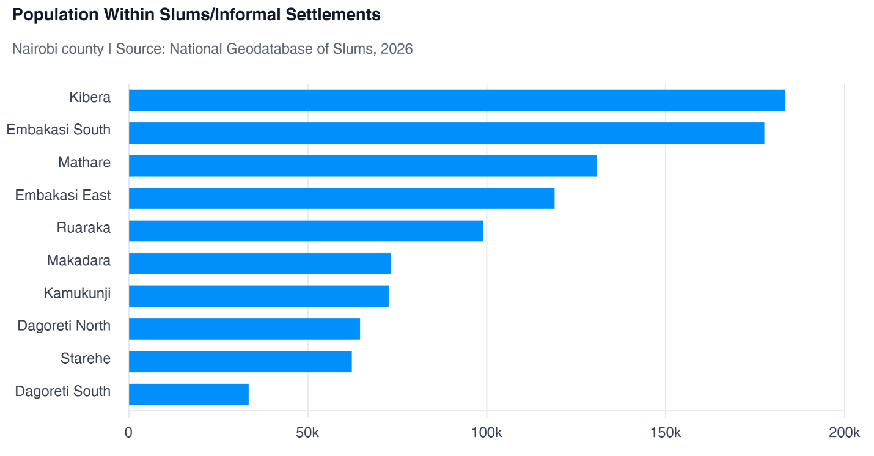
Figure 4: Population within informal settlements and slums (Top 10 counties)

Household socio-economic profiling shows that most households in the mapped settlements are small to medium in size, with the majority comprising between one and five members. Single-person households form the largest category at 25.46%, followed by three-member households at 15.49% and four-member households at 14.50%. Although average household size varies by county and settlement, the overall pattern generally points to household sizes of about three to four persons, with implications for housing demand, sanitation, water supply, solid waste management, social amenities, and other basic services. The household data was derived from sampled household interviews in most settlements, while complete household census data was incorporated for selected settlements undergoing tenure regularization under KISIP.

In terms of marital status, the majority of respondents were married, accounting for 55.37% of the profiled population, while 24.85% were single. This indicates the presence of established family units alongside a significant proportion of younger, independent, or single-person households within the settlements. These demographic patterns are important for understanding housing needs, household vulnerability, livelihood planning, and the design of settlement upgrading interventions.
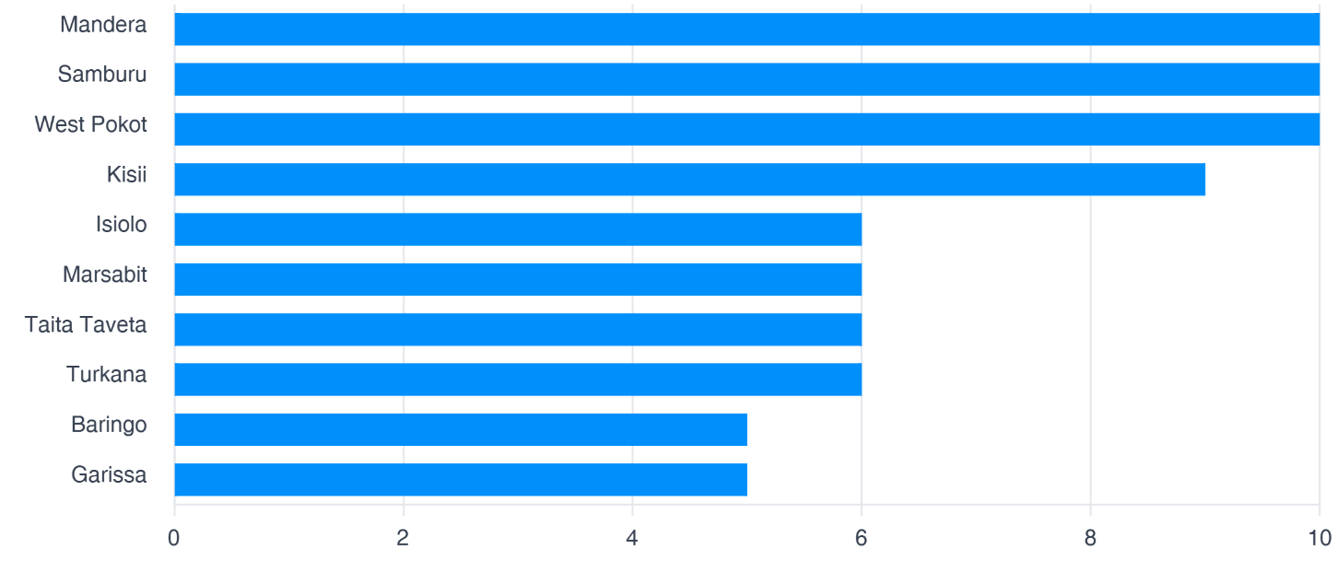
Figure 5: Average Household sizes across the counties (Top 10 counties)

Settlement Typologies

Settlement Classification
Mapped settlements were classified into two broad typologies: informal settlements and slums. Informal settlements account for 747 settlements, representing 72.24% of all mapped settlements, while slums account for 287 settlements, or 27.76%. By density typology, the majority of settlements are low-density, with 884 settlements, representing 85.49% of the national total. Medium-density settlements account for 88 settlements (8.51%), while high-density settlements account for 52 settlements (5.03%). A small number of settlements, 10 in total (0.97%), do not have a recorded density typology. This distribution shows that while most mapped settlements are relatively low-density in spatial form, a smaller but important share of medium- and high-density settlements may require more intensive upgrading, infrastructure provision, and risk-management interventions.
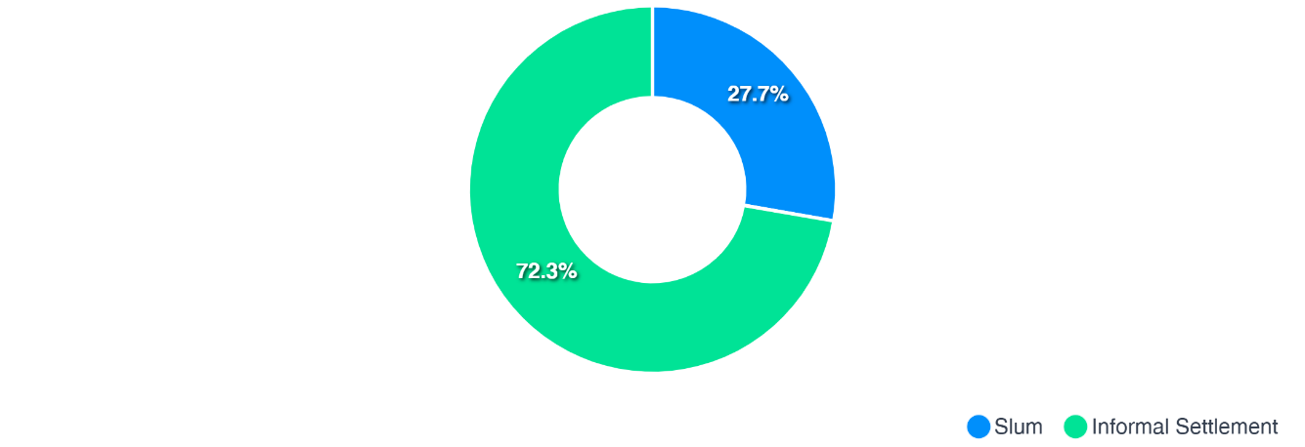
Figure 6: Settlement Typologies
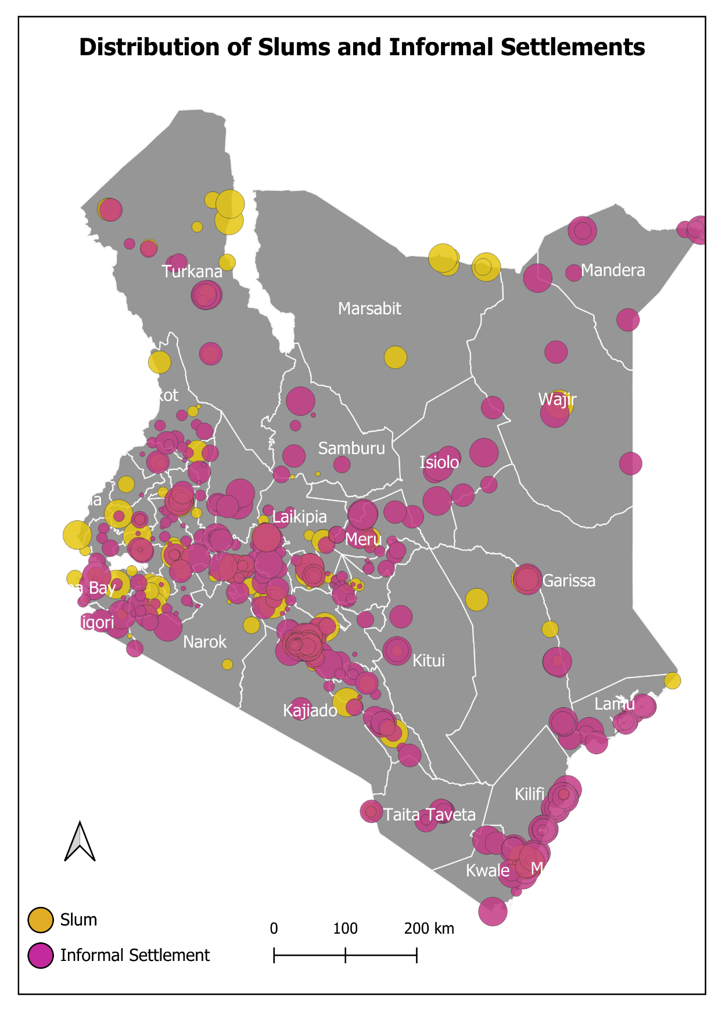
Figure 7:Mapped settlements by type and density typology; circle size is proportional to population.

Development Typology
The mapped settlements are predominantly single-storey in form. A total of 951 settlements, representing 91.97% of all mapped settlements, are recorded as single-storey dominant. Mixed single- and multi-storey development accounts for 24 settlements (2.32%), while exclusively multi-storey settlements remain limited at 11 settlements (1.06%). A further 43 settlements (4.16%) do not have a recorded development typology. This pattern shows that most slums and informal settlements remain low-rise in physical form, although emerging mixed and multi-storey patterns point to gradual densification in some locations.
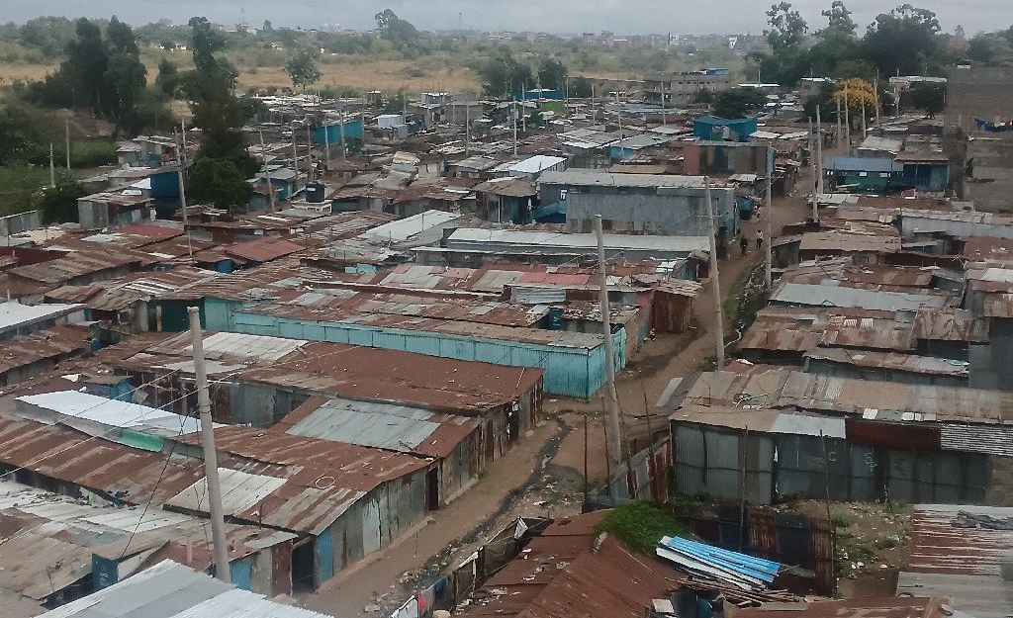
Figure 8: Single-storey housing in an urban informal settlement, City Carton, Nairobi County. Structures are predominantly temporary, with iron-sheet/grass roofing and earth/polythene-carton walling.

Structure Types
Permanent structures are the dominant reported structure type across the mapped settlements. Based on the dataset, 590 settlements, representing 57.06% of all mapped settlements, are recorded as predominantly permanent. Semi-permanent structures account for 271 settlements (26.21%), while temporary structures are reported as the dominant type in 35 settlements (3.38%). Mixed structure typologies are also present, including settlements with combinations of permanent, semi-permanent, and temporary structures, reflecting varied levels of settlement consolidation, household investment, and tenure confidence. Structure type information was not recorded for 42 settlements (4.06%).

Building Materials
Stone/blocks are the predominant reported building material, recorded as the main material in 663 settlements, representing 64.12% of the national total. This indicates substantial use of durable construction materials across many mapped settlements. Mud is the main material in 73 settlements (7.06%), timber/wood in 36 settlements (3.48%), and iron sheets in 11 settlements (1.06%). A further 152 settlements (14.70%) report mixed or detailed material combinations, while 42 settlements (4.06%) do not have recorded building-material information. The mix of durable and less durable materials points to varying levels of housing quality, settlement maturity, and vulnerability across counties.
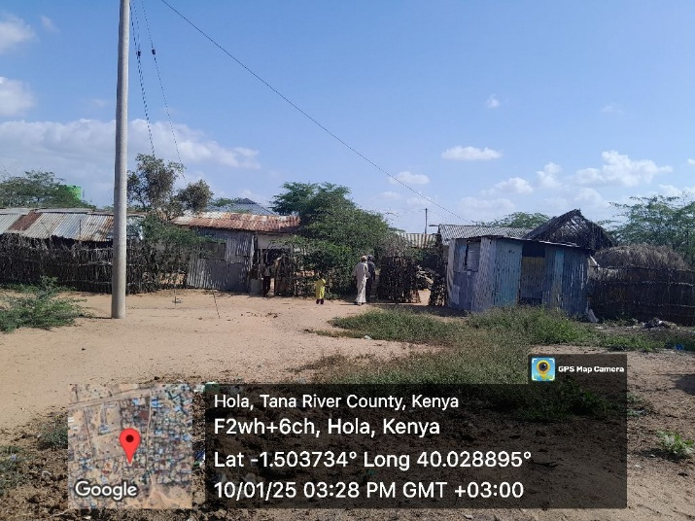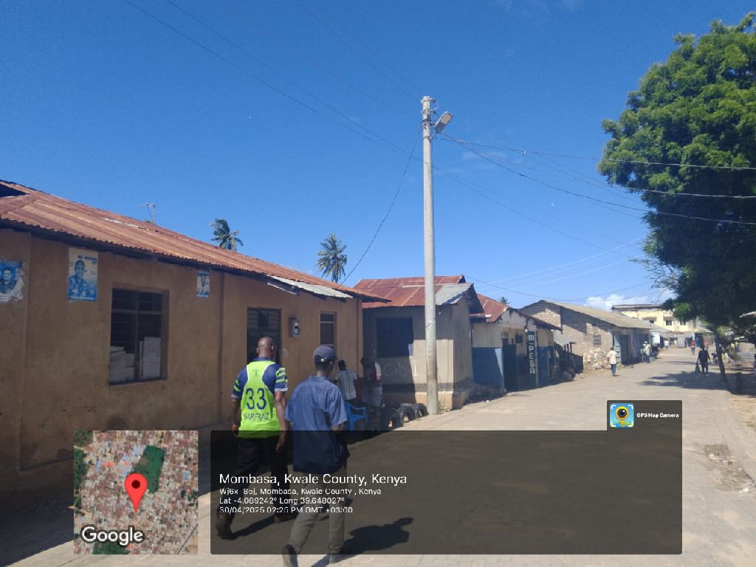
Figure 9: Settlement structures comprised of largely temporary structures in Hola, Tana River (Left) and settlements comprised of permanent structures in Mombasa (Right)

Land Tenure and Ownership

Land Ownership

Land tenure and ownership conditions vary substantially across slums and informal settlements in Kenya. A single national summary can obscure important differences between urban and rural settlement contexts, particularly in tenancy levels, land ownership categories, tenure documentation, and the pathways through which households access land and housing. This section therefore presents tenure analysis by settlement location, drawing on settlement profiling data for 1,036 settlements and household survey data for 71,844 households.

At settlement level, public land is the dominant ownership category, accounting for 543 settlements, or 52.46% of the mapped settlements. Private land accounts for 300 settlements (28.99%), while community land accounts for 79 settlements (7.63%). A further 51 settlements (4.93%) have mixed ownership arrangements, mainly involving combinations of public, private, and community interests, while 62 settlements (5.99%) are recorded as unknown.

The predominance of public land presents opportunities for state-led upgrading, tenure regularization, and infrastructure provision. However, the presence of private, community, mixed, and unknown ownership categories highlights the need for differentiated intervention approaches, including ownership verification, stakeholder engagement, dispute resolution, and careful assessment of tenure and encumbrance risks before implementation.

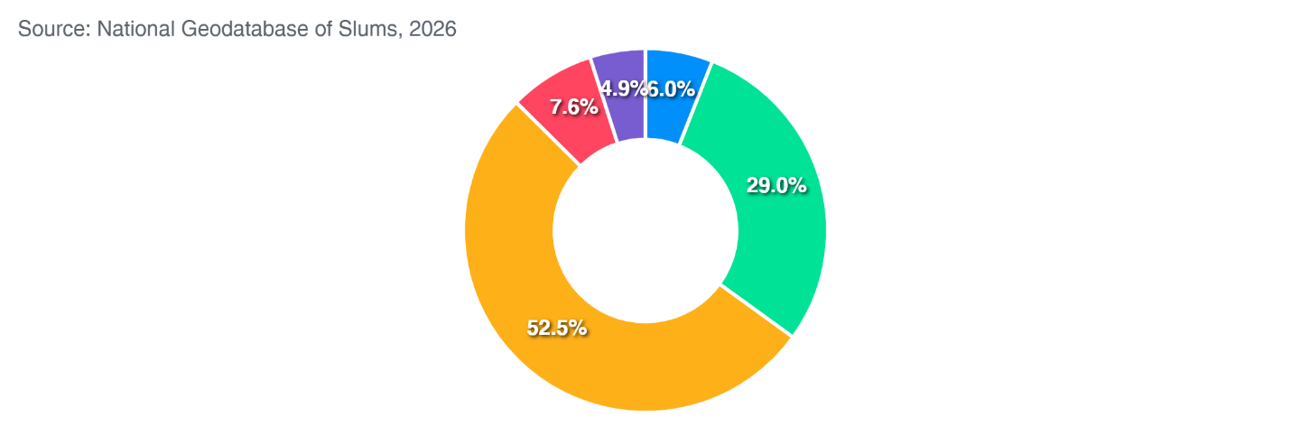
Figure 10: Land Tenure status in the profiled settlements

At household level, tenure arrangements demonstrate that informal settlements are characterized by a mix of individualized, shared, and collective occupancy systems rather than a uniform model of residence. Among households with a valid stated tenure arrangement (32,021 valid responses, excluding unspecified categories), single or individual arrangements overwhelmingly dominate, accounting for 85.37% (27,336 households). Joint household arrangements, including husband–wife or shared family occupancy, represent 11.77% (3,769 households), while group or collective arrangements account for 2.85% (912 households). Tenancy in common arrangements remain extremely rare at only 0.01% (4 households). These findings suggest that although informal settlements are frequently perceived as communal spaces, residential occupation is largely organized around independent household units, reflecting both owner-occupation and privately managed rental arrangements within dense settlement environments.
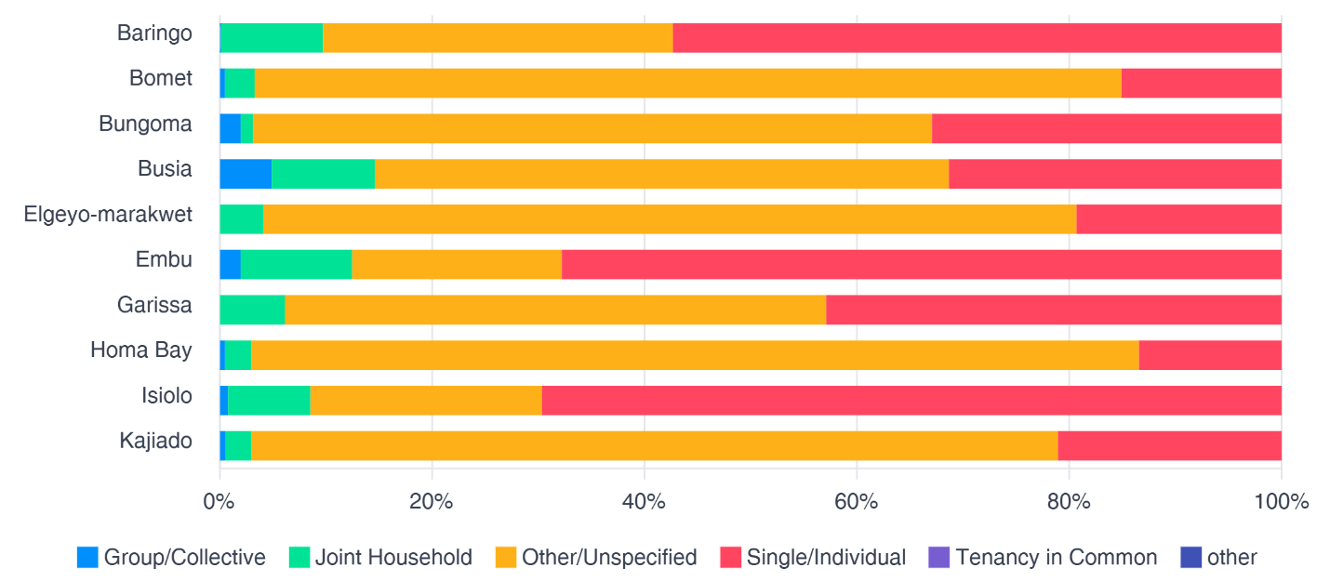
Figure 11: Plot ownership distribution for select counties
Household tenure status further illustrates the coexistence of ownership and rental markets within informal settlements (Figure 12). Among households with a valid reported tenure status (63,082 valid responses, excluding unspecified categories), tenant or renter occupancy constitutes a slight majority at 51.60% (32,552 households), compared to 48.40% (30,530 households) who are owner-occupied. This near parity between renters and owners highlights the important role of informal rental markets in accommodating urban populations unable to access formal housing systems. It also reinforces evidence that many informal settlements increasingly function as established residential neighbourhoods and active housing markets rather than temporary spaces of occupation. However, heavy reliance on rental housing may also contribute to overcrowding, insecure occupancy, and reduced incentives for long-term housing improvements where residents lack secure tenure.
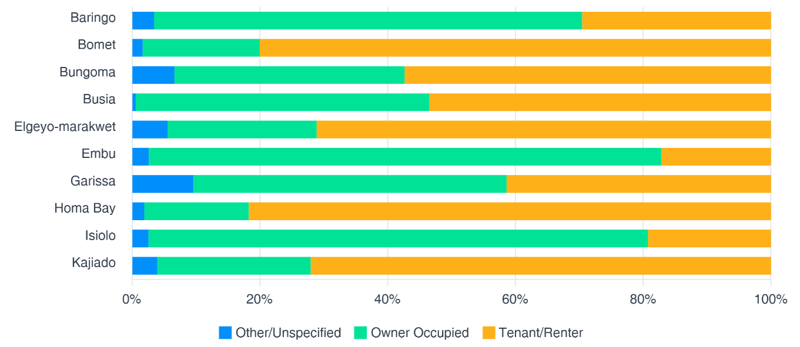
Figure 12: Land occupancy and tenancy arrangements within slums and informal settlements in select counties

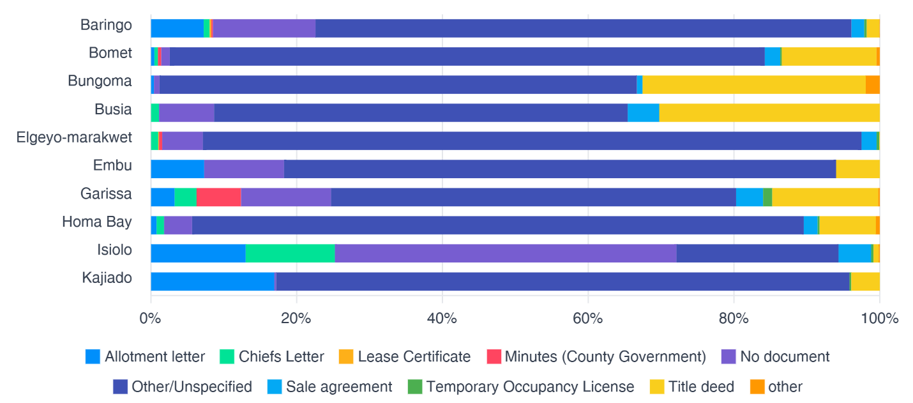
Figure 13 : Evidence of Tenure security in select counties
Evidence of tenure security remains mixed when assessed through documentation. Among households providing a valid response on tenure documentation (15,111 valid responses, excluding unspecified categories), 39.28% (5,936 households) report having no tenure-related documentation, pointing to persistent informality and insecurity of land claims. However, a range of both formal and semi-formal documentation systems is evident. Title deeds account for 19.91% (3,009 households) of valid responses, followed by allotment letters at 14.75% (2,229 households) and sale agreements at 12.76% (1,928 households). Chiefs’ letters represent 7.86% (1,187 households), while county government minutes account for 2.26% (342 households). Temporary occupancy licenses (1.61%; 244 households) and lease certificates (1.56%; 236 households) remain relatively limited.
Land tenure in informal settlements differs sharply between urban and rural locations, and a single national average hides this divide. At household level, among respondents with a stated tenure status, 52.5% of households in urban settlements are tenants compared with only 34.7% in rural settlements; conversely, 42.7% are owners in urban areas versus 54.3% in rural areas, with rural settlements also showing a higher share of occupiers (11.0% compared with 4.8% in urban areas). Nationally, tenants and owners are almost evenly split (48.6% tenants and 45.5% owners), which masks these opposite patterns. At settlement level, urban settlements are more concentrated on public land (56.0% of 575 urban settlements), while rural settlements have a lower share on private land (16.5%) and a higher share on community/communal land (15.0% of 133 rural settlements). Rural settlements also show lower tenancy intensity at plot level, with a median reported plot tenant ratio of 0.3% compared with 1.0% in urban settlements. These findings indicate that urban informal settlements function largely as rental economies on public and private land, whereas rural settlements are characterized more by ownership, informal occupancy, and communal land arrangements, requiring different tenure and upgrading responses in each context.
The diversity of documentation types indicates that tenure security within informal settlements exists along a continuum of formality, ranging from undocumented occupation and socially recognized claims to partially formalized arrangements and registered ownership. The relatively widespread use of allotment letters, sale agreements, chiefs’ letters, and locally recognized administrative records suggests that many households rely on de facto tenure systems rather than fully registered legal ownership. While such arrangements may provide a practical degree of occupancy security, they often constrain access to formal credit, compensation frameworks, infrastructure investments, and long-term housing improvements.

Land Encumbrances
Most mapped settlements have no recorded encumbrances, with 882 settlements, representing 85.30% of the total, recorded as having none. A further 43 settlements (4.16%) have missing or unknown encumbrance information. Encumbrances are reported in 109 settlements overall, comprising 63 settlements (6.09%) with a general indication of encumbrance and 46 settlements (4.45%) with specific reported issues. The specific encumbrances include boundary conflicts, encroachments, ownership disputes, incomplete adjudication, court cases, riparian reserve restrictions, road or powerline wayleaves, and contested public-private land claims. These cases require further verification and risk assessment before upgrading, tenure regularization, infrastructure investment, or planning interventions are undertaken.

Infrastructure and Services
The national mapping and profiling exercise shows mixed progress in infrastructure and services across slums and informal settlements. Basic infrastructure is present in many locations, but service access remains uneven, especially for electricity and piped water. Legal and spatial constraints, including settlement location on reserves, continue to limit reliable service delivery.

Electricity
Electricity infrastructure has expanded across informal settlements, with powerline networks mapped in 832 settlements covering a cumulative length of 1,708.82 km. At settlement level, electricity is reported as available in 752 of 1,035 settlements, representing 72.66%, while 243 settlements, or 23.48%, report no access and 40 settlements, or 3.86%, are unspecified. Excluding missing responses, this corresponds to 75.58% of settlements with electricity and 24.42% without.
This settlement-level pattern is broadly reflected in household access outcomes, although household-level access is assessed using valid non-missing household responses. Among 67,034 households with a stated electricity connection status, 52,264 households, or 77.97%, reported being connected to the main electricity supply, while 14,720 households, or 21.96%, reported no connection. A very small proportion, 50 households, or 0.07%, fell within other response categories. These findings show that electricity access is relatively widespread across surveyed informal settlements, but a sizeable minority of households remain excluded from formal electricity connections.
Among households not connected to electricity, affordability remains the main barrier. Of the 14,712 households with a stated reason for non-connection, more than half, 7,652 households or 52.01%, reported inability to afford the connection deposit. This was followed by lack of electricity infrastructure in the area, reported by 3,841 households or 26.11%, and unclear connection procedures, reported by 2,338 households or 15.89%. A further 881 households, or 5.99%, cited other reasons. These findings suggest that the presence of electricity infrastructure at settlement level does not automatically translate into universal household access, as affordability, infrastructure gaps, and administrative barriers continue to constrain connection.
Household lighting patterns further reinforce the importance of electricity as a dominant energy source. Among 68,700 households with a stated lighting source, electricity was reported as the primary lighting source by 52,395 households, or 76.27%. Solar energy was the second most common source, used by 8,343 households or 12.14%, followed by candles at 3.81%, kerosene at 3.20%, and firewood at 2.22%. Although electricity is the leading source of lighting, continued reliance on solar, candles, kerosene, and firewood indicate remaining pockets of energy poverty, affordability constraints, unreliable supply, and uneven internal distribution of electricity infrastructure.
Cooking energy patterns show that access to electricity for lighting has not translated into widespread use of clean cooking energy. Among 67,042 households with a stated cooking-energy source, charcoal remains the most commonly reported sole cooking fuel, used by 15,412 households or 22.99%, followed by firewood at 20.16% and LPG at 13.95%. Charcoal and firewood as sole fuels together account for 43.15% of non-missing cooking-energy responses before mixed-fuel combinations are considered, underscoring continued dependence on biomass energy and the associated health, environmental, and household-expenditure implications.

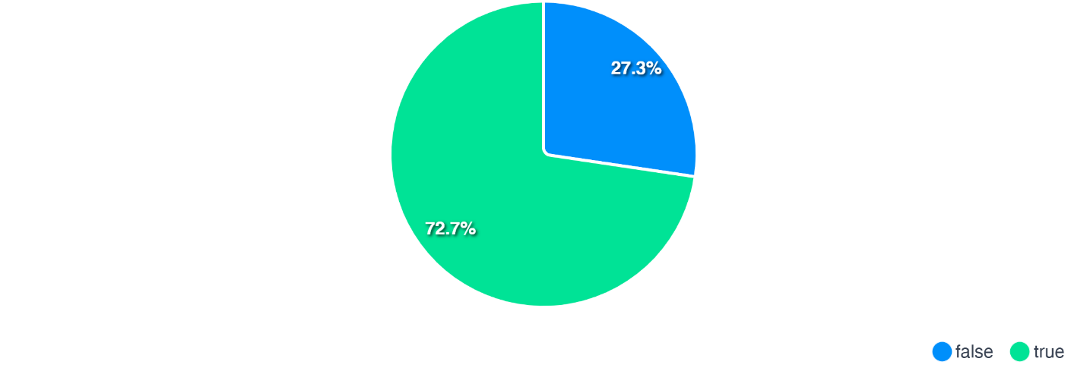
Figure 14: Availability of Electricity Infrastructure in the profiled settlements

Piped Water
Piped water remains one of the most critical service deficits in informal settlements. Two complementary measures are reported: physical network mapping and reported availability/use. Network mapping documented piped-water infrastructure within 329 settlements, with a cumulative length of 378.68 km across 1,164 sections, averaging 1.15 km per mapped settlement. Coverage is geographically dispersed across 34 counties, with Isiolo, Nairobi, Kiambu, Murang’a, and Laikipia together accounting for about 48.2% of the total mapped length.
At settlement level, piped water is reported as available in 538 of 1,035 settlements, representing 51.98%, unavailable in 456 settlements or 44.06%, and unspecified in 41 settlements or 3.96%. Excluding missing responses, this corresponds to approximately 54.14% of settlements with piped-water availability and 45.86% without. The fact that more settlements report availability than have a mapped internal piped-water network suggests that some households rely on connections originating outside settlement boundaries, partial service points, or shared access infrastructure that may not be fully captured as internal networks.
At household level, water access shows a stronger reliance on piped sources, although direct household connections remain limited. Among 71,775 households with a stated main drinking-water source, 41,822 households, or 58.27%, reported using some form of piped water. This includes 17,963 households or 25.03% using piped water into the compound, 14,579 households or 20.31% using piped community taps, 6,382 households or 8.89% with piped water into the house, and 2,898 households or 4.04% recorded under generic piped-water connections.
Despite the prominence of piped water, a considerable share of households continues to rely on alternative sources that may be less reliable, less safe, or more costly. Shallow wells are used by 8,807 households or 12.27%, rivers or streams by 8,395 households or 11.70%, and mobile water vendors by 6,565 households or 9.15%. Smaller shares rely on rainwater or roof catchment at 2.58%, boreholes at 1.43%, and other sources at 3.94%. This combination of partial piped-water access and continued reliance on wells, rivers, streams, and vendors sustains public health risks, increases household water-related expenditure, and highlights the need for targeted upgrading of reliable, affordable, and safe water systems within settlements.

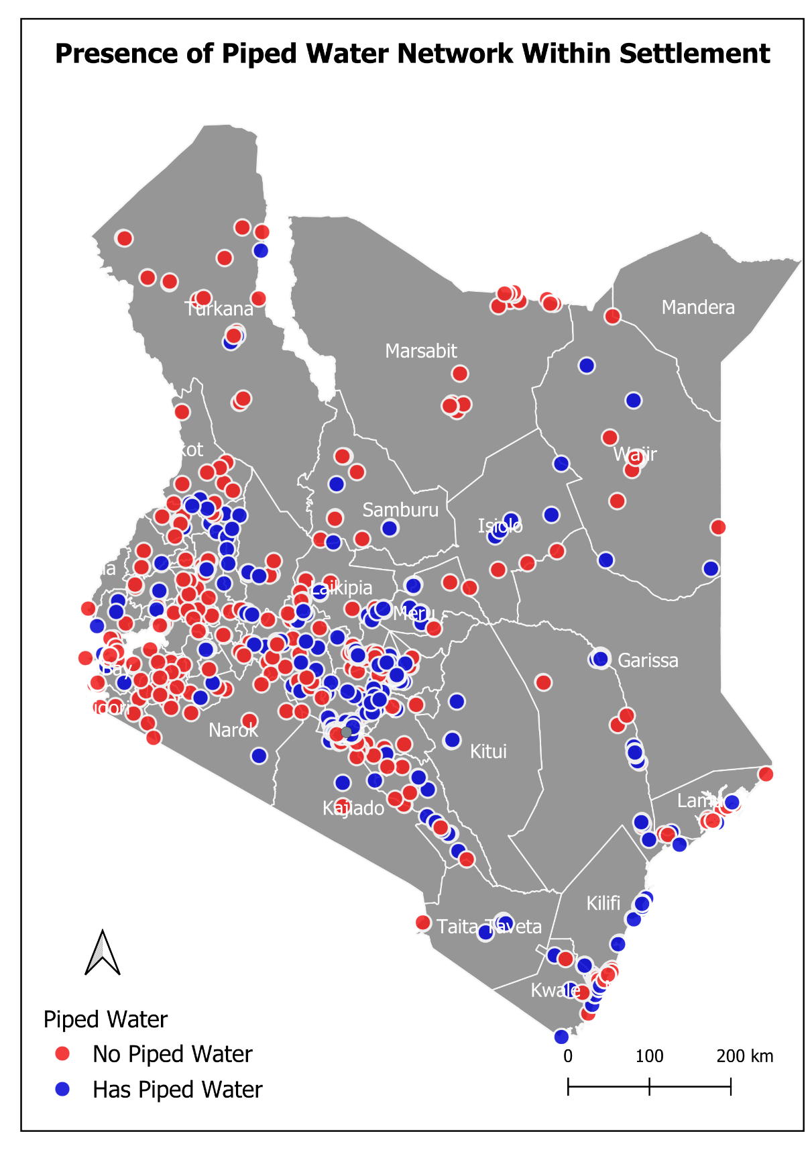
Figure 15: Distribution of settlements with piped water infrastructure within the settlement

Sewer
Sewer infrastructure exhibits the lowest mapped coverage among the core network services. A total of 190 settlements are served by mapped sewer infrastructure, with a cumulative length of 145.64 km across 616 sections, averaging 0.77 km per served settlement. Of the mapped sewer network, 85.3% by length is reported as operational, while smaller shares are broken or not in use, under construction, or decommissioned.
Household-level sanitation outcomes confirm the limited reach of formal sewer-connected systems. Among 60,000 households with a stated toilet type, only 2,052 households, or 3.42%, reported using a WC/sewer-connected facility. The majority of households rely on on-site sanitation, especially pit latrines, which account for 40,931 households or 68.22%. Flush toilets account for 11,410 households or 19.02%, VIP latrines for 3,804 households or 6.34%, and bucket toilets for 1,738 households or 2.90%.
Access to any toilet facility is relatively widespread among households that provided responses, but a significant minority remain without access. Among 67,034 households with a non-missing toilet-access response, 60,000 households, or 89.51%, reported having access to a toilet facility, while 7,034 households, or 10.49%, reported no access. In addition, 4,810 households, representing 6.70% of all 71,844 households, had missing toilet-access responses.
Toilet affordability appears less significant than infrastructure quality and access constraints. Among 67,034 households with a stated toilet-payment response, 63,812 households, or 95.19%, reported that they do not pay to use a toilet, while 3,222 households, or 4.81%, reported paying for toilet use. However, reliance on shared, communal, or informal sanitation facilities may still affect cleanliness, privacy, safety, accessibility, and reliability, particularly for women, children, elderly persons, and persons with disabilities.
Handwashing access remains a major public health concern. Among 67,034 households with a non-missing handwashing response, only 12,880 households, or 19.21%, reported access to handwashing facilities with both soap and water. A further 9,646 households, or 14.39%, reported access to water only, while 19,894 households, or 29.68%, reported handwashing facilities without specification. Conversely, 18,860 households, or 28.13%, reported no handwashing access, and 5,754 households, or 8.58%, reported no facility at all.
The combination of low mapped sewer coverage, limited household connection to WC/sewer systems, continued dominance of pit latrines, and inadequate soap-and-water handwashing facilities highlights a major sanitation and hygiene gap. These deficits are especially concerning in high-density, flood-prone, and environmentally vulnerable settlements, where on-site sanitation systems are more likely to fail and contribute to contamination, disease outbreaks, and wider public health risks.

Road Infrastructure
Roads show the broadest spatial reach of all mapped infrastructure types, serving 889 settlements with a cumulative mapped length of 3,049.27 km across 13,167 road sections, averaging 3.43 km per settlement. This reflects the central role of road infrastructure in settlement access, mobility, emergency response, service delivery, public transport connectivity, and the movement of goods and livelihoods within and beyond informal settlements.
Road surface analysis within mapped settlements indicates the continued dominance of unpaved roads. Paved roads account for 699.43 km, representing 22.94% of mapped road length and 20.79% of road sections. Unpaved roads account for 2,153.28 km, representing 70.62% of mapped road length and 70.56% of road sections. A further 196.56 km, or 6.45% of mapped road length, is recorded as unknown or unspecified surface type, accounting for 8.65% of road sections.
Excluding roads with unknown or unspecified surface type, approximately 24.52% of mapped road length is paved, while 75.48% remains unpaved. This highlights persistent all-weather access, drainage, dust, maintenance, mobility, and emergency-response constraints within many settlements. The dominance of unpaved roads also has implications for service delivery, waste collection, school and health access, safety during rainy seasons, and the movement of construction materials during upgrading works.

Encroachment on Reserves
A significant proportion of settlements remain located on legally designated reserve land. Profiling data indicate 145 settlements (14.01%) on wayleaves and 177 settlements (17.10%) on road reserves, with 211 settlements (20.39%) on at least one type of reserve. These locations create constraints for infrastructure investment and long-term service regularization due to legal restrictions, safety concerns, and the risk of future infrastructure expansion. As a result, residents in reserve-encroached settlements frequently depend on informal or temporary service arrangements, which are generally less safe, less reliable, and less affordable over time.

Environmental Hazards
Environmental and climate-related risk exposure is widespread across Kenya’s slums and informal settlements, reflecting the interaction between settlement location, inadequate infrastructure, environmental degradation, and socio-economic vulnerability. Settlement profiling indicates that many settlements are located in environmentally sensitive or hazard-prone areas, increasing exposure to flooding, service disruption, displacement, and public health risks.
Settlement-level vulnerability assessments show that climate and environmental vulnerability is widespread but varies across settlements. Among 1,045 settlements with valid vulnerability ratings, 659 settlements, or 63.06%, are classified as having medium vulnerability, while 368 settlements, or 35.22%, are classified as low vulnerability. A smaller but important group of 18 settlements, or 1.72%, are classified as high vulnerability. The predominance of medium vulnerability suggests that most settlements face recurring environmental and climate-related stresses that require targeted infrastructure, drainage, sanitation, waste management, and resilience interventions, while highly vulnerable settlements should be prioritized for urgent mitigation and adaptation measures.
Locational characteristics significantly shape vulnerability patterns. Settlement profiling indicates that 271 settlements, or 26.16%, are located near rivers, 145 settlements, or 14.00%, are situated on infrastructure wayleaves, and 178 settlements, or 17.18%, are located on road reserves. These locations heighten exposure to flooding, erosion, infrastructure disruption, environmental degradation, displacement, and legal or spatial constraints that may limit long-term infrastructure investment and service regularization.
Household-level findings further reinforce the extent of environmental and climate-related risks experienced by residents. Based on the updated household survey summary covering 71,844 households, disaster exposure remains widespread. On the disaster-experience field, 43,538 households, equivalent to 60.60% of all households, named at least one disaster type, while 24,927 households, or 34.70%, were recorded as NULL/Missing and 3,379 households, or 4.70%, were coded as blank/NaN. Among the 46,917 households that were not missing on this field, 92.8% listed at least one hazard, indicating very high exposure among respondents who provided disaster information.
Among households with a valid first-ranked disaster response, the leading hazards are drought and flooding. Of the 41,561 households with a non-missing and non-NaN first-ranked disaster, 12,279 households, or 29.54%, identified drought as the primary disaster, while 8,628 households, or 20.76%, identified flooding. These were followed by violent conflicts at 18.42%, disease outbreaks at 14.51%, and fires at 10.98%. Drought and flooding together account for 50.30% of valid first-ranked disaster responses, confirming the central importance of water-related climate risks in informal settlements.
Secondary and tertiary disaster rankings show that hazards often occur in combination rather than as isolated events. Among 39,448 households with a valid second-ranked disaster, disease outbreaks were the most common secondary hazard at 32.95%, followed by flooding at 21.91% and drought at 21.46%. Among 35,948 households with a valid third-ranked disaster, disease outbreaks again ranked highest at 24.62%, followed by flooding at 22.54%, fires at 17.27%, violent conflicts at 15.16%, and drought at 12.53%. This pattern highlights the compound and cascading nature of risk, where climate shocks, public health risks, fires, and insecurity may overlap within the same households and settlements.
Despite high exposure to hazards, household-level preparedness and mitigation remain limited. Excluding NULL/Missing responses, 39,911 households remain in the disaster-mitigation field. Of these, 12,321 households, or 30.87%, reported some form of mitigation, while 26,379 households, or 66.09%, reported no mitigation. Among households with a clear yes/no response, 31.84% reported mitigation measures. These findings point to a major resilience gap, where many households experience environmental and climate-related shocks but lack adequate protective measures.

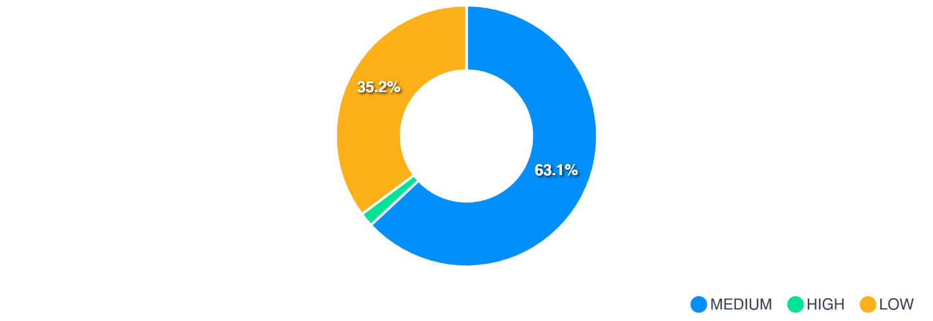
Figure 16:Climate and Environmental Vulnerability Rating of Profiled Settlements — Distribution of settlements by vulnerability category, showing predominantly medium vulnerability, followed by low vulnerability, with few settlements classified as highly vulnerable
The environmental hazards in slums and informal settlements are shaped by both physical location and service deficits. Settlements near rivers, reserves, wayleaves, and road corridors face heightened exposure, while inadequate drainage, limited sewer coverage, poor sanitation, weak solid-waste management, and constrained access infrastructure further increase household vulnerability. The findings underscore the need for integrated settlement-level resilience planning, including improved drainage and flood control, safer sanitation, fire prevention, early warning systems, environmental restoration, and targeted upgrading in high-risk settlements.

Socio-Economic characteristics
This section presents findings from a comprehensive household survey covering 71,844 households across mapped slums and informal settlements in Kenya. The analysis examines key socio-economic indicators, including demographic characteristics, access to basic services, digital inclusion, health access, vulnerability, social protection, safety perceptions, disaster risk, and community resilience factors. Percentages are reported using valid non-missing responses for each indicator; therefore, denominators may vary across variables.
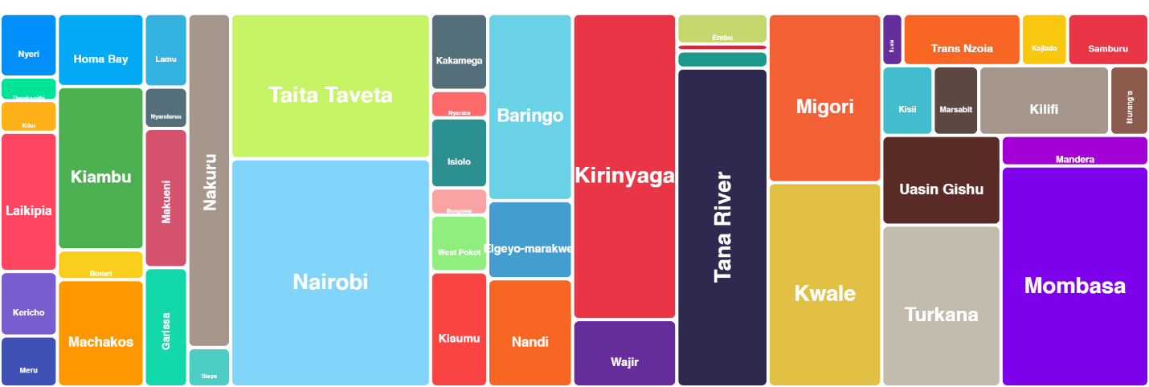
Figure 17: Distribution of profiled households per county

Demographic Composition
The household survey conducted across 71,844 households within mapped slums and informal settlements reveals a predominantly young and economically active population, reinforcing the role of informal settlements as centers of labour mobility, livelihood opportunities, and urban population growth.

Age Distribution
The age structure is strongly concentrated within the productive age groups. Residents aged 26–35 years constitute the largest share at 26.72% (19,195 households), followed by those aged 36–45 years at 22.98% (16,510 households), 46–55 years at 15.59% (11,204 households), and 18–25 years at 12.37% (8,886 households). Overall, the concentration of residents within economically active age bands suggests considerable labour force potential, while simultaneously highlighting the need for expanded employment opportunities, skills development, housing, and urban social services to accommodate growing populations.
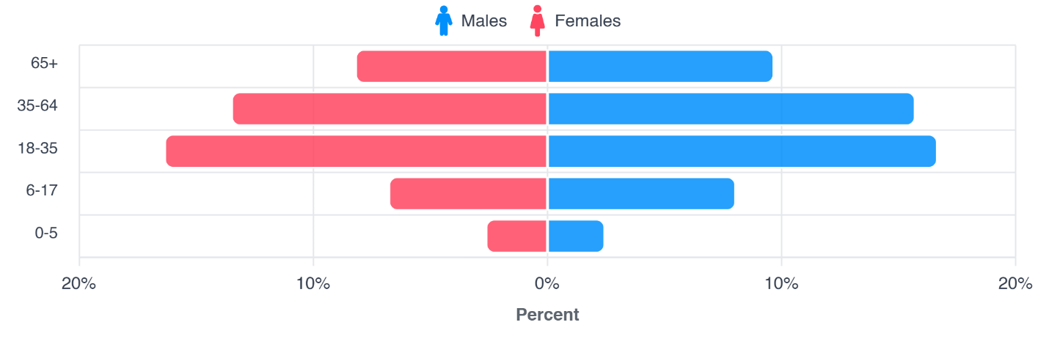
Figure 18: Age-gender population distribution within the settlements
Household composition reflects generally small to medium-sized family structures, typical of low-income urban environments. While household size varies across counties, the majority of households comprise between one and five members, with average household size generally ranging between three and four persons per household. Such household structures have important implications for housing demand, water consumption, sanitation provision, solid waste management, and access to education and health services. Smaller household sizes may reduce pressure on dwelling space, but high settlement densities continue to place significant strain on infrastructure and public services.

Gender Composition (Household heads)
Gender composition across the settlements shows a slight female majority. Among 71,828 households with a stated gender, 53.58% (38,482 households) of respondents were female, while 46.38% (33,314 households) were male. The remaining 0.05% (32 households) comprise intersex, unknown, prefer-not-to-say, or other categories. This demographic structure has implications for gender-responsive planning, particularly in relation to safety, livelihoods, social protection, maternal healthcare, and equitable access to services within informal settlements.

Marital Status
Marital status patterns indicate the coexistence of both established family units and younger or mobile populations within the settlements. Among 71,816 households with a stated marital status, the majority of household heads are married (55.09%; 39,561 households), followed by single respondents (24.83%; 17,829 households). Smaller proportions include widowed (7.41%; 5,325 households), cohabiting (5.80%; 4,163 households), separated (4.77%; 3,427 households), and divorced (2.02%; 1,454 households) respondents. The predominance of married households suggests the presence of relatively stable family units, while the substantial proportion of single-headed households may reflect labor migration, youthful populations, and emerging urban households seeking affordable accommodation within informal settlements.

Residency
Settlement residency patterns indicate a relatively stable but dynamic population profile. Among 66,400 households with a stated residence location, 94.99% (63,073 households) report living within the settlement, while 4.94% (3,278 households) report living outside the settlement but maintaining links to it. In terms of duration of stay, among 67,843 households with a stated residence period, 32.98% (22,377 households) have lived in the settlement for 1–5 years, while 28.47% (19,317 households) report residence periods of 21 years or more. A further 20.44% (13,867 households) have lived in the settlement for 11–20 years, while 18.04% (12,238 households) report residence durations of 6–10 years. This mix of long-term residents and newer migrants demonstrates that many slums and informal settlements are not temporary spaces but rather socially and economically established urban neighborhoods with long-standing populations and continued in-migration.
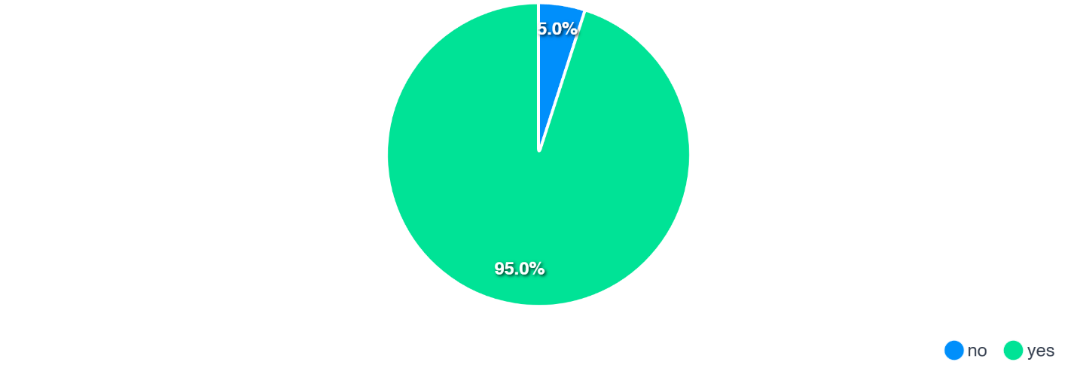
Figure 19: Residency within settlements
Most working household members are employed within their settlements (about 62%), while a substantial share commutes outside the settlement (about 38%), indicating that informal settlement’s function both as places of residence and as important local economic spaces, with only a very small proportion reporting other or unspecified work locations.
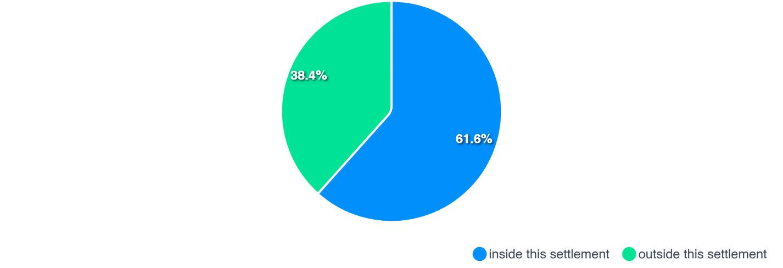
Figure 20:Reported places of work within the slums and informal settlements

Household Income
Household income levels within slums and informal settlements reveal a population predominantly concentrated within low-income and economically vulnerable categories, reflecting the heavy reliance on informal employment, casual labour, and small-scale enterprise activities. The income distribution demonstrates that a substantial proportion of households survive on modest and often irregular earnings, with important implications for affordability of housing, water, sanitation, healthcare, energy, and education.
Analysis of monthly household income indicates that more than half of surveyed households (50.2%; 36,044 households) earn below KES 10,000 per month, highlighting widespread income insecurity and constrained household purchasing power. The KES 0–5,000 category constitutes the largest single income bracket at 24.5% (17,618 households), followed closely by households earning KES 5,001–10,000, which account for 25.6% (18,426 households). These findings suggest that many households operate at or near subsistence levels and may struggle to meet the cost of essential urban services and basic needs.
A further 28.4% (20,419 households) of households earn between KES 10,001 and KES 20,000 per month, comprising 15.6% (11,228 households) in the KES 10,001–15,000 bracket, 11.9% (8,543 households) earning KES 15,001–20,000, and a small proportion (0.9%; 648 households) reporting a broader KES 10,001–20,000 category. Overall, approximately 78.6% of households earn below KES 20,000 per month, underscoring the limited income base available to most residents of informal settlements.
Middle-income households remain comparatively few. Approximately 9.2% (6,642 households) report monthly earnings between KES 20,001–30,000, while 5.0% (3,613 households) fall within the KES 30,001–50,000 range. Only 2.3% (1,652 households) report earnings above KES 50,000 per month, indicating that higher-income households constitute a very small minority within the surveyed settlements.
These income patterns reflect the structure of livelihoods within slums and informal settlements, where employment is frequently concentrated in informal businesses, self-employment, petty trade, casual labour, transport services, domestic work, and low-wage formal employment. Irregular and low incomes limit household capacity to invest in improved housing, sanitation, healthcare, education, and productive assets, while simultaneously increasing vulnerability to economic shocks, inflation, climate hazards, and public health emergencies.

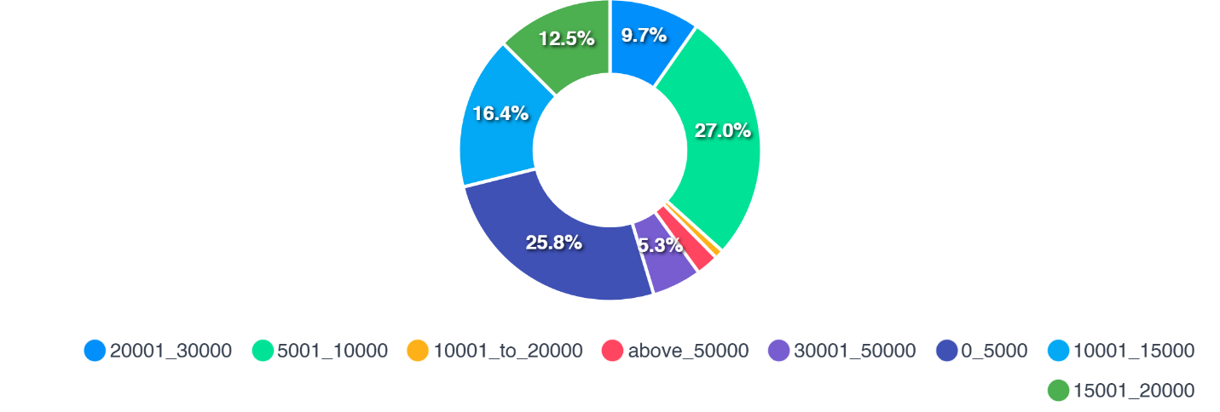
Figure 21: Average Monthly Household Income

Water, Sanitation, and Hygiene (WASH)
Access to water, sanitation, and hygiene services across slums and informal settlements presents a mixed picture of partial service provision and persistent infrastructure deficits. While a majority of households report access to some form of piped water and sanitation facility, significant disparities remain in service quality, reliability, and hygiene conditions, with implications for public health, environmental sustainability, and settlement resilience.

Water Access
Household access to water is dominated by piped sources, although the quality, reliability, and form of access vary considerably. Among 71,775 households with a stated main water source, 58.27% (41,822 households) rely on some form of piped water source. Of these, 25.03% (17,963 households) access water through compound taps, 20.31% (14,579 households) rely on community piped taps, 8.89% (6,382 households) report piped water directly into the house, while 4.04% (2,898 households) report other generic piped-water connections. These findings indicate that although piped water reaches a majority of households, direct household-level connections remain relatively limited, with many residents relying on shared or communal access points.
Despite the prominence of piped water, a considerable share of households continues to depend on alternative and potentially unsafe water sources. Approximately 12.27% (8,807 households) rely on shallow wells, 11.70% (8,395 households) obtain water from rivers and streams, and 9.15% (6,565 households) depend on mobile water vendors, often at higher cost and with uncertain quality. Smaller proportions rely on rainwater harvesting (2.58%; 1,851 households) and boreholes (1.43%; 1,023 households). Continued dependence on untreated or informal water sources exposes households to waterborne disease risks and increased household expenditure, particularly during droughts and supply disruptions.

Sanitation Access and Toilet Facilities
Access to sanitation facilities is relatively widespread among households that provided responses. Among 67,034 households with a stated sanitation response, 89.51% (60,000 households) report having access to a toilet facility, while 10.49% (7,034 households) report no access. However, quality and type of sanitation remain important concerns. Among 60,000 households with a stated toilet type, the majority rely on pit latrines (68.22%; 40,931 households), underscoring continued dependence on low-cost, on-site sanitation systems. Flush toilets account for 19.02% (11,410 households), while VIP latrines comprise 6.34% (3,804 households). Only 3.42% (2,052 households) report access to WC or sewer-connected systems, highlighting the limited penetration of formal sewerage infrastructure. Bucket toilets remain in use among 2.90% (1,738 households), reflecting continued sanitation deprivation in some settlements.
Toilet affordability does not appear to be a major constraint for most households. Among 67,034 households with a stated response, 95.19% (63,812 households) report that they do not pay for toilet use, compared to 4.81% (3,222 households) who rely on paid sanitation facilities. However, reliance on shared or communal facilities may still affect accessibility, cleanliness, privacy, and safety, particularly for women, children, and persons with disabilities.

Types of Toilet Facilities
Pit latrines are the predominant sanitation facility, reflecting constrained access to improved and sewer-connected systems.

Figure 22:Sanitation Facility Types used within a Settlement
The dominance of pit latrines (60.60%) indicates limited sanitation infrastructure and poses risks related to groundwater contamination, poor waste management, and disease transmission, particularly in high-density informal settlements.

Access to Handwashing Facilities
Access to handwashing facilities remains an important public health concern. Among 67,034 households with a stated handwashing response, only 19.21% (12,880 households) report access to handwashing facilities equipped with both soap and water, the minimum standard for effective hygiene and disease prevention. A further 14.39% (9,646 households) report access to water only, while 29.68% (19,894 households) indicate access to handwashing facilities without specification. Conversely, 28.13% (18,860 households) report no handwashing access, while 8.58% (5,754 households) report no facility at all. These findings point to substantial hygiene gaps, particularly in settlements vulnerable to disease outbreaks, flooding, and poor environmental sanitation.

Energy Access
Access to energy within slums and informal settlements has improved considerably over time, particularly with respect to electricity for lighting. However, significant inequalities remain in household connectivity, affordability, and access to clean cooking energy. While most households report access to electricity, a substantial proportion continue to rely on traditional biomass fuels for cooking, with important implications for health, environmental sustainability, and household expenditure.

Electricity Connection
Household access to electricity is relatively high. Among 67,034 households with a stated electricity connection status, 77.97% (52,264 households) report being connected to the main electricity supply, while 21.96% (14,720 households) report no connection, with only a very small proportion (0.07%; 50 households) falling within other categories. These findings suggest meaningful progress in electricity access across informal settlements, although a sizeable minority of households remain excluded from formal electricity networks.
Among households that are not connected to electricity, affordability remains the primary barrier. Among 14,712 households with a stated reason for non-connection, more than half (52.01%; 7,652 households) report inability to afford the connection deposit as the main reason for exclusion. Other commonly reported barriers include lack of electricity infrastructure in the area (26.11%; 3,841 households) and unclear connection procedures (15.89%; 2,338 households). These findings suggest that barriers to electricity access are not solely infrastructural but are also strongly influenced by poverty, affordability constraints, and administrative challenges.

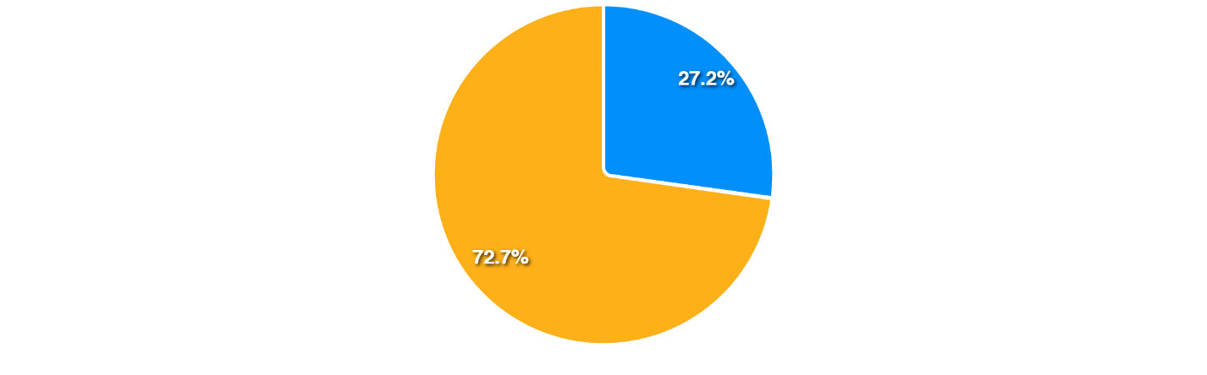
Figure 23: Household connection to main electricity grid
Despite encouraging coverage levels, over one-fifth of households remain without electricity, limiting access to lighting, information, and income-generating opportunities.
Among households that are not connected to electricity, affordability remains the primary barrier. Among 14,712 households with a stated reason for non-connection, more than half (52.01%; 7,652 households) report inability to afford the connection deposit as the main reason for exclusion. Other commonly reported barriers include lack of electricity infrastructure in the area (26.11%; 3,841 households) and unclear connection procedures (15.89%; 2,338 households). These findings suggest that barriers to electricity access are not solely infrastructural but are also strongly influenced by poverty, affordability constraints, and administrative challenges.

Sources of Lighting Energy
Electricity is the predominant source of lighting, complemented by increasing adoption of solar energy.
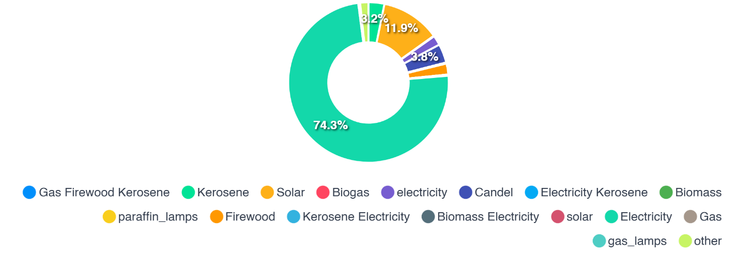
Figure 24: Source of Lighting in the settlements
Electricity is the dominant source of household lighting across the settlements. Among 68,700 households with a stated lighting source, 76.27% (52,395 households) report using electricity as their primary lighting source, while 12.14% (8,343 households) rely on solar energy, reflecting growing uptake of decentralized renewable energy systems. Smaller proportions continue to depend on candles (3.81%; 2,617 households), kerosene (3.20%; 2,196 households), and firewood (2.22%; 1,522 households) for lighting. Although electricity access is relatively widespread, the continued use of candles and kerosene highlights pockets of energy poverty and ongoing exposure to fire hazards and indoor air pollution.

3.4 Cooking Energy Sources
Cooking energy patterns reveal continued dependence on solid biomass fuels, despite gradual uptake of cleaner alternatives. Among 67,042 households with a stated cooking-energy source, charcoal remains the most commonly reported sole cooking fuel at 22.99% (15,412 households), followed by firewood at 20.16% (13,519 households) and liquefied petroleum gas (LPG) at 13.95% (10,021 households). A substantial share of households also report multiple-fuel combinations, including charcoal with firewood and LPG with charcoal, reflecting fuel-stacking practices used to manage affordability, availability, and reliability concerns. Combined, charcoal and firewood as sole cooking fuels account for 43.15% (28,931 households), before considering mixed-fuel use, underscoring the continued dominance of biomass energy within informal settlements.

Health Access and Services
Access to healthcare services within slums and informal settlements is largely dependent on the public health system, which remains the primary provider of medical care for most households. While proximity to health facilities is relatively favorable for many residents, utilization rates remain moderate, and perceptions of service quality suggest persistent challenges relating to affordability, quality of care, and service responsiveness.

Medical Treatment Facilities
Public health facilities dominate healthcare utilization across the surveyed settlements. Among 67,034 households with a stated treatment source, 76.75% (51,455 households) report public hospitals as their main source of medical treatment, underscoring the central role of government health infrastructure in serving low-income urban populations. A smaller proportion rely on private hospitals (8.16%; 5,468 households), while others report combinations of treatment sources, including both public and private hospitals (3.17%; 2,125 households) and public hospitals with chemists (2.83%; 1,899 households). Reliance on chemists alone remains relatively low (1.64%; 1,101 households). These patterns demonstrate that, despite the presence of private alternatives, public facilities remain the backbone of healthcare access in informal settlements.

Distance to Health Facilities
Geographic access to healthcare appears relatively favourable for many households. Among 66,742 households with a stated distance to a health facility, the most commonly reported distance is 1 kilometre (21.57%; 14,399 households), followed by 2 kilometres (19.68%; 13,135 households) and 3 kilometres (11.59%; 7,734 households). A further 6.62% (4,423 households) report living within 0.5 kilometres of a medical facility. Collectively, 52.84% (35,268 households) report access to healthcare facilities within three kilometres, suggesting that physical proximity may not necessarily be the main barrier to healthcare access for many residents. However, transport costs, waiting times, affordability, and quality concerns may continue to influence effective healthcare utilization.

Healthcare Utilization
Healthcare utilization remains moderate among surveyed households. Among 67,034 households with a stated response, 57.29% (38,405 households) report not visiting a health facility within the previous six months, compared to 42.62% (28,567 households) who report at least one visit. Although lower utilization may partly reflect periods of good health, the findings may also indicate barriers such as treatment costs, medication expenses, overcrowding, opportunity costs associated with lost income, or dissatisfaction with available services.

Perceptions of Healthcare Services
Perceptions of healthcare quality are generally positive among households that provided responses. Among 28,567 households with a stated healthcare rating, 56.53% (16,148 households) rate health services as good, while 20.33% (5,807 households) consider them very good. In contrast, 18.43% (5,264 households) perceive services as poor, and 4.72% (1,348 households) rate them as very poor. Overall, 76.85% of respondents rate healthcare services positively (good or very good), while 23.15% express negative perceptions (poor or very poor). These findings suggest that while many residents consider healthcare services acceptable, important concerns remain regarding affordability, service efficiency, medicine availability, and overall user experience.

Vulnerability and Social Protection
Slums and informal settlements host populations facing multiple and intersecting forms of social, economic, and physical vulnerability, often shaped by poverty, insecure livelihoods, limited access to services, and exposure to environmental and health risks. Household survey findings indicate that, among 70,723 households with a stated disability response, 7.36% (5,204 households) report the presence of a person living with disability, while 92.64% (65,519 households) report no disability. Among households that specified the type of disability (5,182 households with a stated disability category), physical disabilities constitute the largest category (35.66%; 1,848 households), followed by visual impairments (12.66%; 656 households), mental disabilities (11.96%; 620 households), hearing impairments (9.36%; 485 households), and self-care difficulties (6.37%; 330 households). These findings point to diverse accessibility and support needs related to healthcare, mobility, housing, and social inclusion within settlement environments. Registration levels among persons living with disabilities remain relatively low. Among households reporting disability and providing registration information (4,826 households with a stated response), only 33.51% (1,617 households) indicate that persons with disabilities are registered, while 66.49% (3,209 households) are not registered, potentially limiting access to disability-related assistance programmes, healthcare support, and targeted welfare interventions.
Broader household vulnerability is also evident across the settlements. Among 66,989 households with a stated vulnerability response, 10.48% (7,019 households) report the presence of vulnerable persons, while 89.52% (59,970 households) report no vulnerable household members. Among households specifying vulnerability types (4,138 households with a stated vulnerability category), elderly persons constitute the largest group (42.97%; 1,778 households), followed by orphans (23.80%; 985 households), widows (10.68%; 442 households), widowers (5.53%; 229 households), and child-headed households (3.99%; 165 households). These vulnerabilities often intersect with poverty, unstable livelihoods, poor housing conditions, and limited access to healthcare and education, reducing household resilience to shocks and crises.
Access to formal social protection remains constrained. Among households reporting vulnerable persons and providing registration information (7,019 households with a stated registration response), only 38.34% (2,691 households) report being registered under social protection programmes, while 61.66% (4,328 households) remain unregistered. Limited registration, combined with low disability enrolment, suggests that many vulnerable households may not be benefiting from available welfare mechanisms, including support targeting elderly persons, orphans, widows, and persons living with disabilities. Overall, the findings indicate that vulnerability within informal settlements is multidimensional and persistent, underscoring the need to strengthen targeted welfare programmes, disability inclusion, registration outreach, and community-based support systems to improve household resilience and social equity

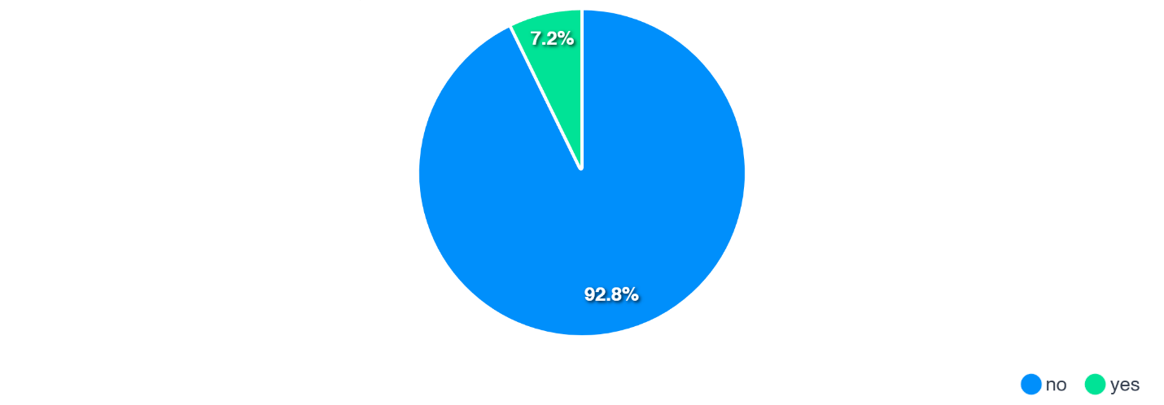
Figure 25: Vulnerable persons within settlements

Digital Access and Information
Digital access plays an increasingly important role in shaping livelihoods, communication, financial inclusion, and access to services within slums and informal settlements. Household survey findings indicate high levels of mobile phone ownership and mobile money usage, reflecting the growing importance of digital technologies in everyday life. However, disparities in internet access, social media use, and information sources suggest that digital inclusion remains uneven, with a substantial share of households still relying on traditional communication channels.

Mobile Phone Ownership and Mobile Money Use
Mobile phone ownership is widespread across the settlements. Among 70,149 households with a stated response, 93.60% (65,657 households) report having access to a mobile phone, while 6.40% (4,492 households) report no access or fall within other non-affirmative categories. The near-universal penetration of mobile phones highlights their importance as tools for communication, access to services, and household coordination in low-income urban environments.
Mobile money usage is even more prevalent among households with access to mobile phones. Among 63,190 households with a stated mobile money response, 97.41% (61,555 households) report using mobile money services, compared to 2.56% (1,615 households) who do not. The widespread use of mobile money platforms demonstrates their critical role in facilitating financial transactions, remittances, savings, bill payments, and household coping strategies during periods of economic stress. It also suggests growing opportunities for digital financial inclusion within informal settlements.

Social Media and Information Access
Patterns of social media use indicate growing but uneven digital engagement. Among 67,034 households with non-missing social media responses, usage is concentrated around a few dominant platforms and platform combinations. The most common reported category is WhatsApp and Facebook (16.06%; 10,765 households), followed by WhatsApp only (10.68%; 7,157 households) and WhatsApp, Facebook, and TikTok (8.84%; 5,926 households). Facebook as a sole platform accounts for 4.74% (3,174 households). However, a substantial share of households (33.04%; 22,145 households) are recorded under blank or unspecified social media entries, suggesting caution in interpreting overall platform reach and possible limitations in response quality or digital participation.
Access to information remains strongly influenced by traditional media channels, despite increasing digital adoption. Among 67,034 households with a stated information source, television is the most commonly reported source (14.60%; 9,784 households), followed by radio (12.44%; 8,339 households) and a combination of television, radio, and internet (11.20%; 7,508 households). Internet as a sole information source accounts for 7.91% (5,303 households), while word of mouth remains important at 4.94% (3,308 households). These findings suggest that while digital platforms are becoming increasingly significant, many households continue to depend on traditional and interpersonal communication channels for information access

Social Capital and Community Engagement
Social capital and community engagement play an important role in shaping resilience, collective action, and social cohesion within slums and informal settlements. Community organizations, welfare groups, savings schemes, and informal support networks often provide residents with mechanisms for mobilizing resources, sharing information, addressing local challenges, and responding to economic or environmental shocks. However, survey findings suggest that while organized participation exists, formal engagement in community structures remains moderate and uneven across settlements.

Community-Based Organization (CBO) Membership
Participation in community-based organizations (CBOs) is moderate among households that provided responses. Among 38,502 households with a stated membership status, 33.83% (13,024 households) report being members of a CBO, while 66.17% (25,478 households) report no membership. Community-based organizations remain important platforms for community mobilization, advocacy, local problem-solving, and participation in upgrading initiatives, particularly in contexts where formal governance and service delivery systems are limited. Among households reporting a type of community organization (12,977 households with a stated CBO type), the most common groups include women’s groups, accounting for 32.27% (4,188 households), followed by savings groups at 26.28% (3,410 households) and youth groups at 20.40% (2,647 households). Smaller proportions participate in combined categories such as women’s and savings groups (7.55%; 980 households) and other localized associations. These groups often play a central role in savings mobilization, welfare support, social cohesion, and economic empowerment.

Cultural Participation and Welfare Networks
Participation in cultural activities remains relatively limited. Among 38,121 households with a stated response, 26.57% (10,129 households) report active participation in cultural activities, while 73.43% (27,992 households) report no involvement. Cultural engagement can strengthen community identity, reinforce social networks, and contribute to cohesion, particularly in long-established settlements with diverse social backgrounds.
Membership in welfare groups is reported by 31.14% (11,843 households) among 38,033 households with a stated response, while 68.86% (26,190 households) report no participation. Welfare groups often function as informal safety nets, supporting households during illness, funerals, emergencies, and periods of financial distress, particularly where formal social protection systems remain inadequate.

Business and Economic Networks
Participation in business networks remains relatively modest but important for economic resilience. Among 37,734 households with a stated response, 25.50% (9,621 households) report membership in business or economic networks, while 74.50% (28,113 households) are not members. Business associations and informal economic groups can facilitate information exchange, market access, savings mobilization, and livelihood opportunities, particularly within settlement economies dominated by micro-enterprises, petty trade, and self-employment.

Security and Safety Perceptions
Security and perceptions of safety remain important concerns within slums and informal settlements, influencing residents’ quality of life, mobility, livelihoods, and social well-being. Household survey findings indicate that perceptions of safety vary significantly between daytime and night-time, with feelings of insecurity increasing considerably after dark. Crime occurrence and reporting patterns further suggest persistent security challenges, although trust in formal and informal reporting mechanisms appears mixed.

Daytime Safety Perceptions
Perceptions of safety during the day are generally positive among households that provided a response. Among 38,534 households with a stated daytime safety rating, 64.90% (25,009 households) describe their settlements as safe, while 22.22% (8,564 households) consider them very safe. In contrast, 11.74% (4,522 households) perceive their settlements as unsafe, and 1.14% (439 households) as very unsafe. Overall, 87.13% of respondents report feeling safe or very safe during the day, compared to 12.87% who report feeling unsafe or very unsafe. These findings suggest that, for most residents, daytime conditions are generally perceived as secure despite the infrastructural and socio-economic challenges facing informal settlements.

Night-Time Safety Perceptions
Perceptions of security deteriorate considerably at night. Among 38,544 households with a stated night-time safety rating, only 48.90% (18,848 households) report feeling safe, while 12.49% (4,815 households) consider their settlements very safe after dark. Conversely, 32.31% (12,455 households) describe their neighbourhoods as unsafe, and 6.29% (2,426 households) as very unsafe. Combined, 61.39% of respondents report feeling safe or very safe at night, while 38.61% feel unsafe or very unsafe, indicating a marked decline in perceived safety after dark. These patterns likely reflect challenges associated with inadequate street lighting, poor settlement accessibility, weak policing presence, and broader socio-economic pressures that may contribute to crime and insecurity.

Crime Occurrence and Reporting
Experiences and perceptions of crime indicate continued exposure to insecurity within many settlements. Among 37,956 households with a stated crime frequency rating, 39.71% (15,073 households) report that crime occurs rarely, while 28.46% (10,803 households) indicate that it occurs occasionally. More concerningly, 20.35% (7,725 households) report that crime occurs frequently, and 6.37% (2,418 households) describe crime as very frequent, while 5.10% (1,937 households) report that crime never occurs. Overall, 26.72% of respondents report crime occurring frequently or very frequently, highlighting persistent security challenges in a substantial number of settlements.
Crime reporting behavior suggests moderate engagement with formal or informal reporting mechanisms. Among 38,754 households with a stated response, 74.06% (28,702 households) indicate that they report crimes, compared to 24.26% (9,401 households) who report that they do not report incidents, while 1.68% fall within other categories. The relatively high rate of crime reporting may indicate some level of trust in community leadership structures, local administration, or formal security institutions, although underreporting may still persist in some areas due to fear of retaliation, perceived inaction, or reliance on informal dispute resolution mechanisms.

Disaster Risk and Climate Resilience
Disaster exposure is widespread across surveyed informal settlements, with 66.34% of households (41,108) reporting that they have experienced one or more disasters, while only 4.44% (2,754 households) report no disaster experience; 33.66% (20,856 households) did not respond, possibly reflecting recall challenges or the normalization of recurring hazards. Climate-related shocks dominate the risk profile: drought (16.33%) and flooding (12.51%) emerge as the most significant primary disasters, together affecting 28.84% of households, followed by violent conflicts (10.18%), disease outbreaks (8.82%), and fires (7.14%). Secondary and tertiary rankings further reinforce the prominence of disease outbreaks, drought, and flooding, highlighting the compound and cascading nature of risks faced by households in informal settlements. Despite this high exposure, preparedness and mitigation remain limited, with only 16.85% of households (10,439) reporting the presence of any disaster mitigation measures, compared to 34.72% (21,513 households) reporting none. Overall, the findings indicate high vulnerability coupled with low resilience, underscoring the urgent need for settlement-level climate resilience interventions, including early warning systems, improved drainage and flood control, fire prevention, and community-based disaster risk management.

Community Priorities
Community-identified development priorities provide important insight into the immediate and longer-term needs of residents within slums and informal settlements. The survey captured priority responses from 61,963 households across 492 settlements, with households often identifying multiple concerns simultaneously. This resulted in 155 unique priority combinations, reflecting the interconnected and multidimensional nature of challenges faced by informal settlement residents. The findings demonstrate that households prioritize not only access to infrastructure and services, but also safety, health, and livelihood concerns that directly affect daily well-being and resilience.

Priority Landscape
Across all surveyed settlements, security emerges as the dominant community concern, accounting for 44.1% (27,342 mentions) of all reported priority responses. This underscores the central role of safety and security in shaping daily life, mobility, access to services, and economic activity within informal settlements. Health ranks as the second most frequently cited priority, representing 32.5% (20,148 mentions), highlighting persistent concerns related to disease burden, healthcare access, environmental health risks, and overall quality of life.
Infrastructure and livelihood-related priorities also feature prominently. Road infrastructure (21.7%), water access (21.1%), and employment opportunities (19.9%) are consistently highlighted by households, reflecting ongoing deficits in mobility, service provision, and economic inclusion. Lighting at night (14.8%) and education (14.1%) further emphasize the importance of both social services and enabling infrastructure in improving living conditions and reducing vulnerability. In contrast, issues such as housing, sanitation, and land tenure appear less frequently among immediate priorities, suggesting that residents may place greater emphasis on pressing safety and service delivery needs when identifying urgent interventions.

Dominant Priority Combinations and Interlinkages
Household priority responses show that informal settlement needs cluster around overlapping risks rather than single-sector deficits. Among 67,050 households that stated a community priority, Security appears in 44.3% of responses, Health in 31.4%, Employment in 19.9%, Roads in 21.3%, and Water in 20.8%. Residents most often identify combined priorities, pointing to interlinked constraints on daily life.
The most frequently cited combination is Security + Health (6,829 households; 10.2%), reported in 664 settlements. This pairing sits alongside a health profile in which facilities are often physically reachable—76.8% of households mainly use public facilities, and about 53% of those reporting distance are within 3 km—but utilization remains limited, with 57.3% reporting no facility visit in the last six months. Among households rating service quality, 23.2% describe facilities as poor or very poor. The Security + Health combination therefore reflects concern with safe, trusted, and effective care as much as physical proximity.
Security + Lighting at night ranks second (3,527 households; 5.3%), followed by Security + Employment (3,054 households; 4.6%). Night-time safety is a distinct stressor: 38.6% of respondents feel unsafe or very unsafe after dark, compared with 12.9% during the day. The Security + Employment linkage aligns with livelihood conditions in which 25.9% of households rely on casual labour, 11.0% are unemployed, and about half of reporting households earn below KES 10,000 per month. Households citing Security + Employment are heavily concentrated in precarious work, including casual labour and low-income self-employment, indicating that insecurity is closely tied to economic vulnerability and limited livelihood security.
Health priorities also connect to wider service conditions. Health + Education (2,756 households; 4.1%) and Health + Water (1,761 households; 2.6%) link wellbeing to schooling and water access, while Health + Employment (1,289 households; 1.9%) connects health outcomes to income and work. Infrastructure priorities follow a similar pattern: Security + Roads (2,714 households; 4.1%) and Security + Water (2,498 households; 3.7%) suggest that roads, water, and lighting are valued partly for their role in safer movement, service access, and liveability.
Taken together, the dominant combinations point to three interlinked systems of concern:
- Safety and mobility — security, lighting, roads, and water;
- Wellbeing and human development — health, education, sanitation, and water quality; and
- Livelihood security — employment, income, and the economic conditions underlying crime, vulnerability, and service use.
Programming that treats these as separate sectoral problems is unlikely to match how communities frame their needs. Interventions are more likely to be relevant where they address combined risks—for example, safer access routes and lighting around health facilities, economic inclusion alongside crime prevention, and infrastructure investments that improve both service delivery and settlement safety.

Conclusion

Key National Findings and Implications
This National Status Report confirms that slums and informal settlements are a permanent and structurally embedded component of Kenya’s urban system rather than a transitional phenomenon. Drawing on findings from settlements mapped and profiled across all counties, the evidence demonstrates that informal settlements are physically established, socially complex, and economically significant spaces that continue to absorb rapid urban growth. Many settlements are characterized by long-term occupation, permanent structures, and sustained population concentration, yet remain only partially integrated into formal planning, service delivery, and land administration systems.
The findings reveal a consistent pattern of partial inclusion and uneven service provision. Core infrastructure—particularly roads, electricity networks, and water systems—is present in many settlements, but quality, reliability, and household access remain uneven. While electricity access for lighting is relatively widespread, sanitation quality remains weak, with continued reliance on pit latrines and limited sewer connectivity, and only a minority of household’s report access to soap-and-water handwashing facilities. Water access is dominated by shared piped systems, but substantial proportions of households continue to rely on shallow wells, rivers, and water vendors. These infrastructure and service deficits continue to constrain health outcomes, safety, mobility, and overall quality of life.
Socio-economic profiling highlights a young and economically active population with strong labour-force potential, but also persistent structural vulnerabilities. Household incomes remain concentrated within lower income brackets, reflecting widespread informality of livelihoods and economic precarity. At the same time, significant deficits persist in clean cooking energy, social protection coverage, disaster preparedness, and access to quality healthcare, despite relatively widespread mobile connectivity and high uptake of mobile money services. Vulnerable groups—including persons with disabilities, elderly persons, widows, orphans, and child-headed households—remain insufficiently integrated into formal social protection systems.
Environmental and climate-related risks further intensify settlement vulnerability. A substantial proportion of households’ report exposure to flooding, drought, disease outbreaks, fires, and violent conflict, often in combination, highlighting the compound and cascading nature of risks affecting informal settlements. Despite widespread hazard exposure, household-level preparedness and mitigation measures remain limited, leaving many settlements vulnerable to recurring shocks. Security concerns also remain pronounced, particularly at night, with many households reporting reduced perceptions of safety after dark and continued exposure to crime-related risks.
Community priorities reinforce these findings. Across settlements, security, health, roads, water, employment, and lighting at night consistently emerge as the most urgent concerns, underscoring the interconnected nature of infrastructure, livelihoods, safety, and social well-being. Residents consistently view settlement challenges not in isolation, but as mutually reinforcing issues requiring integrated responses.
Together, the findings underscore that Kenya’s slums and informal settlements are established yet underserved, resilient in social structure but vulnerable in physical, legal, economic, and environmental terms. Addressing these challenges will require integrated, evidence-based, and multi-sectoral interventions that move beyond fragmented approaches toward coordinated urban upgrading, improved service delivery, climate resilience, and inclusive planning.

Strategic Directions for Action
The national mapping and profiling exercise undertaken under KISIP II provides a comprehensive national evidence base for coordinated urban upgrading and policy action. Going forward, priority should be placed on integrated settlement upgrading approaches that simultaneously address infrastructure quality, tenure responsiveness, environmental risk reduction, and socio-economic inclusion. Investment strategies should shift from merely expanding nominal infrastructure coverage toward improving service functionality, affordability, quality, and resilience, particularly for water, sanitation, drainage, electricity access, roads, healthcare, and public safety systems.
Addressing tenure insecurity, reserve encroachment, and complex ownership arrangements remains central to sustainable upgrading. Pragmatic and context-sensitive pathways will be required to support upgrading while safeguarding public interests, reducing environmental risks, and improving legal certainty. Climate resilience must also be systematically embedded into settlement planning through investments in drainage systems, flood control, fire prevention, risk-sensitive infrastructure, and community-based disaster preparedness mechanisms.
The findings also point to the need for stronger investments in social and economic resilience, including improved social protection registration, expanded access to clean cooking energy, strengthened healthcare access, enhanced night-time safety, and interventions that support livelihoods and employment opportunities. At the same time, the high levels of mobile phone ownership and mobile money usage provide opportunities for digital inclusion, targeted service delivery, financial access, and community communication systems.
The national mapping and profiling exercise establishes a foundational national baseline that should be institutionalized through the Kenya Slum Management Information System (KeSMIS) as a living platform for planning, monitoring, targeting, and coordination between national and county governments. As data continue to be validated, updated, and integrated into planning processes, this evidence base will support more equitable, resilient, inclusive, and sustainable urban development, in line with Kenya Vision 2030, the National Slum Upgrading and Prevention Policy, and commitments under Sustainable Development Goal 11.

Annexes

Annex 1: Mapping Tools

Annex 2: Household Questionnaire

Annex 3: Settlement Profile Outline

Annex 4: Adopted national criteria for defining slums and informal settlements

Kenya Population and Housing Census Analytical Report on Urbanization, 2019
Source: Kenya National Bureau of Statistics based on 2019 baseline data projected to 2026 as per the county level projected growth.

