THE KENYA INFORMAL SETTLEMENT INFORMATION SYSTEM

USER GUIDE

Nov 12, 2024



Contents
Background 5
Prerequisites 5
Recommended Environment 6
Browser Requirements 6
Network Requirements 6
Access 6
Public Portal 6
User Registration 7
Reset Password 8
Feedback 9
Navigation 10
Side Navigation bars 10
Top Navigation bar 10
Last/Current Page 10
Responsive Design 11
Dashboards 13
Status 13
Cards 14
Charts and Maps 14
Configure dashboards 15
Dashboard Composition 15
Create Dashboard 17
Cards 17
Sections/Tabs 19
Charts 19
Types of Charts 20
Pie chart 20
Bar Chart 20
Stacked Bar Chart 21
Population Pyramid 21
Choropleth Maps 22
Add Chart 22
Data 24
Settlements 24
Create a settlement 24
Alternative A: Draw the boundary(default) 25
Alternative B: Upload geometry 25
Edit a settlement 26
View/delete/upload settlement documents 27
Export Settlement List 28
View Settlement Map 28
View Settlement Households 29
Facilities 30
Households 31
Create Household 31
Edit Household 32
Data Importation 33
List (excel) 33
Spatial Data 34
Programmes/Interventions 37
Programmes 37
Create programme 37
Create Programme components 38
Create Implementation Mechanism 39
Activities 39
Projects 40
Create a Project 40
Update/Delete a Project 41
Project Locations 42
Project Activities and Documents 42
Grievances 43
Submitting a Grievance 46
Check Grievance Status 46
Adding a Grievance 47
Grievance Sorting 48
Grievance Resolution 48
Grievance Details 50
Document Repository 51
Adding Documents 51
On the Entity 51
Batch Import 52
Repository View 53
Monitoring and Evaluation Module 55
Activities 55
Indicators 56
Indicator Configuration 56
Reporting 57
Review of M&E Reports 58
Post-Project evaluation 60
Settings 60
Adding an option 61
Editing an option 61
System appearance 62
User Management 63
Types of User rights 63
Approval of User Accounts 63
Allocation of rights 64
User Suspension 64

Background
Welcome to Kenya's National Database of Slums and Informal Settlements, a groundbreaking initiative aimed at addressing the challenges faced by marginalized communities living in slums and informal settlements across the country. This comprehensive database serves as a repository of vital information on living conditions within slums and informal settlements, encompassing data on population, housing, access to basic services, and socio-economic indicators. As a result, it provides invaluable insights for both government and non-governmental actors to develop targeted interventions, uplift living standards, and empower these communities. By consolidating accurate and up-to-date information, this database plays a crucial role in fostering evidence-based decision-making and ensuring a more inclusive and equitable future for all Kenyans.

This National Database of Slums and Informal Settlements in Kenya has been developed through the collaborative efforts of the Kenya Informal Settlements Improvement Program Phase 2 (KISIP2), a World Bank project implemented under the auspices of the State Department of housing and urban development. KISIP2 has been instrumental in spearheading initiatives to enhance the living conditions of slum dwellers by providing tenure security, improving infrastructure, and strengthening community resilience. With expertise and support, this database has been meticulously curated, ensuring its accuracy, reliability, and relevance to the specific needs of Kenya's informal settlements. This collaborative endeavor underscores the commitment of the government, the World Bank, and other stakeholders to tackle the challenges faced by these communities and foster holistic and inclusive urban growth.

System Features
The system has the following key features :
- Web-based - accessible from any standard browser
- Online - Accessible from anywhere
- Dashboards - has multiple dashboards for the various stakeholders
- Secure reporting - only authorized officers provide data reports

Prerequisites
The table below summarizes the key requirements that we need to use the system

Requirement | Specifications
System | The system must have been installed and made publicly available online
Internet | The user must have a live internet connection
Credentials | Required for users authorized to enter/manipulate data in the system. The general public can access the dashboards without registration

Recommended Environment

Browser Requirements

The System has been developed to deliver an application’s graphical user interface through any HTML5/WebGL compatible browser. Performance varies by browser, with Mozilla Firefox delivering the best overall experience. We test on the latest version of each browser and recommend end users use the latest version as well. If, for some reason, one cannot update to the latest version we recommend using the most stable release option available.

Network Requirements

The following requirements must be met in order to successfully connect to and use the system:

 | Aspect |  | Minimum Requirement
1. | Internet Down Speed |  | 10Mb/s
2. | Internet Up Speed |  | 2Mb/s

Access
To use the system to report on partner interventions, a user account is required. The system has multiple layers of security to ensure that entered data is correct, has been provided by authorized persons and has been validated by the Ministry of Water and Sanitation or other authorized persons.

Public Portal
To access the public portal domain, follow these steps:
- Open your browser and type https://kesmis.go.ke/#/landing

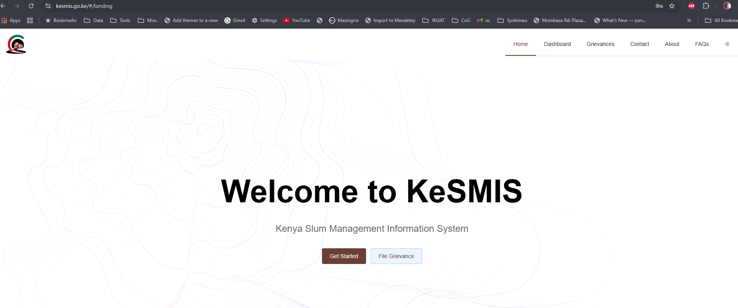
- The system will load the landing page
- Click Get Started to Login in to the platform or
- Click File Grievance to register a complaint on KISIP
- Other links on the menu provide functionalities for:
  - Dashboard - to Login in to the platform
  - Grievances - to register a complaint on KISIP
  - Contact - Send message to system administrators
  - FAQs- Frequently asked questions
  - About - Get more details about this system
  - Switch for day/dark modes
  - Privacy Policy

User Registration
- Click “Get Started”
- Click the Register Button. A registration screen with minimal information will be provided.
- Fill all the required details.

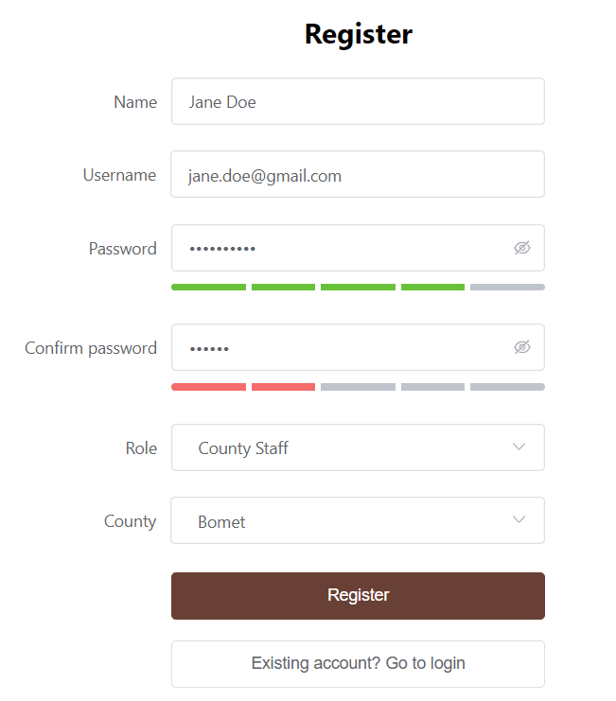

- A message will pop up alerting you of success or failure
- If successful, you will await the administrator to enable your account after verification

Reset Password
- Should you forget your password, use the forgot password link on the login page
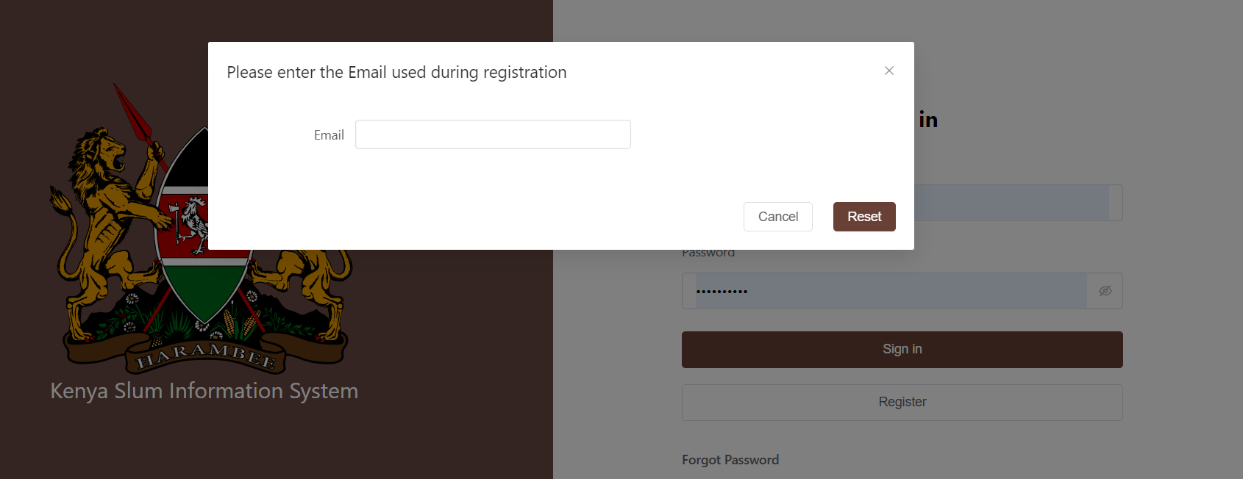

- An email will be sent to the registered email
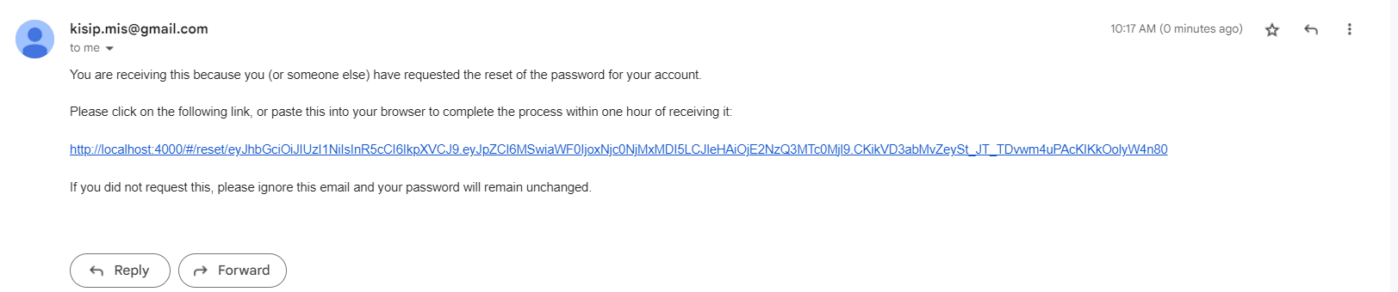
- Click on the link to set a new password

Feedback
- Should you want to send a message to the administrators, click on the feedback icon and a message window will pop up. Type in your message and send. The administrators will be notified.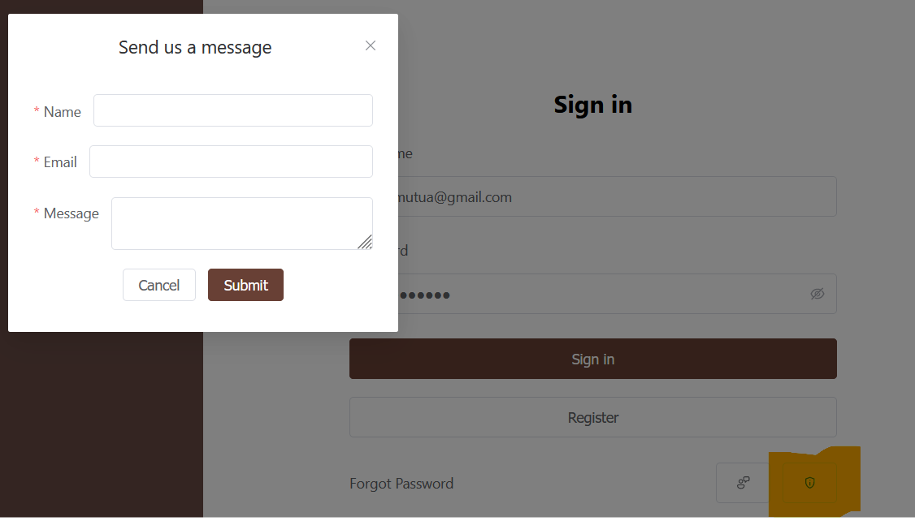

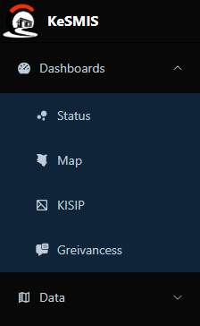
Navigation
The system is designed to provide easy access to information and is structured in to

Side Navigation bars
This allows the user to skip and select the desired component to view.

Top Navigation bar
It shows the user the current location within the system navigation. Click on the the breadcrumb to navigate directly to the desired route
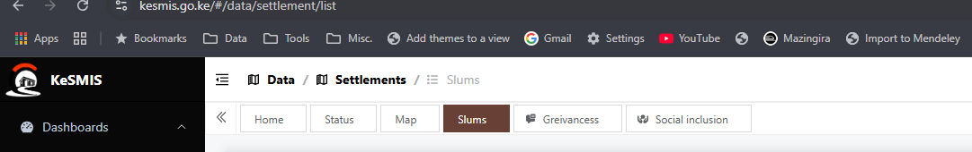

Last/Current Page
It allows the user to return back to a page without necessarily navigating to the top or side bar. The active page is colored.
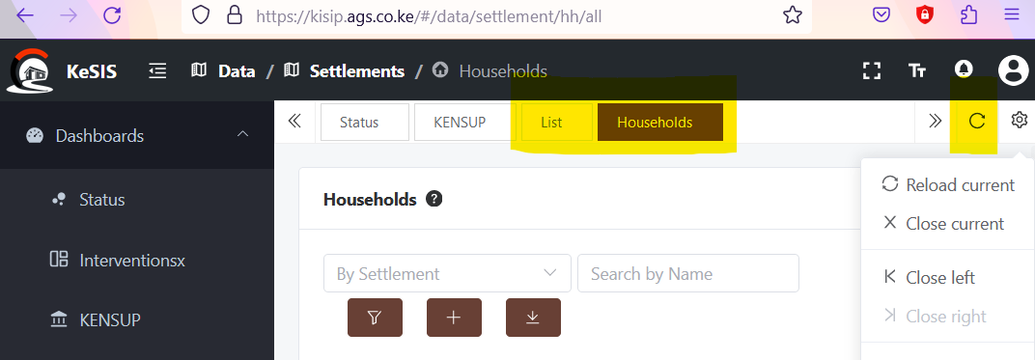
- Click on the previous tabs to go back
- The past pages can be refreshed(reloaded) or closed as per the options provided on the top right corner of the page below the logged-in user

Responsive Design
The system is designed to be fully responsive, adjusting the pages according to the device it's opened on. This allows the user to see the same detail but arranged differently.

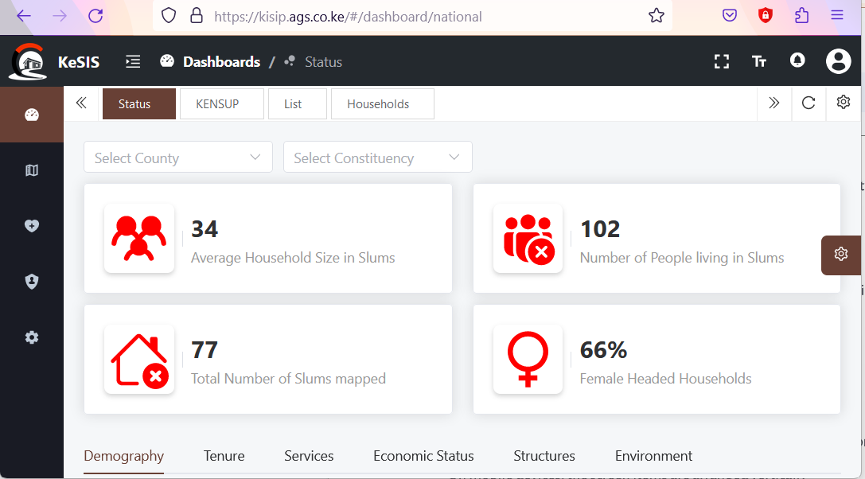

- The collapse icon hodes the navigation text and displays only the icons for smaller screens
- On mobile devices, the screen items are arranged vertically
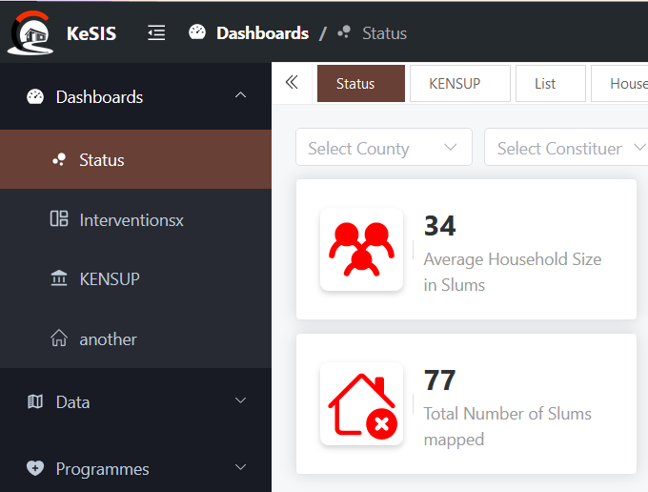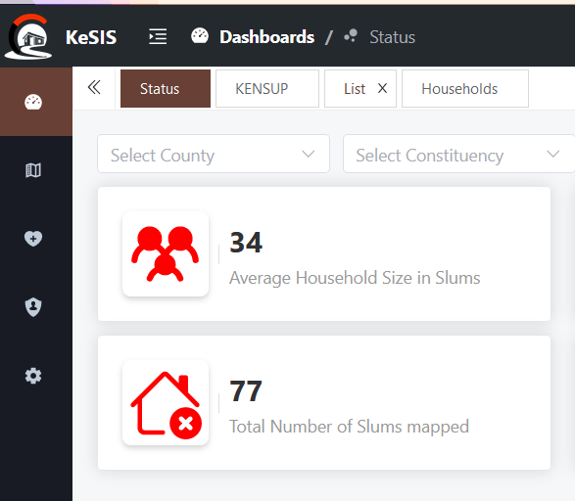

Dashboards
The primary purpose of this system is to allow the counties, the ministry and partners to report and monitor activities (interventions) they are implementing in the various locations within the country with respect to slum upgrading. It captures information primarily from the KISIP project and the Slum upgrading department.
- Go to the system home page https://kesmis.go.ke
- Login using your credentials
- The system will log you in the default dashboard (status)

Status
The overview dashboard gives a snapshot of the current status of informal settlements in the country based on the data collected from the national mapping of informal settlements and other data collection activities carried out through interventions such as KISIP, KENSUP and other regular interventions through the slum upgrading department.
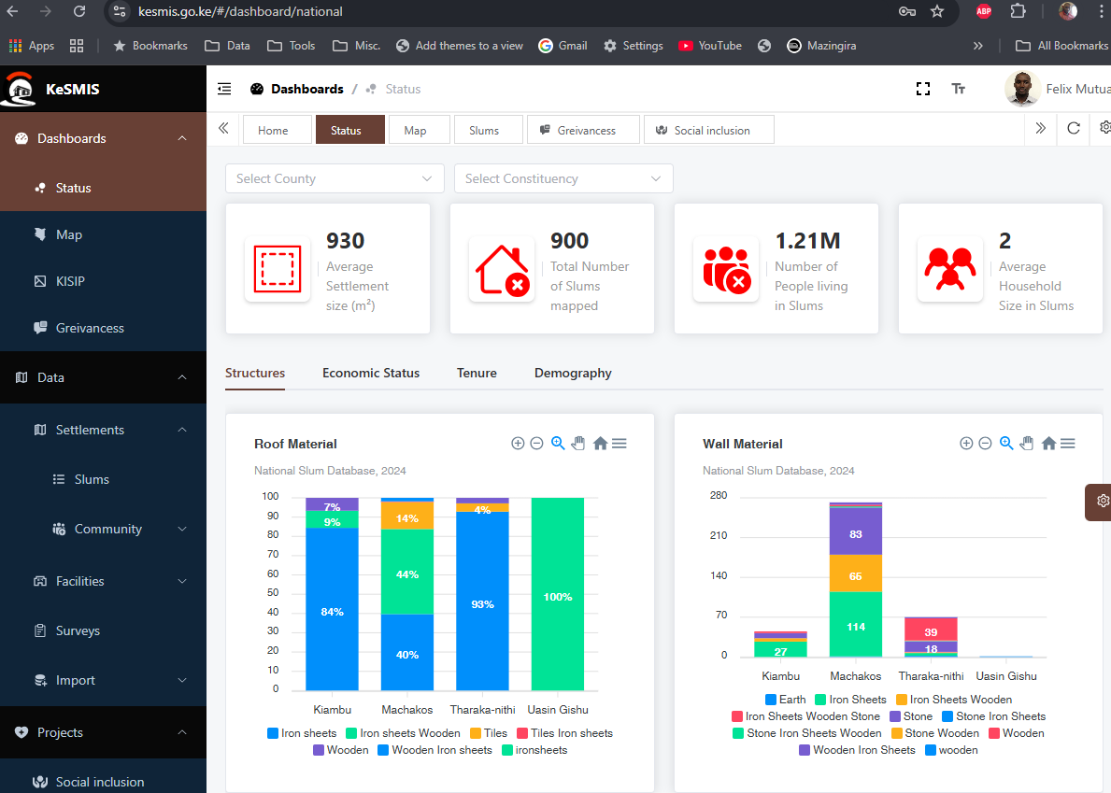
The following information is provided on this dashbaord:

Cards
- Recorded number of informal settlements in the country
- The resident population in these settlements (based on socio-economic surveys conducted through interventions)
- Average household size
- Female-headed households

Charts and Maps
- The overall age-gender demography of the informal settlements and
- The counties with the highest number of settlements in the country

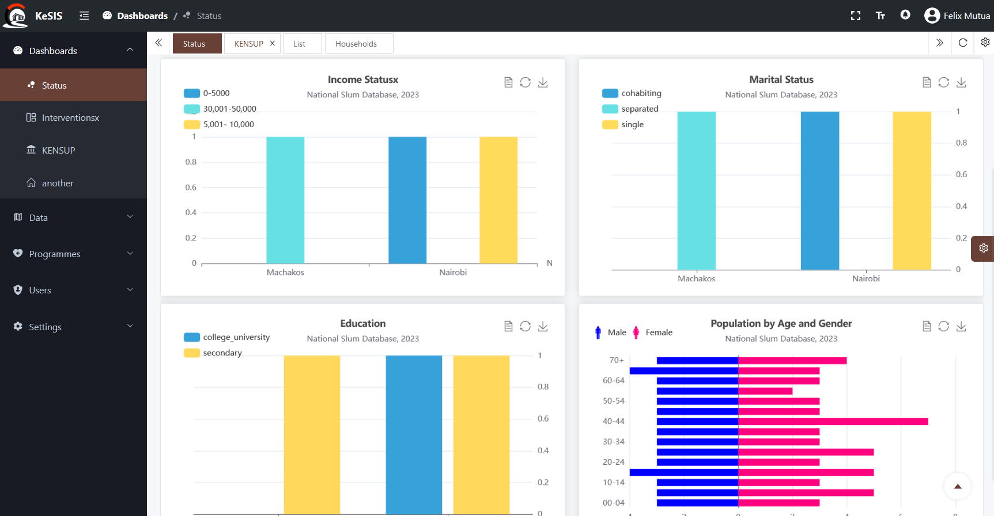
- The resident population in these settlements (based on socio-economic surveys conducted through interventions)
- Settlements per county
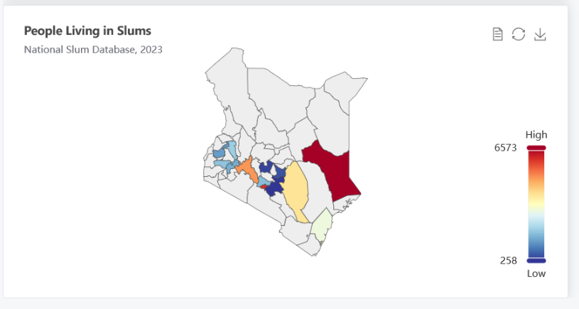
The maps, charts and tables are dynamic and will be automatically updated as data is entered.

Configure dashboards
The administrators of the system will configure different dashboards addressing specific aspects with all dashboards having a similar structure. For instance an interventions dashboard may contain the following information:
- Beneficiaries on Tenure, infrastructure and social-inclusion initiatives
- Outputs disaggregated by gender
- Household water connections resulting from the project
- Rehabilitated roads
- Summary maps for interventions in tenure, infrastructure and social inclusion amongst others

Dashboard Composition

A dashboard will comprise of the following elements: statistical cards, sections/tabs, charts and maps. Cards contain key facts that can be presented as a single value/number while sections are tabs under which various charts can be nested in. Charts will include a variety of presentations that may feature bar charts, pie charts, time series charts and even choropleth maps. The cards, sections and charts are all configurable in this system
Dashboard
Card
Sections/Tabs
Charts
Pie
Line
Bar
Map
..
A typical dashboard comprise of the three mentioned components is shown below
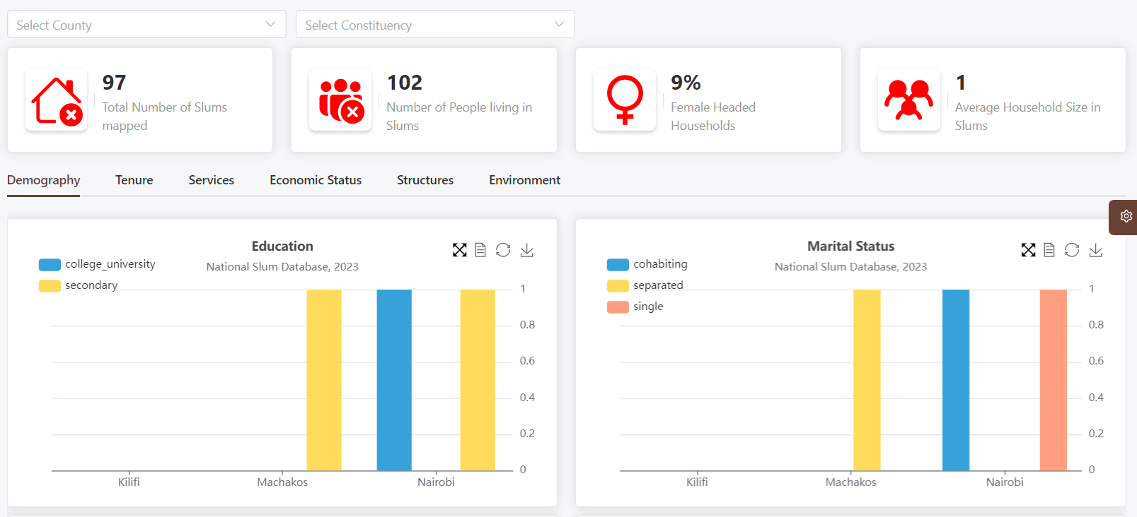
CARD
Tab/Section
Chart
In this system, dashboards are classified into two categories
- Status Dashboard - these provide a framework to summarize data of entities (tables) in the system. These include households, settlements and facilities
- Intervention Dashboards - These kind of dashboards summarize quantitative data primarily generated from the monitoring of intervention projects

Create Dashboard
An administrator can create a dashboard through the following steps:
- Click the settings / dashboards on the sidebar
- A list of the configured dashboards will appear
- Click the + button to add a new dashboard
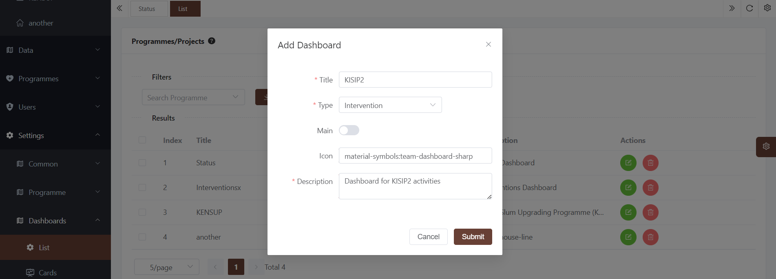
The dashboard properties are:
- Title : This will appear on the list of dashboards visualization menu
- Type: Intervention or status
- Icon: the icon that will appear on the menu
- Main: Switch to specify the first and default dashboard.
- Description : Brief narrative of the dashboard

Cards
A card is a placeholder for a Key Fact such as number of settlements, Household size, Kilometers of roads e..t.c. It features a number, icon and small description as demonstrated below
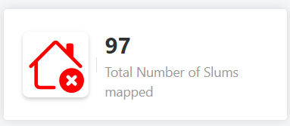
A card can be added to a dashboard as follows:
- Navigate to the settings / dashboard section
- Click cards. A list of all cards in the dashboards will be shown
- Click the + button to create a new card

The following details are required for a card within an intervention dashboard:

- Dashboard - where the card will go
- Title of card - the text that will appear alongside the icon and number/value
- Icon : the cards icon
- Color : The icon color
- Indicator: the indicator to be summarized and presented as a value on the card (This is only for status cards that report on interventions whose indicators are numeric)
- Aggregation method: count, sum or average
- Unique - whether to aggregate unique values based on the selected indicator.
- Filter -whether the selected indicator values will be filtered e.g >a certain value
- Computation : whether the figure will be absolute or a proportion (%).The proportion is computed as a percentage of the filtered data against the total entries for the selected entity/indicator

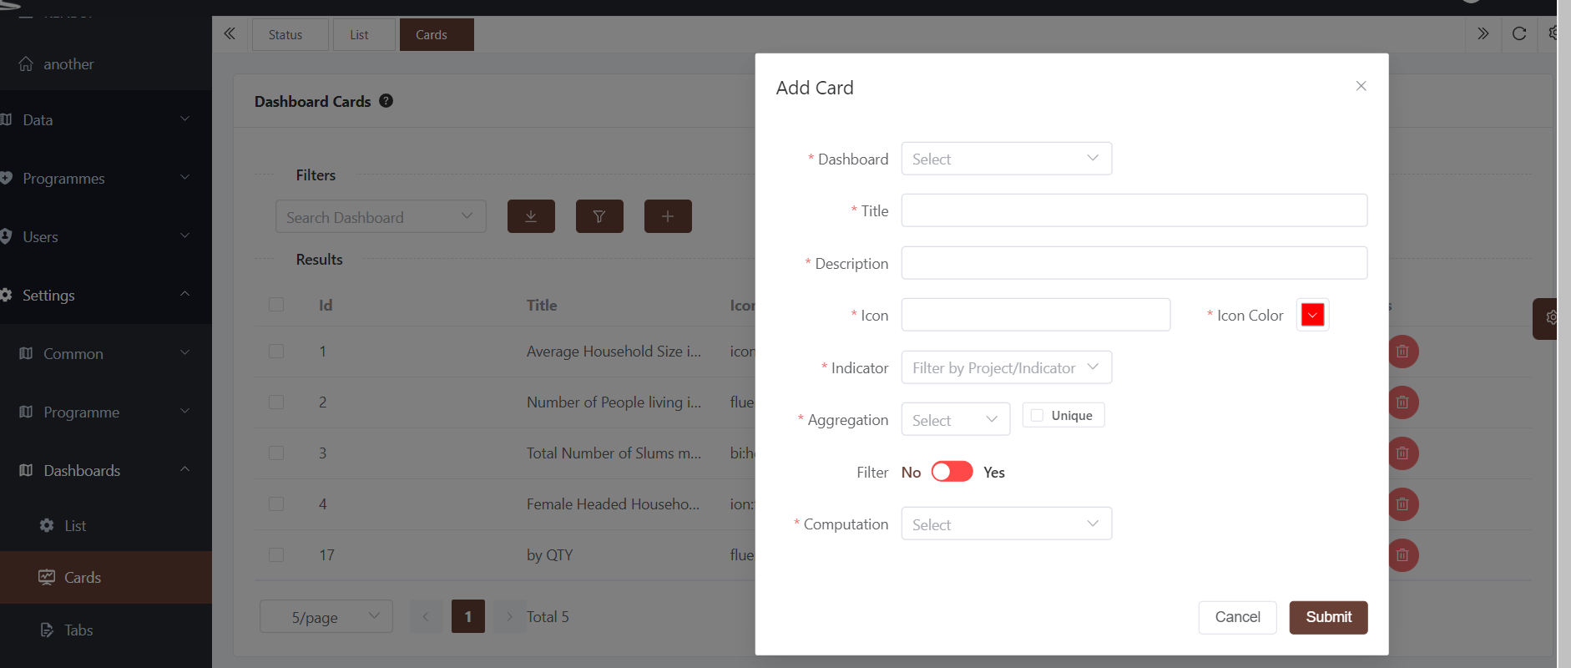

The following details are required for a card within a Status dashboard:

- Dashboard - where the card will go
- Title of card - the text that will appear alongside the icon and number/value
- Icon : the cards icon
- Color : The icon color
- Summary Entity: the table to be summarized and presented as a value on the card
- Function : method of aggregation count, sum or average
- Unique - whether to aggregate unique values based on the selected indicatore
- Filter -whether the selected indicator values will be filtered e.g >a certain value
- Filter fields: the field to filter with
- Filter value : the value to filter
- Filter method - Logical operator for the filter (equal, greater than, …..)
- Computation : whether the figure will be absolute or a proportion (%). The proportion is computed as a percentage of the filtered data against the total entries for the selected entity/indicator

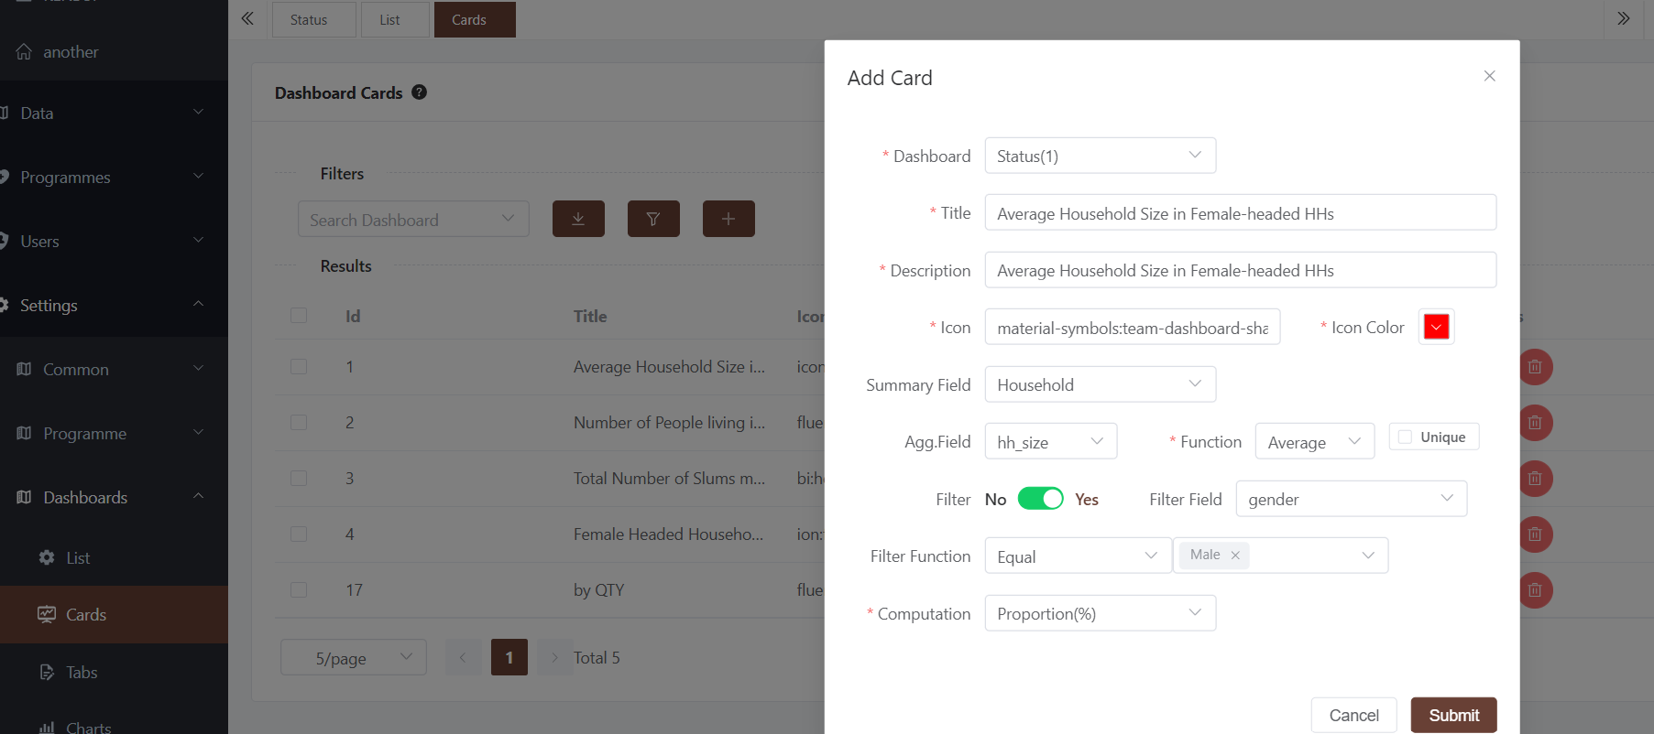

The details provided on the card design enable the querying of data and its presentation to be fully dynamic. Refreshing the data after new entries will immediately reflect on the dashboard. For ease of use, the system has been designed to hold four cards per row. Additional cards will be added on the next row.

Sections/Tabs
Sections are configurable containers under which charts can be inserted. These depend on the dashboard theme and are determined by the administrator. The implementation of sections results in tabs on the dashboard.

A section can be added to a dashboard as follows:
- Navigate to the settings / dashboard section
- Click tabs. A list of all sections in the dashboards will be shown
- Click the + button to create a new tab

The following details are required for a card within a Section dashboard:

- Dashboard - where the card will go
- Title - The text to appear on the tab
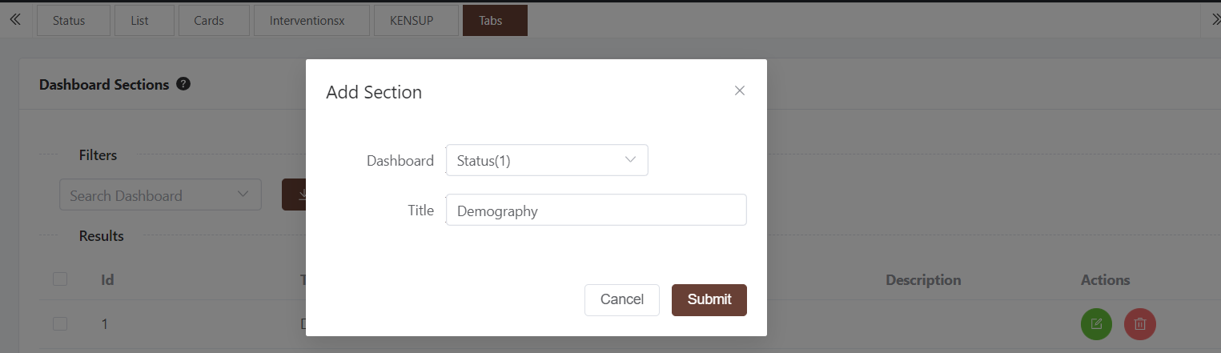

Charts
The dashboard sections hold charts and maps for the system. Various charts are supported on the system.

Types of Charts

Pie chart
A pie chart is a circular statistical graphic which is divided into slices to illustrate numerical proportion. In a pie chart, the arc length of each slice is proportional to the quantity it represents. Pie charts are used to present one variable/indicator but with subcategories.

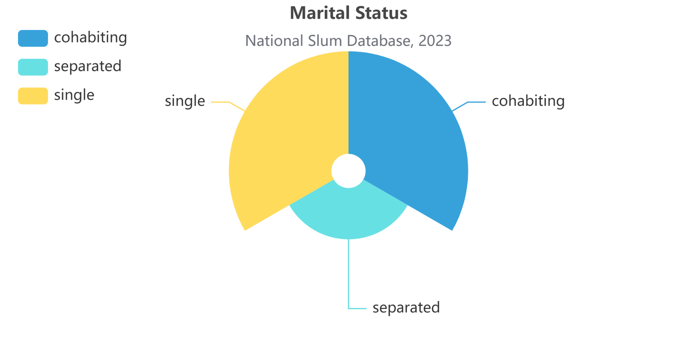

Bar Chart
A bar chart or bar graph is a chart or graph that presents categorical data with rectangular bars with heights or lengths proportional to the values that they represent. The bars can be plotted vertically or horizontally. A vertical bar chart is sometimes called a column chart.

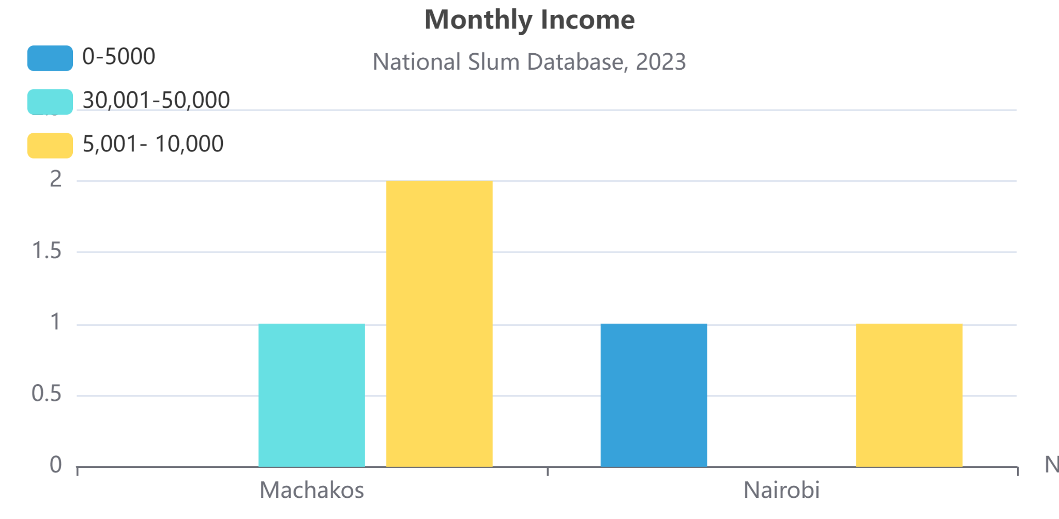

Stacked Bar Chart
The stacked bar chart (aka stacked bar graph) extends the standard bar chart from looking at numeric values across one categorical variable to two. Each bar in a standard bar chart is divided into a number of sub-bars stacked end to end, each one corresponding to a level of the second categorical variable.

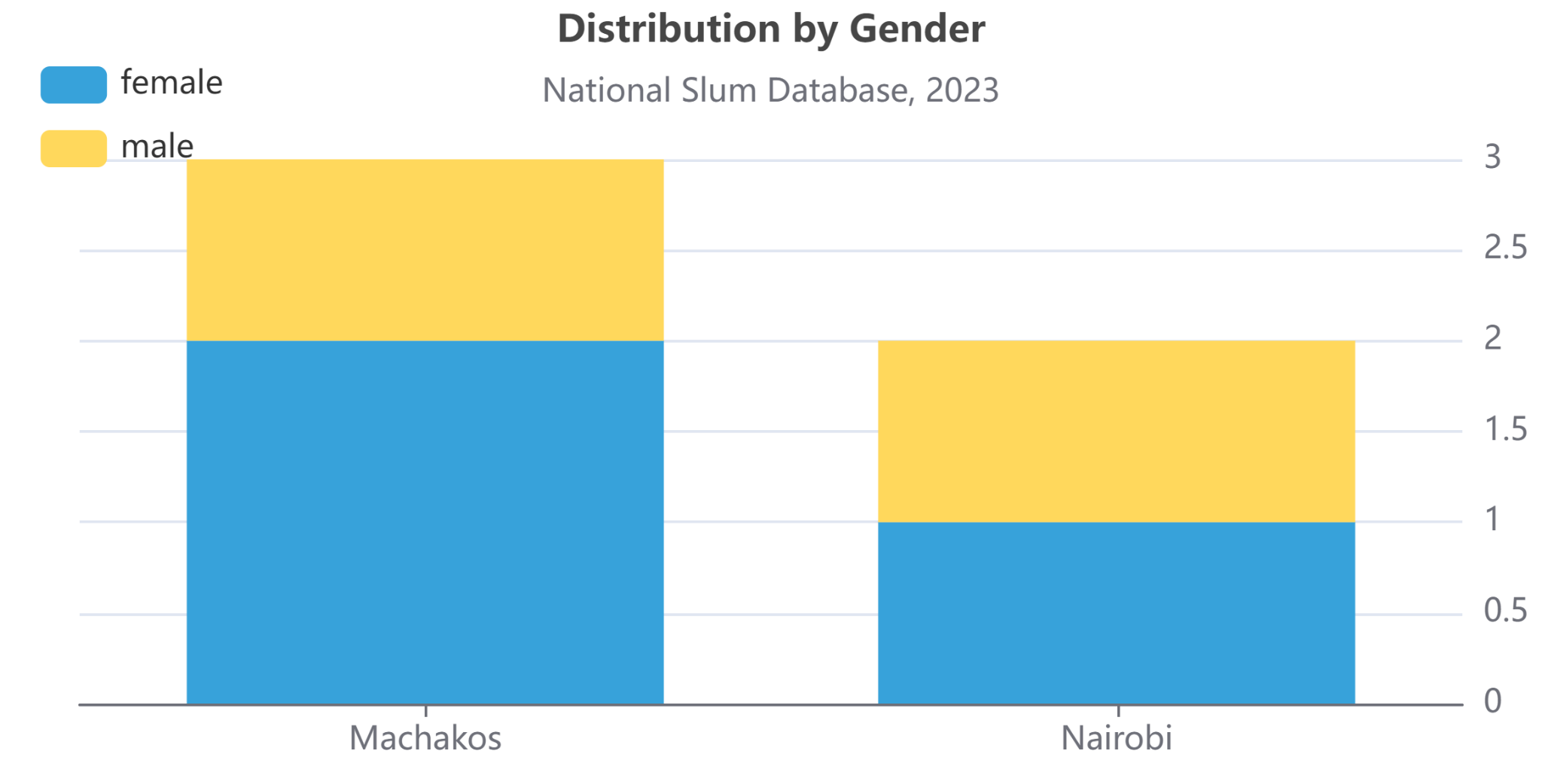

Population Pyramid
A population pyramid is a way to visualize two variables: age and sex. They are used by demographers, who study populations. A population pyramid is a graph that shows the distribution of ages across a population divided down the center between male and female members of the population.

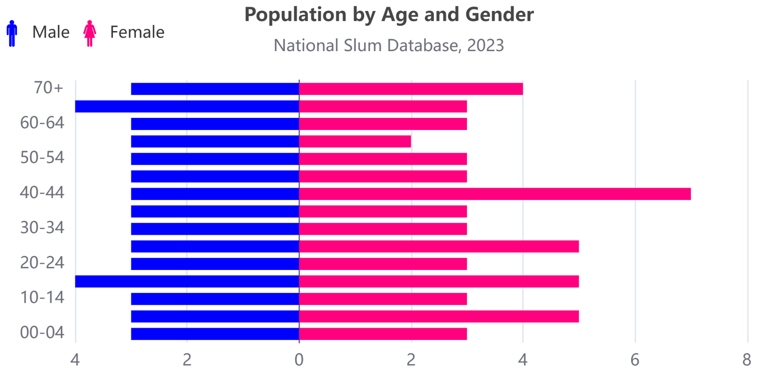

Choropleth Maps
A type of statistical thematic map that uses pseudocolor, meaning color corresponding with an aggregate summary of a geographic characteristic within spatial enumeration units, such as population density.

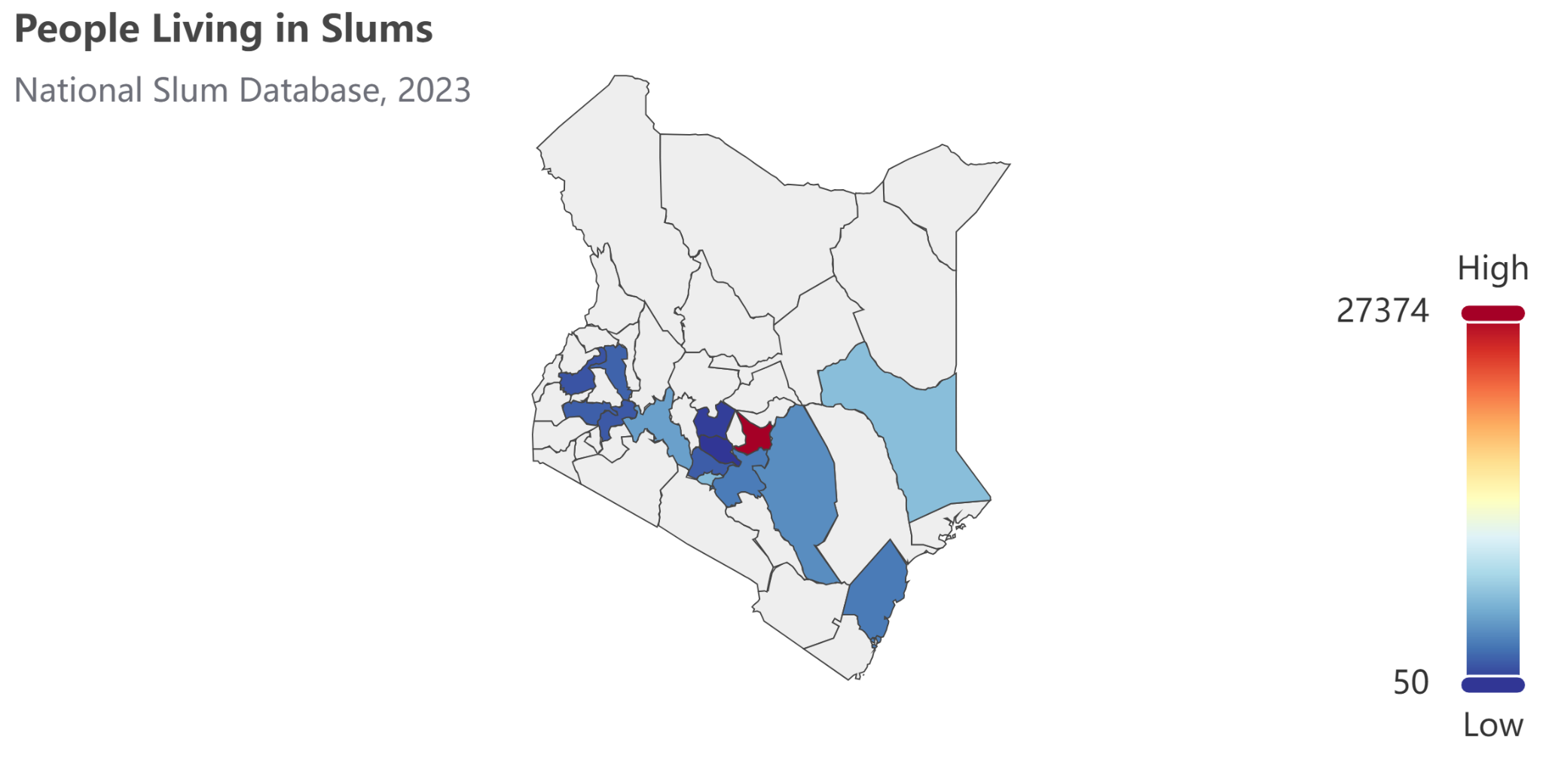

Add Chart
To configure a chart, follow these steps
- Click the settings/dashboards/charts link on the sidebar
- A list of all configured charts will appear
- Click the + button to add a new chart
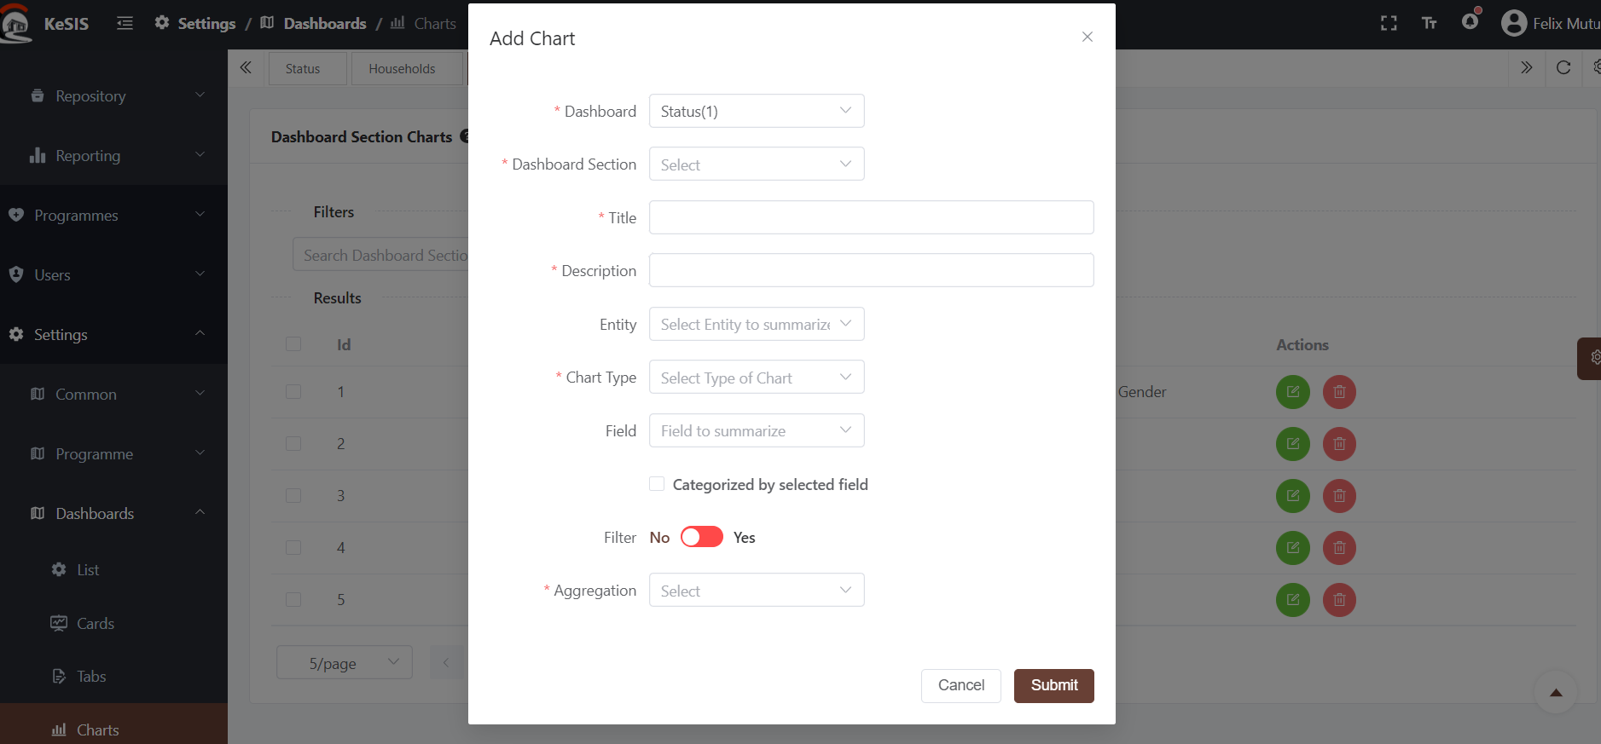
The following details are required for a status dashboard chart
- Dashboard - where the chart will go
- Dashboard section - the tab/section where the chart will be housed in
- Title : Chart Title
- Description: Brief details about the chart
- Entity: the table to be summarized and presented by the chart
- Type : chart Type
- Field - Field to summarize
- Filter -whether the field will be filtered e.g >a certain value
- Filter field: the field to filter with
- Filter value : the value to filter
- Filter method - Logical operator for the filter (equal, greater than, …..)
- Agregation: whether the figure will be absolute or a proportion (%). The proportion is computed as a percentage of the filtered data against the total entries for the selected entity/indicator

The following details are required for a intervention dashboard chart
- Dashboard - where the chart will go
- Dashboard section - the tab/section where the chart will be housed in
- Title : Chart Title
- Description: Brief details about the chart
- Indicator: the indicator to be summarized and presented by the chart
- Type : chart Type
- Field - Field to summarize
- Filter value : the value to filter
- Filter method - Logical operator for the filter (equal, greater than, …..)
- Agregation: whether the figure will be absolute or a proportion (%). The proportion is computed as a percentage of the filtered data against the total entries for the selected entity/indicator

Data
The system has been designed to be user friendly and allows users not only to enter data (authorized) but also view, interface and download the data summaries from the dashboard.

Settlements
The settlement is the minimum unit of representation in the system.
- Click on the settlements icon on the sidebar navigation menu
- A list of all settlements in the system will be listed
- Depending on the rights allocated, the user can add, edit, review or delete a settlement
- Use the filters to subset or search for any settlement based on the county, sub county or the name(or part of it )

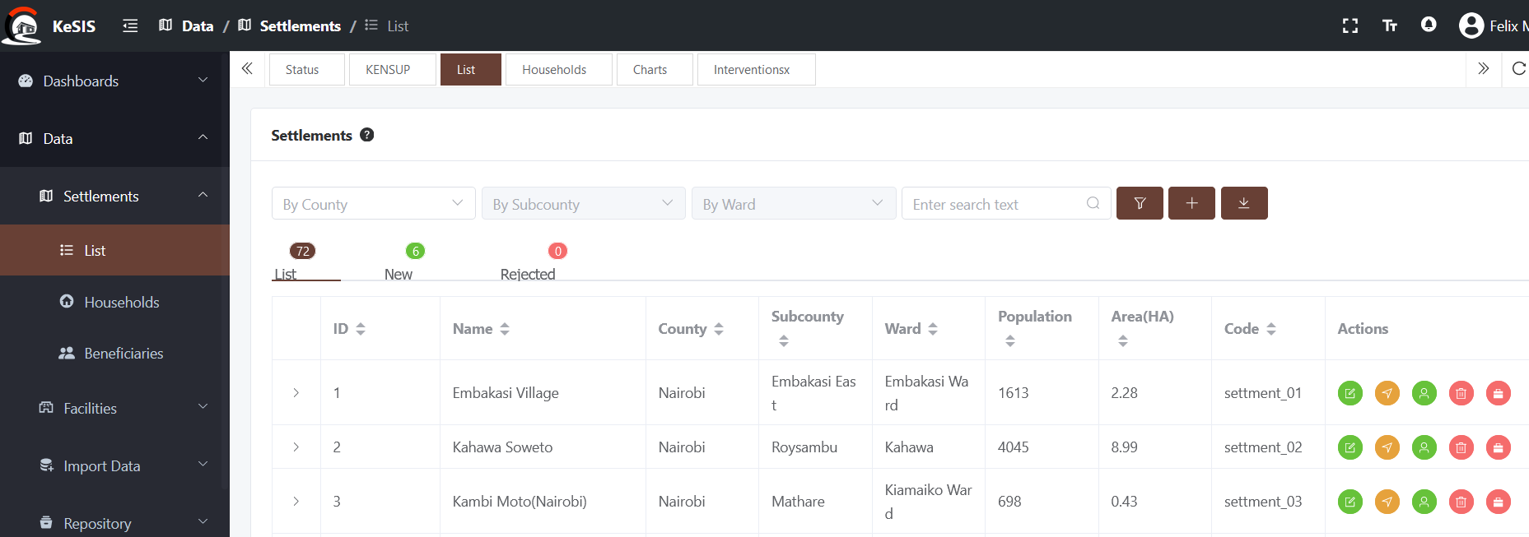

Create a settlement
- Click the  to create a new settlement
- The system will navigate you to the settlement creation window. Fill in all the details as required and click next
- The system will zoom to the selected county/sub county to give you context
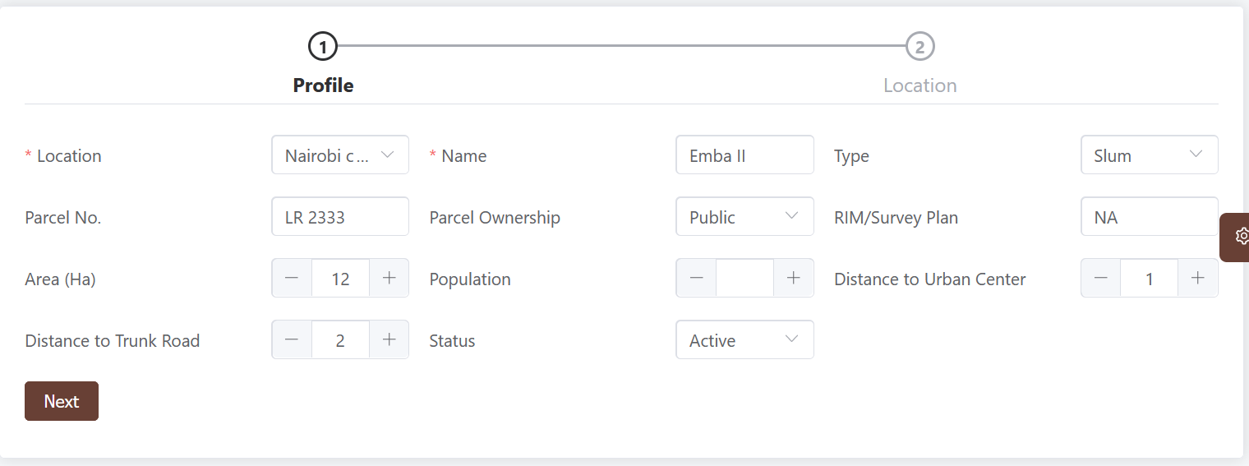
- Click next step to provide location details

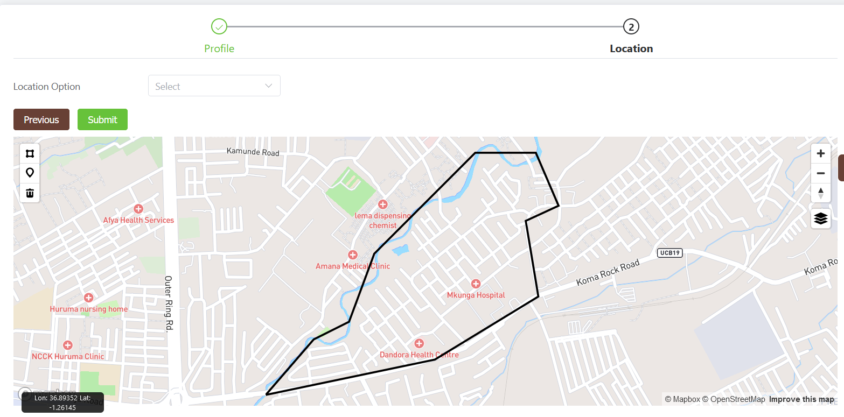
- The system provides two options to define the settlement boundary

Alternative A: Draw the boundary(default)
- Use the map polygon draw tools to define the extent. If not certain use the marker icon 

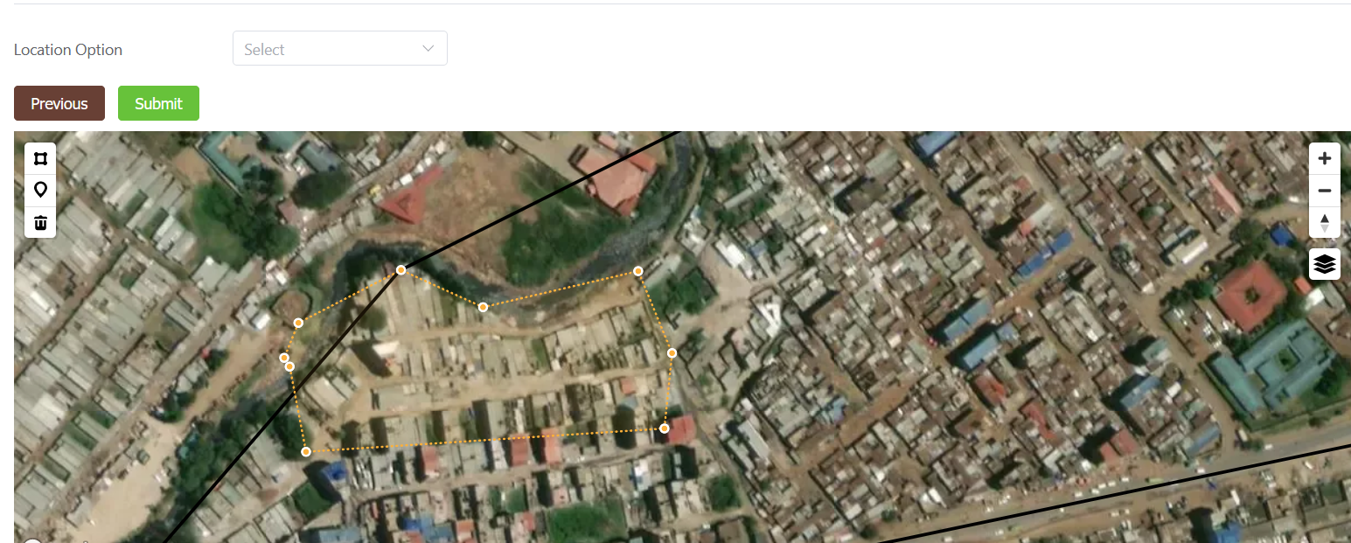

Alternative B: Upload geometry
The system allows the user to upload a defined boundary in the form of a Zipped shapefile or a raw geojson of shapefile file (EPSG:4326)
- Select the option upload file.
- An upload input will appear.
- Select a zipped shapefile or geojson
- If valid,the map will zoom to that location and show the extent, else you will get a warning
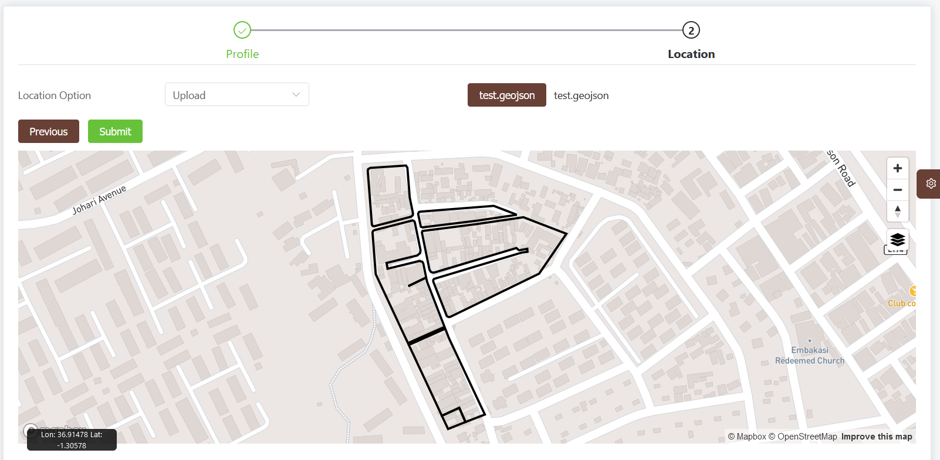
- Click submit to save the record
- The previous button returns to the last page, preserving all data

Edit a settlement
With appropriate rights, a user can update a settlement details.
- Go to the settlement list
- Click the edit icon
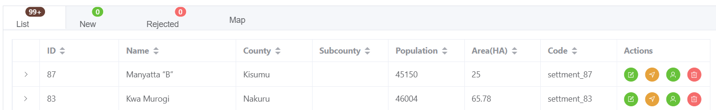
- The system will navigate you to the settlement edit window which is similar to the add window.
- Edit in the details as required and click next
- The system will zoom to the settlement.
- Click the loaded shape to edit the vertices OR
- Upload a new geometry and submit else leave the geometry as is to preserve it
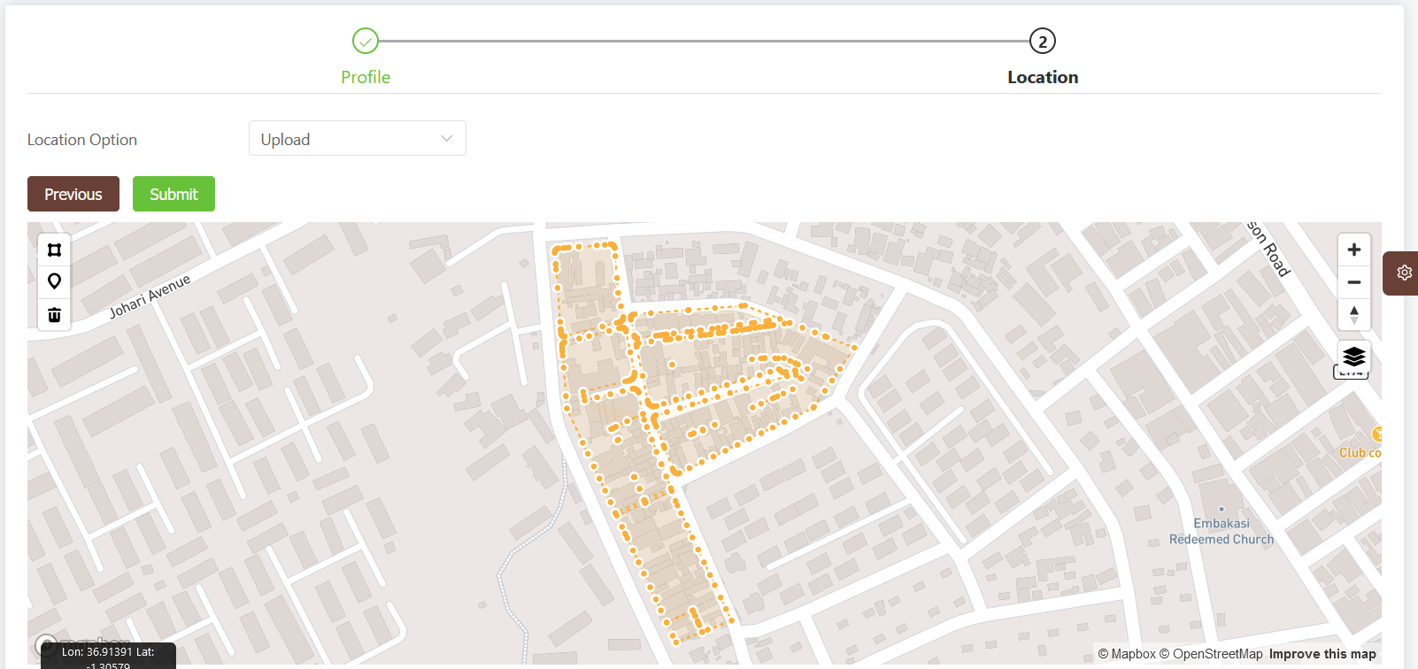

View/delete/upload settlement documents
- To see the currently uploaded documents per settlement, expand the settlement list using the > icon
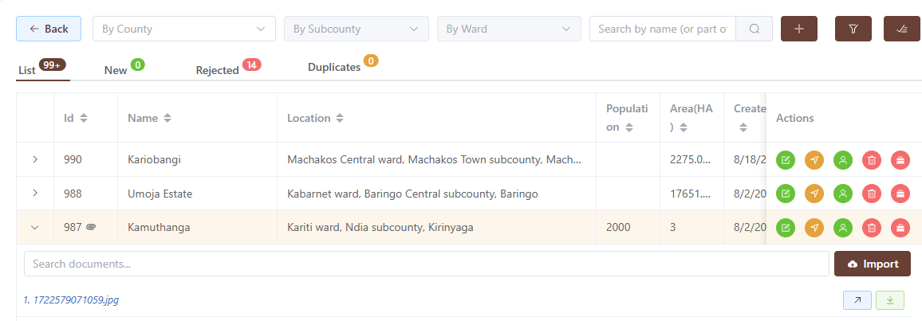
- The documents can be downloaded or deleted using the provided icons
- Click the Import Button to upload new documents
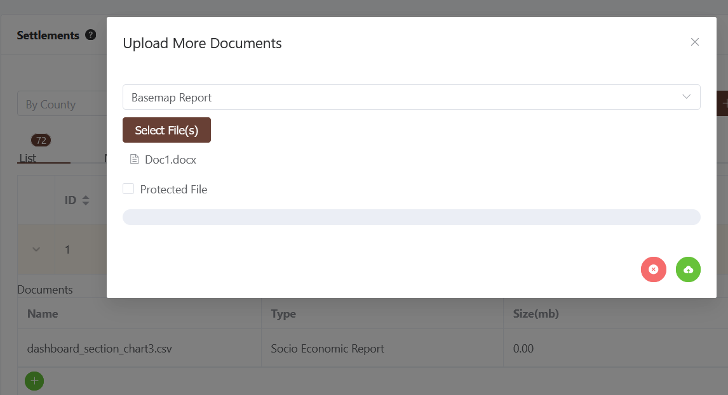

NB: Protected documents are only visible to the administrators or the uploader.

Export Settlement List
- Click the  to download the displayed list of settlements* as an excel spreadsheet
- Use the page selector to choose the number of settlements to download

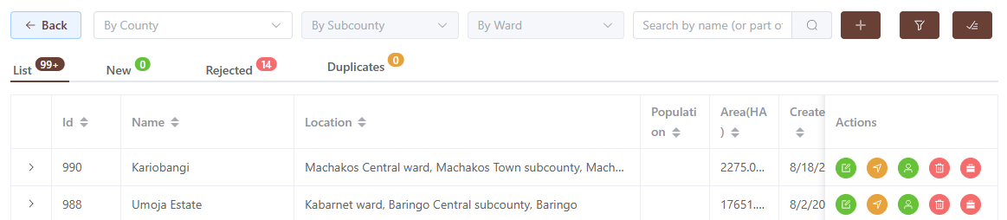
* Please note that this only downloads the displayed list,if you need all the data, use the page selector and pick all. This may take a while to load.

- Select the desired information from the settlement list. These will appear as columns on the downloaded excel file

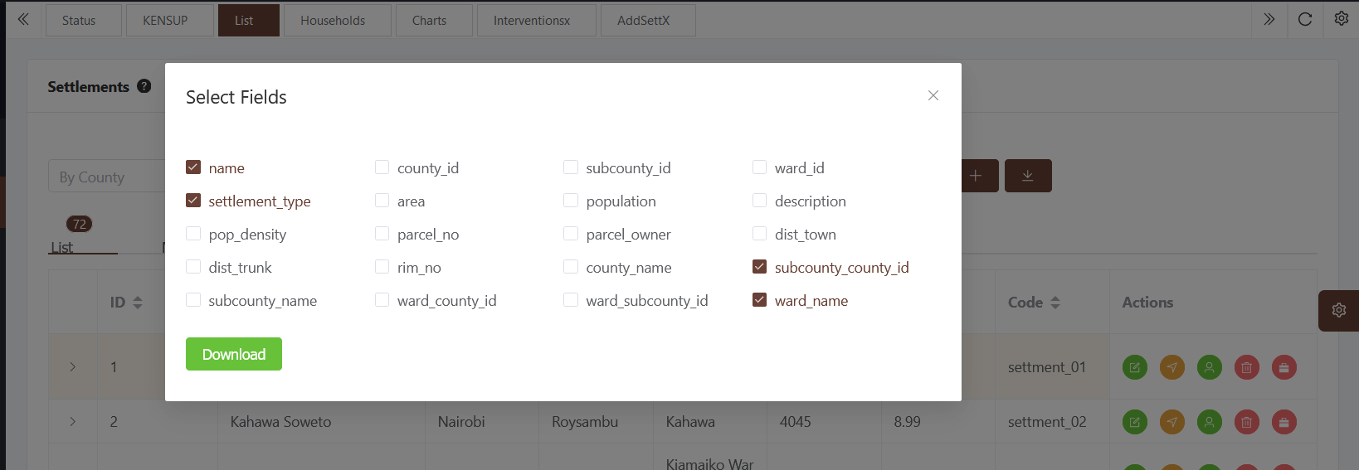

View Settlement Map
A user can view a settlement on a map provided the boundary is defined on the database
- Click the marker icon on the specific settlement as shown on the list
- The system will warn if the boundary is unknown, else it will navigate and zoom to that settlement.
- If the settlement has any tenure regularization data, the parcels will be displayed and color-coded according to land use
- If the settlement has any Aerial photos or drone imagery, it will be loaded as a base layer.
- Layers can be switched on/off via the key panel top-left of the map

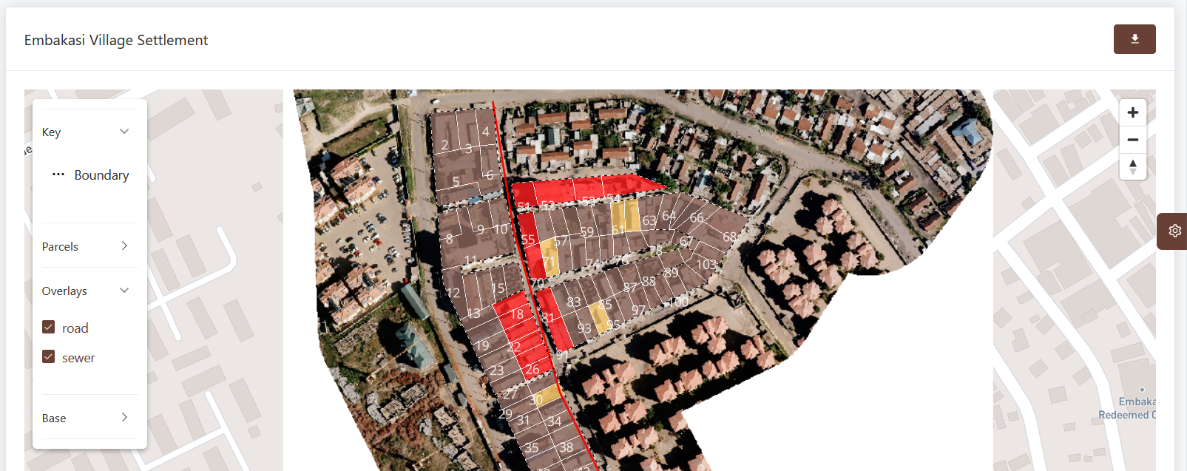
- The user can switch the layers on/off and download the boundary as a GIS file for offline visualization using the layers and download icons on top-right corner of the map
- Click on parcels to get more details

View Settlement Households
With appropriate user rights, a user can view the households enumerated or surveyed during the socio-economic surveys
- Click on the households icon
- The system will navigate to the households list for that settlement only
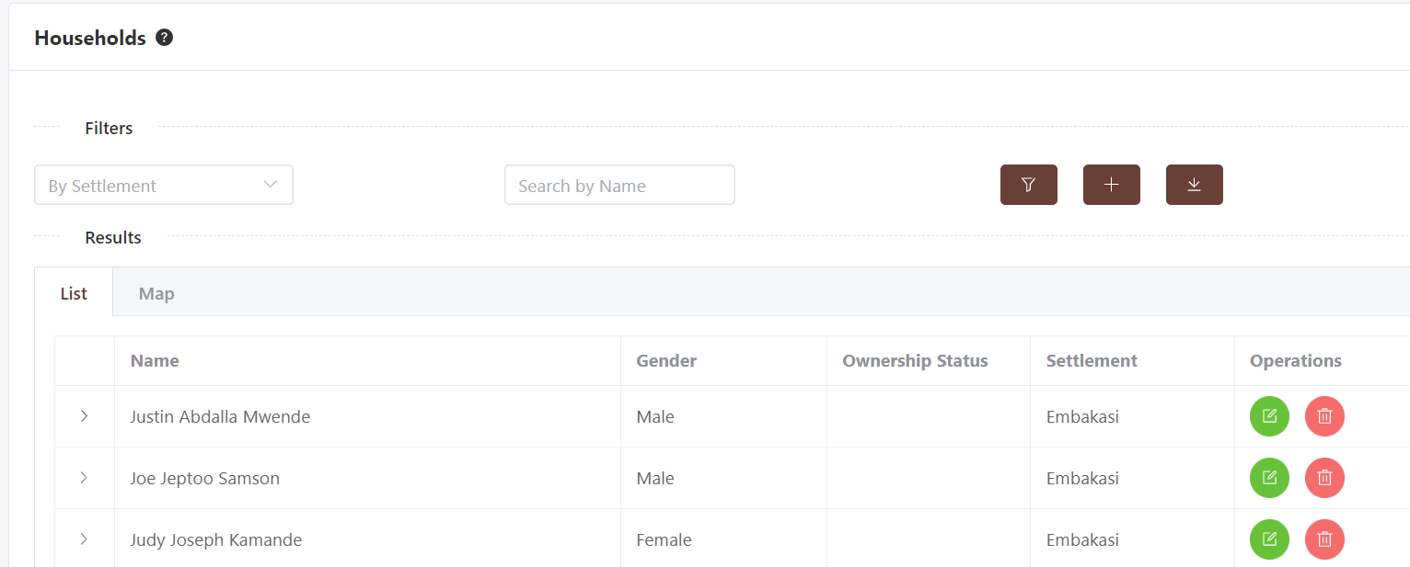

Facilities
The system allows the creation of data on public facilities such as schools, health care facilities, roads and other public-interest data. This information is managed through the facilities module and follows a similar structure across the various entities of interest.

- To create a facility, navigate to the facilities window and click the desired facility of interest e.g health

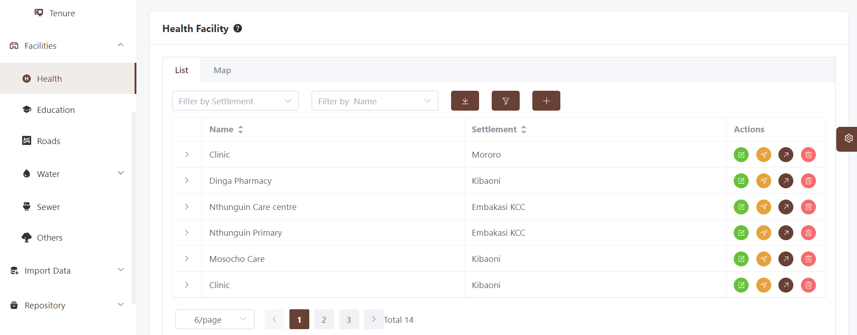
- The existing facilities within the database will be listed for your management
- Click the + button to add a new facility
- The create facility window will appear for data entry
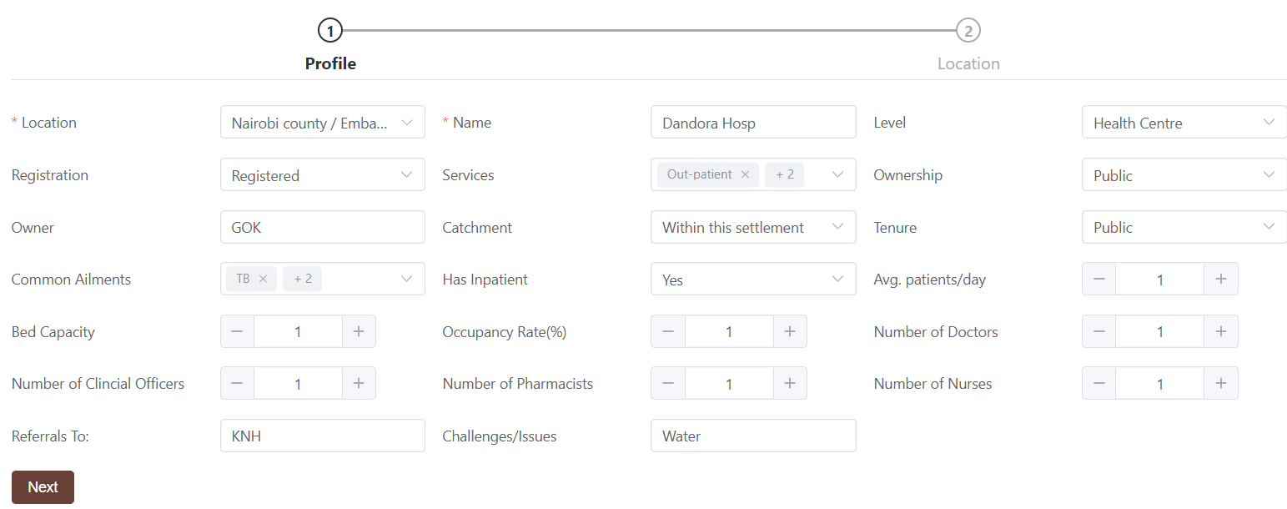
- Enter all the required fields including location - that can be provided in various ways
  - Upload a geoJson file
  - Digitize on screen
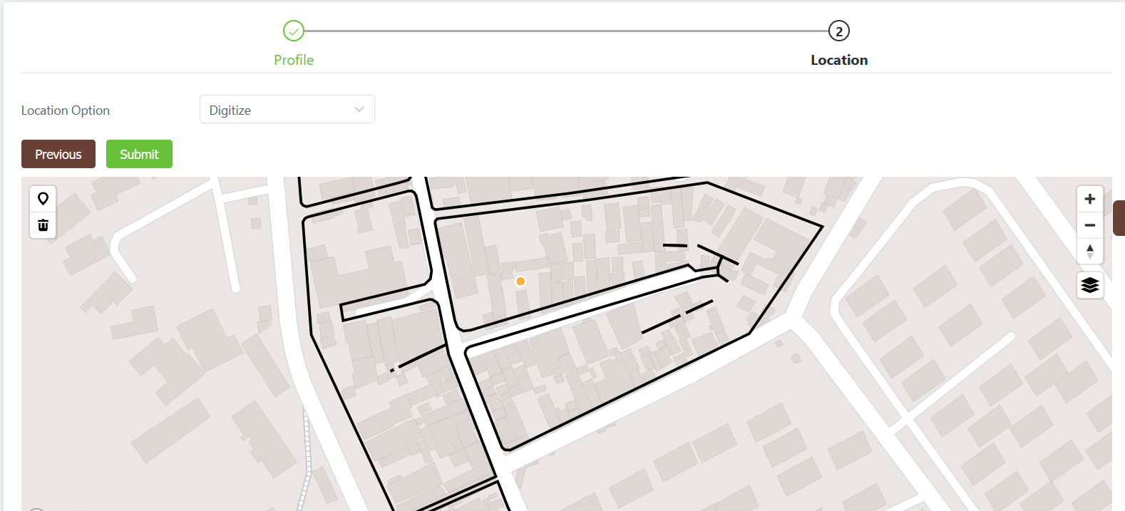

- Click Submit to send data to the database
- On success, the newly added facility will appear on the facility list

Households
During socio-economic surveys for project implementation, some economic surveys and census activities are undertaken. The system supports collection and archiving of the household details. However, this capacity is only available to administrators. The processing, collection and access to this information is restricted with the household data encrypted on transmission and storage.

Data for households can be captured in two ways
- Direct entry using the provided forms
- Importation of household spreadsheets as detailed in Data Importation Section

Create Household
With appropriate rights, the household menu will appear on the navigation sidebar nested under Settlements

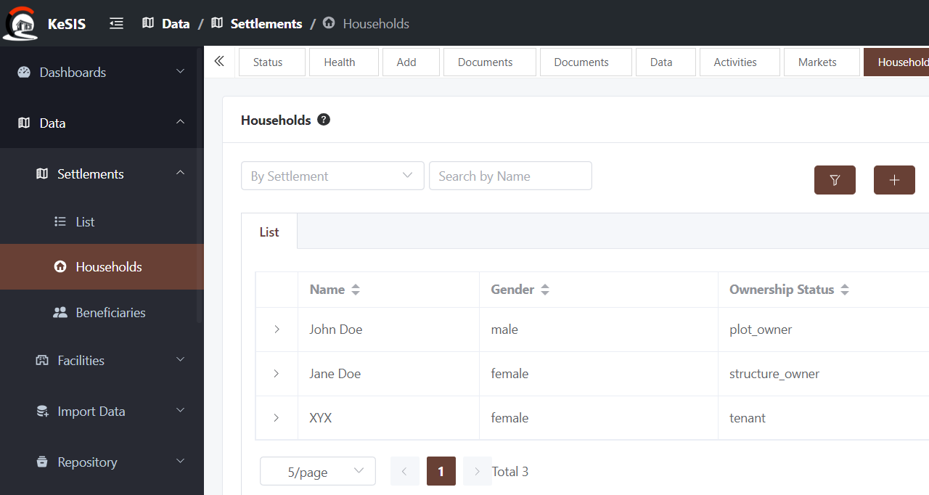
- Click on the Households link
- Click the + button to navigate to the household form
- Fill all the details and click next till end

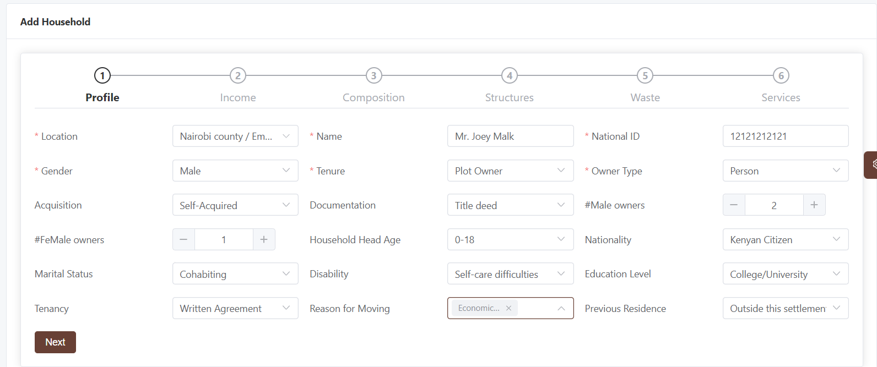

The form captures data based on the standardized data household questionnaire developed and adopted at KISIP2 project.

Edit Household
With appropriate rights, the user can edit/delete the household data from the system
- To Edit, click the edit icon. You will be redirected to the data entry screen with the households data pre-filled
- Adjust as desired then click submit to save
To delete, click the delete icon and confirm on the popup message

Data Importation
The system allows the user with appropriate data creation credentials to import data from excel, geometry and supporting documents in bulk.

List (excel)
To import data from excel, the following steps are followed
- Preprocess the data appropriately ensuring that there's one column that will link the uploaded data to a parent such as a settlement. This code is available from the parent list provided on the system. This is required for proper linkage and is a mandatory field. Such linkages include
  - Beneficiary — Household
  - Household – Settlement
  - Settlement – County
  - Facility — Settlement e.t.c
The table below illustrates such structure

Name | pcode | code | National ID
John Doe | Emba1 | HH1 | 123456
Jane Doe | Emba1 | HH2 | 12789
Julius Caesar | Emba1 | HH3 | 001890

To import excel data follow these steps

- Navigate to the Import Data / List(xlsx) window
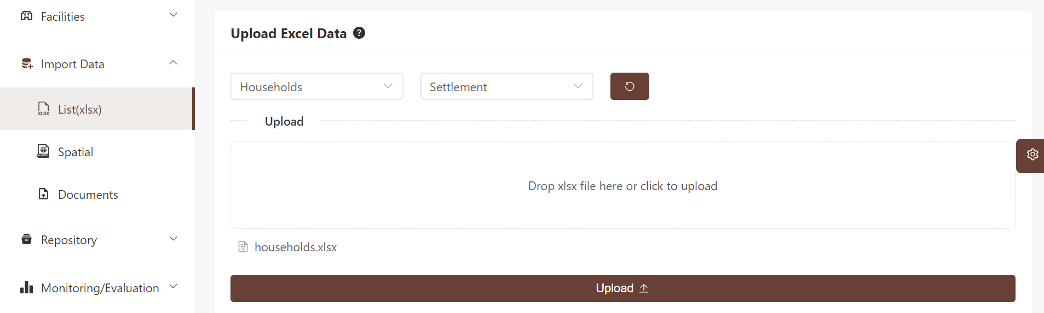
- Select the type of data you want to import followed by the child-parent linkage as described above and shown below. This will open an upload input to drop or select the excel file for upload
- Click the Upload button to pre-processes the data by creating the linkage described above. If no such child-parent linkage exists, the system will warn you.
- Once the linkage is created, the user will be presented with a window to match the fields as required by the database against the fields in the excel file.
- The system will attempt to match the fields based on fuzzy logic matching of strings
- Edit to reflect correct matching
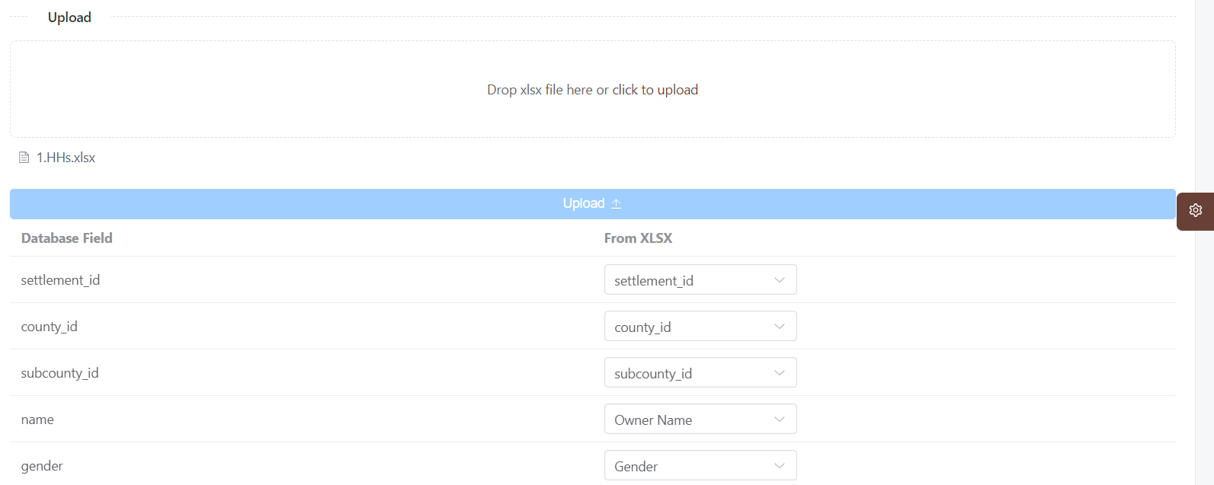
- Scroll down to the bottom of the screen and click submit
- The system will attempt to upload the data and report back on success
- On failure, the appropriate errors will be shown for further pre-processing. These errors may include
  - Missing unique columns, not matched
  - Empty records
  - Duplicate records (if such records are imported)
- Check on each of these errors and adjust your excel file appropriately
- Once the data has been imported successfully, navigate to the respective path/window and confirm addition in the list

Importing though this sub-module is only recommended for system entities that do not have geometry/shape fields such as beneficiaries and households. For entities that require spatial data such as settlements, facilities and projects please refer to the spatial importer.

Spatial Data
The spatial importer functions in the same manner as the excel-based importer only that now the input is spatial data. Follow these steps to import spatial data
- Pre-processing
  - using GIS software, edit the dataset to include all the desired fields especially the pcode
  - Project the data to the system coordinate system (GCS WGS84)
  - Export the data to GeoJson format or a zipped shapefile
- Navigate to the Import Data / Spatial window
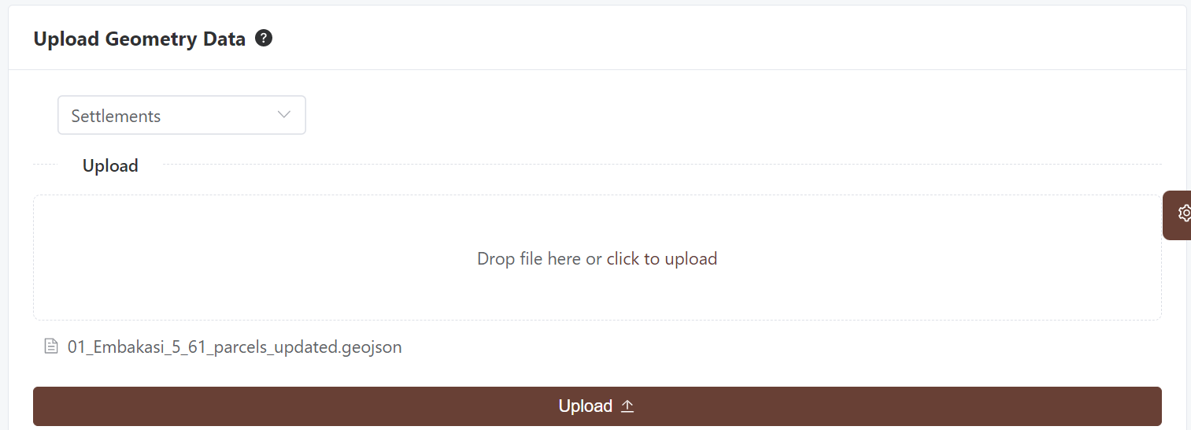
- Select the type of data you want to import followed by the child-parent linkage as described above and shown below. THis will open an upload input to drop or select the geoJson file for upload
- Click the Upload button to pre-processes the data by creating the linkage described above. If no such child-parent linkage exists, the system will warn you.
- Once the linkage is created, the user will be presented with a window to match the fields as required by the database against the fields in the excel file.
- The system will attempt to match the fields based on fuzzy logic matching of strings
- Edit to reflect correct matching

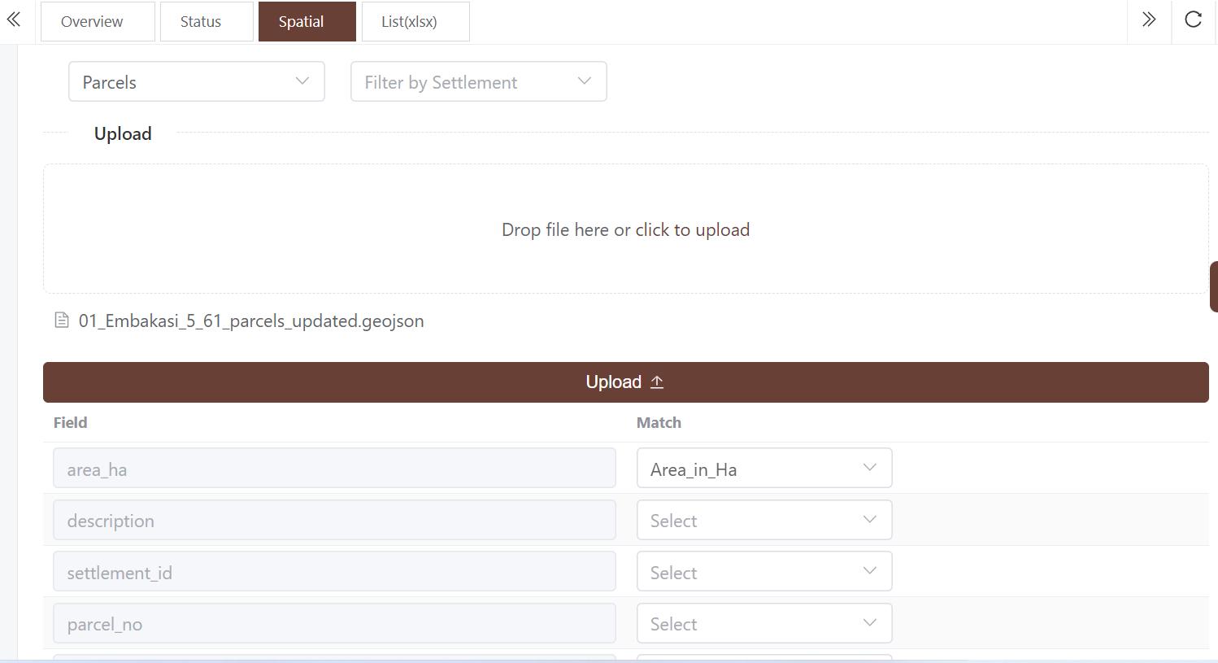
- Scroll down to the bottom of the screen and click submit
- The system will attempt to upload the data and report back on success
- On failure, the appropriate errors will be shown for further pre-processing. These errors may include
  - Missing unique columns, not matched
  - Empty records
  - Duplicate records (if such records are already imported)
- Check on each of these errors and adjust your excel file appropriately
- Once the data has been imported successfully, navigate to the respective path/window and confirm addition in the list
- Additionally, check the location of one of the imported entities to confirm successful geometry importation

Programmes/Interventions
The purpose of the National Slum Upgrading and Prevention is to integrate the existing slums into the formal system, enabling them to enjoy reasonable basic amenities. It will also prevent formation of new slums by adhering to urban planning, provision of infrastructure and low cost housing. To this date, the government and partners have invested in various projects and programmes to upgrade slums in Kenya. These include:
- Kenya Slum Upgrading Programme (KENSUP)
- Kenya Informal Settlement Improvement Project (KISIP)
- Affordable housing
- Others

This system allows the state department to capture information on where these projects are implemented. The locations, activities, projects and beneficiaries are captured as interventions on the system. The system has been designed to allow for a dynamic configuration of this component to allow for future programmes.

Structurally, this section is defined as follows
- There are one or more programmes on slum interventions. A program is a broad intervention area/category e.g housing
- Within a programme there are components tacking different aspects of intervention such as social housing, decanted housing, e.t.c
- Within each component there are one of more projects each composed of one or more activities
- These projects are implemented at the settlement, county or national levels
- Each activity within a project has one or more indicators

Programmes
The task of configuring programmes is only conducted at the national level by the systems administrator. This achieved as follows

Create programme
- Go to the settings at the bottom of side nav
- Click programmes to load existing programmes
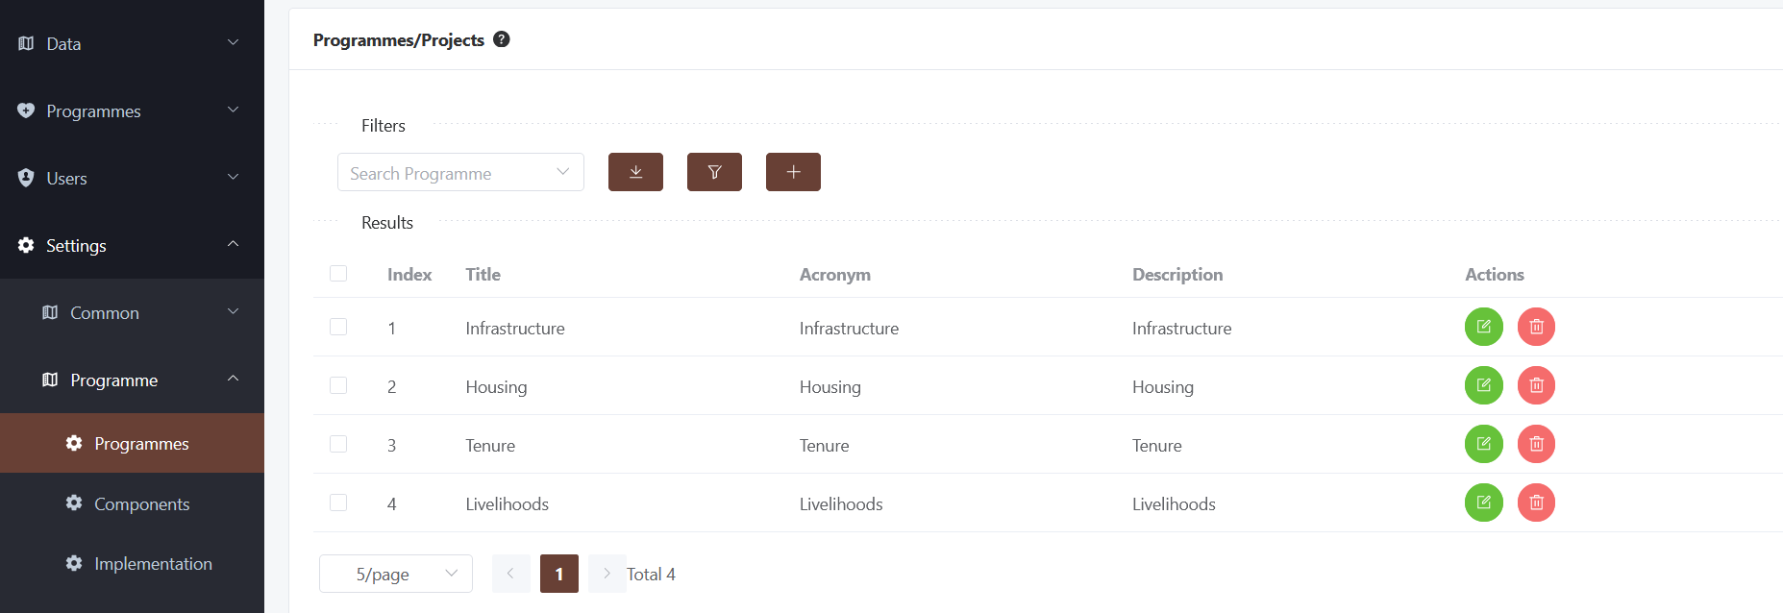
- Click the add button to create a new programme
- Fill in the details

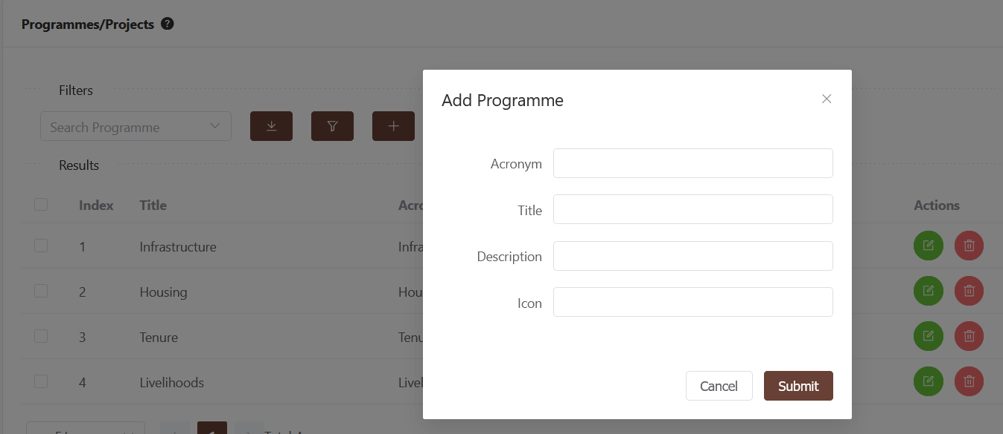
- The information provided in this window will populate the sidebar navigation
- The Acronym - will appear as a link for users to navigate to
- The icon will be displayed on the link as well. Get the desirable icon from https://icon-sets.iconify.design/
- Click submit

Create Programme components

- On the settings menu, click the components link
- A list of all configured components will appear
- Click the + button to add
- Fill all the fields and ensure you've selected the just created programme
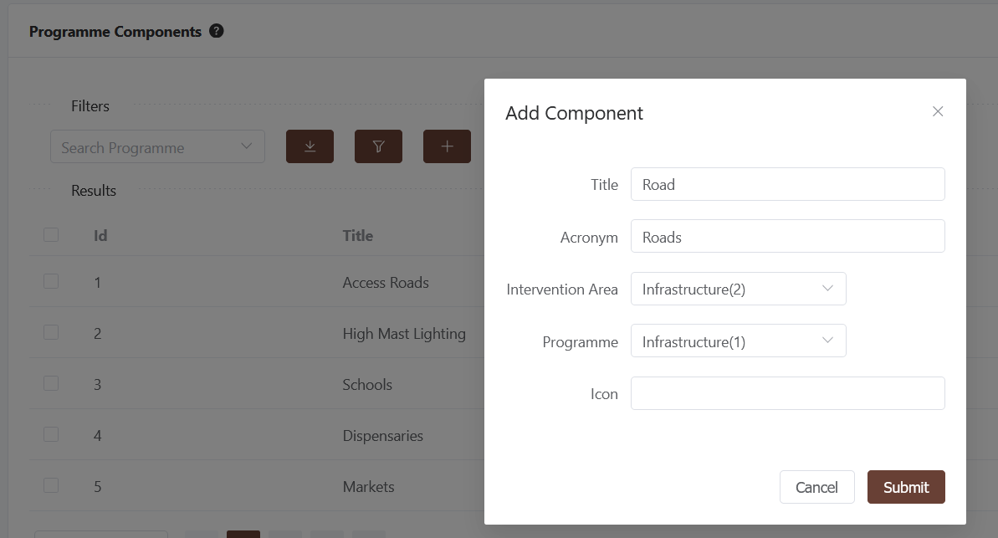
- Add one more component
- Logout and login again, you will notice a new link on the programmes navbar

Create Implementation Mechanism
These are the vehicles through which interventions have been implemented. Eg.
- Kenya Slum Upgrading Programme (KENSUP)
- Kenya Informal Settlement Improvement Project (KISIP)
- Affordable housing

To create an implementation mechanism
- On the settings menu, click the Programme/Implementation link
- A list of all implementations will appear
- Click the + button to add
- Fill all the fields and ensure you've selected the just created programme
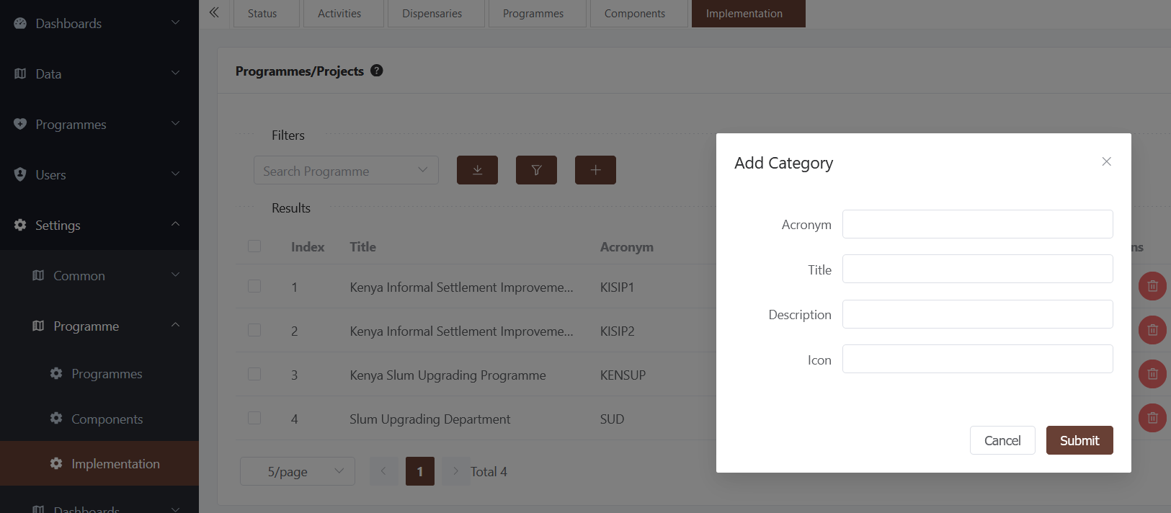

Activities

Activities are menu out of which projects are implemented within the slum upgrading intervention space. These include:
- Construction of access roads
- Construction of footpaths
- Construction of additional classrooms
- Construction of markets and supporting facilities
- Construction of social halls
- …..

It is through these activities which are tied to intervention projects that an intervention dashboard can be implemented. This is achieved through reporting of progress through the monitoring and evaluation module.

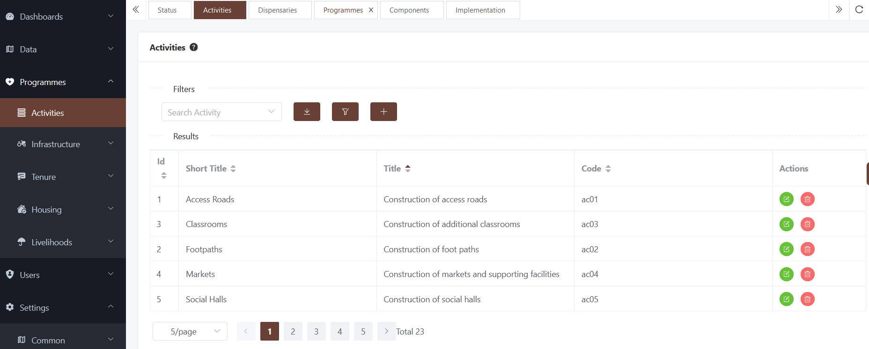

Activities are nested under the programmes menu and can be added as follows
- Click the Add button
- Fill in the form
- Submit

Projects
Projects are interventions towards the improvement of living standards in the slums and informal settlements.A project may comprise one or more activities. These may include simple activities such as installation of high mast streetlights to complex projects such as tenure regularization that will involve survey and planning and social inclusion assessments. For instance a road upgrade project will include construction of access roads, construction of street lights, construction footpaths e.t.c

Create a Project
- A project is resident within a component for a specific programme. Navigate to the specific programme/component as shown below
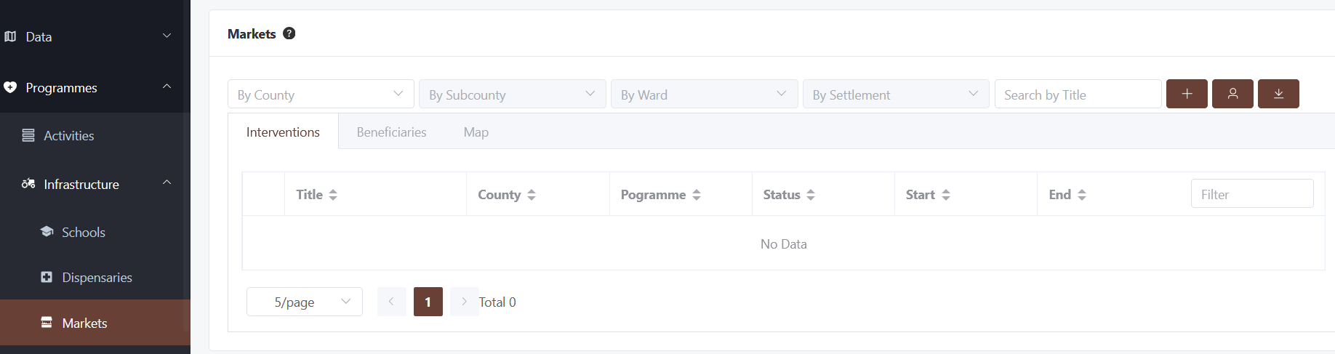
- To create a project, click the create icon
- The system will redirect you to the project creation window

- The system allows the creation project in the existing settlements (recall all settlements will be mapped). However, should this project be outside any known settlement, use the + button next to location to add this new location details

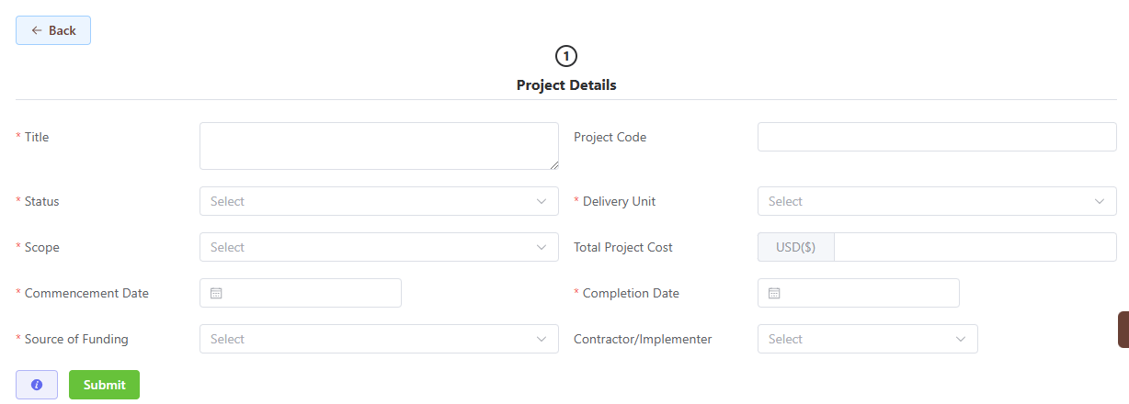
- Fill in all the details and Click submit to save on database
- On success, you will be redirected to the list of projects within this programme
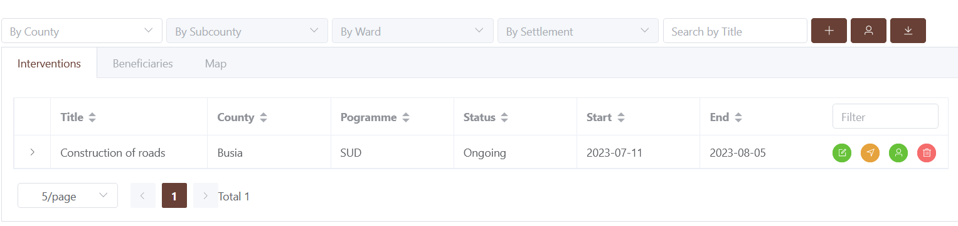
- You can thereafter view the project on the map, view the activities and locations linked to the project and download a list of all projects in the programme

Update/Delete a Project
- A project can be edited or deleted, depending on the rights the user has
- To edit click the edit icon
- You will be redirected to the edit page similar to the add window. Adjust accordingly
- A project can be deleted using the delete icon

Project Locations
A project may exist in multiple locations. To configure project locations, follow these steps
- Expand the project row to open up the details window . The current project locations will be listed
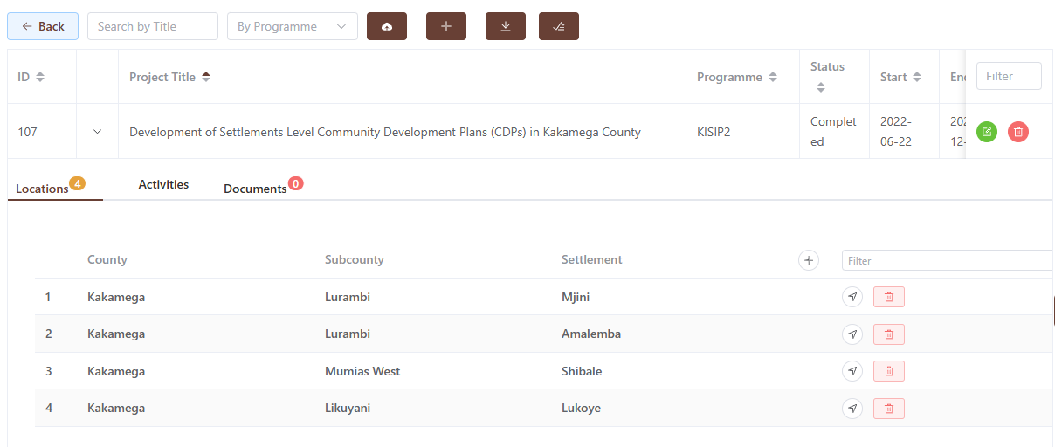
- Click the + button to add a new project location

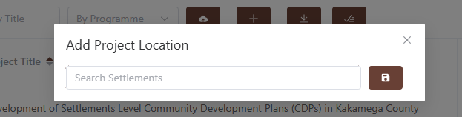
- A popup window will be displayed to search for the settlement. It uses wild card search so any string search will yield a result. Select the correct settlement and save

Project Activities and Documents

Follow the procedures above to manage project activities and documentation

Grievances
The system includes functionality for managing grievances, enabling users to record, track, and update grievance details efficiently. It supports the addition of relevant information, ensures seamless data organization, and facilitates easy retrieval for review, resolution, and reporting. The Grievance Redress Mechanism (GRM) module is a software system designed to manage and resolve grievances raised by stakeholders in a structured and transparent manner. This module forms part of a broader system aimed at enhancing governance, accountability, and responsiveness within the KISIP project.

The primary purpose of the GRM module is to provide a platform for stakeholders (informal settlements residents, project affected persons, contractors and staff) to submit, track, and resolve grievances efficiently. By automating and streamlining the grievance process, the module aims to:
- Improve Responsiveness: Enable timely acknowledgment, tracking, and resolution of grievances, ensuring that stakeholders receive prompt responses to their concerns.
- Enhance Transparency: Provide visibility into the status and handling of grievances, ensuring that all stakeholders are aware of how their concerns are being addressed.
- Facilitate Accountability: Ensure that grievances are addressed by the appropriate personnel, with clear records of actions taken and resolutions provided.
- Support Decision-Making: Provide data and insights to management on common grievance patterns, helping to inform policy adjustments and improvements.
- Benefits
  - For Stakeholders: A user-friendly interface for submitting grievances and tracking their status, reducing frustration and increasing trust in the system.
  - For KISIP: Improved efficiency in handling grievances, reducing manual processes and ensuring that no grievances fall through the cracks.
  - For Management: Data-driven insights into grievances, helping to identify recurring issues and improve overall organizational performance.

The KISIP GRM Information Flow chart illustrates the process of handling grievances, starting with submission through various channels, sorting by type, review and resolution by different committees, and potential escalation to higher authorities or legal action.
- Complaint Submission: The process begins when a complainant submits a grievance through various channels, including the KISIP website, app, form, or in-person assistance.
- Acknowledgement and Sorting: Upon receipt, the grievance is acknowledged via SMS and sorted to determine if it's related to Gender-Based Violence (GBV).
- GRC Committee Review: Non-GBV grievances are reviewed by the GRC Committee. If resolved, the complainant is notified. If not, it's escalated to the County GRC.
- County GRC Review: The County GRC reviews escalated grievances. If resolved, the complainant is notified. If not, it is escalated to the National Grievance Redress Committee (NPCT).
- NPCT Review: The NPCT reviews escalated grievances. If resolved, the complainant is notified. If not, legal redress is recommended.
- GBV Case Referral: GBV-related grievances are referred to the NPCT GBV Focal Person for specialized handling and potential referral to relevant authorities.
- This flowchart outlines the systematic approach to address and resolve grievances within the KISIP framework.
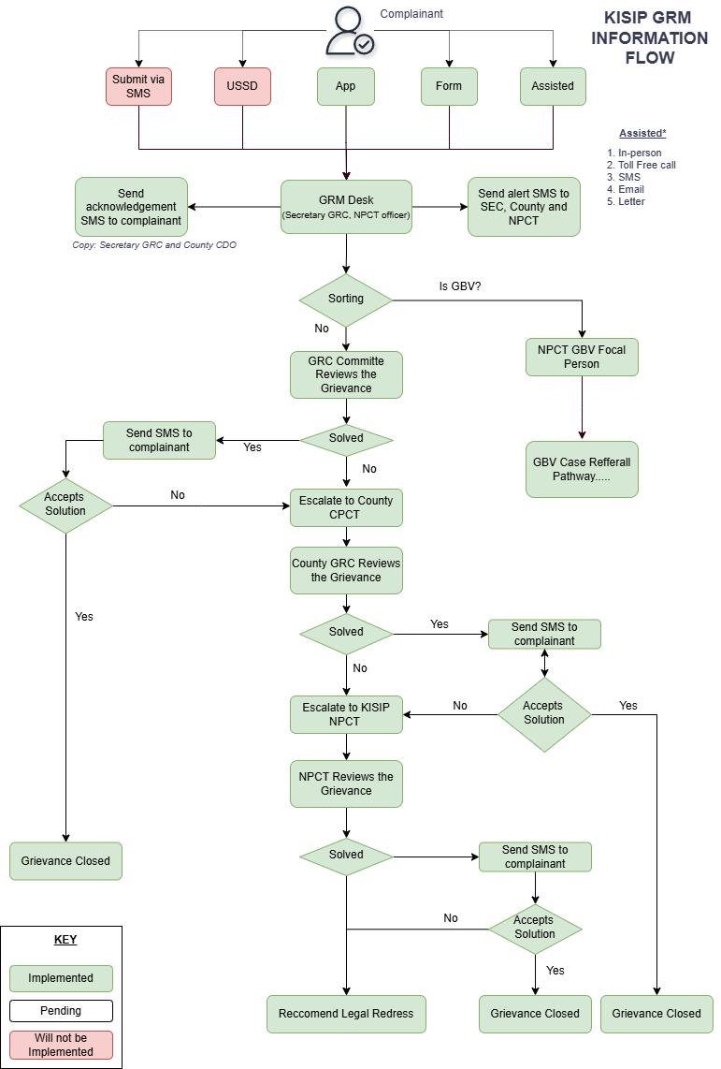

Submitting a Grievance

Any person can file a grievance on the system from the landing page
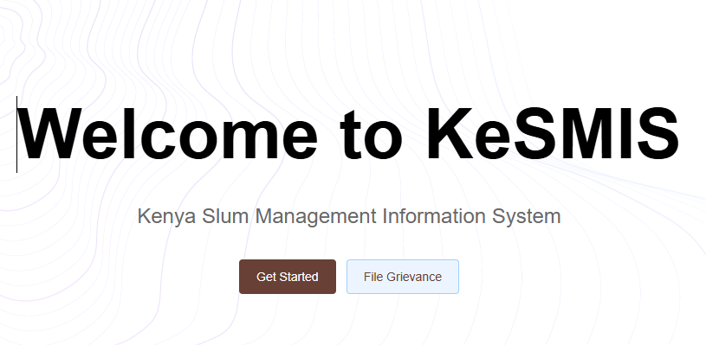
To file a grievance follow these steps:
- Click the file a grievance button
- Fill all the form fields and click next
- Fill in the details required and attached documents on the second page as required
- If you are not the complainant make sure to provide your details for follow up on the form
- Click submit
- An SMS notification will be sent to the number provided
- Additionally, the responsible GRM officer will also be notified va SMS

Check Grievance Status
To check the status of a grievance follow these steps:
- Click the file a grievance button
- Click the “Check status of a grievance tab”
- Fill in the details grievance code and phone number starting with 254*
- Click Check status.
- The status will then be displayed, else “No grievance found for the given criteria” message will be displayed

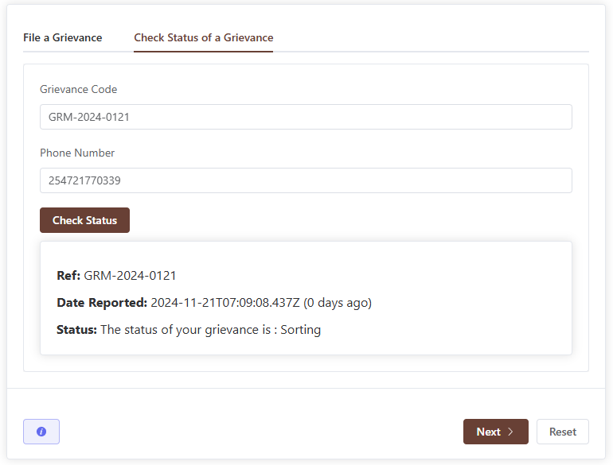

Adding a Grievance
This functionality is only available to GRM officers. It is used for filing grievances that are received through the toll-free number, email, in person or reported to the GRM officer. To Add a grievance received via assisted methods follow these steps:
- Click the Grievances Menu on the sidebar
- A list of all grievances “You can Manage” is listed
- Click the + button to file a grievance on behalf
- Fill all the form fields and click next
- Fill in the details required and attached documents on the second page as required
- Click submit
- An SMS notification will be sent to the complainant’s number provided
- Additionally, the responsible GRM officer will also be notified va SMS

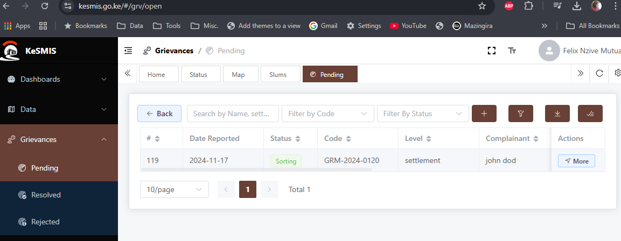

Grievance Sorting
Once a grievance is received on the system, it is automatically sorted into regular grievances and/gbv and the respective responsible officers are alerted through SMS.

Grievance Resolution
For regular grievances, the GRM officer at the settlement is alerted via SMS. As per the grievance redress mechanism, the GRC committee is expected to convene, review the grievance and resolve it. If unable to, the same is escalated to the county GRC. On the system,
- Click the listed grievance on the list
- A window with full details will be shown
- Click the Review and Sort button to submit action
- Select the desired action from (reject, escalate, resolve)
  - Reject - if the case is frivolous and unjustified - the reason for rejection must be provided
  - Escalate - provide a reason for escalation
  - Resolve- Provide all the required details including documentation such as minutes

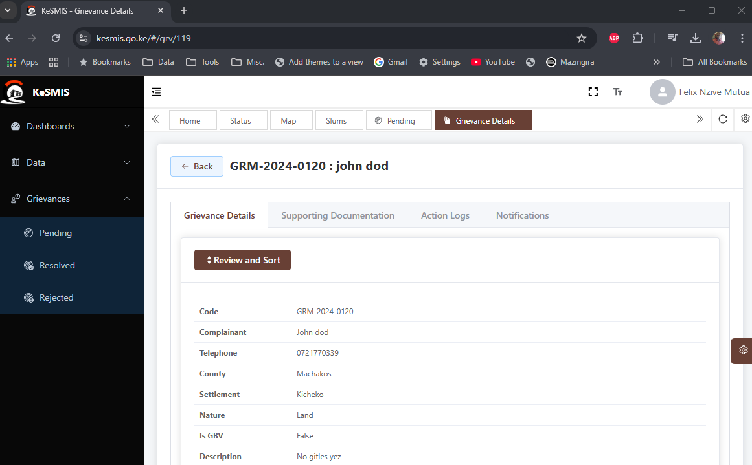
Once a decision has been taken, the complainant will be informed via SMS accordingly.
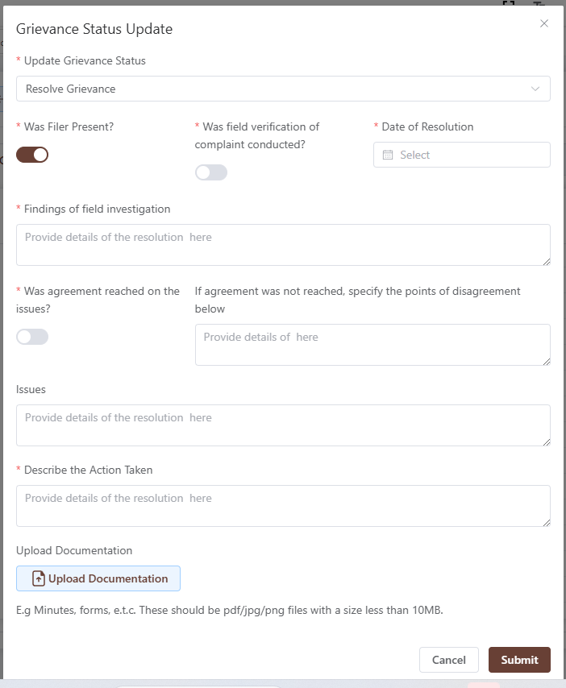

Grievance Details

The "Grievance Details" window provides a comprehensive overview of a specific grievance, showcasing key information such as the grievance ID, submission date, current status, and the category of the grievance (e.g., GBV, corruption). It also highlights the affected party's details, including name and contact information, along with a brief summary of the issue and the location of the grievance.

The "Documentation" tab displays relevant documents, images, or other files attached to the grievance for further context or proof. The “Notifications" tab shows all communications sent to the complainant while the “timeline” tab shows the actions taken on the specific grievance.

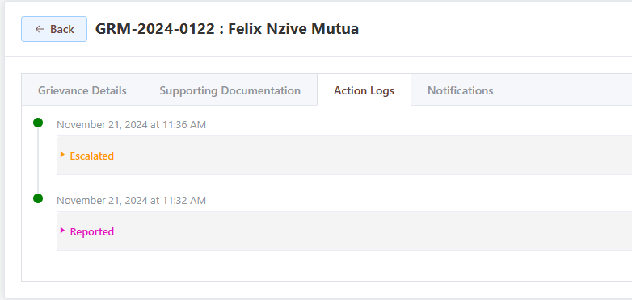

Document Repository
The system has a documents repository module that allows documents to be attached to the various datasets. This may include
- Settlements
  - Socio-economic reports
  - Base map reports
  - Photos
  - List of beneficiaries
- Facilities
  - Photos
  - Ownership documents
  - Copies of titles/maps
- Monitoring and evaluation
  - Progress reports
  - Evaluation data

The documents can be uploaded/managed through various ways.

Adding Documents
Documents can be added on the system through various ways

On the Entity

- Navigate to the list of what you need to add documents for e.g settlement or facility
- Search for the entity of interest
- Click the > icon to open the hidden documents holder
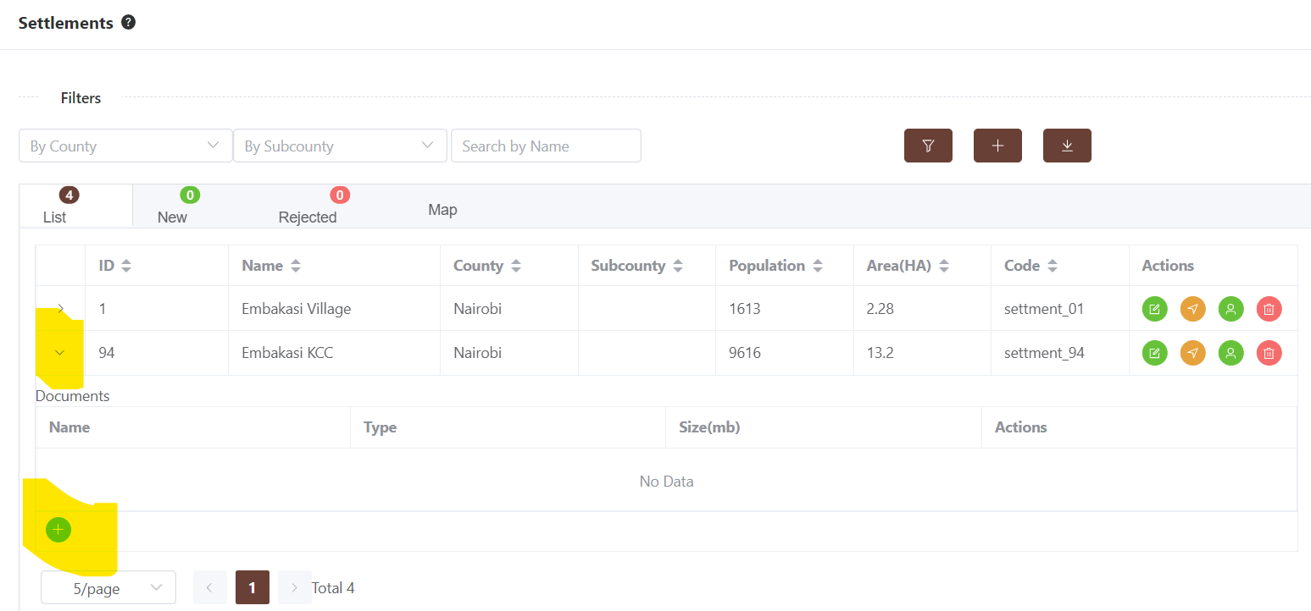
- Click the + button to upload the document
- Fill in the type and then submit
- Refresh your page and check again, the document will be listed
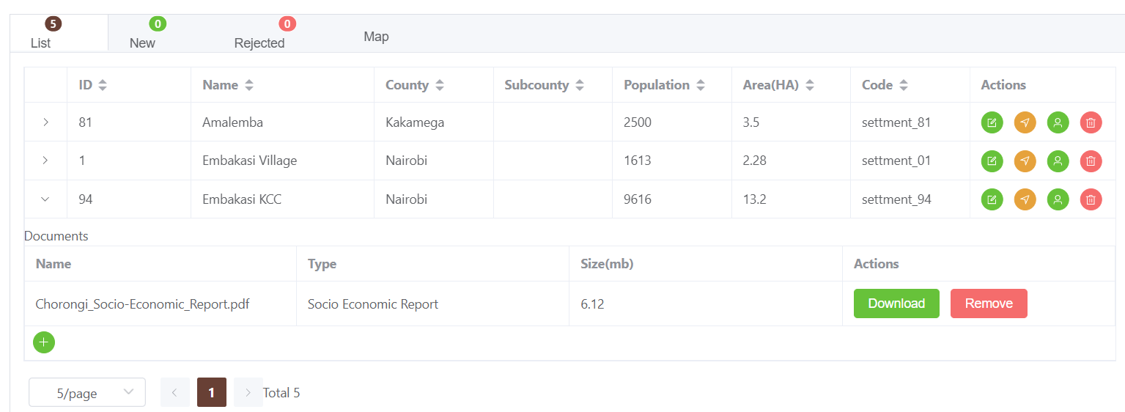
- Edit/download as necessary
The system restricts the formats that may be uploaded for security reasons. If, so you may be required to convert documents to pdf, data to xlsx and photos to PNG.

Batch Import
Alternatively, documents can be imported to the system in batch through these steps
- Navigate to the Import page
- Click on the Documents sub-page

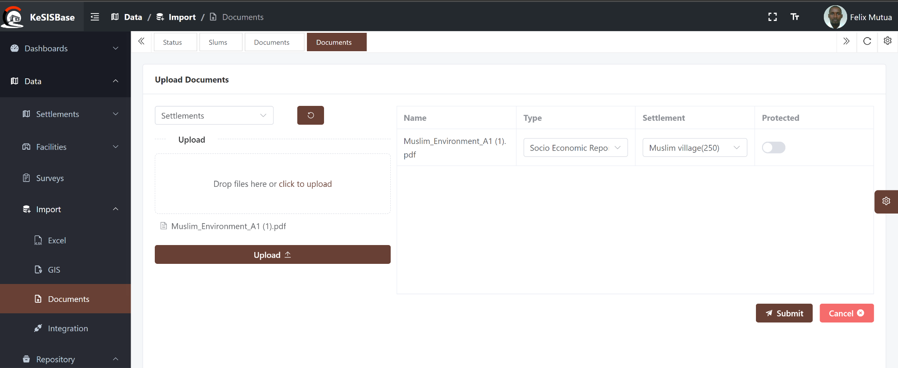

- Select the type of entity(s) you want to import data for. If you have data for facilities and settlements, you will have to repeat for each separately. This is because the system needs to check and import the lists appropriately so that the user can match with ease.

Drop the documents of interest on the upload window and click upload. This will open up a matching table where you will:
- Specify the type of document
- Select the specific entity/activity this documents belongs to
- Thereafter click submit to save the documents on the system
- The system will report back a fail/success appropriately

On success, the uploaded documents will be tucked within the specific entries. With appropriate rights, the user can download the documents, delete existing documents or upload more documents as may be desirable.

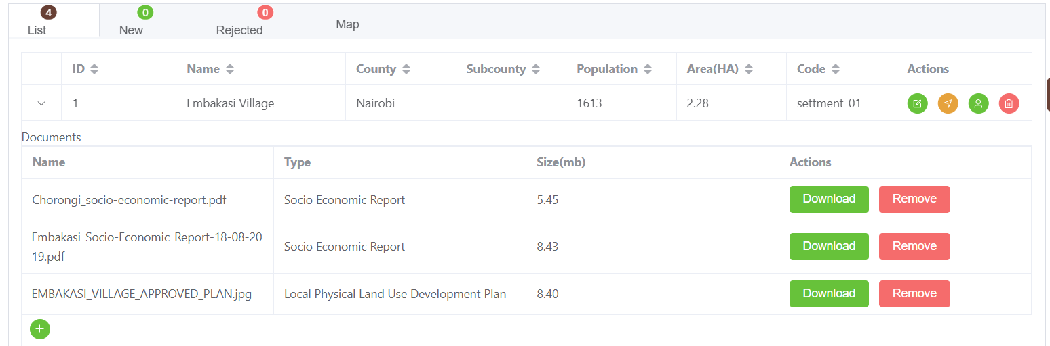
The documents will also be available from the overall list of documents from the repository window as shown below, that will also provide functionalities to view and filter appropriately.

Repository View
The Documents can be access wholesomely from the repository window
- Click on the repository window
- The window allows you to search any document by part of its filename
- The results will filter found documents grouped by type of document
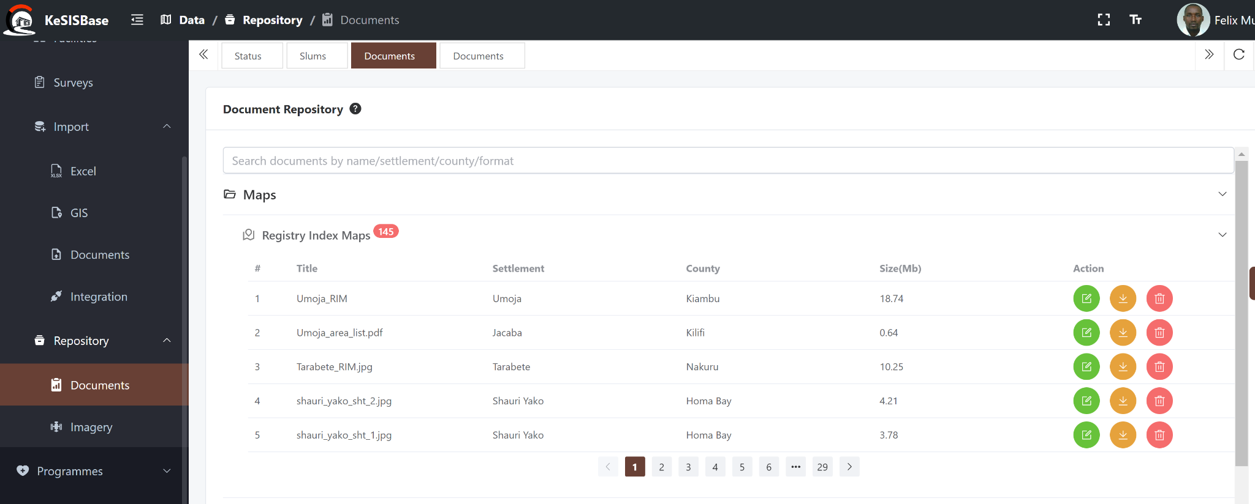
Within the repository you can:
- Search by name of document, county, settlement, project, format etc. This will be limited to 150 records at a go
- Edit document: name, type and where it belongs to
- Delete your own documents (or others if you have administrative rights
- Download

Adding Document Categories
Suppose my document category/type is missing or misspelled?

- Go to Settings
- Open the common settings
- Click on Document Types
- Edit/Add as desired
- Refresh your page and go to add your documents. Your new/category should now be available

Monitoring and Evaluation Module
The Monitoring and evaluation module allows the configuration of indicators to facilitate reporting of achievements of the various slum intervention project activities. Structurally, this module is structure to fit in to these concepts
- There are one or more programmes on slum interventions
- Within a programme there are components tacking different aspects of intervention such as tenure, infrastructure and socio-economic interventions
- Within each component there are one of more projects with various activities
- These projects are implemented at the settlement, county or national levels
- Each activity within a project has one or more indicators

Graphically, the module workflow is represented as follows:
Create Programme
Create Component
Create Activities dictionary
Create Project with a Programmes Component
Create and configure the indicators
Report, Review and approve Indicator Reports
Prior to reporting, the activities, projects and indicators must be configured as discussed below

Activities
- Go to the Monitoring/Evaluation window and click activities
- A list of the existing activities will appear
- Click the + button to create a new activity
- Fill in the full title and the short title
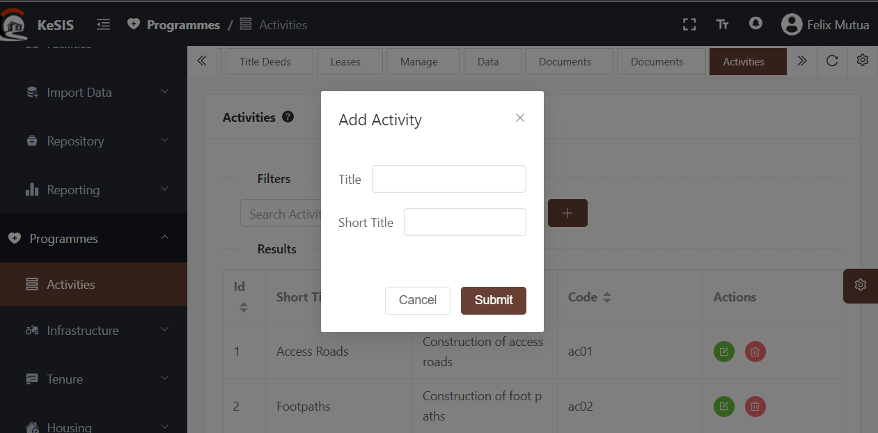

Indicators
Indicators are the core of this module and must be configured prior to any reporting on the system. This is achieved as follows
- Navigate to the Reporting window and open the sidebar to reveal the options
- Click on the Indicators Window to view the existing indicators
- Click the + button to create a new indicator
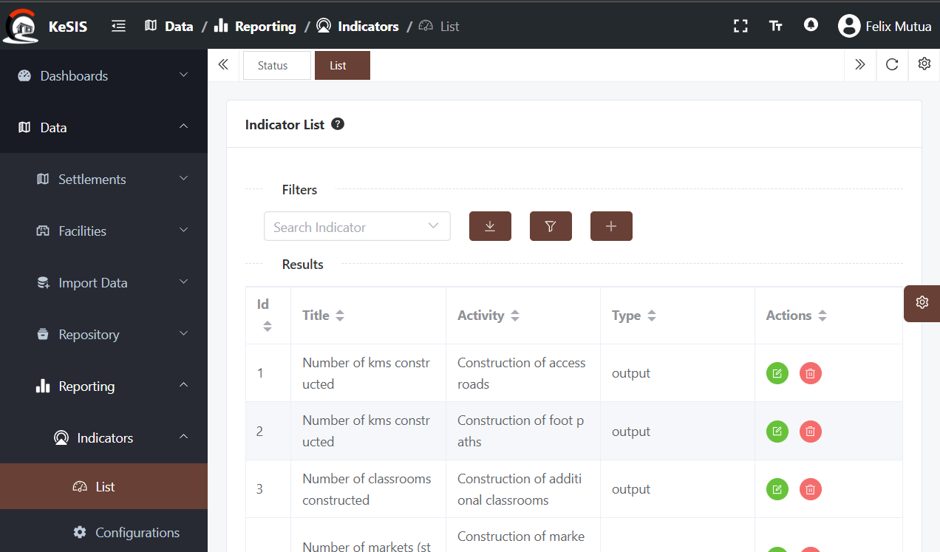
- Fill all the required details and click submit
- The newly added indicator will now appear on the list
The indicators can be edited or deleted by use of the provided buttons against each indicator

Indicator Configuration
The indicators are thereafter configured for reporting purposes. Specifically, setting up the frequency of reporting and the reporting dimension (such as by gender, by age…) as may be appropriate. To configure an indicator:
- Ensure that the indicator has been created and exists on the database
- Navigate to the Reporting >> Configurations window. A list of all existing configurations will appear
- Click the + button to add a new configuration
- Select the project you want to configure indicators for (see the create projects sections on how-to)

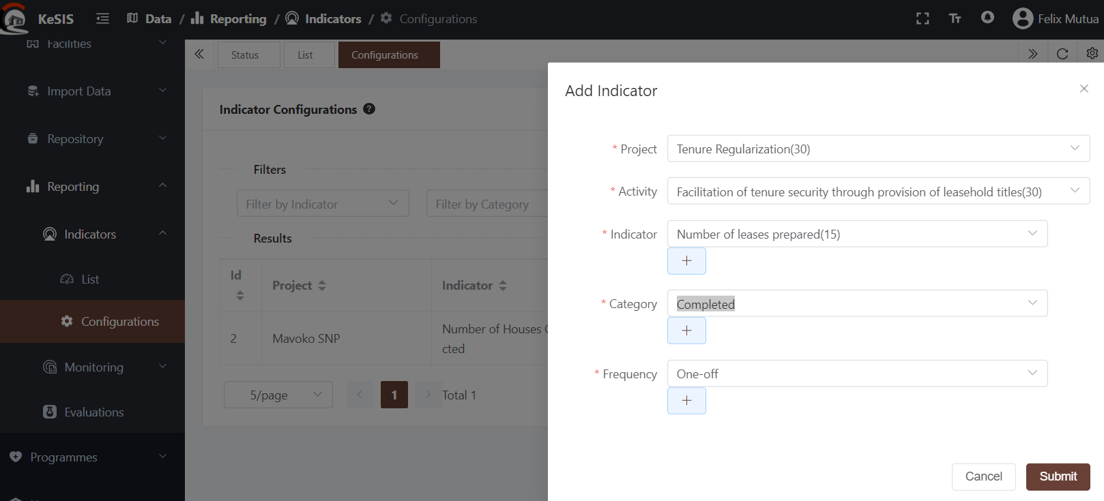
- Select the activity (This will have been added to the project during its creation)
- Select the indicator, the categorization and frequency of reporting the click save
- The newly added configuration will appear on the list on refresh
- Repeat this step until all potential dimensions and reporting frequencies for the specific indicator are created on the system. For instance, you can figure an indicator for the same pr, same activity but for male and female

Reporting
Reporting is based on the indicator configurations and follows the workflow below:
- The designated user reports the amount for the specific project activity
- The reviewer checks the data
  - Approved - updates the dashboard
  - Rejected - send back to submitter for correction

Indicators
Configurations
Reports
Review
Dashboard
Rejected
Approved
Dimensions/Categories
This is achieved through the following steps:
- Navigate to the Reporting window. All previous reports by the user will be listed
- The listed table provides a summary of the indicator, location and approval status of the submitted report.
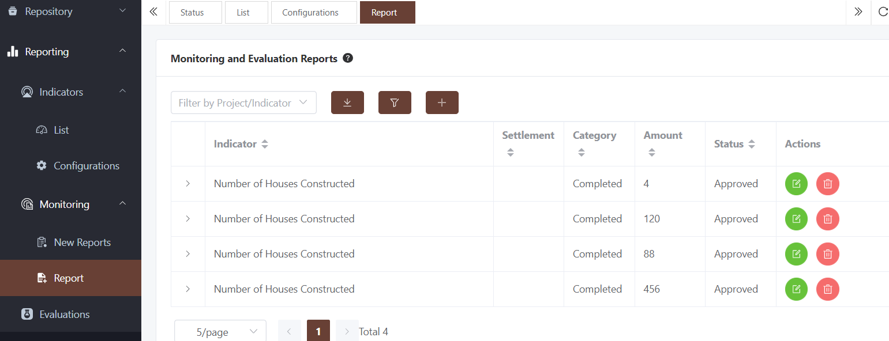
- To file a new report, click the + button
- Select the desired indicator and fill in all the details
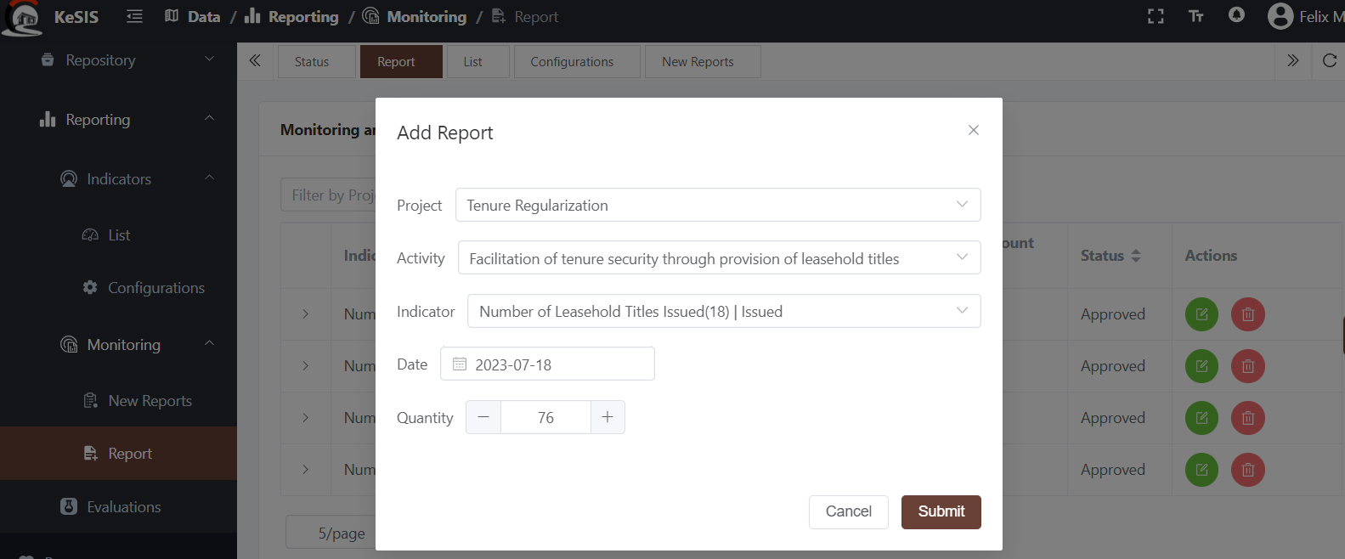
- Click to submit to the M&E reviewers
- Once checked by the reviewer, the status of the report will change to either approved or rejected. if rejected, a reject message will be added to the table against the specific report and a notification added on the top-most part of the system
- Once approved, the submitter cannot modify the report.
- Rejected reports can be edited and resubmitted for review

Review of M&E Reports
The user designated to check and review reports will see an additional window nested on the Monitoring window as New Reports.
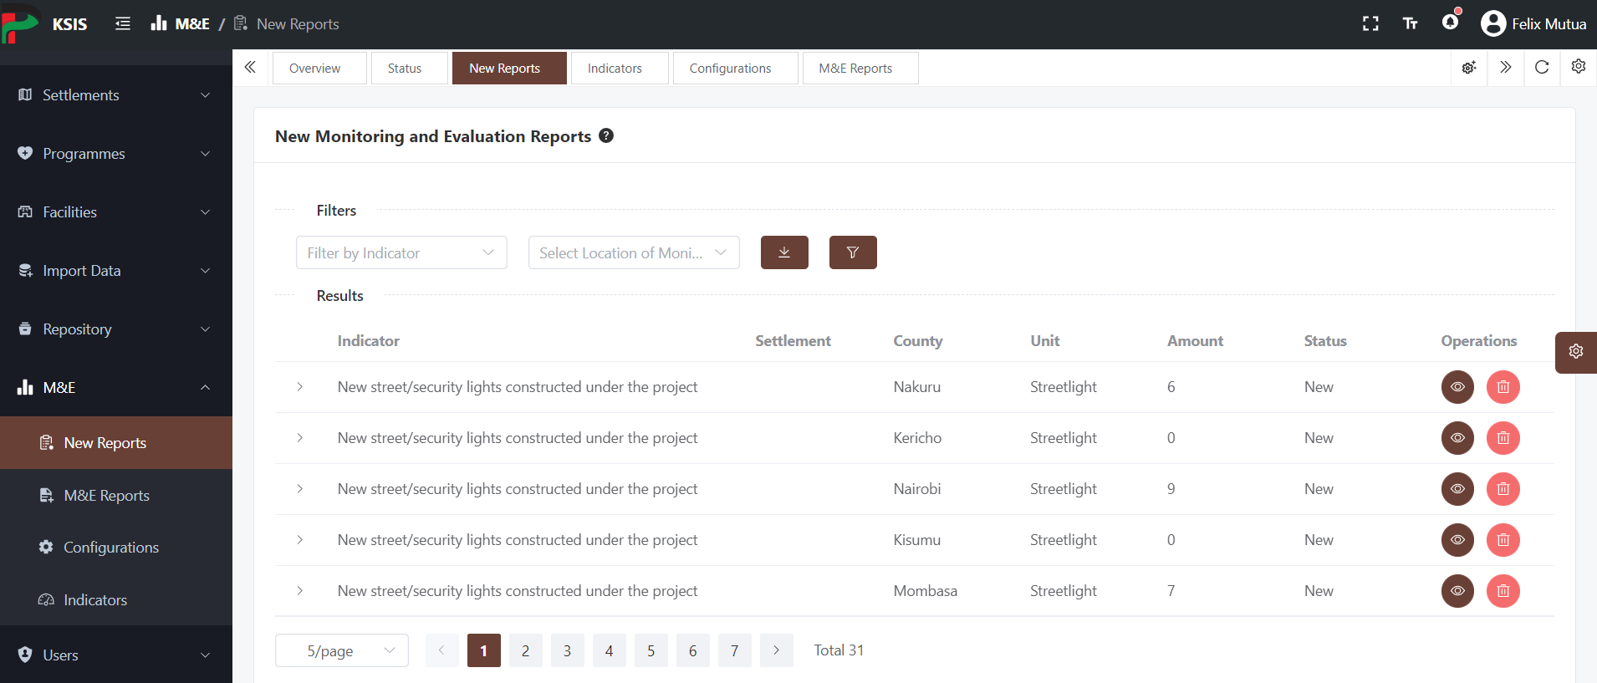
- A notification count will appear on the top-right menu on the screen showing the count of new, yet to be reviewed reports.
- Click the review icon to see the submitted data
- Click the approve/reject buttons
- If rejected, provide a justification on the popup window
- On approval, the data will show-up in the database summaries

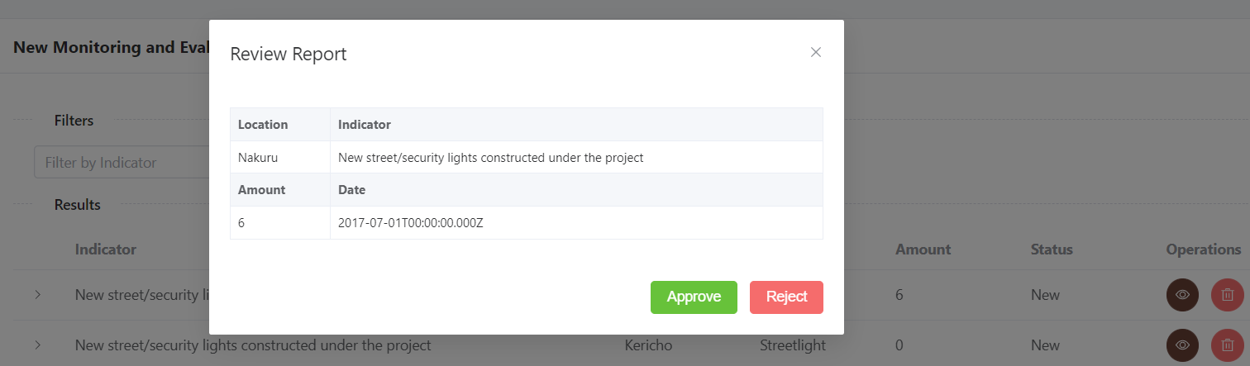

Post-Project evaluation
The system supports archiving of post project evaluations highlighting the impact indicators and provision of evaluation reports.
- Click on the Evaluation Window and M&E section. A list of all in the system will be provided
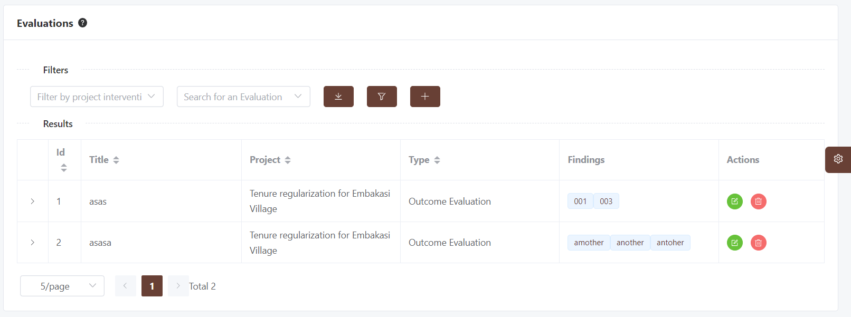
- Click the + button to add a new evaluation
- Fill all the details required including the key findings, separated by comma
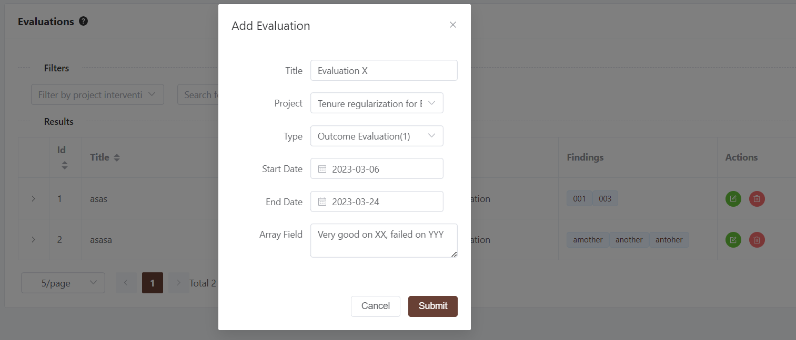
- Click submit
- Supporting documentation can be provided through the batch importer

Settings
The settings module allows for the configuration of common options used widely in the system. The structure followed is similar in presentation, creation, update and deletion. These common modules are

- Evaluation Types - These are tied to the M&E module and allows the administrator to create a list of options for the evaluations.
- Category List - These are the various dimensions an indicator can be configured to e.g male vs female, age-groups, etc. This populations the indicator configuration module
- Programmes - Used for managing the programmes and interventions. See the programmes section for more details
- Components - These are nested under programmes as described in the above section
- Document Categories- These are the various options for specifying documentation Categories
- Document Types- These are the various options for specifying documentation types

Adding an option
- To add an option to either of the settings configuration:
- Click on the standard + button
- Fill in the desired details and save
- Go back to your form (then continue)
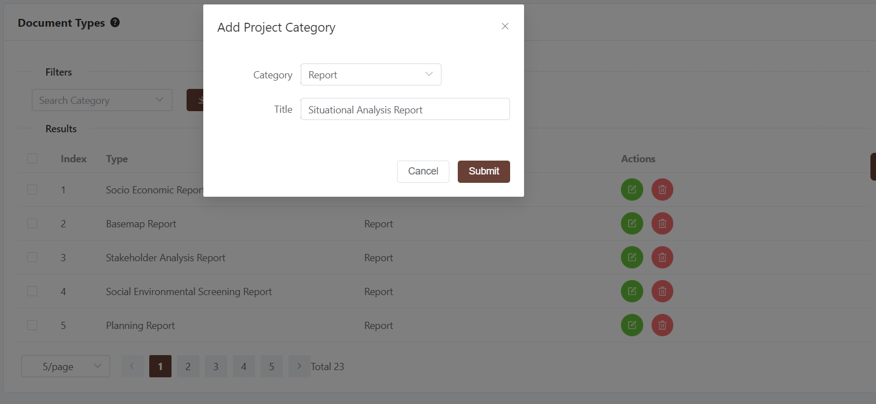

Editing an option
The listed options can be edited or deleted (with access rights) as below
- Navigate to the settings window
- Go to the desired window
- Use the edit and delete buttons appropriately

System appearance
A user can modify the feel, colors and general appearance of the system. This is achieved through the configuration window.
- Click on the configuration icon on the left-middle side of the page 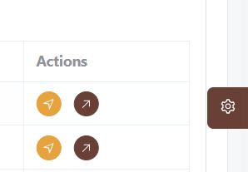
- Select from the various colors for the sidebar, topbar and buttons appearance

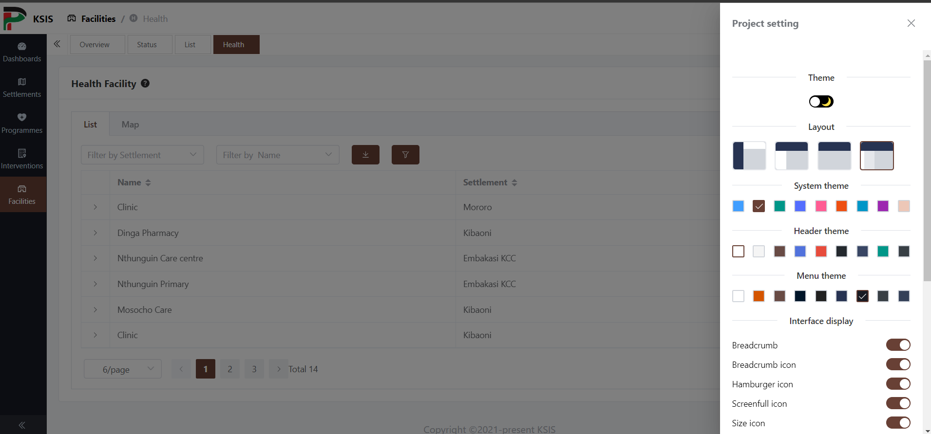

The user can modify
- The Day/Dark modes
- Change Layout
- Change system theme, header and menu themes
- Choose structure - whether to show icons, full screen e.t.c
The system will remember these configurations moving forward until reset by the user

User Management

Types of User rights
The use of the system is governed by rights. Each user right has its limits on what can be viewed, edited or deleted.

Role | Description
super_admin | System Super administrator
admin | National Administrator. Manages the overall System
Staff | A user who can edit data
Consultant | A user who can edit data
Monitoring | An admin user level with additional M&E roles
Public | A viewer-only for the dashboards

A user can have one or more of these rights to use the system. By default, every new registration has the public right.

Approval of User Accounts
Access to the system is restricted to logged in users. Self registration is as described in the Registration section. Once a user has registered, the system administrator receives a notification of a new account

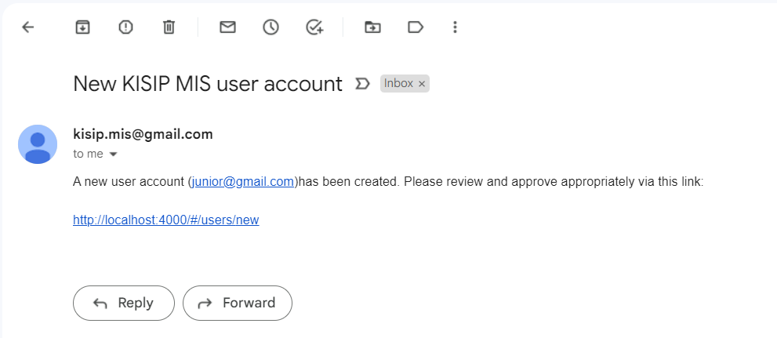

- Clicking on the link will take the administrator to the list of new accounts showing this and any other new accounts
- Click the switch icon under “operations” to activate the user
- If the user tries to login before this he/she will receive this error message “Your account has not been activated yet. Please contact the admin”
- On activation, the user will receive an email notification advising them so

Allocation of rights
- Click the edit button next to activation to allocate user rights
- By default, the public rights are already allocated on registration

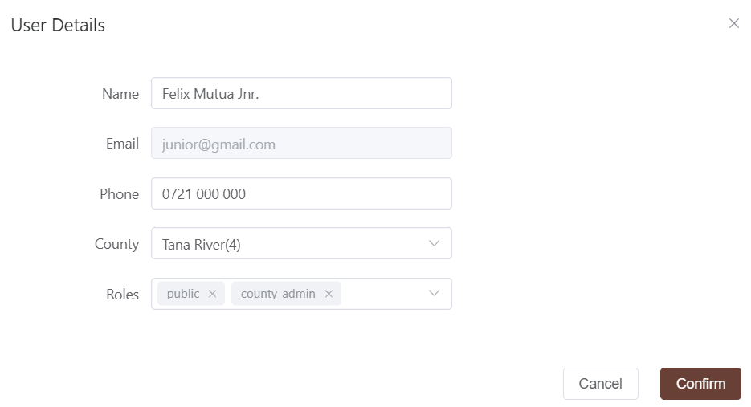
- Use this window to allocate more roles, edit the user details and county if necessary

User Suspension

- The switch button can also be used to deactivate a user for violating the system usage, or any other reason that will necessitate the denial
- The user will receive an email notification on the same

The dashboards are fully dynamic and configurable by the administrators and the content may vary from the one listed here
A shorter version of the activity. Shortened for appearance on small screens

