Physical–statistical characterization of wind power density in complex Andean terrain: A multi-station study in Nariño, Colombia
F.N. Rosero-Rodríguez a,b,c,*, N.V. Naranjo-Castaño a,b, J.M. López-Moreno c, E. Restrepo-Parra a,b, J.C. Riaño-Rojas a,b, S.G. Rosero-Rodríguez d
a Laboratorio de Física del Plasma, Facultad de Ciencias Exactas y Naturales, Universidad Nacional de Colombia Sede Manizales, Manizales 170003, Colombia.
b PCM Computational Applications Research, Facultad de Ciencias Exactas y Naturales, Universidad Nacional de Colombia Sede Manizales, Manizales 170003, Colombia.
c GISMAR Grupo de Investigación de Ingeniería de Sistemas, Universidad Mariana, Pasto 520001, Colombia.
d Escuela Normal Superior Pio XII, Pupiales, Nariño, Colombia.
Corresponding author.
E-mail address: favionrosero@umariana.edu.co

Highlights
- WPD was characterized as a physical state variable in complex Andean terrain.
- Zone 1 showed intermittent energetic dominance driven by high-speed tails.
- Weibull fitting captured zone-dependent wind-speed probability structures.
- Daily WPD revealed temporal memory rather than independent fluctuations.
- FFT identified distinct spectral-energy signatures across analytical zones.

Abstract
Wind-resource assessment in complex terrain requires more than estimating mean wind speed, because topography, altitude and atmospheric variability control how the wind’s kinematic signal is transformed into an energetic state. This study presents a physical–statistical and spectral characterization of wind power density (WPD) in Nariño, Colombia, using IDEAM multi-station observations from 2017 to 2022 grouped into four analytical zones. WPD was estimated from wind speed and daily zone-level air density, and a conservative wind-speed quality-control threshold (VV ≤20 m s^-1) retained 137,484 records, equivalent to 99.7562% of the selected WPD dataset. The workflow combined descriptive statistics, Weibull and Rayleigh distribution fitting, daily autocorrelation analysis and FFT-based spectral-band decomposition. WPD separated regional wind-energy regimes more clearly than wind speed alone. Zone 1 reached the highest mean WPD, approximately 140.76 W m^-2, while Zones 2–4 remained much lower, with mean values of approximately 15.82, 12.96 and 16.95 W m^-2, respectively. This dominance was not caused by uniformly high wind speeds, but by an intermittent distribution with frequent low-speed states and a long high-speed tail that became decisive under the cubic WPD transformation. Weibull outperformed Rayleigh in all zones, with Zone 1 showing a shape parameter below one, consistent with strong asymmetry. Daily WPD exhibited temporal memory, and FFT revealed zone-dependent spectral-energy signatures, including low-frequency dominance in Zone 1. These results support WPD as a physical state variable for interpreting wind-energy regimes in complex Andean terrain and provide a reproducible basis for future physically informed forecasting studies.

Keywords
Wind power density; Complex terrain; Physical–statistical characterization; Weibull distribution; Temporal memory; Spectral analysis; Andean region

1. Introduction
Wind-energy assessment is a key component of renewable-energy planning, particularly in regions where topographic complexity produces strong spatial and temporal variability in near-surface atmospheric conditions. In mountainous and complex-terrain environments, wind behavior cannot be adequately represented by simple averages or isolated station-level summaries, because terrain, altitude, pressure, temperature and local atmospheric circulation can modify wind intensity, persistence and energy availability (Palma et al., 2008; Carvalho et al., 2013; Radünz et al., 2020).
Most preliminary wind-resource assessments rely on wind speed as the main descriptive variable. However, from a physical point of view, wind speed alone is not sufficient to represent the available energy in the atmospheric flow. Wind power density (WPD) provides a stronger descriptor because it incorporates the cubic dependence on wind speed and the influence of air density (Manwell et al., 2009; Burton et al., 2011; Carta and Mentado, 2007). This makes WPD more directly related to the kinetic energy available in the moving air mass and therefore more appropriate for regional wind-energy characterization.
Colombia has an official wind-resource assessment background through the national wind and wind-energy atlas developed by IDEAM and UPME (2006). Recent Colombian studies have also evaluated wind-power potential using observational and reanalysis data, especially in the Caribbean region (Gil Ruiz et al., 2021; Gil Ruiz et al., 2022). However, localized physical–statistical characterizations of WPD in complex Andean regions remain limited. In Nariño, Eraso Checa and Escobar Rosero (2018) provided a direct regional precedent for wind-resource characterization in Túquerres, supporting the relevance of further wind-energy analysis in this department.
Nariño, located in southwestern Colombia, is characterized by complex Andean terrain, marked altitudinal gradients and heterogeneous meteorological conditions. These characteristics make the region suitable for a physical–statistical analysis of WPD, because wind-energy regimes may vary substantially across zones due to terrain-mediated atmospheric dynamics. Similar Andean and mountainous wind-assessment studies have shown that complex topography can produce non-uniform wind-resource distributions and requires careful spatial characterization (Ayala et al., 2017; Tang et al., 2019).
This study presents a physical–statistical characterization of WPD in Nariño, Colombia, using multi-station meteorological observations grouped into analytical zones. The analysis estimates WPD from wind speed and daily zone-level air density, applies quality control to reduce the influence of extreme cubic amplification, compares Weibull and Rayleigh distributional models, evaluates temporal persistence using ACF as the main diagnostic with PACF as supplementary support, and identifies dominant temporal-energy regimes using FFT-based spectral analysis.
The contribution of this work is not limited to estimating wind power density from observational records. The manuscript proposes an interpretable physical–statistical route for reducing ambiguity in wind-resource characterization under complex-terrain conditions. In this route, wind speed is first treated as the kinematic state of the atmospheric flow; WPD is then used as the energetic transformation of that state; distributional fitting describes the probability structure of the observed regimes; autocorrelation reveals temporal memory; and FFT-based spectral analysis identifies dominant temporal-energy modes. This sequence allows the wind field to be read as a structured physical system rather than as a collection of isolated meteorological records, and provides a reproducible basis for future forecasting-oriented studies.

2. Study area and meteorological data

2.1 Study region
The study focuses on the department of Nariño, located in southwestern Colombia. Nariño is part of the Colombian Andes and contains strong topographic variation, which can generate heterogeneous atmospheric and wind-energy conditions. This regional setting justifies the use of a zone-level approach rather than a single aggregated analysis. Figure 1 presents the physiographic setting, topographic relief, IDEAM meteorological stations and analytical zoning used in this study.
Figure 1. Physiographic setting and analytical zoning in Nariño, Colombia. The map shows the department of Nariño, topographic relief, municipal boundaries, IDEAM meteorological stations and the four analytical zones used for the regional physical–statistical characterization of wind power density.

2.2 Meteorological stations and analytical zoning
Meteorological records from IDEAM stations located in Nariño were grouped into four analytical zones. This zonal grouping was used to reduce station-level fragmentation and to support regional comparison of wind speed, air density and WPD. The analytical zones are used throughout the manuscript as the main spatial unit for comparison.
Table 1. IDEAM meteorological stations and analytical zoning. The table summarizes the station grouping used to define the four analytical zones, including station identifiers, station names, municipalities and altitude ranges. The corrected observational period used in the analysis was 2017–2022.
Analytical zone | Number of stations | Station IDs | Station names | Municipalities | Altitude range (m a.s.l.)
Zone 1 | 5 | S01; S02; S03; S04; S05 | Reserva Natural La Planada; Biotopo; Altaquer; Granja Mira; CCCP Dl Pacifico | Barbacoas; Ricaurte (Nariño); Tumaco | 1–1835
Zone 2 | 4 | S06; S07; S08; S09 | Volcán Chiles; La Josefina; El Paraíso; Aeropuerto San Luis | Aldana; Contadero; Cumbal; Túquerres | 442–3120
Zone 3 | 5 | S10; S11; S12; S13; S14 | El Encano; Universidad de Nariño; Las Iglesias; Cerro Páramo; Botana | Pasto; Puerres | 2626–3585
Zone 4 | 2 | S15; S16 | Viento Libre; Aponte | El Tablón; Taminango | 1400–1800

2.3 Variables and observational period
The meteorological records were obtained from IDEAM, the official Colombian institution responsible for hydrological and meteorological information. The DHIME system provides access to hydrological and meteorological data series and supports the data-origin traceability of this study (IDEAM, 2024).
The analysis used meteorological variables required to estimate WPD and characterize its temporal behavior. The main variable was wind speed (VV), while pressure and temperature variables were used to estimate air density. The corrected observational period covered 2017–2022 after datetime validation.
The main variables used in the article were wind speed, atmospheric pressure, air temperature, air density, WPD, analytical zone and datetime.

2.4 Datetime validation and preprocessing
Before computing WPD, the datetime structure was validated to avoid temporal misinterpretation. The correct date parser was identified as DMY, which allowed the study period to be consistently restricted to the 2017–2022 interval. This preprocessing step was necessary because incorrect date interpretation can distort seasonal, temporal-dependence and spectral analyses.

3. Methodology

3.1 Air density and wind power density formulation
WPD was used as the main physical descriptor of wind-energy potential. The available wind power per unit area depends on air density and the cube of wind speed, which makes WPD more physically informative than wind speed alone (Manwell et al., 2009; Burton et al., 2011).
WPD was computed as:
WPD = 0.5 · rho · v^3
where WPD is wind power density, rho is air density and v is wind speed.
Air density was estimated from available pressure and temperature information using the ideal-gas relationship:
rho = p / (R · T)
where rho is air density, p is atmospheric pressure, R is the specific gas constant for dry air and T is absolute temperature.
The inclusion of air density is relevant because density variations can affect WPD and wind-energy estimates, particularly when atmospheric conditions vary across space or time (Carta and Mentado, 2007; Ulazia et al., 2019; Jung et al., 2019).

3.2 Daily zone-level density strategy
Exact hourly co-occurrence among wind speed, atmospheric pressure and air temperature records was limited. Therefore, different air-density representations were evaluated, including hourly observed density, daily zone-level density, monthly zone-level density, overall zone-level density and standard air density.
The selected strategy was daily zone-level air density. This strategy represents a conservative physical and practical compromise under incomplete hourly overlap. It preserves day-to-day and zone-dependent air-density variability while avoiding the excessive loss of wind-speed observations that would result from strict hourly matching. It also avoids assuming a constant standard air density across a region characterized by strong Andean altitudinal gradients and heterogeneous atmospheric conditions.
Daily zone-level density was not used to artificially increase WPD values or to replace the physical dependence of WPD on air density. Instead, pressure and temperature records were first transformed into air density through the ideal-gas relationship and then aggregated by date and analytical zone. The resulting density field was coupled with wind-speed records to compute WPD while maintaining consistency with the spatial and temporal resolution supported by the available observational data.
Thus, the daily zone-level density strategy was selected because it retained physically meaningful density variation, improved the representativeness of the WPD dataset and provided a more defensible alternative than either strict hourly matching with severe record loss or the use of a single standard-density value for the entire region.

3.3 Quality-control criterion
Because WPD depends on the cubic power of wind speed, extreme or potentially inconsistent wind-speed values can produce disproportionately large changes in the resulting energy-density estimates. For this reason, a conservative quality-control criterion of VV ≤20 m s^-1 was selected as the main article-level scenario.
The purpose of this threshold was not to remove natural variability from the wind field, but to reduce the influence of extreme cubic amplification on WPD while preserving the dominant structure of the observational dataset. After applying this criterion, the final article-level dataset retained 137,484 records, corresponding to 99.7562% of the available records under the selected WPD strategy. Only 0.2438% of the records were excluded.
Therefore, the quality-control procedure should be interpreted as a conservative stabilization step rather than an aggressive filtering stage. Its effect was limited in terms of record removal, but important for preventing a small number of extreme wind-speed values from exerting excessive leverage on the physical–statistical characterization of WPD.
This decision is particularly relevant because the transformation from wind speed to WPD is nonlinear. Small deviations in the upper wind-speed range may generate large differences in WPD after cubic amplification. The selected threshold therefore improves the robustness of the WPD analysis while maintaining the representativeness of the regional wind-energy signal.

3.4 Descriptive and distributional analysis
Descriptive statistics were computed by analytical zone for wind speed and WPD. These statistics included the number of records, mean, median, selected percentiles and maximum values.
Wind-speed distributions were fitted using Weibull and Rayleigh models. Weibull distributions are widely used in wind-energy analysis because they can represent different wind-speed regimes through their shape and scale parameters, while several estimation approaches have been proposed for wind-energy applications (Justus et al., 1978; Seguro and Lambert, 2000; Akdağ and Dinler, 2009; Carta et al., 2009). The Rayleigh distribution was included as a constrained reference model commonly used in wind-resource assessment (Celik, 2004; Pishgar-Komleh et al., 2015).
Model comparison was performed using distribution parameters, information criteria and visual evaluation of density and cumulative distribution fits. The interpretation of Weibull performance was made cautiously, recognizing that alternative distributions may outperform Weibull in some contexts and that distributional selection should be dataset-specific (Drobinski et al., 2015).

3.5 Temporal-dependence analysis
Daily WPD and wind-speed series were constructed by analytical zone. Short gaps were interpolated conservatively to allow regular time-series diagnostics. Autocorrelation functions (ACF) were used as the main diagnostic to evaluate temporal persistence and memory structure in the daily WPD signal. Partial autocorrelation functions (PACF) were also computed as supplementary diagnostics to identify direct short-lag dependence after accounting for correlations at shorter lags.
ACF and PACF are standard tools in time-series analysis for evaluating persistence, memory and direct temporal dependence (Box et al., 2008). In wind-energy studies, time-series models have been used to simulate, forecast and interpret wind speed and wind power, supporting the relevance of temporal-dependence analysis in wind-resource characterization (Brown et al., 1984; Torres et al., 2005; Kavasseri and Seetharaman, 2009; Erdem and Shi, 2011).

3.6 Spectral analysis
FFT-based spectral analysis was applied to daily WPD and wind-speed series by zone. For each zone, the longest continuous daily segment was selected to reduce distortion caused by large missing gaps.
The fast Fourier transform provides a computational basis for decomposing time series into frequency components (Cooley and Tukey, 1965). Spectral analysis has a long tradition in atmospheric wind studies, including the classic analysis of horizontal wind-speed spectra by Van der Hoven (1957). More recent studies have also connected wind-power spectral analysis with wind-resource assessment and complex-terrain interpretation (Lopez-Villalobos et al., 2021; Telesca et al., 2016).
Spectral power was summarized using physically interpretable period bands: 2–10 days, 10–30 days, 30–120 days, 120–365 days and >365 days. This analysis was used to identify whether WPD variability was dominated by short-term, intra-monthly, seasonal or low-frequency components.
3.7 Reproducibility and computational traceability
The analysis was organized as a reproducible computational workflow. The processing scripts generate the derived datasets, quality-control summaries, descriptive statistics, distributional fits, temporal-dependence outputs, spectral-band summaries, figures and tables used in the manuscript. This structure allows the main results to be traced from data preprocessing to final graphical and tabular outputs.
The raw meteorological records were obtained from the official IDEAM data platform and are not redistributed with this study due to source-data redistribution considerations. However, the derived outputs, scripts, figures, tables and reproducibility documentation associated with the analysis are made available through the project repository. This organization follows the principles of reproducible computational research and supports data and workflow transparency in line with FAIR-oriented scientific documentation practices.
The reproducibility structure follows the logic of reproducible computational research, where analytical results should be traceable from data preprocessing to final outputs rather than depending only on narrative description (Peng, 2011). In addition, the organization of scripts, derived datasets, figures, tables and documentation supports FAIR-oriented practices by improving findability, accessibility, interoperability and reuse of the research workflow, within the redistribution limits associated with the original IDEAM records (Wilkinson et al., 2016).

4. Results
The results are presented as a sequence of physical interpretation layers. First, wind speed is analyzed as the initial kinematic state of the atmospheric flow. Second, WPD is evaluated as the energetic state obtained after the density-supported cubic transformation of wind speed. Third, empirical and fitted distributions are used to identify the probability structure of the wind regimes. Fourth, autocorrelation analysis is used to evaluate temporal memory. Finally, FFT-based spectral decomposition is used to identify dominant temporal-energy modes. This organization is intended to make the behavior of a complex wind-energy system transparent, reproducible and physically interpretable.

4.1 Wind-speed variability as the initial kinematic state
The monthly mean wind-speed series showed that the wind field in Nariño cannot be treated as a spatially homogeneous or temporally stationary signal. Each analytical zone exhibited a different kinematic behavior, reflecting the influence of the complex physiographic setting and the zone-level structure defined in the study area.
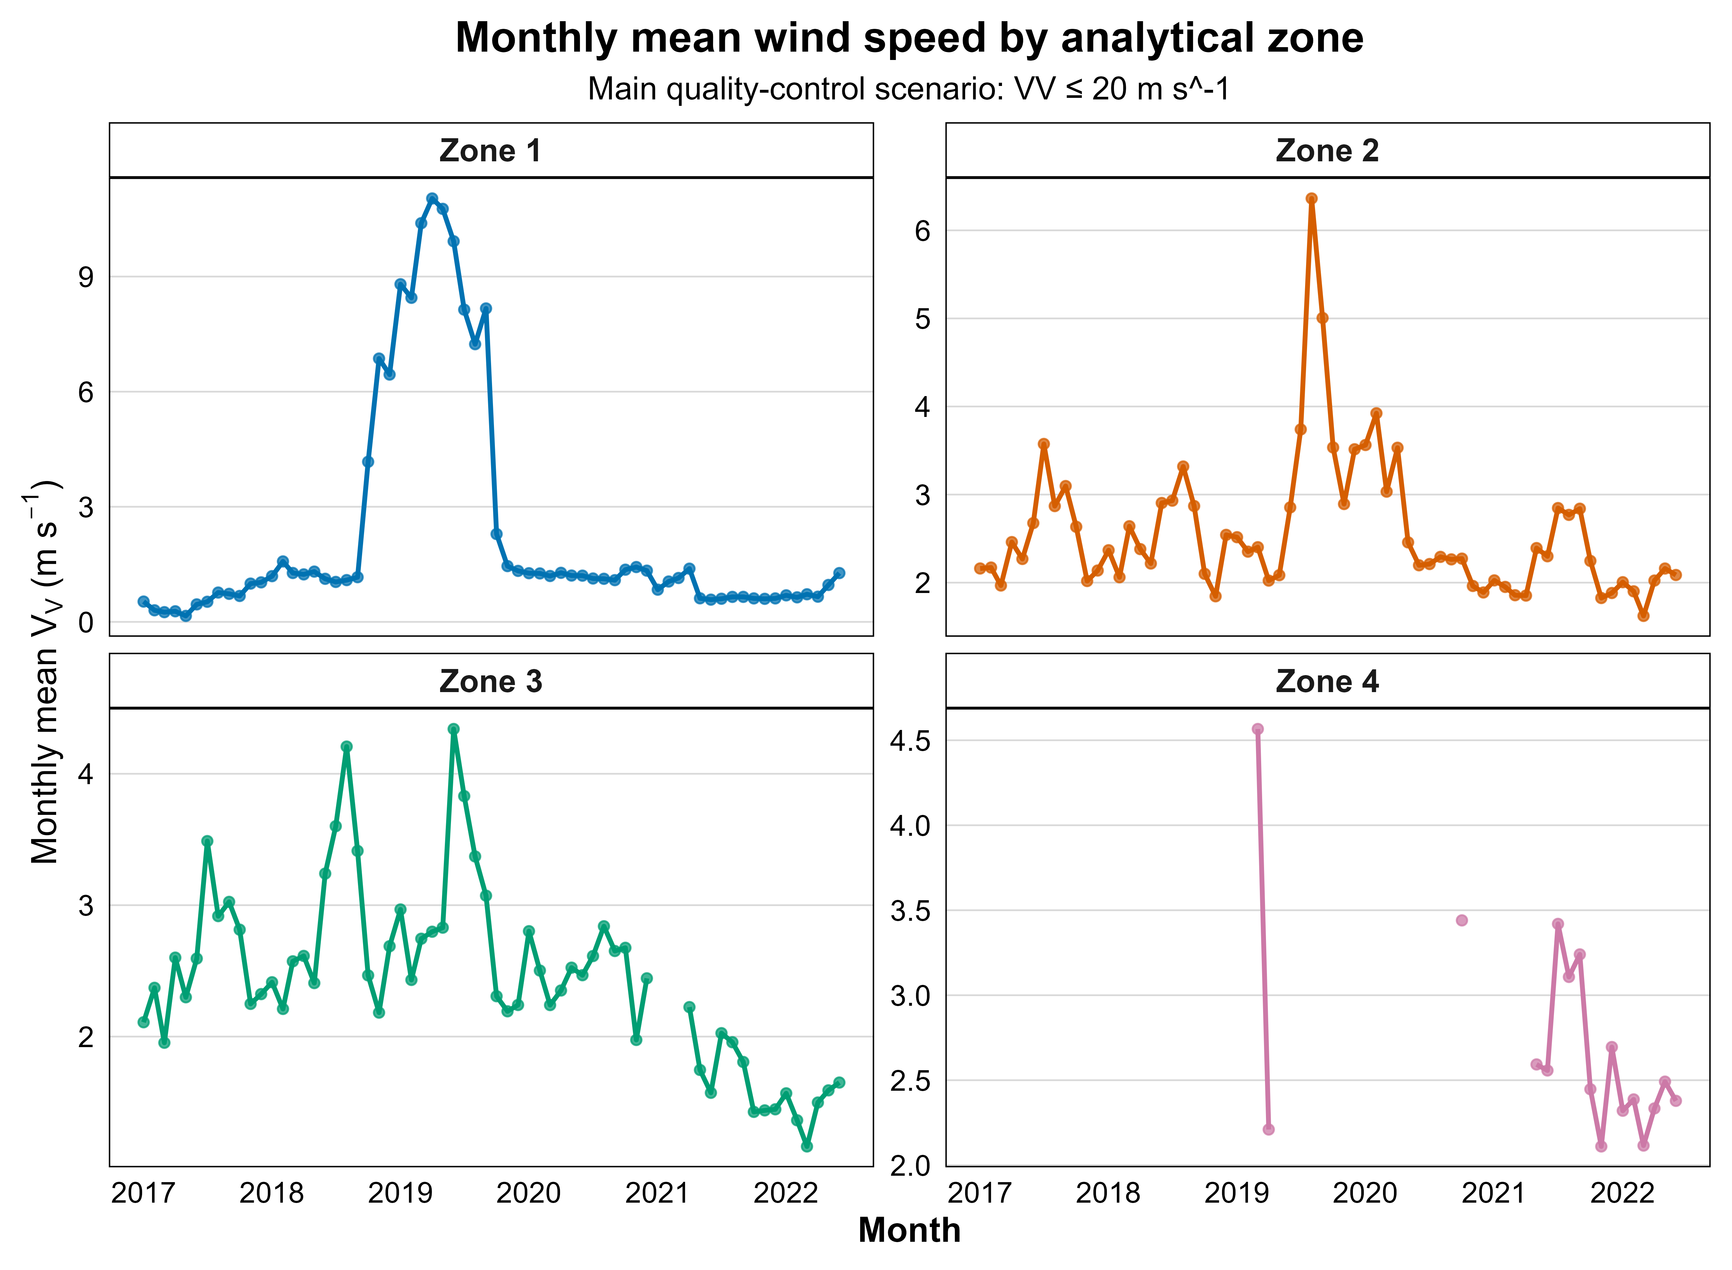
Figure 2. Monthly mean wind speed by analytical zone.
Zone 1 showed the most pronounced temporal contrast. During 2017–2018, monthly mean wind speed remained generally low, but a marked high-speed interval appeared during 2018–2019, followed by a return to lower values after late 2019. Zones 2 and 3 showed more moderate variability, with monthly wind-speed values concentrated in lower ranges and only isolated peaks. Zone 4 presented a more fragmented temporal record and was therefore interpreted cautiously.
This first layer of analysis defines the kinematic state of the wind system. The differences observed in Figure 2 are physically relevant because wind speed is not linearly transferred into available wind power. Instead, wind power density depends on the cube of wind speed. Therefore, even moderate changes in wind-speed state may become strongly amplified when transformed into WPD.

4.2 Wind power density as an energetic state variable
Monthly mean WPD amplified the spatial and temporal contrasts previously observed in wind speed. The global mean WPD after quality control was approximately 53.82 W m^-2, but this value masked strong zonal heterogeneity.
Zone 1 exhibited the highest mean WPD, reaching approximately 140.76 W m^-2. In contrast, Zones 2, 3 and 4 showed substantially lower mean WPD values, approximately 15.82 W m^-2, 12.96 W m^-2 and 16.95 W m^-2, respectively. Thus, mean WPD in Zone 1 was about 8.9 times higher than in Zone 2, 10.9 times higher than in Zone 3 and 8.3 times higher than in Zone 4.
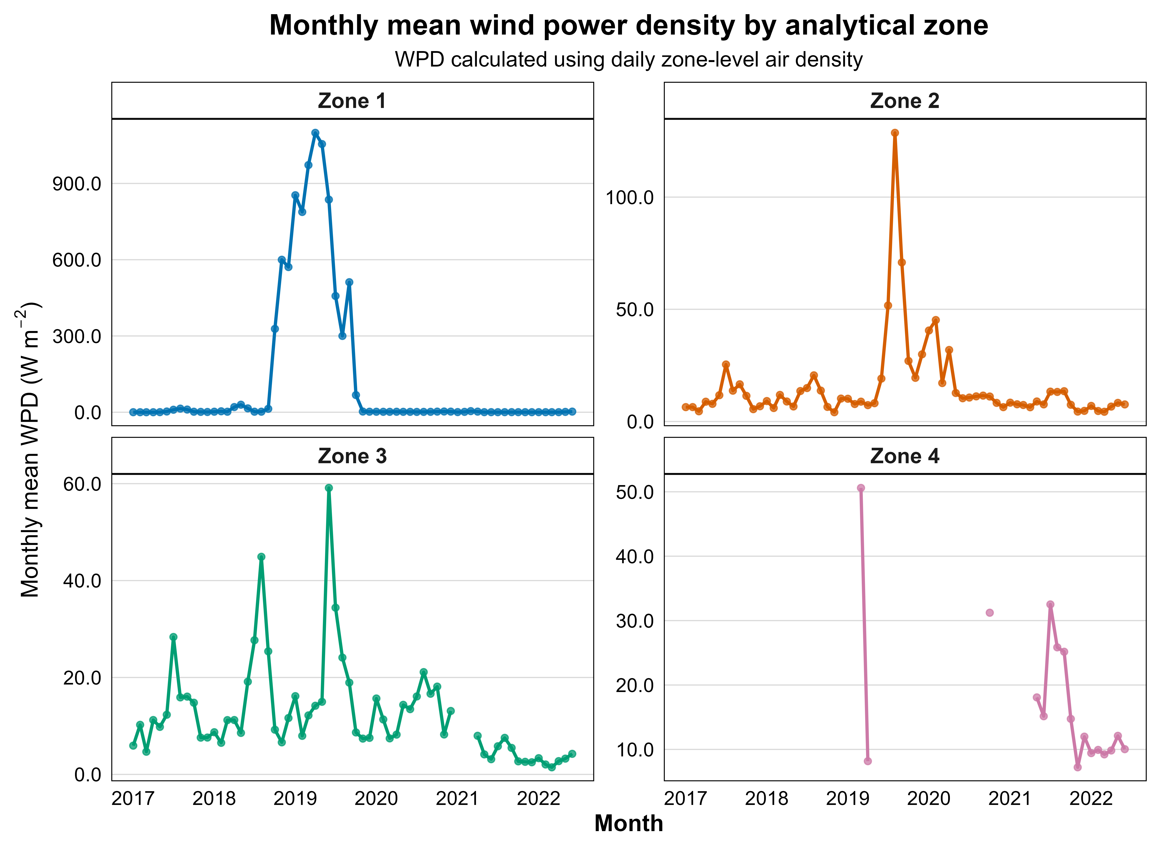
Figure 3. Monthly mean wind power density by analytical zone.
The temporal structure of WPD showed that Zone 1 changed from a low-energy state to a short but energetically dominant regime during 2018–2019. This transition was much more evident in WPD than in wind speed, confirming that WPD acts as a more discriminating physical descriptor of wind-energy behavior. Zones 2 and 3 showed lower energetic regimes, although both presented isolated peaks. Zone 4 showed moderate WPD values, but its lower temporal continuity requires caution.
The descriptive statistics confirmed that WPD provides a stronger physical separation among zones than wind speed alone. Although Zone 1 did not have the highest mean wind speed, it exhibited the highest mean WPD. This result is explained by the strong asymmetry of its wind-speed distribution: Zone 1 had a low median wind speed, high standard deviation and an upper tail reaching the quality-control threshold. After the cubic transformation from wind speed to WPD, these intermittent high-speed states produced a disproportionate energetic contribution.
Table 2. Descriptive statistics of wind speed and wind power density by analytical zone. Statistics are reported after applying the selected quality-control criterion. WPD values show stronger zonal contrast than wind speed because of the cubic dependence of WPD on velocity.
Zone | n | Mean VV (m s^-1) | Median VV (m s^-1) | SD VV (m s^-1) | Max VV (m s^-1) | Mean WPD (W m^-2) | Median WPD (W m^-2) | SD WPD (W m^-2) | Max WPD (W m^-2)
Zone 1 | 42,706 | 2.43 | 0.97 | 3.80 | 19.99 | 140.76 | 0.48 | 494.63 | 4485.72
Zone 2 | 43,618 | 2.62 | 2.38 | 1.41 | 14.05 | 15.82 | 5.85 | 33.39 | 1171.01
Zone 3 | 42,416 | 2.50 | 2.33 | 1.27 | 12.57 | 12.96 | 5.57 | 23.60 | 870.69
Zone 4 | 8,744 | 2.69 | 2.52 | 1.32 | 8.47 | 16.95 | 7.53 | 26.65 | 287.45

4.3 Distribution of kinematic and energetic states
The empirical wind-speed distributions showed that the analytical zones differed not only in central tendency, but also in the probability structure of wind-speed states.
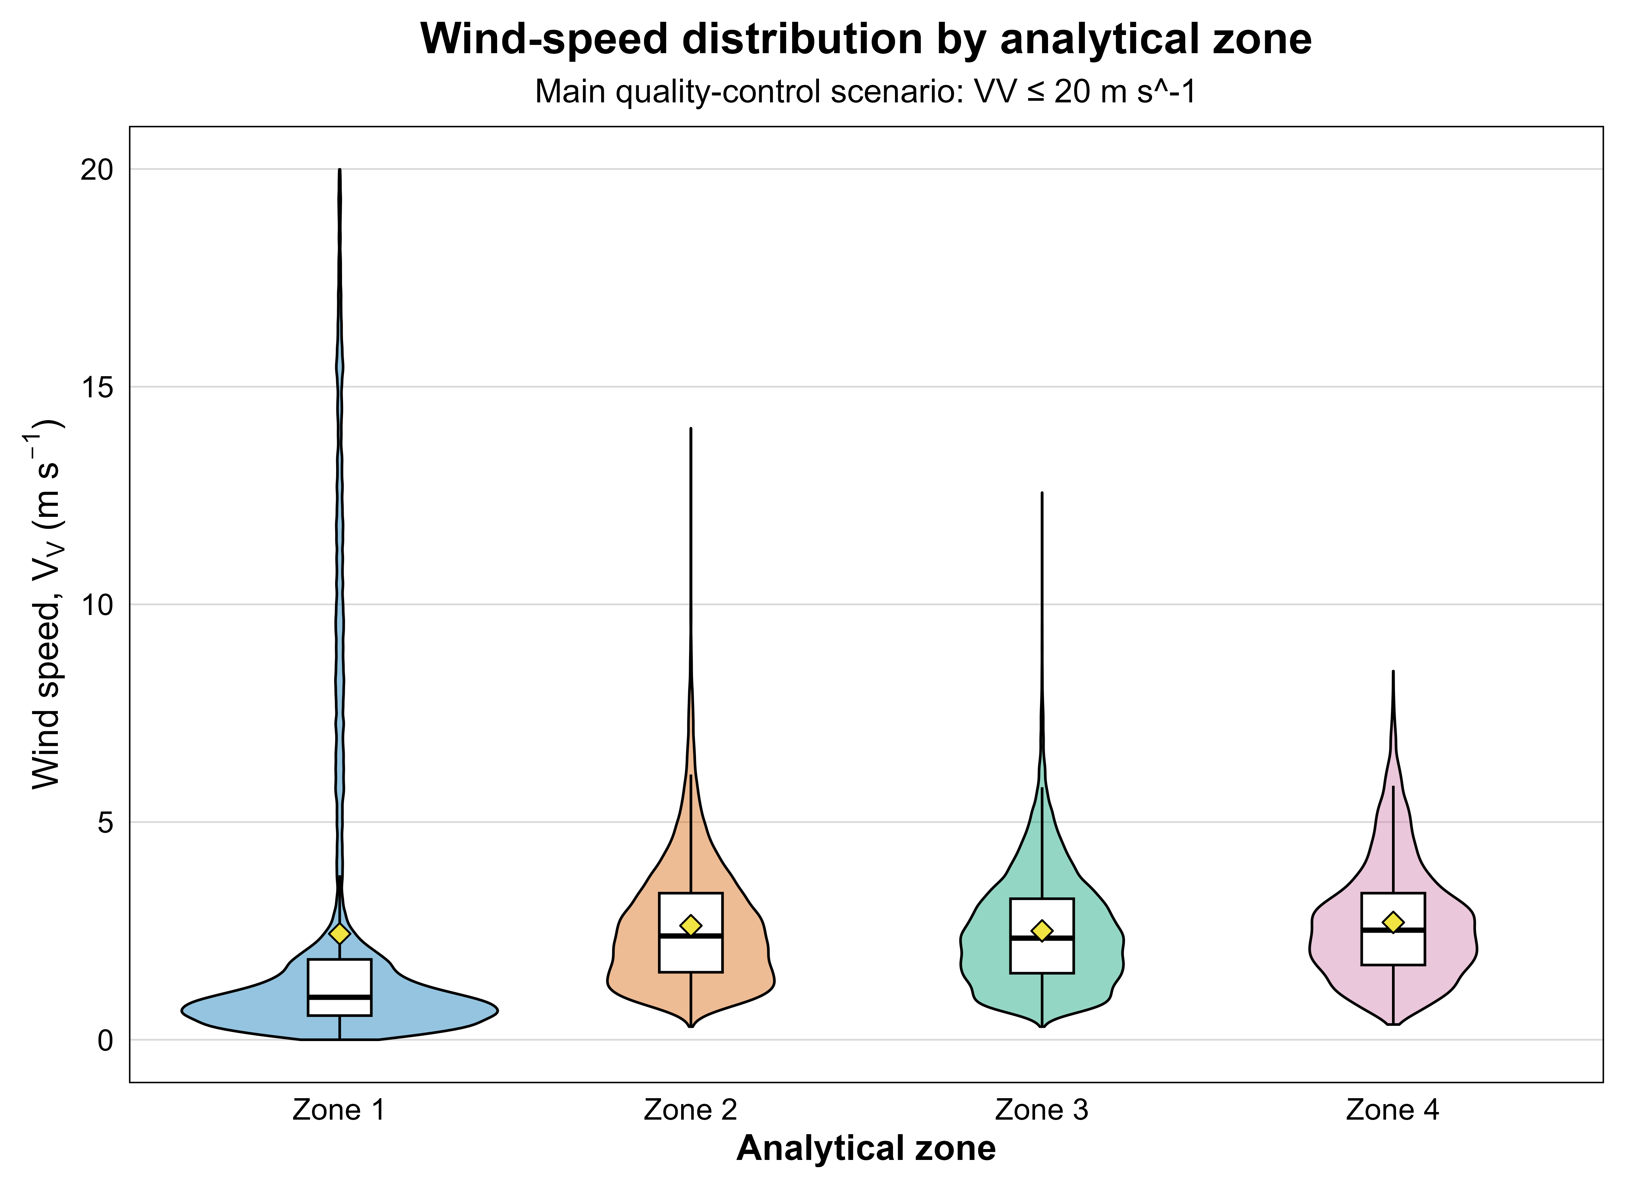
Figure 4. Wind-speed distribution by analytical zone.
Zone 1 presented the most asymmetric wind-speed distribution. Most of its records were concentrated at low wind speeds, but the distribution retained a long upper tail reaching values close to the quality-control threshold. This indicates an intermittent kinematic regime in which low-speed states are frequent, while occasional high-speed events remain physically relevant. Zones 2 and 3 exhibited more regular distributions, with moderate central values and shorter upper tails. Zone 4 presented a more compact distribution and a lower extreme range, although its interpretation remains constrained by temporal coverage.
The WPD distributions confirmed the nonlinear amplification of wind-speed variability. Because WPD depends on the cube of wind speed, the upper tail of the wind-speed distribution became energetically decisive.
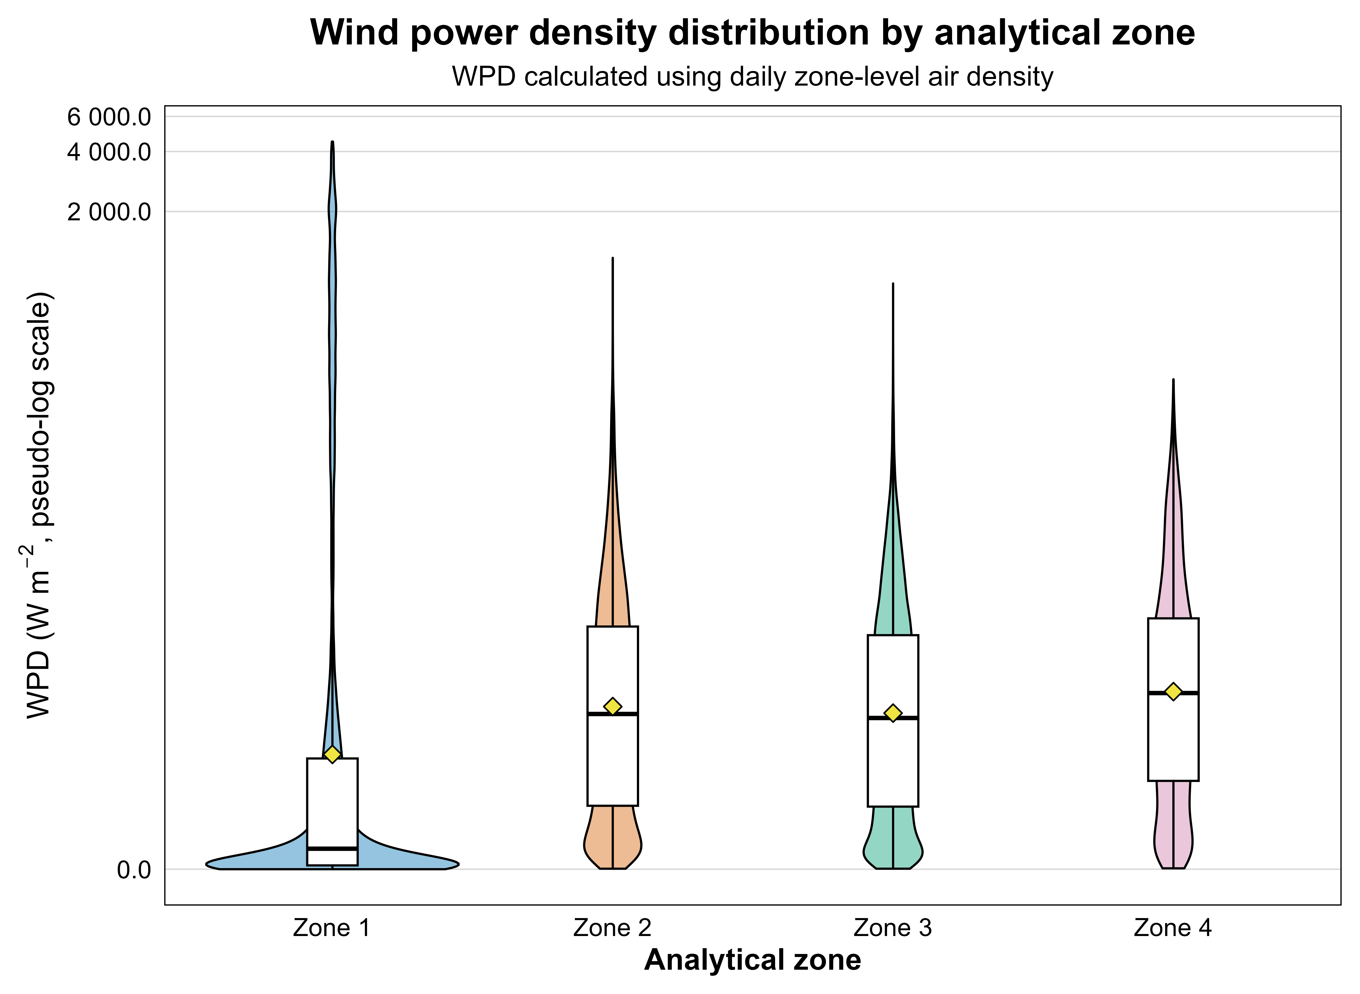
Figure 5. Wind power density distribution by analytical zone.
Zone 1 showed a WPD distribution dominated by low-energy states but with a long high-energy tail, reaching the largest WPD values observed in the study. This indicates that its energetic dominance is not associated with a permanently high-energy condition, but with intermittent events that carry disproportionate energy-density weight. Zones 2 and 3 exhibited more compact WPD distributions with shorter upper tails, whereas Zone 4 showed a narrower energetic range and was interpreted cautiously due to its lower temporal continuity.
Together, Figures 4 and 5 show that the energetic structure of the wind field cannot be inferred from mean wind speed alone. Instead, the full distribution of wind-speed states must be considered, because rare high-speed states may control the energetic response after the cubic transformation into WPD.

4.4 Weibull and Rayleigh probabilistic characterization
Weibull and Rayleigh models were fitted to the wind-speed distributions to characterize the probability structure of the wind regimes. The goodness-of-fit results confirmed that Weibull was the best-performing distribution in all analytical zones.
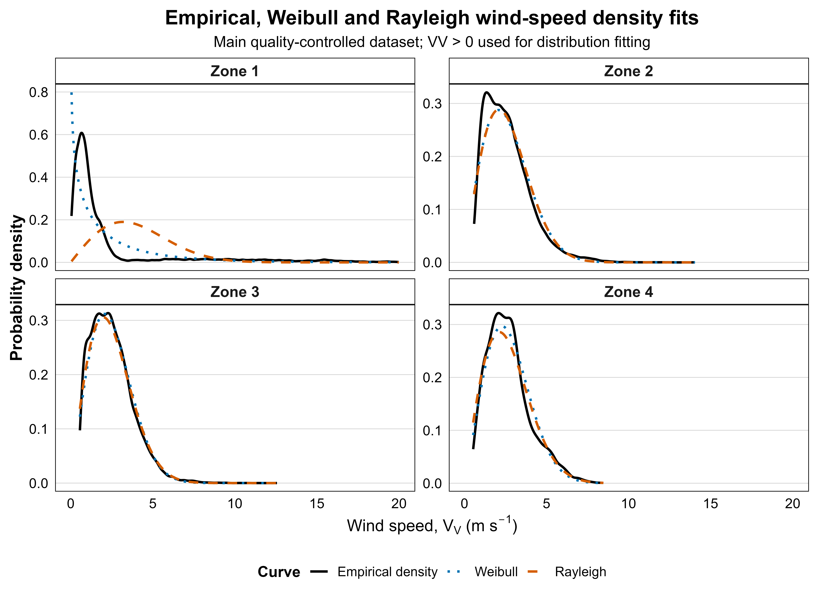
Figure 6. Weibull and Rayleigh density fits by analytical zone.
The density-fit comparison showed the strongest contrast in Zone 1. The empirical density was highly concentrated at low wind speeds and extended through a long upper tail. The Rayleigh model shifted excessive probability mass toward intermediate wind speeds and did not adequately represent the asymmetric low-speed concentration. In contrast, the Weibull model better captured the intermittent structure of the zone.
In Zones 2 and 3, Weibull and Rayleigh fits were visually closer, reflecting more regular wind-speed regimes. However, Weibull retained greater flexibility to adjust the empirical shape. Zone 4 showed a compact distribution with local empirical irregularities and was interpreted cautiously.
The cumulative distribution comparison confirmed the density-based interpretation.
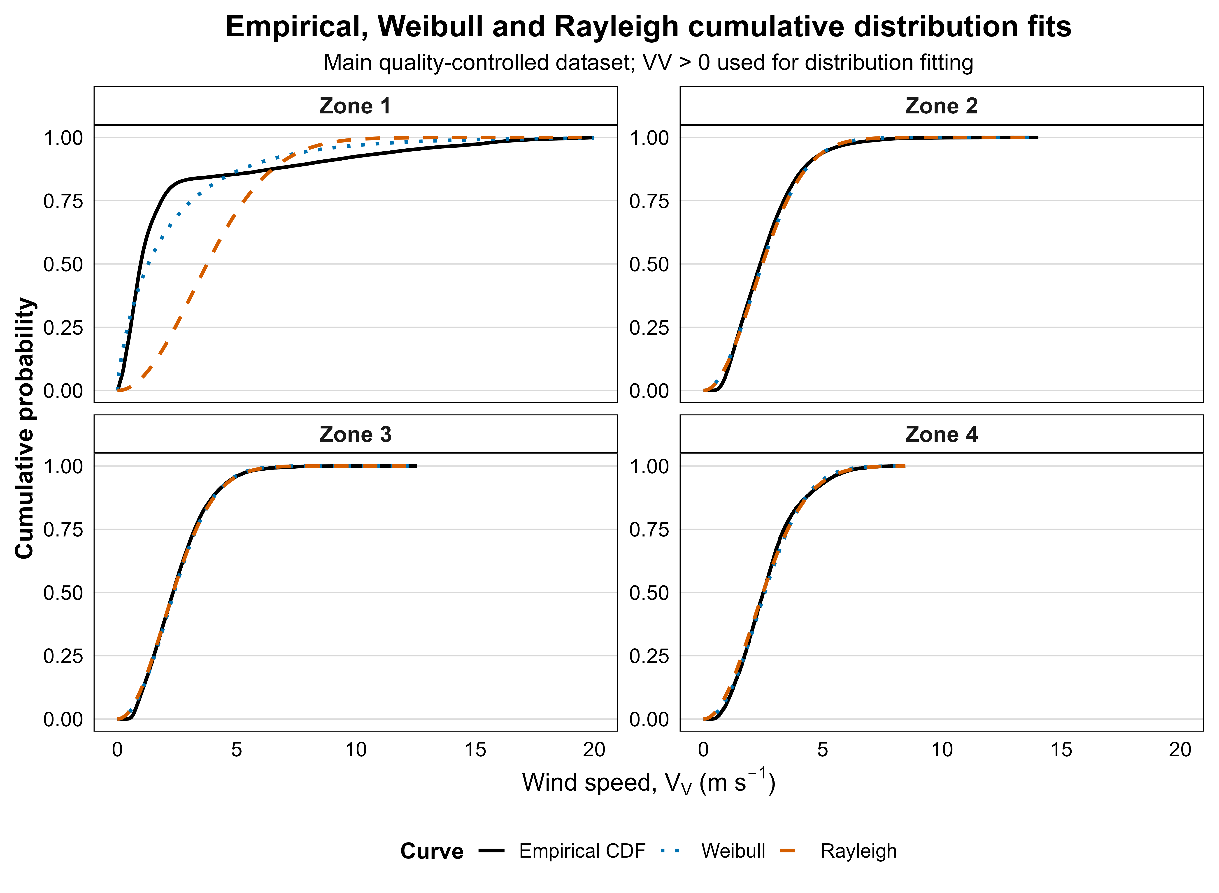
Figure 7. Weibull and Rayleigh cumulative distribution fits by analytical zone.
In Zone 1, the empirical CDF increased rapidly at low wind speeds, indicating that a large proportion of records belonged to low-speed states. However, the distribution also retained an upper tail associated with intermittent high-speed events. Weibull followed this cumulative structure more closely than Rayleigh, which smoothed the transition between low and intermediate wind speeds.
The estimated Weibull parameters supported this interpretation. Zone 1 presented a shape parameter below one, approximately k = 0.789, confirming a highly asymmetric and intermittent wind-speed regime. In contrast, Zones 2, 3 and 4 showed shape parameters close to or above two, with k ≈ 1.984, k ≈ 2.089 and k ≈ 2.164, respectively. These values indicate more regular wind-speed regimes, closer to a Rayleigh-like structure, although Weibull remained the best-fitting model in all zones.
Table 3. Selected wind-speed distribution parameters and goodness-of-fit metrics by analytical zone. The table reports the best-performing model identified from the Weibull–Rayleigh comparison. Distribution fitting was performed using valid positive wind-speed records compatible with the support of the fitted distributions.
Zone | Selected distribution | n fit | Weibull k | Weibull scale | AIC | BIC | KS statistic | RMSE density | RMSE CDF
Zone 1 | Weibull | 42,679 | 0.788 | 2.058 | 155909.44 | 155926.77 | 0.151 | 0.065 | 0.053
Zone 2 | Weibull | 43,618 | 1.984 | 2.968 | 145163.72 | 145181.09 | 0.044 | 0.018 | 0.014
Zone 3 | Weibull | 42,416 | 2.089 | 2.831 | 134634.44 | 134651.75 | 0.031 | 0.012 | 0.008
Zone 4 | Weibull | 8,744 | 2.164 | 3.052 | 28620.32 | 28634.47 | 0.044 | 0.020 | 0.016
Therefore, Weibull fitting provides a probabilistic characterization of the wind-speed states and supports the interpretation that Zone 1 is governed by an intermittent rather than uniformly high-speed regime.

4.5 Temporal memory of the WPD state variable
The daily ACF analysis showed that WPD has a zone-dependent temporal memory structure. Autocorrelation remained positive at short lags in all zones, indicating that daily WPD values are not independent fluctuations.
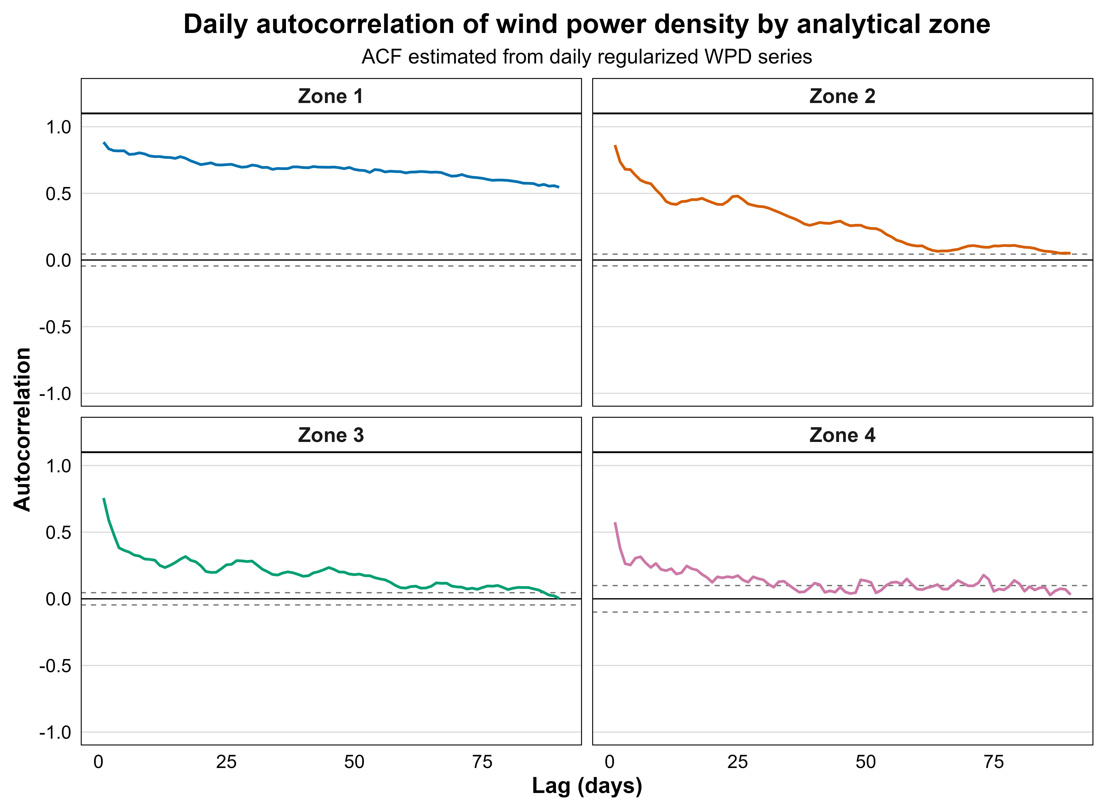
Figure 8. Daily autocorrelation function of wind power density by analytical zone.
Lag-1 autocorrelation was high in all zones, with values of approximately 0.884 in Zone 1, 0.862 in Zone 2, 0.757 in Zone 3 and 0.575 in Zone 4. Zone 1 showed the strongest and most persistent autocorrelation decay, confirming that its energetic regime is not only intermittent in distributional terms, but also temporally structured.
The first lag at which the absolute ACF decreased below 0.2 also differed by zone. Zone 1 did not fall below this threshold within the 90-day lag window, indicating the longest energetic persistence among the analyzed zones. Zone 2 crossed the threshold at lag 54, Zone 3 at lag 22 and Zone 4 at lag 13.
These results show that WPD behaves as a temporally structured physical state variable rather than as an uncorrelated sequence of daily energy-density values. Zone 4 was interpreted cautiously because of its lower temporal coverage.
The supplementary PACF diagnostics confirmed that the strongest direct dependence was concentrated at the first daily lags, particularly for WPD in Zones 1 and 2, while most longer-lag partial correlations were smaller and closer to the confidence bounds (Fig. S3; see also Fig. S5 for wind speed). These results support the ACF-based interpretation without changing the main temporal-memory conclusions.

4.6 Spectral-energy signatures of WPD
FFT-based spectral-band analysis revealed that daily WPD has zone-dependent temporal-energy signatures. The spectral decomposition allowed the WPD signal to be evaluated in physically interpretable period bands: 2–10 days, 10–30 days, 30–120 days, 120–365 days and periods longer than 365 days.
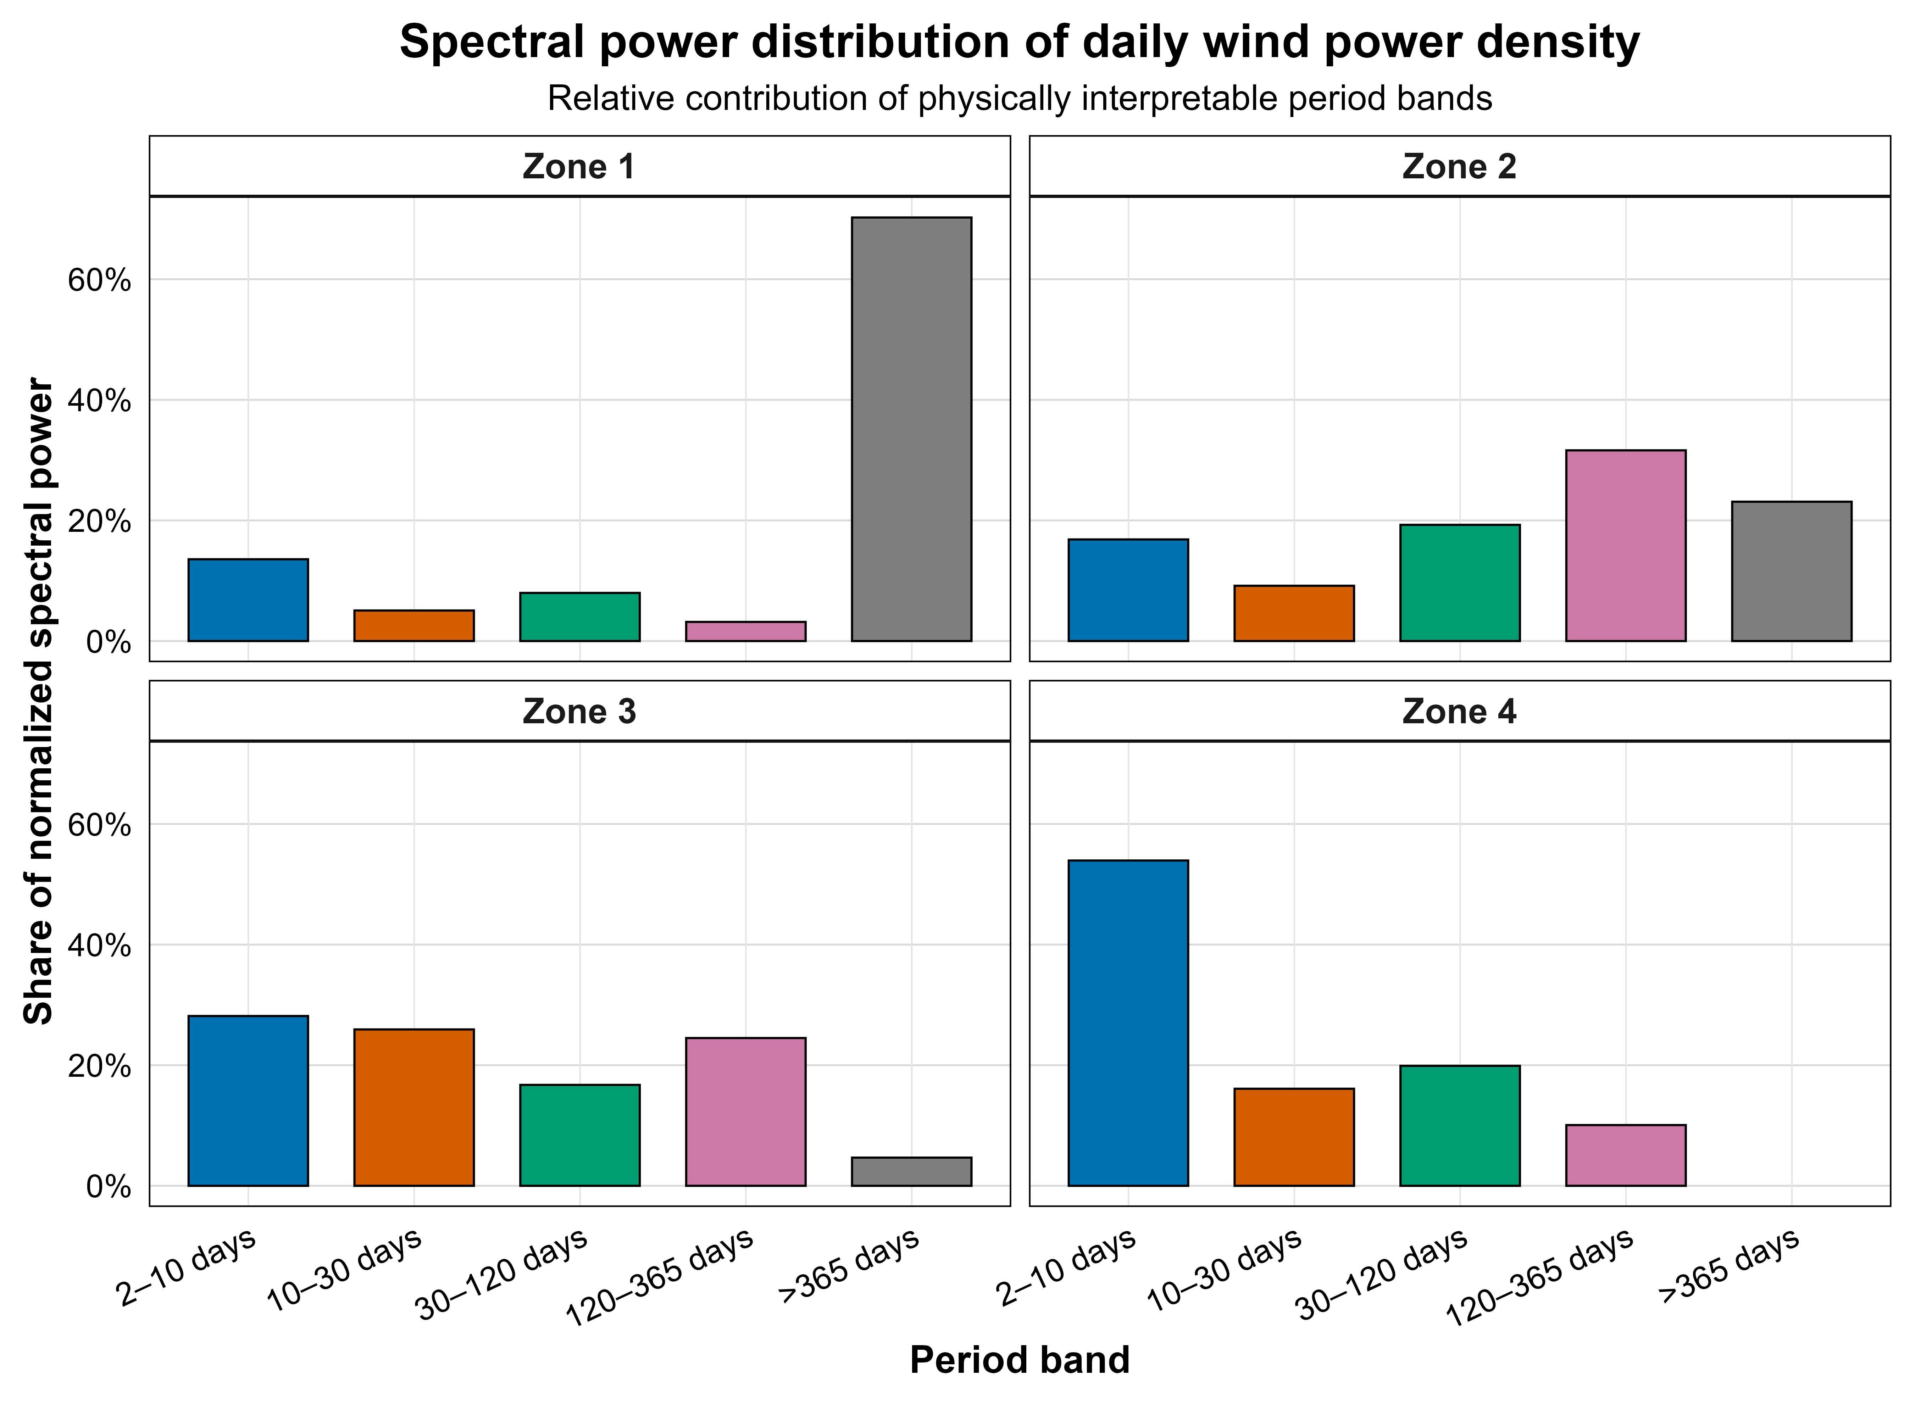
Figure 9. FFT-based spectral-band energy of daily wind power density by analytical zone.
Zone 1 was dominated by low-frequency variability, with approximately 70.23% of its normalized WPD spectral power concentrated in periods longer than 365 days. This result indicates that the strongest energetic zone is not only characterized by high WPD values and strong temporal persistence, but also by a dominant long-period spectral structure.
Zone 2 showed a more distributed spectrum, with relevant contributions from intermediate and low-frequency bands. Its largest contribution appeared in the 120–365 day band, followed by periods longer than 365 days and the 30–120 day band. Zone 3 presented a more balanced spectral structure, with substantial contributions from short, intra-monthly and seasonal scales. Zone 4 was dominated by the 2–10 day band, suggesting a shorter-period energetic regime, although this result should be interpreted cautiously because of its lower temporal continuity.

Table 4. Temporal and spectral summary of wind power density by analytical zone. The table reports lag-1 WPD autocorrelation, the first lag where the absolute ACF falls below 0.2, the dominant spectral-energy band and the corresponding physical interpretation for each analytical zone.
Zone | WPD lag-1 ACF | First lag where |ACF| < 0.2 | Dominant spectral band | Dominant band share (%) | Interpretation
Zone 1 | 0.884 | Not reached within 90 days | >365 days | 70.23 | Long memory and low-frequency energetic dominance
Zone 2 | 0.862 | 54 | 120–365 days | 31.62 | Persistent regime with seasonal-to-low-frequency contribution
Zone 3 | 0.757 | 22 | 2–10 days | 28.16 | More balanced spectral structure with short-period dominance
Zone 4 | 0.575 | 13 | 2–10 days | 53.94 | Short-period energetic variability; interpret cautiously due to lower temporal continuity
Overall, the spectral analysis confirms that WPD regimes in Nariño are not only spatially heterogeneous and temporally persistent, but also spectrally differentiated. In this sense, FFT-based WPD analysis provides a spectral diagnostic of wind-energy variability, identifying dominant temporal-energy modes that characterize each analytical zone.

5. Discussion

5.1 From complex terrain to wind-energy state characterization
The results show that WPD characterization in complex Andean terrain requires more than an average-based description of wind speed. The physiographic configuration of Nariño, the altitudinal gradients, the spatial distribution of IDEAM stations and the analytical zoning define a heterogeneous atmospheric domain where wind behavior changes across space and time. Therefore, the regional wind field should not be interpreted as a single homogeneous signal, but as a set of zone-dependent physical states shaped by terrain, atmospheric density and temporal variability.
This study does not remove the complexity of the wind field; rather, it reduces interpretive ambiguity by decomposing that complexity into physically meaningful layers. First, the analytical zones define the spatial boundary conditions of the system. Second, wind speed describes the initial kinematic state of the atmospheric flow. Third, WPD transforms that kinematic signal into an energetic state variable through the combined effect of air density and cubic velocity amplification. Fourth, empirical and fitted distributions characterize the probability structure of the observed regimes. Fifth, autocorrelation analysis reveals temporal memory. Finally, FFT-based spectral decomposition identifies dominant temporal-energy modes.
This sequence moves wind-energy assessment from isolated descriptive indicators toward integrated physical state characterization. Under this framework, the wind field is complex because it is shaped by terrain, density variation, intermittency, temporal persistence and spectral organization. However, it becomes analyzable when these components are separated into a coherent state–memory–spectrum interpretation. This is the main methodological value of the proposed workflow: it provides a reproducible way to read regional wind-energy behavior without reducing it to mean wind speed alone.

5.2 Intermittent energetic dominance of Zone 1
The dominant result of the study is the behavior of Zone 1. This zone exhibited the highest mean WPD, the strongest wind-speed asymmetry, the most extreme WPD tail, the lowest Weibull shape parameter, the longest temporal persistence and the strongest low-frequency spectral dominance. The convergence of these independent diagnostics supports the interpretation of Zone 1 as an intermittent but energetically dominant regime.
Importantly, Zone 1 should not be interpreted as a zone with uniformly high wind speed. The descriptive statistics and empirical distributions show that low-speed states are frequent. However, the same zone also presents a long upper tail in wind speed. After transformation into WPD, this tail becomes energetically decisive because of the cubic dependence on velocity. Thus, the energetic dominance of Zone 1 emerges from intermittent high-speed states rather than from a permanently elevated wind-speed condition.
This distinction is central for wind-resource interpretation. A wind-speed-only assessment could underestimate or misrepresent the energetic structure of the region because it would not fully capture how rare high-speed states contribute to WPD. In contrast, the WPD-based approach reveals the nonlinear energy response of the atmospheric flow and allows the identification of zones whose energy signal is controlled by intermittent events.

5.3 Probabilistic structure and cumulative state behavior
The Weibull and Rayleigh comparisons showed that the wind-speed regimes require flexible probabilistic characterization. Weibull was selected as the best distribution in all analytical zones, but the physical interpretation of its parameters differed by zone.
In Zone 1, the Weibull shape parameter below one confirmed a highly asymmetric and intermittent wind-speed regime. This result is consistent with the empirical density, the rapid CDF accumulation at low wind speeds and the long upper tail. In Zones 2–4, shape parameters close to or above two indicated more regular wind-speed behavior, closer to a Rayleigh-like regime, although Weibull remained preferable because it better represented zone-specific distributional forms.
The probabilistic results are not only statistical descriptors. They provide a bridge between the kinematic state of the wind and the energetic response observed in WPD. In particular, the upper tail of the wind-speed distribution becomes physically important because it is amplified by the WPD equation. Therefore, probability-state analysis is necessary to understand why a zone with frequent low-speed records can still dominate the regional WPD structure.

5.4 Temporal memory and spectral-energy modes
The ACF results demonstrated that daily WPD is temporally structured. Zone 1 and Zone 2 showed the strongest lag-1 autocorrelation, while Zone 1 maintained persistence throughout the 90-day lag window considered in the analysis. This indicates that WPD does not behave as a sequence of independent daily fluctuations. Instead, it expresses zone-specific memory, where energetic states may persist over characteristic time scales.
This temporal memory is relevant because it connects physical characterization with future forecasting-oriented analysis. The present study does not validate a predictive model and does not claim operational forecasting capability. However, the persistence detected in daily WPD indicates that the energetic state variable contains temporal information that may support future physically informed forecasting, uncertainty analysis and time-series modeling. In this sense, the ACF results are not only descriptive; they identify whether the WPD signal retains memory that can be used in subsequent modeling stages.
The FFT results provided the final layer of characterization. While the distributional analysis described the probability structure of wind-speed and WPD states, and the ACF described temporal memory, the FFT identified the dominant temporal scales through which the energetic signal is organized. Zone 1 was dominated by low-frequency WPD variability, with most of its spectral power concentrated at periods longer than 365 days. Zone 2 combined intermediate and low-frequency components, Zone 3 distributed its energy across several bands, and Zone 4 was dominated by shorter-period variability, although this result must be interpreted cautiously because of its lower temporal continuity.
The combined interpretation of ACF and FFT is important because it separates persistence from spectral organization. A persistent signal is not necessarily dominated by the same temporal scales in all zones. Therefore, WPD characterization in complex terrain should consider both memory and frequency-domain structure. Analogous to how spectral methods identify characteristic signatures in physical systems, FFT-based WPD analysis identifies dominant temporal-energy modes of wind variability. This strengthens the contribution of the study by moving wind-resource assessment from average-based description toward state, memory and spectral characterization.
The persistence observed in daily WPD is also consistent with the broader idea that wind-power signals may exhibit non-random temporal organization and persistence properties, which are relevant for future forecasting-oriented analysis (Weber et al., 2019).

5.5 Methodological contribution

The methodological contribution of this study is the integration of air-density-supported WPD estimation, conservative quality control, distributional fitting, temporal-dependence analysis, spectral-band decomposition and reproducible computational documentation within a single physical–statistical workflow.

The key contribution is not only the calculation of WPD, but the interpretation of WPD as a physical state variable. In this framework, WPD connects atmospheric density, wind-speed variability, nonlinear energetic amplification, probability structure, temporal persistence and spectral organization. This provides a more complete characterization of wind-energy regimes than wind-speed averages alone.

The proposed workflow is especially relevant for complex terrain because spatial heterogeneity can produce regimes that differ not only in magnitude, but also in distributional shape, persistence and dominant temporal scales. A zone may have frequent low-speed states and still become energetically dominant if its upper wind-speed tail is sufficiently amplified by the cubic WPD transformation. Similarly, two zones with comparable mean values may differ in memory or spectral organization. These differences would remain partially hidden in an assessment based only on central tendency.

Therefore, the physical–statistical framework used here provides a structured route for interpreting regional wind-energy behavior. It does not replace turbine-level feasibility studies, micrositing analysis or mesoscale atmospheric simulations. Instead, it establishes a prior layer of evidence: a regional characterization of the energetic state, probability structure, temporal memory and spectral modes of WPD. This layer can support future forecasting-oriented studies, uncertainty quantification, terrain-specific modeling and more detailed wind-resource assessment.

5.6 Implications and limitations
The results suggest that WPD-based characterization is useful for identifying regional wind-energy regimes in complex Andean terrain. In Nariño, the most relevant result is the identification of a spatially localized, intermittent and spectrally differentiated energetic regime in Zone 1. However, this finding should be interpreted as regional physical–statistical evidence, not as a direct demonstration of turbine-level feasibility or commercial wind-farm viability.
This study does not perform hub-height extrapolation, turbine power-curve modeling, micrositing analysis, CFD simulation, economic feasibility analysis or grid-integration assessment. These elements are required before operational or investment decisions can be made. For that reason, the results should be understood as a characterization layer that reduces uncertainty about the regional behavior of WPD, rather than as a final technical feasibility assessment.
The use of daily zone-level air density was a practical and physically motivated strategy under limited hourly overlap among wind speed, pressure and temperature records. Although this strategy preserves meaningful density variation and improves record retention, it does not replace fully synchronized high-resolution meteorological observations. Zone 4 results should also be interpreted cautiously because of lower temporal continuity and limited data availability for some time-series analyses.
Future work should extend this framework by incorporating turbine-specific power curves, vertical wind extrapolation, high-resolution terrain modeling, mesoscale atmospheric simulations, forecasting models and uncertainty quantification. These developments would allow the physical–statistical characterization presented here to evolve toward operational wind-energy assessment under complex-terrain conditions, while preserving the state–memory–spectrum structure identified in the present study.

6. Conclusions
This study presented a physical–statistical and spectral characterization of wind power density in Nariño, Colombia, using multi-station meteorological observations grouped into four analytical zones. The proposed workflow characterized WPD not only as an energy indicator, but as a physical state variable shaped by terrain conditions, air-density variation, nonlinear wind-speed transformation, probability structure, temporal memory and spectral-energy organization.
WPD provided a stronger physical descriptor of regional wind-energy behavior than wind speed alone. Because WPD depends on air density and the cube of wind speed, moderate differences in wind-speed states were transformed into stronger energetic contrasts among analytical zones. This was especially evident in Zone 1, which reached the highest mean WPD, approximately 140.76 W m^-2, compared with substantially lower values in Zones 2, 3 and 4.
The energetic dominance of Zone 1 was not produced by uniformly high wind speed. Instead, it emerged from an intermittent regime characterized by frequent low-speed states, a long high-speed tail and strong cubic amplification in WPD. This result shows that regional wind-energy interpretation cannot rely only on mean wind speed or central tendency, because the upper tail of the wind-speed distribution may become energetically decisive.
Weibull fitting provided the most appropriate probabilistic characterization of wind-speed regimes in all analytical zones. The shape parameter below one in Zone 1 confirmed a highly asymmetric and intermittent regime, whereas Zones 2–4 showed more regular behavior with shape parameters close to or above two.
Daily WPD exhibited zone-dependent temporal memory. The strongest persistence occurred in Zone 1, where autocorrelation did not fall below the selected threshold within the 90-day lag window. This indicates that WPD behaves as a temporally structured physical signal rather than as a sequence of independent daily fluctuations.
FFT-based spectral-band analysis revealed distinct temporal-energy signatures across zones. Zone 1 was dominated by low-frequency variability, Zone 2 showed mixed intermediate-to-low-frequency behavior, Zone 3 presented a more balanced spectral structure and Zone 4 was dominated by shorter-period variability, although the latter should be interpreted cautiously due to lower temporal continuity.
Overall, the combined analysis of spatial conditions, WPD transformation, probability structure, temporal persistence and spectral-energy modes provides a reproducible framework for wind-energy characterization in complex Andean terrain. The study does not establish turbine-level feasibility or commercial wind-farm viability. Instead, it provides regional physical–statistical evidence that can support future forecasting, uncertainty analysis, terrain-specific modeling and energy-planning studies.

Data availability statement
The meteorological records used in this study were obtained from IDEAM, the official meteorological and hydrological data source in Colombia. Due to source-data redistribution considerations, the raw observational dataset is not redistributed in this repository. The scripts, derived summary outputs, figures, tables and reproducibility documentation supporting the results of this study are available in the associated GitHub repository. Access to the original raw meteorological records should be requested or downloaded from the official IDEAM data platform (IDEAM, 2024).
The repository was structured to document the computational route from preprocessing to final figures and tables, supporting reproducibility and FAIR-oriented scientific transparency while respecting the redistribution conditions of the original IDEAM data source.

CRediT author statement
Favio Nicolás Rosero Rodríguez: Conceptualization, Methodology, Software, Validation, Formal analysis, Investigation, Data curation, Visualization, Writing – original draft, Writing – review and editing.
Nini Valentina Naranjo Castaño: Methodology, Validation, Formal analysis, Writing – review and editing.
Javier Mauricio López Moreno: Software, Data curation, Validation, Visualization, Writing – review and editing.
Elisabeth Restrepo Parra: Conceptualization, Methodology, Supervision, Project administration, Writing – review and editing.
Juan Carlos Riaño Rojas: Methodology, Validation, Supervision, Writing – review and editing.
Sonia Graciela Rosero Rodríguez: Resources, Writing – review and editing.

Declaration of competing interest
The authors declare that they have no known competing financial interests or personal relationships that could have appeared to influence the work reported in this paper.

Funding statement
This research did not receive any specific grant from funding agencies in the public, commercial, or not-for-profit sectors.

Declaration of generative AI and AI-assisted technologies in the writing process
During the preparation of this work, the corresponding author used ChatGPT as an AI-assisted tool to support manuscript organization, editorial planning, language refinement and code-review discussion. All scientific analyses, data processing, statistical calculations, figures and tables were generated from the author-controlled research workflow in R. After using this tool, all authors reviewed, edited and verified the content as needed and take full responsibility for the content of the manuscript.

References
Akdağ, S.A., Dinler, A., 2009. A new method to estimate Weibull parameters for wind energy applications. Energy Conversion and Management 50, 1761–1766. https://doi.org/10.1016/j.enconman.2009.03.020
Ayala, M., Maldonado, J., Paccha, E., Riba, C., 2017. Wind Power Resource Assessment in Complex Terrain: Villonaco Case-study Using Computational Fluid Dynamics Analysis. Energy Procedia 107, 41–48. https://doi.org/10.1016/j.egypro.2016.12.127
Box, G.E.P., Jenkins, G.M., Reinsel, G.C., 2008. Time Series Analysis: Forecasting and Control, 4th ed. John Wiley & Sons. https://doi.org/10.1002/9781118619193
Brown, B.G., Katz, R.W., Murphy, A.H., 1984. Time series models to simulate and forecast wind speed and wind power. Journal of Climate and Applied Meteorology 23, 1184–1195. https://doi.org/10.1175/1520-0450(1984)023<1184:TSMTSA>2.0.CO;2
Burton, T., Jenkins, N., Sharpe, D., Bossanyi, E., 2011. Wind Energy Handbook, 2nd ed. John Wiley & Sons. https://doi.org/10.1002/9781119992714
Carta, J.A., Mentado, D., 2007. A continuous bivariate model for wind power density and wind turbine energy output estimations. Energy Conversion and Management 48, 420–432. https://doi.org/10.1016/j.enconman.2006.06.019
Carta, J.A., Ramírez, P., Velázquez, S., 2009. A review of wind speed probability distributions used in wind energy analysis: Case studies in the Canary Islands. Renewable and Sustainable Energy Reviews 13, 933–955. https://doi.org/10.1016/j.rser.2008.05.005
Carvalho, D., Rocha, A., Santos, C.S., Pereira, R., 2013. Wind resource modelling in complex terrain using different mesoscale–microscale coupling techniques. Applied Energy 108, 493–504. https://doi.org/10.1016/j.apenergy.2013.03.074
Celik, A.N., 2004. A statistical analysis of wind power density based on the Weibull and Rayleigh models at the southern region of Turkey. Renewable Energy 29, 593–604. https://doi.org/10.1016/j.renene.2003.07.002
Cooley, J.W., Tukey, J.W., 1965. An algorithm for the machine calculation of complex Fourier series. Mathematics of Computation 19, 297–301. https://doi.org/10.1090/S0025-5718-1965-0178586-1
Drobinski, P., Coulais, C., Jourdier, B., 2015. Surface wind-speed statistics modelling: Alternatives to the Weibull distribution and performance evaluation. Boundary-Layer Meteorology 157, 97–123. https://doi.org/10.1007/s10546-015-0035-7
Eraso Checa, F., Escobar Rosero, E., 2018. Metodología para la determinación de características del viento y evaluación del potencial de energía eólica en Túquerres-Nariño. Revista Científica 31, 19–31. https://doi.org/10.14483/23448350.12304
Erdem, E., Shi, J., 2011. ARMA based approaches for forecasting the tuple of wind speed and direction. Applied Energy 88, 1405–1414. https://doi.org/10.1016/j.apenergy.2010.10.031
Gil Ruiz, S.A., Cañón Barriga, J.E., Martínez, J.A., 2021. Wind power assessment in the Caribbean region of Colombia, using ten-minute wind observations and ERA5 data. Renewable Energy 172, 158–176. https://doi.org/10.1016/j.renene.2021.03.033
Gil Ruiz, S.A., Cañón Barriga, J.E., Martínez, J.A., 2022. Assessment and validation of wind power potential at convection-permitting resolution for the Caribbean region of Colombia. Energy 244, 123127. https://doi.org/10.1016/j.energy.2022.123127
IDEAM, 2024. Sistema de Información para la gestión de datos Hidrológicos y Meteorológicos — DHIME. Instituto de Hidrología, Meteorología y Estudios Ambientales, Colombia. https://www.ideam.gov.co/dhime
IDEAM, UPME, 2006. Atlas de viento y energía eólica de Colombia. Instituto de Hidrología, Meteorología y Estudios Ambientales; Unidad de Planeación Minero Energética. https://www1.upme.gov.co/Hemeroteca/Paginas/atlas-viento-energia-eolica-2006.aspx
Jung, C., Schindler, D., Albrecht, A., Buchholz, A., 2019. The role of air density in wind energy assessment — A case study from Germany. Energy 171, 385–392. https://doi.org/10.1016/j.energy.2019.01.041
Justus, C.G., Hargraves, W.R., Mikhail, A., Graber, D., 1978. Methods for estimating wind speed frequency distributions. Journal of Applied Meteorology 17, 350–353. https://doi.org/10.1175/1520-0450(1978)017<0350:MFEWSF>2.0.CO;2
Kavasseri, R.G., Seetharaman, K., 2009. Day-ahead wind speed forecasting using f-ARIMA models. Renewable Energy 34, 1388–1393. https://doi.org/10.1016/j.renene.2008.09.006
Lopez-Villalobos, C.A., Rodriguez-Hernandez, O., Martínez-Alvarado, O., Hernandez-Yepes, J.G., 2021. Effects of wind power spectrum analysis over resource assessment. Renewable Energy 167, 761–773. https://doi.org/10.1016/j.renene.2020.11.147
Manwell, J.F., McGowan, J.G., Rogers, A.L., 2009. Wind Energy Explained: Theory, Design and Application, 2nd ed. John Wiley & Sons. https://doi.org/10.1002/9781119994367
Palma, J.M.L.M., Castro, F.A., Ribeiro, L.F., Rodrigues, A.H., Pinto, A.P., 2008. Linear and nonlinear models in wind resource assessment and wind turbine micro-siting in complex terrain. Journal of Wind Engineering and Industrial Aerodynamics 96, 2308–2326. https://doi.org/10.1016/j.jweia.2008.03.012
Peng, R.D., 2011. Reproducible research in computational science. Science 334, 1226–1227. https://doi.org/10.1126/science.1213847
Pishgar-Komleh, S.H., Keyhani, A., Sefeedpari, P., 2015. Wind speed and power density analysis based on Weibull and Rayleigh distributions: A case study of Firouzkooh county of Iran. Renewable and Sustainable Energy Reviews 42, 313–322. https://doi.org/10.1016/j.rser.2014.10.028
Radünz, W.C., Mattuella, J.M.L., Petry, A.P., 2020. Wind resource mapping and energy estimation in complex terrain: A framework based on field observations and computational fluid dynamics. Renewable Energy 152, 494–515. https://doi.org/10.1016/j.renene.2020.01.014
Seguro, J.V., Lambert, T.W., 2000. Modern estimation of the parameters of the Weibull wind speed distribution for wind energy analysis. Journal of Wind Engineering and Industrial Aerodynamics 85, 75–84. https://doi.org/10.1016/S0167-6105(99)00122-1
Tang, X.-Y., Zhao, S., Fan, B., Peinke, J., Stoevesandt, B., 2019. Micro-scale wind resource assessment in complex terrain based on CFD coupled measurement from multiple masts. Applied Energy 238, 806–815. https://doi.org/10.1016/j.apenergy.2019.01.129
Telesca, L., Lovallo, M., Kanevski, M., 2016. Power spectrum and multifractal detrended fluctuation analysis of high-frequency wind measurements in mountainous regions. Applied Energy 162, 1052–1061. https://doi.org/10.1016/j.apenergy.2015.10.187
Torres, J.L., García, A., De Blas, M., De Francisco, A., 2005. Forecast of hourly average wind speed with ARMA models in Navarre, Spain. Solar Energy 79, 65–77. https://doi.org/10.1016/j.solener.2004.09.013
Ulazia, A., Sáenz, J., Ibarra-Berastegi, G., González-Rojí, S.J., Carreno-Madinabeitia, S., 2019. Global estimations of wind energy potential considering seasonal air density changes. Energy 187, 115938. https://doi.org/10.1016/j.energy.2019.115938
Van der Hoven, I., 1957. Power spectrum of horizontal wind speed in the frequency range from 0.0007 to 900 cycles per hour. Journal of Meteorology 14, 160–164. https://doi.org/10.1175/1520-0469(1957)014<0160:PSOHWS>2.0.CO;2
Weber, J., Reyers, M., Beck, C., Timme, M., Pinto, J.G., Witthaut, D., Schäfer, B., 2019. Wind Power Persistence Characterized by Superstatistics. Scientific Reports 9, 19971. https://doi.org/10.1038/s41598-019-56286-1
Wilkinson, M.D., Dumontier, M., Aalbersberg, I.J., Appleton, G., Axton, M., Baak, A., et al., 2016. The FAIR Guiding Principles for scientific data management and stewardship. Scientific Data 3, 160018. https://doi.org/10.1038/sdata.2016.18

