MARKED-UP REVISED MANUSCRIPT — revised or newly added text is shown in blue; replaced figures and tables are presented in their revised form.
Physical–statistical characterization of wind power density in complex Andean terrain: A multi-station study in Nariño, Colombia

Highlights
- Station-hour transformation changed the inferred wind-energy state.
- Single stations contributed 63–94% of zonal mean wind power density.
- Weibull superiority was clear only in one of four analytical zones.
- Short-gap interpolation changed lag-1 correlations by less than 0.002.
- Temporal dependence substantially widened uncertainty in zonal mean estimates.

Abstract
Wind-resource characterization in complex terrain depends not only on the observed wind field but also on the scale and order used to transform heterogeneous station observations into wind power density (WPD). This study analyzes 16 IDEAM stations in Nariño, Colombia, from January 2017 to June 2022 using four analytical aggregation units. Wind speed was constructed at station-hour scale, quality controlled before energetic transformation, converted locally to WPD using daily zone-level air density, and then aggregated to zone-hour summaries. The dataset contains 137,811 observations. Mean WPD was 31.96, 30.44, 26.30, and 18.68 W m⁻² in Zones 1–4, respectively, while mean wind speed was 1.22, 2.61, 2.50, and 2.70 m s⁻¹. Zone 1 combined the highest mean WPD with a median of only 0.62 W m⁻², showing strong upper-tail influence rather than uniformly elevated resource conditions. Station-composition analysis showed that dominant individual stations contributed 63–94% of zonal mean WPD across the four analytical units. Weibull clearly outperformed Rayleigh only in Zone 1, whereas model preference elsewhere depended on the goodness-of-fit metric. Kruskal–Wallis tests showed larger global effect sizes for wind speed than for WPD. Short-gap interpolation changed lag-1 WPD correlations by less than 0.002, indicating that persistence was not created by interpolation. Dependence-aware moving-block bootstrap intervals widened uncertainty in zonal mean WPD, limiting interpretation of the descriptive ranking as distinct resource classes. Complex-terrain wind-energy characterization should therefore preserve local nonlinear transformation, observational-network composition, temporal dependence, and uncertainty before regional aggregation is interpreted.

Keywords
Wind power density; Complex terrain; Wind-resource assessment; Temporal dependence; Uncertainty quantification; Monitoring networks

1. Introduction
Wind-energy deployment is expanding rapidly as electricity systems seek low-carbon, diversified and increasingly resilient generation portfolios. Global installed wind-power capacity reached approximately 1.29 TW by the end of 2025, representing a net increase of approximately 158.7 GW relative to 2024. South America reached approximately 48.4 GW, whereas Colombia reported only 34 MW of installed wind capacity over the same period (IRENA, 2026). Figure 1 places these three scales in the same temporal context for 2016–2025 and illustrates the contrast between global growth, regional expansion and the still limited installed wind capacity reported for Colombia.
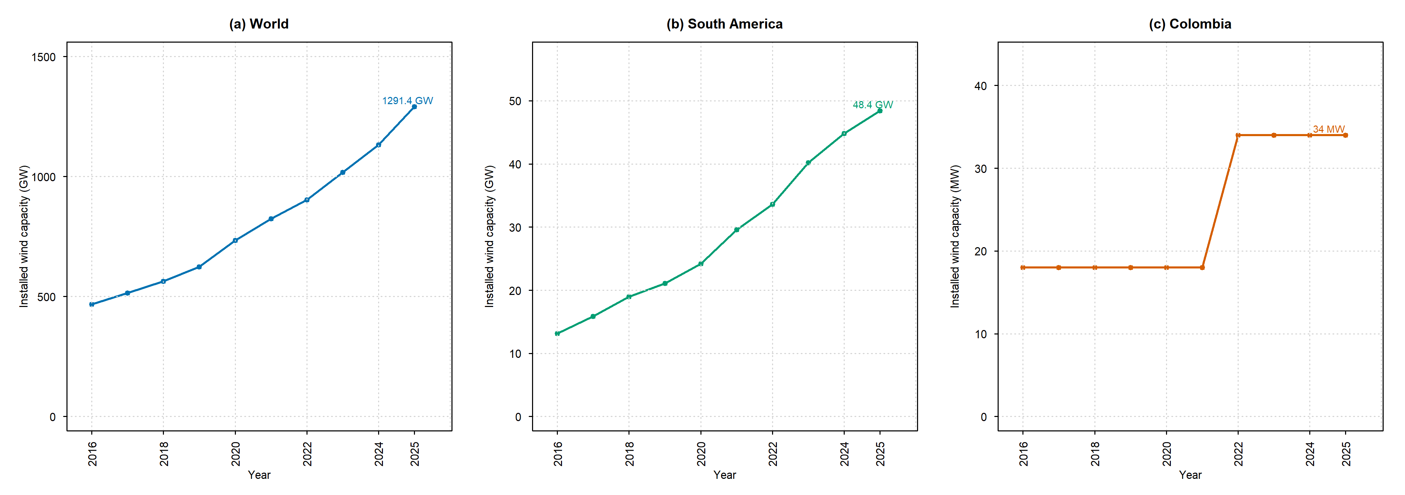
Figure 1. Evolution of installed wind-power capacity at global, South American, and Colombian scales from 2016 to 2025. Annual observations are shown as discrete yearly values connected by line segments to emphasize temporal progression. Panels use independent vertical scales to preserve readability. Capacity corresponds to maximum net generating capacity installed and connected at the end of each calendar year. Source: IRENA (2026), Renewable Capacity Statistics 2026.
Low installed capacity, however, should not be interpreted as evidence of limited resource potential. A recent IRENA zoning assessment estimated a maximum development potential of approximately 31.5 GW for utility-scale onshore wind in Colombia and identified favourable areas in both northern and southwestern parts of the country (IRENA, 2025). This distinction between installed capacity and favourable development potential is particularly important for regions such as Nariño, where complex Andean terrain can generate strong local contrasts in wind conditions and where regional potential cannot be inferred directly from national deployment statistics.
Wind-resource assessment in complex terrain therefore requires more than the estimation of mean wind speed. Wind power density (WPD) is physically related to air density and to the cube of wind speed, so the energetic response is nonlinear. This cubic dependence means that the analytical scale and order of operations matter: quality control, local energetic transformation and spatial aggregation are not interchangeable steps. In a heterogeneous monitoring network, averaging wind speed before calculating WPD may yield a different energetic representation from calculating WPD at the local observation scale and aggregating afterwards. This issue becomes especially relevant when high-speed states, uneven station availability and strong spatial heterogeneity coexist.
Previous wind-resource studies have established the usefulness of Weibull and Rayleigh distributions, wind-load and power-density indicators, temporal analysis and turbine-oriented assessment. Gugliani et al. (2018), for example, proposed an integrated methodology to assess wind speed, load, power and direction and examined Weibull-parameter estimation in relation to wind-energy applications. More recent work has extended resource assessment toward turbine selection, capacity-factor estimation and levelized cost of energy using turbine-specific information (Gupta et al., 2025a), while machine-learning approaches have been applied to wind-speed prediction as a subsequent forecasting layer (Gupta et al., 2025b). These studies demonstrate that statistical characterization, forecasting and techno-economic assessment address different levels of the wind-energy decision problem and require different evidential inputs.
Colombia has an established wind-resource assessment background through the national wind and wind-energy atlas developed by IDEAM and UPME (2006), and recent studies have evaluated wind-power potential using observational and reanalysis data, particularly in the Caribbean region (Gil Ruiz et al., 2021, 2022). For Nariño, Eraso Checa and Escobar Rosero (2018) provided a regional precedent through wind-resource characterization in Túquerres. Nevertheless, the broader methodological problem remains relevant in complex Andean settings: how should heterogeneous station observations be transformed into regional energetic information without obscuring the effects of nonlinear WPD construction, unequal station composition, temporal gaps and serial dependence?
The research gap addressed here is therefore not the absence of individual tools such as WPD, Weibull fitting, autocorrelation or spectral analysis. Each of these methods is well established. The gap lies in the physical and statistical architecture that connects them. In particular, regional summaries may appear precise while remaining sensitive to the order of quality control and aggregation, the stations contributing at each time step, the persistence of the observed series, the treatment of missing intervals and the uncertainty associated with temporally dependent observations. These issues also constrain the extent to which analytical zones can be interpreted as spatial wind-resource classes.
Accordingly, this study develops an uncertainty-aware physical–statistical characterization of wind speed and WPD from a multi-station observational network in Nariño, Colombia, from January 2017 to June 2022. The revised workflow constructs wind speed at station-hour scale, applies quality control before the nonlinear energetic transformation, calculates local station-hour WPD using daily zone-level air density, and only then obtains equal-station zone-hour summaries. The analysis subsequently evaluates descriptive and distributional structure, formal inter-zonal differences, station-composition sensitivity, temporal persistence, spectral organization and dependence-aware uncertainty.
The scientific contribution is therefore methodological and interpretative rather than the introduction of a new statistical distribution or time-series algorithm. The study demonstrates how the inferred wind-energy state changes when nonlinear transformation, observational-network support and temporal uncertainty are treated explicitly within the same workflow. The four zones are used as comparative analytical aggregation units, not as homogeneous wind-resource regions or continuous spatial estimates. This framing provides a transferable principle for observational wind-resource studies in other complex-terrain environments: energetic quantities should be constructed at a physically meaningful observation scale before aggregation, and the information retained by the monitoring network should delimit the strength of the resulting regional interpretation.

2. Study area and meteorological data

2.1 Study region
The study focuses on the department of Nariño in southwestern Colombia, where the Western and Central Andean cordilleras, inter-Andean valleys, Pacific lowlands and strong altitudinal gradients produce a physically heterogeneous atmospheric setting. This heterogeneity motivates comparison across groups of monitoring stations, but it does not imply that the regional wind field can be represented as a set of internally homogeneous resource areas. Figure 2 shows the physiographic setting, topographic relief, IDEAM meteorological stations and the four analytical aggregation units used to organize the observational network.
Figure 2. Physiographic setting, IDEAM meteorological stations, and analytical aggregation units in Nariño, Colombia. The four units organize the observed monitoring network for comparative analysis and should not be interpreted as homogeneous wind-resource regions, administrative regionalizations, area-weighted resource estimates, or continuous spatial interpolations of the wind field.

2.2 Meteorological stations and analytical aggregation units
Meteorological records from 16 IDEAM stations were organized into four analytical aggregation units. The grouping is operational and comparative rather than a formal geographic regionalization. It was retained to support comparisons among observed regimes while considering station location, record continuity, availability of the variables required for WPD estimation, and the physical diversity represented by the network. Elevation is reported as a descriptive station characteristic, but it is not treated as the sole criterion defining the groups. Consequently, all zone-level statistics are conditional on the stations that contribute observations and should not be interpreted as area-weighted estimates of a continuous regional wind resource.
Table 1. IDEAM meteorological stations and analytical aggregation units. Original IDEAM station identifiers are reported as the primary identifiers; S01–S16 are retained only as graphical labels for Figure 2. The grouping is operational and comparative and does not represent homogeneous wind-resource regions. The analysis period was January 2017–June 2022.
Analytical unit | Number of stations | IDEAM station IDs (map labels) | Station names | Municipalities | Altitude range (m a.s.l.)
Zone 1 | 5 | 5102500128 (S01); 51025060 (S02); 51025080 (S03); 51025090 (S04); 51035020 (S05) | Reserva Natural La Planada; Biotopo; Altaquer; Granja Mira; CCCP Dl Pacifico | Barbacoas; Ricaurte (Nariño); Tumaco | 1–1835
Zone 2 | 4 | 52055160 (S06); 52055170 (S07); 52055220 (S08); 52055230 (S09) | Volcán Chiles; La Josefina; El Paraíso; Aeropuerto San Luis | Aldana; Contadero; Cumbal; Túquerres | 442–3120
Zone 3 | 5 | 47015100 (S10); 52045080 (S11); 5205500123 (S12); 52055150 (S13); 52055210 (S14) | El Encano; Universidad de Nariño; Las Iglesias; Cerro Páramo; Botana | Pasto; Puerres | 2626–3585
Zone 4 | 2 | 52035040 (S15); 52040050 (S16) | Viento Libre; Aponte | El Tablón; Taminango | 1400–1800

2.3 Variables and observational period
The meteorological records were obtained from IDEAM, the official Colombian institution responsible for hydrological and meteorological information. The original data source was the DHIME system, which provides the provenance and institutional traceability of the observations used in this study (IDEAM, 2024).
Wind speed (VV) was the principal kinematic variable. Atmospheric pressure and air temperature were used to estimate air density, which was subsequently coupled with wind speed for the WPD calculation. The analysis window extended from 1 January 2017 to 30 June 2022 after datetime validation, corresponding to a 2007-day calendar for the temporal analyses.
The analytical variables were wind speed, atmospheric pressure, air temperature, derived air density, WPD, station identifier, analytical unit, date and time. Station availability was not assumed to be spatially or temporally uniform; the number of stations contributing to a zone-hour was therefore retained as part of the canonical V2 dataset.

2.4 Datetime validation and preprocessing
Before energetic transformation, the datetime field was validated and parsed consistently using the day–month–year structure of the source records. Wind observations were then assigned to station-hour intervals. When more than one valid observation from the same station occurred within an hour, those observations were consolidated as the station-hour mean wind speed. This station-hour representation became the fundamental scale for quality control, local energetic transformation and subsequent zonal aggregation.

3. Methodology
The revised workflow was designed to preserve the physical scale of the nonlinear energetic transformation before regional aggregation. The sequence begins with station-hour construction, assigns daily zone-level air density, applies wind-speed quality control at station level, calculates local station-hour WPD, and only then aggregates valid stations to zone-hour summaries. Subsequent stages evaluate network-composition sensitivity, statistical structure, temporal dependence, spectral organization and uncertainty (Figure 3).
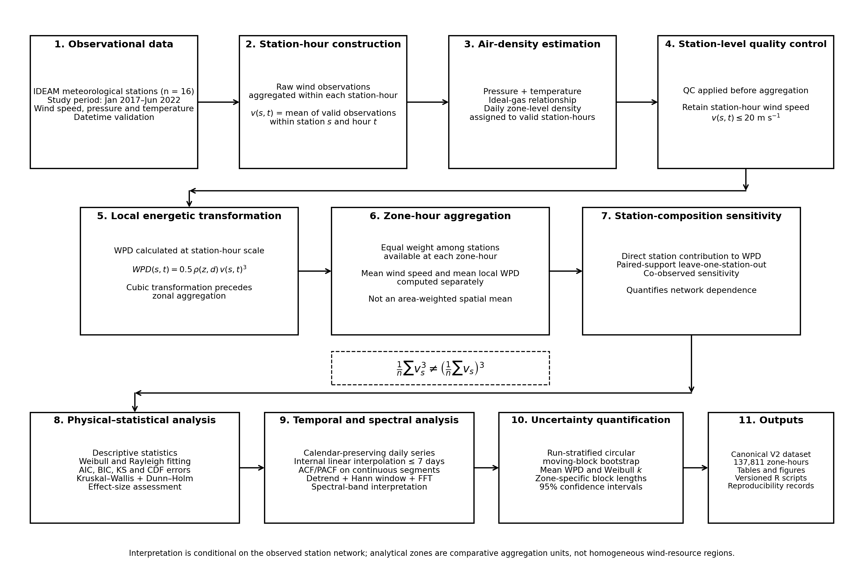
Figure 3. Revised methodological framework for the physical–statistical characterization of wind power density. Quality control and nonlinear energetic transformation are applied at station-hour scale before equal-station zonal aggregation. Subsequent analyses quantify distributional structure, station-composition sensitivity, temporal dependence, spectral organization and uncertainty.

3.1 Station-hour physical construction and local WPD
The station-hour was treated as the fundamental physical observation scale for wind speed. For station s and hour t, vₛ,ₜ denotes the mean of the valid wind-speed observations assigned to that station-hour. WPD was then calculated locally from the station-hour wind speed and the corresponding daily zone-level air density, rather than from a previously averaged zonal wind speed.
For each retained station-hour, WPD was computed as:
WPDₛ,ₜ = 0.5 · ρz,d(t) · vₛ,ₜ³
where WPDₛ,ₜ is the local wind power density for station s and hour t, ρz,d(t) is the daily air density assigned to analytical unit z on the corresponding date, and vₛ,ₜ is the station-hour mean wind speed. This ordering is essential because the cubic transformation is nonlinear.
The distinction between local transformation and zonal aggregation is expressed by the inequality
1/n · Σ vₛ³ ≠ (1/n · Σ vₛ)³
so an energetic quantity constructed from the mean wind speed is generally different from the mean of the local energetic states. The revised architecture therefore preserves the station-hour cubic transformation before computing zone-hour WPD.
This formulation defines the zonal WPD reported in the revised manuscript as the equal-station mean of locally calculated station-hour WPD among the stations contributing valid observations at each zone-hour. It is not an area-weighted estimate of the continuous wind field.

3.2 Daily zone-level air-density strategy
Air density was estimated from available pressure and temperature observations using the ideal-gas relationship
ρz,d = pz,d / (Rd · Tz,d)
where pz,d and Tz,d are the daily pressure and absolute-temperature representations for analytical unit z, and Rd is the specific gas constant for dry air. Exact hourly co-occurrence among wind speed, pressure and temperature was limited; therefore, hourly observed, daily zone-level, monthly zone-level, overall zone-level and standard-density representations were evaluated during workflow development.
Daily zone-level density was retained as the operational strategy because it preserves day-to-day and between-unit density variation while avoiding the severe record loss associated with strict hourly matching and avoiding the assumption of a single standard density for the entire region. The resulting daily density was assigned to each valid station-hour within the corresponding analytical unit and date. This strategy does not imply station-specific density variation within a given zone-day and is interpreted accordingly.

3.3 Station-level quality control and zone-hour aggregation
Because WPD depends on the cube of wind speed, quality control was applied before energetic transformation and zonal aggregation. Station-hour wind speeds were retained when vₛ,ₜ ≤ 20 m s⁻¹ under the main article scenario. The threshold was applied to the station-hour series, preventing an extreme station value from being diluted through prior zonal averaging and subsequently amplified through the cubic transformation.
For each analytical unit z and hour t, the valid contributing stations were then aggregated with equal weight. Zone-hour wind speed and WPD were calculated separately as
VVz,t = 1/nz,t · Σ vₛ,ₜ and WPDz,t = 1/nz,t · Σ WPDₛ,ₜ
where nz,t is the number of valid stations contributing to the corresponding zone-hour. Station availability was therefore allowed to vary over time rather than being artificially balanced by deleting observations. The resulting canonical V2 dataset contains 137,811 zone-hour records and retains the number of contributing stations for each observation. These summaries describe the observed network and are not area-weighted spatial means.

3.4 Station-composition sensitivity
Dependence of the zonal WPD summaries on the monitoring network was quantified explicitly. First, each station’s direct contribution to the long-term zonal mean WPD was decomposed from the canonical aggregation, with station contributions constrained to sum to 100% within each analytical unit.
Second, leave-one-station-out (LOSO) sensitivity was evaluated using paired temporal support so that the baseline and station-removed estimates were compared over the same eligible zone-hours. Third, a co-observed LOSO analysis restricted comparison to hours in which the removed station and at least one remaining station were observed simultaneously. These paired approaches separate station influence from changes caused only by temporal-support loss.
The station-composition analysis is used to delimit the spatial meaning of the analytical units. It quantifies network dependence but does not by itself estimate uncertainty associated with unsampled locations or continuous spatial representativeness.

3.5 Descriptive, distributional and inter-zonal analysis
Descriptive statistics were calculated by analytical unit for wind speed and WPD, including sample size, number of observed days, mean, median, standard deviation, selected percentiles and maxima. Wind-speed probability models were fitted to positive observations using Weibull and Rayleigh distributions. Model performance was compared with Akaike and Bayesian information criteria (AIC and BIC), Kolmogorov–Smirnov distance, and errors between empirical and fitted cumulative distributions (CDF RMSE and CDF MAE). Model preference was interpreted jointly across metrics rather than from a single diagnostic.
Formal inter-zonal differences were evaluated using Kruskal–Wallis tests for both wind speed and WPD. Tests were performed at zone-hour scale and on daily-zone means. Effect magnitude was summarized using epsilon-squared (ε²), and significant global tests were followed by Dunn pairwise comparisons with Holm adjustment for multiple testing. The daily-scale comparisons were used as the more conservative pairwise interpretation because the zone-hour dataset contains strong temporal dependence and a very large number of observations.

3.6 Temporal dependence, missing intervals and interpolation sensitivity
Daily wind-speed and WPD series were represented on the complete calendar from 1 January 2017 to 30 June 2022 (2007 days). For each analytical unit, observed days, missing days, missing-run length and the maximum internal gap were quantified before temporal analysis. Linear interpolation was permitted only for internal gaps of seven consecutive days or less. Leading gaps, trailing gaps and internal gaps longer than seven days remained missing.
Interpolation sensitivity was assessed using calendar-preserving lag correlations calculated separately from observed calendar pairs and from the short-gap-interpolated series. Lag-1 correlation and the first lag at which the absolute correlation fell below 0.2 were evaluated within a 90-day diagnostic window. Standard ACF and PACF diagnostics were then calculated only on the explicitly identified longest continuous segment available after short-gap interpolation, thereby avoiding correlation calculations across unresolved long missing intervals.
This separation allows the analysis to distinguish temporal dependence present in the observations from dependence that could be introduced by interpolation. Zone 4, which has substantially lower calendar coverage than the other analytical units, is therefore interpreted only within the support of its observed and continuous segments.
3.7 Spectral analysis
Spectral analysis was applied to the same longest continuous daily segments used for the standard temporal diagnostics after interpolation of internal gaps of seven days or less. Each series was linearly detrended, centered and multiplied by a Hann window before computing a one-sided fast Fourier transform (FFT). Segments shorter than 128 days were excluded from spectral analysis.
Spectral power was summarized in five period bands: 2–10 days, 10–30 days, 30–120 days, 120–365 days and >365 days. Dominant periods and band-energy fractions are treated as descriptors of temporal organization rather than as evidence of deterministic atmospheric cycles, particularly when a dominant period approaches the length of the analyzed segment.
The frequency-domain analysis complements, rather than replaces, the autocorrelation analysis: ACF describes persistence in time, whereas FFT summarizes how variance is distributed among temporal scales.

3.8 Dependence-aware uncertainty quantification
Uncertainty in mean WPD and the Weibull shape parameter k was quantified using a run-stratified circular moving-block bootstrap. The observed daily series were first partitioned into contiguous runs separated by missing calendar intervals. Bootstrap blocks were sampled circularly within each observed run rather than across gaps, preserving the original run composition while retaining local serial dependence.
Block-length sensitivity was evaluated at 7, 30 and 90 days. The primary block lengths were 90 days for Zones 1 and 2, 30 days for Zone 3 and 7 days for Zone 4, balancing the detected persistence structure with the amount of observed data supported by runs of the requested length. For each primary configuration, 1000 bootstrap replicates were used to obtain percentile 95% confidence intervals for mean WPD and Weibull k.
These confidence intervals quantify temporal/statistical sampling uncertainty conditional on the observed station network. They do not quantify uncertainty due to unsampled locations, terrain-scale spatial representativeness or alternative station-network configurations; those issues are addressed separately through the station-composition sensitivity analysis.
3.9 Reproducibility and computational traceability
All revised analyses were implemented in version-controlled R scripts. The workflow generates the canonical V2 zone-hour dataset, quality-control audits, station-composition diagnostics, descriptive and inferential statistics, distribution fits, temporal and spectral outputs, uncertainty estimates, publication tables and figures. Exact reconstruction checks were used during the revision to verify consistency between the frozen analytical dataset and the reported results.
The original IDEAM meteorological records are not redistributed with the study because of source-data redistribution considerations. Versioned scripts, derived summaries, figures, tables and reproducibility documentation are maintained in the associated research repository, allowing the reported analysis to be traced from preprocessing decisions to final outputs while respecting the conditions of the source data (Peng, 2011; Wilkinson et al., 2016).

4. Results
Results are organized according to the revised physical-statistical architecture. The analysis first describes observational support and the kinematic-to-energetic transformation, then evaluates probability structure and formal inter-zonal differences, quantifies dependence on station composition, and finally examines temporal persistence, spectral organization, and dependence-aware uncertainty.

4.1 Observational support and kinematic–energetic characterization
The canonical V2 dataset contained 137,811 zone-hour observations after station-hour quality control, local WPD calculation, and equal-station zonal aggregation. Observational support was uneven among analytical units: Zones 1–3 contained 42,416–43,618 zone-hour observations and 1,795–1,895 observed days, whereas Zone 4 contained 8,744 zone-hours distributed across 378 observed days.
Mean wind speed was 1.22, 2.61, 2.50, and 2.70 m s⁻¹ in Zones 1–4, respectively. The corresponding mean WPD values were 31.96, 30.44, 26.30, and 18.68 W m⁻². The ordering of the energetic means therefore differed from the ordering of mean wind speed, as expected when local cubic transformation precedes spatial aggregation.
Zone 1 showed the strongest contrast between central and upper-tail energetic behavior. Its median WPD was only 0.62 W m⁻², while its mean was 31.96 W m⁻² and its 99th percentile reached 981.08 W m⁻². This difference indicates that the zonal mean is strongly influenced by relatively infrequent high-WPD station-hour states rather than by a persistently high energetic condition. Zones 2–4 had higher median WPD values (7.67–9.47 W m⁻² for Zones 2–3 and 8.59 W m⁻² for Zone 4) but less extreme upper-tail amplification.
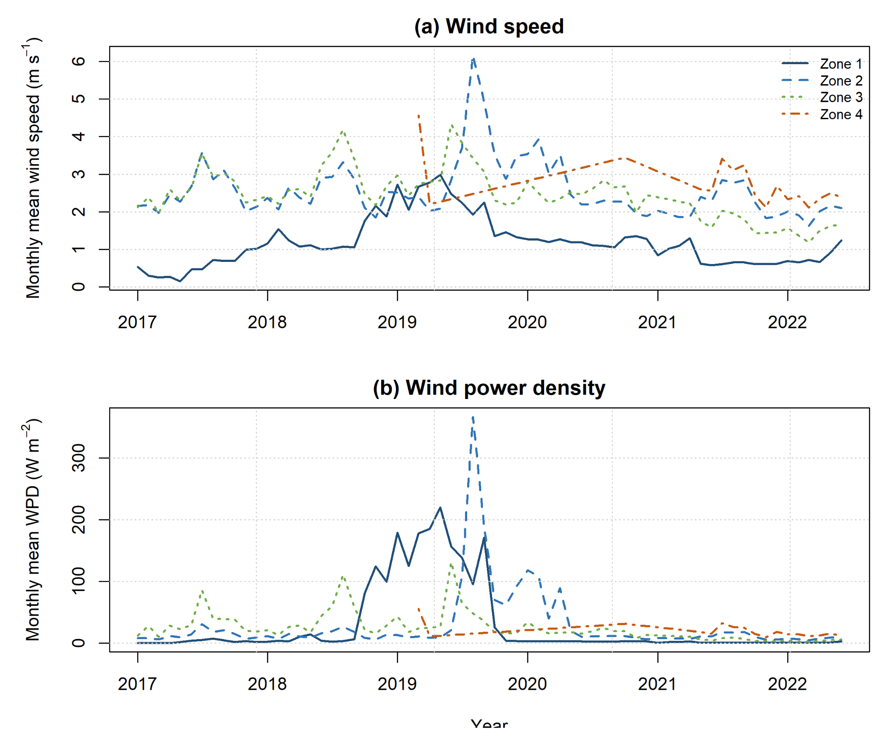
Figure 4. Monthly mean wind speed and wind power density for the four analytical units using the canonical V2 dataset. Local station-hour WPD was calculated before equal-station zonal aggregation.
Table 2. Descriptive statistics and dependence-aware 95% confidence intervals for mean WPD by analytical unit. Confidence intervals were obtained with the run-stratified circular moving-block bootstrap.
Zone | n | Observed days | Mean VV  (m s⁻¹) | Median VV  (m s⁻¹) | Mean WPD [95% CI]  (W m⁻²) | Median WPD  (W m⁻²) | P95 WPD  (W m⁻²) | P99 WPD  (W m⁻²)
Zone 1 | 43,033 | 1881 | 1.22 | 0.91 | 31.96 [14.92, 49.43] | 0.62 | 21.78 | 981.08
Zone 2 | 43,618 | 1895 | 2.61 | 2.38 | 30.44 [17.28, 48.21] | 7.67 | 143.22 | 455.50
Zone 3 | 42,416 | 1795 | 2.50 | 2.34 | 26.30 [21.83, 31.18] | 9.47 | 99.48 | 272.90
Zone 4 | 8,744 | 378 | 2.70 | 2.52 | 18.68 [16.71, 20.88] | 8.59 | 72.06 | 128.96

4.2 Weibull and Rayleigh probabilistic characterization
The Weibull–Rayleigh comparison was strongly zone-dependent. In Zone 1, Weibull provided a clear relative improvement over Rayleigh: AIC decreased from 134,204.58 to 100,746.11 and the KS distance from 0.2748 to 0.0632. The corresponding Weibull shape parameter was k = 1.190 (95% CI: 1.112–1.326). Nevertheless, the empirical density and cumulative distribution retained visible deviations from the fitted model, so the result is interpreted as relative superiority over Rayleigh rather than as a perfect absolute fit.
In Zone 2, the fitted Weibull shape parameter was k = 2.010, close to the Rayleigh special case. The two models consequently produced nearly identical AIC values; Rayleigh performed slightly better in BIC and CDF error metrics, whereas Weibull produced a slightly smaller KS distance. Zone 3 also showed metric-dependent evidence: Weibull was favored by AIC, BIC, and KS distance, while Rayleigh produced slightly lower CDF RMSE and MAE. In Zone 4, Weibull was favored by AIC, BIC, RMSE, and MAE, whereas Rayleigh produced the slightly smaller KS distance.
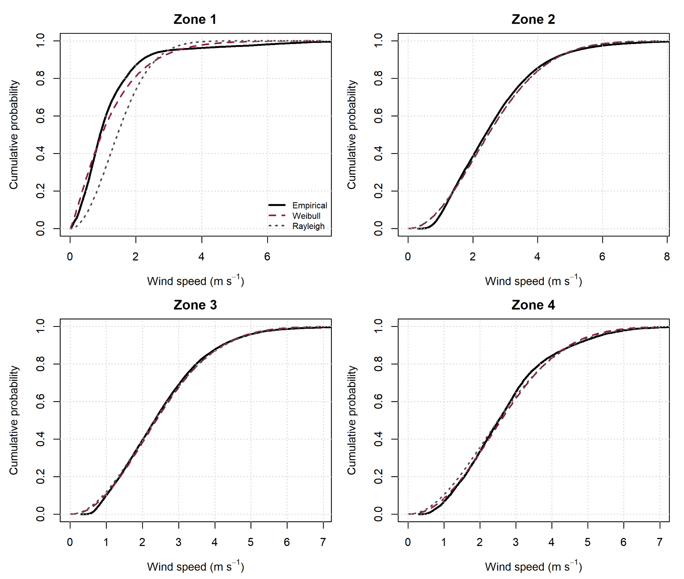
Figure 5. Empirical cumulative wind-speed distributions with fitted Weibull and Rayleigh models by analytical unit. Solid black lines show the empirical CDF, dashed orange lines show Weibull fits, and dotted green lines show Rayleigh fits.
The corresponding empirical-density comparison is provided as Supplementary Figure S1 to distinguish relative model preference from absolute fit adequacy.
Table 3. Weibull and Rayleigh fit parameters and goodness-of-fit metrics by analytical unit. Dependence-aware 95% confidence intervals are reported for the Weibull shape parameter k.
Zone | Model | k [95% CI] | Scale / σ | AIC | BIC | CDF RMSE | CDF MAE | KS D
Zone 1 | Rayleigh | — | 1.219 | 134204.58 | 134213.25 | 0.1880 | 0.1681 | 0.2748
Zone 1 | Weibull | 1.190 [1.112, 1.326] | 1.302 | 100746.11 | 100763.45 | 0.0452 | 0.0410 | 0.0632
Zone 2 | Rayleigh | — | 2.091 | 144244.46 | 144253.14 | 0.0211 | 0.0190 | 0.0431
Zone 2 | Weibull | 2.010 [1.866, 2.243] | 2.960 | 144244.39 | 144261.76 | 0.0216 | 0.0196 | 0.0421
Zone 3 | Rayleigh | — | 1.986 | 134837.76 | 134846.41 | 0.0124 | 0.0094 | 0.0374
Zone 3 | Weibull | 2.092 [1.997, 2.202] | 2.835 | 134690.69 | 134708.00 | 0.0128 | 0.0113 | 0.0303
Zone 4 | Rayleigh | — | 2.126 | 28737.46 | 28744.54 | 0.0236 | 0.0202 | 0.0400
Zone 4 | Weibull | 2.166 [2.077, 2.269] | 3.057 | 28646.29 | 28660.44 | 0.0200 | 0.0166 | 0.0430

4.3 Formal inter-zonal comparison
Kruskal–Wallis tests rejected equality of the four zonal distributions for both wind speed and WPD at zone-hour and daily-zone scales. At zone-hour resolution, H was 41,035.88 for wind speed and 33,621.28 for WPD, with epsilon-squared effect sizes of 0.298 and 0.244, respectively. At daily-zone resolution, the corresponding effect sizes were 0.409 for wind speed and 0.212 for WPD. Thus, the revised inferential analysis does not support the previous interpretation that WPD globally separates the analytical units more strongly than wind speed.
Dunn pairwise comparisons with Holm adjustment further showed that not all zonal contrasts were significant at daily resolution. For wind speed, the Zone 2–Zone 3 comparison was not significant (adjusted p = 0.273), whereas all remaining daily pairwise comparisons were significant. For WPD, the Zone 3–Zone 4 comparison was not significant (adjusted p = 0.666), whereas the remaining daily comparisons were significant. Full pairwise results are provided in the supplementary material.
Table 4. Kruskal–Wallis tests and effect sizes for wind speed and WPD at zone-hour and daily-zone scales.
Scale | Variable | N | H | df | p-value | Epsilon-squared
Zone-hour | VV | 137,811 | 41035.88 | 3 | <0.001 | 0.298
Zone-hour | WPD | 137,811 | 33621.28 | 3 | <0.001 | 0.244
Daily-zone mean | VV | 5,949 | 2436.95 | 3 | <0.001 | 0.409
Daily-zone mean | WPD | 5,949 | 1263.19 | 3 | 1.43e-273 | 0.212

4.4 Dependence on station composition
The energetic summaries were strongly dependent on the composition of the observed station network. Direct decomposition of the long-term zonal mean WPD showed that station 51025060 contributed 94.08% of Zone 1, station 52055160 contributed 62.51% of Zone 2, station 52055150 contributed 78.24% of Zone 3, and station 52040050 contributed 79.31% of Zone 4.
Paired-support leave-one-station-out analysis confirmed substantial sensitivity in Zones 1–3: removing the dominant contributor reduced mean WPD by 93.18%, 60.85%, and 74.57%, respectively, on the corresponding paired temporal support. In Zone 4, removing station 52040050 increased the paired-support mean by 35.56%, reflecting the interaction between station contribution and the limited set of co-observed periods. Co-observed analyses led to the same general conclusion: zonal energetic summaries cannot be interpreted independently of station availability and composition.
These results establish that the four zones are observational aggregation units rather than homogeneous wind-resource classes. The long-term zonal mean summarizes the stations contributing to each zone-hour; it is not an area-weighted estimate of a continuous wind field.
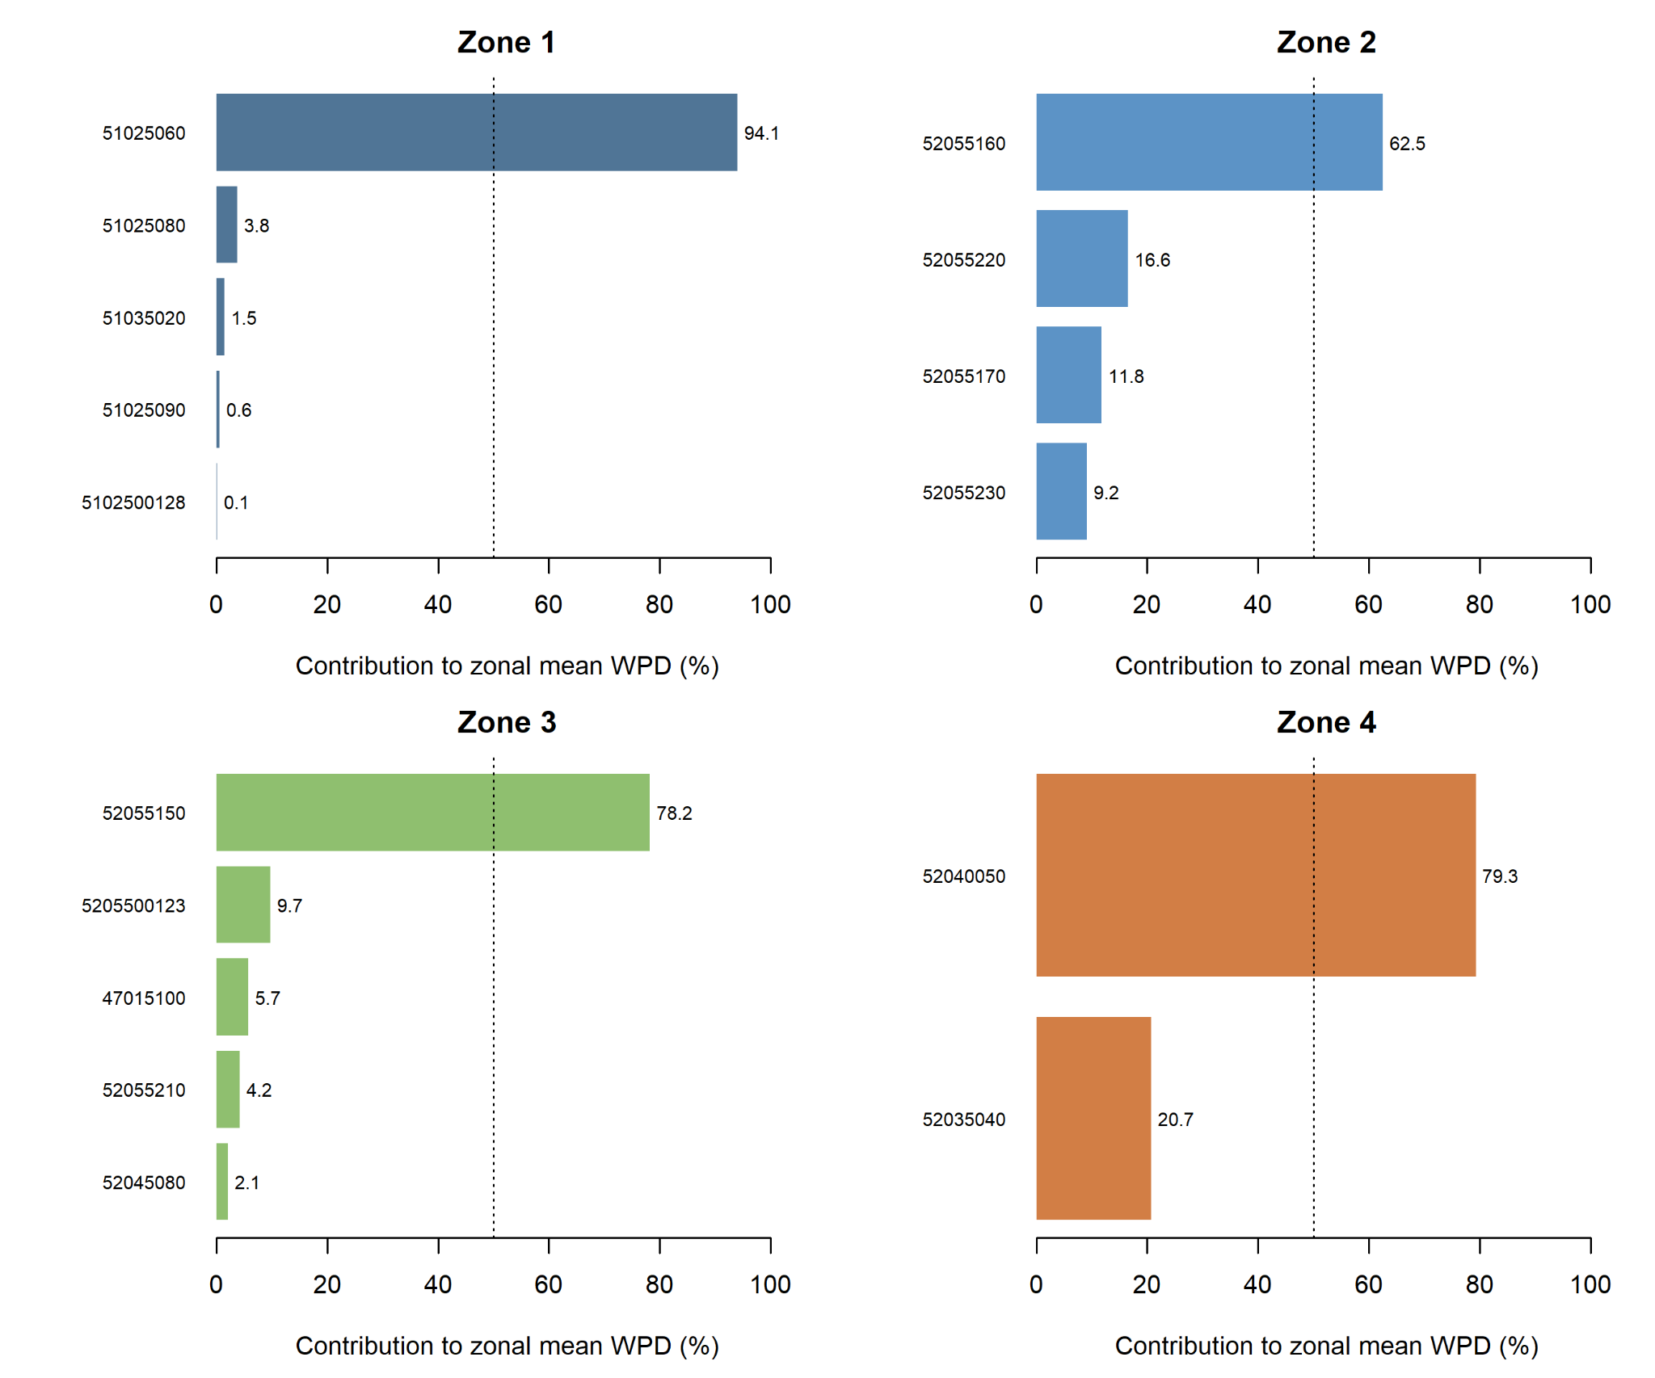
Figure 6. Direct contribution of individual IDEAM stations to the long-term zonal mean WPD. Contributions sum to 100% within each analytical unit and quantify the dependence of the aggregated energetic signal on the observed station network.

4.5 Temporal coverage, interpolation sensitivity, and persistence
Calendar coverage differed markedly among zones. Zones 1, 2, and 3 contained observations on 93.72%, 94.42%, and 89.44% of the January 2017–June 2022 analysis calendar, respectively, whereas Zone 4 covered only 18.83%. Maximum missing gaps were 36, 11, 116, and 818 days, with a 552-day maximum internal gap in Zone 4.
Linear interpolation was restricted to internal gaps of seven days or less and added only 1.49%, 4.09%, 1.44%, and 0.60% of the total calendar in Zones 1–4. Calendar-preserving lag-1 WPD correlations changed only from 0.835 to 0.837, 0.899 to 0.900, 0.733 to 0.734, and 0.565 to 0.567 after short-gap interpolation. The close agreement indicates that the observed short-lag persistence was not generated by the interpolation procedure.
Using observed calendar pairs, the first lag at which |r| fell below 0.2 was not reached within 90 days in Zone 1, occurred at 54 days in Zone 2, 12 days in Zone 3, and 3 days in Zone 4. These values describe different temporal-dependence structures; they do not identify a unique atmospheric mechanism.
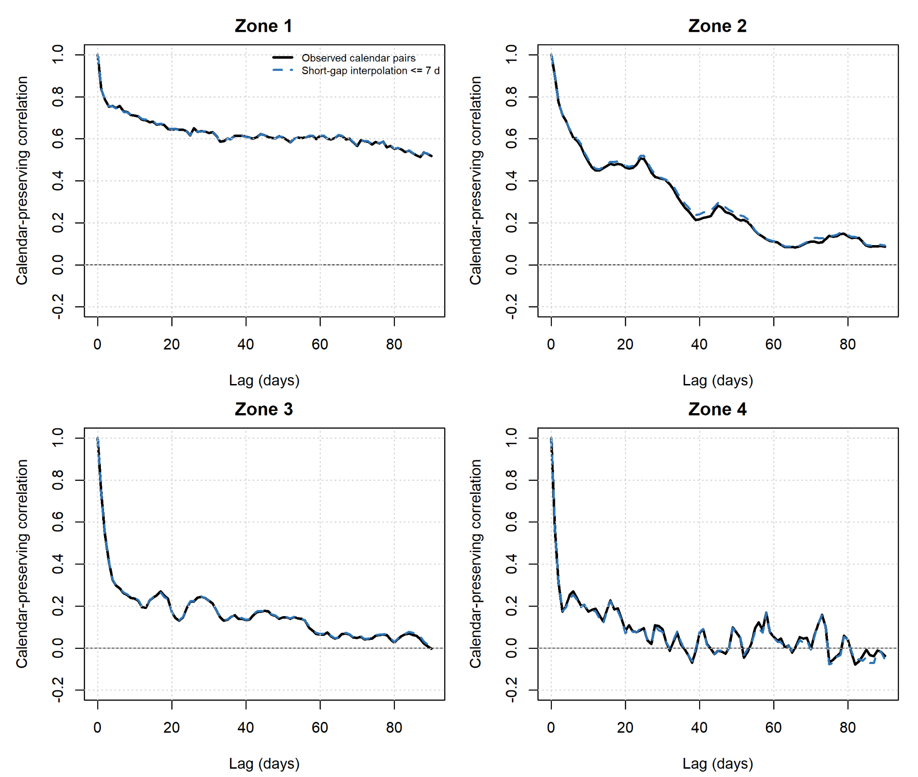
Figure 7. Sensitivity of calendar-preserving WPD lag correlations to short-gap interpolation. Solid black lines use observed calendar pairs; blue dashed lines use linear interpolation only for internal gaps of seven days or less.
Table 5. Temporal coverage, interpolation sensitivity, persistence, and spectral summary for WPD by analytical unit.
Zone | Observed  calendar (%) | Interpolated  calendar (%) | Max gap / internal  (d) | Lag-1 WPD  obs. / interp. | First |r|<0.2  (d) | FFT segment  (d) | Dominant period  (d) | Largest spectral band  (fraction)
Zone 1 | 93.72 | 1.49 | 36 / 36 | 0.835 / 0.837 | >90 | 1531 | 765.5 | >365 d (0.609)
Zone 2 | 94.42 | 4.09 | 11 / 11 | 0.899 / 0.900 | 54 | 1291 | 645.5 | 120-365 d (0.341)
Zone 3 | 89.44 | 1.44 | 116 / 116 | 0.733 / 0.734 | 12 | 1427 | 356.8 | 2-10 d (0.300)
Zone 4 | 18.83 | 0.60 | 818 / 552 | 0.565 / 0.567 | 3 | 246 | 246.0 | 2-10 d (0.522)

4.6 Spectral organization of WPD variability
FFT analysis was restricted to the longest continuous daily segment available after interpolation of short internal gaps. Segment lengths were 1,531, 1,291, 1,427, and 246 days for Zones 1–4, respectively. The distribution of one-sided spectral power differed substantially among zones.
Zone 1 concentrated 60.9% of its WPD spectral power at periods longer than 365 days. Zone 2 showed its largest fraction in the 120–365 day band (34.1%), with an additional 25.3% at periods longer than 365 days. Zone 3 showed a more distributed spectrum, with the largest single fraction in the 2–10 day band (30.0%) and substantial contributions from the 10–30, 30–120, and 120–365 day ranges. Zone 4 concentrated 52.2% of spectral power in the 2–10 day band and had no resolved >365-day component because its continuous segment was only 246 days.
The nominal dominant periods were approximately 765.5, 645.5, 356.8, and 246 days in Zones 1–4. The first two are interpreted as low-frequency structure rather than established cycles; the Zone 3 feature is compatible with an annual-scale component without implying causal attribution; and the Zone 4 value coincides with the full segment length and therefore cannot support a periodicity claim.
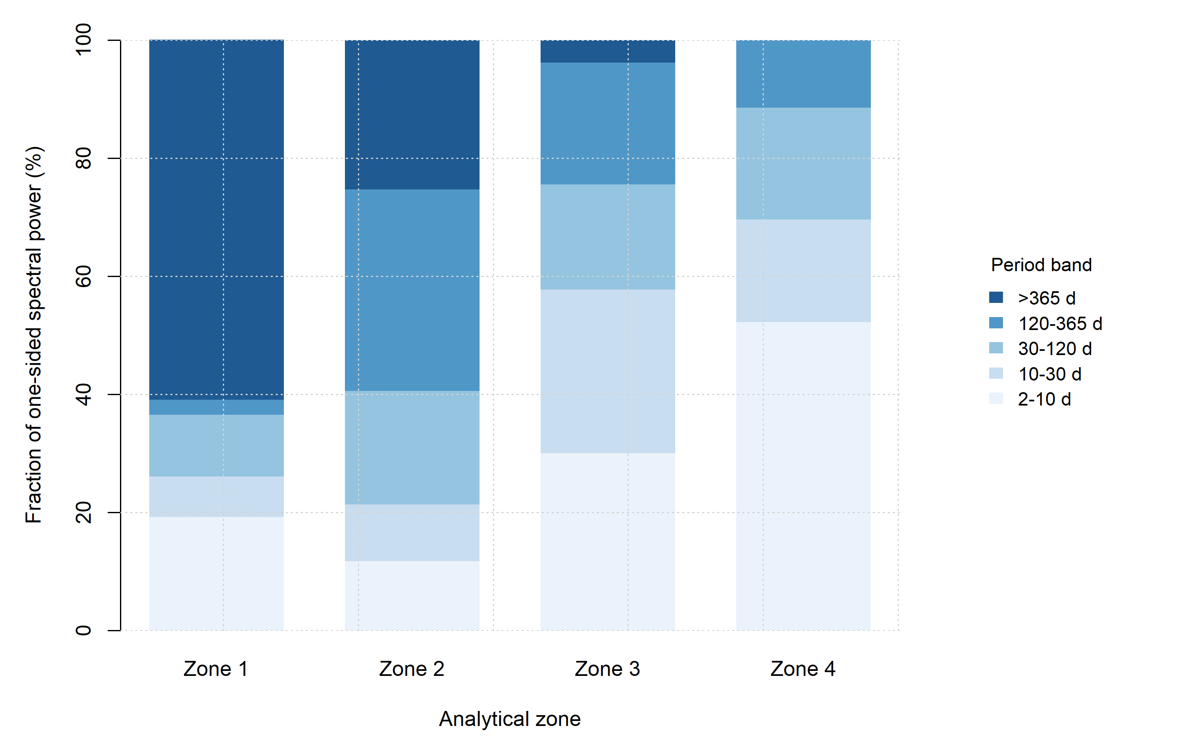
Figure 8. Fraction of one-sided WPD spectral power by period band for the longest continuous daily segment available in each analytical unit after interpolation of internal gaps of seven days or less. Spectral fractions are interpreted as descriptors of temporal variability rather than as evidence of deterministic atmospheric cycles.

4.7 Dependence-aware uncertainty
Run-stratified circular moving-block bootstrap intervals showed that temporal dependence materially affects the apparent precision of the zonal energetic means. The primary block lengths were 90 days for Zones 1 and 2, 30 days for Zone 3, and 7 days for Zone 4, selected from the observed run support and sensitivity analysis.
The resulting 95% confidence intervals for mean WPD were 14.92–49.43 W m⁻² in Zone 1, 17.28–48.21 W m⁻² in Zone 2, 21.83–31.18 W m⁻² in Zone 3, and 16.71–20.88 W m⁻² in Zone 4. Weibull k intervals were 1.112–1.326, 1.866–2.243, 1.997–2.202, and 2.077–2.269, respectively.
The overlap of marginal confidence intervals should not be interpreted as a pairwise significance test. The bootstrap intervals quantify uncertainty in selected parameters under temporal dependence, whereas the Kruskal–Wallis and Dunn procedures address distributional differences. Both forms of evidence are retained because they answer different inferential questions. All confidence intervals remain conditional on the observed station network and do not quantify spatial representativeness uncertainty.

5. Discussion

5.1 Nonlinear energetic transformation and analytical scale
The revised results show that the energetic interpretation of the observed wind field cannot be inferred directly from mean wind speed. Zone 1 provides the clearest example: it had the lowest mean wind speed (1.22 m s⁻¹) but the highest mean WPD (31.96 W m⁻²), while its median WPD was only 0.62 W m⁻². This combination indicates a distribution in which relatively infrequent high-energy states exert a disproportionate influence on the mean rather than a persistently elevated energetic condition.
The distinction follows directly from the nonlinear construction of WPD. Because the energetic quantity is proportional to v³, averaging wind speed before applying the cubic transformation does not preserve the information contained in the local observations. In general, the mean of v³ is not equal to the cube of mean v. The revised workflow therefore treats the station-hour wind state and its energetic transformation as distinct analytical stages: quality control is first applied at station-hour scale, local WPD is then calculated, and only afterwards are equal-station zone-hour summaries obtained.
This ordering is particularly consequential in complex terrain, where local exposure and topographic effects can generate markedly different wind conditions among observation sites (Palma et al., 2008; Carvalho et al., 2013; Radünz et al., 2020; Tang et al., 2019). In the present dataset, time-varying station availability further changes the observational support of each zonal aggregate. The main physical implication is therefore not that WPD is intrinsically a stronger spatial discriminator than wind speed, but that it is a nonlinear energetic descriptor whose value depends on the distribution and scale of the underlying wind observations.

5.2 Distributional structure and model adequacy
The revised Weibull–Rayleigh comparison also changes the interpretation of the probabilistic results. Weibull provides a clear relative improvement over Rayleigh in Zone 1, where the empirical distribution is strongly concentrated at low wind speeds while retaining an extended upper tail. However, the absolute Weibull fit remains imperfect, particularly in the lowest-speed portion of the distribution. This distinction between relative model preference and absolute model adequacy is important because a model can outperform a simpler alternative without reproducing every feature of the observed distribution.
In Zones 2–4, evidence for Weibull superiority is not uniform across goodness-of-fit criteria. The revised shape parameters are approximately 2.01, 2.09 and 2.17, respectively, placing these regimes close to the mathematical structure represented by Rayleigh when the Weibull shape parameter approaches two. Consequently, AIC, BIC, CDF error and KS-based diagnostics do not always identify the same preferred model. This result supports a metric-dependent interpretation rather than a universal statement that one distribution is superior in every analytical unit (Carta et al., 2009; Drobinski et al., 2015).
The dependence-aware confidence intervals for the Weibull shape parameter further show that k should be treated as an estimated statistical descriptor rather than an exact physical property of an analytical zone. This is consistent with the broader interpretation adopted in the revised manuscript: probability models summarize the observed wind-speed state under a particular network and temporal support; they do not, by themselves, establish a unique physical mechanism.

5.3 Station composition and the spatial meaning of the analytical units
The station-composition analysis is one of the most important additions to the revised study because it directly quantifies the spatial support behind the zonal summaries. Individual stations contributed approximately 94.1%, 62.5%, 78.2% and 79.3% of the long-term zonal mean WPD in Zones 1–4, respectively. Paired-support leave-one-station-out analysis produced reductions of approximately 93%, 61% and 75% when the dominant station was removed from Zones 1–3. In Zone 4, removing the dominant station increased the paired-support zonal mean because the comparison is restricted to the subset of times shared by the remaining observations.
These results demonstrate that the four analytical units cannot be interpreted as homogeneous wind-resource regions or continuous areal estimates. They are comparative summaries of an observational network whose spatial and temporal support varies among stations. A multi-station analytical unit can still be energetically dominated by one observation site if that site combines sufficiently high local WPD with substantial temporal availability.
The revised interpretation therefore treats network dependence as information rather than as a hidden source of error. Complex-terrain wind-resource studies routinely face strong local variability and scale dependence, particularly when measurements are spatially sparse relative to topographic variability (Palma et al., 2008; Radünz et al., 2020; Tang et al., 2019). The transferable lesson from the Nariño case is that aggregated wind-energy indicators should be accompanied by explicit assessment of station composition before they are generalized spatially.

5.4 Temporal dependence and the effect of gap treatment
The temporal analysis shows that WPD retains substantial but zone-dependent persistence. Calendar-preserving lag-1 correlations were 0.835, 0.899, 0.733 and 0.565 for Zones 1–4, respectively. The absolute correlation remained above 0.2 throughout the 90-day diagnostic window in Zone 1, whereas the corresponding thresholds were reached at approximately 54, 12 and 3 days in Zones 2–4. These differences indicate distinct temporal-dependence structures across the observed analytical units.
A central robustness result is that this persistence is not created by the short-gap interpolation procedure. Linear interpolation was restricted to internal gaps of seven days or less and affected only 1.49%, 4.09%, 1.44% and 0.60% of the full calendar in Zones 1–4. The resulting changes in lag-1 WPD correlation were below approximately 0.002 in every zone. Thus, the principal short-lag dependence is already present in the observed calendar pairs.
Autocorrelation nevertheless establishes temporal dependence, not a unique atmospheric cause. Persistence may be consistent with synoptic forcing, boundary-layer evolution, terrain-related circulation or seasonal organization, but the present observational design does not isolate their individual causal contributions. This distinction is particularly important for Zone 4, where observed daily coverage was only 18.8% and the maximum missing interval reached 818 days. Temporal conclusions for this zone therefore apply to the available observational segments rather than to the complete January 2017–June 2022 period.

5.5 Spectral organization without causal overinterpretation
The frequency-domain analysis complements the autocorrelation results by describing how WPD variability is distributed across temporal scales. Zone 1 contains a large fraction of low-frequency power, Zone 2 combines intermediate and low-frequency contributions, Zone 3 distributes a greater share across shorter and approximately annual scales, and Zone 4 is dominated by the 2–10 day band within its available continuous segment. These patterns confirm that temporal variability is organized differently across the observed units.
Dominant FFT periods, however, should not be interpreted automatically as deterministic physical cycles. The approximately 765- and 646-day peaks obtained for Zones 1 and 2 identify low-frequency structure but do not establish recurrent oscillations. The approximately 357-day feature in Zone 3 is compatible with variability near an annual scale, whereas the 246-day peak in Zone 4 coincides with the length of the continuous segment used for the FFT and therefore cannot support a periodicity claim. Accordingly, spectral peaks are treated here as descriptors of temporal organization rather than as established physical cycles. This conservative interpretation is consistent with the descriptive use of frequency-domain analysis in wind studies (Van der Hoven, 1957; Telesca et al., 2016; Lopez-Villalobos et al., 2021).
Accordingly, the revised manuscript uses spectral analysis as a descriptor of temporal organization rather than as evidence of specific atmospheric mechanisms. This moderation directly separates what is measured—the distribution of variance across frequencies—from what would require additional process-based observations or atmospheric modeling.

5.6 Dependence-aware uncertainty and the interpretation of zonal ranking
Accounting explicitly for temporal dependence changes the apparent precision of the zonal WPD estimates. The run-stratified circular moving-block bootstrap produced 95% intervals of 14.92–49.43, 17.28–48.21, 21.83–31.18 and 16.71–20.88 W m⁻² for mean WPD in Zones 1–4, respectively. The wider intervals in Zones 1 and 2 reflect the interaction between temporal persistence, intermittent energetic states and the available continuous runs.
The descriptive ordering of the sample means, Z1 > Z2 > Z3 > Z4, is therefore retained as a numerical summary but should not be interpreted as four sharply separated energetic classes. This does not contradict the Kruskal–Wallis and Dunn–Holm results: the rank-based tests evaluate distributional differences, whereas the bootstrap intervals quantify uncertainty in selected parameters under serial dependence. In fact, wind speed produced the larger global Kruskal–Wallis effect size at both zone-hour and daily-zone resolutions, which is why the original claim that WPD separates the zones more strongly has been removed.
The bootstrap intervals are conditional on the observed station network. They quantify temporal/statistical sampling uncertainty under the selected resampling architecture but do not quantify uncertainty associated with unobserved locations, spatial representativeness or alternative station networks. Keeping those uncertainty sources conceptually separate prevents the confidence intervals from being interpreted beyond what the data support.

5.7 Practical and techno-economic implications
The revised results provide a stronger basis for deciding where additional wind-resource investigation is warranted, but they do not constitute a turbine-siting or investment-feasibility assessment. Near-surface WPD alone cannot determine expected turbine energy production. Operational assessment additionally requires validated hub-height wind conditions, vertical shear, turbulence and direction, turbine-specific power curves, rotor and control characteristics, micrositing and wake effects, grid constraints, and project-specific economic assumptions (Manwell et al., 2009; Burton et al., 2011).
This distinction also explains why the present revision does not introduce capacity factor or levelized cost of energy calculations from assumed turbine and cost parameters. Recent turbine-selection and techno-economic studies operate at a later decision level by combining wind-resource information with turbine-specific and economic inputs (Gupta et al., 2025a). Introducing comparable indicators here without those inputs would create apparent precision unsupported by the observational dataset.
The practical contribution of the present analysis is therefore earlier in the decision chain. It identifies where the energetic signal is concentrated in particular stations, where temporal persistence is strongest, where data gaps materially restrict interpretation, and where uncertainty is sufficiently large that a simple zonal mean would be an incomplete basis for subsequent engineering decisions. These outputs can be used to prioritize validation and measurement before moving toward turbine-specific assessment.

5.8 Generalizability, limitations, and scientific contribution
The principal contribution of this study does not lie in proposing a new probability distribution, autocorrelation statistic or spectral transform. Each of these tools is established. The contribution lies in demonstrating how their interpretation changes when the physical construction of WPD, station composition, missing-data structure, serial dependence and uncertainty are treated as connected components of the same observational problem.
This distinction is especially relevant in complex terrain. A regional summary is produced through a sequence of transformations: a local wind state is observed, quality control determines the admissible support, the wind state is transformed nonlinearly into an energetic quantity, station-level information is aggregated, temporal dependence modifies effective information content, and uncertainty constrains the strength of the resulting interpretation. Changing the order or ignoring one of these stages can materially change the inferred regional picture.
Several limitations remain. The monitoring network is spatially uneven, station availability differs across analytical units, and Zone 4 has substantially lower temporal coverage. The study does not produce a continuous wind field, area-weighted resource estimates, terrain-resolving flow simulations, validated hub-height reconstruction, turbine-specific energy yield or economic feasibility. In addition, the station-influence analysis identifies locations that strongly condition the zonal results but does not independently validate every high-WPD episode or instrument history.
Within these boundaries, the broader methodological implication is transferable: in heterogeneous terrain, nonlinear wind-energy metrics should be constructed at the physical observation scale before aggregation, and both observational-network support and temporal dependence should be carried explicitly into uncertainty and interpretation. This provides a more defensible basis for subsequent forecasting, spatial modeling and engineering assessment than a workflow based only on regional averages.

6. Conclusions
This study developed a revised physical–statistical framework for characterizing wind power density from a heterogeneous multi-station observational network in the complex Andean terrain of Nariño, Colombia. The revision demonstrates that regional wind-energy interpretation depends not only on the observed wind field, but also on the physical scale of the nonlinear transformation, the composition of the monitoring network, temporal dependence and the uncertainty retained throughout the analytical process.
First, computing WPD at station-hour scale before equal-station zonal aggregation produced a physically different representation from applying the cubic transformation to an already averaged wind speed. Under the revised workflow, mean WPD was 31.96, 30.44, 26.30 and 18.68 W m⁻² for Zones 1–4, respectively. Zone 1 combined the lowest mean wind speed with the highest mean WPD but a median WPD of only 0.62 W m⁻², showing that its energetic mean is strongly influenced by intermittent upper-tail states rather than by uniformly high wind conditions.
Second, the probability structure did not support a universal distributional winner. Weibull clearly improved on Rayleigh in Zone 1, whereas Zones 2–4 showed mixed or metric-dependent evidence. The revised Weibull shape parameters ranged from approximately 1.19 to 2.17, and their dependence-aware confidence intervals reinforce their interpretation as uncertain statistical descriptors rather than fixed physical properties.
Third, zonal energetic summaries were strongly conditioned by station composition. Dominant individual stations contributed approximately 63–94% of long-term zonal mean WPD across the four analytical units, and leave-one-station-out analysis materially changed the corresponding zonal estimates. The analytical units should therefore be interpreted as comparative summaries of the observed network, not as homogeneous wind-resource regions or continuous spatial estimates.
Fourth, WPD retained substantial but zone-dependent temporal persistence, while sensitivity analysis showed that interpolation of internal gaps of seven days or less changed lag-1 correlations by less than approximately 0.002. Spectral analysis further demonstrated different distributions of variability across temporal scales, but the revised interpretation does not treat dominant FFT periods as deterministic atmospheric cycles.
Fifth, dependence-aware uncertainty materially reduced the apparent precision of the zonal means. The descriptive ordering Z1 > Z2 > Z3 > Z4 remains valid for the sample means, but overlapping confidence intervals and the station-composition results show that these values should not be interpreted as sharply separated regional resource classes.
Taken together, the results support a broader methodological conclusion: in complex terrain, wind-resource characterization should preserve the distinction between the local physical observation, its nonlinear energetic transformation, the spatial support of the monitoring network and the uncertainty associated with incomplete and temporally dependent observations. The resulting framework provides an uncertainty-aware characterization layer rather than a direct turbine-siting or investment recommendation.

6.1 Future research scope
Future work should extend the present framework in four connected directions. First, influential stations and high-WPD regimes should be independently validated using additional measurements, station metadata and complementary observational sources. Second, spatial representativeness should be strengthened through denser monitoring, terrain-resolving atmospheric modeling or high-resolution reanalysis corrected against local observations. Third, the characterization should be translated from near-surface conditions to turbine-relevant heights using validated vertical extrapolation, meteorological masts, LiDAR or equivalent observational systems. Fourth, turbine-specific power curves, capacity-factor estimation, micrositing, wake effects, grid accessibility and CAPEX/OPEX assumptions should be incorporated before techno-economic conclusions are drawn.
A subsequent stage should also evaluate how the observed persistence, spectral organization and station-dependent uncertainty propagate into wind-energy forecasting. In that setting, uncertainty becomes not only an interval around a historical estimate but information that constrains the reliability of future energetic scenarios. The resulting research trajectory progresses from observation to energetic transformation, from transformation to uncertainty-aware characterization, and from characterization toward prediction and decision support.

Data availability statement
The meteorological records used in this study were obtained from IDEAM, the official meteorological and hydrological data source in Colombia. Due to source-data redistribution considerations, the raw observational dataset is not redistributed in this repository. The scripts, derived summary outputs, figures, tables and reproducibility documentation supporting the results of this study are available in the associated GitHub repository. Access to the original raw meteorological records should be requested or downloaded from the official IDEAM data platform (IDEAM, 2024).
The repository was structured to document the computational route from preprocessing to final figures and tables, supporting reproducibility and FAIR-oriented scientific transparency while respecting the redistribution conditions of the original IDEAM data source.

Declaration of competing interest
The authors declare that they have no known competing financial interests or personal relationships that could have appeared to influence the work reported in this paper.

Funding statement

The first author was supported by the Minciencias Doctoral Excellence Scholarship (Cohort I), Colombia. The funding body had no role in the study design, data analysis, manuscript preparation, or the decision to publish the results.

Declaration of generative AI and AI-assisted technologies in the writing process
During the preparation of this work, the corresponding author used ChatGPT as an AI-assisted tool to support manuscript organization, editorial planning, language refinement and code-review discussion. All scientific analyses, data processing, statistical calculations, figures and tables were generated from the author-controlled research workflow in R. After using this tool, all authors reviewed, edited and verified the content as needed and take full responsibility for the content of the manuscript.

References
Burton, T., Jenkins, N., Sharpe, D., Bossanyi, E., 2011. Wind Energy Handbook, 2nd ed. John Wiley & Sons. https://doi.org/10.1002/9781119992714
Carta, J.A., Ramírez, P., Velázquez, S., 2009. A review of wind speed probability distributions used in wind energy analysis: Case studies in the Canary Islands. Renewable and Sustainable Energy Reviews 13, 933–955. https://doi.org/10.1016/j.rser.2008.05.005
Carvalho, D., Rocha, A., Santos, C.S., Pereira, R., 2013. Wind resource modelling in complex terrain using different mesoscale–microscale coupling techniques. Applied Energy 108, 493–504. https://doi.org/10.1016/j.apenergy.2013.03.074
Drobinski, P., Coulais, C., Jourdier, B., 2015. Surface wind-speed statistics modelling: Alternatives to the Weibull distribution and performance evaluation. Boundary-Layer Meteorology 157, 97–123. https://doi.org/10.1007/s10546-015-0035-7
Eraso Checa, F., Escobar Rosero, E., 2018. Metodología para la determinación de características del viento y evaluación del potencial de energía eólica en Túquerres-Nariño. Revista Científica 31, 19–31. https://doi.org/10.14483/23448350.12304
Gil Ruiz, S.A., Cañón Barriga, J.E., Martínez, J.A., 2021. Wind power assessment in the Caribbean region of Colombia, using ten-minute wind observations and ERA5 data. Renewable Energy 172, 158–176. https://doi.org/10.1016/j.renene.2021.03.033
Gil Ruiz, S.A., Cañón Barriga, J.E., Martínez, J.A., 2022. Assessment and validation of wind power potential at convection-permitting resolution for the Caribbean region of Colombia. Energy 244, 123127. https://doi.org/10.1016/j.energy.2022.123127
Gugliani, G.K., Sarkar, A., Ley, C., Mandal, S., 2018. New methods to assess wind resources in terms of wind speed, load, power and direction. Renewable Energy 129, 168–182. https://doi.org/10.1016/j.renene.2018.05.088
Gupta, M.N., Gautam, A., Yadav, H.K., Gupta, P., Sarkar, J., Sarkar, A., 2025a. Assessment of wind energy potential and turbine selection for sustainable energy generation in India. Energy Sources, Part A: Recovery, Utilization, and Environmental Effects 47, 12090–12111. https://doi.org/10.1080/15567036.2025.2505193
Gupta, M.N., Kumar, V., Yadav, H.K., Gossai, A., Brisenia, A., Sarkar, J., Sarkar, A., 2025b. Leveraging machine learning for wind speed prediction in Varanasi: A path to sustainable energy in the spiritual hub of India. Sustainable Energy Technologies and Assessments 83, 104678. https://doi.org/10.1016/j.seta.2025.104678
IDEAM, 2024. Sistema de Información para la gestión de datos Hidrológicos y Meteorológicos — DHIME. Instituto de Hidrología, Meteorología y Estudios Ambientales, Colombia. https://ideam.gov.co/dhime
IDEAM, UPME, 2006. Atlas de viento y energía eólica de Colombia. Instituto de Hidrología, Meteorología y Estudios Ambientales; Unidad de Planeación Minero Energética. https://www1.upme.gov.co/Hemeroteca/Paginas/atlas-viento-energia-eolica-2006.aspx
IRENA, 2025. Investment opportunities for utility-scale solar and wind areas: Colombia zoning assessment. International Renewable Energy Agency, Abu Dhabi. https://www.irena.org/Publications/2025/Jun/Investment-opportunities-for-utility-scale-solar-and-wind-areas---Colombia-zoning-assessment
IRENA, 2026. Renewable capacity statistics 2026. International Renewable Energy Agency, Abu Dhabi. https://www.irena.org/Publications/2026/Mar/Renewable-capacity-statistics-2026
Lopez-Villalobos, C.A., Rodriguez-Hernandez, O., Martínez-Alvarado, O., Hernandez-Yepes, J.G., 2021. Effects of wind power spectrum analysis over resource assessment. Renewable Energy 167, 761–773. https://doi.org/10.1016/j.renene.2020.11.147
Manwell, J.F., McGowan, J.G., Rogers, A.L., 2009. Wind Energy Explained: Theory, Design and Application, 2nd ed. John Wiley & Sons. https://doi.org/10.1002/9781119994367
Palma, J.M.L.M., Castro, F.A., Ribeiro, L.F., Rodrigues, A.H., Pinto, A.P., 2008. Linear and nonlinear models in wind resource assessment and wind turbine micro-siting in complex terrain. Journal of Wind Engineering and Industrial Aerodynamics 96, 2308–2326. https://doi.org/10.1016/j.jweia.2008.03.012
Peng, R.D., 2011. Reproducible research in computational science. Science 334, 1226–1227. https://doi.org/10.1126/science.1213847
Radünz, W.C., Mattuella, J.M.L., Petry, A.P., 2020. Wind resource mapping and energy estimation in complex terrain: A framework based on field observations and computational fluid dynamics. Renewable Energy 152, 494–515. https://doi.org/10.1016/j.renene.2020.01.014
Tang, X.-Y., Zhao, S., Fan, B., Peinke, J., Stoevesandt, B., 2019. Micro-scale wind resource assessment in complex terrain based on CFD coupled measurement from multiple masts. Applied Energy 238, 806–815. https://doi.org/10.1016/j.apenergy.2019.01.129
Telesca, L., Lovallo, M., Kanevski, M., 2016. Power spectrum and multifractal detrended fluctuation analysis of high-frequency wind measurements in mountainous regions. Applied Energy 162, 1052–1061. https://doi.org/10.1016/j.apenergy.2015.10.187
Van der Hoven, I., 1957. Power spectrum of horizontal wind speed in the frequency range from 0.0007 to 900 cycles per hour. Journal of Meteorology 14, 160–164. https://doi.org/10.1175/1520-0469(1957)014<0160:PSOHWS>2.0.CO;2
Wilkinson, M.D., Dumontier, M., Aalbersberg, I.J., Appleton, G., Axton, M., Baak, A., et al., 2016. The FAIR Guiding Principles for scientific data management and stewardship. Scientific Data 3, 160018. https://doi.org/10.1038/sdata.2016.18

