Supplementary Material
Physical–statistical characterization of wind power density in complex Andean terrain: A multi-station study in Nariño, Colombia
Manuscript EGYR-D-26-02665
Scope. This supplementary material reports the detailed pairwise tests, station-composition sensitivity, bootstrap block-length sensitivity, and full spectral-band fractions supporting the revised V2 manuscript. All quantities derive from the frozen R1/V2 analytical workflow.

Supplementary Figure S1
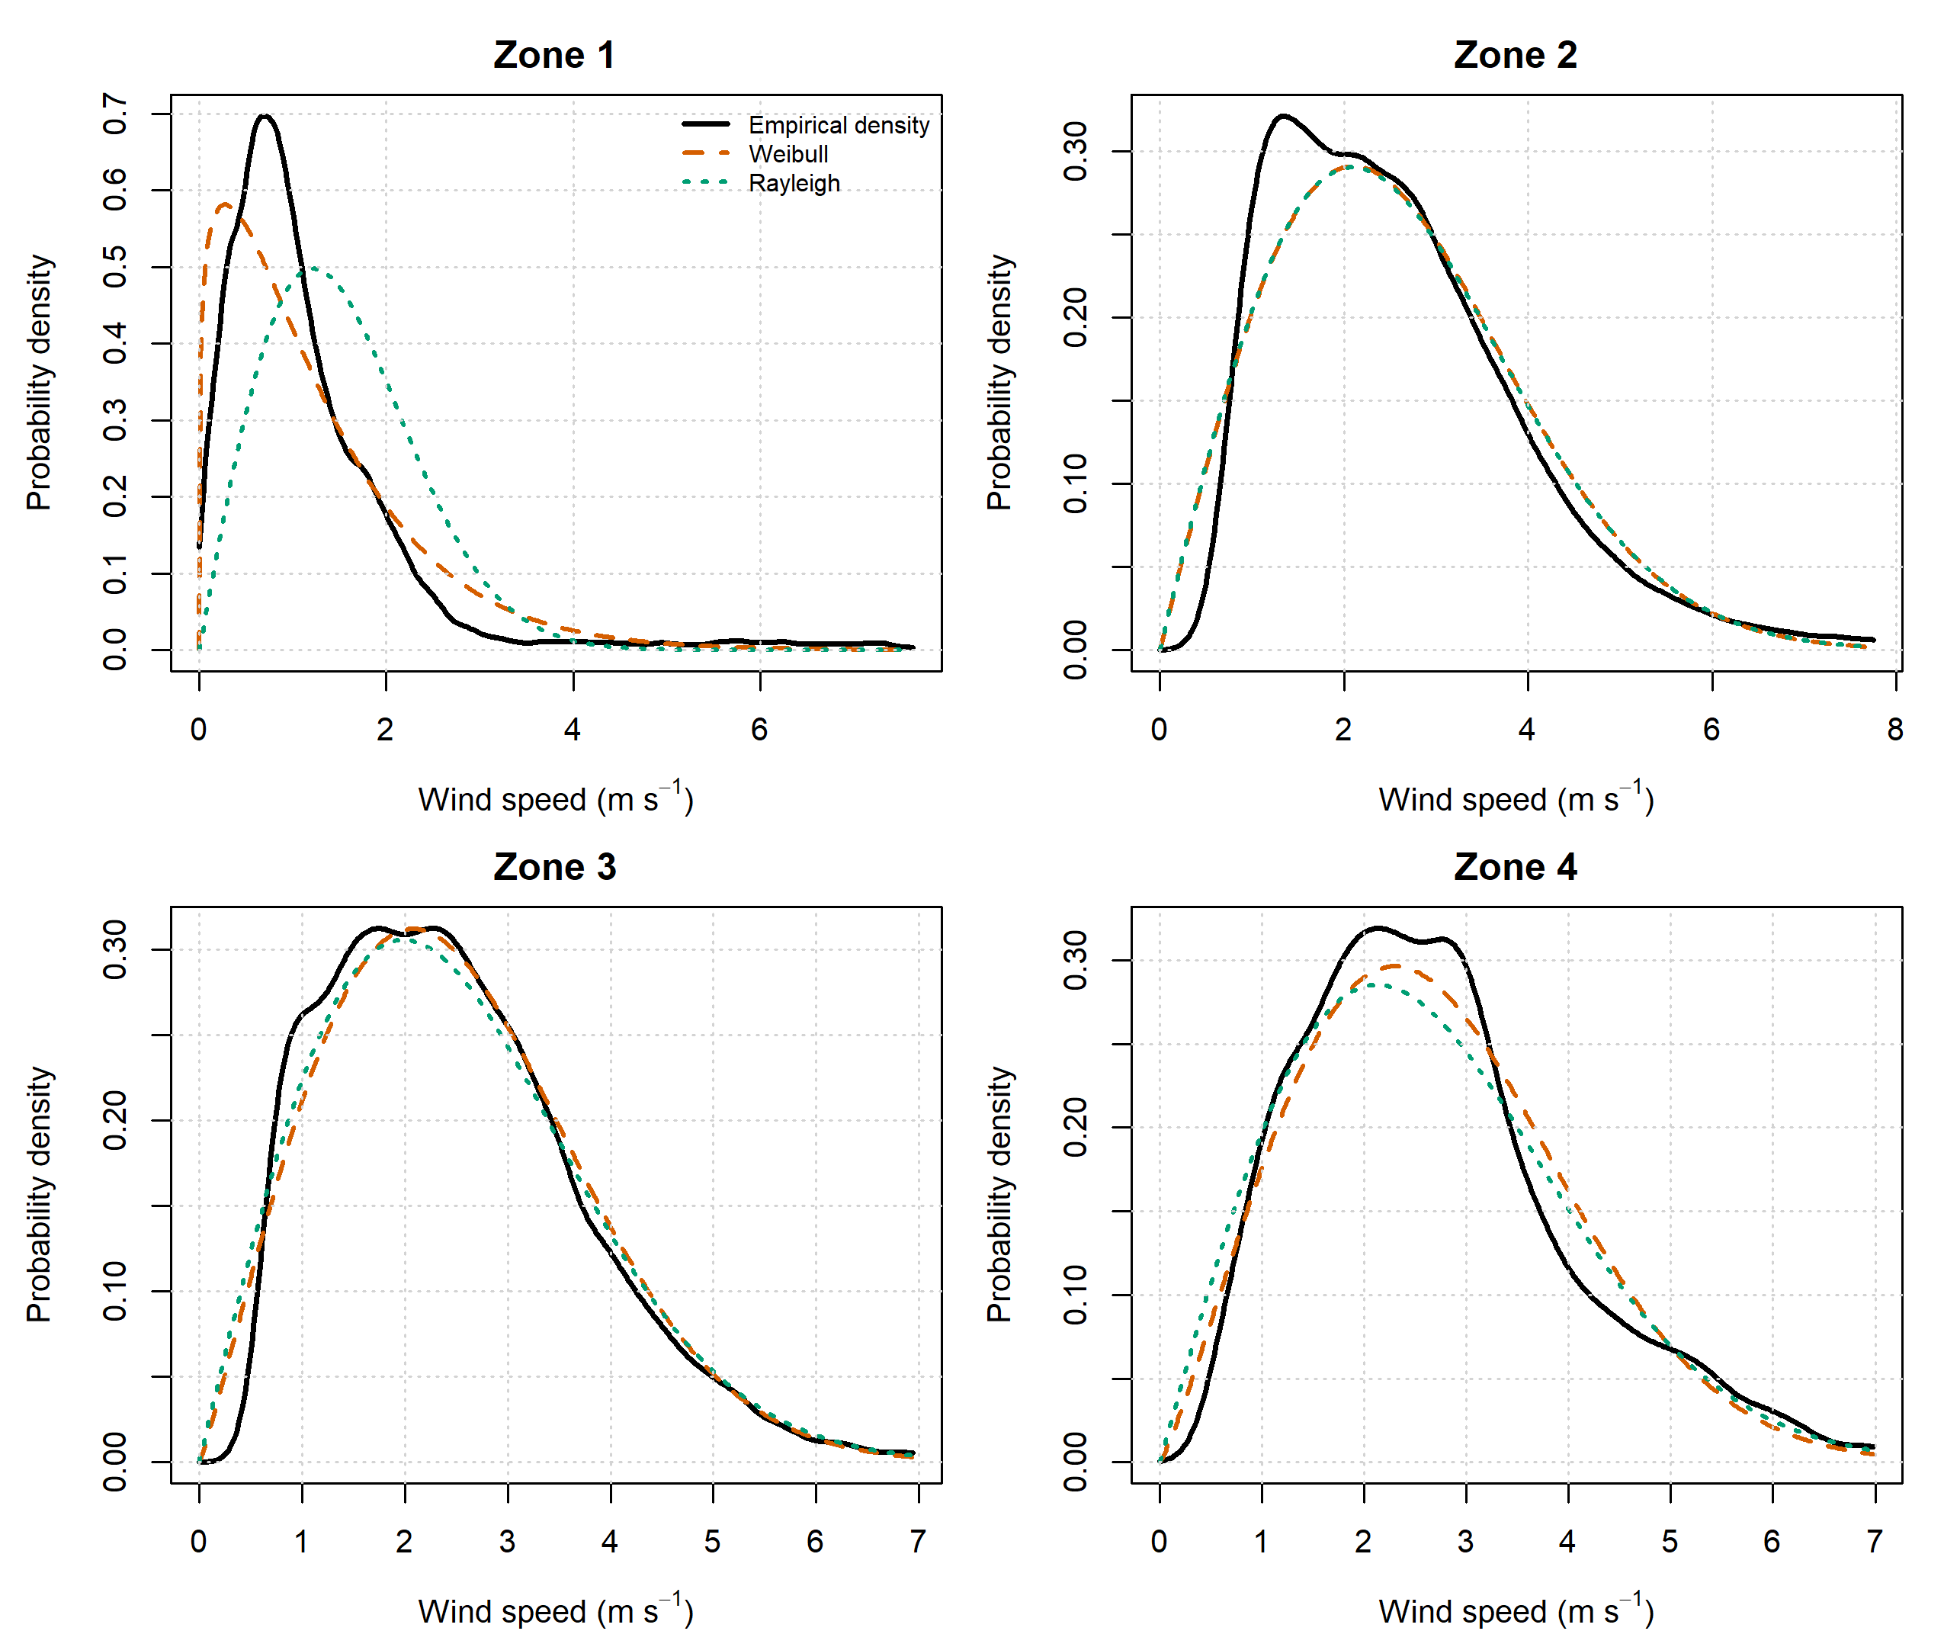
Figure S1. Empirical wind-speed density with fitted Weibull and Rayleigh models by analytical unit. Solid black lines show empirical densities, dashed orange lines show Weibull fits, and dotted green lines show Rayleigh fits. The figure distinguishes relative model preference from absolute fit adequacy, particularly in Zone 1, where Weibull improves substantially on Rayleigh but does not reproduce the empirical density perfectly near the lowest wind-speed states.

Supplementary Table S1
Table S1. Dunn pairwise comparisons with Holm adjustment following the Kruskal–Wallis tests. Daily-scale comparisons provide the conservative pairwise interpretation used in the main manuscript; zone-hour results are included for completeness.
Scale | Variable | Group 1 | Group 2 | n1 | n2 | Mean rank 1 | Mean rank 2 | z | p raw | p Holm | Sig.
Zone-hour | VV | Zone 1 | Zone 2 | 43,033 | 43,618 | 36742.2 | 84105.2 | -175.223 | <0.001 | <0.001 | Yes
Zone-hour | VV | Zone 1 | Zone 3 | 43,033 | 42,416 | 36742.2 | 82135.4 | -166.766 | <0.001 | <0.001 | Yes
Zone-hour | VV | Zone 1 | Zone 4 | 43,033 | 8,744 | 36742.2 | 87205.1 | -108.135 | <0.001 | <0.001 | Yes
Zone-hour | VV | Zone 2 | Zone 3 | 43,618 | 42,416 | 84105.2 | 82135.4 | 7.261 | 3.85e-13 | 7.69e-13 | Yes
Zone-hour | VV | Zone 2 | Zone 4 | 43,618 | 8,744 | 84105.2 | 87205.1 | -6.650 | 2.93e-11 | 2.93e-11 | Yes
Zone-hour | VV | Zone 3 | Zone 4 | 42,416 | 8,744 | 82135.4 | 87205.1 | -10.850 | 1.99e-27 | 5.96e-27 | Yes
Zone-hour | WPD | Zone 1 | Zone 2 | 43,033 | 43,618 | 39826.4 | 80221.4 | -149.444 | <0.001 | <0.001 | Yes
Zone-hour | WPD | Zone 1 | Zone 3 | 43,033 | 42,416 | 39826.4 | 83932.6 | -162.038 | <0.001 | <0.001 | Yes
Zone-hour | WPD | Zone 1 | Zone 4 | 43,033 | 8,744 | 39826.4 | 82682.4 | -91.834 | <0.001 | <0.001 | Yes
Zone-hour | WPD | Zone 2 | Zone 3 | 43,618 | 42,416 | 80221.4 | 83932.6 | -13.680 | 1.34e-42 | 4.02e-42 | Yes
Zone-hour | WPD | Zone 2 | Zone 4 | 43,618 | 8,744 | 80221.4 | 82682.4 | -5.280 | 1.30e-07 | 2.59e-07 | Yes
Zone-hour | WPD | Zone 3 | Zone 4 | 42,416 | 8,744 | 83932.6 | 82682.4 | 2.676 | 0.007 | 0.007 | Yes
Daily-zone mean | VV | Zone 1 | Zone 2 | 1,881 | 1,895 | 1364.1 | 3715.7 | -42.068 | <0.001 | <0.001 | Yes
Daily-zone mean | VV | Zone 1 | Zone 3 | 1,881 | 1,795 | 1364.1 | 3653.7 | -40.402 | <0.001 | <0.001 | Yes
Daily-zone mean | VV | Zone 1 | Zone 4 | 1,881 | 378 | 1364.1 | 4054.8 | -27.794 | 5.13e-170 | 2.05e-169 | Yes
Daily-zone mean | VV | Zone 2 | Zone 3 | 1,895 | 1,795 | 3715.7 | 3653.7 | 1.096 | 0.273 | 0.273 | No
Daily-zone mean | VV | Zone 2 | Zone 4 | 1,895 | 378 | 3715.7 | 4054.8 | -3.505 | 4.57e-04 | 9.14e-04 | Yes
Daily-zone mean | VV | Zone 3 | Zone 4 | 1,795 | 378 | 3653.7 | 4054.8 | -4.127 | 3.68e-05 | 1.10e-04 | Yes
Daily-zone mean | WPD | Zone 1 | Zone 2 | 1,881 | 1,895 | 1826.2 | 3342.4 | -27.124 | 5.11e-162 | 2.56e-161 | Yes
Daily-zone mean | WPD | Zone 1 | Zone 3 | 1,881 | 1,795 | 1826.2 | 3641.7 | -32.037 | 3.31e-225 | 1.99e-224 | Yes
Daily-zone mean | WPD | Zone 1 | Zone 4 | 1,881 | 378 | 1826.2 | 3683.7 | -19.187 | 4.71e-82 | 1.89e-81 | Yes
Daily-zone mean | WPD | Zone 2 | Zone 3 | 1,895 | 1,795 | 3342.4 | 3641.7 | -5.291 | 1.21e-07 | 3.64e-07 | Yes
Daily-zone mean | WPD | Zone 2 | Zone 4 | 1,895 | 378 | 3342.4 | 3683.7 | -3.527 | 4.20e-04 | 8.40e-04 | Yes
Daily-zone mean | WPD | Zone 3 | Zone 4 | 1,795 | 378 | 3641.7 | 3683.7 | -0.432 | 0.666 | 0.666 | No

Supplementary Table S2
Table S2. Station contribution to long-term zonal mean WPD and leave-one-station-out sensitivity. Paired-support changes compare the baseline and station-removed estimates over identical eligible zone-hours; co-observed changes restrict support to hours shared by the removed and remaining stations.
Zone | IDEAM station | Contribution to zonal mean WPD (%) | Paired-support Δ mean WPD (%) | Co-observed Δ mean WPD (%)
Zone 1 | 51025060 | 94.08 | -93.18 | -97.46
Zone 1 | 51025080 | 3.75 | 42.71 | 46.08
Zone 1 | 51035020 | 1.48 | 21.83 | 38.73
Zone 1 | 51025090 | 0.56 | 24.67 | 46.91
Zone 1 | 5102500128 | 0.13 | 3.75 | 28.45
Zone 2 | 52055160 | 62.51 | -60.85 | -91.14
Zone 2 | 52055220 | 16.55 | 21.58 | 22.95
Zone 2 | 52055170 | 11.78 | 20.14 | 24.96
Zone 2 | 52055230 | 9.16 | 20.35 | 30.49
Zone 3 | 52055150 | 78.24 | -74.57 | -86.28
Zone 3 | 5205500123 | 9.69 | -3.38 | -15.83
Zone 3 | 47015100 | 5.74 | 3.63 | 14.89
Zone 3 | 52055210 | 4.23 | 47.10 | 52.65
Zone 3 | 52045080 | 2.11 | 27.04 | 41.67
Zone 4 | 52040050 | 79.31 | 35.56 | 36.78
Zone 4 | 52035040 | 20.69 | -10.70 | -36.78

Supplementary Table S3
Table S3. Run-stratified circular moving-block bootstrap sensitivity for 7-, 30-, and 90-day requested block lengths. The primary configurations used in the manuscript were 90 days for Zones 1–2, 30 days for Zone 3, and 7 days for Zone 4.
Zone | Block (d) | Parameter | Estimate | B | Boot. mean | Bias | SE | |bias|/SE | Percentile 95% CI | Basic 95% CI | Use
Zone 1 | 7 | Mean WPD | 31.959 | 1000 | 31.905 | -0.054 | 3.123 | 0.017 | 25.971–38.012 | 25.906–37.947
Zone 1 | 30 | Mean WPD | 31.959 | 1000 | 31.922 | -0.037 | 5.959 | 0.006 | 20.407–43.709 | 20.210–43.511
Zone 1 | 90 | Mean WPD | 31.959 | 1000 | 32.018 | 0.058 | 8.941 | 0.007 | 14.921–49.427 | 14.491–48.997 | Primary
Zone 1 | 7 | Weibull k | 1.190 | 1000 | 1.191 | 0.001 | 0.022 | 0.057 | 1.152–1.235 | 1.145–1.228
Zone 1 | 30 | Weibull k | 1.190 | 1000 | 1.195 | 0.005 | 0.038 | 0.123 | 1.128–1.281 | 1.099–1.252
Zone 1 | 90 | Weibull k | 1.190 | 1000 | 1.198 | 0.008 | 0.056 | 0.151 | 1.112–1.326 | 1.054–1.268 | Primary
Zone 2 | 7 | Mean WPD | 30.440 | 1000 | 30.397 | -0.043 | 4.032 | 0.011 | 23.315–38.838 | 22.041–37.564
Zone 2 | 30 | Mean WPD | 30.440 | 1000 | 30.504 | 0.064 | 6.843 | 0.009 | 19.023–45.170 | 15.710–41.856
Zone 2 | 90 | Mean WPD | 30.440 | 1000 | 29.733 | -0.707 | 8.142 | 0.087 | 17.281–48.211 | 12.669–43.598 | Primary
Zone 2 | 7 | Weibull k | 2.010 | 1000 | 2.017 | 0.007 | 0.052 | 0.135 | 1.917–2.118 | 1.903–2.103
Zone 2 | 30 | Weibull k | 2.010 | 1000 | 2.024 | 0.014 | 0.083 | 0.164 | 1.874–2.185 | 1.835–2.146
Zone 2 | 90 | Weibull k | 2.010 | 1000 | 2.040 | 0.030 | 0.105 | 0.284 | 1.866–2.243 | 1.778–2.154 | Primary
Zone 3 | 7 | Mean WPD | 26.298 | 1000 | 26.339 | 0.041 | 1.790 | 0.023 | 23.265–30.133 | 22.463–29.330
Zone 3 | 30 | Mean WPD | 26.298 | 1000 | 26.318 | 0.020 | 2.436 | 0.008 | 21.833–31.184 | 21.411–30.763 | Primary
Zone 3 | 90 | Mean WPD | 26.298 | 1000 | 26.453 | 0.155 | 2.919 | 0.053 | 21.072–32.230 | 20.366–31.523
Zone 3 | 7 | Weibull k | 2.092 | 1000 | 2.095 | 0.003 | 0.039 | 0.079 | 2.016–2.169 | 2.015–2.169
Zone 3 | 30 | Weibull k | 2.092 | 1000 | 2.096 | 0.004 | 0.052 | 0.067 | 1.997–2.202 | 1.983–2.188 | Primary
Zone 3 | 90 | Weibull k | 2.092 | 1000 | 2.100 | 0.007 | 0.062 | 0.118 | 1.991–2.223 | 1.962–2.193
Zone 4 | 7 | Mean WPD | 18.683 | 1000 | 18.725 | 0.042 | 1.064 | 0.039 | 16.712–20.881 | 16.485–20.654 | Primary
Zone 4 | 30 | Mean WPD | 18.683 | 1000 | 18.581 | -0.102 | 1.367 | 0.075 | 15.981–21.310 | 16.056–21.385
Zone 4 | 90 | Mean WPD | 18.683 | 1000 | 18.650 | -0.033 | 0.552 | 0.059 | 17.554–19.732 | 17.634–19.811
Zone 4 | 7 | Weibull k | 2.166 | 1000 | 2.168 | 0.003 | 0.048 | 0.056 | 2.077–2.269 | 2.063–2.254 | Primary
Zone 4 | 30 | Weibull k | 2.166 | 1000 | 2.171 | 0.006 | 0.047 | 0.118 | 2.079–2.262 | 2.070–2.253
Zone 4 | 90 | Weibull k | 2.166 | 1000 | 2.167 | 0.001 | 0.023 | 0.044 | 2.123–2.212 | 2.119–2.208

Supplementary Table S4
Table S4. Full one-sided FFT band-energy decomposition for wind speed (VV) and wind power density (WPD) on the longest continuous daily segment available after interpolation of internal gaps of seven days or less. Energy fractions are descriptive and are not interpreted as deterministic cycles.
Zone | Variable | Segment (d) | Period band | Frequency bins | Band power | Energy fraction (%)
Zone 1 | VV | 1531 | 2-10 d | 612 | 88129.598 | 12.46
Zone 1 | VV | 1531 | 10-30 d | 102 | 40902.762 | 5.78
Zone 1 | VV | 1531 | 30-120 d | 39 | 69017.282 | 9.76
Zone 1 | VV | 1531 | 120-365 d | 8 | 14702.934 | 2.08
Zone 1 | VV | 1531 | >365 d | 4 | 494721.159 | 69.93
Zone 1 | WPD | 1531 | 2-10 d | 612 | 1923938736.839 | 19.23
Zone 1 | WPD | 1531 | 10-30 d | 102 | 688111177.999 | 6.88
Zone 1 | WPD | 1531 | 30-120 d | 39 | 1047053222.581 | 10.47
Zone 1 | WPD | 1531 | 120-365 d | 8 | 250115290.568 | 2.50
Zone 1 | WPD | 1531 | >365 d | 4 | 6093633726.182 | 60.92
Zone 2 | VV | 1291 | 2-10 d | 516 | 86853.125 | 13.95
Zone 2 | VV | 1291 | 10-30 d | 86 | 108174.654 | 17.37
Zone 2 | VV | 1291 | 30-120 d | 33 | 98266.169 | 15.78
Zone 2 | VV | 1291 | 120-365 d | 7 | 175957.144 | 28.26
Zone 2 | VV | 1291 | >365 d | 3 | 153474.723 | 24.65
Zone 2 | WPD | 1291 | 2-10 d | 516 | 378178905.239 | 11.78
Zone 2 | WPD | 1291 | 10-30 d | 86 | 308408881.867 | 9.61
Zone 2 | WPD | 1291 | 30-120 d | 33 | 615968407.873 | 19.19
Zone 2 | WPD | 1291 | 120-365 d | 7 | 1093273575.687 | 34.07
Zone 2 | WPD | 1291 | >365 d | 3 | 813334054.100 | 25.34
Zone 3 | VV | 1427 | 2-10 d | 571 | 187888.618 | 26.80
Zone 3 | VV | 1427 | 10-30 d | 95 | 147928.495 | 21.10
Zone 3 | VV | 1427 | 30-120 d | 36 | 97325.280 | 13.88
Zone 3 | VV | 1427 | 120-365 d | 8 | 209654.791 | 29.90
Zone 3 | VV | 1427 | >365 d | 3 | 58285.780 | 8.31
Zone 3 | WPD | 1427 | 2-10 d | 571 | 681691939.221 | 30.04
Zone 3 | WPD | 1427 | 10-30 d | 95 | 629110007.831 | 27.72
Zone 3 | WPD | 1427 | 30-120 d | 36 | 403637579.287 | 17.79
Zone 3 | WPD | 1427 | 120-365 d | 8 | 467608988.197 | 20.61
Zone 3 | WPD | 1427 | >365 d | 3 | 87150005.830 | 3.84
Zone 4 | VV | 246 | 2-10 d | 99 | 7409.023 | 46.73
Zone 4 | VV | 246 | 10-30 d | 16 | 2499.098 | 15.76
Zone 4 | VV | 246 | 30-120 d | 6 | 3353.043 | 21.15
Zone 4 | VV | 246 | 120-365 d | 2 | 2593.024 | 16.36
Zone 4 | VV | 246 | >365 d | 0 | 0.000 | 0.00
Zone 4 | WPD | 246 | 2-10 d | 99 | 3294508.498 | 52.25
Zone 4 | WPD | 246 | 10-30 d | 16 | 1091927.366 | 17.32
Zone 4 | WPD | 246 | 30-120 d | 6 | 1196277.273 | 18.97
Zone 4 | WPD | 246 | 120-365 d | 2 | 722578.769 | 11.46
Zone 4 | WPD | 246 | >365 d | 0 | 0.000 | 0.00
Reproducibility note. The complete supplementary tables are generated from R1_V2_SUPPLEMENTARY_TABLES.xlsx in the revision workspace. Raw IDEAM meteorological observations are not redistributed.

