Supplementary Material
Physical–statistical characterization of wind power density in complex Andean terrain: A multi-station study in Nariño, Colombia
F.N. Rosero-Rodríguez et al.
This file contains supplementary figures supporting the quality-control, distributional, temporal-dependence and spectral analyses reported in the main manuscript.

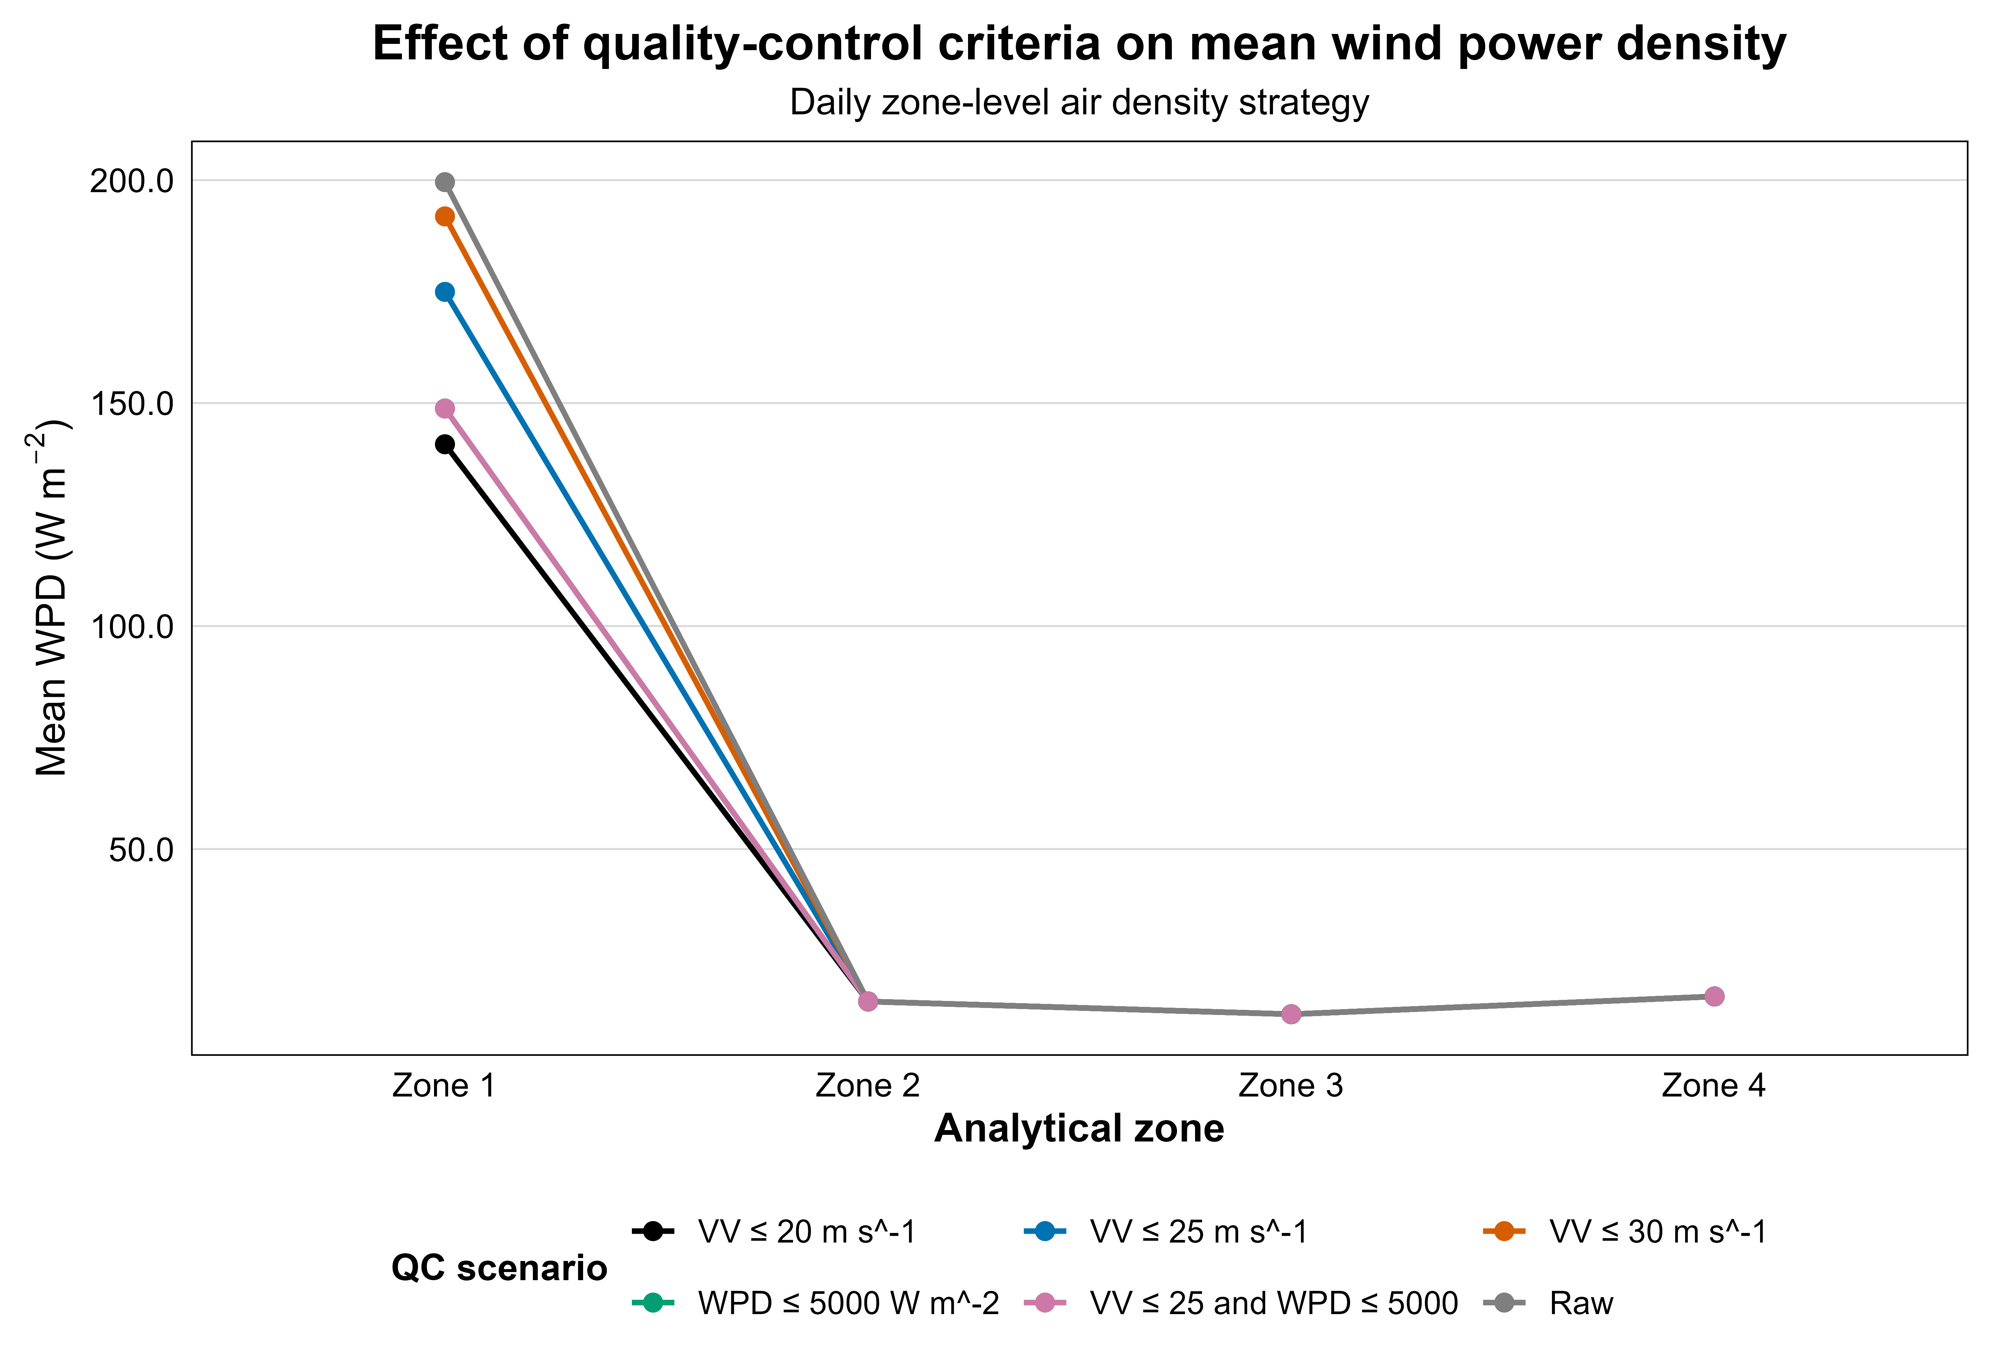
Fig. S1. Quality-control sensitivity of mean wind power density (WPD) by analytical zone. The figure summarizes the effect of the selected wind-speed quality-control threshold on zone-level mean WPD and supports the use of the conservative article-level criterion.

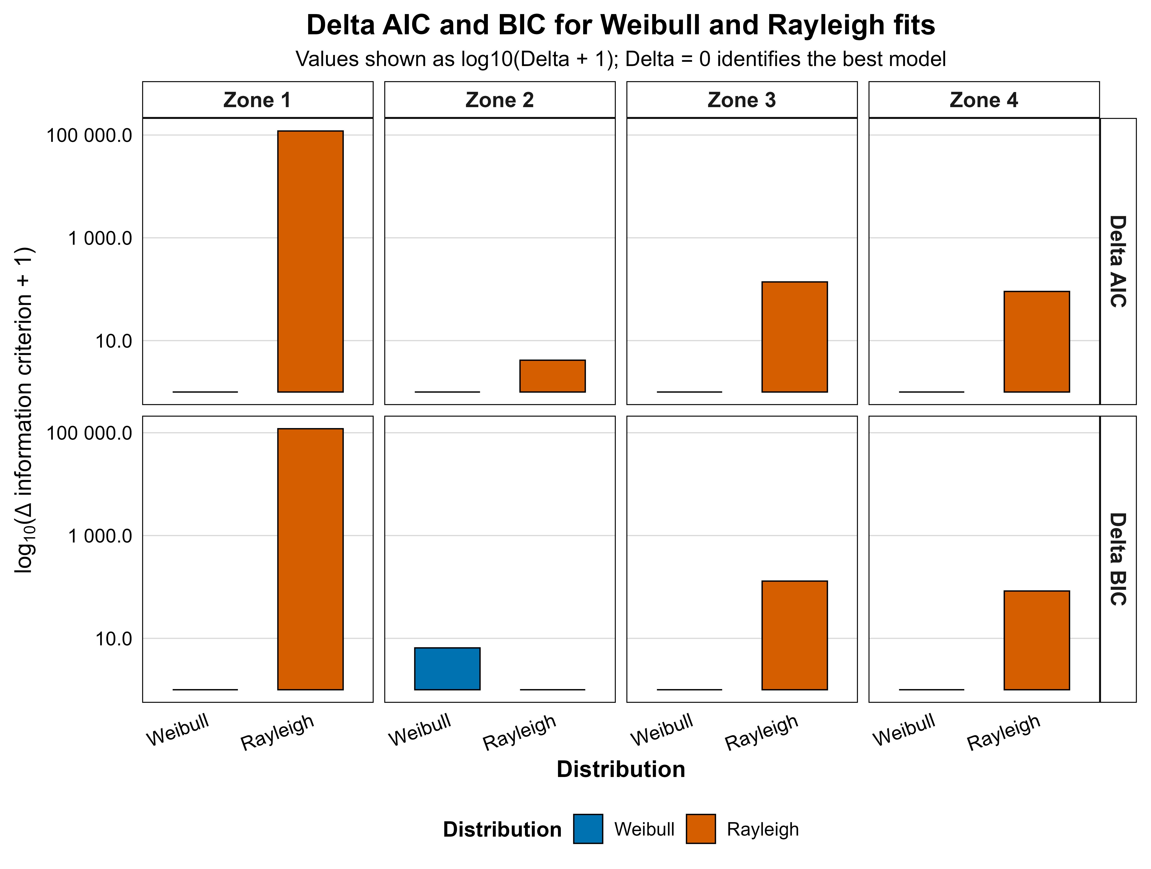
Fig. S2. Delta AIC and BIC comparison between Weibull and Rayleigh distribution models by analytical zone. Lower information-criterion values indicate better relative model performance.

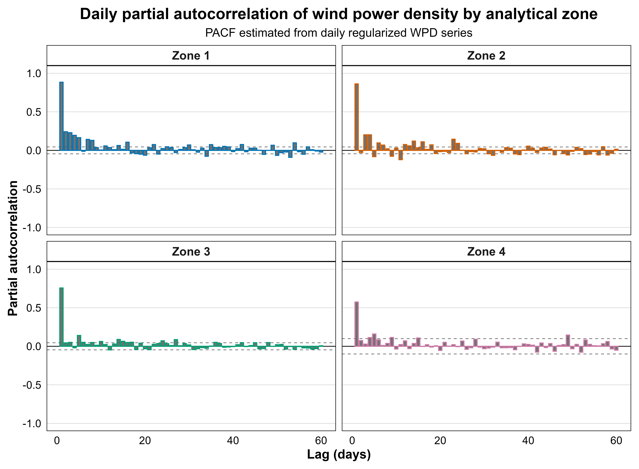
Fig. S3. Daily partial autocorrelation function of wind power density by analytical zone. PACF was used as a supplementary diagnostic of direct short-lag dependence in the daily WPD signal.

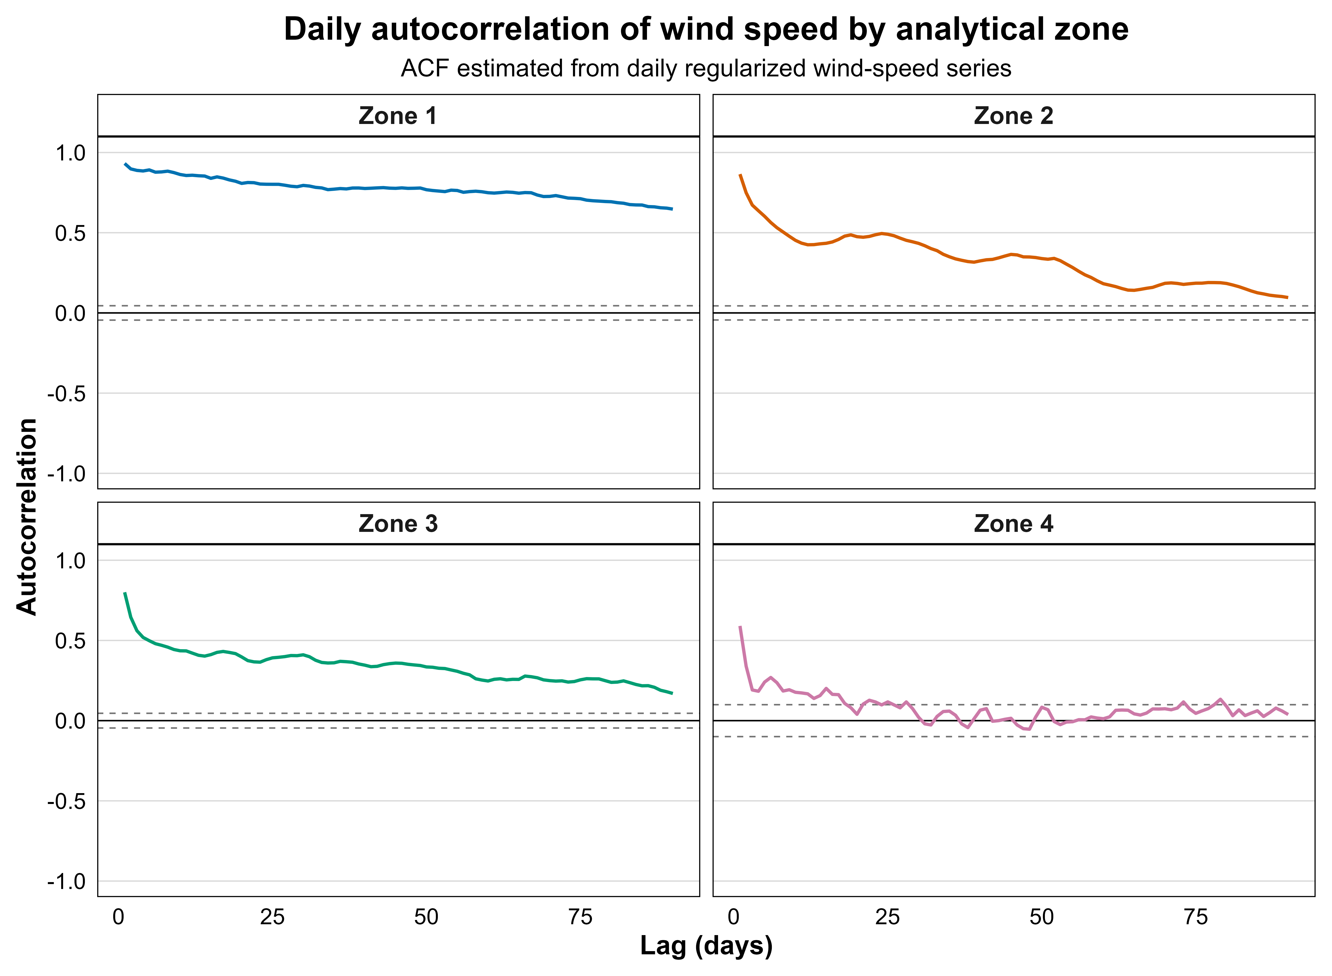
Fig. S4. Daily autocorrelation function of wind speed by analytical zone. The figure provides a supplementary comparison between the kinematic wind-speed state and the energetic WPD state.

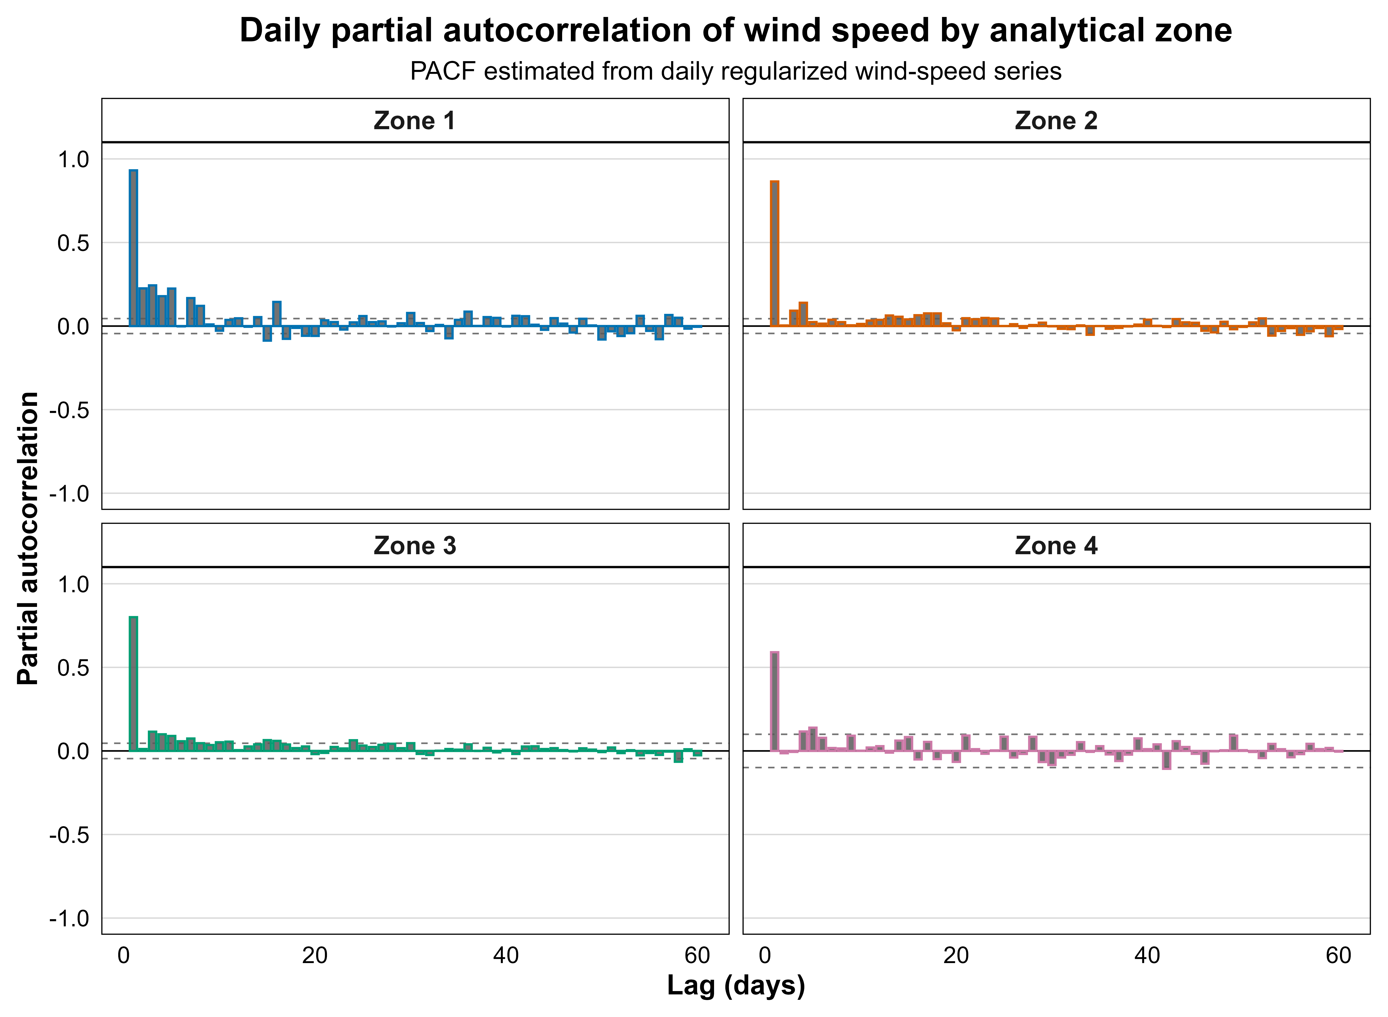
Fig. S5. Daily partial autocorrelation function of wind speed by analytical zone. PACF was used as a supplementary diagnostic of direct short-lag dependence in the wind-speed signal.

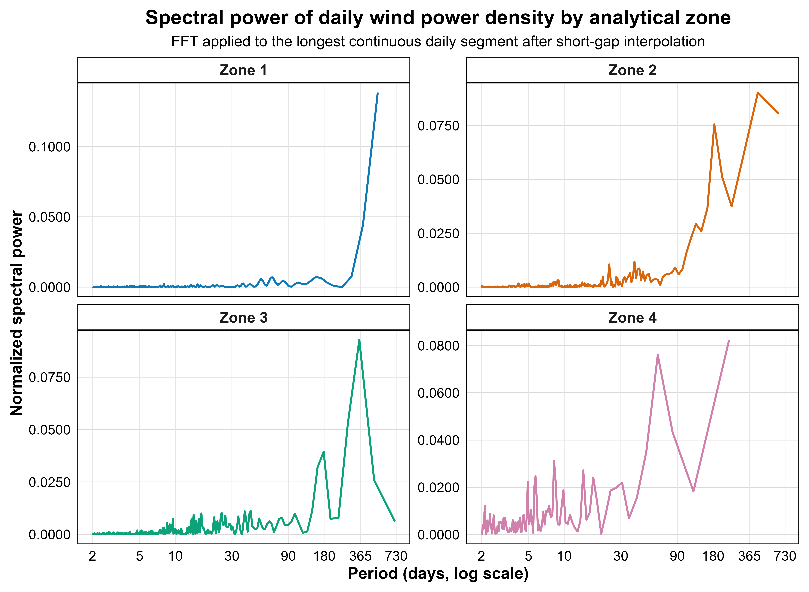
Fig. S6. FFT spectrum of daily wind power density by analytical zone. The figure shows the frequency-domain structure underlying the WPD spectral-band summary reported in the main manuscript.

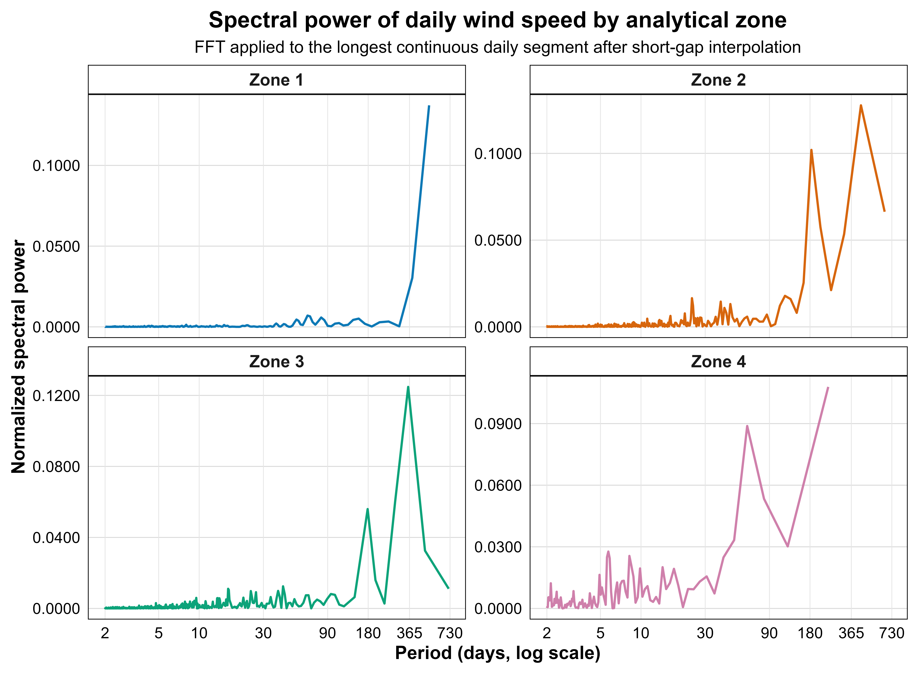
Fig. S7. FFT spectrum of daily wind speed by analytical zone. The figure provides the supplementary frequency-domain characterization of the kinematic wind-speed signal.

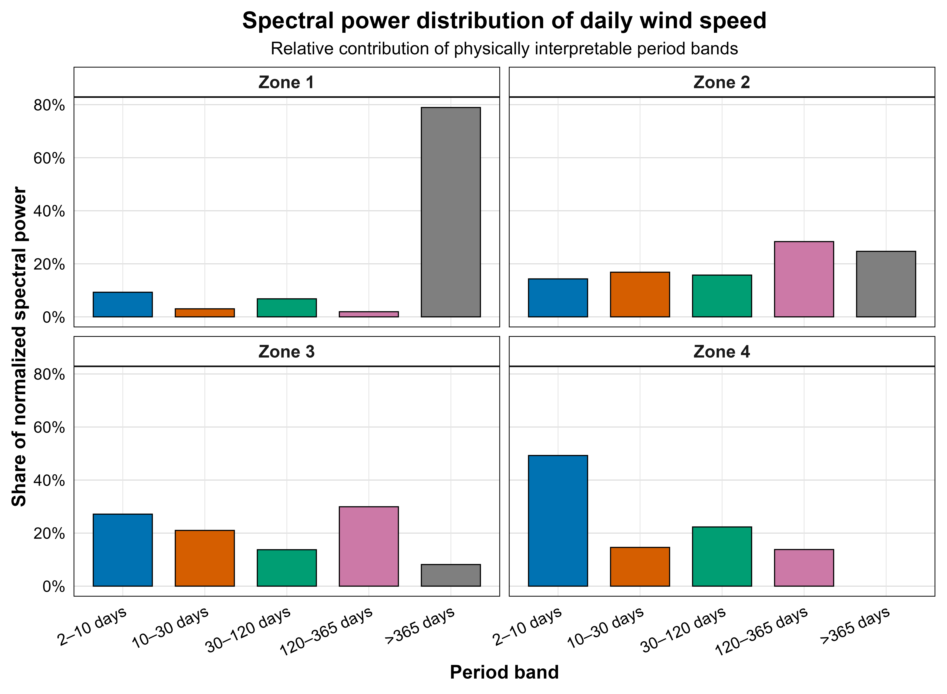
Fig. S8. FFT-based spectral-band energy of daily wind speed by analytical zone. The figure summarizes the dominant period-band contributions of the wind-speed signal for comparison with WPD spectral behavior.

