Actualización de la WEB

https://www.wgic26.barcelona/program/workshops

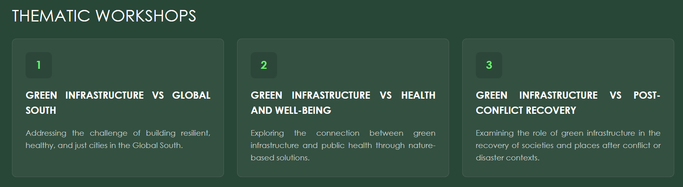

Se deberia poner en cada una de estas pestañas la información referente a cada taller, que viene a continuación

WORSHOP. FEATURED TOPIC
“GLOBAL SOUTH”

Title
“Global Minds. Global South Research Partnerships on Green Infrastructure”

Leadership
Bert Belmans – University of Antwerp


Working group
Francesca Mosca (University of Genoa, Italy)
Elaise Gabriel (Federal University of Santa Maria, Brazil)
Rutineia Tassi (Federal University of Santa Maria, Brazil)
Fabiana Pimentel (Federal University of Santa Maria, Brazil)
Aline Vilela (Ares - Eficiência Energética e Sustentabilidade, Brazil)
Kamal Passi (Central Public Works Department, India)
Irfan Haider Khan (Central Public Works Department, India)
Manika Goel (School of Planning and Architecture, New Delhi and Guru Gobind Singh Indraprastha University , India)
Jack Omondi (CIDE Group & Kenyatta University, Kenya)
Andrea Castro (Nfinite, Colombia)
Luowen Lyu (University of Technology, Australia)
Anouk De Bock (University of Antwerp, Belgium)
Lotte Carron (University of Antwerp, Belgium)

Why?
The climate crisis and interconnected sustainability challenges we face today affect all nations - albeit with profoundly unequal impacts and responsibilities. Countries of the Global South often face the most severe consequences while possessing invaluable knowledge systems, innovative approaches, and context-specific solutions essential for addressing our shared planetary challenges.
This topic will be dedicated to exploring how we can shift from viewing the Global South primarily as a recipient of Northern expertise to embracing genuine partnership characterized by mutual learning, co-creation of knowledge, and equitable benefit sharing.

Main objective
To foster genuinely equitable collaboration between Global North and Global South researchers, practitioners and emerging professionals in the field of green infrastructure and nature-based solutions, moving beyond the uncritical transfer of Northern frameworks to embrace co-design, mutual learning and shared knowledge production.

To document and amplify innovative GI and NbS approaches developed in resource-constrained Global South contexts that are largely absent from mainstream literature.

Specific objectives
To establish an operational framework for equitable North-South GI collaboration grounded in co-design, explicit power analysis, context sensitivity, hybrid knowledge systems and mutual capacity building.

To co-produce a manifesto at WGIC26 in Barcelona advocating for structural change in how GI knowledge is produced, published and recognised globally.

Examples/study cases to illustrate the concept

Case study 1
Eye-level green pixel analysis, behavioural observation and structured perception surveys were applied across contrasting urban streets in Lucknow, India to evaluate greenery as experienced urban infrastructure rather than statistical green cover. Findings demonstrated that the quality of the green experience at street level matters more than quantitative canopy coverage alone, with shaded and visually enclosed environments showing significantly higher pedestrian activity. The framework is scalable and transferable to other rapidly urbanising cities in the global South and the Global North.
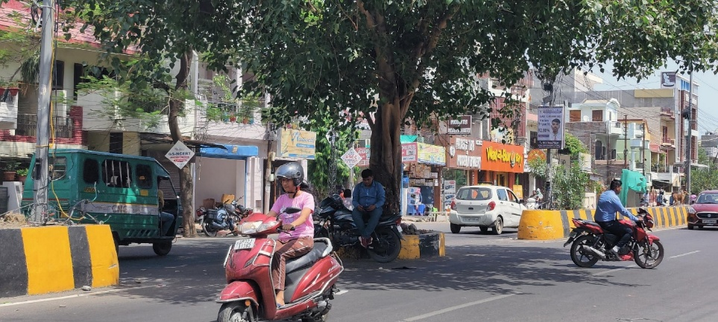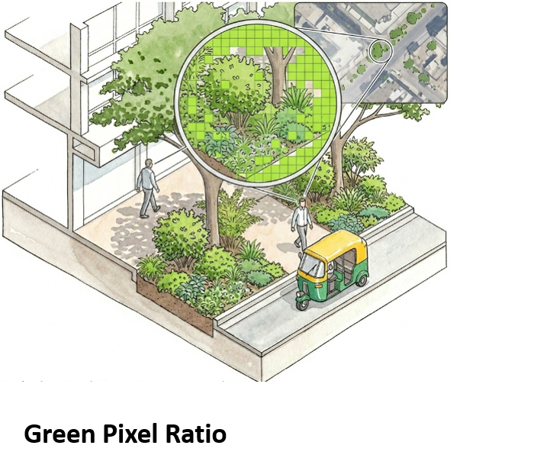
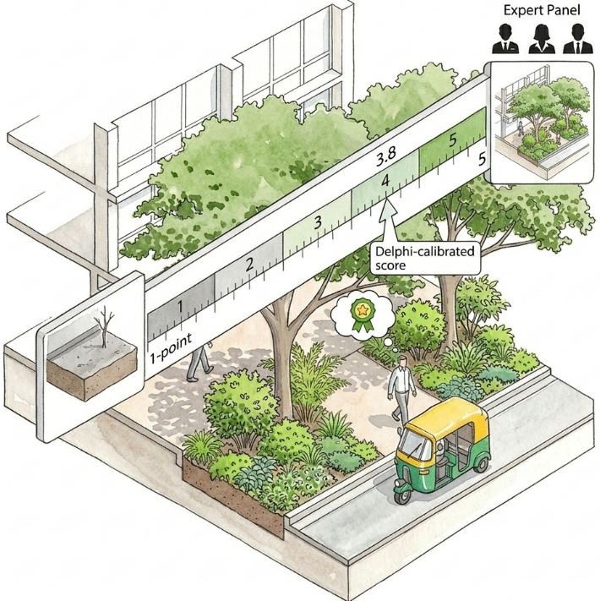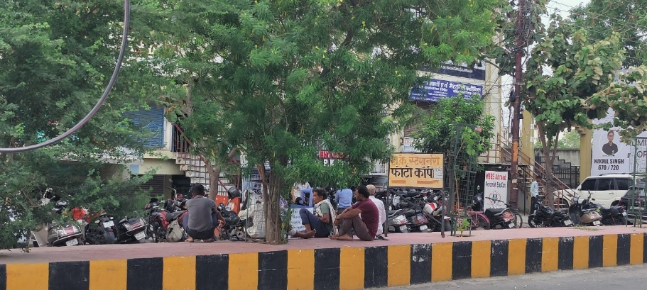
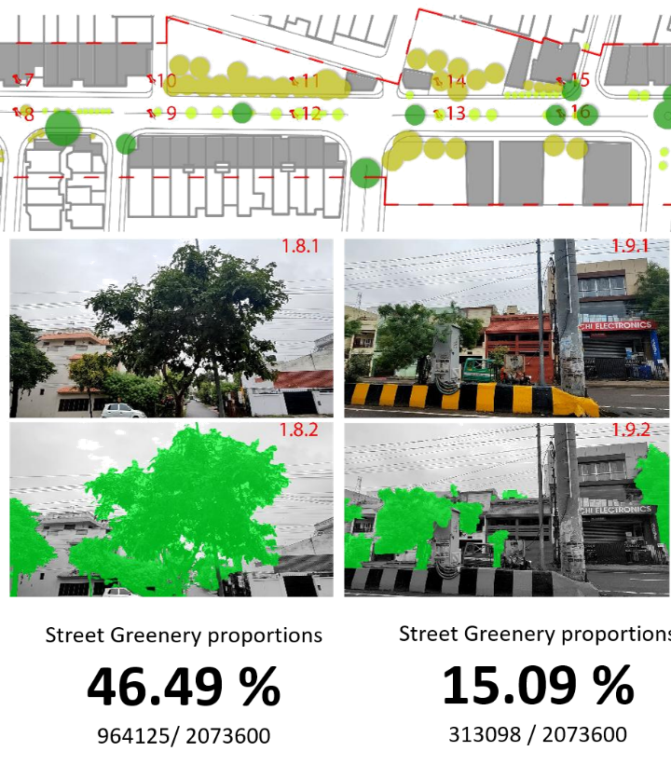

Case study 2 Community-Led NbS Regeneration (Latin America).
Projects from Medellin, São Paulo, Buenos Aires and Chile demonstrate how GI can function as a multifunctional response to overlapping urban crises under conditions of resource scarcity and socio-spatial inequality. NbS effectiveness depends as much on social appropriation, community participation and local adaptation as on technical performance. Solutions cannot be transferred as standardised models from the Global North.
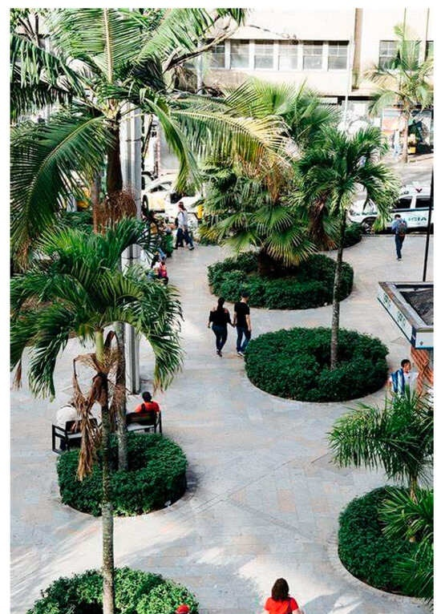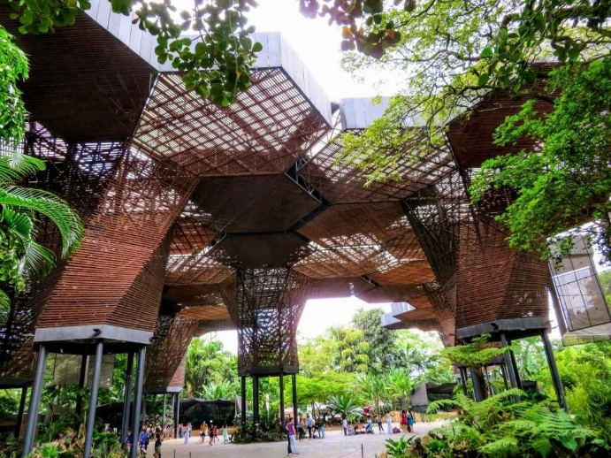
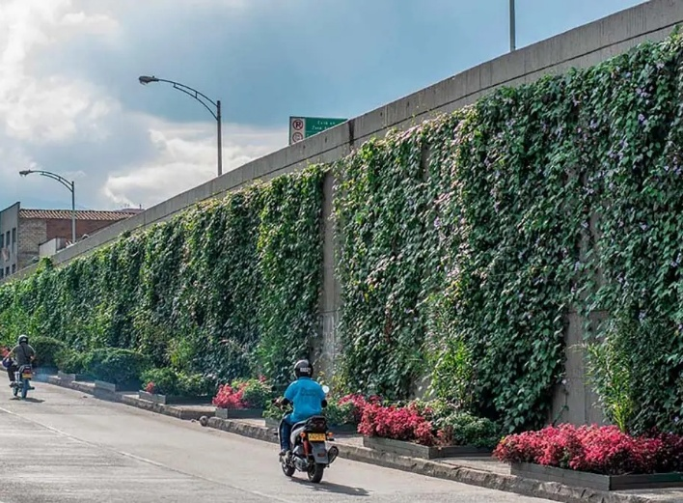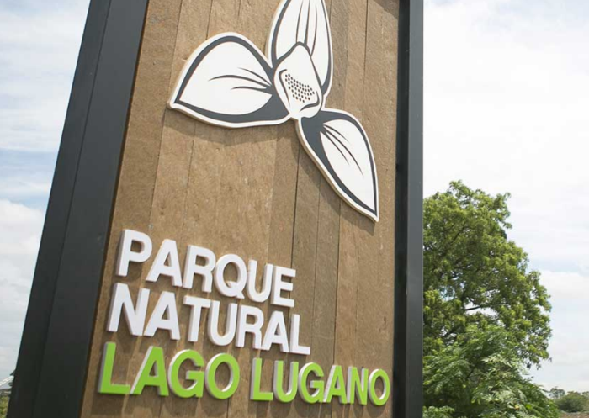
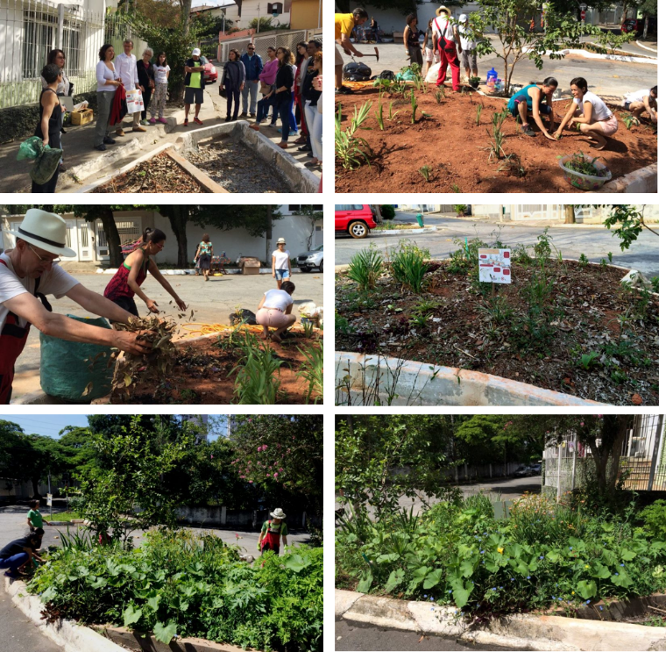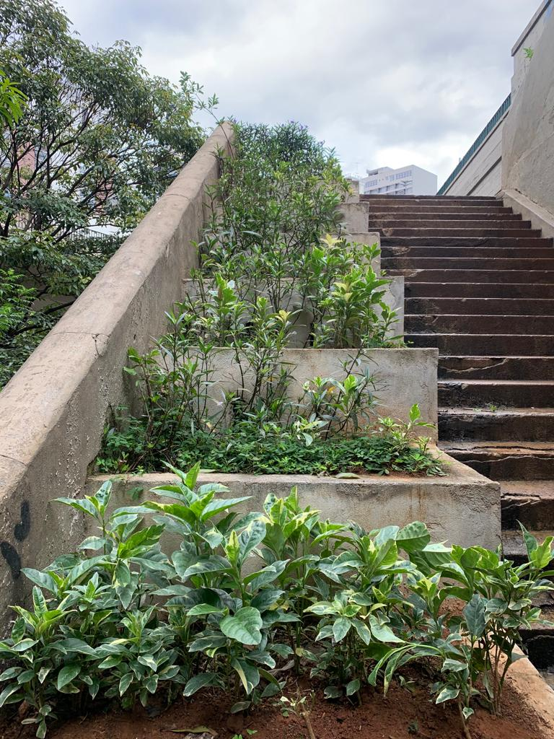
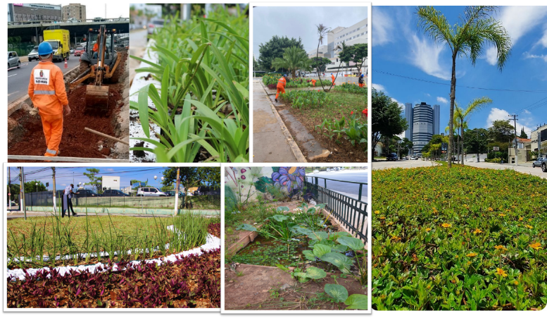

Case study 3: Vertical Greening for Informal Settlements (Kibera, Kenya).
Kibera, Nairobi’s largest informal settlement, houses up to 750,000 people across 2.5 km² under conditions of extreme resource scarcity, critically limited ground-level space, intense heat stress, perennial flooding and high poverty. Low-cost living walls and green roofs made from upcycled locally available materials were shown to deliver thermal comfort, urban farming capacity and flood resilience simultaneously, without demanding scarce ground space. The use of schools as anchor points for scaling NbS was identified as a particularly important strategy, as school buildings are recognised as shared community assets and tend to be preserved even during episodes of deliberate destruction. Kibera illustrates innovation under pressure and the urgency of cross-regional collaboration that learns from the Global South rather than imposing Northern solutions.
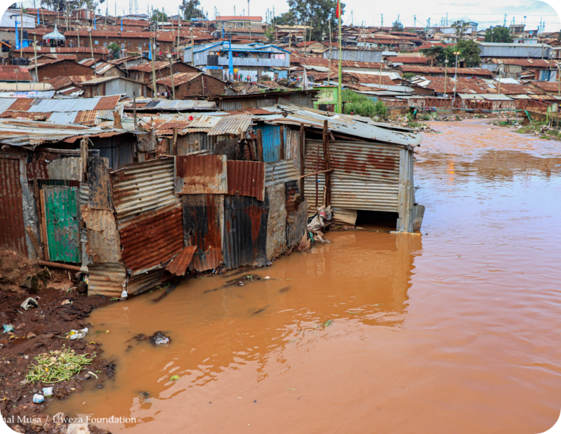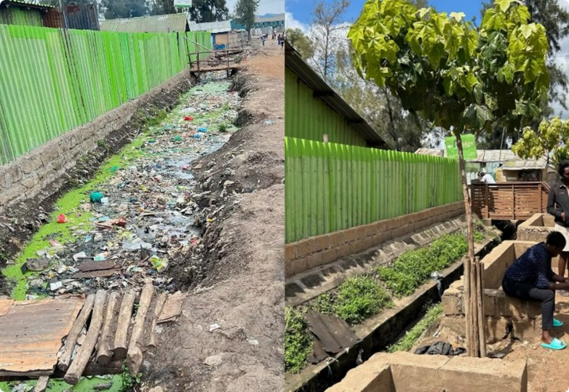
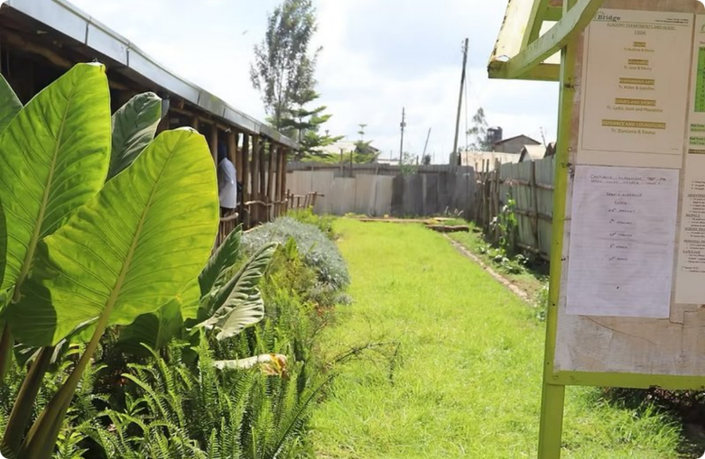
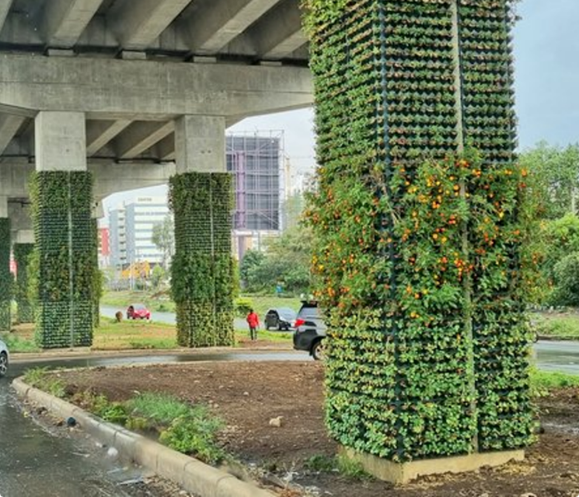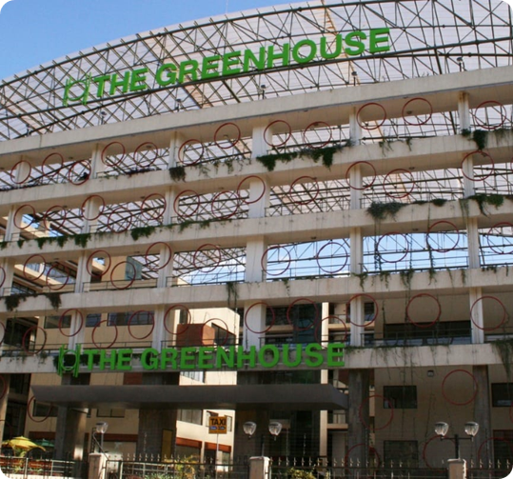

Case study 4. Teto Verde Favela
A socio-environmental initiative created in 2014, in Benfica (North Zone of Rio). The project transforms rooftops into green roofs to mitigate the urban heat island effect, improve air quality, and make the favela a more pleasant place to live.
https://wikifavelas.com.br/index.php/Teto_Verde_Favela#Contato

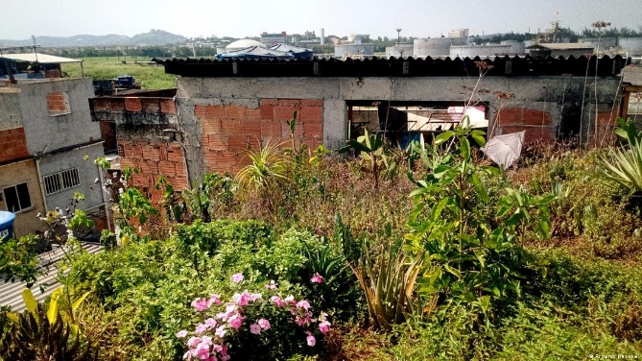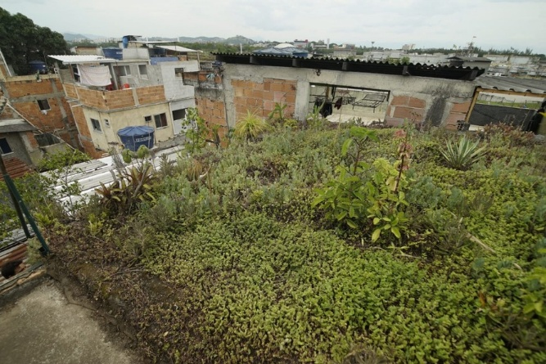
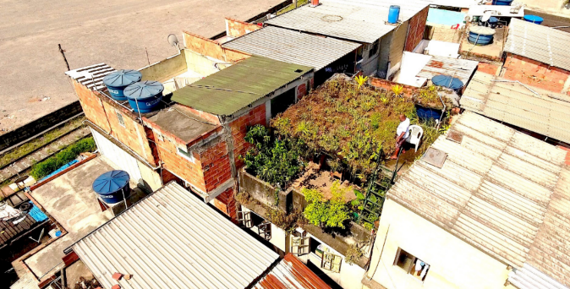

What we propose for the workshop:
- A participatory, open session co-producing the first full draft of the manifesto on equitable GI and NbS collaboration with a broad international audience.
- The session builds on the blueprint developed during the Global Minds workshop in Antwerp (May 2026) and will be structured around six thematic clusters: (1) knowledge equity and access to information; (2) funding gaps and support for early-career researchers; (3) policy engagement and making NbS visible to governments; (4) community empowerment and informal settlements; (5) education, capacity building and North-South exchange; (6) strategic North-South partnerships and active CEP hubs. The session will result in an agreed set of commitments to be published as the WGIN-CEP Global South Manifesto.
- Manifesto launch and dissemination. Following the co-production session, the manifesto will be published through WGIN-CEP channels and shared with participants, keynote speakers, and the broader GI and NbS community. The manifesto will advocate for structural change in how GI knowledge is produced, published, funded and recognised globally, with a specific focus on equity, informal settlements, and the recognition of Global South innovation.

Featured Keynote Speaker at WGIC26
The congress will feature Dorothy Asuza Aseyo (Green Belt Movement), a leading voice at the intersection of ecological restoration and social justice.
The Green Belt Movement (GBM) demonstrates how Nature-based Solutions can transform both landscapes and communities:
- Large-scale reforestation and ecosystem restoration
- Women’s empowerment through environmental action
- Development of sustainable livelihoods
- Environmental education and community mobilisation
- Climate action with both local and global impact

WORSHOP. FEATURED TOPIC
“HEALTH AND WELL-BEING”

Title
“Bridging the Gap—Health and Wellbeing as the Heart of Green Infrastructure”

Leadership
David Brasfield - World Green Infrastructure Network
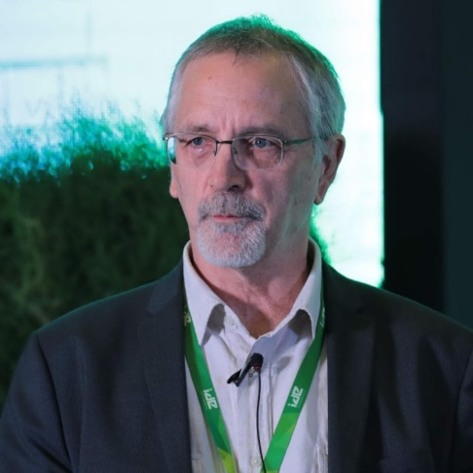

Working group
Silvia Silvia Solé Cases - University of Lleida
Laura Herrera Diez - University of Lleida
Elsa Punset - Punset Terraviva Foundation
Rocio Varela de Seijas Sapia - VASE arquitectos
Lucía Gómez Rodríguez - VASE arquitectos

Why?
Can our cities actually heal us? The World Green Infrastructure Network (WGIN) advocates for the optimal use of green infrastructure to support the health and wellbeing of both people and the planet. However, there is a recognized gap in the attention given to the specific human health benefits of urban greening. The World Green Infrastructure Congress 2026 (WGIC26) in Barcelona aims to bridge this divide between urban planning and public health. We explore how "Green Infrastructure"—from urban forests to living roofs and walls—is a prerequisite for mental and physical flourishing and the prevention of non-communicable diseases (NCDs). Nature in the city acts as the ultimate preventive medicine, lowering cortisol levels, improving air quality, supporting the human microbiome, and mitigating extreme heat to create resilient environments where people can thrive.
This thematic track will foster interdisciplinary collaboration and highlight key areas of focus:
- The Science of Connection: Examining how nature exposure reduces chronic disease and boosts mental health.
- Urban Design as Therapy: Strategies for transforming "gray" spaces into functional "healing landscapes".
- Success Stories: Showcasing global cities that are leading the way in health-centric sustainability.
A Call to Action for the Health Community through stronger interdisciplinary collaboration, we can foster greater recognition for the relevance of building-integrated green infrastructure in health research, policy, and practice.

Goals
Improve human health and well-being through optimal uptake and design of green infrastructure in urban areas
- Facilitate better collaboration between the community of practice for green infrastructure and the health sector
- Offer specific examples, concepts and design elements that can be incorporated in Health facilities and urban developments in Barcelona and BIG4LIFE participating municipalities
- Improve green infrastructure advocacy through deeper understanding of the health and well-being benefits of human contact with nature
- Identify main measurament variables in these kinds of interventions

Examples/study cases to illustrate the concept

- Terapeutic Garden in Cancer Institute of Catalonia
https://arquitopia.com/portfolio/reforma-del-patio-del-instituto-catalan-de-oncologia-ardi-platejat/
- Therapeutic garden in Hospital de Sant Pau, Barcelona
https://www.santpau.cat/en/comunic-actualitat/-/asset_publisher/0n2ILqhO4yy6/content/lhospital-de-sant-pau-estrena-jardins-terapeutics?_assetEntryId=803018
- Therapeutic Gardens, October 12th Hospital
https://vasearq.com/proyecto/jardines-terapeuticos-12-octubre/

- Fundación Juegaterapia: terapeutic gardens in the roof of the Hospital la Paz, Gregorio and 12 de Octubre in Madrid and Hospital la Fe in Valencia
https://www.juegaterapia.org/proyectos-solidarios-cancer-infantil/el-jardin-de-mi-hospi-12-de-octubre/

- Tres Roures Forest, next to Olot Hospital
https://hospiolot.com/lhospital-dolot-inaugura-el-bosc-dels-tres-roures/

- Terapeutic Garden in Hospital de Santa Creu I Sant Pau
https://fundaciosantpau.cat/es/news/lhospital-estrena-jardins-terapeutics

- Maggies Yorkshire Palliative Cancer Care Facility, Leeds UK. Heatherwick Studio
https://heatherwick.com/project/maggies/

- Rehabilitation Hospital in Basel, Switzerland. Herzog & de Meuron Architects
https://www.herzogdemeuron.com/projects/165-rehab-clinic-for-neurorehabilitation-and-paraplegiology/

WORSHOP. FEATURED TOPIC
“POST-CONFLICT AND DISASTER RECOVERY”

Title
“Green Infrastructure as Recovery Infrastructure: Community Recovery, Damage Assessment and Resilient Reconstruction”

Leadership
Oleksandra Strashok – Wroclaw University of Environmental and Life Sciences, Department of Landscape Architecture; National University of Life and Environmental Sciences of Ukraine, Department of Phytodesign and Landscape Architecture; Ukrainian Association of Green Infrastructure; World Green Infrastructure Network;


Working group
David Brasfield – Norwegian Association for Green Infrastructure; World Green Infrastructure Network.
Marta Weber – Wroclaw University of Environmental and Life Sciences, Department of Landscape Architecture; Polish Green Roofs Association; World Green Infrastructure Network.
Selim Bayraktar – İstanbul University-Cerrahpaşa, Faculty of Forestry, Department of Landscape Architecture.
Maria Gabriella Trovato – Norwegian University of Life Sciences; International Federation of Landscape Architects.
Audrey Timm – International Association of Horticultural Producers.
Zoë Avery – Associate Director of Design (Urban Planning), School of Architecture and Planning, University of Auckland; Director of The Urbanist; Chair of Design for Nature; Australasian Green Infrastructure Network; World Green Infrastructure Network.

Why?
Cities recovering from conflicts and disasters face a common challenge and opportunity: not only rebuilding what was lost, but using recovery processes to create safer, more resilient, environmentally sustainable and socially inclusive urban environments through the strategic integration of green and grey infrastructure.
Recovery programmes traditionally focus on housing, transport, energy systems and public utilities. However, parks, urban forests, street trees, private gardens, green roofs, public open spaces and other forms of GI are rarely considered essential recovery assets despite their proven contribution to public health, climate adaptation, ecosystem restoration and community well-being.
International experience demonstrates that GI can serve as more than an environmental amenity. It can function as recovery infrastructure by supporting social cohesion, facilitating community participation, improving mental health outcomes, restoring ecosystem services and reducing long-term climate vulnerability.
At the same time, significant challenges remain. Damage to GI is rarely quantified, ecosystem losses are seldom incorporated into compensation frameworks, and funding mechanisms for green recovery remain limited. Landscape architects, planners and ecologists are often underrepresented in damage assesments recovery decision-making processes.
This Featured Topic explores how GI can become a measurable, investable and implementation-ready component of post-conflict and post-disaster recovery.

Main objective
To position GI as a strategic component of urban recovery and resilience-building, capable of delivering social, environmental and economic benefits throughout post-conflict and post-disaster reconstruction processes.

Specific objectives
- Explore international experiences where GI contributed to recovery and resilience.
- Discuss how GI losses can be better recognized within recovery assessments and planning processes.
- Investigate the role of community participation in shaping recovery outcomes.
- Explore the evolving role of landscape architects in recovery governance and implementation.
- Identify barriers and opportunities for financing green recovery initiatives.
- Co-produce recommendations for integrating green infrastructure into recovery frameworks.

Examples / Study Cases to Illustrate the Concept[
Case Study 1. Community-Led Recovery and Adaptation in New Zealand
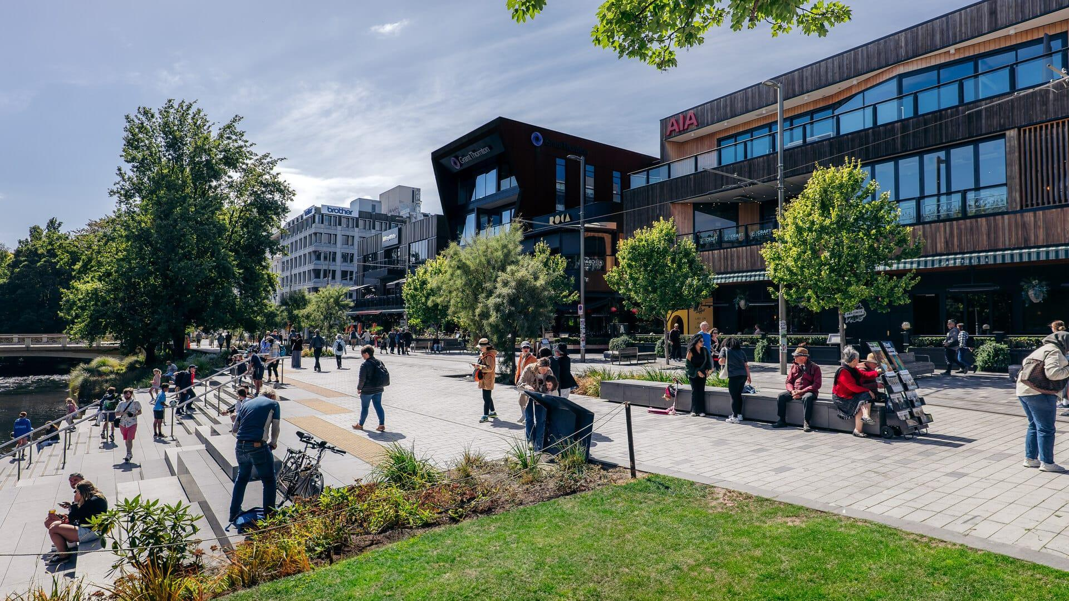
Source: https://www.gehlpeople.com/projects/christchurch-redevelopment-plan/
New Zealand provides internationally recognized examples of community-centered recovery and resilience planning. Following the Christchurch earthquakes, initiatives such as Greening the Rubble and Gap Filler transformed vacant sites into temporary public spaces that supported social recovery, community participation and place-making long before permanent reconstruction was completed.
More recently, experiences from Far North communities have demonstrated how local communities, planners and decision-makers are working together to address increasing climate risks, including managed retreat, relocation planning and nature-based adaptation strategies.
Together, these examples illustrate how community engagement can shape recovery outcomes and how green infrastructure can support both recovery and long-term resilience.

Case Study 2. Green Infrastructure Damage Assessment and Recovery Planning in Ukraine
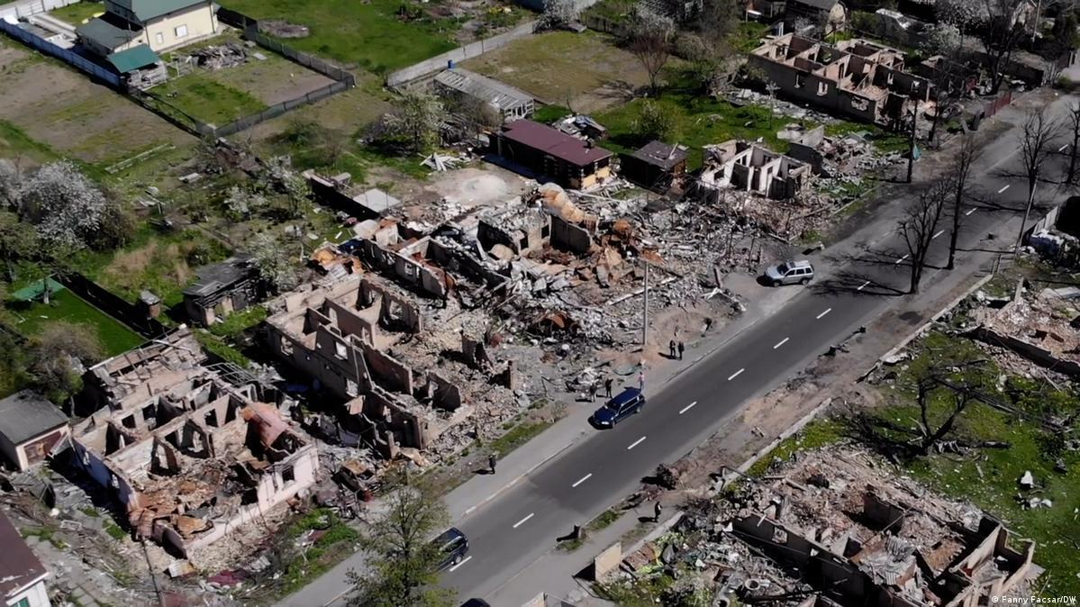
Source: https://www.gettyimages.com/editorial-images/news/event/kyiv-suburbs-begin-cleanup-and-commemorate-their-dead-after-war-shifts-away-from-capital/775803516

The recovery of Ukrainian cities presents a unique opportunity to rethink the role of GI within reconstruction frameworks. While significant progress has been made in assessing damage to buildings and technical infrastructure, methodologies for evaluating losses to urban forests, parks, street trees and ecosystem services remain limited. Emerging approaches based on remote sensing, ecosystem service valuation and spatial analysis provide opportunities for developing evidence-based methods to assess green infrastructure damage and support recovery planning.
The Ukrainian case highlights the need for practical approaches to quantify ecosystem losses, prioritise green recovery investments and integrate climate resilience into reconstruction strategies.

What we propose for the workshop
The workshop will be organised as an interactive World Café session combining short expert introductions with facilitated round-table discussions. Participants will rotate between four thematic discussion tables, each led by a member of the working group and supported by practical examples from the case studies.
The workshop aims to facilitate dialogue between researchers, policymakers, practitioners, investors and community representatives while generating practical recommendations for integrating green infrastructure into recovery processes.
Expected Outcomes
- Identification of key barriers and opportunities for integrating GI into recovery processes.
- Exchange of international experiences from New Zealand, Ukraine and other recovery contexts.
- Shared understanding of how community engagement, landscape architecture and GI contribute to resilient recovery.
- Initial recommendations for improving the recognition of GI within recovery planning, assessment and funding frameworks.
- Identification of priority areas for future research, policy development and international collaboration.
- Summary of key messages and recommendations generated through the World Café discussions.

