Entropy-Adaptive Constraint Dynamic Time Warping (EAC-DTW): An Entropy-Driven Alignment Strategy for Robust ECG Classification
Fnu Ashutosh, Shivam Jha
Faculty Advisor: Sung-Hyuk Cha
Seidenberg School of Computer Science and Information Systems, Pace University, New York, NY, USA
{an05893n, }@pace.edu

Dynamic Time Warping (DTW) is widely used for temporal alignment in physiological signal analysis, yet unconstrained DTW can suffer from pathological warping in noisy segments—aligning transient artifacts with clinically meaningful morphology (e.g., QRS complexes). Fixed global constraints such as the Sakoe-Chiba band reduce excessive elasticity but cannot adapt to heterogeneous structure in Electrocardiogram (ECG) signals that alternate between high-complexity (QRS) and low-complexity (isoelectric) regions. We present Entropy-Adaptive Constraint Dynamic Time Warping (EAC-DTW), a modified DTW formulation that computes a rolling Shannon entropy profile and maps it through a sigmoid to produce a position-dependent constraint vector. Low-entropy regions receive tight warping limits to suppress singularities; high-entropy regions allow broader alignment flexibility to preserve morphological fidelity. Using a controlled synthetic ECG-like dataset (five arrhythmia classes: Normal, LBBB, RBBB, PVC, APC) under three noise conditions (clean, 20 dB, 10 dB SNR), EAC-DTW achieves 79.3% classification accuracy at 10 dB—improving by 6.0 percentage points over a fixed 10% Sakoe-Chiba band and outperforming unconstrained DTW in noise robustness. Singularity counts (horizontal/vertical path runs) are reduced (168 vs 286 for standard DTW), indicating mitigation of pathological warping. These results, while promising, are preliminary: clinical validation on the MIT-BIH Arrhythmia Database is planned to assess generalizability. The contribution is incremental—adapting classical band constraints via entropy rather than proposing a differentiable relaxation (e.g., Soft-DTW). Future work includes parameter sensitivity optimization (k, window bounds), real-data benchmarking, multilead extensions, and potential integration with learned feature representations.

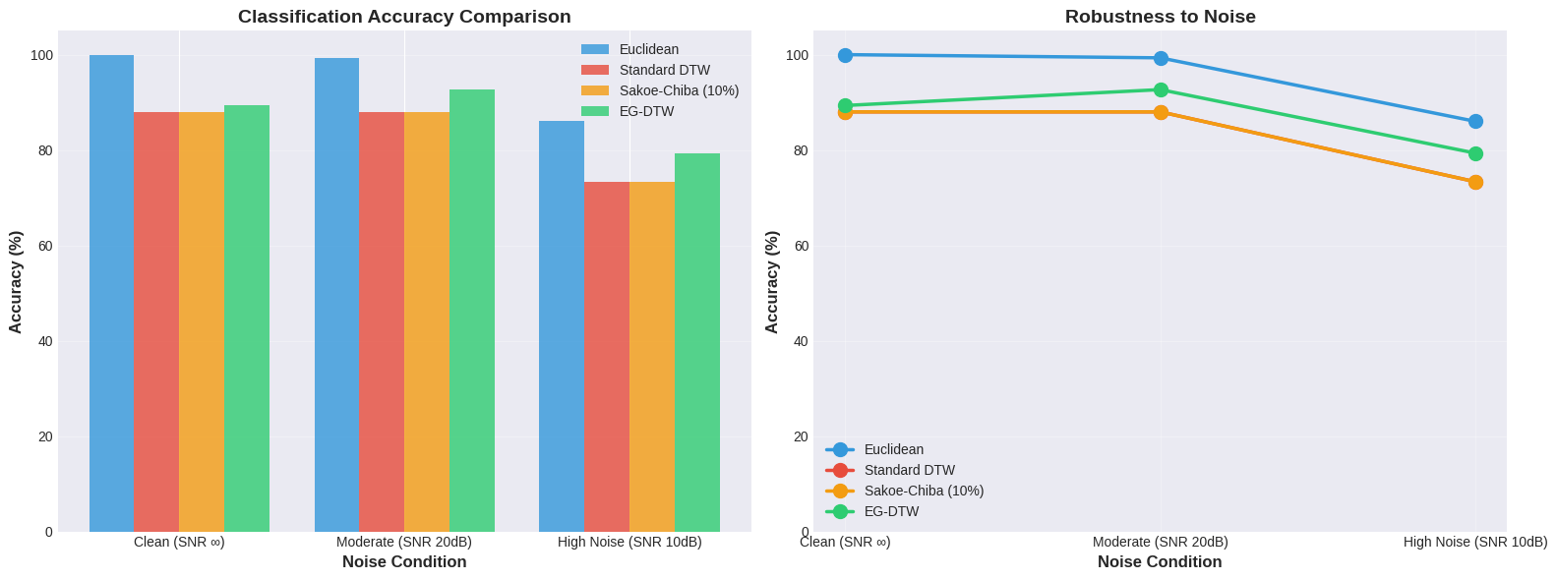
References
[1] H. Sakoe and S. Chiba, "Dynamic programming algorithm optimization for spoken word recognition," IEEE Transactions on Acoustics, Speech, and Signal Processing, vol. 26, no. 1, pp. 43-49, 1978.
[2] M. Müller, Information Retrieval for Music and Motion, Springer, New York, 2007.
[3] C. A. Ratanamahatana and E. Keogh, "Everything you know about Dynamic Time Warping is wrong," in Third Workshop on Mining Temporal and Sequential Data, pp. 22-25, 2004.
[4] M. Cuturi and M. Blondel, "Soft-DTW: a differentiable loss function for time-series," in International Conference on Machine Learning, pp. 894-903, 2017.
[5] J. Pan and W. J. Tompkins, "A Real-Time QRS Detection Algorithm," IEEE Transactions on Biomedical Engineering, vol. BME-32, no. 3, pp. 230-236, 1985.
[6] G. B. Moody and R. G. Mark, "The impact of the MIT-BIH Arrhythmia Database," IEEE Engineering in Medicine and Biology Magazine, vol. 20, no. 3, pp. 45-50, 2001.
[7] C. E. Shannon, "A mathematical theory of communication," Bell System Technical Journal, vol. 27, no. 3, pp. 379-423, 1948.

