Rapid prototyping guide for Explorer Hat and Scratch

Setup
This initializes the GPIO server application that listens to broadcasts and updates variables in Scratch.

Broadcast message: gpioserveron
To set up the use of special ExplorerHAT options, create a variable called AddOn.
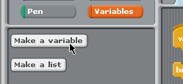
Create a block to assign it to the value ExplorerHAT.
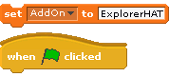
Attach the broadcast gpioserveron block and the set AddOn to ExplorerHAT blocks to the when Flag is clicked event block. This makes sure that the script runs the initialization at the very beginning.
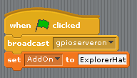

The name ExplorerHAT is case-sensitive. In general, with programming and code, it is best practice to pay close attention to both the spelling and capitalizations.

Input & Output Control
Basic input / output control using Scratch is accomplished using the broadcast message block. The easiest way is to create a new broadcast message for each command.
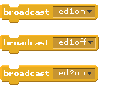
LED control
There are four coloured LEDs under the touch pads. These can be controlled with a simple broadcast message.
Broadcast message: led#[on/off]
OUTPUT control - (OUTPUT1 - OUTPUT4)
There are four controllable outputs on the ExplorerHAT. These are active LOW OUTPUTs (Sinks to GND).
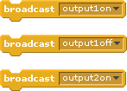
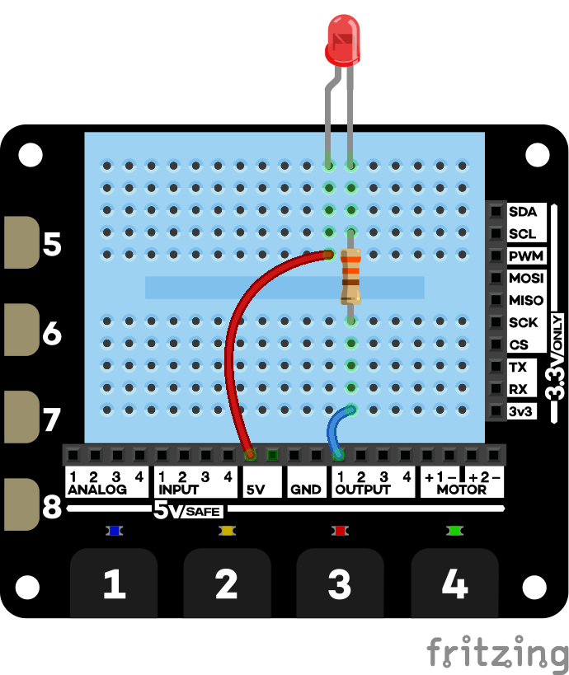
To turn on an LED, wire LED to 5V and connect negative (the shortest) leg to output pin (through a current limiting resistor)
Broadcast message: output#[on/off]
Motor control - Motor1 and Motor2
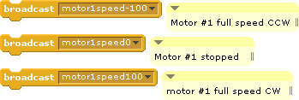
The speed of the motors can be controlled to spin CW and CCW by sending it a value between -100 and +100. Connect the two wires (red/black) from each motor to the + and - pins. You can also use these commands to control the solenoid.
The structure of the command is: Broadcast message: motor#speed[value]

Using variables to simplify the broadcast messages
You can also uses variables and the join block to create your own broadcast messages in the code. Here's an example that blinks a random LED on and off.
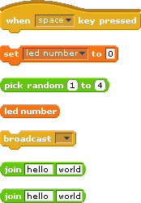
Here are all of the blocks that you're going to need for this.
Create a variable called led number.
You're going to use the pick random block to randomly pick which LED to turn on.
You need the led number variable block, the broadcast block, and two join blocks.
You're going to use the two join blocks to join three elements together into a compound broadcast message. Drag one join into the second space (world) of the first join.
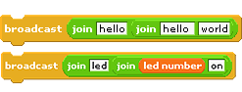
Now, change the text so that it joins the text led with the variable led number and the text on.

Putting it all together. Here's the complete script that picks a random number from 1 to 4, and blinks that LED - turning it on for one second and then off for one second.
You can use the join block and variables to control any number of other features in scratch.
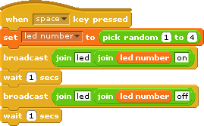

Touch Input
There are four points that use capacitive touch to detect a touch input. These are labelled 1, 2, 3, & 4. There are four additional clip points that can be used with alligator clips to connect to a variety of conductive objects to use as digital sensors.
A 'touch[#]' broadcast message is received when one of the tabs is touched. You can use the "When I receive [ ]" event block to define what happens when a touch is received.  You must clear the touch event by broadcasting a message: "touchreset" If you don't it won't be able to detect another touch event. | Example:  Moves sprite 10 spaces in x and turns on LED1  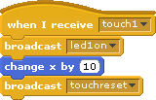

Connecting Other Inputs
There are four points that use capacitive touch to detect a touch input. These are labelled 1, 2, 3, & 4. There are four additional clip points that can be used with alligator clips to connect to a variety of conductive objects to use as digital sensors.

Digital Inputs
A digital input is something like a switch. It is either on (1) or off (0). The on state indicates that it's connected to 5V.
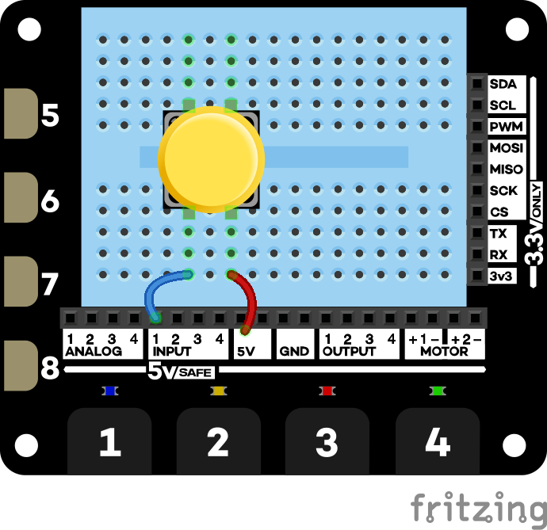
Here is a simple example using a button switch. Connect up the circuit shown. When you push the button, you connect the input pin to 5V.
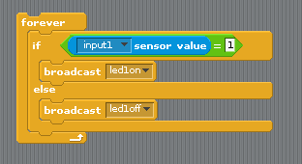

Analog inputs
An analog input can measure not only on and off, but variations in between. It converts a voltage into a value that you can use in the code.
Here is a wiring example of connecting up a light dependant resistor (LDR).

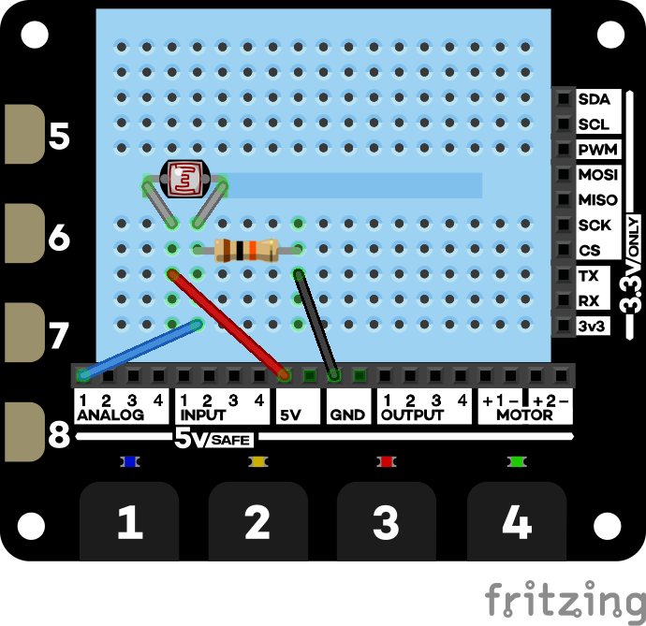
The circuit diagram for this looks like this. Vout of the sensor is connected to the analog1 input pin. When connected like this, the LDR works as a variable voltage divider. As the light changes, the voltage between the two resistors changes between 0V and 5V.
Under the sensor block, you'll find an option for analog1 and adc1. How do the values compare?
This is taken and modified from: https://sparkfuneducation.com/how-to/explorerhat-and-scratch-on-raspberry-pi.html

