Exercise 1
BATCH_ID = f”s01-5753df2c"
EXPERIMENT_NAME = "/Shared/muiaap-operacion-modelos/semana01-tracking"
BEST_RUN_ID = 5edfc168e7fd4fc68eccd19900969459

Validation measure:
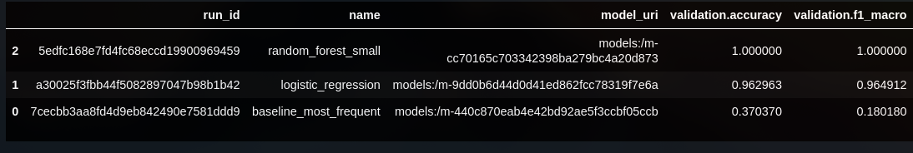
Test measure:
Smoke Test:
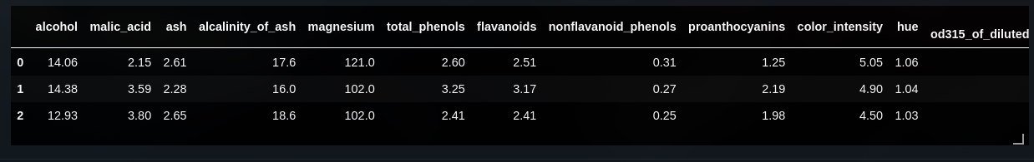

Exercise 2

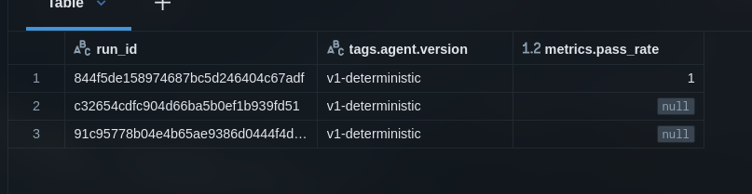
evaluation_run_id = 844f5de158974687bc5d246404c67adf
pass_rate = 1.0

