**Install vite app**

**Create folder vite name….**

Go to folder and run powershell or type cmd on directory path 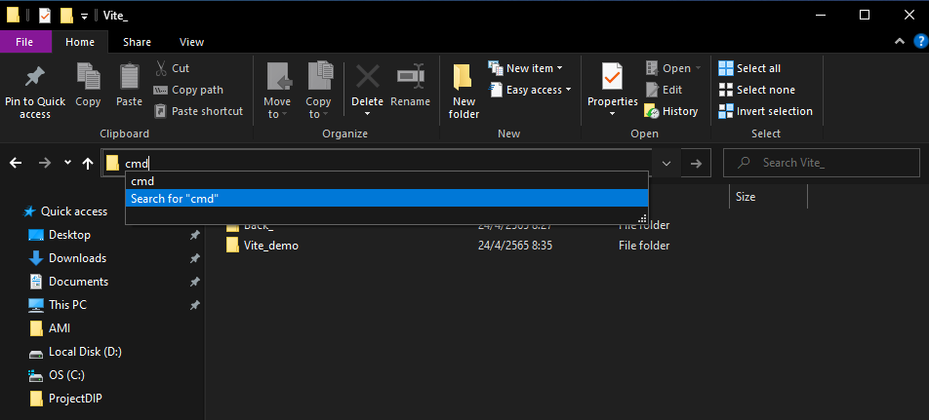

And type **: code . for open vs code**

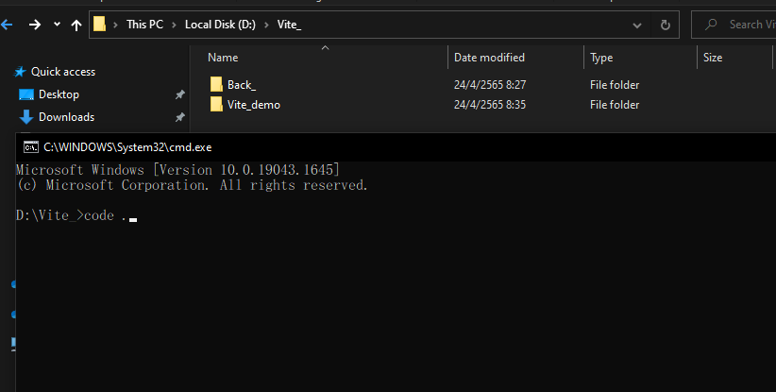

We should be See

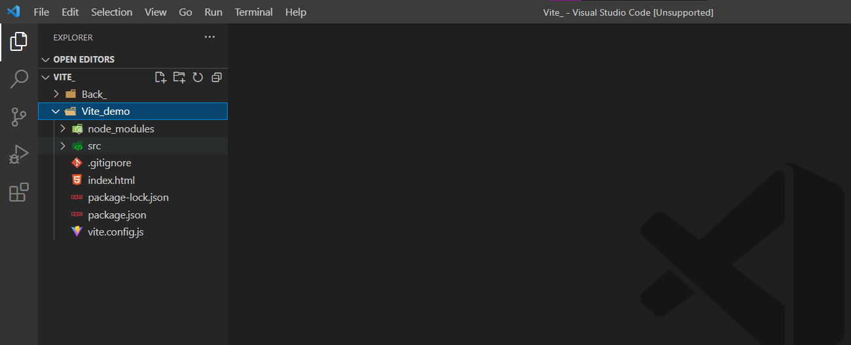

And New Terminal

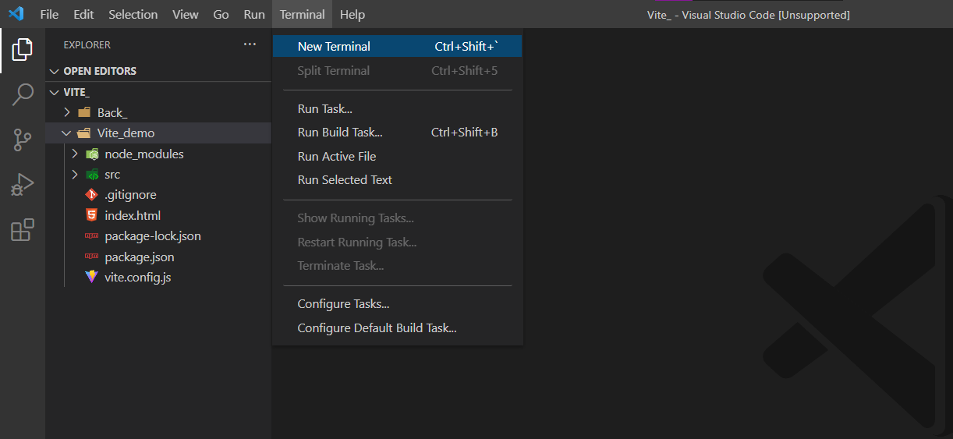

And create folder

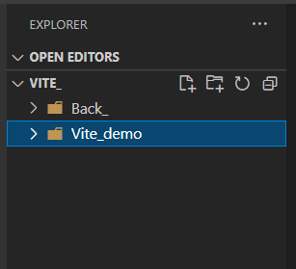

And setup project

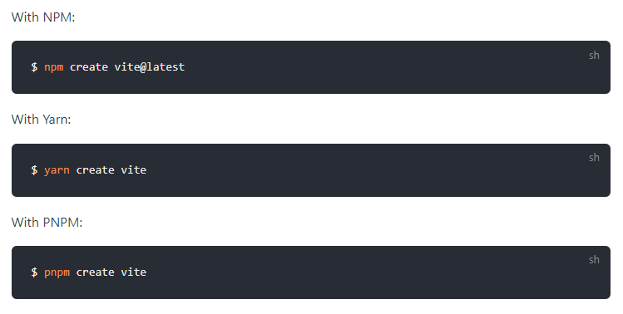

After we got setup :

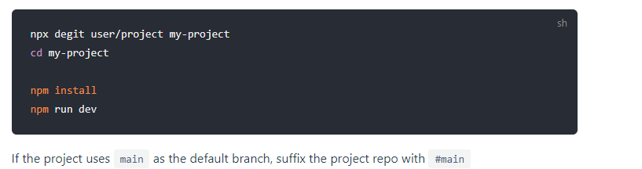

**Front end**

[Vite App](http://localhost:3000/)

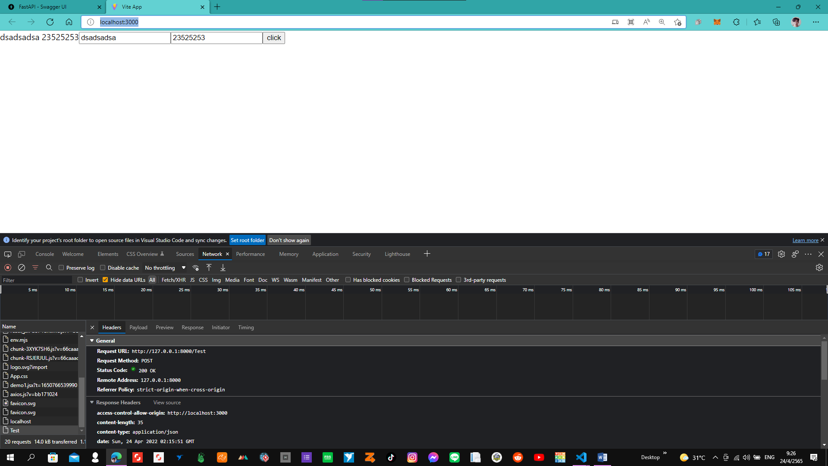

Back end python

[FastAPI - Swagger UI](http://127.0.0.1:8000/docs#/default/Test_Test_post)

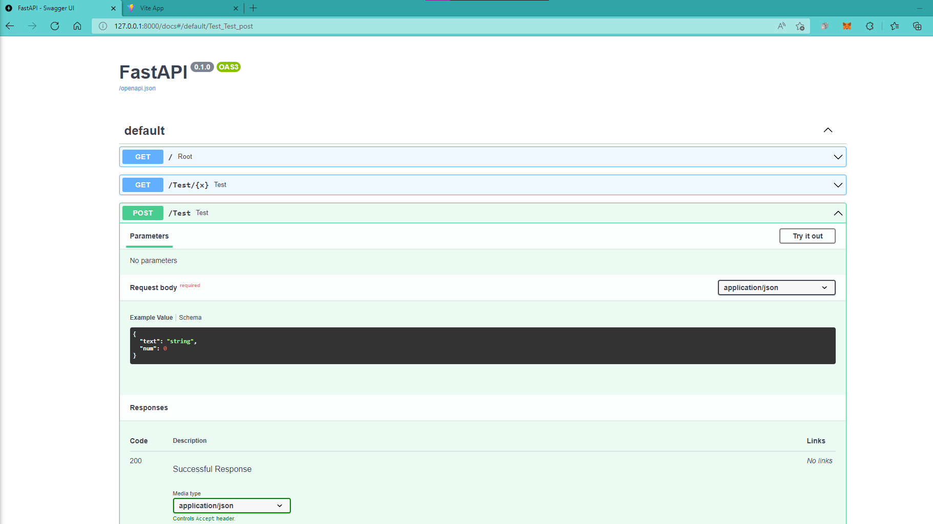

**BACK END**

**Download requirement.txt**

**Pip install uvicorn**



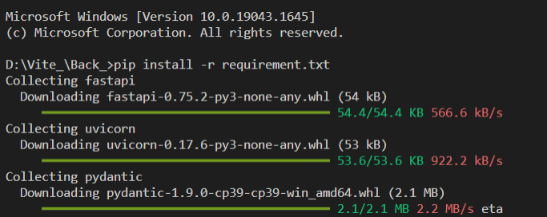

If pip old version should be upgrade Version by upgrade command

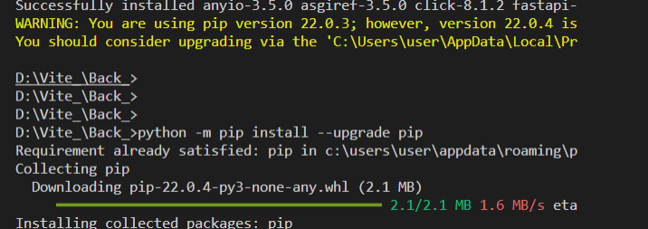

And re install

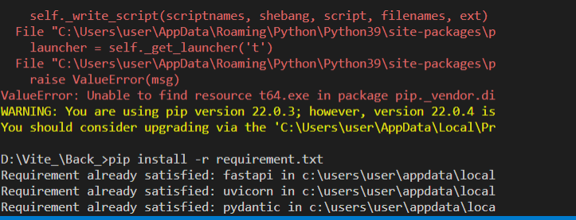

And start up App by Command : uvicorn back_:app --reload

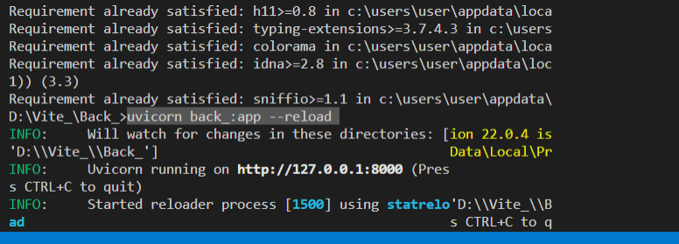

And copy path

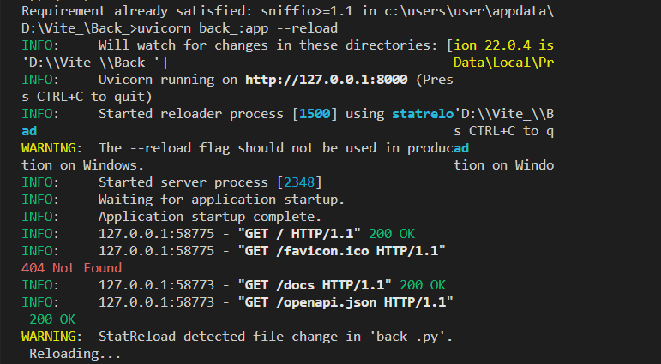

This example data json log file

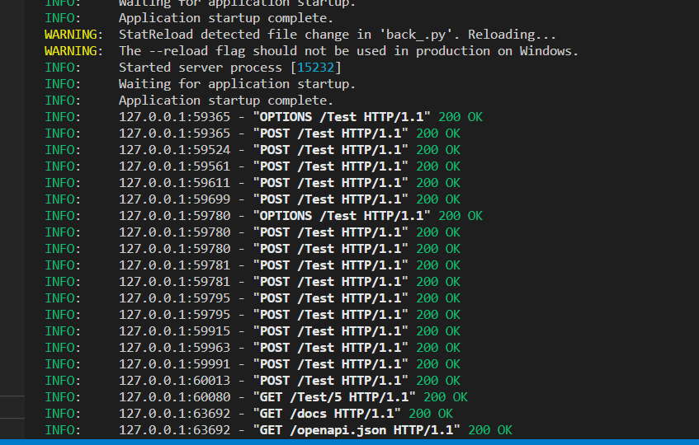

**Front end**

Create folder in vite

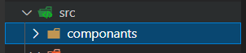

And install **Axios :npm i axios**

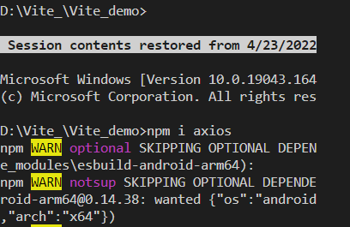

And file .jsx scss

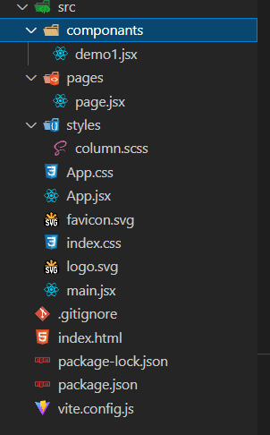

Form

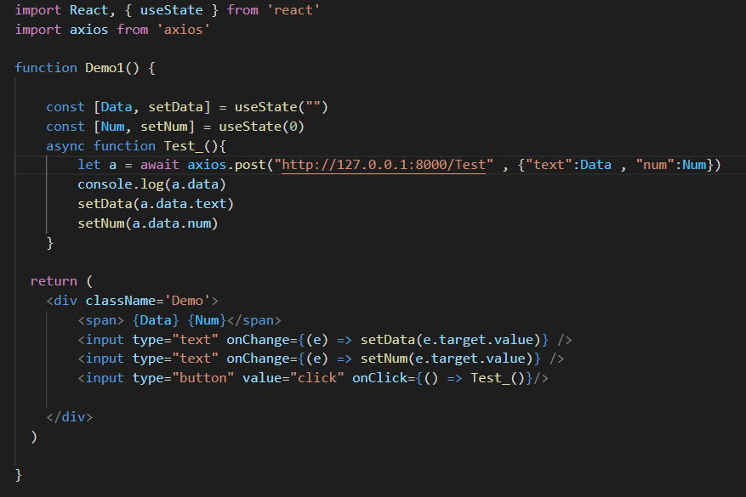

Run by : **npm run dev**

