Party Game

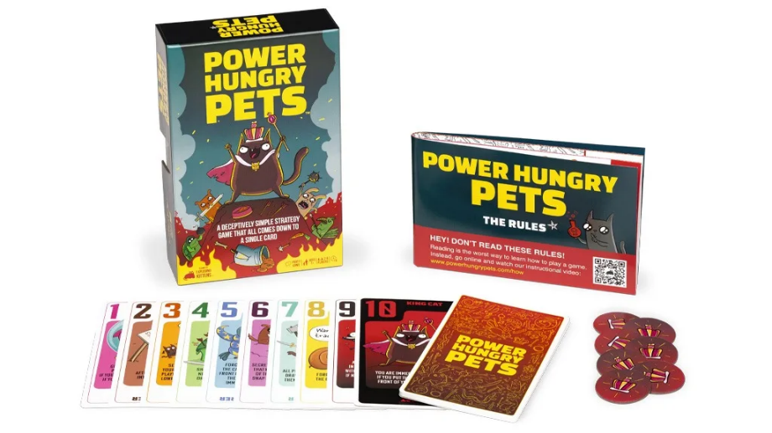

power hungry pets

Number of players: 2-6

age: 7 years old or older

playing time: 15 minutes

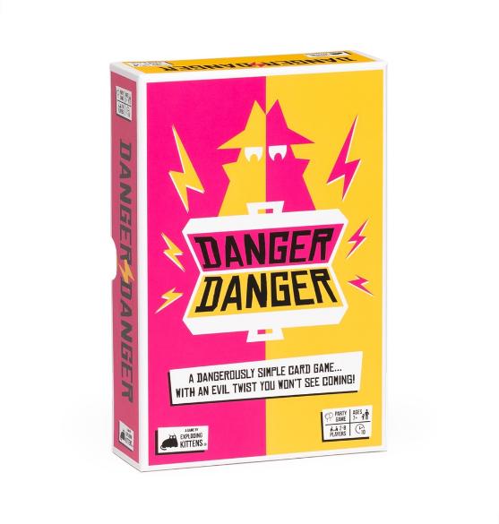

Danger Danger

Number of players: 2-8

age: 7 years old or older

playing time: 10 minutes

Mind Up

Number of players: 3-6

age: 8 years old or older

playing time: 15-20 minutes

Long Shot the Dice Game

Number of players: 1-8

age: 14 years old or older

playing time: 25 minutes

Family Game

Food Fighters

Number of players: 2

age: 8 years old or older

playing time: 20-30 minutes

Exploding Kittens

Number of players: 2-5

age: 7 years old or older

playing time: 15 minutes

That’s Not a Hat

Number of players: 3-8

age: 8 years old or older

playing time: 15 minutes

Codenames: Marvel Edition

Number of players: 2-8

age: 8 years old or older

playing time: 15 minutes

Love Letter

Number of players: 2-6

age: 10 years old or older

playing time: 20 minutes

strategy game

Intrepid: Deluxe

Number of players: 1-4

age: 13 years old or older

playing time: 90 minutes

Rats of Wistar

Number of players: 1-4

age: 13 years old or older

playing time: 90 minutes

The White Castle

Number of players: 1-4

age: 12 years old or older

playing time: 80 minutes

Nucleum

Number of players: 1-4

age: 14 years old or older

playing time: 60-150 minutes

Coimbra

Number of players: 2-4

age: 14 years old or older

playing time: 60-90 minutes