

**Ticket Concert Project**

By

1. Miss Kob Student ID 6504062610013 No.2

2. Miss Paphawarin Suchantabut Student ID 6504062610170 No.15

3. Miss Usanee Komas Student ID 6504062610331 No.28

4. Miss Sutthara Pornlerdsawangsuk Student ID 6504062620205 No.44

Adviser

Asst.prof.Khantharat Anekboon, Ph.D.

This project is a part of the System Analysis and Design course

King Mongkut’s University of Technology North Bangkok

1. System Request

System request – Concert ticket Project

**Project Sponsor**: Marketing

**Business Need**: This is a website for search and purchase concert tickets online. The project was initiated to boost concert ticket sales for

**Business Requirement**: By using our website, customers will be able to do the following:

-Search for concert tickets

-Purchase concert tickets

-Check dates, times, venues, and prices of concerts

-Receive e-tickets to avoid additional printing costs for customers.

**Business Value** : Within 4 years, we believe that we will make a profit

-selling tickets 1,535,000 baht

-Fee 9,000 baht

-Sponsor 325,000 baht

**Tangible**: Increasing profit by 1.5 to 2.5 million per year, after four years of starting the business.

**Intangible**: -Customers are increasingly satisfied.

-The company's reputation is becoming more widely recognized.

-Bringing in more customers than before.

-Attracting a greater number of investors to invest in the company.

**Special issues or constraints**:

-The website might not sell well because there is a new competitor.

- Security and Privacy Concerns

- Payment System

- User Experience

- Cross-Device Compatibility

- Technical Challenges

- Maintenance and Updates

- Integration with Other System

2. Feasibility

**Technical Feasibility**

-The total number of team members is 4 people. The total working period is about 4 months. The probability of completing this project is 80%.

**Economic Feasibility**

**Organizational Feasibility**

There is enough money to support and maintain the website for the long term. In addition to capital, there are wages that are necessary for work. Understanding of marketing management is required. market success readiness to deal with problems and ticketing system Must have an understanding of customer needs have a plan and cope with obstacles.

3.Project Schedule

The agile approach to SDLC (Software Development Life Cycle) has many advantages that can help the project work efficiently and respond to the changing needs of customers and the business environment.

**Advantages of using SDLC Agile**

- Flexibility to update requirements Because there may be demands that change all the time, such as increasing or decreasing concert times.

- Responding to the needs of users can listen to their needs. Which makes it possible to get the right work that meets the needs of the user.

- The website for concert tickets may involve intricate operations, and employing Agile methodologies enables the capability to continuously adapt to changes.

- Tested and rated for high and stable performance all the time.

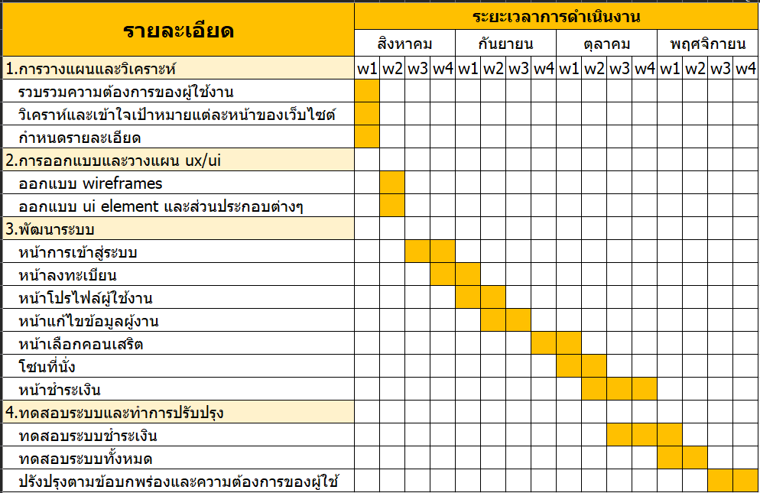

4. Functional Requirement

- Can search for desired concerts.

- Edit your account anytime.

- View dates, times, venues, prices, and other special conditions.

- Check seat availability.

- Convenient e-ticket for users.

- Multiple and convenient payment options.

5. Non-functional Requirement

**Availability**

- It is a system that works 24 hours a day.

- When it comes to the payment process, the system will be more stable. no downtime Because it is a very important step for the user.

**Usability**

- The screen is designed to be easy to use. due to the use of contrasting colors Easy-to-read fonts for easy visibility by users and accompanying icons for easy understanding.

- There are languages ​​to support both Thai and English which are international languages.

**Security**

- The system is safe in the process of entering the password because there is protection from seeing the password.

- There is an I'm not a robot function to prevent bots from entering the system.

6.Requirement

**Interview with individuals**

Interviews with people who have experience with pressing concert tickets, online interviews

**Observation of workers**

- The website crashed

- Slow seat updates, not real time

- It's hard to pay. If you slip off the pay page, you have to start all over again

- require a person to press not too many concert tickets