1. A screenshot of a diagram

   Description automatically generatedA screenshot of a computer

   Description automatically generatedUsecase diagram
2. 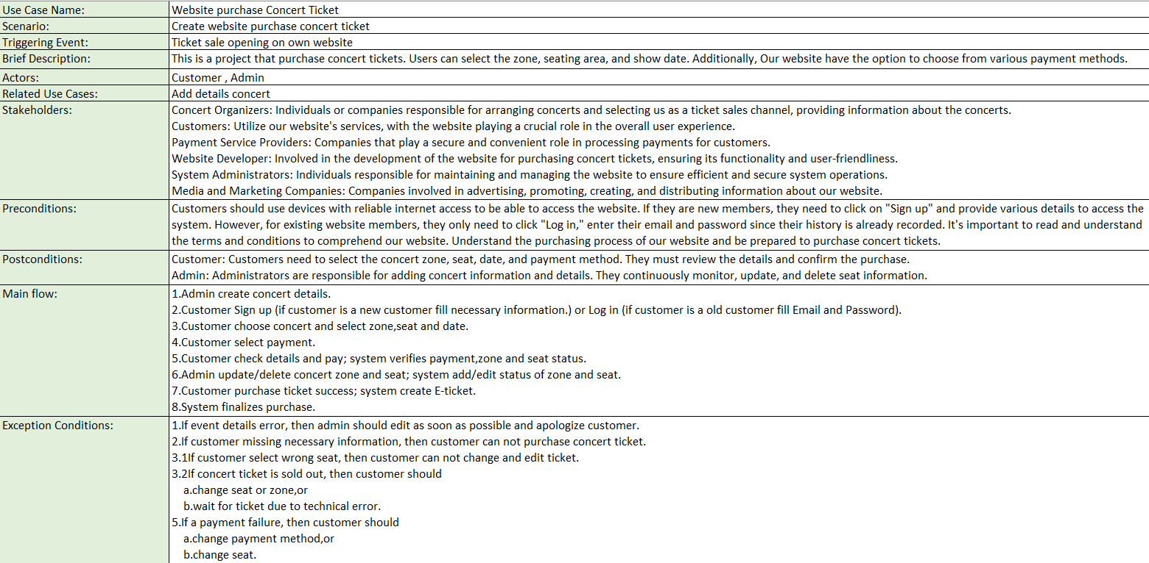Usecase description
3. Context diagram

1. DFD level 0

