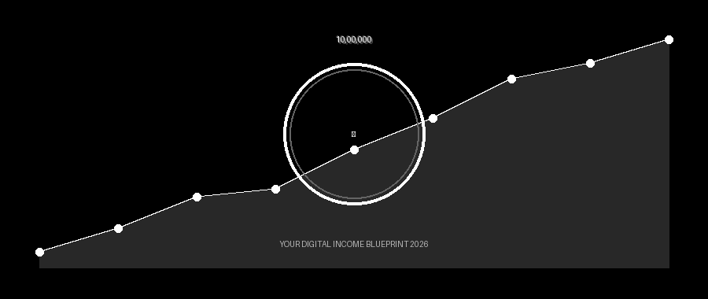
EARN
₹10 LAKH
BEFORE 2027

Your Complete Digital Income Blueprint
5 Proven Strategies That Are Working RIGHT NOW in India

Welcome: Why This eBook Is Different

You have picked up this eBook because you are serious about changing your financial future — and you want to do it fast. No fluff, no theory. Every strategy in this guide is being used right now by real Indians to build income online in 2026.
Earning ₹10 lakh (₹1,000,000) before the end of 2026 means roughly ₹88,000 per month from now. That is absolutely achievable if you combine even two of the five methods in this book.
This is not a motivational PDF. It is a step-by-step operational guide. Read it with a pen, mark what excites you, and start executing within 24 hours.

Chapter 1: Faceless Video Clipping & YouTube Automation

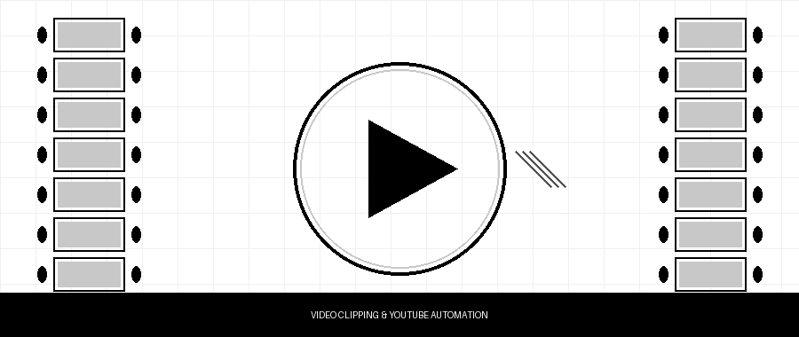

What Is It?
Video clipping means taking long-form content — podcasts, interviews, or courses — and re-editing them into short, viral clips for YouTube Shorts, Instagram Reels, and YouTube channels. You do not appear on camera. You do not record your voice. You simply package great content in a way that earns ad revenue and affiliate commissions.

How to Make Money
- YouTube AdSense: A Shorts channel with 5–8 million views per month earns ₹30,000–₹60,000 passively.
- Affiliate links in video descriptions: Promote courses, tools, or products related to the clips’ topic.
- Sell the service: Charge content creators ₹15,000–₹40,000/month to manage their clipping.

Step-by-Step Action Plan
- Week 1–2: Pick a niche (finance, motivation, tech, fitness). Download 10 long podcasts using yt-dlp.
- Week 3: Use CapCut or OpusClip to auto-generate 60–90 second clips. Add captions and hook text overlays.
- Week 4 onward: Upload 2 Shorts daily. Consistency beats perfection every single time.
- Month 3+: Monetise with AdSense and DM 5 creators per week offering your clipping service.

Realistic income by Month 6: ₹40,000–₹1,00,000/month (service + ad revenue combined).

Chapter 2: Selling Digital Products Online

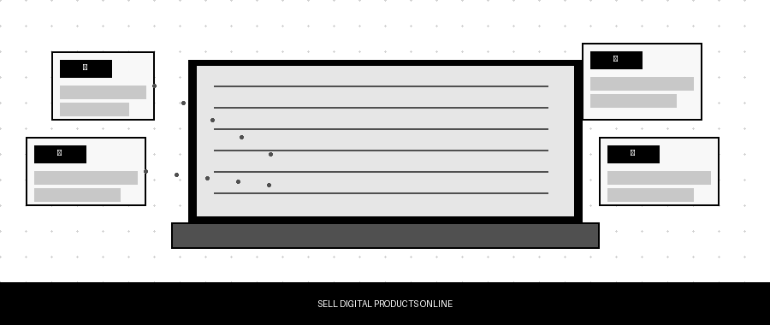

Why Digital Products Win
A digital product is created once and sold unlimited times. There is no shipping, no inventory, and no customer-service headaches. In 2026, the Indian creator economy is booming and buyers are ready to pay for quality information and tools.

Best-Selling Digital Products Right Now
- eBooks & PDF Guides: Niche guides on investing, fitness, study tips, or side hustles. Price: ₹199–₹999.
- Templates: Notion dashboards, Canva social-media kits, Excel budget trackers. Price: ₹299–₹2,999.
- Mini Courses: 60–120 minute recorded courses on Teachable or Gumroad. Price: ₹999–₹4,999.
- Prompt Packs & AI Tool Kits: Curated ChatGPT/Claude prompts for professionals. Price: ₹499–₹1,999.

How to Launch in 30 Days
- Day 1–7: Validate your idea. Post: “Would you pay ₹499 for a guide on [topic]? Comment YES.”
- Day 8–20: Create the product using Canva (design) + ChatGPT (content). Keep it 20–40 pages.
- Day 21–30: List on Gumroad or Instamojo. Promote daily on Instagram Stories and WhatsApp broadcast.

Target: 100 sales at ₹999 = ₹99,900/month. Scale to 3 products for ₹3,00,000/month.

Chapter 3: Making Money With AI Tools & Services

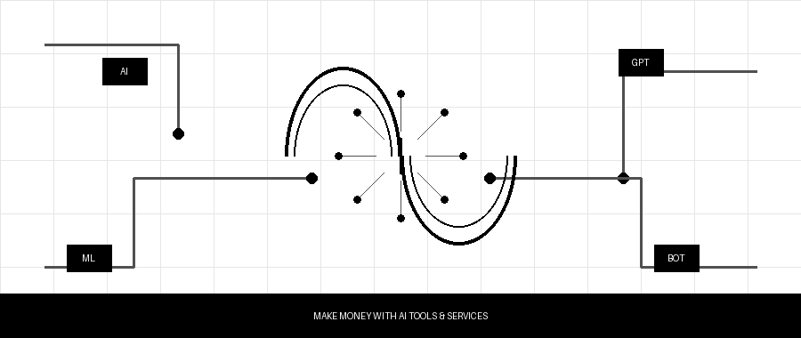

The AI Opportunity Is Huge — and Still Early
Most business owners in India know AI tools exist but have no idea how to use them. That gap is your business. You can earn serious money simply by knowing how to use ChatGPT, Claude, Midjourney, and other tools better than the average person.

High-Income AI Services You Can Offer Today
- AI Content Writing: Blogs, email sequences, and product descriptions for SMEs. Rate: ₹20,000–₹50,000/month per client.
- AI Image & Ad Creative Generation: Social media ad creatives for local businesses using Midjourney + Canva.
- Chatbot Setup: Build WhatsApp or website chatbots for restaurants, clinics, and e-commerce brands. One-time fee: ₹15,000–₹40,000.
- AI Automation Consulting: Automate repetitive business tasks using Make.com and AI APIs.

Getting Your First Client
- Build a 3–5 post portfolio on LinkedIn showing before/after results (old vs AI-generated content).
- Offer one free audit to a local business. Convert them to a paid retainer.
- Join Indian freelancing groups on Facebook and Telegram to find leads fast.

Target: 3 retainer clients at ₹30,000/month each = ₹90,000/month. Achievable within 90 days.

Chapter 4: Affiliate Marketing (The Passive Income Engine)

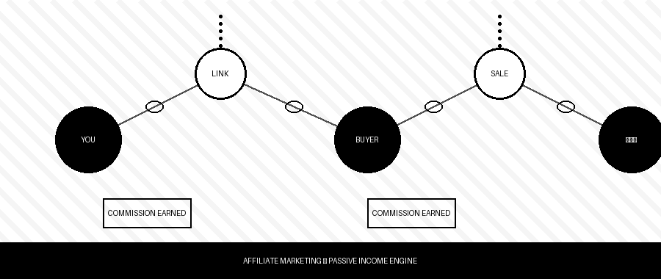

How Affiliate Marketing Works
You promote someone else’s product and earn a commission every time someone buys through your unique link. No product creation, no support, no delivery. You are purely the bridge between buyer and seller.

Top Affiliate Programs for Indian Creators
- Amazon Associates India: 2–8% commission on every product. Great for tech, books, and lifestyle niches.
- Hostinger / Bluehost India: Earn ₹2,000–₹6,000 per hosting referral. Very popular in the blogging niche.
- Digistore24 & ClickBank: International products with 30–60% commissions. Finance and self-help sell very well.
- Udemy / Coursera Affiliates: Earn 10–15% on every course sale. Education content converts extremely well.

The Fastest Affiliate Strategy in 2026
Build a niche YouTube channel or Instagram page where you review and compare products. Add your affiliate links in every video description and bio. A channel with 10,000 subscribers in the finance or tech niche can generate ₹30,000–₹80,000 per month in affiliate commissions alone. Combine this with a simple blog to capture Google search traffic and your earnings compound over time.

Target: 50 affiliate sales per month across 2–3 programs = ₹25,000–₹75,000/month passively.

Chapter 5: High-Ticket Freelancing & Skill Monetisation

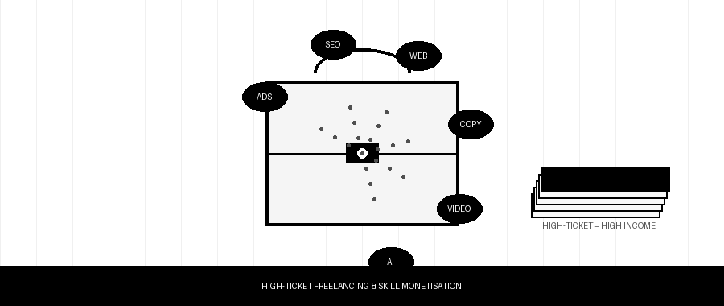

Stop Trading Time for Peanuts
Most Indian freelancers compete on price and earn ₹500–₹2,000 per project. High-ticket freelancers solve big business problems and charge ₹20,000–₹1,50,000 per project. The difference is positioning, not skill level.

Skills With the Highest Demand Right Now
- Performance Marketing (Meta + Google Ads): Run paid ad campaigns for e-commerce brands. ₹40,000–₹1,20,000/month.
- No-Code Web Development (Webflow / WordPress): Build professional websites. ₹25,000–₹75,000 per project.
- Sales Copywriting: Write landing pages and email funnels that convert visitors into buyers. ₹30,000–₹1,00,000 per project.
- Short-Form Video Editing: Edit Reels, Shorts, and TikTok-style content for brands. ₹20,000–₹60,000/month per client.

How to Land High-Ticket Clients Fast
- Pick one skill. Spend 2 weeks getting very good at it using free YouTube tutorials.
- Create 3 portfolio samples (even if self-initiated — create mock campaigns or websites).
- Post on LinkedIn daily about your skill with specific results and insights.
- Charge a premium from day one. Buyers associate higher price with higher quality.

Target: 2 high-ticket clients at ₹50,000/month each = ₹1,00,000/month.

Your 8-Month Roadmap to ₹10 Lakh

- Month 1–2 — Foundation: Pick 1 primary strategy + 1 supporting strategy. Build your online presence. Get your first client or first 100 subscribers.
- Month 3–4 — Momentum: Hit ₹20,000–40,000/month. Launch your first digital product. Onboard 2 freelance clients.
- Month 5–6 — Scale: Add affiliate marketing as a passive layer. Systematise your workflow using AI tools. Target ₹70,000–1,00,000/month.
- Month 7–8 — ₹10 Lakh Unlocked: With multiple income streams running, crossing ₹10 lakh cumulative is not just possible — it is your minimum expectation.

Final Words: The Only Difference Is Action

You now have five proven, working strategies that thousands of Indians are using to build real income in 2026. The internet does not care about your age, background, city, or degree. It rewards execution.
Do not try all five at once. Pick the one that excites you most. Start this week, not next month. Take one small action today — create your first Reel, list your first digital product, or send your first pitch. That single step separates the person who earns ₹10 lakh from the person who only reads about it.

“The best time to start was yesterday. The second best time is right now.”
Go build your ₹10 lakh story.

