MERCHANT CHURN &
RETENTION ANALYSIS

Power BI Dashboard Report

Understanding why and when merchants stop doing business,
and how to improve merchant retention.

Executive Summary

This report presents a comprehensive Power BI dashboard analyzing merchant churn and retention across a multi-year transaction dataset. The analysis spans 5,881 merchants across multiple countries from January 2010 to December 2011.
The most critical finding is a 50.79% churn rate, meaning more than half of all merchants have stopped transacting. Despite this, the business shows strong revenue concentration in the United Kingdom and clear signs of improving retention in late 2011 cohorts, suggesting that retention strategies implemented during that period had a measurable positive effect.

Key metrics briefly:

5,881  Total Merchants | 50.79%  Churn Rate | 49.21%  Retention Rate | 9.1  Avg Tenure (Months)

Three immediate actions are recommended:
(1) Focus re-engagement on merchants in their first 3 months, where churn risk is highest.
(2) Launch a win-back campaign targeting high-spend churned merchants.
(3) replicate the onboarding practices used in late 2011, which produced dramatically higher retention rates.

Project Overview & Objectives

Background
Merchant churn — the loss of business customers who stop transacting — is one of the costliest challenges in B2B commerce. Acquiring a new merchant is significantly more expensive than retaining an existing one. Understanding the patterns, timing, and drivers of churn is therefore essential for sustainable business growth.

Objectives
This project was designed to answer the following business questions:
- What is the overall churn rate and how has it changed over time?
- Which countries have the highest and lowest churn rates?
- Is there a relationship between how long a merchant has been active (tenure) and their likelihood of churning?
- Which cohorts of merchants (grouped by when they first joined) show the strongest retention?
- Who are the highest-value merchants and are they at risk of churning?
- What are the overall business trends in revenue and transaction volume over time?

Scope
The analysis covers transaction data from December 2009 through December 2011, encompassing 5,881 unique merchants across 40+ countries. The primary focus is on the merchant lifecycle, from first transaction through potential churn, with secondary analysis on revenue trends and merchant value segmentation.

Data Description

The analysis is built on four interconnected datasets, each serving a specific analytical purpose:

1. merchant_level.csv — Primary Table
One row per merchant. This is the most important table in the analysis, containing the full lifecycle profile of each merchant including their first and last transaction dates, total spend, transaction count, country, churn status, and tenure. All churn rate, retention, and segmentation metrics are derived from this table.
Key columns: MerchantID, Total_Spend, Total_Transactions, Country, Avg_Order_Value, Cohort_Month, Tenure_Months, Days_Since_Last_Transaction, Is_Active, Is_Churned.

2. transactions_clean.csv — Transaction Level
One row per transaction line item. This table provides granular detail on what merchants purchased, when, and at what price. It is used to support time-based trend analysis and detailed behavioral investigation when needed.
Key columns: MerchantID, Invoice, StockCode, Description, Quantity, Price, Total_Spend, TransactionDate, Country.

3. cohort_retention.csv — Cohort Analysis
One row per cohort month. This table pre-aggregates merchant counts and retention rates by the month merchants first joined. It is the primary data source for the Cohort Retention dashboard page and enables comparison of how different joining cohorts performed over time.
Key columns: Cohort_Month, Total_Merchants, Active_Merchants, Churned_Merchants, Avg_Tenure, Retention_Rate_%.

4. monthly_activity.csv — Time Trends
One row per month. This table summarizes business activity at the monthly level, enabling trend analysis of revenue, transaction volume, and active merchant counts over time. It is used exclusively for the Transaction Trends dashboard page.
Key columns: TransactionDate, Total_Transactions, Total_Merchants, Total_Spend.

Dashboard — Power BI Screenshots

The following pages show each of the five dashboard pages built in Power BI. Each page is designed to answer a specific set of business questions, with interactive slicers allowing filtering by country and merchant status.

Page 1 — Overview (KPI Summary)
Provides a high-level snapshot of the business: total merchants, active vs churned split, overall churn rate, retention rate, and average tenure. The donut chart and churn trend line give immediate visual context for the scale of the retention challenge.
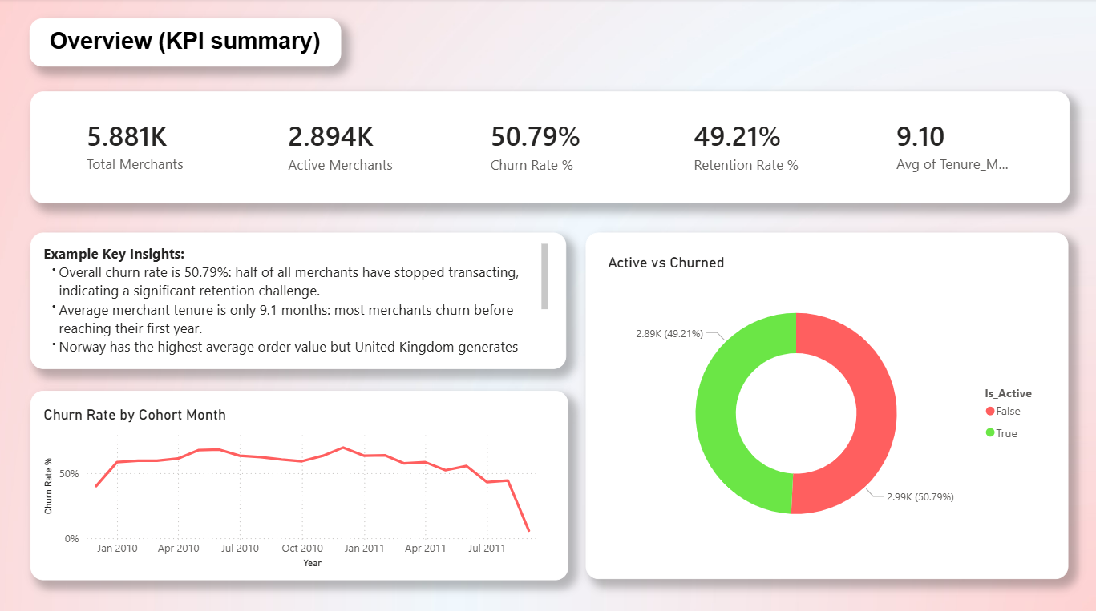

Page 2 — Churn Analysis
Deep dives into who is churning and why. The scatter plot reveals the relationship between merchant tenure and inactivity, while the bar chart shows which countries have the highest churn rates. The inactivity distribution chart highlights how many merchants are at various stages of disengagement.
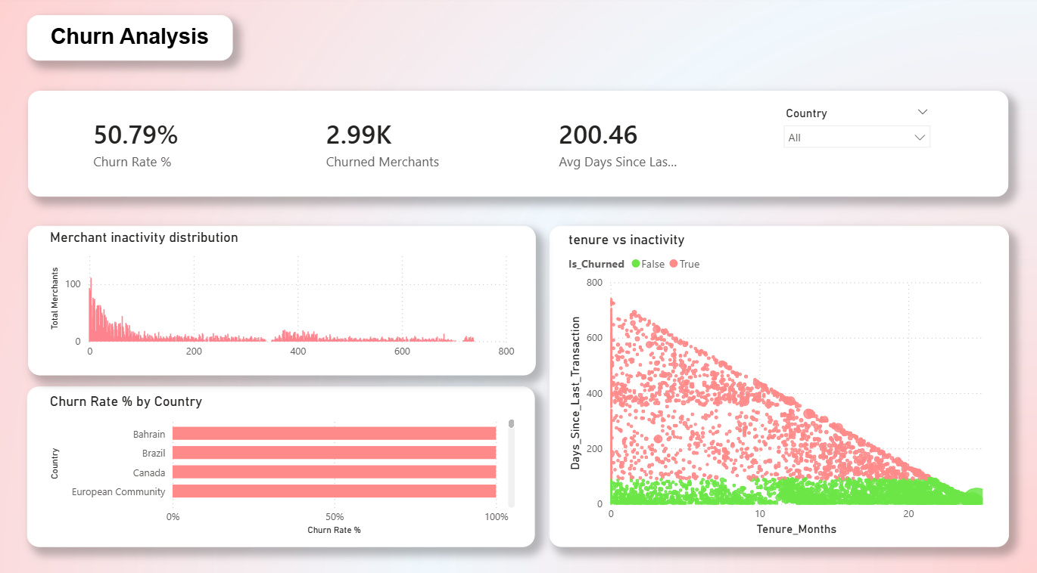

Page 3 — Cohort Retention
Analyzes retention performance by cohort, the month each merchant first joined. The line chart with 50% benchmark line shows which cohorts performed above or below average, while the heatmap matrix uses color to make retention patterns immediately visible.
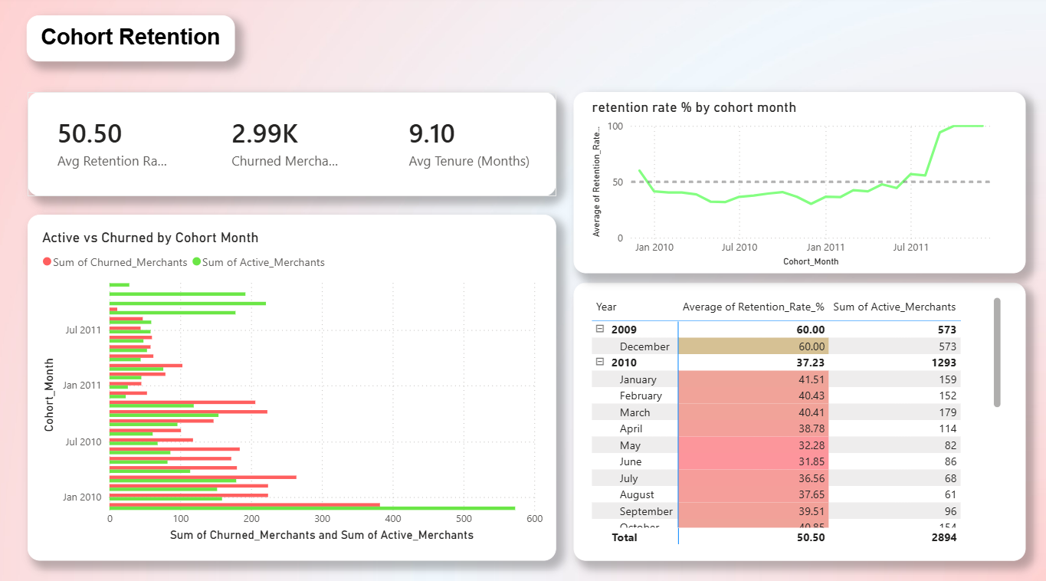

Page 4 — Merchant Segmentation
Segments merchants by value, identifying the top 10 highest-spending merchants and comparing average order value and total spend across countries. The Country and Is_Active slicers allow filtering to compare active vs churned merchant spending patterns.
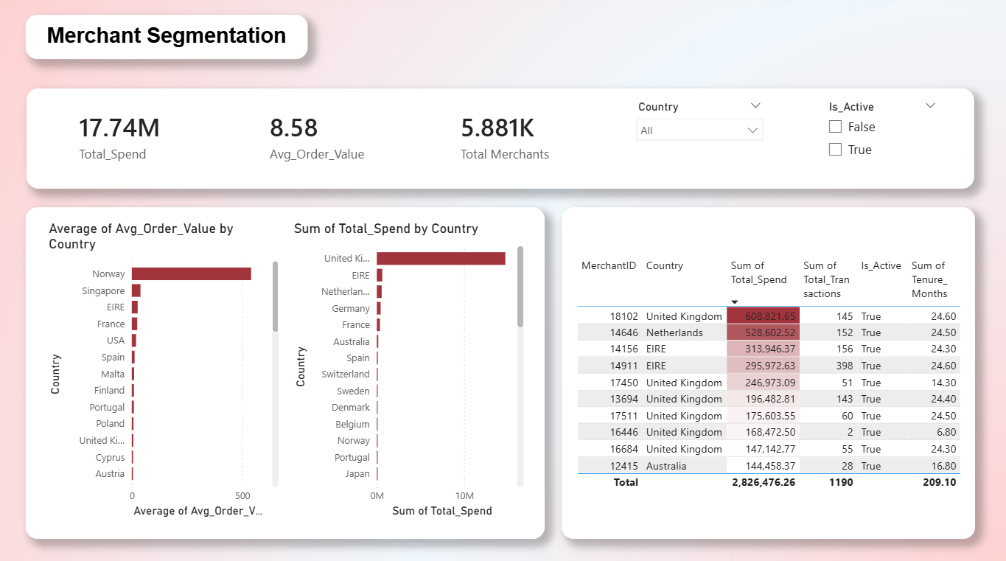

Page 5 — Transaction Trends
Shows the overall business trajectory over time, monthly revenue, active merchant counts, and transaction volume. The trend line on the transactions chart cuts through monthly noise to reveal the underlying growth or decline direction.

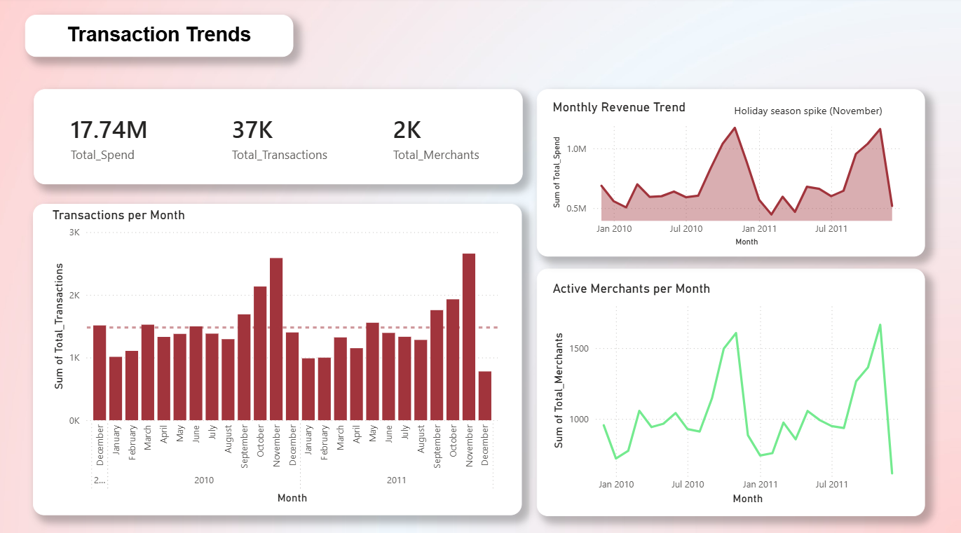

Key Findings

The following findings emerge from the five dashboard pages. Each is grounded in the data and directly relevant to the business goal of improving merchant retention.

Finding 1 — Churn Rate is Critically High
- 50.79% of all merchants have churned, and more than half the merchant base has been lost.
- Average merchant tenure is only 9.1 months, meaning most merchants churn before completing their first year.
- This level of churn represents a major revenue leakage; every churned merchant is losing future spending.

Finding 2 — Early Tenure is the Highest Risk Period
- The scatter plot (tenure vs inactivity) shows that merchants with 0–5 months tenure have the widest spread of inactivity days.
- This indicates that the first few months are the most critical factors, merchants who disengage early are unlikely to return.
- Retention interventions should be focused on newly onboarded merchants.

Finding 3 — Country-Level Churn is Broadly Similar
- Some countries show churn rates clustering near 100%, with notable exceptions.
- Greece shows lower churn rates (~60–70%), suggesting different market dynamics or stronger local engagement.
- The United Kingdom dominates total revenue despite not having the lowest churn, simply due to merchant volume.

Finding 4 — Late 2011 Cohorts Show Dramatically Better Retention
- Cohorts from September–December 2011 show retention rates of 90–100%, compared to ~30–40% for 2010 cohorts.
- This is the most positive signal in the entire dataset — something changed in late 2011 that dramatically improved retention.
- Identifying and replicating whatever drove this improvement should be a top business priority.

Finding 5 — November is Consistently the Peak Month
- Transaction volume spikes sharply every November in both 2010 and 2011, indicating strong seasonal demand.
- Revenue follows the same seasonal pattern, with January 2011 also showing a strong spike.
- Planning around this seasonality — with targeted promotions and increased support — could maximize peak-period revenue.

Finding 6 — Top Merchants Are Active and High-Tenure
- All top 10 merchants by spend show Is_Active = True, meaning the highest-value merchants are currently retained.
- Norway has the highest average order value per merchant, UK dominates total revenue due to merchant volume.
- Protecting these high-value relationships through dedicated account management is a priority.

Recommendations

Based on the findings above, the following actions are recommended. Each is directly tied to a specific data insight from the dashboard.

1. Launch an Early Tenure Retention Program
Since the highest churn risk is in the first 3–5 months, implement a structured onboarding program for all new merchants. This could include:
- A welcome email series with product tips and success stories
- A dedicated account manager check-in at 30, 60, and 90 days
- Early warning alerts when a new merchant goes 14+ days without a transaction

Expected impact: Reducing early churn by even 10% would retain ~100+ additional merchants per cohort.

2. Win-Back Campaign for High-Value Churned Merchants
Not all churned merchants are equal. Prioritize re-engagement efforts on merchants who had high historical spend before churning. A targeted win-back offer (discount, dedicated support, new product access) has a higher ROI than broad re-engagement campaigns.

Action: Export the list of churned merchants from Page 4 filtered by Total_Spend, and reach out to those above a spend threshold.

3. Investigate and Replicate the Late 2011 Retention Improvement
The jump from ~35% retention in 2010 cohorts to 90–100% in late 2011 cohorts is the single most important finding in this project. There was clearly a change in onboarding, product, pricing, or support during this period.

Action: Interview the team members who managed merchant relationships in Q3-Q4 2011 and identify what changed. Document and scale those practices across all future merchant onboarding.

4. Plan for November Seasonality
Transaction volume consistently doubles in November both years. This is likely holiday-season driven demand. Capitalizing on this pattern requires advance preparation:
- Ensure inventory and fulfillment capacity is in place by October
- Run promotional campaigns in October to prime merchants for November ordering
- Use the November spike as a re-engagement moment for dormant merchants

Appendix A — Metrics Dictionary

The following table defines all key metrics used across the five dashboard pages. This dictionary is designed to ensure consistent interpretation of the data by all stakeholders.

Metric | Category | Definition | Why It Matters
Churn Rate % | Churn | % of merchants who stopped transacting. Calculated as: Churned Merchants ÷ Total Merchants. | Core health metric — high churn means losing customers faster than growing.
Retention Rate % | Retention | % of merchants still active. Calculated as: Active Merchants ÷ Total Merchants. | Opposite of churn — shows how well the business keeps its merchants.
Active Merchant | Activity | A merchant who has transacted within the observation period (Is_Active = True). | Defines who is still engaged with the business.
Churned Merchant | Churn | A merchant who has not transacted recently (Is_Active = False). | Identifies lost customers who may need re-engagement campaigns.
Tenure (Months) | Activity | How many months since a merchant's first transaction, derived from First_Transaction date. | Short tenure + churn = early dropout risk. Long tenure = higher loyalty signal.
Days Since Last Transaction | Churn | Number of days since the merchant last placed an order. | Key churn signal — the higher this number, the more at-risk the merchant.
Avg Order Value (AOV) | Value | Average spend per transaction for a merchant. Calculated as: Total Spend ÷ Total Transactions. | High AOV merchants are more valuable even if fewer in total number.
Cohort Month | Retention | The month a merchant placed their first transaction — used to group merchants by joining period. | Allows comparison of retention across different periods to spot onboarding improvements.

All metrics are calculated in Power BI using DAX measures stored in the _Musers table. Source data is loaded from four CSV files: merchant_level, transactions_clean, cohort_retention, and monthly_activity.

