PORTFOLIO PROJECT
Payments Operations
Intelligence Dashboard & Metrics Framework
Fadwa Ramadan Ali Hassan
Data Analyst | Operations Intelligence & Strategy
May 2026
Python (Pandas) Power BI & DAX Cohort Analysis Fraud Detection

1. Executive Summary
This project simulates the end-to-end work of an Operations Intelligence Data Analyst at a fintech payments company. It demonstrates the ability to transform raw transactional data into structured KPI frameworks, cohort-level insights, and executive-ready dashboards.

Using a synthetic dataset of 6.36 million payment transactions, this project delivers:
- A complete Metrics Dictionary with 8+ core operational KPIs.
- A 4-page interactive Power BI dashboard with DAX measures.
- Merchant cohort analysis tracking behavior from day of first transaction.
- Fraud and chargeback pattern analysis across transaction types.
- Data quality pipeline built in Python (Pandas) with feature engineering.

2. Business Context & Problem Statement

2.1 The Operational Challenge
Payment platforms process millions of transactions daily across diverse merchant types, currencies, and payment methods. Without a structured analytics framework, operations teams face three core problems:

- Inconsistent KPI definitions across teams lead to conflicting reports and delayed decisions
- Chargeback and fraud signals are detected reactively rather than proactively
- Merchant onboarding quality is invisible without cohort-level retention tracking

2.2 Why This Matters
For a payments company, a 0.1% improvement in acceptance rate on $1.14T in volume equals over $1.1B in recovered revenue. Similarly, reducing chargeback rates from 0.13% to 0.10% can eliminate millions in dispute processing costs. This project demonstrates exactly the analytical capability needed to surface and act on these opportunities.

3. Dataset Overview

3.1 Data Source
PaySim — a synthetic mobile money transaction simulator designed to replicate real-world financial transaction patterns, widely used in fintech analytics research and published on Kaggle.

3.2 Scale & Structure
Attribute | Value
Total Transactions | 6,360,000 rows
Total Volume | $1.14 Trillion
Time Period | 30 days (simulated)
Transaction Types | TRANSFER, CASH_OUT, CASH_IN, PAYMENT, DEBIT
Key Fields | amount, type, isFraud, isFlaggedFraud, is_success, oldbalanceOrig, newbalanceOrig
Derived Fields | cohort_day, day, hour, acceptance_rate, chargeback_rate

4. Metrics Dictionary
A structured Metrics Dictionary was designed before any dashboard was built, following best practices in Operations Intelligence, where metric definition must precede reporting.

KPI Name | Formula | Target | Importance
Acceptance Rate | Successful Txns / Total Txns | > 99.5% | Core health metric
Chargeback Rate | Chargebacks / Total Txns | < 0.5% | Risk & dispute signal
Fraud Rate | Flagged Fraud / Total Txns | < 0.1% | Fraud detection quality
Avg Transaction Value | Total Volume / Total Txns | Benchmark | Merchant value signal
Merchant Retention Rate | Active M. Day N / Active M. Day 1 | > 60% Day-30 | Cohort health
Daily Transaction Volume | SUM(amount) per day | Trending up | Growth indicator
Chargeback-to-Fraud Ratio | Chargeback Rate / Fraud Rate | < 2x | Ops efficiency signal
Peak Hour Concentration | Txns in top 3hrs / Total Txns | < 40% | System risk indicator

Note: Each metric above is implemented as a DAX measure in Power BI and documented with formula, business definition, data source, and known limitations.

5. Methodology & Technical Approach

5.1 Python Data Pipeline
- Loaded raw PaySim CSV (6.36M rows) using Pandas with memory optimization
- Cleaned nulls, standardized transaction type labels, removed duplicates
- Engineered cohort_day: derived from each merchant's first transaction date
- Calculated daily acceptance_rate and chargeback_rate per merchant cohort
- Exported 3 clean tables: transactions_clean, daily_kpi, cohort_kpi

5.2 Power BI Dashboard Architecture
The dashboard is organized into 4 pages plus a drill-through layer:

- Page 1 — Executive Summary: Top-level KPIs, daily rate trends, volume by transaction type
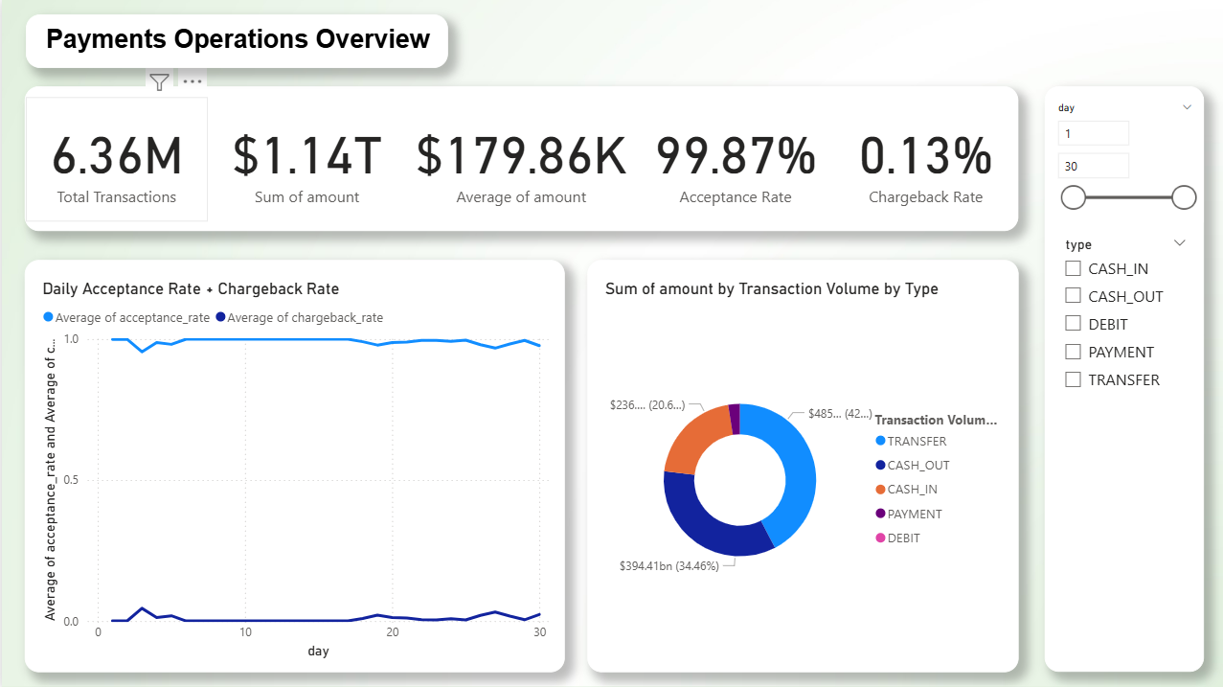
- Page 2 — Cohort Analysis: Merchant retention grid, chargeback volatility by cohort, new merchant trends
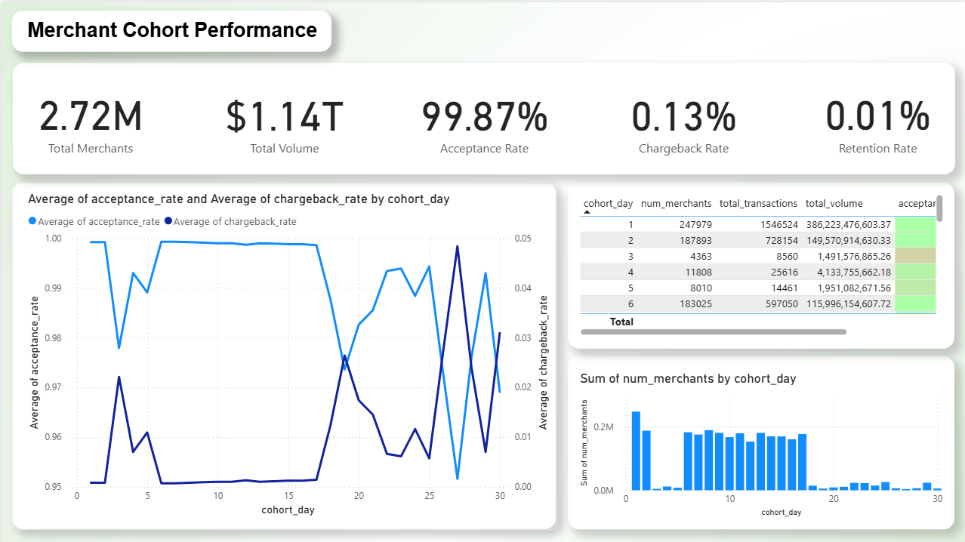
- Page 3 — Daily Performance: Volume/transaction trends, peak hour heatmap, day-of-week patterns
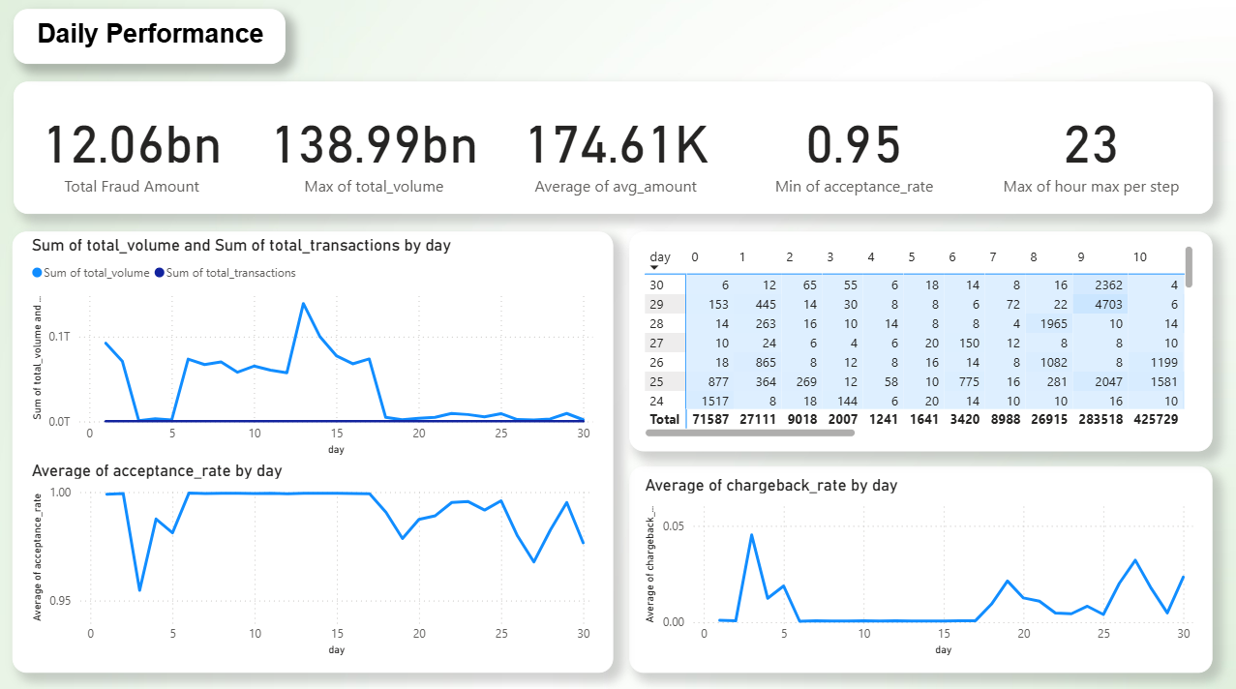
- Page 4 — Transaction Breakdown: Fraud analysis by type, success/failure split, balance pattern anomalies
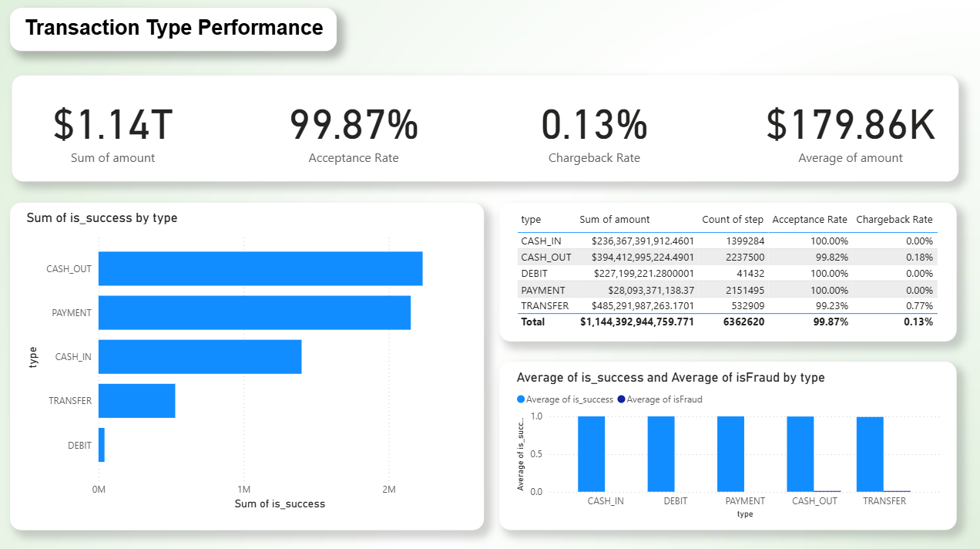
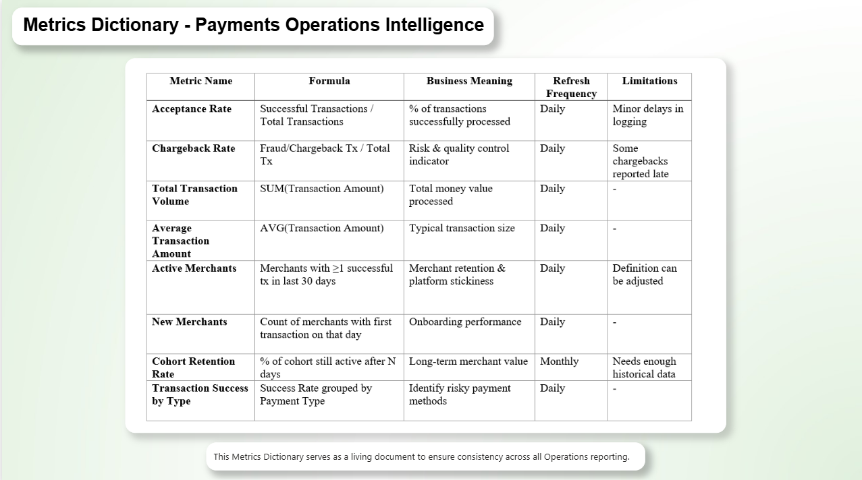

5.3 Key DAX Measures Built
- Acceptance Rate = DIVIDE(COUNTROWS(FILTER(transactions_clean, is_success=1)), COUNTROWS(transactions_clean))
- Fraud Rate = DIVIDE(SUM(isFraud), COUNTROWS(transactions_clean))
- Merchant Retention Rate = DIVIDE(active merchants day N, active merchants day 1)
- Avg Transaction Value = DIVIDE(SUM(amount), COUNTROWS(transactions_clean))
- Flagged-Not-Fraud Count = COUNTROWS(FILTER(..., isFlaggedFraud=1 && isFraud=0))

6. Key Findings

Finding | Value | Status | Action
Platform Acceptance Rate | 99.87% | Excellent | Maintain & monitor daily
Chargeback Rate | 0.13% | Good | Watch TRANSFER type closely
TRANSFER Fraud Concentration | 42.45% of volume | Risk Flag | Prioritize fraud controls
Day-1 Cohort Dominance | Top 5 cohorts = 80% volume | Insight | Study early cohort behavior
Daily Volume Spike (Day 13) | 138.99bn peak | Anomaly | Investigate root cause
Flagged-but-Not-Fraud Rate | isFlaggedFraud > isFraud | Risk Gap | Tune detection model

6.1 Notable Observations
Cohort Behavior
The first 5 merchant cohorts (Days 1-5) account for approximately 80% of total transaction volume. This suggests that early merchant onboarding quality has outsized long-term impact on platform performance — a critical insight for merchant success teams.
Fraud Concentration
TRANSFER transactions represent 42.45% of total volume but carry disproportionately higher fraud risk. CASH_OUT shows the highest transaction count but lower average value. The gap between isFlaggedFraud and isFraud indicates the detection model has a significant false-positive rate that warrants tuning.
Daily Anomaly
Day 13 shows a volume spike to 138.99bn — over 2x the average daily volume. This type of anomaly could indicate a major merchant onboarding event, a promotional campaign, or a data quality issue — and would require immediate investigation in a live environment.

7. Recommendations

7.1 Immediate Actions
- Deploy real-time chargeback alerting threshold: trigger review when daily rate exceeds 0.20%.
- Prioritize fraud model retraining for TRANSFER type — current flagging precision is suboptimal.
- Investigate Day 13 volume anomaly before using data for forecasting models.

7.2 Strategic Recommendations
- Implement the Metrics Dictionary as a living document maintained by the Operations team — assign ownership per KPI.
- Use cohort retention heatmap as a standard onboarding quality score for merchant success KPIs.
- Build automated daily digest: acceptance rate, fraud rate, and chargeback rate emailed to ops leadership each morning.
- Segment merchants into tiers based on cohort performance — apply differentiated support and monitoring.

8. Skills Demonstrated
Skill Area | Evidence in This Project
KPI Definition & Documentation | 8-metric Metrics Dictionary with formulas, targets, and business meaning.
Cohort Analysis | Merchant retention grid, cohort-day segmentation, behavioral pattern detection.
Data Engineering | Python pipeline: cleaning, feature engineering, 3-table schema design.
Advanced Power BI | DAX measures, drillthrough pages, custom tooltips, conditional formatting.
Fraud & Risk Analytics | isFraud/isFlaggedFraud gap analysis, type-level risk profiling.
Business Communication | Executive summary page, annotated anomalies, leadership-ready narrative.
Operational Thinking | Recommendations tied to business impact, not just data observations.

9. Tools & Technologies
- Python 3.x with Pandas — data cleaning, feature engineering, cohort logic, KPI calculation.
- Power BI Desktop — 4-page interactive dashboard, DAX measures, drillthrough, conditional formatting.
- DAX (Data Analysis Expressions) — custom measures for acceptance rate, fraud rate, cohort retention.
- GitHub — version control, README documentation, project portfolio hosting.
- PaySim Dataset — open-source synthetic financial transaction simulator.

Fadwa Ramadan Ali Hassan | May 2026

