Industrial Bottle Anomaly Detection
Technical Debugging Log
1. Executive Summary
This document logs the iterative development and technical troubleshooting phases for our Convolutional Autoencoder designed to detect structural anomalies (cracks, chips, and foreign objects) in industrial bottle imagery. Through rigorous architectural modifications including LeakyReLU integration, a high-compression bottleneck vector, tensor denormalization, and Top 1% spatial pooling the model evolved from initial baseline collapse to achieving an overall test set performance of 84.76% AUROC.
2. Chronological Debugging & Iteration Stages
Stage 1: Initial Failure — Model Collapse & Activation Saturation
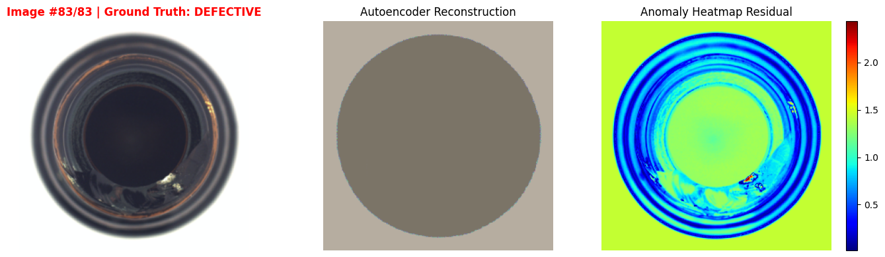
- Observed Symptom: The model reconstruction yielded a completely flat, featureless grey disc accompanied by a uniform yellow-green residual map covering the entire image area.
- Root Cause: Severe neuron death and activation saturation. Standard ReLU functions killed off negative gradients during backpropagation across normalized inputs, while a trailing Sigmoid layer squashed output pixel predictions outside natural normalized boundaries.
- Technical Resolution: Replaced standard ReLU with LeakyReLU(0.2) to maintain gradient flow for negative values, integrated BatchNorm2d layers to stabilize feature distributions, and removed Sigmoid from the final layer.
Stage 2: High-Capacity Shortcut — Defect Replication
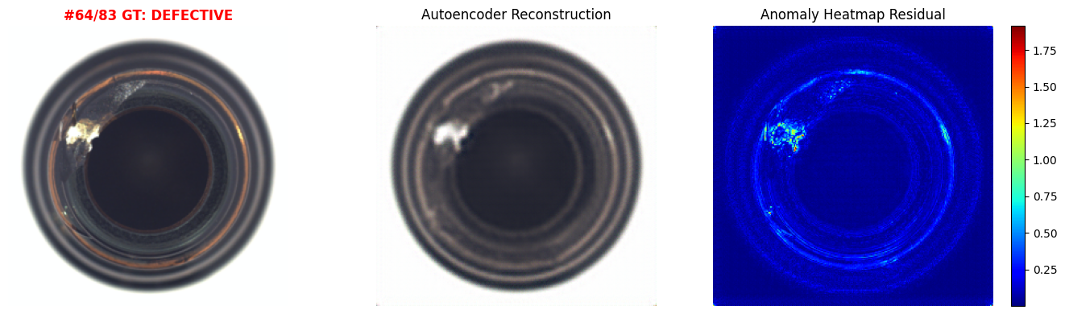
- Observed Symptom: The reconstruction generated a sharp image of the bottle, but faithfully rebuilt the severe glass fracture/chip directly onto the output image, resulting in a dark, unresponsive anomaly heatmap.
- Root Cause: Excessive spatial capacity allowed the network to learn an identity shortcut where high-frequency defect details passed straight through without filtering.
- Technical Resolution: Introduced a tight linear compression bottleneck (fc_encode / fc_decode) squeezing feature maps down to a 128-dimensional vector (1,024× compression ratio), forcing the network to discard flaw details and output generalized, 'healed' bottle structures.
Stage 3: Visualization Correction — RGB Color Normalization
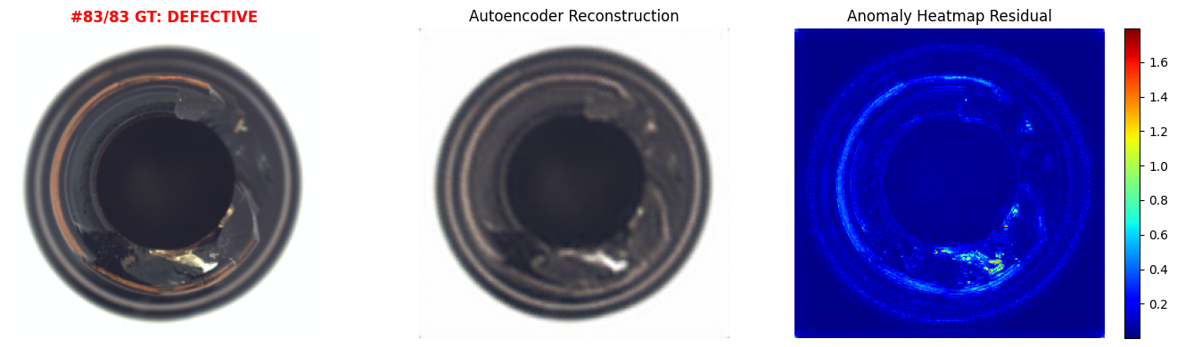
- Observed Symptom: Reconstructions successfully removed defects, but rendered images appeared discolored, dark, or inverted when displayed.
- Root Cause: ImageNet normalization produces pixel tensors in the range [-2.1, +2.2]. Plotting raw tensors directly caused libraries to clip negative values to zero, distorting the color space.
- Technical Resolution: Implemented an explicit denormalization step (Tensor × σ + μ) prior to plotting, restoring standard [0, 1] RGB color rendering for accurate visual inspection.
Stage 4: Optimization — Successful 'Healing' & High-Contrast Heatmaps
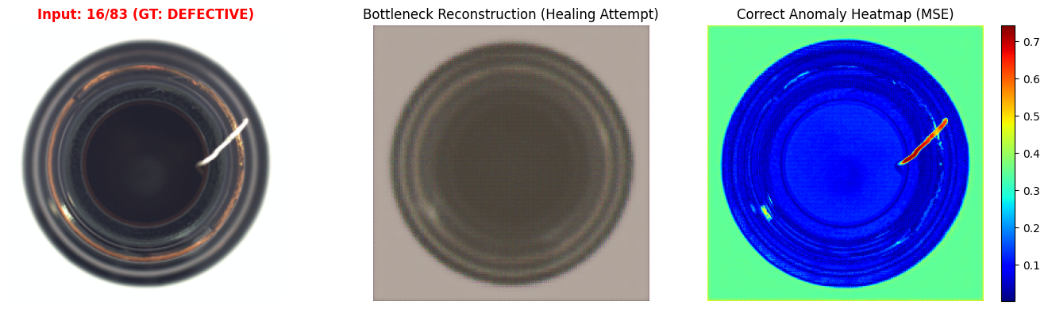
- Observed Symptom: Initial anomaly scores yielded a minimal score gap (~0.0088) and 70.56% AUROC because global mean averaging diluted tiny local defects across healthy background pixels.
- Root Cause: A crack or foreign object occupies only 1–3% of the total pixels; averaging across all 65,536 pixels drowns out the localized anomaly signal.
- Technical Resolution: Switched from global mean error to Top-1% spatial pooling, isolating the worst 1% of reconstructed pixels (k ≈ 655). This widened the score gap to 0.1167 and boosted test set AUROC to 84.76%.

3. Project Milestones Summary Table
Progression Stage | Observed Image Problem | Root Cause | Resolution Implemented | Result / Metric
1. Baseline Setup | Flat grey reconstruction | Neuron death (ReLU) & Sigmoid squashing | Applied LeakyReLU(0.2) + BatchNorm2d; removed output activation | Restored structural generation
2. Bottleneck Tuning | Reconstructed defects onto output | High spatial capacity / Identity shortcut | Built 128-dim dense vector bottleneck (1024× compression) | Forced model to 'heal' defects
3. Display Pipeline | Dark / discolored plots | Raw normalized values plotted directly | Added tensor denormalization (× σ + μ) before plotting | True RGB visual representation
4. Anomaly Isolation | Weak gap between good and bad images | Global mean diluted tiny local defects | Implemented Top-1% spatial error pooling | 84.76% AUROC on test set

