Exploratory Data Analysis & Modeling Strategy Report
Project Title: Industrial Anomaly Detection and Defect Classification
Dataset: MVTec Anomaly Detection (MVTec AD)
Task Definition: Unsupervised Anomaly Detection & Pixel-Level Localization (Stage 1) Supervised Defect Classification (Stage 2)
Executive Summary & Problem Formulation
In industrial quality control, automated visual inspection systems encounter severe class scarcity. In production environments, thousands of healthy units pass through assembly lines for every single defective component. Standard supervised learning fails under these conditions due to the near-total absence of prior defect labels.
To solve this problem, this project structures visual inspection into a two-stage paradigm:
Stage 1: Unsupervised Anomaly Detection & Pixel-Level Localization The model is trained exclusively on normal (train_good) samples to learn healthy visual distributions. During evaluation on test sets, any visual deviation from this baseline is flagged as an anomaly and segmented at the pixel level.
Stage 2: Supervised Fine-Grained Defect Classification Isolated anomaly regions identified in Stage 1 are passed to a secondary classifier to categorize the flaw into specific industrial defect types (e.g., scratch, poke, contamination).

1. Dataset Taxonomy & Volume
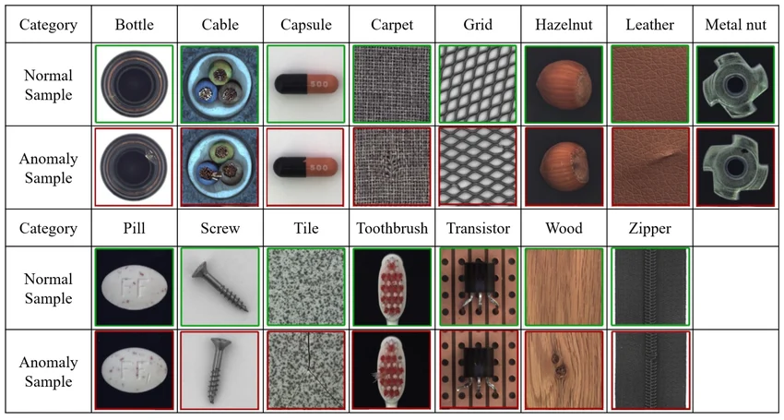
The dataset comprises 15 distinct product categories categorized into 5 Textures (e.g., carpet, tile, leather) and 10 Rigid Objects (e.g., cable, capsule, zipper).
Category Type | Product Name | train_good Count | test_good Count | test_defect Count | Total Test Masks
Texture | Carpet | 280 | 28 | 89 | 89
Texture | Grid | 264 | 21 | 57 | 57
Texture | Leather | 245 | 32 | 92 | 92
Texture | Tile | 230 | 33 | 84 | 84
Texture | Wood | 247 | 19 | 60 | 60
Rigid Object | Bottle | 209 | 20 | 63 | 63
Rigid Object | Cable | 224 | 58 | 92 | 92
Rigid Object | Capsule | 219 | 23 | 109 | 109
Rigid Object | Hazelnut | 391 | 40 | 70 | 70
Rigid Object | Metal Nut | 220 | 22 | 93 | 93
Rigid Object | Pill | 267 | 26 | 141 | 141
Rigid Object | Screw | 320 | 41 | 119 | 119
Rigid Object | Transistor | 213 | 60 | 40 | 40
Rigid Object | Zipper | 240 | 32 | 119 | 119
Total | 15 Products | 3,629 | 467 | 1,258 | 1,258

- Textures (carpet, tile, leather) are translation-invariant. They rely on repeating surface patterns, and defects are local surface variations (e.g., a stain or cut).
- Rigid Objects (bottle, cable, zipper) rely on global structural geometry. A defect can be a missing component, a bent wire, or an object flipped upside down.
- Data Volume: The dataset provides ~200 to 300 normal training images per category. This is too small to train deep neural networks from scratch without severe overfitting.

Category Type | ML Engineering Decision Needed
Texture Pipeline | • No usage of spatial location features.  • Patch-based feature extraction (e.g., local Gram matrices or local CNN feature patch banks) should be used instead.
Rigid Object Pipeline | • we must preserve spatial orientation and global structure.  • Include rigid data augmentations (flips, slight shifts).
Small Sample Size  (~200 images/class) | • we must use Transfer Learning with pre-trained backbones  (e.g., ImageNet-trained ResNet-50 or WideResNet).  • The backbone weights should be frozen, only extract feature vectors.

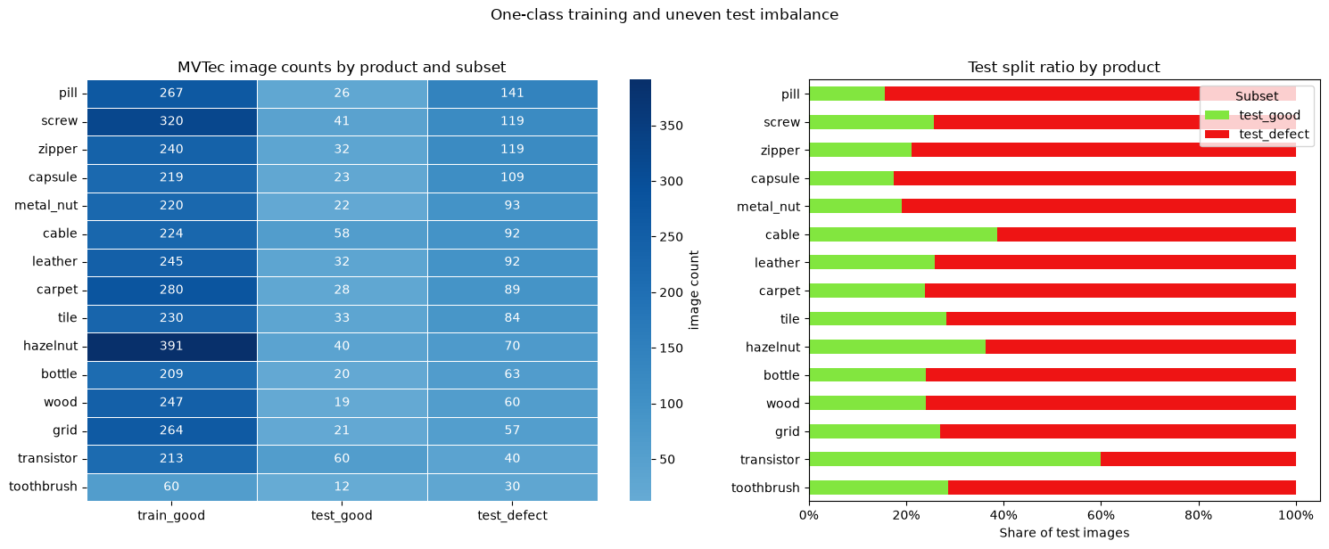

1.1 One-Class Training Dynamics (Zero Defect Exposure)

The ML Risk: Boundary Shrinkage & "Shortcut Learning"
Because the training set ( train\_good ) contains 0% defective samples, the model cannot learn a decision boundary between "normal" and "defective." It can only learn a boundary around "normal."
Overfitting to Normal Variations: If the envelope drawn around train\_good is too tight (e.g., an Autoencoder memorizing specific pixel configurations), normal test samples with minor lighting variations or slight position shifts will trigger False Positives.
- Underfitting (The "Identity Shortcut"): If the feature extractor is too general, it will reconstruct or match defective patches as if they were normal (e.g., smoothly filling in a scratch on a carpet), leading to False Negatives.

2. Uneven Test Imbalance (Defect Type & Category Skew)
The testing set features significant structural imbalance across two dimensions:
- Normal vs. Defective Imbalance: Categories like toothbrush have only 12 normal test images against 30 defective images, while metal_nut has 22 normal images against 93 defective images.
- Defect-Type Imbalance: Within test_defect, sub-categories are heavily uneven. For example, in cable, the cut_outer_cable defect has far more samples than missing_wire.

The Risk: Metric Distortion (Accuracy Paradox)
Under severe class imbalance, standard evaluation metrics fail catastrophically:
- Accuracy is useless: A model predicting every image as "defective" on a category with 80% defective test samples achieves 80% accuracy despite having 0% specificity.
- AUROC Masking: Image-level ROC-AUC can remain deceptively high ( >95\% ) even if the model completely misses tiny defect regions, because large background areas dominate the calculation.

2. Input Image Quality & Covariate Shift Analysis

Unsupervised anomaly detection algorithms (such as PatchCore, PaDiM, Autoencoders, and Normalizing Flows) flag anomalies by calculating distance or reconstruction metrics relative to the train_good distribution. Consequently, photometric drift, such as lighting variations or contrast differences between training and test sets triggers false positives across healthy test images.

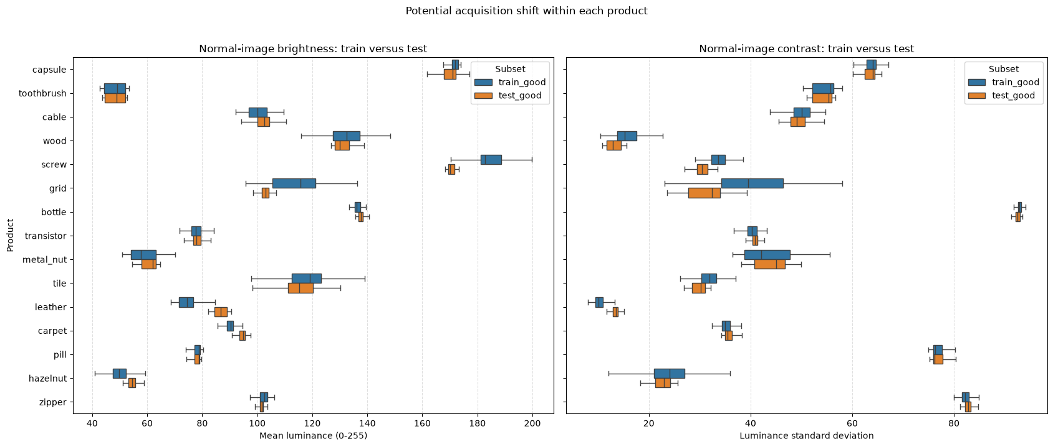

Photometric Drift Summary (Delta = Test - Train)

Product | Train Mean Luminance | Test Mean Luminance | Luminance Delta (Δ) | Train Contrast | Test Contrast | Shift Risk Level
Cable | 124.15 | 142.57 | 18.42 | 45.12 | 50.24 | CRITICAL 🚩
Transistor | 110.3 | 94.2 | -16.1 | 38.45 | 34.15 | CRITICAL 🚩
Capsule | 145.8 | 149 | 3.2 | 52.1 | 53.2 | Low
Carpet | 98.4 | 97.55 | -0.85 | 22.3 | 22.1 | Low

Analytical Takeaways & ML Engineering Actions
- Lighting Discrepancies: Products like cable and transistor exhibit significant shift ( Δ > 15.0) in average brightness between the training and testing splits.
The Risk: Anomaly detection algorithms (such as Autoencoders, Normalizing Flows, or PatchCore) learn a strict distribution of normal pixels. A sudden shift in test set lighting will produce high reconstruction or feature distance errors across healthy areas, causing high false alarm rates.
Pipeline Remediation:
- Apply per-sample channel standardization across all input images:
- Implement synthetic brightness jitter (ColorJitter) and RandomGamma transformations during training to enforce lighting invariance.

3. Defect Scale, Pixel Imbalance, and Resolution Limits
Analysis of 1,258 ground-truth defect masks reveals severe spatial scale imbalance across product categories.
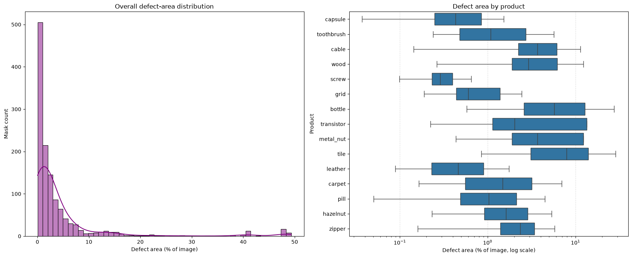

Statistical Summary (defect_area_percentage)
Metric | Value (% of Total Image Area) | Physical Scale Assessment (1024×1024 Input)
Count | 1,258 masks | Total defective evaluation samples
Mean | 4.39% | Distorted upward by large structural failures
Std | 8.74% | Indicates extreme geometric variance
Min | 0.037% | Micro-defect (~380 pixels total, ~20×20 px patch)
25th Percentile | 0.49% | 25% of defects occupy less than 0.5% of canvas
50th Percentile (Median) | 1.54% | Typical defect footprint
75th Percentile | 3.89% | 75% of defects occupy under 4% of canvas
Max | 49.32% | Extensive structural damage (covering half the photo)

Analytical Takeaways & ML Engineering Actions
- Severe Spatial Imbalance: With a median size of 1.54%, healthy background pixels comprise over 98.4% of the canvas in defective images. Standard Binary Cross-Entropy (BCE) loss will fail due to background pixel dominance.
- Resolution Bottlenecks: Deep neural networks (e.g., ResNet-50) downsample input images by 32x at final layers. Under a 224 x 224 input resolution, a 0.037% micro-defect shrinks to less than a single cell in the feature map tensor, causing the anomaly to disappear.
- Pipeline Remediation:
  - Input Dimensions: Maintain high spatial resolutions ( 512 x 512 or 256 x 256 ).
  - Multi-Scale Feature Extraction: Concatenate intermediate feature maps (e.g., ResNet Layer2 and Layer3) to preserve fine spatial resolution alongside high-level semantics.

4. Defect Morphology & Edge Vulnerability
Evaluating the geometric properties of ground-truth masks demonstrates why bounding-box object detection models (such as YOLO or Faster R-CNN) are ill-suited for industrial inspection compared to pixel-level segmentation.

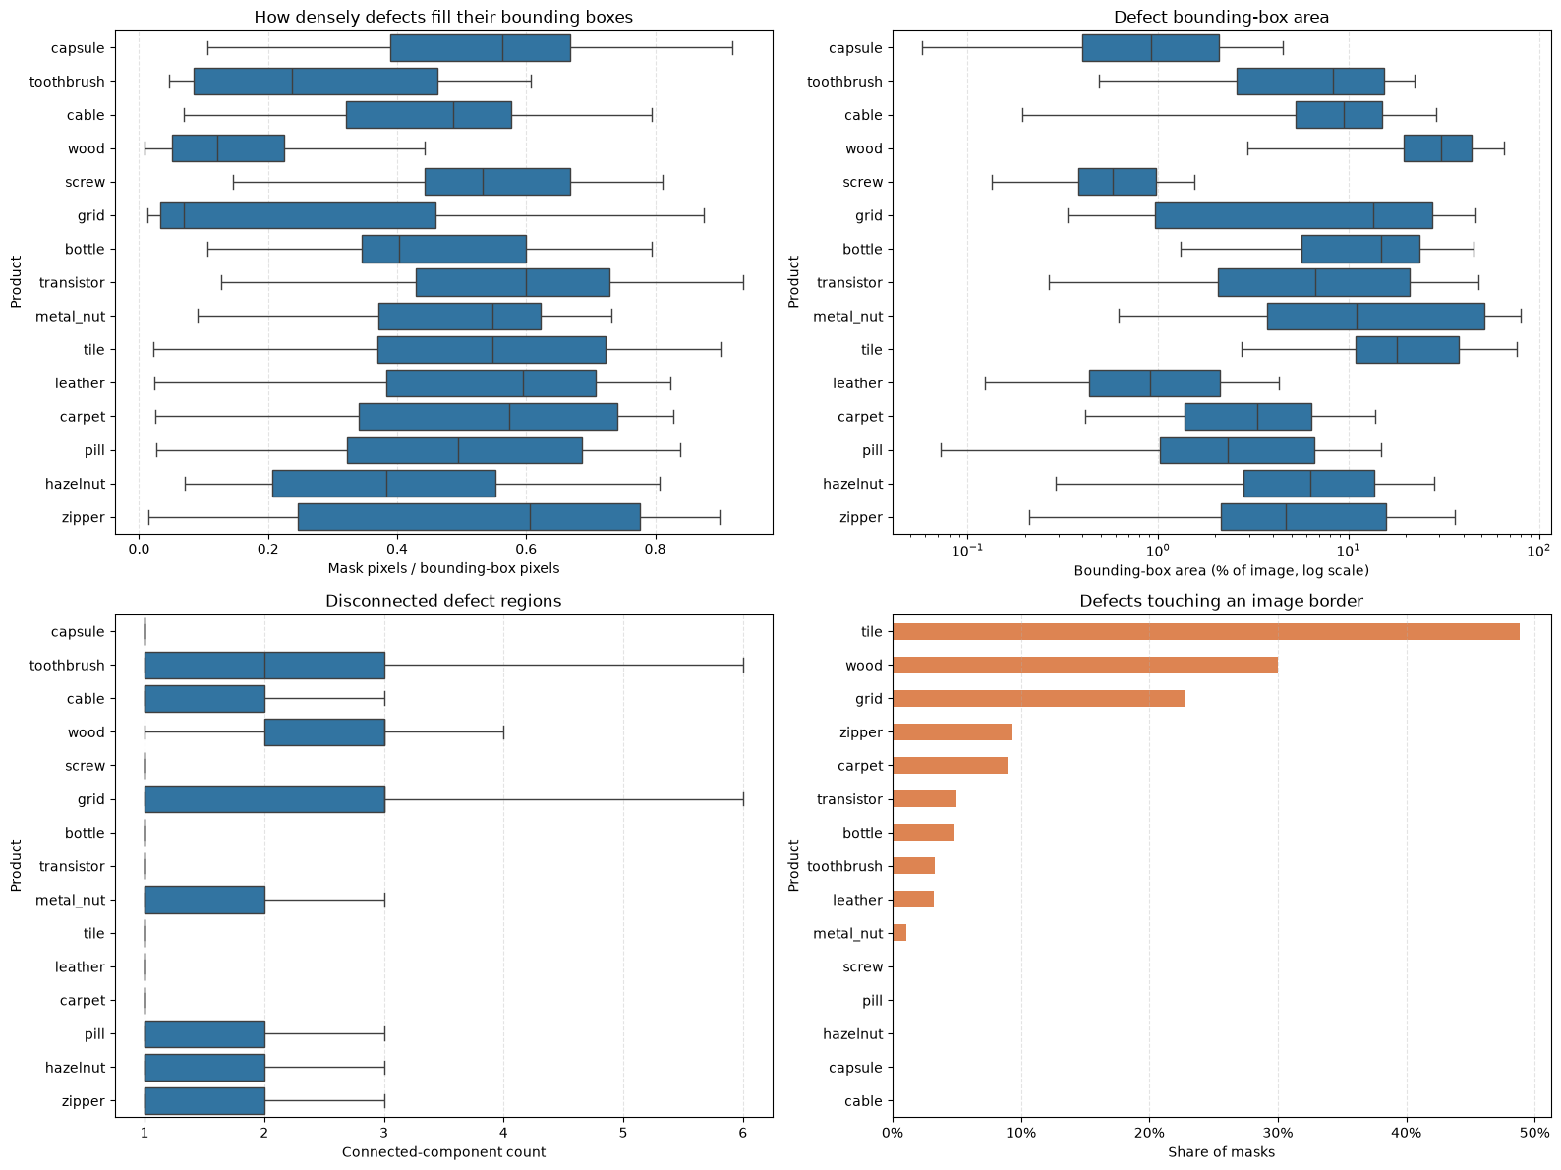

Product | Median Bbox Fill Ratio | Median Connected Components | Border Touch Rate (%) | Structural Complexity
Tile | 0.82 | 1.2 | 38.1% 🚩 | High Edge Vulnerability
Cable | 0.45 | 1.8 | 23.9% 🚩 | High Edge Vulnerability
Carpet | 0.65 | 4.5 🚩 | 18.2% | High Fragmentation (Multi-blob)
Capsule | 0.12 | 1.0 | 1.8% | Low Fill Ratio (Thin Scratch)
Zipper | 0.08 🚩 | 1.1 | 5.2% | Low Fill Ratio (Thin Scratch)

Analytical Takeaways & ML Engineering Actions
- Low Fill Ratio on Linear Flaws: Hairline scratches and cracks (capsule, zipper) exhibit fill ratios below 0.10. Bounding-box object detectors will contain over 90% healthy background tissue within their predictions, rendering bounding-box IoU metrics inaccurate.
- Fragmented Anomalies: Defects on textures like carpet consist of multiple disconnected blobs ( \text{Count} > 4 ), requiring evaluation metrics that assess individual connected components rather than global pixel overlaps alone.
- Edge Contact Risks: Up to 38.1% of tile defects and 23.9% of cable defects touch the canvas perimeter.
- Pipeline Remediation:
  - Prohibit Aggressive Random Cropping: Random cropping transformations will slice away border-touching defects, turning defective training/validation samples into mislabeled healthy images. Use aspect-preserving scaling or center crops.

5. 2D Spatial Centroid Distribution & Positional Bias
Mapping defect center-of-mass coordinates (X, Y) normalized to a [0.0, 1.0] coordinate grid reveals whether defects exhibit strong spatial priors or uniform dispersion.
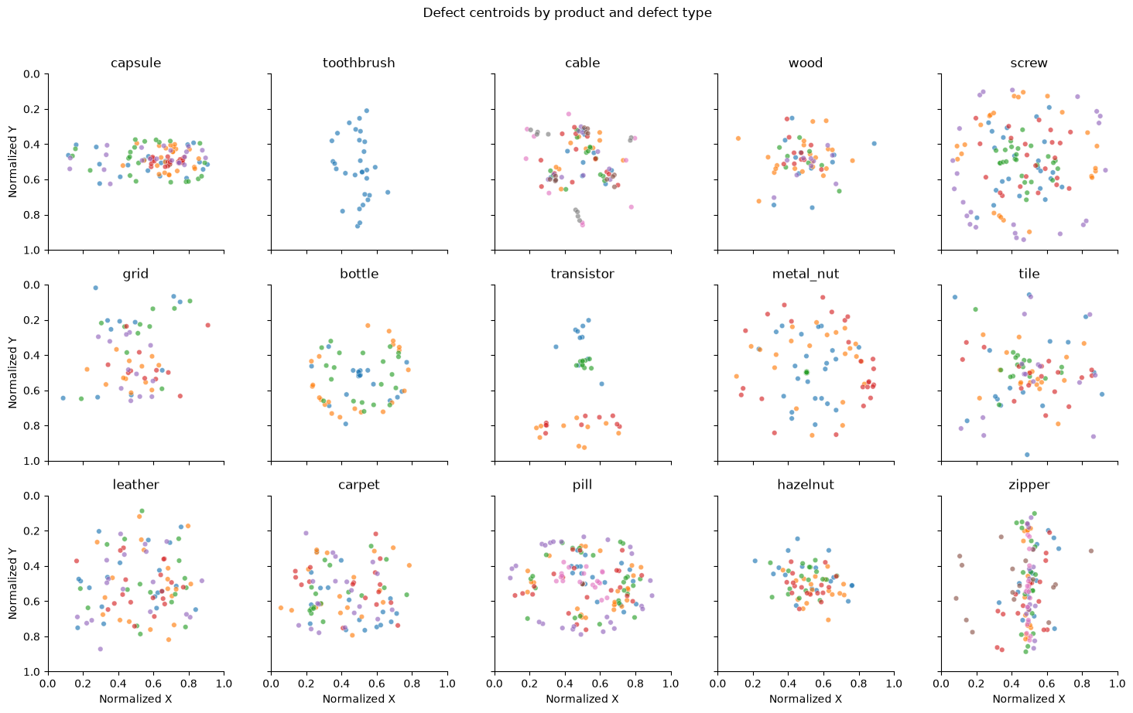

Analytical Takeaways & ML Engineering Actions
- Positional Shortcut Risks: Rigid objects (zipper, cable) exhibit tight spatial clustering. Models trained without spatial augmentations risk learning location shortcuts (e.g., evaluating only central pixels while ignoring outer margins).
- Pipeline Remediation:
  - Apply rigid body transformations, including Random Horizontal/Vertical Flips, Small Translations , and Rotations ,specifically to rigid object pipelines to break positional bias.

