Quantitative Methods in Political Science - Homework 2
Fatih Özhasar
Due: September 22, 2022

Part 1: Definitions
1.1 Define in one sentence what a random variable is. Give two examples from your field of studies. One with a discrete and one with continuous realizations.
A random variable is a function that assigns a number to each outcome of the sample space of an experiment.
The number of time a MP deviate from party line can be given as an example if discrete and increase of vote share of a party in a decade can be given as an example of continuous realization
1.2. Define in one sentence what is meant by the colloquial phrase “the probability of x is…”
Answer: the probability of an x event means that long-run relative frequency of an x.

Part 2: Probability in R
You should get familiar with the basic probability distributions and their behavior. In the following you will have to plot several of them. Please choose a suitable way of displaying them in each case (i.e., adjust axis limits, choose informative labels).
2.1. Plot the density function of a normal distribution with mean 1 and variance of 1. Then plot the cumulative distribution function of this variable.
x_values <- seq(from = -6, to = 6, by = 0.1)
plot(x = x_values,
y = dnorm(x_values, mean = 1, sd = 1),
bty = "n",
las = 1,
type = "l",
col = viridis(1),
lwd = 2,
main = "PDF of N(1, 1)",
ylab = "f(x)",
xlab = "x"
)
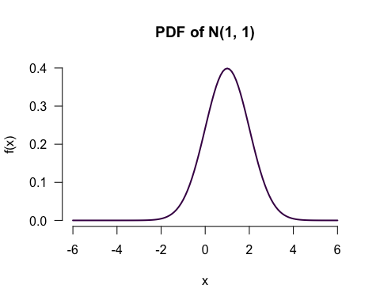
plot(x = x_values,
y = pnorm(x_values),
bty = "n",
las = 1,
type = "l",
col = viridis(1),
lwd = 2, #line with
main = "CDF of N(1, 1)", #title
ylab = "F(x)",
xlab = "x"
)
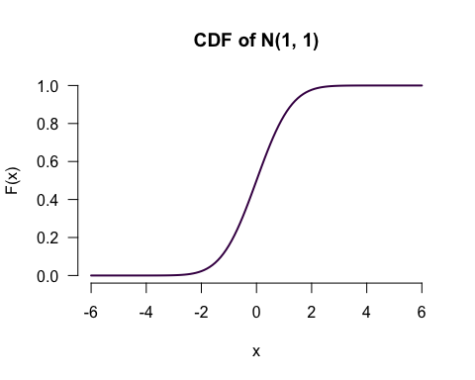
x_values <- seq(from = -5, to = 5, by = 0.1) # seq go from 0.5 to 5 by 0.1 range
plot(x = x_values,
y = dnorm(x_values), #calculate the density
bty = "n",
las = 1,
type = "p",
col = viridis(1),
lwd = 2,
main = "PDF of N(0, 1)",
ylab = "f(x)",
xlab = "x"
)
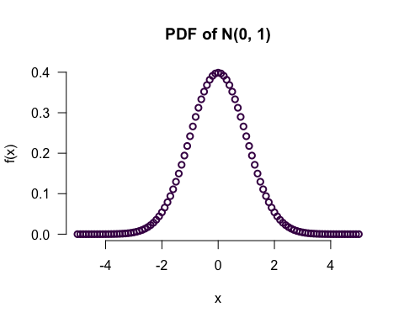
# below is to have a line to have a continuous line type= "l"
plot(x = x_values,
y = pnorm(x_values),
bty = "n",
las = 1,
type = "l",
col = viridis(1),
lwd = 2, #line with
main = "CDF of N(0, 1)", #title
ylab = "F(x)",
xlab = "x"
)
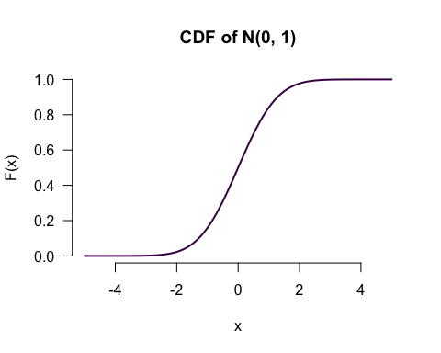
dnorm(0, mean = 1, sd = 1) #density function of a normal distribution with mean 1 and variance of 1
## [1] 0.2419707
plot(dnorm)
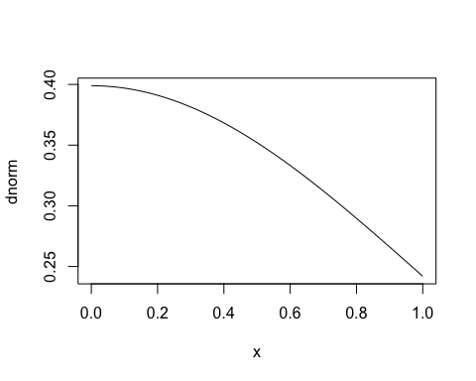
#plot the cumulative distribution function of this variable.
x_values <- 0:100
plot(x = x_values,
y = pbinom(x_values, size = 100, p = 0.5),
type = "p",
main = "CDF for Binomial (n = 100, p = 0.5)",
xlab = "x",
ylab = "Probability",
bty = "n",
las = 1,
pch = 19,
cex = 0.3,
col = viridis(1),
frame = F
)
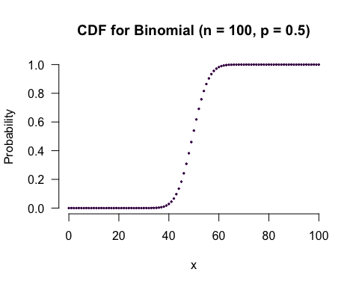
2.2. Briefly explain the difference between the density function and the cumulative distribution function.
Answer:
Probability Density Function, returns the probability of a given continuous outcome while the Cumulative Distribution Function, returns the probability of a value less than or equal to a given outcome.
2.3. Plot the density function and the cumulative distribution function of a standard normal distribution.
dnorm(20, mean = 0, sd = 1) #density function
## [1] 5.520948e-88
pnorm(20, mean = 0, sd = 1) #cumulative distribution function
## [1] 1
x_values <- seq(from = -5, to = 5, by = 0.1) # seq go from 0.5 to 5 by 0.1 range
plot(x = x_values,
y = dnorm(x_values), #calculate the density
bty = "n",
las = 1,
type = "p",
col = viridis(1),
lwd = 2,
main = "PDF of N(0, 1)",
ylab = "f(x)",
xlab = "x"
)
# below is to have a line to have a continuous line type= "l"
plot(x = x_values,
y = pnorm(x_values),
bty = "n",
las = 1,
type = "l",
col = viridis(1),
lwd = 2, #line with
main = "CDF of N(0, 1)", #title
ylab = "F(x)",
xlab = "x"
)
plot(dnorm)
plot(pnorm)
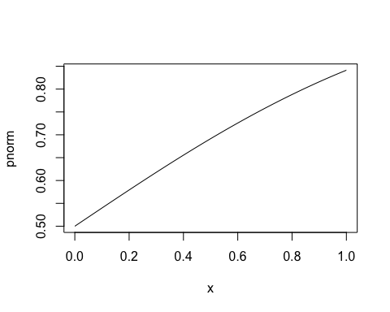
2.4. Plot the probability mass function of a random variable that follows a binomial distribution with 30 trials and a success probability of $\frac{1}{2}$.
x_values <- 0:100
# Now we produce an empty plot.
plot(
x = x_values,
ylim = c(0, 0.1), # With ylim you can adjust the limits of the y axis.
type = "n", # type "n" produces an empty plot window.
main = "PMF for Binomial (n = 30, p = 0.5)",
xlab = "x",
ylab = "p(x)",
las = 1,
frame = F
)
# Let's add the points.
points(x_values,
dbinom(x_values, size = 30, p = 0.5),
cex = 0.3,
pch = 19,
col = viridis(1)
)
# And lines
segments(x0 = x_values,
y0 = 0,
x1 = x_values,
y1 = dbinom(x_values, size = 30, p = 0.5),
col = viridis(1)
)
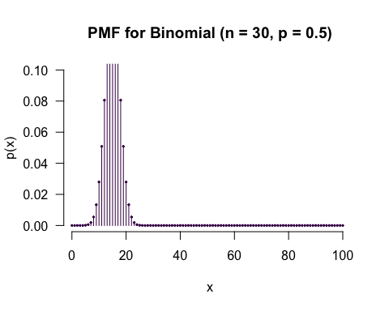
rbinom(n = 1, size = 30, prob = 0.5)
## [1] 13
# First, we need an x-axis
x_values <- 0:40
# Now we produce an empty plot.
plot(
x = x_values,
ylim = c(0, 0.15), # With ylim you can adjust the limits of the y axis.
type = "n", # type "n" produces an empty plot window.
main = "PMF for Binomial (n = 30, p = 0.5)",
xlab = "x",
ylab = "p(x)",
las = 1,
frame = F
)
# Let's add the points.
points(x_values,
dbinom(x_values, size = 30, p = 0.5),
cex = 0.3,
pch = 19,
col = viridis(1)
)
# And those lines we know from the lecture.
segments(x0 = x_values,
y0 = 0,
x1 = x_values,
y1 = dbinom(x_values, size = 30, p = 0.5),
col = viridis(1)
)
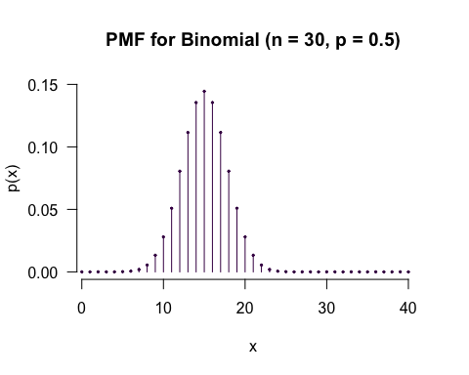
x_values <- 0:50
plot(x = x_values,
y = pbinom(x_values, size = 50, p = 0.5),
type = "p",
main = "CDF Fair coin (n = 50, p = 0.5)",
xlab = "coin tosses",
ylab = "Probability",
bty = "n",
las = 1,
pch = 19,
cex = 0.3,
col = viridis(1),
frame = F
)
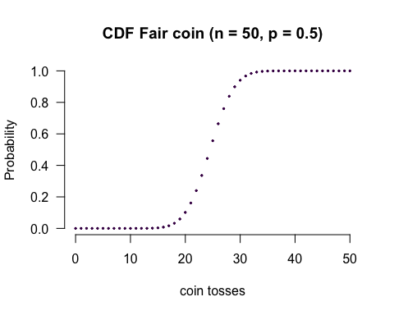
#a biased coin: let the probability of having a Head be 0.60.
plot(x = x_values,
y = pbinom(q = x_values, size = 50, p = 0.6),
bty = "n",
las = 1,
pch = 19,
xlab = "coin tosses",
ylab = "Probability of having head",
main = "CDF biased coin (n = 50, p = 0.6)",
cex = 0.5,
col = viridis(1),
frame = F
)
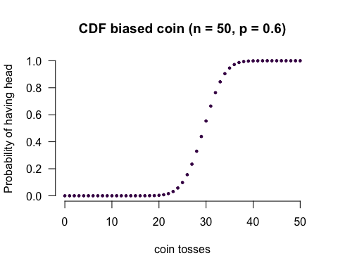
2.5. Compare the cumulative distribution function of 50 coin tosses for (i) a fair coin and (ii) a biased coin (choose the amount of bias yourself).
rbinom(n = 1000, size = 50, prob = 0.5) #(i) a fair coin
## [1] 31 26 31 23 22 26 20 26 27 17 29 32 21 26 26 20 32 33 28 28 20 21 20 26
## [25] 23 22 26 28 22 25 22 19 21 23 29 26 19 27 29 28 27 24 18 25 20 25 31 22
## [49] 21 21 24 27 31 29 24 27 18 23 27 19 23 30 20 32 27 23 23 27 30 27 24 26
## [73] 24 30 23 24 30 28 27 22 27 32 26 25 26 22 23 29 31 29 26 23 19 24 20 25
## [97] 27 26 25 26 29 26 26 25 22 22 25 23 22 22 21 27 26 25 29 27 23 26 29 25
## [121] 18 28 22 26 23 20 24 23 23 25 23 23 27 21 21 25 27 28 22 22 22 28 32 26
## [145] 31 25 25 24 28 31 28 27 22 25 23 25 27 25 22 28 31 26 23 25 29 27 30 26
## [169] 26 23 27 24 20 27 19 25 27 23 27 29 23 23 33 29 27 24 24 29 28 25 22 29
## [193] 25 27 29 22 26 26 25 22 32 25 23 27 24 26 27 23 25 31 24 18 31 27 26 28
## [217] 21 24 18 26 29 20 29 29 31 28 23 22 26 25 25 26 25 24 20 27 25 22 21 29
## [241] 29 22 25 14 31 22 26 25 26 26 20 28 26 27 19 24 24 30 22 31 21 28 20 21
## [265] 27 17 26 21 30 32 26 23 24 21 26 29 29 20 20 24 24 25 19 22 28 30 20 19
## [289] 28 20 30 25 22 23 25 26 22 24 26 20 22 21 33 26 18 25 26 21 23 24 25 27
## [313] 26 27 25 23 17 19 23 24 25 30 32 22 19 35 23 20 30 26 32 19 26 24 25 20
## [337] 24 32 23 22 26 23 29 28 25 34 25 29 26 25 27 27 26 28 21 21 24 24 26 31
## [361] 24 24 28 29 23 24 24 23 27 26 29 22 19 18 26 31 24 34 19 26 22 25 20 18
## [385] 20 20 33 24 25 24 25 26 25 28 28 25 27 24 21 25 27 24 23 25 28 27 19 23
## [409] 26 22 31 28 20 23 20 26 27 23 24 26 20 25 20 23 28 25 26 28 22 26 16 22
## [433] 22 21 28 31 23 26 19 29 26 28 21 21 23 27 27 26 26 30 25 26 26 24 19 22
## [457] 26 30 22 22 26 25 28 31 27 31 28 26 25 26 30 23 23 27 29 22 27 23 24 25
## [481] 20 23 23 21 24 25 18 27 21 27 31 25 28 22 18 25 17 29 19 18 30 25 24 25
## [505] 23 21 26 19 24 29 26 27 25 24 23 23 29 21 22 21 26 19 34 20 23 27 26 20
## [529] 28 20 21 26 26 22 25 20 23 25 30 25 29 25 26 29 29 23 23 27 27 23 23 26
## [553] 25 27 27 31 22 24 27 24 17 26 21 23 26 26 26 30 20 22 25 31 26 17 25 23
## [577] 24 30 23 25 26 28 29 29 23 25 27 29 25 20 22 26 23 20 21 25 26 23 20 23
## [601] 23 27 27 33 20 24 29 25 28 24 23 29 24 26 25 25 28 23 25 27 26 19 24 24
## [625] 25 25 19 25 22 26 25 21 19 24 28 23 25 28 25 30 19 21 26 27 28 32 26 25
## [649] 24 28 25 24 27 27 23 22 25 23 25 28 21 29 28 30 28 28 30 29 24 18 23 22
## [673] 16 22 27 29 25 23 22 21 23 26 27 26 26 25 30 20 23 27 26 23 17 18 23 20
## [697] 26 22 30 28 28 30 20 27 25 21 25 30 19 22 21 27 25 24 23 20 32 28 27 20
## [721] 24 20 28 25 27 29 24 28 27 26 23 22 25 25 27 26 21 20 27 27 19 24 21 25
## [745] 31 29 28 23 26 24 20 24 26 30 24 28 28 28 22 28 27 28 23 21 22 30 28 18
## [769] 27 19 27 27 24 23 27 20 27 28 25 25 23 22 23 24 25 21 27 32 23 26 30 28
## [793] 30 31 19 24 23 23 28 29 23 29 27 23 20 34 22 22 23 25 25 29 24 23 25 29
## [817] 23 21 21 24 24 32 28 29 28 29 23 31 29 34 27 22 31 25 26 22 28 23 29 28
## [841] 15 30 20 27 21 28 22 25 24 26 19 24 22 25 19 25 21 20 22 25 24 26 28 21
## [865] 26 28 29 29 27 31 23 24 29 26 25 29 29 21 27 27 23 22 22 22 28 21 23 25
## [889] 18 25 23 26 23 18 27 21 21 19 22 21 27 29 22 25 26 28 25 30 26 29 26 22
## [913] 31 28 24 26 22 19 23 26 26 26 24 23 22 26 24 24 22 23 26 29 25 27 21 19
## [937] 18 23 22 24 27 25 29 28 15 28 23 21 24 23 19 28 24 28 25 35 24 24 27 24
## [961] 27 24 26 25 29 27 29 21 26 22 25 29 31 30 23 24 27 22 23 24 22 23 22 18
## [985] 19 23 26 17 31 29 17 23 26 19 33 26 27 27 25 27
rbinom(n = 1000, size = 50, prob = 0.75) #(ii) a biased coin
## [1] 35 36 36 42 41 37 32 40 33 40 39 37 35 36 36 32 37 43 39 42 40 41 37 37
## [25] 37 39 36 41 40 40 38 39 39 36 37 36 36 38 37 38 36 41 37 40 37 40 44 39
## [49] 36 36 43 34 37 40 36 39 39 39 44 40 41 38 35 40 29 41 30 36 38 40 40 39
## [73] 40 37 34 35 36 36 35 36 46 38 34 39 33 42 39 33 30 41 29 36 39 34 34 39
## [97] 35 41 40 40 37 33 36 34 41 38 37 40 36 30 30 33 37 39 38 40 42 34 36 35
## [121] 42 36 39 39 45 38 33 34 34 38 40 35 39 39 43 26 41 42 36 38 33 38 42 41
## [145] 38 42 36 37 39 34 40 35 38 41 38 41 35 38 36 40 32 39 36 36 36 43 40 36
## [169] 35 33 43 38 37 41 36 40 37 37 44 40 37 35 38 37 35 40 38 36 36 32 34 38
## [193] 38 35 35 36 40 40 37 38 36 38 40 42 37 32 43 42 39 39 42 36 35 38 38 35
## [217] 36 35 44 36 30 37 40 41 38 39 37 36 40 38 44 39 40 39 42 41 37 36 40 37
## [241] 38 40 38 45 38 40 37 36 35 34 41 41 36 39 41 38 37 35 39 34 40 34 39 37
## [265] 36 38 40 38 38 32 36 36 36 36 41 39 36 39 37 38 35 38 37 34 35 34 36 34
## [289] 39 34 40 32 37 37 39 33 33 38 35 39 39 39 35 38 39 43 39 35 38 39 39 42
## [313] 42 31 38 35 38 36 30 35 38 36 42 35 38 40 42 38 33 39 39 41 35 38 40 41
## [337] 39 33 38 35 44 42 31 37 37 36 44 34 35 39 39 33 41 35 43 38 37 34 38 37
## [361] 35 38 44 39 37 42 40 34 33 34 36 43 35 41 34 40 33 34 40 39 38 39 39 37
## [385] 32 37 38 42 40 30 35 33 36 38 37 40 33 36 40 34 41 40 40 37 39 33 31 36
## [409] 38 37 37 36 39 29 42 27 39 41 35 41 35 40 40 38 40 40 40 41 36 40 32 43
## [433] 35 42 43 38 38 37 39 34 44 39 34 35 37 38 35 41 38 38 30 41 41 37 26 41
## [457] 31 36 38 34 35 40 33 41 39 32 40 38 35 40 38 35 39 39 42 37 34 43 38 36
## [481] 37 34 37 35 33 41 36 37 40 36 39 33 37 41 42 33 38 40 34 39 37 38 39 41
## [505] 39 37 37 37 40 37 41 35 40 33 38 41 39 41 39 34 33 40 36 43 35 39 42 35
## [529] 39 37 35 36 36 41 31 42 33 41 38 35 35 41 34 42 35 40 37 37 33 37 37 35
## [553] 35 37 36 37 41 43 38 34 31 34 38 34 37 37 38 33 36 38 42 37 36 37 36 34
## [577] 36 38 40 33 39 35 38 37 44 38 38 42 36 40 37 36 34 28 37 38 36 38 37 37
## [601] 34 35 42 37 39 39 39 35 38 33 37 42 37 37 40 36 41 34 31 47 35 38 36 37
## [625] 39 37 41 33 37 38 44 37 41 35 38 32 40 33 38 39 38 41 34 37 35 36 35 40
## [649] 38 39 32 41 34 33 37 40 36 41 40 38 39 33 35 43 40 40 36 28 39 35 36 36
## [673] 43 40 41 34 39 35 34 36 37 40 36 40 43 35 37 36 40 39 34 43 34 41 42 41
## [697] 36 39 35 42 38 39 37 33 34 35 40 34 43 36 39 38 38 35 39 40 35 41 37 41
## [721] 40 37 36 40 41 38 35 40 34 36 39 44 38 34 39 35 33 39 37 42 35 39 39 39
## [745] 38 36 37 38 36 37 35 38 37 40 42 42 32 38 40 39 42 41 40 39 32 34 39 40
## [769] 42 37 34 40 34 39 37 44 33 35 40 39 34 42 33 38 43 38 34 40 37 39 41 33
## [793] 39 36 39 37 36 38 38 39 33 38 35 32 37 41 36 39 37 38 40 36 37 35 43 42
## [817] 33 35 35 35 35 37 41 37 39 39 38 39 36 40 38 35 40 35 35 32 33 36 41 35
## [841] 44 45 39 37 33 34 41 33 38 40 34 38 39 37 40 36 36 36 40 38 30 39 38 42
## [865] 36 37 39 35 40 40 39 35 36 39 38 39 36 36 36 42 42 32 42 33 39 29 33 36
## [889] 39 41 38 33 31 36 36 35 33 40 36 40 38 39 42 34 41 41 41 37 37 38 39 36
## [913] 37 44 37 43 35 30 41 34 35 38 38 40 34 37 40 33 33 38 31 32 39 39 34 40
## [937] 31 39 40 40 38 36 35 34 39 38 37 35 30 39 38 36 34 37 41 33 40 38 35 41
## [961] 40 30 37 39 40 41 34 39 35 41 40 41 35 33 35 45 36 40 38 32 30 38 37 35
## [985] 37 33 43 35 34 36 38 39 42 38 35 39 34 37 33 38
plot(x = rbinom(n = 1000, size = 50, prob = 0.5),
y = rbinom(n = 1000, size = 50, prob = 0.75),
type = "p",
main = "CDF for fair and biased coin",
xlab = "x",
ylab = "Probability",
bty = "n",
las = 1,
pch = 19,
cex = 0.3,
col = viridis(1),
frame = F
)
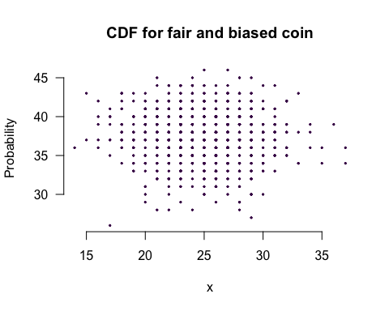

Part 3: Answer probabilistic questions
Suppose you want to forecast election results. You believe that voters are very good in forecasting the elections. Therefore, you take a sample from the voter population and ask them: What percentage of votes will the Greens receive in the upcoming elections? You find that the answers to this question in your sample approximately follow a normal distribution with a mean of 18 and a standard deviation of 3.
3.1. Plot the distribution in your sample.
pop <- rnorm(1000, mean = 18, sd = 3)
plot(density(pop),
bty = "n",
las = 1,
col = viridis(1),
lwd = 2,
main = "Density of population"
)
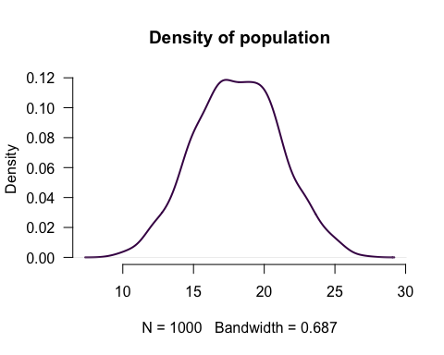
dnorm(20, mean = 18, sd = 3)
## [1] 0.1064827
plot(dnorm)
3.2. What is the percentage of voters in your sample that thought the Greens will win less than 15%?
Answer:
pnorm(q=0.15, mean = 0, sd = 1) * 100
## [1] 55.96177
population <- 0:1000
pnorm(q = 0.15, mean = 0, sd =1)
## [1] 0.5596177
3.3. How many voters in your sample thought that the Greens will win more than 20% but less than 25%?
pnorm(q = 0.25, mean = 0, sd = 1) - pnorm(q = 0.20, mean =0, sd = 1)
## [1] 0.01944662
Answer:
3.4. Last time, in the German federal election 2021, the Greens actually won around 14.8%. Is this value within the range of what 90% of the voters that are most optimistic about the success of the Greens think?
qnorm(p = 0.14, mean = 0, sd = 1)
## [1] -1.080319

Part 4: Applied probability
Just prior to the selection of the jury for O.J. Simpson’s murder trial in 1995, a poll found that about 20% of the adult population believed Simpson was innocent. For illustration, take it as the true percentage of people who thought Simpson was innocent prior to jury selection.
Assume that the 12 jurors were selected randomly and independently from the population (although this turned out not to be true).
4.1. Find the probability that the jury had at least one member who believed in Simpson’s innocence prior to jury selection.
Hint: Define the Binomial(12, 0.2) random variable X to be the number of jurors believing in Simpson’s innocence.
1 - pbinom(q = 10, size = 12, p = 0.2)
## [1] 2.00704e-07
4.2. Find the probability that the jury had at least two members who believed in Simpson’s innocence.
Hint: $P\left(X≥2\right)=1−P\left(X≤1\right)$, and $P\left(X≤1\right)=P\left(X=0\right)+P\left(X=1\right).$
1 - pnorm(q = 1.96, mean = 0, sd = 1)
## [1] 0.0249979
4.3. Explain in two sentences what is the implication of random and independent selection process of jurors for our calculations.
Answer:
# 3.3
sum(pop > 20 & pop < 25)
## [1] 257
# 3.4
qnorm(p = 0.10, mean = 18, sd = 3)
## [1] 14.15535
# 4.1
1 - pbinom(q = 0, size = 12, p = 0.2)
## [1] 0.9312805
# 4.2
1 - pbinom(q = 1, size = 12, p = 0.2)
## [1] 0.7251221

