- Purpose of this document

This document describes how to implement a CI/CD pipeline for SAP work zone standard, using Cloud Transport Management (CTM).

The goal is to:
- Automate deployment of work zone content (ui cards, workpages, HTML5 apps, roles, catalogs)
- Ensure consistent delivery across DEV -> QA -> Prod tenants
- Reduce manual deployment and configuration errors
- Provide traceability and version control

- High level architecture overview

Git Repository
↓
CI Pipeline (Build & Validate)
↓
Deployable Package
↓
CD Pipeline (Trigger CTM)
↓
Cloud Transport Management
↓
DEV → QA → PROD Work Zone Tenants
↓
End users see updated content

The workflow with a step-by-step guide for implementing CI/CD + CTM for SAP work zone.
Step 1. Prepare the source code /content
- Store all your work zone content (cards, workpages, HTML5 apps etc.) in a Git repository.
- Organize it so each package or app has its own folder
- Version control is automatically handled by Git; Commits, branches, tags

Step 2. Set up CI (continuous Integration)
- CI automatically builds and tests your content whenever you push changes.
- Tools you can use: Jenkins, GitHub Actions, GitLab, or SAP Continuous Integration Service.
Tasks CI should do:
- Pull the latest code from the Git branch
- Build the work zone package (card, apps, pages)
- Run automated validation or unit tests
- Generate a deployable package (ZIP or transport-ready folder)
TIP:
- IF you’re working with UI5 apps, include “npm install” and “ui5 build” in the pipeline
- For cards, check JSON/XML syntax, card ID’s and any dependencies.
Step 3. Set Up CD (continuous Delivery/Deployment)
- CD moves the tested package into a Work Zone tenant automatically.
- Here’s how it works with CTM:
  - CI pipeline produces the package
  - CD pipeline calls the CTM API to create a transport in the Dev tenant
  - Optionally, automatically move it to the QA tenant for testing
  - After QA approval, move it to the Prod tenant
- Key Idea: CTM handles transport order and dependency resolution – you don’t have to manually upload or move content.

Step 4. Configure CTM (Cloud Transport Management)
- Create tenant connections in CTM for dev, QA, and Prod tenants.
- Ensure you have service credentials / roles for API access.
- Configure transport routes (DEV -> QA -> Prod) so that dependencies are respected.
- CTM can be triggered by your CD pipeline via API calls.

Step 5. Integrate CI/CD with CTM
- In your CD pipeline, after successful CI build:
  - Use CTM API to create a transport for the new package
  - Deploy it to the Dev tenant
  - Optionally, automatically push to QA tenant after test pass
- After final approval, transport moves to Prod tenant.
TIP; Add notifications (slack, teams, email) to alert your team after deployments.

Step 6. Validate in work zone
- After deployment, log into your work zone advanced tenant and:
  - Check that cards appear in the workpage
  - Verify pages are working correctly
  - Ensure user permissions and role assignments are intact
Step 7. Repeat and Maintain
- Every time a developer pushes changes, the pipeline repeats the process automatically
- Versioning is handled by Git
- Transports via CTM guarantee safe movement between environments/tenants

Benefits.
- Full automation from code commits to deployment
- Reduced human error
- Consistent versioning and tracking
- Clear separation of Dev, QA, Prod environments
- Full traceability of changes
- Scalable for large teams

Key takeaway
SAP Build Work Zone fits naturally into a modern CI/CD model. With Git as the source of truth, CI for validation, CD for automation, and CTM for transport control, organizations can deploy Work Zone content reliably and at scale.

Deploying an app via CI/CD to work zone standard
https://developers.sap.com/tutorials/set-up-cicd.html

First of all we need to subscribe to the Continuous Integration and Delivery
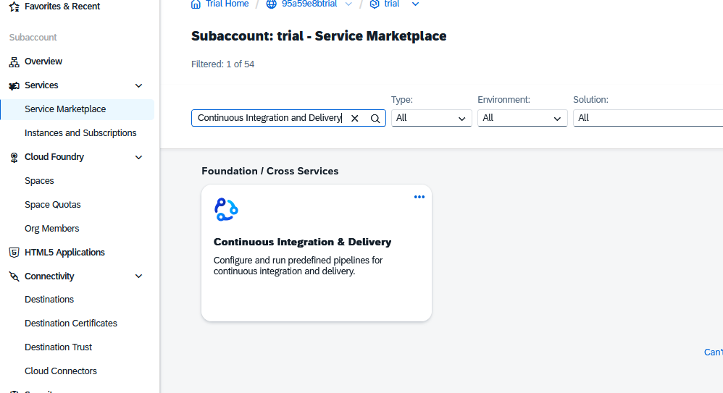

Then it comes under the subscriptions -> Make sure you added the admin role to the user
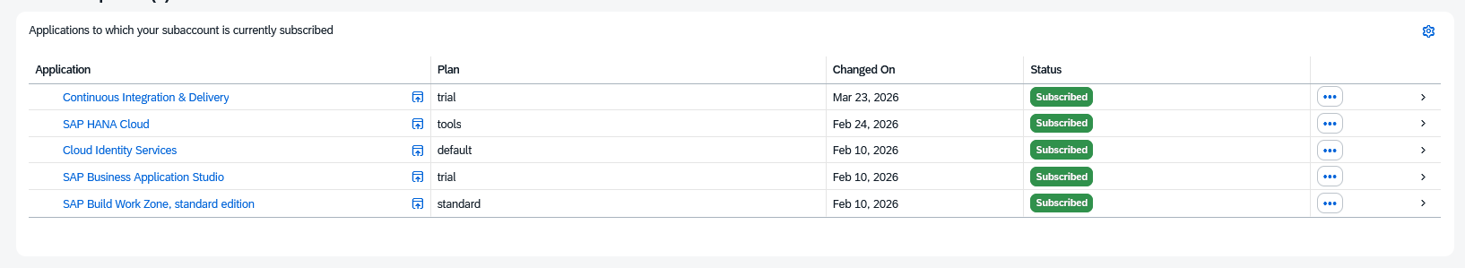

Open the app
Now we are going to connect the CI/CD to the credentials.
We have two
  - The one of the Github where the code is pushed to
  - The BTP where the code needs to be deployed to
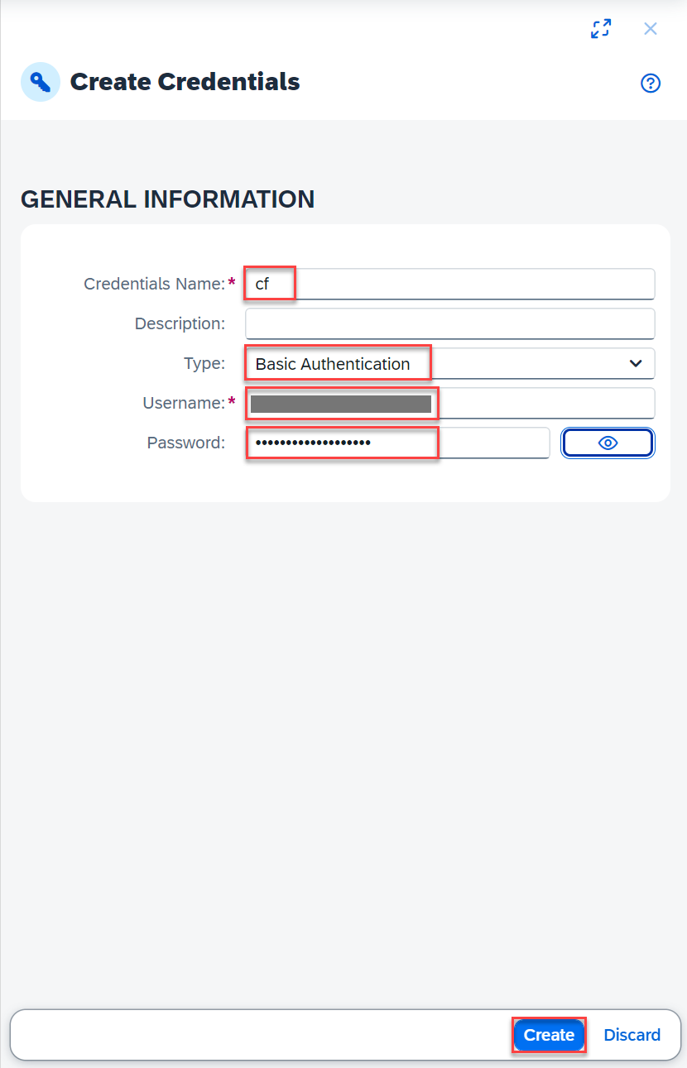
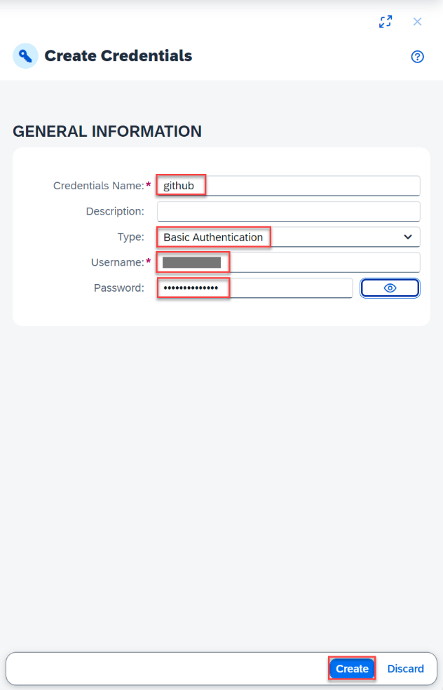
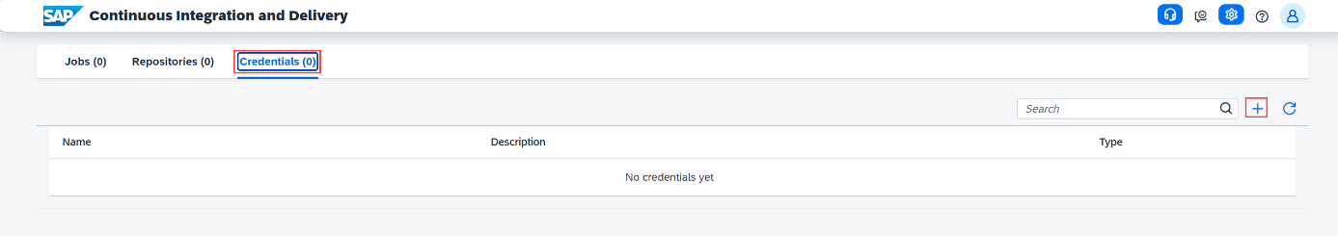

In the git you will need to create a Personal Access token, to be able to enter the git.

Settings developer settings -> personal access token -> Tokens
Give it a useful name, and select the full repo scope

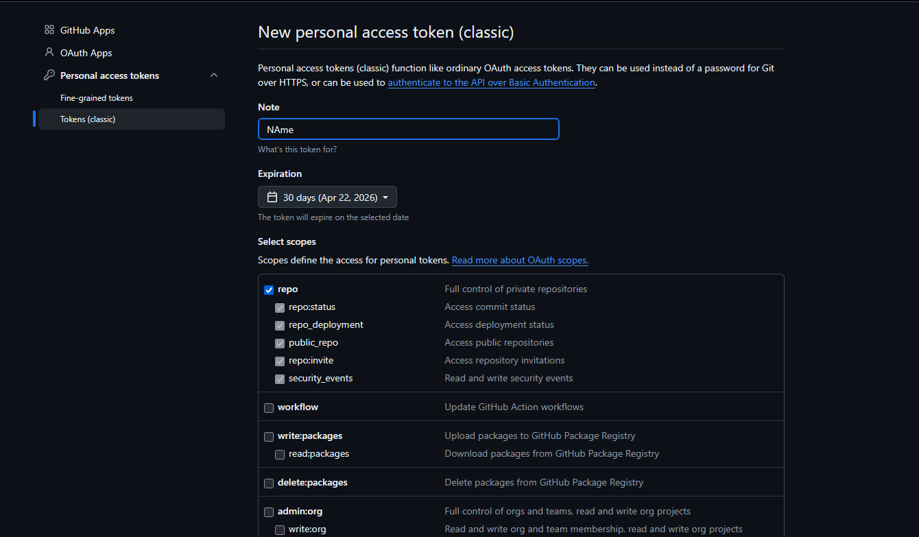
Make sure to copy the secret key.
Because that is the one we will use as the
Password for the github credentials
In combination with the username of the git
As Username.

For the cf credentials we will use the basic log-in credentials of the btp user

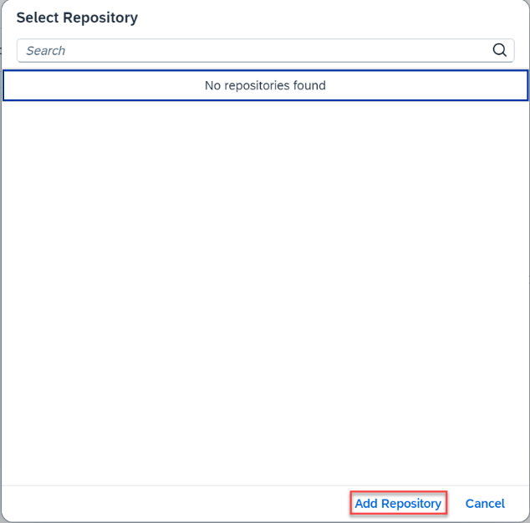
Now we have the credentials ready
we will create our job that get’s the code from the github repo to the btp
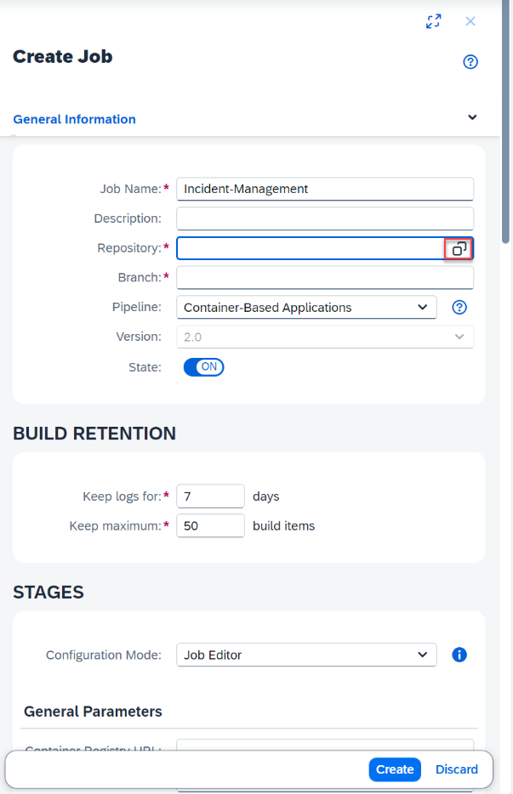

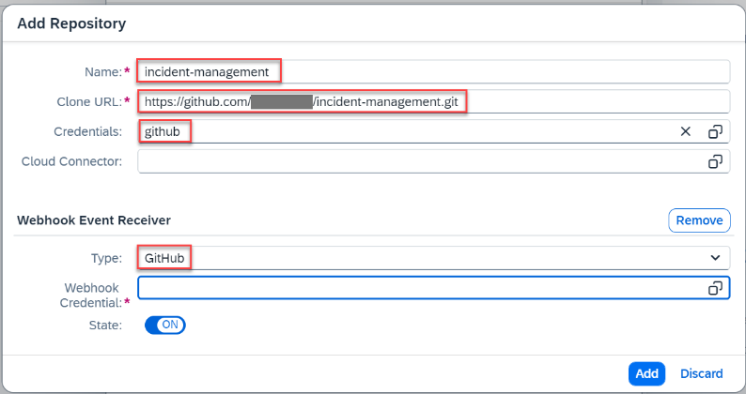

We will clone the url of the git repo and place it in the add repo + connect it to the github credentials.
Then we need to connect a webhook:
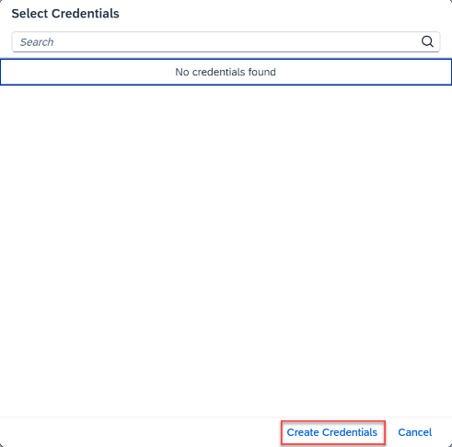
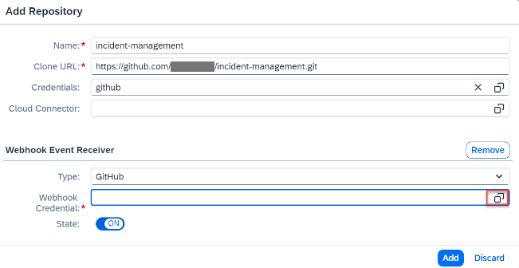

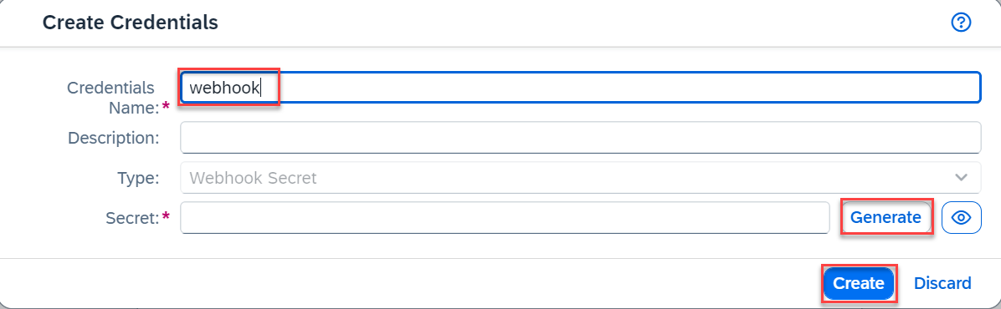

Generate a secret and copy this, this we will need for the git webhook!!
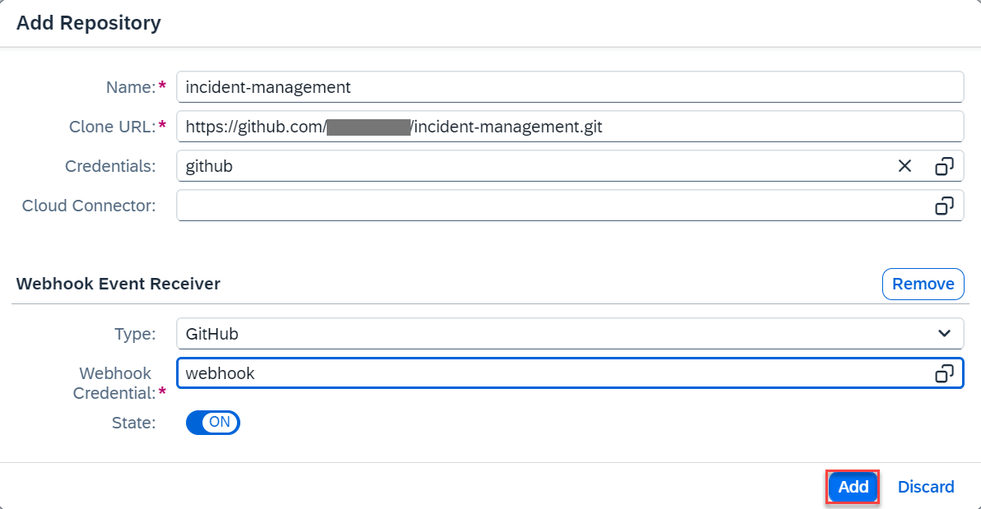

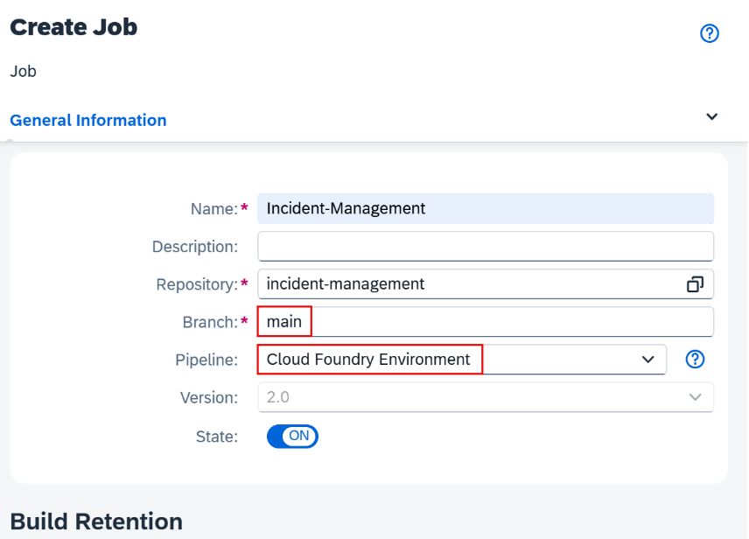
And after that simple click add

Then we will configure the pipeline and stages:
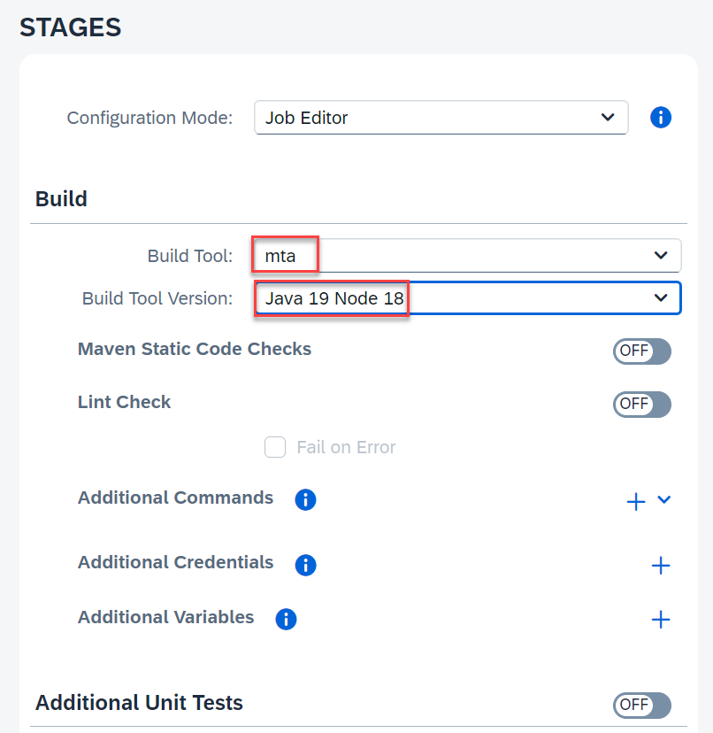

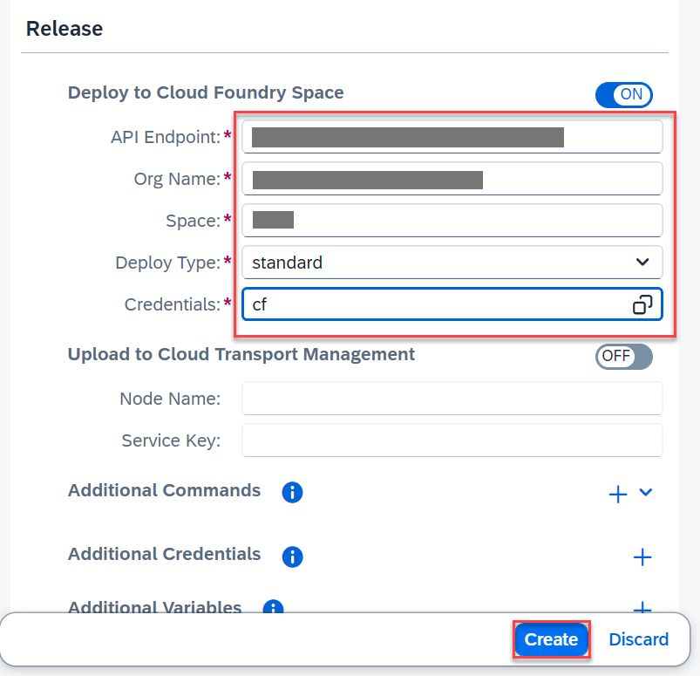

In the release fill in the credentials of you find at the overview of the subaccount.

To make it automatic, that when you push the changes to git it automatically runs the job. We need to create a webhook.
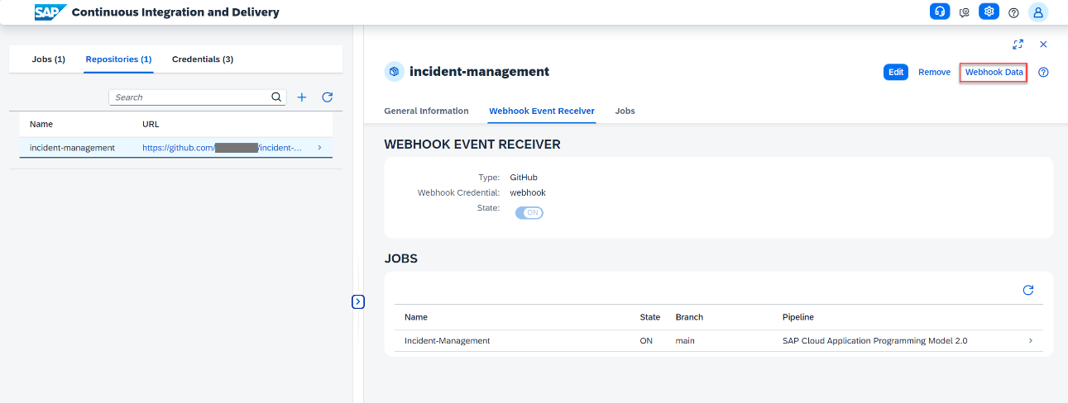

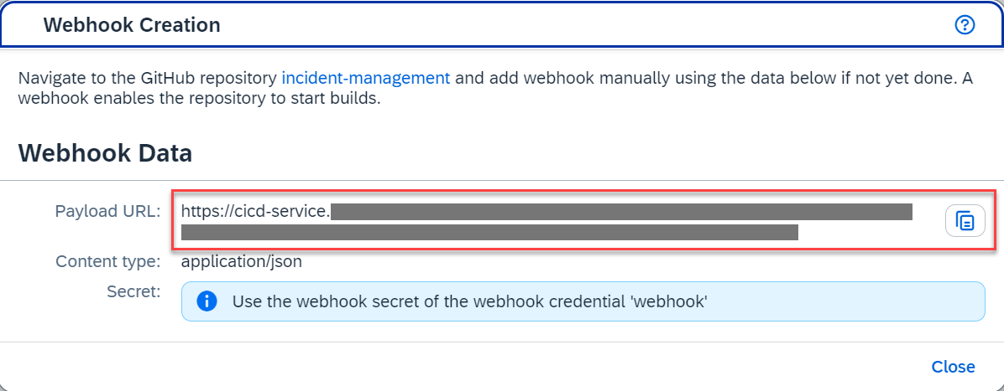

Then we go to git and create a webhook inside the correct repo.
So go to the git repo -> settings -> webhook

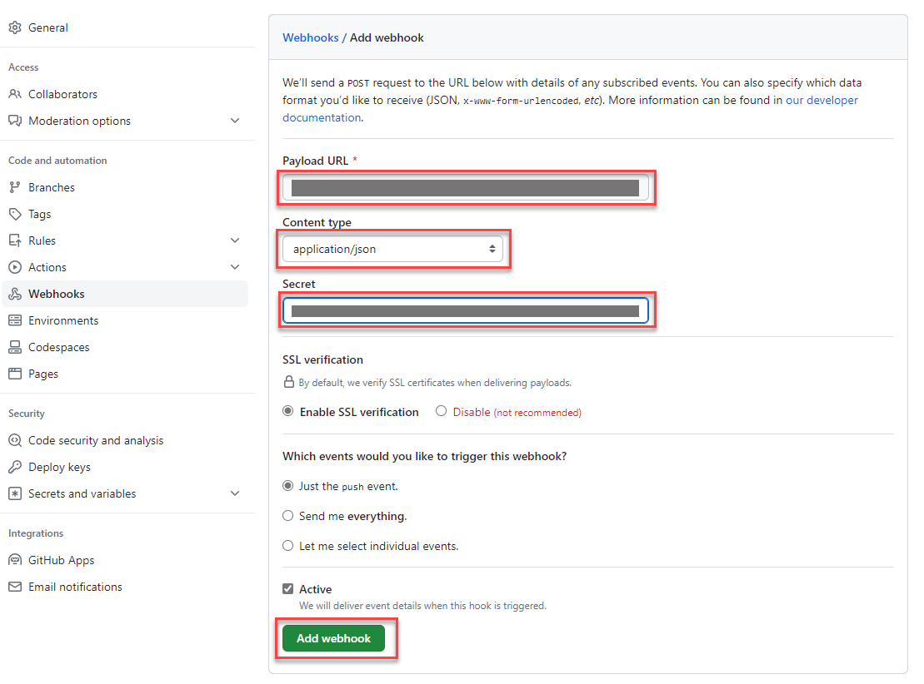

The url is the one you just copied, the secret is the one you created when creating the webhook on the job.

If there are problems with the deployment to btp
  - Look in the: /APP/WEBAPP/manifest.json
  - In datasource find; OdataVersion
  - Change it to 4.0!!!!!!!!!!!!

