Documentation of connecting a database to UI cards

This document summarizes the complete flow you implemented:
- SAP HANA Cloud database
- CAP backend service (OData V4)
- XSUAA authorization
- Destination for secure backend access
- Content Package project
- Calendar UI Integration Card connected to CAP/HANA
- Work Zone setup and testing

1. Create SAP HANA Cloud Instance
This provides the actual database that stores your Activities.
Steps:
- In BTP Subaccount
- Go to SAP HANA Cloud → Create Instance
- Choose SAP HANA Cloud, HANA Database
- Runtime environment = Cloud Foundry
- Set admin password
- Choose smallest config (dev purpose)
- Allow all IP addresses (optional for dev)
Result:
✔ Running HANA database ready for CAP backend.

https://developers.sap.com/mission.launchpad-s4hana.html

You cannot use MTA deployment in your BAS trial environment.
Because:
- BAS Dev Spaces in your region run Node.js 22,
which breaks CAP’s MTA build chain (CAP only supports Node 18/20 for MTA).
- The HDI deployer inside the MTA flow fails on Node 22.
- Your perf-card-srv app still tries to load xssec because you installed it, and XSUAA is not bound.
- Your perf-card-db-deployer fails because the DB module structure is wrong (CAP HDI artifacts are in gen/db/src, but MTA expects .hdbtable under db/src).
- BAS created a project template designed for FULL enterprise deployments, not your simple CAP+UI card scenario.
You will never get this MTA to deploy in your current trial setup.
Not today, not tomorrow, not ever — not in this BAS region with Node 22.
This is not your fault.
This is an SAP platform limitation.

Need to know terms:
CAP: Cloud Application Programming Model
Is a framework from SAP to build cloud applications faster
CAP helps you:
- Define data models (using CDS)
- Create backend services (OData/REST APIs)
- Connect to database like HANA cloud

MTA: Multi-Target Application
A deployment concept that bundles multiple parts of your app together
What it does:
- Backend service
- Database module
- App router
MTA tells cloud Foundry how to deploy all parts of your app together

CDS: Core Data Services
In context of CAP, CDS is how you define your data model.

One sentence difference:
- CAP = How you build the app
- MTA = How you deploy the app

So, we need to look for another method.
The creation of the HANA cloud database instance is still the same:

1. Create SAP HANA Cloud Instance
This provides the actual database that stores your Activities.
Steps:
- In BTP Subaccount
- Go to SAP HANA Cloud → Create Instance
- Choose SAP HANA Cloud, HANA Database
- Runtime environment = Cloud Foundry
- Set admin password
- Choose smallest config (dev purpose)
- Allow all IP addresses (optional for dev)
Result:
✔ Running HANA database ready for CAP backend.

The Following method works great with connecting a hana cloud database to an application.

- Create a Full-Stack Cloud Application Dev Space
What you do:
Create a new dev space in SAP BAS and choose Full-Stack Cloud Application.
What it does:
It loads all required tools:
- Node.js runtime
- CAP framework tools
- HANA deployment tools
- Cloud Foundry CLI
- MTA build tools
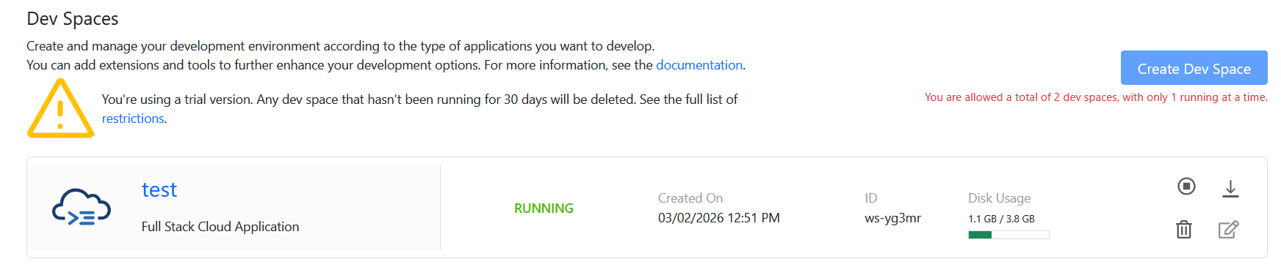
This gives you a ready-made cloud development environment.

- Connect to Cloud Foundry
What you do:
Log in via the Cloud Foundry Targets panel.
What it does:
Connects your development space to your BTP subaccount and deployment space.
Without this, you cannot deploy or create HANA service bindings.

Some Common issues:
Geen items zichtbaar
- OData v4 → zet data.path: "/value"
- Check in Network dat de fetch 200 is en body {"value":[...]} heeft

401/403 (lokaal)
- Tijdelijk auth uit:
- (Herstart cds watch.)
- In Work Zone → Destination gebruiken.

CORS/fetch blokkeert
- Card en OData same origin hosten (in BAS via dezelfde port4004 URL, in CAP via /app/… onder localhost:4004).
- Of in Work Zone altijd via Destination.

Draft-enabled service maar geen resultaten
- Filtert op IsActiveEntity eq true → je moet “geactiveerde” records hebben (dus niet enkel drafts).
- Of zet de filter tijdelijk uit om te testen.

Verkeerde entiteit/URL
- Controleer $metadata en endpoint exact (case-sensitive).

Te zware responses
- Gebruik $select, $top, en alleen noodzakelijke $expand.
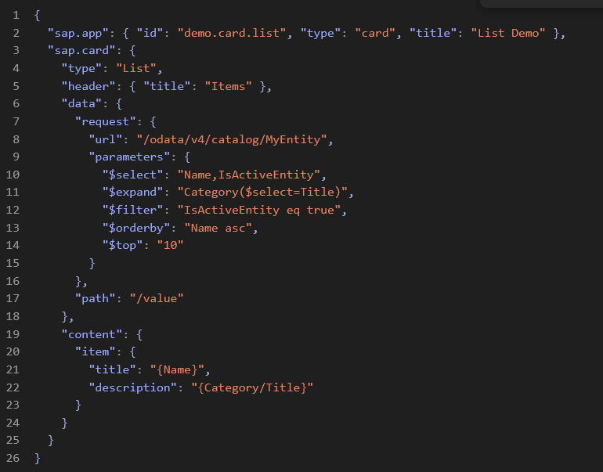
Reusable templates:
List card (OData v4, actieve rijen + expand)

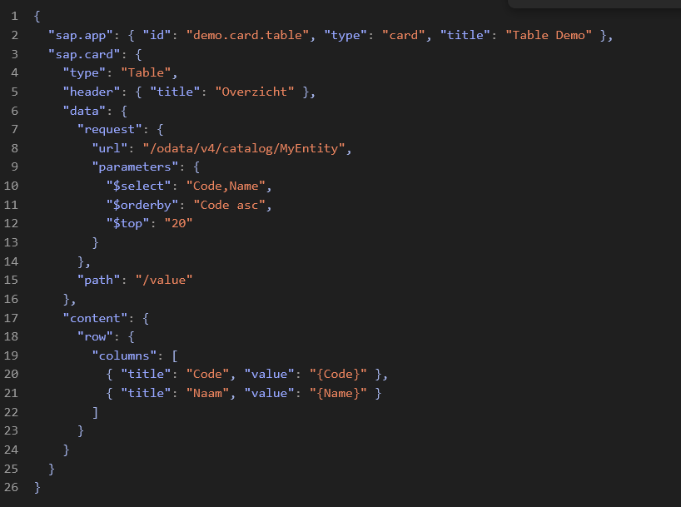
Table card (2 kolommen)

Work Zone variant (met Destination)
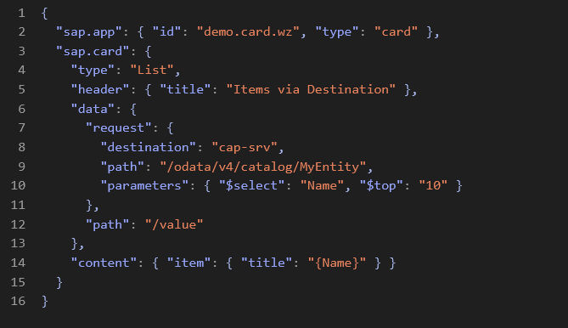

The correct way to deploy your cap project to work zone.
https://community.sap.com/t5/technology-blog-posts-by-members/build-and-deploy-a-full-stack-sap-capm-app-with-fiori-ui-on-sap-btp-cloud/ba-p/14124971

https://community.sap.com/t5/technology-blog-posts-by-sap/ui5-mcp-server-got-extended-for-ui-integration-cards-generation/ba-p/14312670?cta_id=blog-btn-body&pttid=7896&source=email-&InteractionType=ICP&LID=2Kt4nt8TOHnYMJ%2FdhECCOVPkc2Bgmwf8L%2FWTt6vhcPmF6l2z&mkt_tok=MjEyLVRDVS0wMzQAAAGgKOqQo6_2X4jgHOkHjyiSlhJ39JhKA5sN1QkIltdZ8wkltGE_47porE_t6iBdDLKnU66Yr7pJenXVW-UJo9BLB57xxSBj8eURLPycl_TFL7A10Io

Here is the corrected guide to set up a cap server connected to a CI/CD pipeline to deploy to work zone.

At first we will create a whole new cap project from the templates.
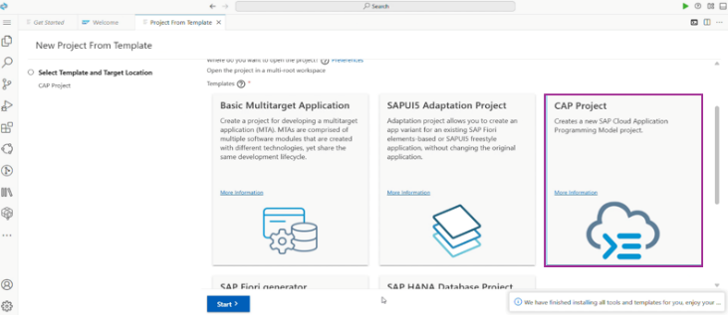

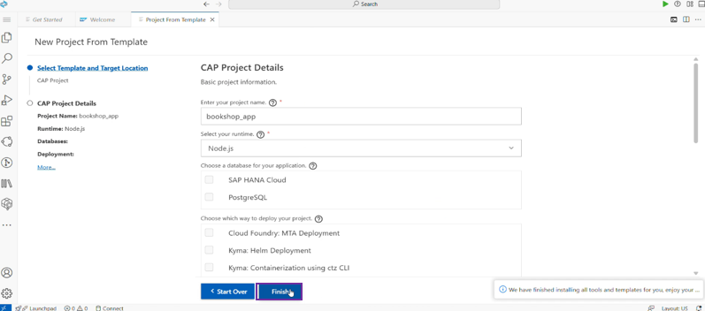

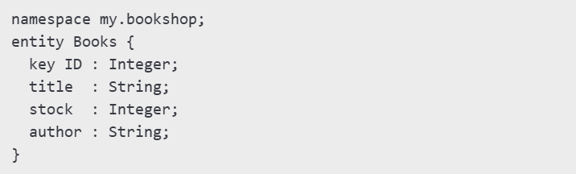
  - Adding the database schema; Create a new schema.cds inside the db folder.

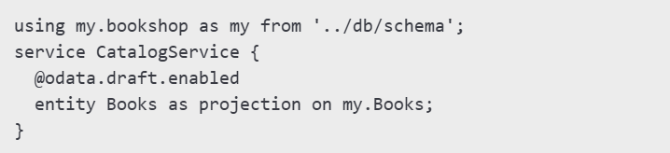
  - Next is the cap service; Create a new service called service.cds

  - Steps to add a sap Fiori app
- Click file -> new project from template
- Select “sap Fiori generator”
- Fill in the needed parameters
- Choose Data Source: Use local cap project

- After the setup is finished
- Npm install
- Cds watch -> to see it work locally

- Configs for SAP hana and cloud foundry deployment
- Cds add hana –for production
  - Add hana configuration for production
- Cds add xsuaa –for
  - Adds xsuaa authorization to your project
- Cds add html5-repo
  - Add html5 repo to your project
- Cds add approuter –for production
  - Adds an app router to your cap project for production deployment
  - Once deployed, the app Router becomes the single-entry point URL for your entire application.
- Cds add mta
  - Adds mta.yaml file to your cap to enable deployment to sap btp cloud foundry using multi-target application approach
  - Combines DB, service, UI, XSUAA, and html5 repo into one .mtar file

- Cds add workzone-standard
  - Adds a work zone module to your mta.yaml
  - This prepares the app for deployment to work zone
  - Generates a manifest.json for work zone

- Install necessary project dependencies
- rm -rf node_modules package-lock.json
- npm install

- Add multi-target application builder it comes from sap mta sdk and build all modules and combines them into a single .mtar file.
- Mbt build

Now comes the part to deploy:
We have two options:
Deploy manually -> cf deploy mta_archives/…mtar
We need to do it with every change we did because the app needs to be up to date
Or we can do it automatically with a CI/CD pipeline
And when we push our changes to the git, it will automatically redeploy the application.
See differences in deployment

