Creating UI cards for the AI extraction project:

For the project I was asked to create a UI card/UI cards to display the extracted data on a clean way.
For the data I got an excel with a crazy amount of information, were I didn’t understands a single thing of, for that I had a meeting with Tom -> Tom is on of the colleagues that is on the project.
He explained the data so I could follow.
The important thing of the excel:
It is an overview of the documents that are extracted from.

To start at the beginning.
They created a program that was able to read out email contents with AI.
They or order placements.
A customer places an order -> get’s an order conformation through the mail with an overview of what the customer ordered.
The AI is asked to look for specific fields inside the document, for example OrderDate, OrderNumber, currency, delivery date, …

For each file the AI will look for those parameters.
And then it will give a lot of data -> That data is stored inside the excel file.
Each document has different lines for example a order conformation is build like this.

Order conformation:
OrderNumber | OrderDate | articleNumber | Quantity | DeliveryDate
5155 | 11/12/2026 | 54896 | 44 | 20/12/2026
5155 | 11/12/2026 | 76215 | 12 | 20/12/2026

As you see we have two lines, every line is handled separately.
So what means the AI will have 2 lines and will look if every item is filled in.
In this case everything is filled in: which means total: 100%
OrderNumber | OrderDate | articleNumber | Quantity | DeliveryDate
2/2 -> 100% | 2/2 -> 100% | 2/2 -> 100% | 2/2 -> 100% | 2/2 -> 100%

But maybe
OrderNumber | OrderDate | articleNumber | Quantity | DeliveryDate
5155 | 11/12/2026 | 54896 | 44
5155 | 11/12/2026 | 76215 | 12 | 20/12/2026
there is something like -> for one product they didn’t fill in the delivery date

In this case not everything is found everywhere so total: 90%

OrderNumber | OrderDate | articleNumber | Quantity | DeliveryDate
2/2 -> 100% | 2/2 -> 100% | 2/2 -> 100% | 2/2 -> 100% | 1/2 -> 50%

And then we need to figure out where the problem lays -> Was it the AI that wasn’t able to find the data (wrong prompt, …), or was the data not inside the file for that specific line? -> In that case the AI did his job but it simply wasn’t in the file

Now my task is to create an UI card that makes it easy to look in which files the problems lay.
If we read out 250 files and they have a minimum of 4 line that means we have 1000 lines extracted and we need to figure out were the problem lays!
That’s a bit crazy, so in an overview we make it easy to find the problem file in 5 seconds.

I create an UI card with the extraction information on it -> Diagram.
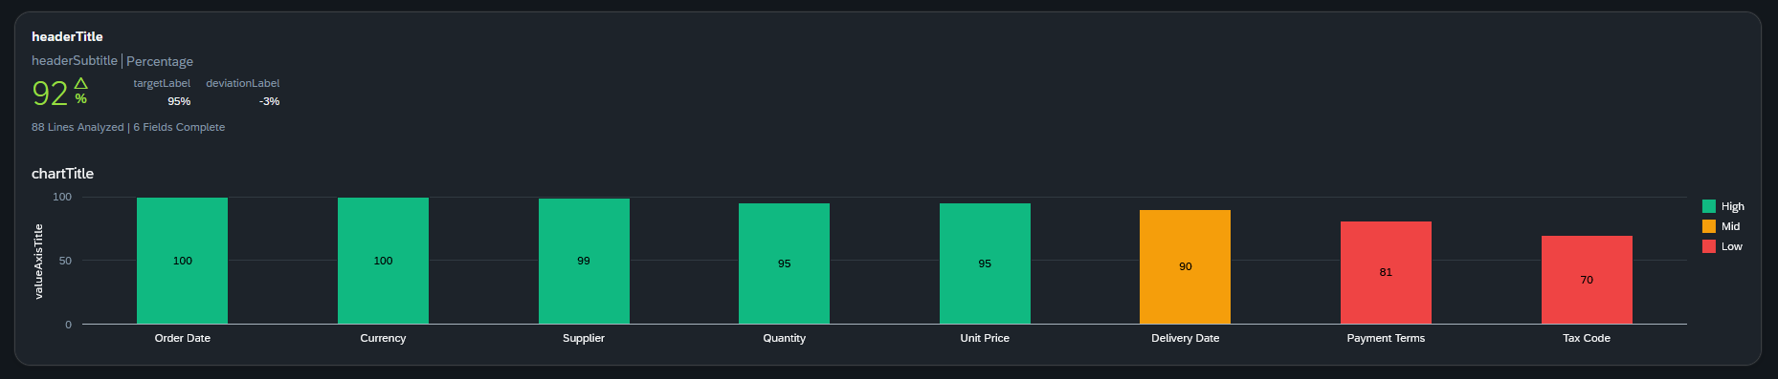

Now if we look at this, we still don’t see in which file the missing data is -> So I will try to add a hover action or something, so we can easily see which file is the problem child.

