SAP Build Work Zone Advanced Edition

Complete Functional and Deployment Documentation

What is SAP Build Work Zone, Advanced Edition
SAP Build Work Zone, Advanced Edition is SAP’s enterprise workplace and digital experience platform. It enables organizations to create personalized, role-based digital workspaces that unify:
- SAP applications (S/4HANA, SuccessFactors, CAP apps)
- Non-SAP applications
- UI Integration Cards
- Workpages and layouts
- Content from multiple systems and tenants

Unlike the Standard Edition, the Advanced Edition provides:
- Full Administrative control
- Content packages and lifecycle management
- Role-based access
- Multi-tenant readiness

Core concepts & Terminology
Before diving into deployment, it is crucial to understand the core building blocks

Sites
A site represents the overall digital workplace experience
- Each site has its own navigation
- Each site has its own workpages and content
- Multiple sites can exist per tenant

Workpages
Workpages are layout containers shown inside a site.
- Configurable by administrators
- Contain sections, columns and rows
- Host UI integration Card and applications
- Do no contain business logic

Apps
In work zone, an app is a business artifact that can have:
- One or more visualizations (tile, card, link)
- Navigation targets
- Role assignments
Apps are the central object for access control.

UI integration Cards
UI Integration Cards are:
- Lightweight UI elements
- Config-driven (manifest.json)
- Used to display read-only or limited-interaction data
- Stateless
- Backend-driven via destination

IMPORTANT LIMITATIONS:
UI cards can only consume token-based, stateless backends
They do not support cookies or browser sessions

Content Packages
A content package is a transportable container that groups:
- UI cards
- Apps
- Visualizations
- Workpages
- Roles
- Catalogs
Content packages are the foundation for lifecycle management in the advanced edition

Standard vs Advanced Edition – deployment differences
Topic | Standard Edition | Advanced Edition
Content Upload | Content Manager | Admin Console
Content Packages | Limited | Central concept
CI/CD Support | Minimal | Full support
CTM Integration | No | Yes
Governance | Basic | Enterprise-grade

The functional concept is the same, but administration and scalability differ.

Deploy strategy of content packages

Key principle
Content packages must be uploaded first, then activated and made available for use.

Uploading content packages
In Advanced, content packages are uploaded via:
Administrator Console -> UI integration -> Content packages -> upload content packages

Package processing
After uploading, work zone;
- Validates packages structure
- Registers cards, apps, roles and catalogs
- Makes visualizations available in the UI integration layer

Accessing uploaded cards
After successful upload;
- Go to Administrator console -> UI integration -> Cards
- Uploaded cards automatically appear in the card list
- Cards are now reusable across sites and workpages

Using the content in workpages
- Open site manager
- Select a site
- Open a workpage
- Add cards from ui integration catalog
- Save and publish changes

- Standard Edition vs Advanced Edition – What’s the difference?
Standard Edition is for simple content consumption; Advanced Edition is for enterprise-scale content lifecycle, governance, and automation.

  - Positioning; who is each edition for?
Standard Edition
Static consumption-focused

Advanced Edition
Dynamic experience-oriented

What SAP Build Work Zone Advanced can do that Standard cannot.

- Dynamic configuration & runtime context
In Advanced, work zone supports runtime context propagation, meaning;
- Page context (filters, parameters)
- Cross-card interaction
- Dynamic configuration per user/role

- Card-to-card interaction
Advanced supports context propagation between cards, such as:
- Filter cards
- Parameter cards
- Analytical cards

- Standalone artifact lifecycle management
Advanced:
- UI cards can exist standalone
- Cards registered centrally in UI integration
- Independent versioned
- Independent governed

Standard:
- Content largely bound to packaging and site usage
- Less fine-grained lifecycle control

- Application visualization
In advanced, apps and visualization are first-class citizens:
- One app
- Multiple visualization
  - Tile
  - Card
  - Link
- Different visibility per role
- Different entry points per site

Clear Summary Table
Capability | Standard | Advanced
Dynamic parameters & page context | ❌ | ✅
Card-to-card interaction | ❌ | ✅
Standalone UI cards | ⚠️ Limited | ✅
Multiple visualizations per app | ❌ | ✅
Enterprise search | ❌ | ✅
Workflow & task integration | ❌ | ✅
Shell services | ❌ | ✅
CI/CD + CTM | ❌ | ✅
Enterprise governance | ❌ | ✅

Final takeaway
Advanced Edition enables dynamic configuration, runtime context, interaction, and orchestration that is simply not available in standard edition.

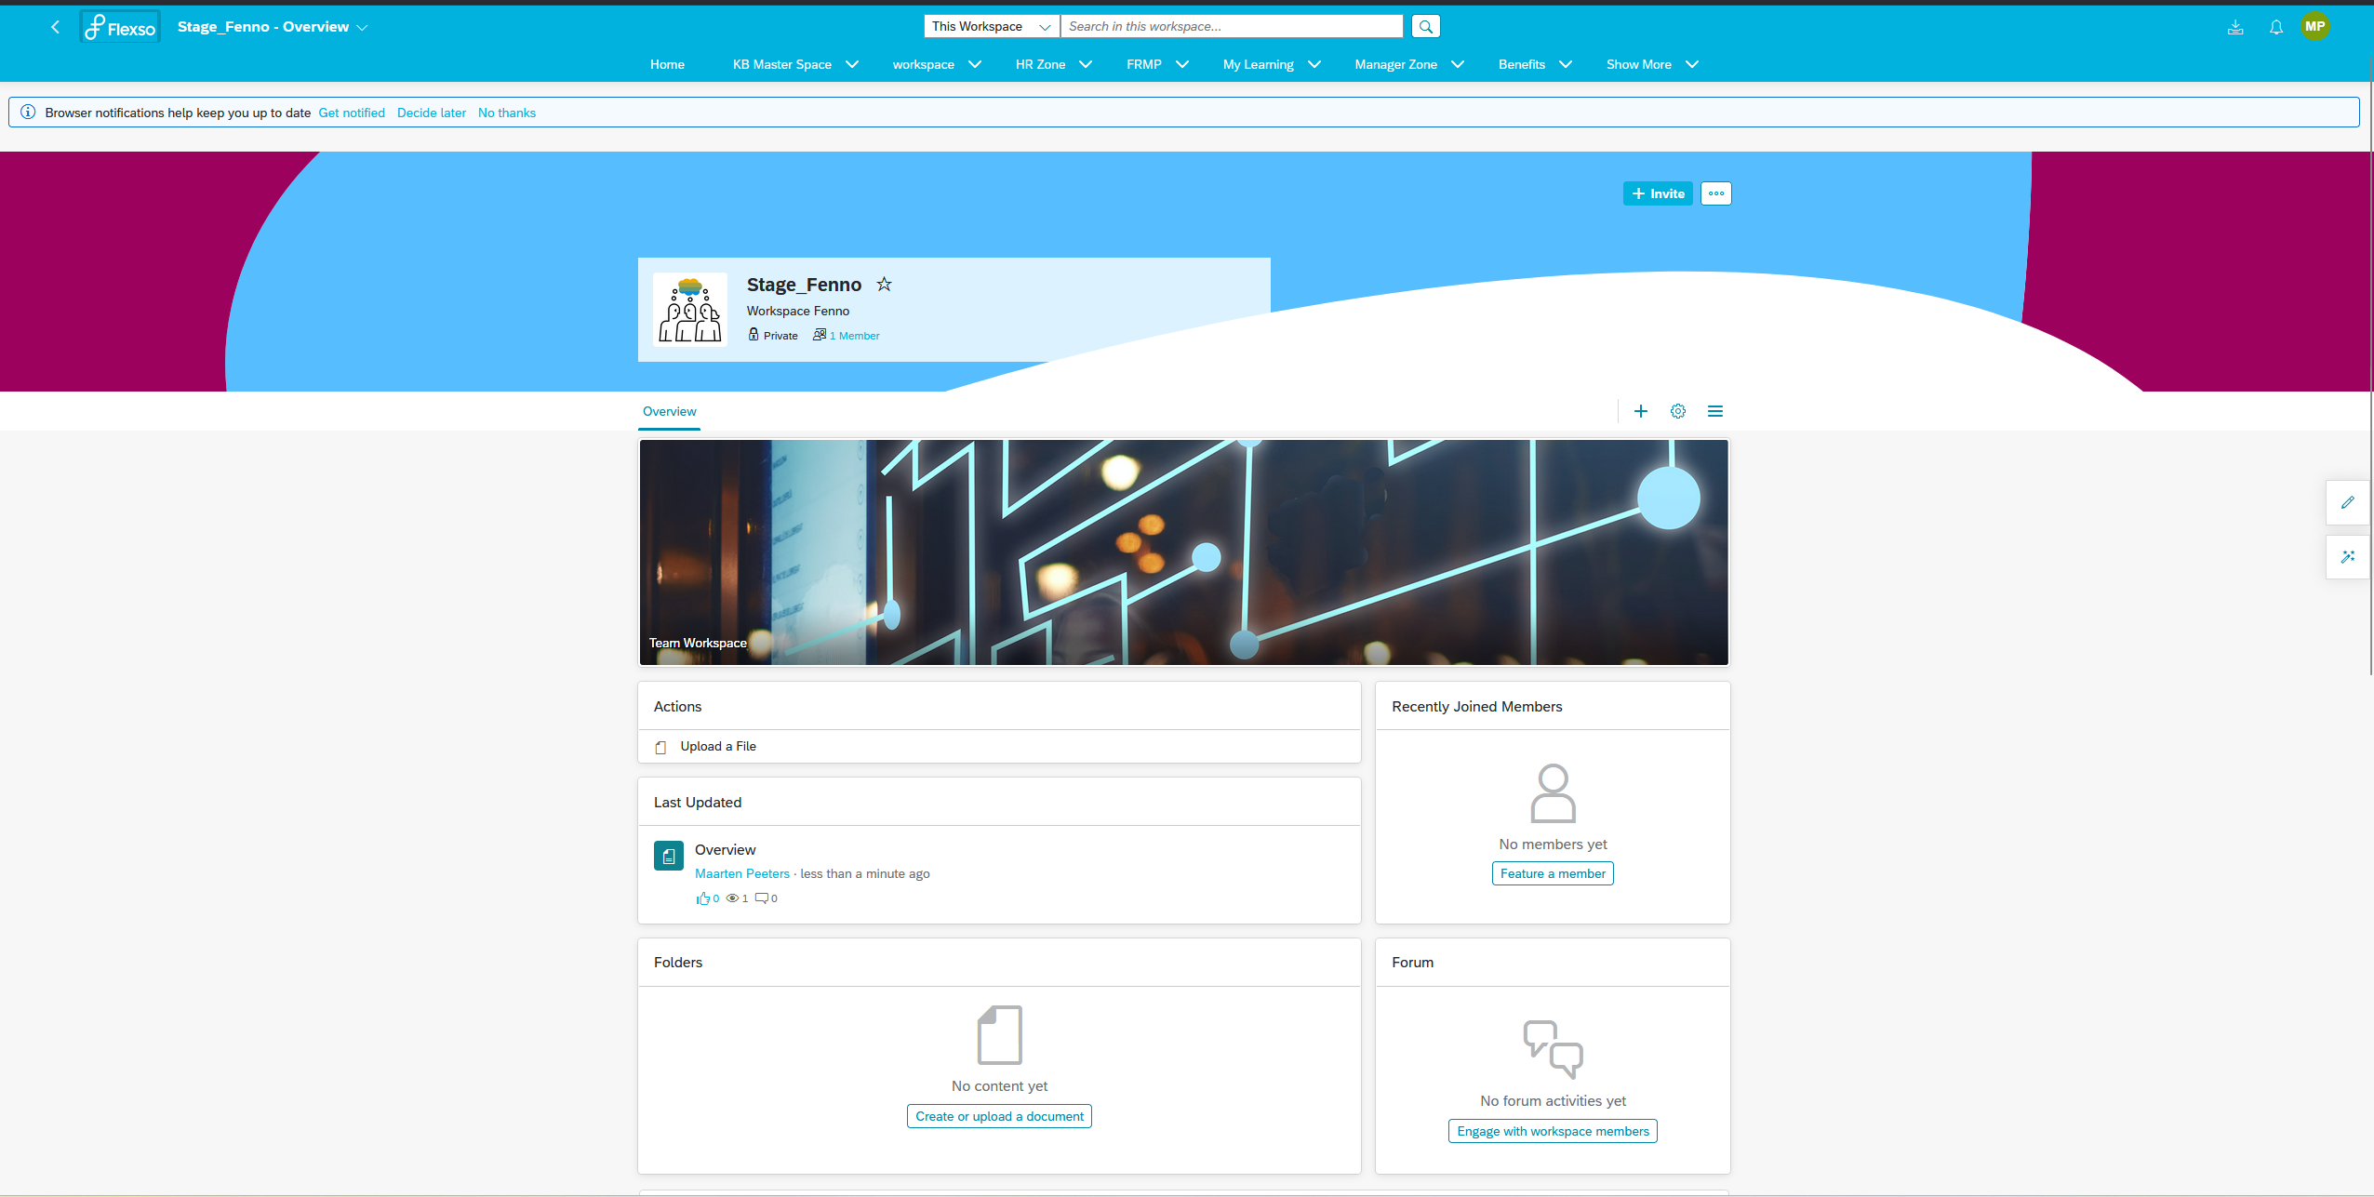

https://help.sap.com/docs/btp/sap-business-technology-platform/continuous-integration-and-delivery-ci-cd?locale=en-US

Some terms you need to understand:
Tenant:
A Tenant is a self-contained SAP cloud system
  - It’s like your own “workspace” in the cloud
  - Each tenant has its own users, data, apps, configurations and content.
  - You can’t see or interfere with other tenants
Tenant | Purpose
Dev Tenant | Developers build and test content/apps here
QA Tenant | Testers validate that everything works correctly
Prod Tenant | Live system for end users to work in
Environments:
An environment usually refers to a logical stage in the development lifecycle, often implemented as a tenant.

