Submission for Homework 8 – James Fogg
For Concepts in Statistical Data Analysis, Spring 2026
Note: See the end of the document at the end for the full R script. I just commented out the code except for the specific plot that I needed, one at a time.

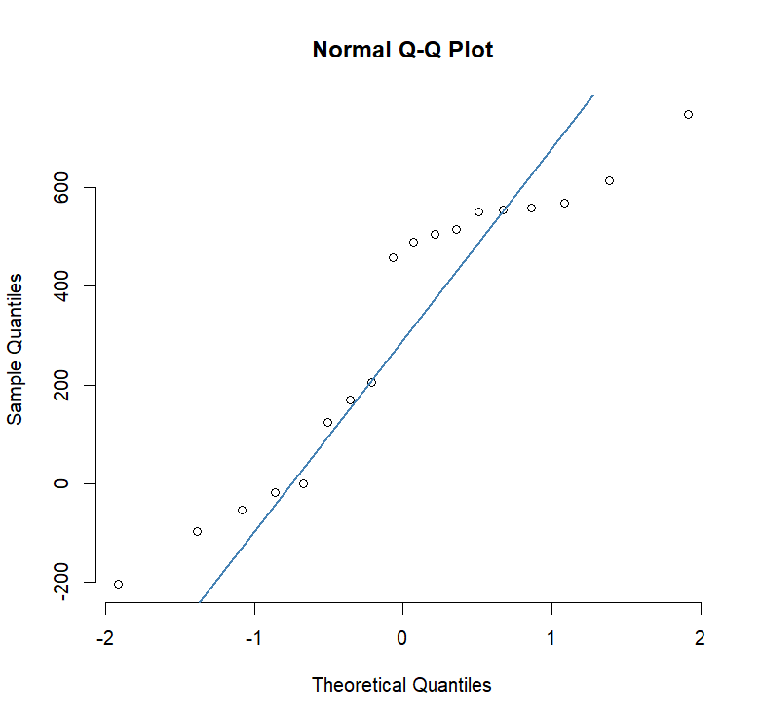
This data does not come from a normal distribution. Towards either end of the graph, there are significant outliers both above and below the line. ss

