计 算 机 网 络

实

验

报

告

Web Server
- 题目要求
配置web服务器

- 开发环境
操作系统：Mac OS
机器规格信息：
CPU型号:Intel 酷睿i7 6820HQ
CPU主频率:2.7GHz
核心／线程数:四核心／八线程
RAM大小:16GB
操作系统位数（32/64）:64

- 程序流程图
Mac自带apache
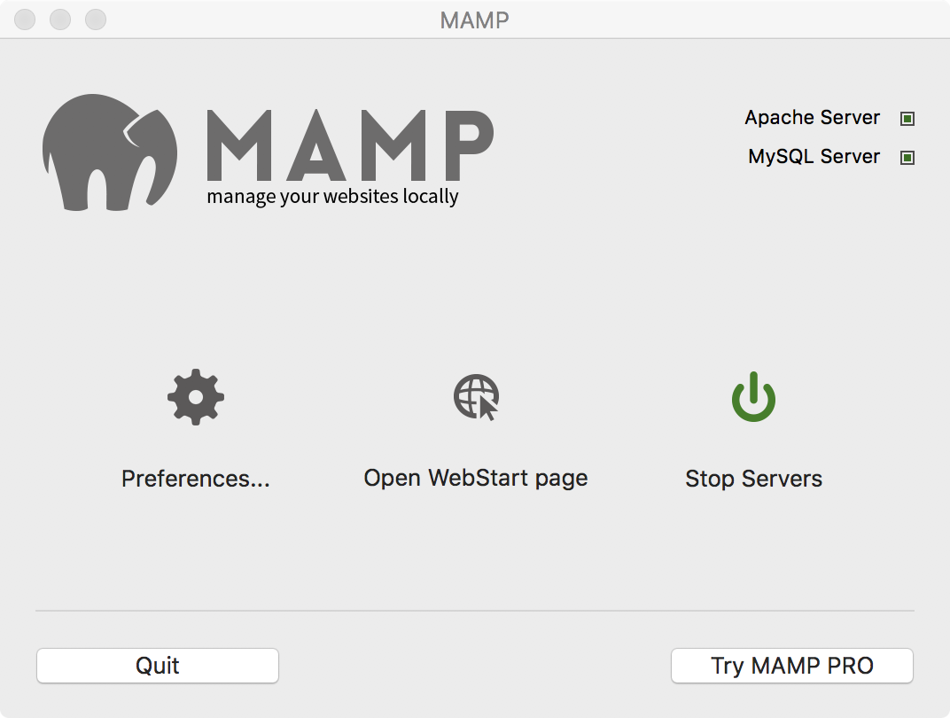
- 程序详解
服务器基本功能：
可以用回环地址访问，也可以用ip地址访问。且其他电脑与手机均可访问。
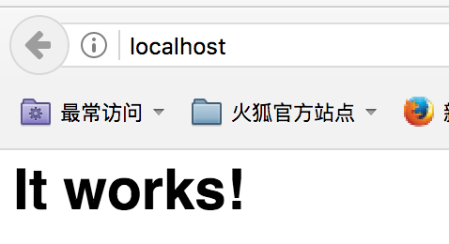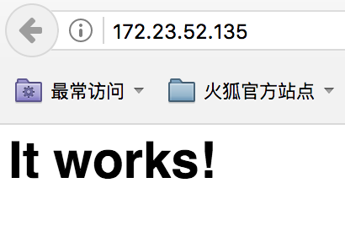
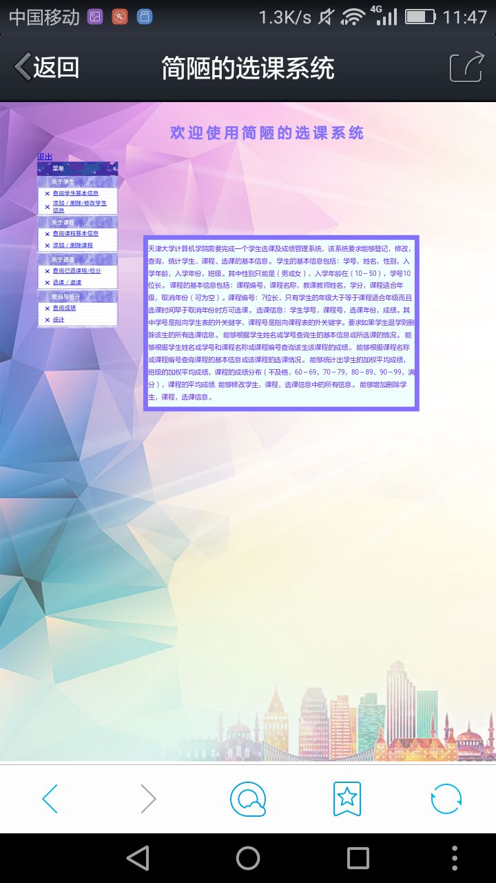
并发测试：
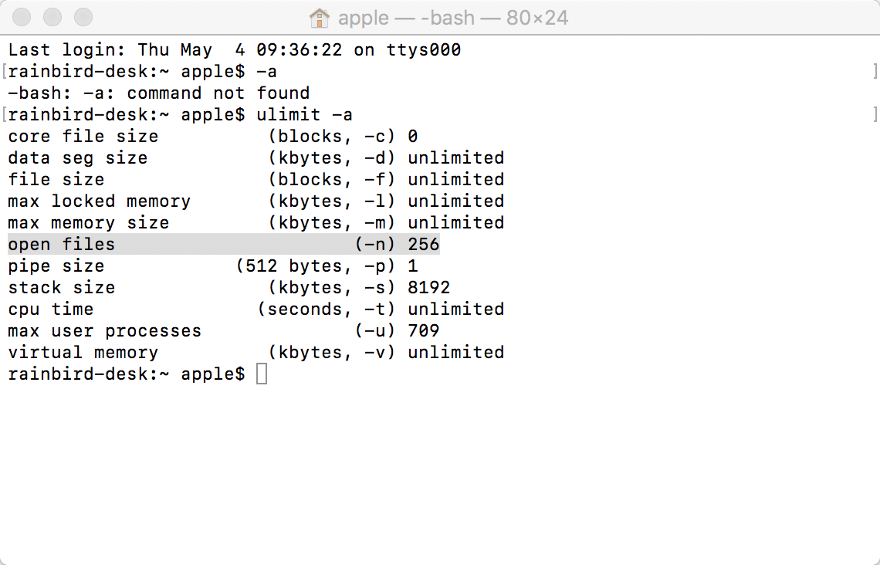
50个并发执行1分钟：
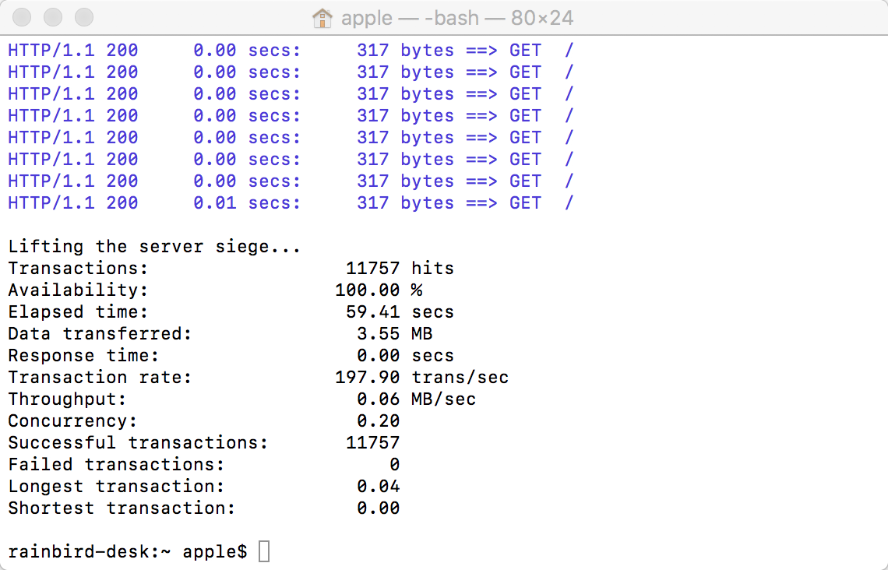
500个并发执行1分钟：
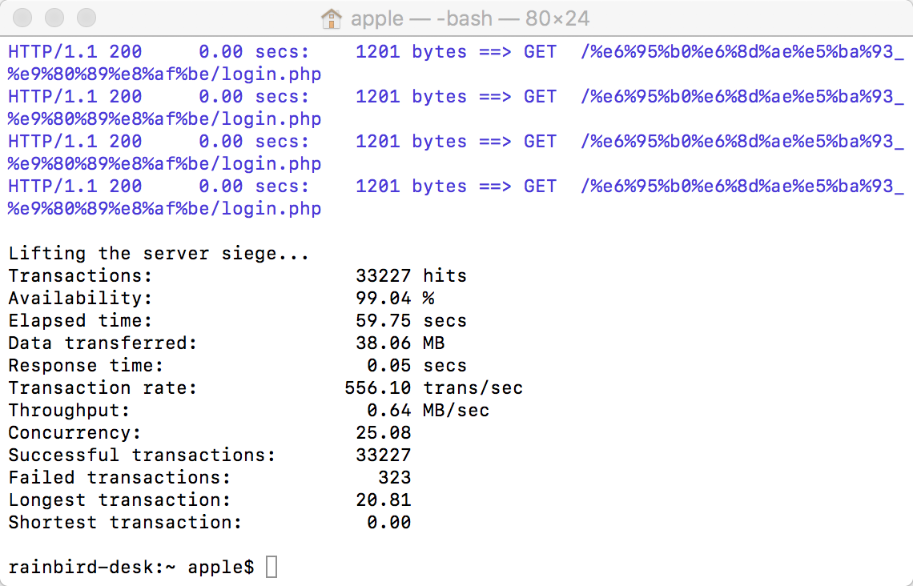
通过终端，访问网址：
rainbird-desk:~ apple$ telnet www.google.cn 80
Trying 2401:3800:4001:11::101f...
Connected to www.google.cn.
Escape character is '^]'.
GET /index.html HTTP/1.1
connection: close
Host: www.google.cn

HTTP/1.1 200 OK
Accept-Ranges: none
Vary: Accept-Encoding
Content-Type: text/html
Date: Fri, 05 May 2017 11:29:17 GMT
Expires: Fri, 05 May 2017 11:29:17 GMT
Cache-Control: private, max-age=0
Last-Modified: Thu, 08 Dec 2016 01:00:57 GMT
X-Content-Type-Options: nosniff
Server: sffe
X-XSS-Protection: 1; mode=block
Connection: close

<!DOCTYPE html>
<html lang="zh">
<meta charset="utf-8">
<title>Google</title>
<style>
html { background: #fff; margin: 0 1em; }
body { font: .8125em/1.5 arial, sans-serif; text-align: center; }
h1 { font-size: 1.5em; font-weight: normal; margin: 1em 0 0; }
p#footer { color: #767676; font-size: .77em; }
p#footer a { background: url(//www.google.cn/intl/zh-CN_cn/images/cn_icp.gif) top right no-repeat; padding: 5px 20px 5px 0; }
ul { margin: 2em; padding: 0; }
li { display: inline; padding: 0 2em; }
div { -moz-border-radius: 20px; -webkit-border-radius: 20px; border: 1px solid #ccc; border-radius: 20px; margin: 2em auto 1em; max-width: 650px; min-width: 544px; }
div:hover, div:hover * { cursor: pointer; }
div:hover { border-color: #999; }
div p { margin: .5em 0 1.5em; }
img { border: 0; }
</style>
<div>
<a href="http://www.google.com.hk/webhp?hl=zh-CN&amp;sourceid=cnhp">
<img src="//www.google.cn/landing/cnexp/google-search.png" alt="Google" width="586" height="257">
</a>
<h1><a href="http://www.google.com.hk/webhp?hl=zh-CN&amp;sourceid=cnhp"><strong id="target">google.com.hk</strong></a></h1>
<p>请收藏我们的网址
</div>
<ul>
<li><a href="http://translate.google.cn/?sourceid=cnhp">翻译</a>
</ul>
<p id="footer">&copy;2011 - <a href="http://www.miibeian.gov.cn/">ICP证合字B2-20070004号</a>
<script>
var gcn=gcn||{};gcn.IS_IMAGES=(/images\.google\.cn/.exec(window.location)||window.location.hash=='#images'||window.location.hash=='images');gcn.HOMEPAGE_DEST='http://www.google.com.hk/webhp?hl=zh-CN&sourceid=cnhp';gcn.IMAGES_DEST='http://images.google.com.hk/imghp?'+'hl=zh-CN&sourceid=cnhp';gcn.DEST_URL=gcn.IS_IMAGES?gcn.IMAGES_DEST:gcn.HOMEPAGE_DEST;gcn.READABLE_HOMEPAGE_URL='google.com.hk';gcn.READABLE_IMAGES_URL='images.google.com.hk';gcn.redirectIfLocationHasQueryParams=function(){if(window.location.search&&/google\.cn/.exec(window.location)&&!/webhp/.exec(window.location)){window.location=String(window.location).replace('google.cn','google.com.hk')}}();gcn.replaceHrefsWithImagesUrl=function(){if(gcn.IS_IMAGES){var a=document.getElementsByTagName('a');for(var i=0,len=a.length;i<len;i++){if(a[i].href==gcn.HOMEPAGE_DEST){a[i].href=gcn.IMAGES_DEST}}}}();gcn.listen=function(a,e,b){if(a.addEventListener){a.addEventListener(e,b,false)}else if(a.attachEvent){var r=a.attachEvent('on'+e,b);return r}};gcn.stopDefaultAndProp=function(e){if(e&&e.preventDefault){e.preventDefault()}else if(window.event&&window.event.returnValue){window.eventReturnValue=false;return false}if(e&&e.stopPropagation){e.stopPropagation()}else if(window.event&&window.event.cancelBubble){window.event.cancelBubble=true;return false}};gcn.resetChildElements=function(a){var b=a.childNodes;for(var i=0,len=b.length;i<len;i++){gcn.listen(b[i],'click',gcn.stopDefaultAndProp)}};gcn.redirect=function(){window.location=gcn.DEST_URL};gcn.setInnerHtmlInEl=function(a){if(gcn.IS_IMAGES){var b=document.getElementById(a);if(b){b.innerHTML=b.innerHTML.replace(gcn.READABLE_HOMEPAGE_URL,gcn.READABLE_IMAGES_URL)}}};
gcn.listen(document, 'click', gcn.redirect);
gcn.setInnerHtmlInEl('target');
</script>
Connection closed by foreign host.

